Name – Khushal Kumar Singh

Course No. - COMP 3005

ASSIGNMENT – 5

PART 1

CREATE TABLE Person(

P# char(4) primary key,

Name varchar(10) unique Not Null,

Age Integer );

CREATE TABLE Hobby(

H# char(4) primary key,

Name varchar(10) unique Not Null);

CREATE TABLE Play(

P# char(4),

H# char(4),

Times Integer

Foreign key(P#) references Person(P#),

Foreign key(H#) references Hobby(H#));

PART 2

INSERT INTO Person VALUES ('P1','Smith',20);

INSERT INTO Person VALUES ('P2','Jones',30);

INSERT INTO Person VALUES ('P3','Blake',25);

INSERT INTO Person VALUES ('P4','Singh',20);

INSERT INTO Person VALUES ('P5','Adams',30);

INSERT INTO Hobby VALUES('H1','Bowling');

INSERT INTO Hobby VALUES('H2','Chess');

INSERT INTO Hobby VALUES('H3','Dancing');

INSERT INTO Hobby VALUES('H4','Hiking');

INSERT INTO Hobby VALUES('H5','Skating');

INSERT INTO Hobby VALUES('H6','Ski');

INSERT INTO Play VALUES('P1','H1',3);

INSERT INTO Play VALUES('P1','H2',2);

INSERT INTO Play VALUES('P1','H3',4);

INSERT INTO Play VALUES('P1','H4',2);

INSERT INTO Play VALUES('P1','H5',1);

INSERT INTO Play VALUES('P1','H6',1);

INSERT INTO Play VALUES('P2','H1',3);

INSERT INTO Play VALUES('P2','H2',4);

INSERT INTO Play VALUES('P2','H3',5);

INSERT INTO Play VALUES('P2','H4',2);

INSERT INTO Play VALUES('P3','H2',2);

INSERT INTO Play VALUES('P3','H3',3);

INSERT INTO Play VALUES('P4','H2',3);

INSERT INTO Play VALUES('P4','H3',4);

PART 3

1. Get the names of hobbies that “lastname” plays.

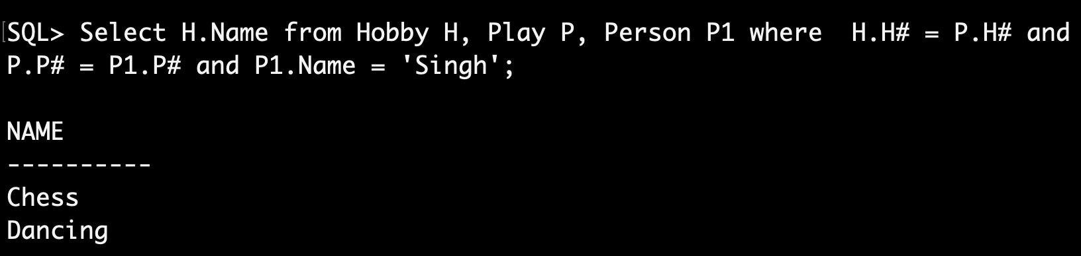

1. Get the names of persons who play Bowling.

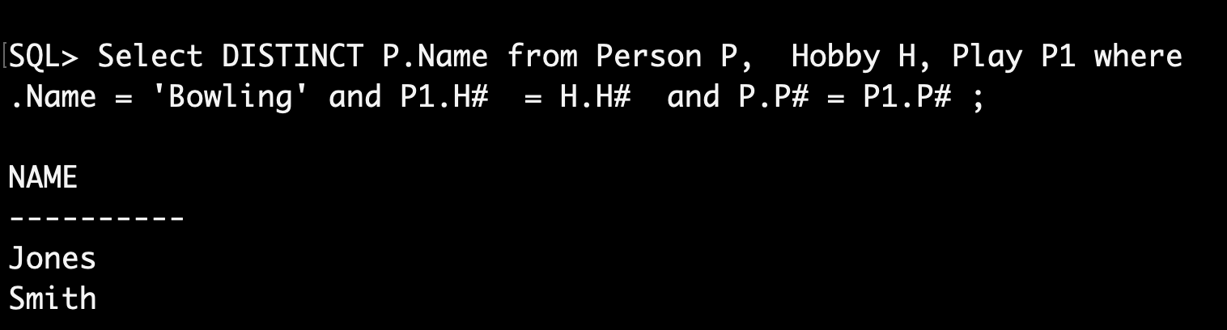

1. Get the names of persons who play a hobby more than 3 times.

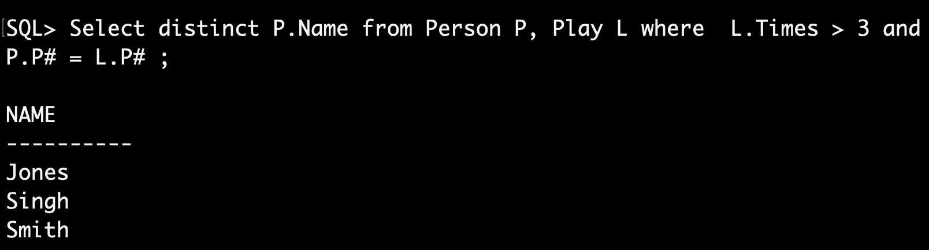

1. Get the names of persons who play either chess or dancing.

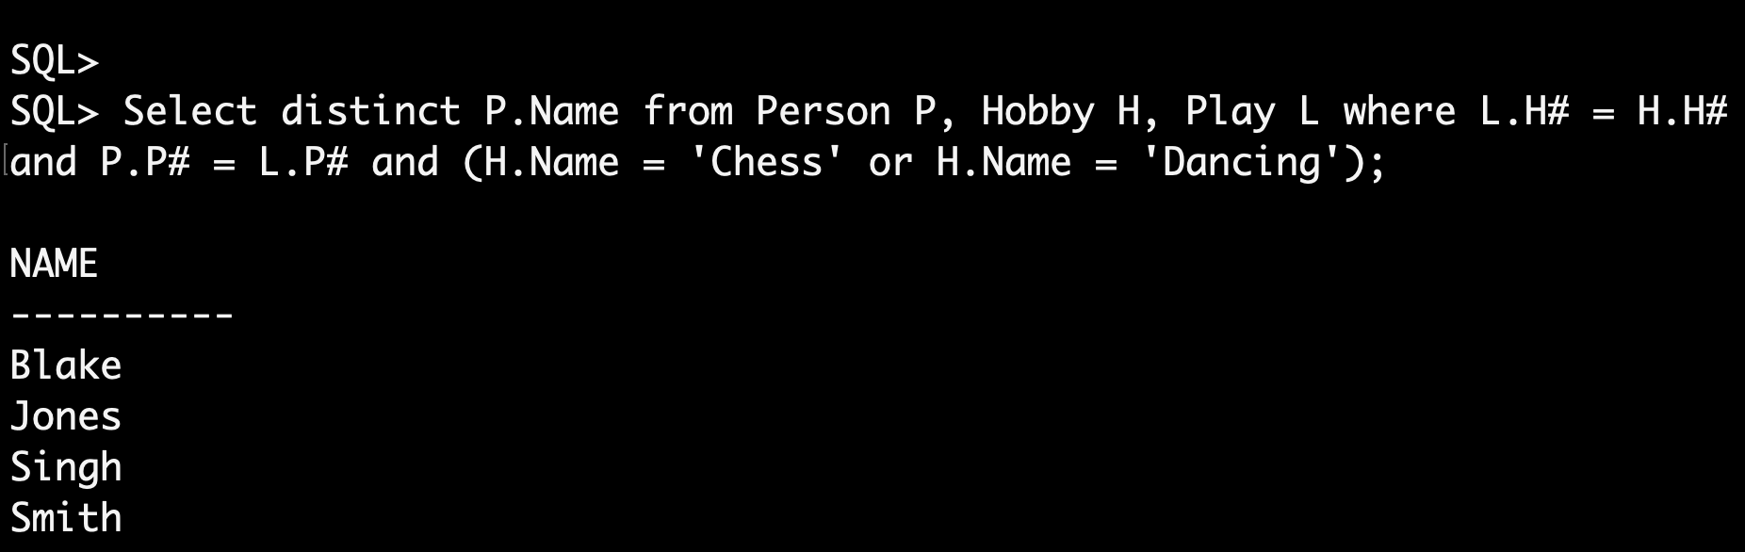

1. Get the names of persons who play both chess and dancing.

Select X.Name from Person X, Play P1, Play P2, Hobby H1, Hobby H2 where X.P# = P1.P# and X.P# = P2.P# and P1.H# = H1.H# and P2.H# = H2.H# and H1.Name = 'Chess' and H2.Name = 'Dancing'

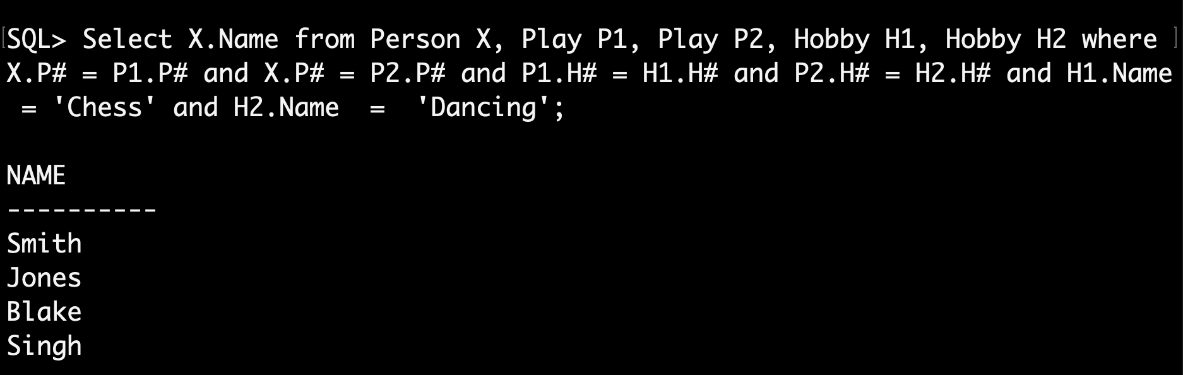

1. Get the person name/hobby name pairs such that the indicated person plays the indicated hobby.

Select P.Name, H.Name from Person P, Hobby H, Play L where P.P# = L.P# and L.H# = H.H#;

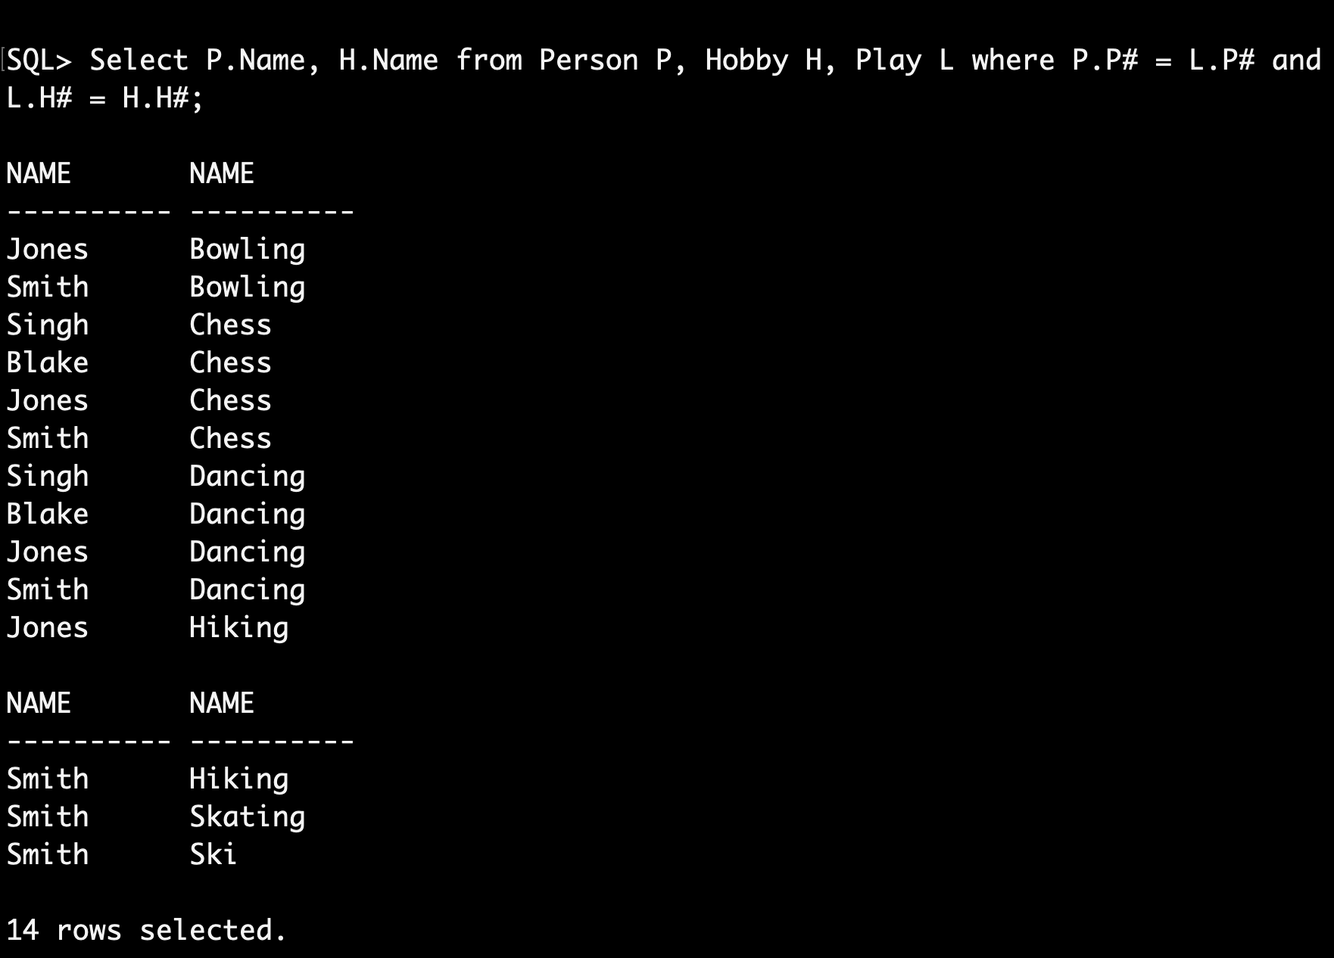

1. Get the names of persons who do not play Ski.

Select Name from Person P WHERE NOT EXISTS (select \* from Hobby H WHERE Exists (Select \* from Play L where P.P# = L.P# and L.H# = H.H# and H.Name = 'Ski'));

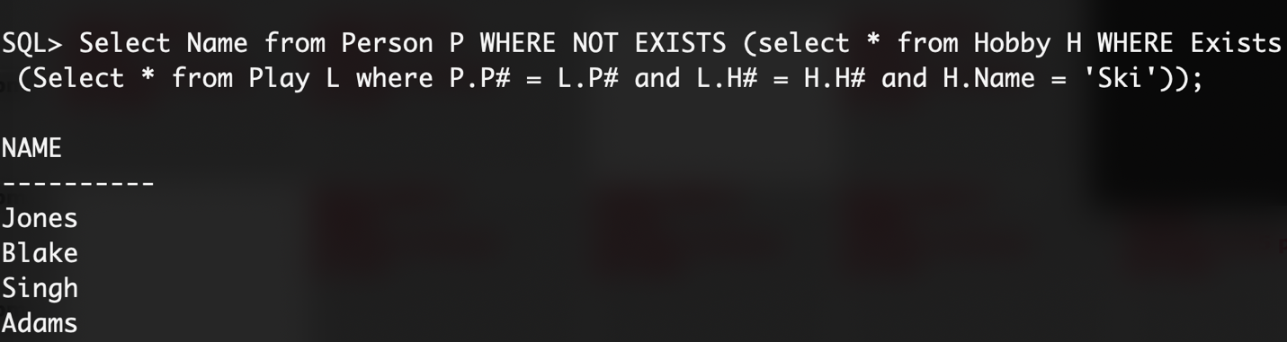

1. Get the names of persons who do not play any hobby.

Select Name from Person P WHERE NOT EXISTS (select P# from Play L where P.P# = L.P#);

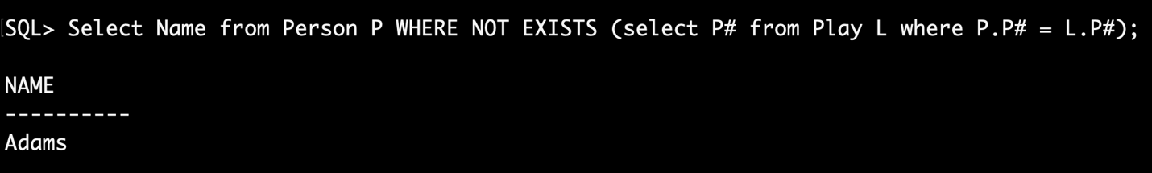

1. Get the names of persons who play all hobbies.

Select Name from Person P WHERE NOT EXISTS (select \* from Hobby H WHERE NOT Exists (Select \* from Play L where P.P# = L.P# and L.H# = H.H#));

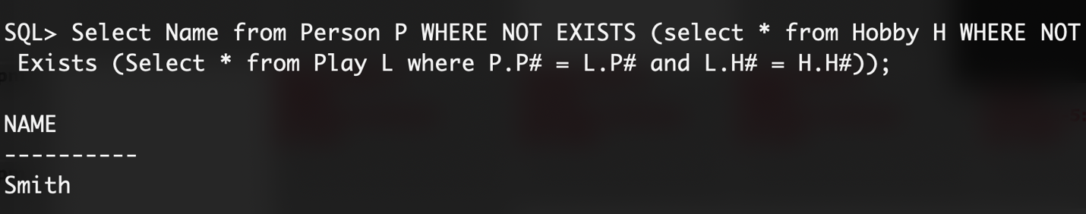

1. Get the names of persons who play all hobbies that “lastname” plays.

Select P1.Name from Person P1 where P1.Name != 'Singh' and Not Exists (Select H.H# From Hobby H, Play L, Person P where P.Name = 'Singh' and P.P# = L.P# and L.H# = H.H# MINUS Select H.H# From Hobby H, Play L where P1.P# = L.P# and L.H# = H.H#);

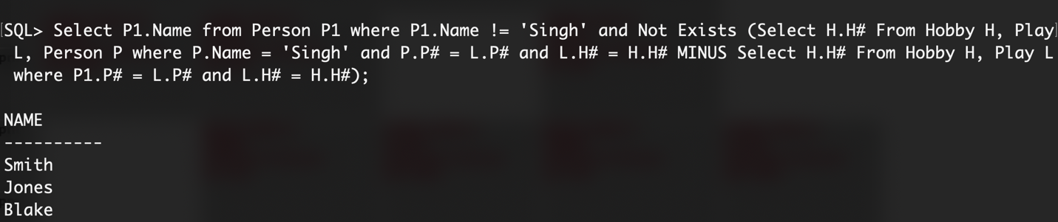

1. Get the names of persons who play only all the hobbies that “lastname” plays.

Select P1.Name FROM Person P1, Person P2

Where P1.Name != 'Singh' and P2.Name = 'Singh' and Not Exists

(Select \* from Hobby H WHERE NOT EXISTS

(Select \* From Play L, Play L1

Where P2.P# = L.P# and L.H# = H.H# and P1.P# = L1.P# and L1.H# = H.H#)

And EXISTS

(Select \* From Play L

Where (P2.P# = L.P# and H.H# = L.H#) or (P1.P# = L.P# and L.H# = H.H# )));

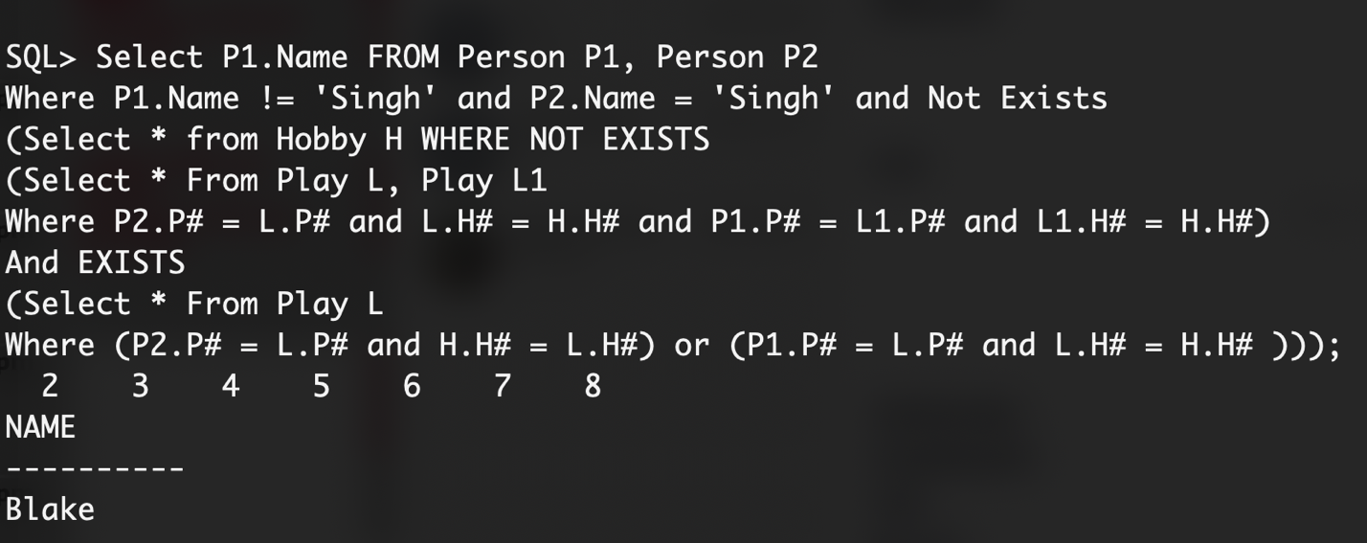

1. Get the names of persons who play all hobbies except Skating and Ski.
2. Get the names of persons who play hobbies, the number of hobbies and total number of times they play those hobbies.

Select Name, Count(P#), Sum(Times) from Person Natural Join Play group by Name;

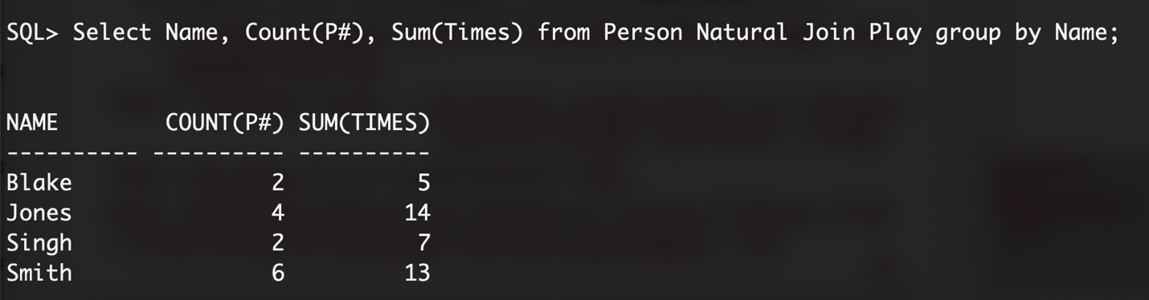

1. Get the names of persons who play hobbies but play the least number of hobbies.

CREATE TABLE T1 (Name, Cnt) As Select Name, count(H#) from Person Natural Join Play group by Name ;

Select Name from T1 Group by Name Having min(cnt);

Select Name, min(H#) from Person Natural Join Play group by Name;

Select P.Name, count(L.H#), Sum(L.Times) from Person P, Play L group by P.P# Where P.P# = L.P# ;

Select Name, min(count(P#)) from (Select Name, count(H#) from Person Natural Join Play group by Name) ;

Select T.Name, min(cnt) as cnt from T1 T where ;

Select name from T1 where cnt = min(cnt);

Alter:

CREATE TABLE T1 (P#, Cnt) As Select P#, count(H#) from Play group by P# ;

CREATE TABLE T2(Name, Res) AS Select Name, MIN(cnt) as cnt from Person natural join T1 group by name;

Select Name, MIN(cnt) as cnt from Person natural join T1;