Name – Khushal Kumar Singh

Course No. - COMP 3005

ASSIGNMENT – 5

PART 1 --- DDL ---

CREATE TABLE Person(

P# char(4) primary key,

Name varchar(10) unique Not Null,

Age Integer );

CREATE TABLE Hobby(

H# char(4) primary key,

Name varchar(10) unique Not Null);

CREATE TABLE Play(

P# char(4),

H# char(4),

Times Integer,

Foreign key(P#) references Person(P#),

Foreign key(H#) references Hobby(H#));

PART 2 --- DML ---

INSERT INTO Person VALUES ('P1','Smith',20);

INSERT INTO Person VALUES ('P2','Jones',30);

INSERT INTO Person VALUES ('P3','Blake',25);

INSERT INTO Person VALUES ('P4','Singh',20);

INSERT INTO Person VALUES ('P5','Adams',30);

INSERT INTO Hobby VALUES('H1','Bowling');

INSERT INTO Hobby VALUES('H2','Chess');

INSERT INTO Hobby VALUES('H3','Dancing');

INSERT INTO Hobby VALUES('H4','Hiking');

INSERT INTO Hobby VALUES('H5','Skating');

INSERT INTO Hobby VALUES('H6','Ski');

INSERT INTO Play VALUES('P1','H1',3);

INSERT INTO Play VALUES('P1','H2',2);

INSERT INTO Play VALUES('P1','H3',4);

INSERT INTO Play VALUES('P1','H4',2);

INSERT INTO Play VALUES('P1','H5',1);

INSERT INTO Play VALUES('P1','H6',1);

INSERT INTO Play VALUES('P2','H1',3);

INSERT INTO Play VALUES('P2','H2',4);

INSERT INTO Play VALUES('P2','H3',5);

INSERT INTO Play VALUES('P2','H4',2);

INSERT INTO Play VALUES('P3','H2',2);

INSERT INTO Play VALUES('P3','H3',3);

INSERT INTO Play VALUES('P4','H2',3);

INSERT INTO Play VALUES('P4','H3',4);

PART 3 --- QL ---

1. Get the names of hobbies that “lastname” plays.

Select H.Name from Hobby H, Play P, Person P1 where H.H# = P.H# and P.P# = P1.P# and P.P# = P1.p# and P1.Name = 'Singh';

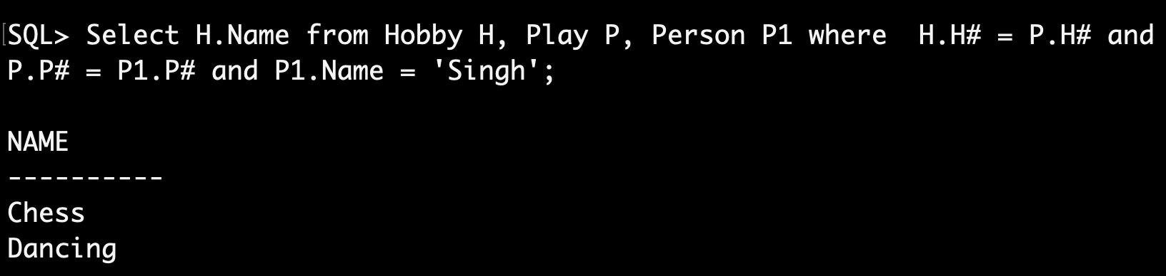

1. Get the names of persons who play Bowling.

Select DISTINCT P.Name from Person P, Hobby H, Play P1 where H.Name = 'Bowling' and P1.H# = H.H# and P.P# = P1.P#;

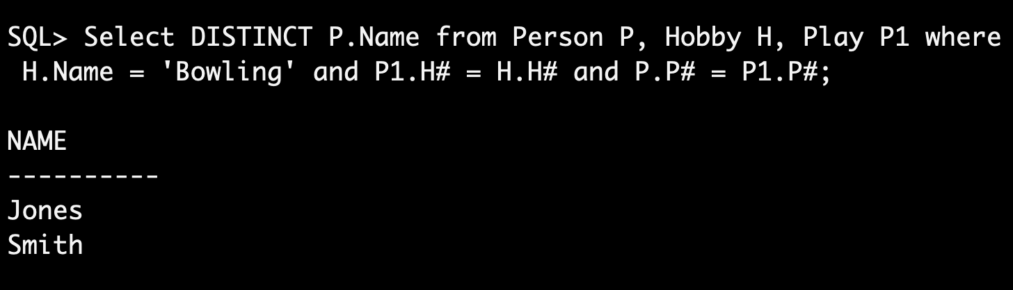

1. Get the names of persons who play a hobby more than 3 times.

Select distinct P.Name from Person P, Play L where L.Times > 3 and P.P# = L.P#;

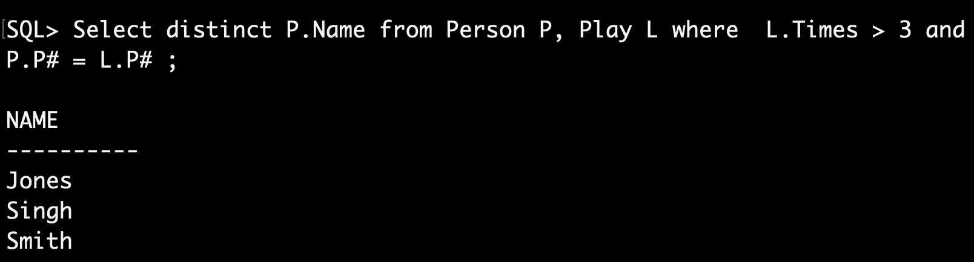

1. Get the names of persons who play either chess or dancing.

Select distinct P.Name from Person P, Hobby H, Play L where L.H# = H.H# and P.P# = L.P# and (H.Name = 'Chess' or H.Name = 'Dancing');

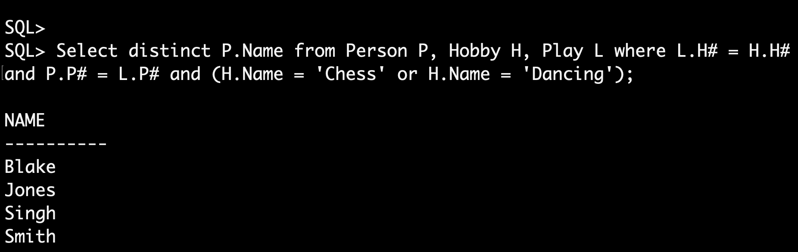

1. Get the names of persons who play both chess and dancing.

Select X.Name from Person X, Play P1, Play P2, Hobby H1, Hobby H2 where X.P# = P1.P# and X.P# = P2.P# and P1.H# = H1.H# and P2.H# = H2.H# and H1.Name = 'Chess' and H2.Name = 'Dancing';

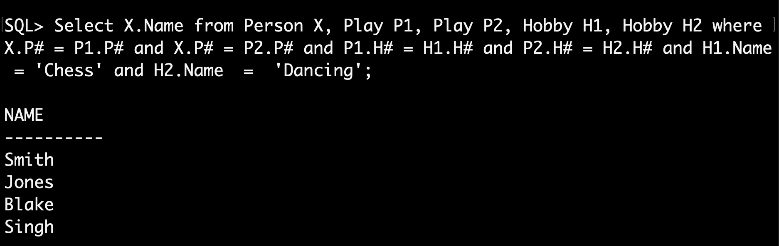

1. Get the person name/hobby name pairs such that the indicated person plays the indicated hobby.

Select P.Name, H.Name from Person P, Hobby H, Play L where P.P# = L.P# and L.H# = H.H#;

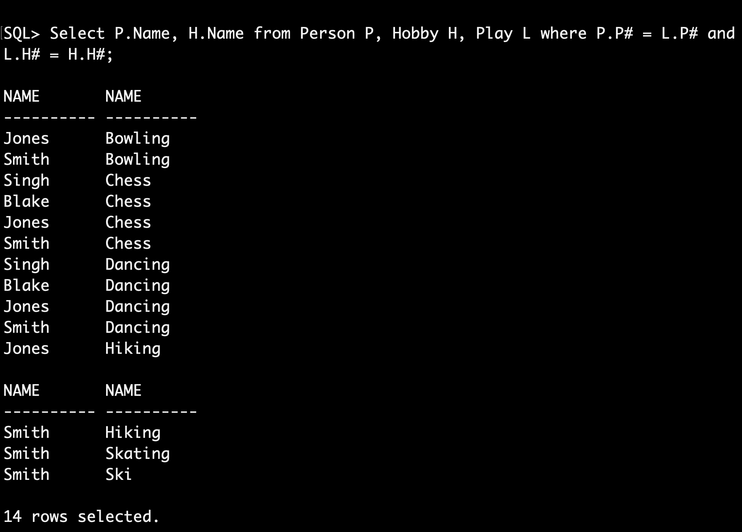

1. Get the names of persons who do not play Ski.

Select Name from Person P WHERE NOT EXISTS (select \* from Hobby H WHERE Exists (Select \* from Play L where P.P# = L.P# and L.H# = H.H# and H.Name = 'Ski'));

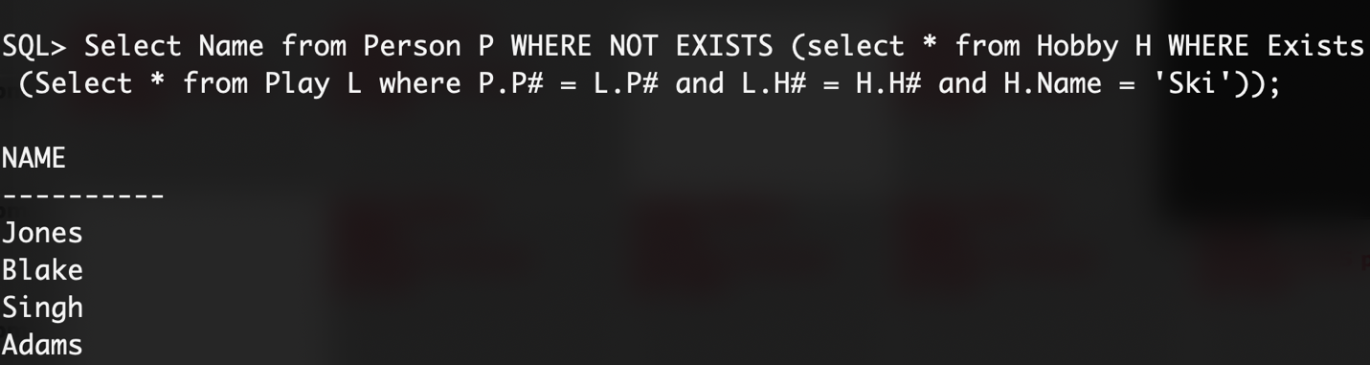

1. Get the names of persons who do not play any hobby.

Select Name from Person P WHERE NOT EXISTS (select P# from Play L where P.P# = L.P#);

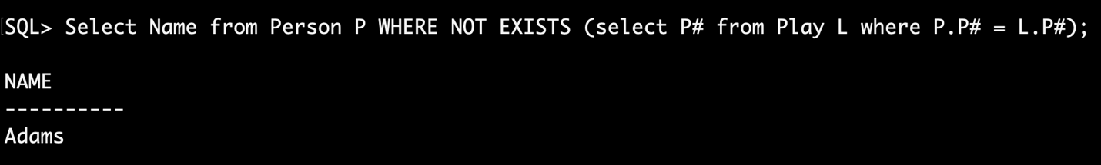

1. Get the names of persons who play all hobbies.

Select Name from Person P WHERE NOT EXISTS (select \* from Hobby H WHERE NOT Exists (Select \* from Play L where P.P# = L.P# and L.H# = H.H#));

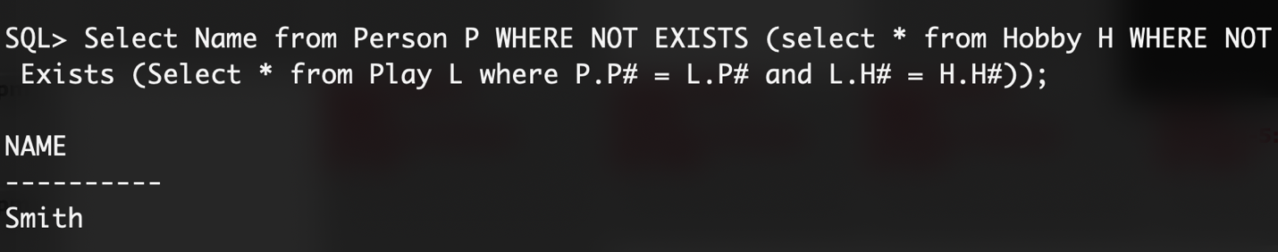

1. Get the names of persons who play all hobbies that “lastname” plays.

Select P1.Name from Person P1 where P1.Name != 'Singh' and Not Exists (Select H.H# From Hobby H, Play L, Person P where P.Name = 'Singh' and P.P# = L.P# and L.H# = H.H# MINUS Select H.H# From Hobby H, Play L where P1.P# = L.P# and L.H# = H.H#);

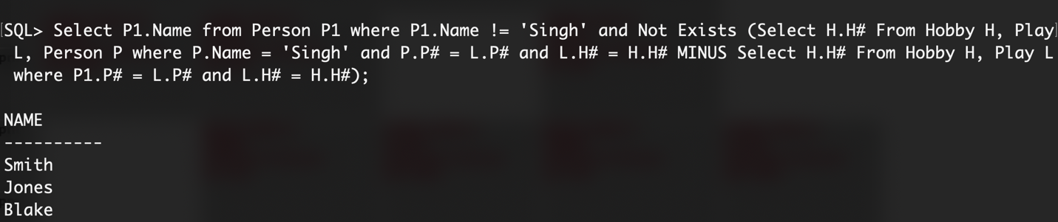

1. Get the names of persons who play only all the hobbies that “lastname” plays.

Select P1.Name FROM Person P1, Person P2

Where P1.Name != 'Singh' and P2.Name = 'Singh' and Not Exists

(Select \* from Hobby H WHERE NOT EXISTS

(Select \* From Play L, Play L1

Where P2.P# = L.P# and L.H# = H.H# and P1.P# = L1.P# and L1.H# = H.H#)

And EXISTS

(Select \* From Play L

Where (P2.P# = L.P# and H.H# = L.H#) or (P1.P# = L.P# and L.H# = H.H# )));

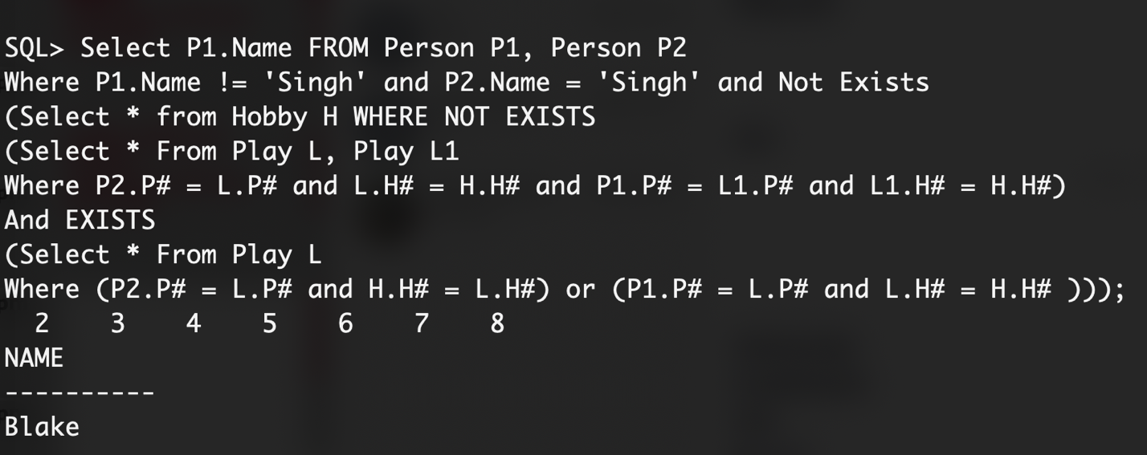

1. Get the names of persons who play all hobbies except Skating and Ski.

Select Name FROM Person P where not exists

(Select \* from Hobby H where

(H.Name != 'Skating' and H.Name != 'Ski' or exists

(Select \* From Play L where P.P# = L.P# and H.H# = L.H#))

And

(H.Name = 'Skating' or H.Name = 'Ski' or Not exists

(Select \* From Play L where P.P# = L.P# and H.H# = L.H#)));

1. Get the names of persons who play hobbies, the number of hobbies and total number of times they play those hobbies.

Select Name, Count(P#), Sum(Times) from Person Natural Join Play group by Name;

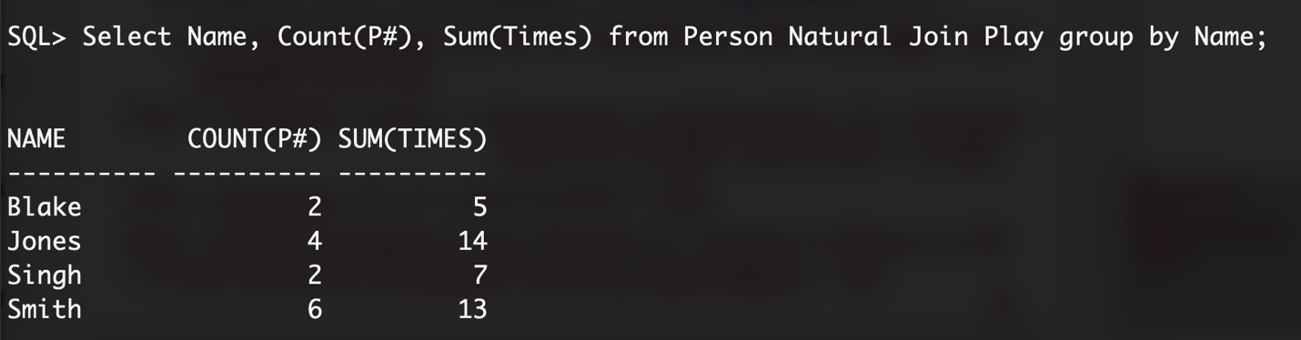

1. Get the names of persons who play hobbies but play the least number of hobbies.

CREATE TABLE T1 (Name, Cnt) As (Select Name, count(H#) from Person Natural Join Play group by Name ;

Select Name from T1 where cnt = (select min(cnt) from T1);

Drop table T1;

