**VICE: Vision, Innovation, Creativity, Excellence**

**Final Document**

**Table of Contents:**

Team Charter: 2

Business Case: 6

Project Charter: 12

Scope Management Plan: 18

Project Sponsor Approval Form: 19

Change Request Form: 20

Revisions and Distribution Form: 22

Data-Flow Diagram: 23

Use-Case Diagram: 24

Product Backlog: 25

Sprint Backlog: 26

Project-Management Plan: 27

Work-Breakdown Structure: 31

Communications Management Plan: 32

Risk Management Plan: 36

Staffing Management Plan: 40

Cost Baseline: 41

Quality Management Plan: 42

Change Management Plan: 47

Appendix: 51

**VICE Team Charter**

**Vision, Innovation, Creativity, Efficiency**

**Purpose Statement and Team Objective**

This team has been formed to replace the Oracle Server Database.  The Information Systems and Analytics department needs an updated system to facilitate the effective learning of SQL.  Since Oracle discontinued support for the Oracle iSQL\*Plus software, the ISA department needs to update the system to enable professors to effectively teach SQL. Given the importance of SQL, it is critical to have a system that is easy to use and facilitates learning.  The recreating and refurbishing of the system will add the most value to the education of students and benefit the teaching lessons of professors.  Our team will update the system to be relevant, user-friendly, and beneficial to our stakeholders.  We are committed to working effectively as a team, by monitoring our process effectiveness, following through on commitments, and helping one another to learn.

**Team Members:**

Ellie Crist

Zach Carson

Casey Salopek - PM

Maura Manning

Parker Donnelly - PM

Wes Kerbuski

Jeff Nicksa

Ruichao Liu

Joseph Jarvis

Jean Paul Mugizi

**Analysis of Strengths and Developmental Needs**

In determining a common set of performance goals, we analyzed the skill sets of all team members in relation to nature of the work we have to complete.  We identified background, experience, and complementary skills of each and defined individual levels of accountability.

While every member has a basic understanding of the coding that will be implemented into the project, JP has been chosen as the coding team leader.  Ellie and Zach are heading up the work requiring Microsoft Visio and Microsoft Project.  Jeff will head the documentation team that drives the project.  The project managers will be overseeing the project and the collaboration of the entire team.

**Strengths:**

*Knowledge and Skills*

* Highly organized
* Ability to multi-task
* Effective communicators
* Detail-oriented
* Recognize and solve problems using critical thinking
* Personal experience using the Oracle Server Database
* Strength in multiple computer applications
* Drive to complete tasks under a tight schedule
* Team synergy

*Background and Experience*

* Database development
* Web application development
* UX/UI Design
* Software Engineering - Agile Development
* Designing Business Systems
* SQL Coding

*Interpersonal Skills*

* Patience
* Communication
* Teamwork Oriented
* Collaboration
* Conflict Resolution
* Desire to Learn

*Areas of Improvement*

* High-Level Coding with Java
* Improving communication between team members
* Distributing work amongst team members

**Team Process Management**

**Team Meetings:**

The agenda of each meeting will vary, but all the team members will be aware of what needs to be accomplished at the end of the meeting by the project manager or team lead. Teams will also be divided into groups - a programming group and a documentation group.

The smaller team meetings will be led by the assigned group leaders.  Meeting location and times will be determined on a week to week schedule depending on what the requirements are. Along with in person meetings, we plan on working in a virtual collaboration setting. We will share the documents in a google drive folder so the team members can simultaneously work on elements of the deliverables. The design team will also be able to simultaneously edit through GitHub.

**Decision Making Procedure:**

Open discussion on all topics to solicit opinions from all members.  At the conclusion of the discussion, allow for feedback on unresolved issues related to the topic.  Ask each person for final comments on issues.  Look for consensus.  We define consensus as the point where all team members can say “This is the best to move forth with.”

**Team Communication:**

We will communicate with one another through various means.  Electronic and phone communication are the most widely used modes outside of meetings.  Prompt responses to messages/inquiries from one another is expected.  If a member is unable to deliver as promised, they should advise the group at least 24 hours in advance so that alternate arrangements can be made.  Primary sharing of all documents will be done through GoogleDocs.  GitHub allows the various versions of the system to be viewed by all members.

**Roles and Responsibilities:**

*Project Sponsor*

* The project sponsor will participate in reviews of the proposed schedule and approve the final schedule before it is base-lined.  Additional duties will include mentoring the VICE project team and act as a last resort for problem resolution.  The project sponsor will make clear what is expected and why.

*Project Manager*

* Ensures agenda is ready, guides team through meeting discussion topics, delegates certain assignments, and summarizes key meeting outcomes and next steps.  The project manager will foster an environment that focuses on team cohesiveness and individual ownership amongst team members.  The project manager will act as the main line of communication between the project team and other outside stakeholders.

*Team Leader*

* Facilitates smaller group meetings and delegation of the work to be accomplished.  Reports the work completed, time spent, and the quality of work to PMs.  These team leaders will initiate the work that has been allocated out into the smaller work groups.  Once the project manager has determined which tasks are pertinent to the goal at hand the team leaders will provide additional stability, which will ensure that our tasks get completed on time and with quality.

**Expectations of Team Members:**

*Attendance at meetings*

* Attendance is expected for every meeting by all team members.  If a member is absent, they are expected to send the team their work prior to the meeting.  On-time arrival for the meetings is also expected.  If you cannot attend a meeting you will provide at least 24-hour notification to the project manager.

*Participation*

* Full participation is expected of all team members.  If someone feels that a team member is not doing their job, the concerned member will discuss it one-on-one, offline.  If that does not work, then the member will bring it up with the project manager.  Team members are expected to complete their section of the project at least two days before the due date.

*General Courtesy and Respect*

* Members must respect and trust those whom they work with.  100% effort should be made at all times.  Failing to fulfill your assigned tasks on time is letting your team down and will not be tolerated.

**Signatures**

Ellie Crist                      \_\_\_\_\_\_\_\_\_\_\_\_\_\_\_\_\_\_\_\_\_\_\_\_\_\_\_\_\_\_\_\_\_\_\_\_\_\_

Zach Carson                \_\_\_\_\_\_\_\_\_\_\_\_\_\_\_\_\_\_\_\_\_\_\_\_\_\_\_\_\_\_\_\_\_\_\_\_\_\_

Casey Salopek          \_\_\_\_\_\_\_\_\_\_\_\_\_\_\_\_\_\_\_\_\_\_\_\_\_\_\_\_\_\_\_\_\_\_\_\_\_\_

Maura Manning            \_\_\_\_\_\_\_\_\_\_\_\_\_\_\_\_\_\_\_\_\_\_\_\_\_\_\_\_\_\_\_\_\_\_\_\_\_\_

Parker Donnelly           \_\_\_\_\_\_\_\_\_\_\_\_\_\_\_\_\_\_\_\_\_\_\_\_\_\_\_\_\_\_\_\_\_\_\_\_\_\_

Wes Kerbuski              \_\_\_\_\_\_\_\_\_\_\_\_\_\_\_\_\_\_\_\_\_\_\_\_\_\_\_\_\_\_\_\_\_\_\_\_\_\_

Jeff Nicksa                   \_\_\_\_\_\_\_\_\_\_\_\_\_\_\_\_\_\_\_\_\_\_\_\_\_\_\_\_\_\_\_\_\_\_\_\_\_\_

Ruichao Liu                  \_\_\_\_\_\_\_\_\_\_\_\_\_\_\_\_\_\_\_\_\_\_\_\_\_\_\_\_\_\_\_\_\_\_\_\_\_\_

Joseph Jarvis              \_\_\_\_\_\_\_\_\_\_\_\_\_\_\_\_\_\_\_\_\_\_\_\_\_\_\_\_\_\_\_\_\_\_\_\_\_\_

Jean Paul Mugizi         \_\_\_\_\_\_\_\_\_\_\_\_\_\_\_\_\_\_\_\_\_\_\_\_\_\_\_\_\_\_\_\_\_\_\_\_\_\_

**Business Case**

***SQL Server***

**Team Members:**

Zach Carson, Ellie Crist, Parker Donnelly, Joseph Jarvis, Wes Kerbuski, Rachel Liu, Maura Manning, JP Mugizi, Jeff Nicksa, Casey Salopek

**February 12, 2014**

**Executive Summary**

**Problem –**

The Information Systems and Analytics department needs an updated system to facilitate the effective learning of SQL for its students.

**Strategy –**

The ISA department frequently uses the SQL and Oracle servers to teach students to read and write SQL statements. Using actual software is a crucial component of the ISA curriculum because it provides hands on experience that will assist students in their future careers. Given the importance of SQL for the ISA department, it is critical to have a system that is easy to use and facilitates learning.

**Measurable Organizational Value –**

The new system will add value to the learning process of students while increasing the overall satisfaction of using the system for all stakeholders by May 2015.

**Alternatives –**

- Alternative I: Keep using the current unsupported Oracle system

- Alternative II: Build a new system

- Alternative III: Select an open source system

- Alternative IV: Select a system from another vendor

- Alternative V: Recreate and refurbish the current Oracle system

**Outcome –**

We recommend proceeding with Alternative V for the project. Recreating and refurbishing the system will allow for additional functionality to be added to the current system. Ultimately the new system will be a more effective tool for effectively teaching SQL to ISA students.

**Introduction**

**Background –**

Miami University uses several Oracle products that serve various purposes for different departments throughout the university. Within the Farmer School of Business, the Information Systems and Analytics department specifically uses SQL and Oracle servers to facilitate teaching. The software is used primarily in ISA 235 and ISA 245 to teach the students how to read and write queries using Structured Query Language (SQL). SQL knowledge provides students with the skill to manipulate and analyze data on a deeper level. The ability to write SQL and understand the outputs gives Miami students a competitive advantage upon graduation. Professors teach the students the basic Data Manipulation Language (DML) commands in ISA 235 and focus on more complicated DML queries and Data Definition Language (DDL) in ISA 245. Every teacher uses the SQL and Oracle servers to facilitate this learning; however, there are some limitations to what the software allows the students to do.

**Current Situation –**

Recently, Oracle has announced that they will no longer provide support for some of their older products. These products include the Oracle iSQL\*Plus server currently being used by the Information Systems and Analytics department. As of now the servers can still be used to teach ISA 235 and ISA 245 students; however, the FSB IT department will have to provide support if there are issues with the system. The ISA faculty and IT department believe it is necessary to develop a system that can be maintained in the future. Additionally this provides an opportunity for additional functionality to be added to the system and offers an opportunity for our team to gain valuable hands on experience managing an IT project.

**Problem –**

Since Oracle discontinued support for the Oracle iSQL\*Plus software, the ISA department needs to consider updating the system to enable professors to effectively teach SQL.

**Measurable Organizational Value –**

Desired Areas of Impact

* Customer
  + As the main users of the current Oracle system, students currently struggle with interacting with the user interface and downloading their final data.  Our new system aims to eliminate these problems so that students’ experience allows them to learn SQL more effectively.  In addition to students, ISA 235 professors are main customers of the system.  With our system’s enhancements, professors will receive Excel files containing students’ final results making grading much easier for them.
* Social
  + By enhancing the new Oracle system we will improve the education system at Miami University. Our new system will impact the learning processes of every business student that enrolls in ISA 235.  This new system will add benefits to the professor’s of ISA 235 lessons plan by improving functionality.

Desired Value of the IT Project

The key aspects that we are looking to improve upon for our new system are the effectiveness, efficiency, quality, and the speed.  With teaching SQL to ISA 235 students as the main goal of the system, by enhancing the user interface we will effectively encourage students to explore and enjoy SQL more.  The current system’s manner of displaying results in a table that is difficult to transfer to a Word document or Excel file hinders the student’s ability to turn in results to their professors.  Our new system aims to rectify this problem by allowing students to directly download their table results into an Excel file, improving the effectiveness of the tool, the quality of results that students deliver, and the speed with which professor can grade.

Desired Achievements

Our intended purpose is to create a system that will add value to a student’s learning of SQL without having negative experience with the user interface. This new system will not be able to decrease the amount of time professors spend teaching SQL, rather increase user satisfaction with easier functionality.

MOV Statement

The new system will add value to the learning process of students while increasing the overall satisfaction of using the system for all stakeholders by May 2015.

**Supporting Overall Strategy –**

With additional functionality and teaching tools, the system will enhance the learning of SQL for the students while providing a more enjoyable experience. This directly correlates to the overall strategy of the ISA department to provide hands on experience writing SQL statements. Overall the new system will give the students the necessary experience with SQL in a more effective way.

**Objective of Business Case –**

The purpose of this Business Case is to provide a detailed analysis of the project for the ISA and IT departments. The business case will examine the feasibility of various alternatives and our reasoning for our final recommendation. Moving forward, this document should provide a clear indication of the proper alternative to implement.

**Alternatives**

**Alternative I**

*Keep using the current unsupported Oracle system.*

The unsupported Oracle System would continue to be maintained by the FSB IT staff.  Business students would be taught SQL through the unsupported system, which students and professors both dislike.

**Alternative II**

*Build a new system.*

Our team would need to start by developing software that runs SQL coding and processes it to produce results.  These results would be pulled from a database that we would also develop.  Finally, a user interface would be created that integrates our SQL software in a user-friendly environment.

**Alternative III**

*Select an open source system.*

An open source alternative would require our team to extensively research viable alternatives to Oracle’s iSQL\*Plus that is currently being used to find a software that can reliably run SQL codes and offers a user-friendly interface.

**Alternative IV**

*Select a system from another vendor.*

Microsoft’s SQL server is another alternative to the current software.  This change of vendor would require Miami to purchase licenses from Microsoft and then out team would need to design a suitable user interface to run Microsoft’s SQL server.

**Alternative V**

*Recreate and refurbish the current system.*

Maintaining the current backend Oracle SQL server and database server, our team would enhance the user’s experience by adding more functionality and developing a more desirable user interface.

**Analysis of Alternatives**

* Alternative I: Keep using current unsupported Oracle system
  + Data Collection
    - Handout a survey to students and professors who have experienced the Oracle System
  + Metrics
    - Satisfactory levels
* Alternative II: Building a new system
  + Data Collection
    - Research hard and soft costs to implement in-house system
  + Metrics
    - Total Cost of Ownership
    - Total Benefits of Ownership
* Alternative III: Open source system
  + Data Collection
    - Compare and contrast different open source systems
  + Metrics
    - Total Benefits of Ownership
    - Indirect costs
* Alternative IV: Going with another vendor
  + Data Collection
    - Compare and contrast different vendors
  + Metrics
    - Total Cost of Ownership
    - Total Benefits of Ownership
* Alternative V: Recreate and refurbish system
  + Data Collection
    - Handout survey to students and professors who have experienced the Oracle System
  + Metrics
    - Satisfactory level

**Presentation of Results**

* Metrics
  + Alternative I:
    - Low satisfactory levels
  + Alternative II:
    - Total cost of ownership include maintenance and development costs
    - Total benefit of ownership is increased flexibility
  + Alternative III:
    - Lowers software and hardware costs
    - Increases maintenance costs
    - Large learning curve
  + Alternative IV:
    - Large learning curve
    - Decreases hardware costs through virtualization
    - Includes out-of-the-box features
    - Lower cost of multicore and user licensing
  + Alternative V:
    - Increased satisfaction among students and professors
    - Implements students and professors’ feedback
* Risks
  + Alternative I:
    - Costs for maintenance and support
  + Alternative II:
    - Higher costs
    - Outgrowing organization’s processes
  + Alternative III:
    - Unanticipated costs
    - Learning curve with IT staff
    - Compatibility
    - Possibility of source ending it’s life cycle
  + Alternative IV:
    - Business disruption
    - Learning curve with IT staff
    - Compatibility
  + Alternative V:
    - Costs for maintenance and support

**Proposed Recommendation –**

After analyzing each alternative, VICE recommends alternative V for teaching SQL to Miami University students in the Farmer School of Business.  The recreating and refurbishing of the system will add the most value to the education of students and benefit the teaching lessons of professors.  Adding more functionality to the previous system is the most effective way to enhance the learning of SQL.  This new system will provide unparalleled learning opportunities that were previously not possible.

Professors all across the Farmer’s School of Business will have the opportunity to leverage new and improved curriculum that will work to provide the highest quality business education to each and every student.  In order for this substantial investment to achieve its potential and deliver value across all departments of the Farmer School of Business, IT personnel are urged to maintain this system and uphold the unwavering expectations of high academic standards.  By the completion of the project life cycle, this new system will act as the anchor for learning objectives within multiple ISA courses, specifically ISA 235 and ISA 245.

All in all, in our estimation this Vice SQL system will provide quantifiable value to Miami University and its affiliates for years to come.  In terms of our budgeting for this project, we have estimated a few numbers that will help VICE complete project.  With each student making $30/hour, the estimated actual cost of this project will be $477,000. Given these labor costs, our estimated budget would be $500,000. Maintaining the server and hardware depreciation would account for any further expenses incurred throughout the project. The Work Breakdown Structure shows a more aggregated view of where the labor costs are assigned.

**Project Charter**

***SQL Server***

**Team Members:**

Zach Carson, Ellie Crist, Parker Donnelly, Joseph Jarvis, Wes Kerbuski, Rachel Liu, Maura Manning, JP Mugizi, Jeff Nicksa, Casey Salopek

**February 20, 2014**

**SQL Server | Project Charter**

**Project Stakeholders**

|  |  |  |  |  |
| --- | --- | --- | --- | --- |
| **Name** | **Title** | **Role in the Project** | **Phone Number** | **Email** |
| Mike Edwards | Network Administrator | Project Sponsor | (513) 529-6320 | edwardm2@miamioh.edu |
| Skip Benamati | ISA Department Chair | Key Stakeholder | (513) 529-4826 | [benamajh@miamioh.edu](mailto:benamajh@miamioh.edu) |
| ISA 235 Professors | Professors | Key Stakeholders | *Varies* | *Varies* |
| ISA Students | Student | End User | *Varies* | *Varies* |
| Casey Salopek | ISA 406 Student | Project Manager | (614) 325-1111 | salopecl@miamioh.edu |
| Parker Donnelly | ISA 406 Student | Project Manager | (630) 701-4703 | donnelp2@miamioh.edu |
| JP Mugizi | ISA 406 Student | Design Lead | (513) 409-2327 | mugizijc@miamioh.edu |
| VICE Team Members | ISA 406 Students | Team Member | *Varies* | *Varies* |

**Project Description**

The Information Systems and Analytics department needs an updated system to facilitate the effective learning of SQL.  Since Oracle discontinued support for the Oracle iSQL\*Plus software, the ISA department needs to update the system to enable professors to effectively teach SQL. Given the importance of SQL, it is critical to have a system that is easy to use and facilitates learning.  The recreating and refurbishing of the system will add the most value to the education of students and benefit the teaching lessons of professors.

**Measurable Organizational Value**

The new system will add value to the learning process of students while increasing the overall satisfaction of using the system for all stakeholders by May 2015.

**Project Scope**

*Within Scope*

* User interface containing username/password boxes, and login help section
* Command-line box to manipulate SQL queries
* Help section containing basic SQL queries and system navigation direction
* Hook between User interface and Oracle Database on Citrix
* Final deliverable available on the internet
* Add paging to display table
* Display full name of student on work screen

*Outside Scope*

* Oracle Database Server
* Add videos to work screen help page

**Project Schedule Summary**

Project Start Date: February 12, 2014

Project End Date: May 2, 2015

*Timeline of Project*

* Sprint 1: Completion Date 2/27/2014

At the closure of the first sprint our team will have the mock up design for the interface completed. Mike Edwards prefers to keep the same layout of the original Oracle website: Our goal is to satisfy his needs while improving the user-friendliness of the site at the same time. Additionally, the export to excel functionality will be defined. This will be a simple way to copy the results and make any further aggregations.  The last functionality for our first sprint will be to complete the define command line feature.

* Sprint 2: Completion Date 4/3/2014

At the completion of the second sprint our team will have the basics of the website up and running. Our system will be able to communicate with the SQL server provided to us by Mike.  Other tasks that we have for this sprint include several coding features such as the user log in screen and export to excel. Additionally, we will improve error messages using the Oracle standards. Other features include: history check, logout feature, clear function, format table, and further cosmetic functionality for the interface.

* Sprint 3: Completion Date 5/2/2014

For the third and final sprint, we will increase the functionality as we work to close the project. The features that will be worked on are SQL help (main screen), server help (login screen), paging, session timeout,, and loading/saving scripts. Finally, we will add DDL functionality. At the end of this sprint the whole project will be completed. This sprint focuses on the added value to the user to improve their learning process of SQL

**Quality Issues**

*Quality Requirements*

* Run SQL queries and receive immediate feedback either in the form of an error message or a table
* Require authentication to access the server
* Help screen provides information on basic SQL statements and how to login and use the system
* User friendly interface

**Resources Required**

*People*

* VICE Team Members
* Project Managers
* Network Administrator – Mike Edwards
* ISA Professors

*Technology*

* Visual Basic Software
* FSB Server – *provided to us*
* Microsoft Visio
* Microsoft Project
* GitHub

**Assumptions and Risks**

*Key Risks*

* Integrating our new system with the database server
  + High Risk – will have major impact on our new system if unable to integrate
* Unable to include enhanced features
  + Low Risk – will decrease user satisfaction
* Scope Creep
  + Low Risk
  + The features and functionality could quickly get out of hand and cause a backup on the budget as well as the schedule. This risk can be identified as an internal risk but have an external effect. The line between the two is sometimes difficult because a scope creep could have an effect on both the team as well as our customers (Mike Edwards and the students).
* Unpredictable Project Schedule
  + Medium-High Risk - scheduling times are difficult and hard to estimate
  + Project tasks will take longer than anticipated and will affect the project schedule and budget
* Project Rejection
  + Medium Risk
  + The project sponsor or customer may not accept the project.
* MOV does not contain a concrete metric
  + Low Risk - the methods of mitigation can be easily executed
  + This type of risk is internal because the MOV is created in terms of how the IT project will affect the organization.
* Strife and conflict develops within the project team
  + Low Risk - PM will have control of these interactions and each team member will be mutually respectful
  + Upon working with 10 people, different opinions will be voiced.

*Known Constraints*

* Sprint Deadlines
* Technological
  + SQL system must be functional on any web browser
  + Each user must be registered with an ID and username
  + The SQL command portion must be able to communicate with database server
  + System needs to be scalable and carefully documented in order to continually develop and expand the database
  + Ability for students in higher level ISA classes to use the system for data scrubbing and business intelligence assignments

*Dependencies*

* Database server for the backend of the system that is being provided by Mike Edwards
* Relying on Miami University’s hardware and software

*Organizational Impact*

This project will be prevalent for years to come in each and every ISA 235 and some ISA 245 course classrooms. It is an essential teaching tool for professors to help students understand and develop SQL programming in a business environment.  The success of this project will have a considerable effect on the curriculum that ISA professors can develop to enhance the learning experience in the classroom.

**Project Administration**

*Communications Plan –*

The project managers will be the primary contact for the major stakeholders.  If the project manager is unavailable, the next highest-ranking team member will communicate with the stakeholders.  Communication should be face-to-face to ensure that no information is lost or misunderstood.  In the event that face-to-face communication is not possible, the next best medium of communication will be used.  Email is an acceptable form of communication but should not be the primary mode of contact.  Team members must respond to other team members and outside stakeholders in a timely manner.

All forms of communication will be in effect on a continual basis.  When issues or roadblocks arise it is pivotal that the project team disperse that information to ensure that all team members are on the same page.  If misunderstandings due occur it is our duty to take prompt action in order to resolve such issues.  In addition, heightened levels of communication and collaboration amongst team members and outside stakeholders will take place after each sprint period and major milestone in the project.  Communication between Mike Edwards and the project team is crucial to ensure that the team is moving in a manner to meet his requirements and expectations.  As means to grow our collective knowledge capital, all meetings and communications between the team and the stakeholders should be documented.

*Scope Management Plan –*

The scope as defined at the commencement of the project should try to be followed strictly throughout the project duration.  The scope is to be determined by the team and finalized by the project sponsor.  Should the project scope need to be changed the whole team must be notified and meet together to formulate a plan to accommodate the changes.  The project managers will have the final decision and they must present it to the stakeholders.  Approval from the stakeholders will be required to continue.  If the project sponsor, Mike Edwards, rejects the new scope requirements, the team must meet to review the necessary changes and be clear on the project direction.

*Quality Management Plan*

Quality in the project is a requisite for success.  Quality of work should be driven from the project sponsor and ensured by the project managers throughout the duration of the project.  At the conclusion of each sprint, the quality of the work completed will be assessed and reviewed. Retrospective meetings should be held following each sprint. A meeting should be held with the project owner to determine what steps to keep and which activities should be eliminated to avoid loss of productivity.

*Change Management and Implementation Plan*

As for any new system, it is to be expected that there will be pushback from the stakeholders that will use the system, primarily ISA 235 teachers. As a team, we need to determine an action plan and convey the importance of the adoption of this new system to enhance the learning experience of students. Continuous user involvement throughout the project will ensure that various stakeholders will be up to date and accepting of the new system.

*A Human Resources Plan*

Team needs will constantly be adapting to meet demand.  The project managers and team leaders will not be changed unless necessary.  The group can vote as a whole or the project managers can make a change necessary to facilitate the delivery of the final project.  It is important for the project managers to set the standards for the rest of the group, and provide leadership and direction to guide this project to a success.  As in any project, team members will have other commitments or reasons for not attending scheduled meetings. However, it is necessary as a team we recognize this and work productively during our meeting times even if we are shorthanded.

Scope Management Plan

*SQL Server*

*VICE:* Vision, Innovation, Creativity, Efficiency

**Team Members:**

Zach Carson, Ellie Crist, Parker Donnelly, Joseph Jarvis, Wes Kerbuski, Rachel Liu, Maura Manning, JP Mugizi, Jeff Nicksa, Casey Salopek

**Project Description**  
This team has been formed to replace the Oracle Server User Interface. Our team will update the system to be relevant, user-friendly, and beneficial to our stakeholders.  We are committed to working effectively as a team, by monitoring our process effectiveness, following through on commitments, and helping one another to learn.

**Project MOV**

The new system will add value to the learning process of students while increasing the overall satisfaction of using the system for all stakeholders by May 2015.

**DSC**

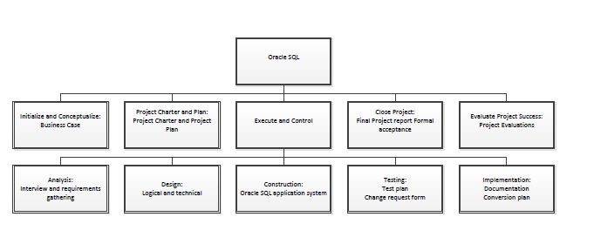

**Scope**

*Within Scope*

* User interface containing username/password boxes, and login help section
* Command-line box to manipulate SQL queries
* Help section containing basic SQL queries and system navigation direction
* Hook between User interface and Oracle Database on Citrix
* Final deliverable available on the internet
* Add paging to display table
* Display full name of student on work screen

*Outside Scope*

* Oracle Database Server
* Add videos to work screen help page

The scope as defined at the commencement of the project should try to be followed strictly throughout the project duration.  The scope is to be determined by the team and finalized by the project sponsor.  Should the project scope need to be changed the whole team must be notified and meet together to formulate a plan to accommodate the changes.  The project managers will have the final decision and they must present it to the stakeholders and reacquire approval to continue.  If the project sponsor, Mike Edwards, rejects the new scope requirements, the team must meet to review the necessary changes and be clear on the project direction.

Once the project scope is finalized by the team they must bring it to the sponsor and gain their approval. This should be documented on the Project Sponsor Approval Form.

**Project Sponsor Approval Form**

|  |  |  |
| --- | --- | --- |
| **Prepared by:** | **Reviewed by:** | **Approved by Proj. Sponsor:** |
| Place, dd/mm/yyy | Place, dd/mm/yyy | Place, dd/mm/yyy |
|  |  |  |

After the project scope has been signed off on by the sponsor any further changes to scope will need to be done with a Change Request Form and followed up on by notifying all stakeholders using the Revisions and Distributions Form.

Accurate communication is ensured by logging the revision and release date of approved changes. This is the final form in the scope management plan and it ensures that all stakeholders will be notified of any changes to the original scope. This form enhances accountability from the project team standpoint by allowing the team to document each change and notify relevant stakeholders without missing any people who need to be informed.

**Change Request Form**

|  |  |  |  |
| --- | --- | --- | --- |
| **Sponsor Name** |  | **Change #** |  |
| **Project Name** |  | **Date Submitted** |  |
| **Requested By** |  | **Date Reply Due** |  |

**Description of Change:**

**Justification:**

|  |  |  |  |  |
| --- | --- | --- | --- | --- |
| **Effect on Schedule, Deliverables, and Project Cost** | | | | |
| No. | Deliverable / Item | Revised End Date | Net Change, Hours  Increase or (Decrease) | Net Change, Cost  Increase or (Decrease) |
|  |  |  |  |  |
|  |  |  |  |  |
|  |  |  |  |  |
|  | Totals |  |  |  |
|  | Revised Project End Date |  |  |  |

|  |  |  |  |  |  |
| --- | --- | --- | --- | --- | --- |
| Signature |  | Title |  | Date |  |

**Project Manager Approval:**

**Comments:**

**Revisions and Distribution Form**

|  |  |  |  |  |  |  |  |  |  |  |  |  |  |
| --- | --- | --- | --- | --- | --- | --- | --- | --- | --- | --- | --- | --- | --- |
| **Revision** | **Release date** | **Distributed to\*** | | | | | | | | | | | |
| Mike Edawards | Parker Donnelly | Casey Saloupek |  |  |  |  |  |  |  |  |  |
| Rev. 0 (draft) | 29/10/2013 |  |  |  |  |  |  |  |  |  |  |  |  |
|  |  |  |  |  |  |  |  |  |  |  |  |  |  |
|  |  |  |  |  |  |  |  |  |  |  |  |  |  |
|  |  |  |  |  |  |  |  |  |  |  |  |  |  |
|  |  |  |  |  |  |  |  |  |  |  |  |  |  |
|  |  |  |  |  |  |  |  |  |  |  |  |  |  |
|  | | | | | | | | | | | | | |

\*\* See the appendix for the project’s scope change requests

Data Flow Diagrams

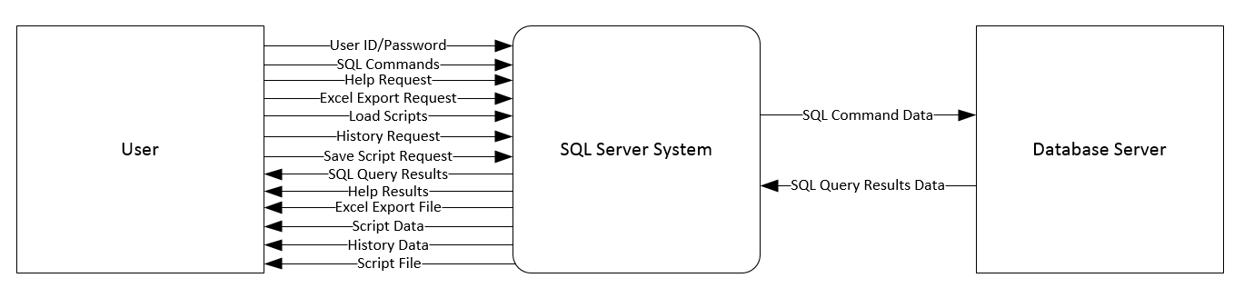Context Diagram

Level 0 Diagram

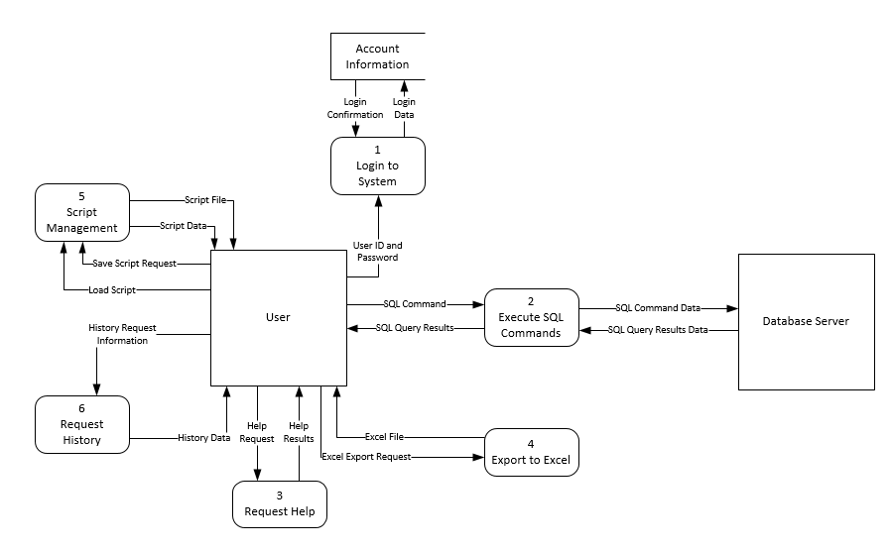

Use Case Diagrams

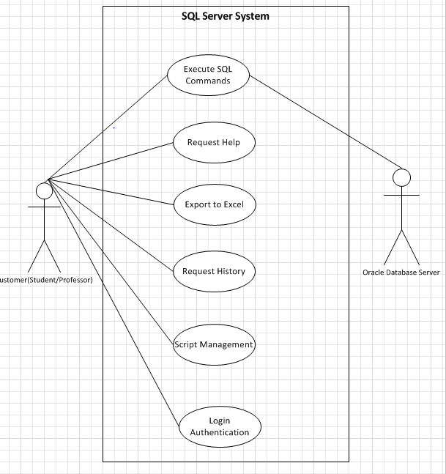

Product Backlog

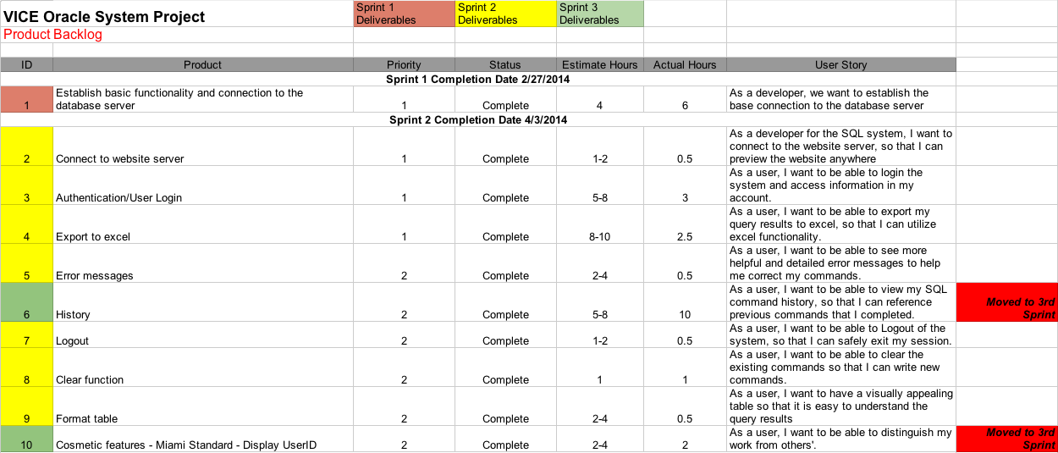

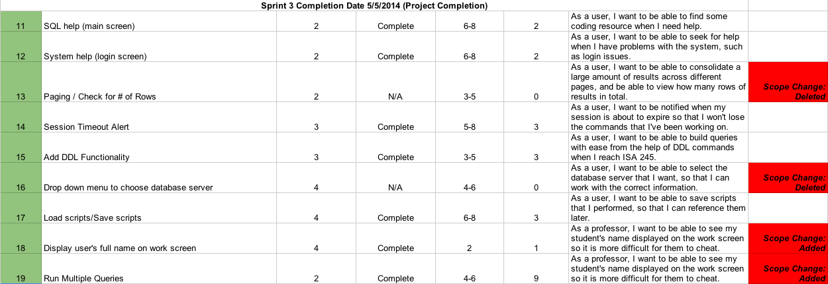

Sprint Backlog

Sprint Backlog.tiff

**Project Management Plan**

**VICE: Vision, Innovation, Creativity, Excellence**

**Table of Contents**

Introduction.

Project Management Approach.

Project Scope.

Milestone List.

Work Breakdown Structure.

Communications Management Plan.

Procurement Management Plan.

Project Scope Management Plan.

Schedule Management Plan.

Quality Management Plan.

Risk Management Plan.

Staffing Management Plan.

Resources Required.

Cost Baseline.

Sponsor Acceptance.

**Introduction**

The Information Systems and Analytics department needs an updated system to facilitate the effective learning of SQL.  Since Oracle discontinued support for the Oracle iSQL\*Plus software, the ISA department needs to update the system to enable professors to effectively teach SQL. Given the importance of SQL, it is critical to have a system that is easy to use and facilitates learning. The new system will be designed and developed through a customers perspective, focusing on ease of use and additional functionality to encourage students to learn and appreciate SQL.  The recreating and refurbishing of the system will add the most value to the education of students through key-functionalities being added that were absent in the previous versions, and benefit the teaching lessons of professors by allowing them to better document and navigate the various SQL statements being taught and ran through the system.

**Project Management Approach**

**Project Stakeholders**

|  |  |  |  |  |
| --- | --- | --- | --- | --- |
| **Name** | **Title** | **Role in the Project** | **Phone Number** | **Email** |
| Mike Edwards | Network Administrator | Project Sponsor | (513) 529-6320 | edwardm2@miamioh.edu |
| Skip Benamati | ISA Department Chair | Key Stakeholder | (513) 529-4826 | benamajh@miamioh.edu |
| ISA 235 Professors | Professors | Key Stakeholders | *Varies* | *Varies* |
| ISA Students | Student | End User | *Varies* | *Varies* |
| Casey Salopek | ISA 406 Student | Project Manager | (614) 325-1111 | salopecl@miamioh.edu |
| Parker Donnelly | ISA 406 Student | Project Manager | (630) 701-4703 | donnelp2@miamioh.edu |
| JP Mugizi | ISA 406 Student | Design Lead | (513) 409-2327 | mugizijc@miamioh.edu |
| VICE Team Members | ISA 406 Students | Team Member | *Varies* | *Varies* |

**Vice Team Members**

|  |  |  |  |
| --- | --- | --- | --- |
| **Name** | **Email** | **Phone Number** | **Role** |
| **Parker Donnelly** | **donnelp2@miamioh.edu** | **630-701-4703** | **Project Manager** |
| **Jean Paul Mugizi** | **mugizijc@miamioh.edu** | **513-409-2327** | **Programming Leader** |
| **Maura Manning** | **manninme@miamioh.edu** | **908-458-1213** |  |
| **Casey Salopek** | **Salopecl@miamioh.edu** | **614-325-1111** | **Project Manager** |
| **Ruichao Liu** | **liur3@miamioh.edu** | **513-593-6350** |  |
| **Ellie Crist** | **cristeg@miamioh.edu** | **847-757-8419** | **Team 2 Leader** |
| **Jeff Nicksa** | **nicksajc@miamioh.edu** | **781-801-4430** | **Team 1 Leader** |
| **Zach Carson** | **carsonzc@miamioh.edu** | **717-419-8785** |  |
| **Wes Kerbuski** | **kerbuspl@miamioh.edu** | **703-850-6810** |  |
| **Joseph Jarvis** | **jarvisjf@miamioh.edu** | **913-221-8900** |  |

**Project Scope**

The scope as defined at the commencement of the project should try to be followed strictly throughout the project duration. The scope is to be determined by the team and finalized by the project sponsor. Should the project scope need to be changed the whole team must be notified and meet together to formulate a plan to accommodate the changes. The project managers will have the final decision and they must present it to the stakeholders and reacquire approval to continue. If the project sponsor, Mike Edwards, rejects the new scope requirements, the team must meet to review the necessary changes and be clear on the project direction. Once the project scope is finalized by the team they must bring it to the sponsor and gain their approval. This should be documented on the Project Sponsor Approval Form.

*Within Scope*

* User interface containing username/password boxes, and login help section
* Command-line box to manipulate SQL queries
* Help section containing basic SQL queries and system navigation direction
* Hook between User interface and Oracle Database on Citrix
* Final deliverable available on the internet
* Add paging to display table
* Display full name of student on work screen

*Outside Scope*

* Oracle Database Server
* Add videos to work screen help page

After the project scope has been signed off on by the sponsor any further changes

to scope will need to be done with a Change Request Form and followed up on by notifying all stakeholders using the Revisions and Distributions Form.  Accurate communication is ensured by logging the revision and release date of approved changes. This is the final form in the scope management plan and it ensures that all stakeholders will be notified of any changes to the original scope. This form enhances accountability from the project team standpoint by allowing the team to document each change and notify relevant stakeholders without missing any people who need to be informed.

**Milestone List**

The below chart lists the major milestones for the VICE Project.  This chart is comprised only of major project milestones such as completion of a project phase or gate review.  There may be smaller milestones which are not included on this chart but are included in the project schedule and WBS.  If there are any scheduling delays which may impact a milestone or delivery date, the project manager must be notified immediately so proactive measures may be taken to mitigate slips in dates.  Any approved changes to these milestones or dates will be communicated to the project team by the project manager.

|  |  |  |
| --- | --- | --- |
| Milestone | Description | Date |
| Team Charter | Describes VICE”s Purpose, Objectives, Team Members, Roles and Responsibilities, and Expectations | 2/3/14 |
| Business Case | Provides Project Background, Business Value, Scope, and Potential Alternatives, VICE’s recommendations for moving forward | 2/5/14 |
| Project Charter | Identifies Project:   * Stakeholders * Project Description * MOV * Scope * Resources Required | 2/10/14 |
| Detailed Scope Management Plan | Provides:   * Project Description * MOV * Deliverable Structure Chart * Project Sponsor Approval Form * Change Request Form * Revisions and Distribution Form | 3/31/14 |
| Risk Management Plan | Identifies risks, estimates impacts, and define responses to issues | 3/12/14 |
| Quality Plan | Defines the acceptable level of quality as defined by the client. Describes how the project will ensure the level of quality in its deliverables and work processes | 3/26/14 |
| Change Management Plan | Identifies potential areas of employee resistance to accepting new system and how VICE will strategically implement new system | 4/4/14 |
| Logic Design Documents | * Data Flow Diagram * Use Case Diagram * Product/Sprint Backlog | 4/7/14 |
| Technical Design  Documents | Identifies the Functions implemented into system | 4/9/14 |
| Completed System | Designed and functional system | 4/25/14 |
| Systems Testing Documents | Ensures proper testing and debugging have been performed | 4/29/14 |
| Project Acceptance Documents | Official acceptance of a quality project determined by the MOV by the client | 4/30/14 |
| Project Evaluation Documents | Project and team member evaluations and reflections of completed project | 5/2/14 |

Work-Breakdown Structure:

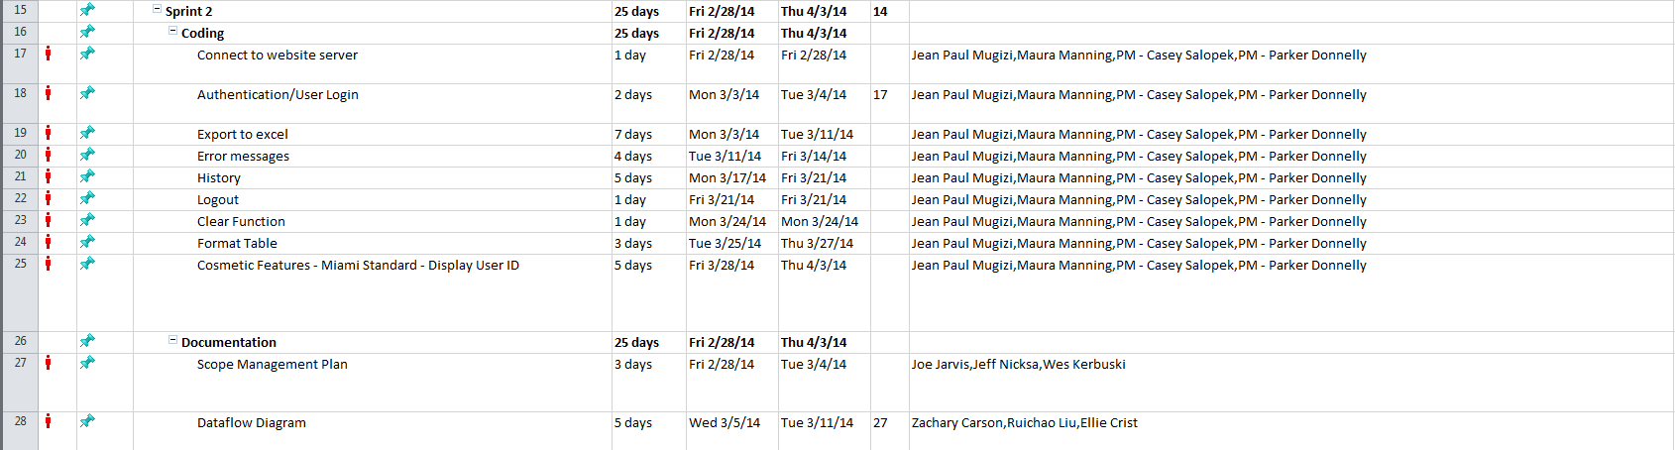

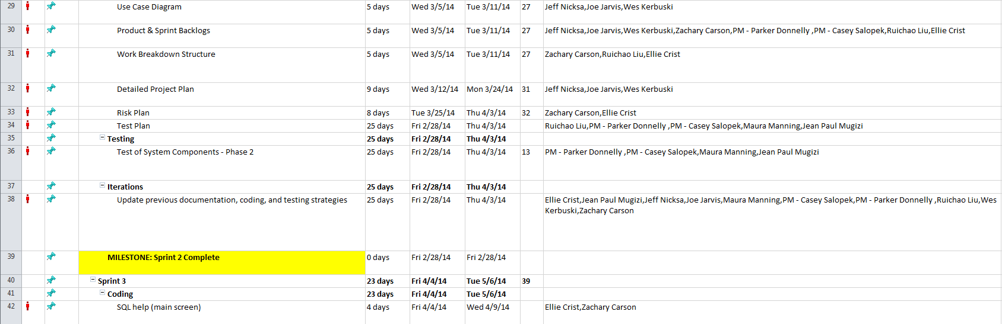

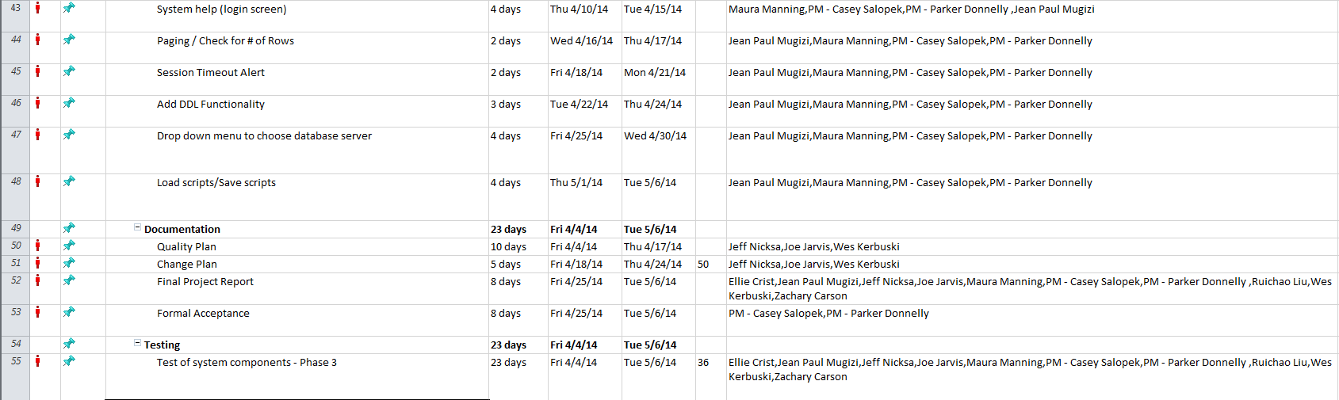

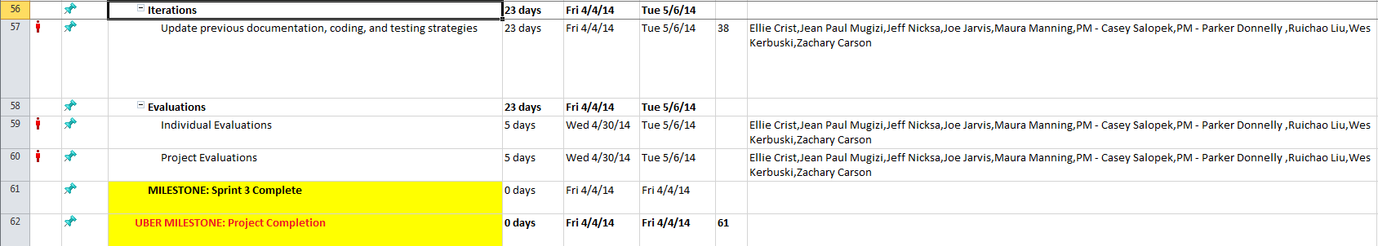

**Communications Management Plan**

We will communicate with one another through various means.  Electronic and phone communication are the most widely used modes outside of meetings.  Prompt responses to messages/inquiries from one another is expected.  If a member is unable to deliver as promised, they should advise the group at least 24 hours in advance so that alternate arrangements can be made.  Primary sharing of all documents will be done through GoogleDocs.

**Change Request Form**

|  |  |  |  |
| --- | --- | --- | --- |
| **Sponsor Name** |  | **Change #** |  |
| **Project Name** |  | **Date Submitted** |  |
| **Requested By** |  | **Date Reply Due** |  |

**Description of Change:**

**Justification:**

|  |  |  |  |  |  |
| --- | --- | --- | --- | --- | --- |
| Signature |  | Title |  | Date |  |

**Project Manager Approval:**

**Comments:**

Project team directory for all communications is:

|  |  |  |  |
| --- | --- | --- | --- |
| **Name** | **Email** | **Phone Number** | **Role** |
| Parker Donnelly | donnelp2@miamioh.edu | 630-701-4703 | Project Manager |
| Jean Paul Mugizi | mugizijc@miamioh.edu | 513-409-2327 | Programming Leader |
| Maura Manning | manninme@miamioh.edu | 908-458-1213 |  |
| Casey Salopek | Salopecl@miamioh.edu | 614-325-1111 | Project Manager |
| Ruichao Liu | liur3@miamioh.edu | 513-593-6350 |  |
| Ellie Crist | cristeg@miamioh.edu | 847-757-8419 | Team 2 Leader |
| Jeff Nicksa | nicksajc@miamioh.edu | 781-801-4430 | Team 1 Leader |
| Zach Carson | carsonzc@miamioh.edu | 717-419-8785 |  |
| Wes Kerbuski | kerbuspl@miamioh.edu | 703-850-6810 |  |
| Joseph Jarvis | jarvisjf@miamioh.edu | 913-221-8900 |  |

**Procurement Management Plan**

The Project Manager will provide oversight and management for all procurement activities under this project.  Any procurement actions must be approved by the Project Sponsor.

While this project requires minimal or no procurement, in the event procurement is required, the Project Manager will work with the project team to identify all items or services to be procured for the successful completion of the project.  The Project Manager will then ensure these procurements are reviewed by the Project Sponsor.  The project sponsor will review the procurement actions, determine whether it is advantageous to design or purchase the items or resource required services internally, and begin the vendor selection, purchasing and the contracting process.

In the event a procurement becomes necessary, the Project Manager will be responsible for management any selected vendor or external resource.  The Project Manager will also measure performance as it relates to the vendor providing necessary goods and/or services and communicate this to the purchasing and contracts groups.

**Project Scope Management Plan**

**Project Description**

This team has been formed to replace the Oracle Server Database. Our team will update the system to be relevant, user-friendly, and beneficial to our stakeholders. We are committed to working effectively as a team, by monitoring our process effectiveness, following through on commitments, and helping one another to learn.

**Project MOV**

The new system will add value to the learning process of students while increasing the overall satisfaction of using the system for all stakeholders by May 2015.

**DSC**

**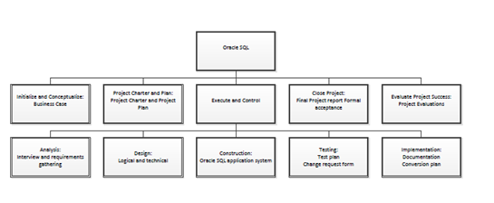**

The scope as defined at the commencement of the project should try to be followed strictly throughout the project duration. The scope is to be determined by the team and finalized by the project sponsor. Should the project scope need to be changed the whole team must be notified and meet together to formulate a plan to accommodate the changes. The project managers will have the final decision and they must present it to the stakeholders and reacquire approval to continue. If the project sponsor, Mike Edwards, rejects the new scope requirements, the team must meet to review the necessary changes and be clear on the project direction.  Once the project scope is finalized by the team they must bring it to the sponsor and gain their approval. This should be documented on the Project Sponsor Approval Form.

After the project scope has been signed off on by the sponsor any further changes

to scope will need to be done with a Change Request Form and followed up on by

notifying all stakeholders using the Revisions and Distributions Form.  Accurate communication is ensured by logging the revision and release date of approved changes. This is the final form in the scope management plan and it ensures that all stakeholders will be notified of any changes to the original scope.  This form enhances accountability from the project team standpoint by allowing the team to document each change and notify relevant stakeholders without missing any people who need to be informed.

**Schedule Management Plan**

Project schedules for the VICE Project will be created using MS Project 2010 starting with the deliverables identified in the project’s Work Breakdown Structure (WBS).  Once a preliminary schedule has been developed, it will be reviewed by the project team and any resources tentatively assigned to project tasks.  Many of the deliverables have been assigned with a concrete deadline date.  Once this is achieved the project sponsor will review and approve the schedule and it will then be base-lined.

**Roles and responsibilities for schedule development are as follows:**

The project manager will create the project schedule using MS Project 2010 and validate the schedule with the project team, stakeholders, and the project sponsor.  The project manager will obtain schedule approval from the project sponsor and baseline the schedule.

The project team will also review and validate the proposed schedule and perform assigned activities once the schedule is approved. The project sponsor will participate in reviews of the proposed schedule and approve the final schedule before it is base-lined.

**Quality Management Plan**

Quality in the project is a requisite for success.  Quality of work should be driven from the project sponsor and ensured by the project managers throughout the duration of the project.  At the conclusion of each sprint, the quality of the work completed will be assessed and reviewed.  Retrospective meetings should be held following each sprint.  A meeting should be held with the project sponsor to determine what work to keep pursuing and which activities should be eliminated to avoid loss of productivity.  The PMs have the final say before submission of any deliverable.  All work is expected to be finished and uploaded to the Google Doc shared account by 9pm every Wednesday.

**Risk Management Plan**

**Project Description**

This team has been formed to replace the Oracle Server Database.  Our team will update the system to be relevant, user-friendly, and beneficial to our stakeholders.  We are committed to working effectively as a team, by monitoring our process effectiveness, following through on commitments, and helping one another to learn.

**Measurable Organizational Value**

Desired Areas of Impact

* Customer
  + As the main users of the current Oracle system, students currently struggle with interacting with the user interface and downloading their final data.  Our new system aims to eliminate these problems so that students’ experience allows them to learn SQL more effectively.  In addition to students, ISA 235 professors are main customers of the system.  With our system’s enhancements, professors will receive Excel files containing students final results making grading much easier for them.
* Social
  + By enhancing the new Oracle system we will improve the education system at Miami University. Our new system will impact the learning processes of every business student that enrolls in MIS 235.  This new system will add benefits to the professor’s of MIS 235 lessons plan by improving functionality.

Desired Value of the IT Project

The key aspects that we are looking to improve upon for our new system is the effectiveness, efficiency, quality, and the speed.  With teaching SQL to ISA 235 students as the main goal of the system, by enhancing the user interface we will effectively encourage students to explore and enjoy SQL more.  The current system’s manner of displaying results in a table that is difficult to transfer to a Word document or Excel file hinders the student’s ability to turn in results to their professors.  Our new system aims to rectify this problem by allowing students to directly download their table results into an Excel file, improving the effectiveness of the tool, the quality of results that students deliver, and the speed with which professor can grade.

Desired Achievements

Our intended purpose is to create a system that will add value to a student’s learning of SQL without having negative experience with the user interface. This new system will not be able to decrease the amount of time professors spend teaching SQL, rather increase user satisfaction with easier functionality.

MOV Statement

The new system will add value to the learning process of students while increasing the overall satisfaction of using the system for all stakeholders by May 2015.

risk_1.tiff

**risk_2.tiff**

**risk_3.tiff**

**risk_4.tiff**

**risk_5.tiff**

**Staffing Management Plan**

**Project Manager** (2 positions) – responsible for all management for the VICE Project.  The Project Manager is responsible for planning, creating, and/or managing all work activities, variances, tracking, reporting, communication, performance evaluations, staffing, and internal coordination with project sponsor.

**Team Leaders** (2 position) – responsible for oversight of  the deliverables and  responsible for working with the Project Manager to manage risk, manage schedule, identify requirements, and create reports.

**Programmer Lead** (1 position) – responsible for coding and programming for the VICE Project.  All coding and programming tasks will be reviewed by the PMs prior to implementation.  Responsibilities also include assisting with risk identification and determining impacts of change requests.  The Programmer will be managed by the Project Manager.

**Resource Required**

*People*

* VICE Team Members
* Project Managers
* Network Administrator – Mike Edwards
* ISA Professors

*Technology*

* Visual Basic Software
* Microsoft Project Software
* GitHub

FSB Server – *provided to us*

**Cost Baseline**

The cost baseline for the VICE project includes all budgeted costs for the successful completion of the project.  Because of the nature of students completing the project for free as past of their curriculum there are no costs to create the system.

|  |  |  |
| --- | --- | --- |
| **Project Phase** | **Budgeted Total** | **Comments** |
| Planning | $20,000 | Includes work hours for all project team members for gathering requirements and planning project |
| Design | $10,000 | Includes work hours for all project team members for work on VICE conceptual design |
| Coding | $20,000 | Includes all work hours for coding of VICE |
| Testing | $10,000 | Includes all work hours for testing (including beta testing) of VICE software |
| Transition and Closeout | $5,000 | Includes all work hours for project conclusion |

**Sponsor Acceptance**

Approved by the Project Sponsor:

\_\_\_\_\_\_\_\_\_\_\_\_\_\_\_\_\_\_\_\_\_\_\_\_\_\_\_\_\_\_\_\_\_\_\_\_\_\_\_\_\_\_             Date:\_\_\_\_\_\_\_\_\_\_\_\_\_\_\_\_\_\_\_

<Mike Edwards>

<Provost and Executive Vice President for Academic Affairs for the Farmer School of Business>

*VICE*

Project Quality Management Plan

TABLE OF CONTENTS

1   Introduction..

1.1         Purpose of The Project Quality Management Plan..

2   Project Quality Management Overview...

2.1         Organization, Responsibilities, and Interfaces.

2.2         Tools, Environment, and Interfaces.

3   Project Quality Management..

3.1         Quality Planning.

3.1.1   Define Project Quality.

3.1.2   Measure Project Quality.

3.2         Quality Assurance.

3.2.1   Analyze Project Quality.

3.2.2   Improve Project Quality.

3.3         Quality Control

Appendix A: Project Quality Management Plan Approval..

**1**      **Introduction**

**1.1**         **Purpose of The Project Quality Management Plan**

The Project Quality Management Plan documents the necessary information required to effectively manage project quality from project planning to delivery. It defines a project’s quality policies, procedures, criteria for and areas of application, and roles, responsibilities and authorities.  The intended audience is the project manager, project team, project sponsor and any senior leaders whose support is needed to carry out the plan.

**2**      **Project Quality Management Overview**

**2.1**         **Organization, Responsibilities, and Interfaces**

|  |  |  |
| --- | --- | --- |
| **Name** | **Role** | **Quality Responsibility** |
| *Mike Edwards* | *Project Sponsor* | *Quality Standard Provider* |
| *Parker*  Donnelly | *Project Manager* | *Quality Oversight* |
| *Casey Salopek* | *Project Manager* | *Quality Oversight* |

**2.2**         **Tools, Environment, and Interfaces**

|  |  |
| --- | --- |
| **Tool** | **Description** |
| Milestones | Sprint periods of work to be completed, reviewed, and finalized |
| Group Standups | Periodic check of what each team member has been doing, how they did it, and what they will be doing next |
| SCRUM Meetings | Collaborative group meeting to accomplish work goals. |
| Debugging | Ensuring that the coding is functioning to the highest standards of quality expected. |
| Documentation Deadlines | Strict deadlines for achieving all the written documentation are completed on time. |
| The Team | Reviewing and scrutinizing the work that has been completed and openly expressing the satisfaction with each other. |
| Unit Testing | Analyzing methods and functions by creating equivalency classes(case groups) for each method and testing for a positive response. |

**3**      **Project Quality Management**

At the highest of levels Quality Management involves planning, doing, checking, and acting to improve project quality standards. The three main areas of project quality management are: Quality Planning (QP), Quality Assurance (QA) and Quality Control (QC). The following sections define how this project will apply each of these groups to control quality standards.

**3.1         Quality Planning**

Identify which quality standards are relevant to the project and how to satisfy them. Identify and define appropriate quality metrics and measures for standards for project processes, product functionality, regulatory compliance requirements, project deliverables, project management performance, documentation, testing, deliverables and product performance.

**3.1.1     Define Project Quality**

The quality standards for the customers (students) using the system that need to be met are ease of use through a more intuitive interface, the ability for students to save and load previous sql scripts, and the ability to download the results into excel. For the project, all deliverables and milestones need to be completed on time and looked over by the project managers to ensure documents are professional and complete. Quality standards from the project sponsor are a working system that replicates and enhances the previous SQL learning platform. The success of the project depends on our teams ability to adhere to the deadlines while meeting the quality standards we have defined. We will receive this feedback a few months into the implementation. Our team plans on issuing a series of comprehensive surveys that will outline their experience with the server. We will measure the success of the project based on the feedback from the customers in regards to our project goals.

**3.2         Quality Assurance**

Identify and define those actions, and the metrics to measure them, that provide the confidence that project quality is in fact being met and has been achieved. Relate these actions to the quality standards defined in the planning section of this document.

To ensure project quality we will test the system using students and professors who have had experience with the old system and assess their feedback in regards of the quality standards mentioned in the quality planning section of this document.

**3.2.1     Analyze Project Quality**

We will use Unit Testing for the functions of the system with test  case groups and determine those that need to be re-factored. Each VB function will be white box tested( by using N-UNIT Tests) and black-box tested by running it against specific test cases.  We also need to perform System Testing(stress-testing the system as whole to see how it runs) and Integration Testing( to see if all the various parts of the website are properly structured and referenced)

**3.2.2**     **Improve Project Quality**

Improving the quality of the project will be done in two phases: identification of errors  and correction, respectively. Those two phases will be done consecutively but separated as to avoid further error-spreading. In addition, team meetings will discuss lessons learned from previous errors and how to avoid them in the future by following standard design patterns and proper unit testing.

**3.3         Quality Control**

At the end of each milestone the work that has been completed will be reviewed with the entire team.  The work that is deemed to be of the highest quality will be finalized and the work that does not meet the standards of the team will be evaluated.  Areas of improvement will be communicated from all members to ensure that the project be satisfactory to all involved.

Documentation will be reviewed upon completion by each individual member assigned to that task, and then reviewed again by the team as a whole prior to submission to the project manager. Having each project team member look over the document individually prior to the group review will allow for each individual to analyze and comment on how to make the document better.  Following the individual review, the team as a whole will review the document together to provide quality assurance that the document is ready to be submitted. The final quality control of documentation will come from the project managers, who will review the document a final time in order to ensure all components of the document are thorough and complete.

The Oracle platform needs to be functional with ease to the users.  The coding should  not have any errors and should function without any interruptions. During the coding process, we will use Paired Programming to ensure the code is up to industry standards.  Partner Programming will allow VICE to better monitor errors in code as they appear, and fix them on an ongoing basis to ensure the program runs smoothly.  We will utilize the services of GitHub software.  This web-based service provides rock solid version control of our exhaustive coding.  As updates are made to the coding GitHub will provide a stored backup of every updated version of code that is produced.  This will help our VICE programmers understand what was changed and where.  Having that knowledge is a priceless commodity in the world of programming.  That being said our commitment to version control will provide assurance that are code is progressing rather than regressing.  VICE programmers will test each portion of the system as it is completed to prevent any setbacks from occurring near the end of the project. The program upon completion will undergo beta-testing from end-users and the project sponsor prior to launch to prevent and detect any errors. The final measure of quality comes from the users that interact with the system.  Should the system not work flawlessly and provide greater value to the users during beta-testing, the setbacks will be reviewed with the team and addressed to better the product.

**Appendix A: Project Quality Management Plan Approval**

The undersigned acknowledge they have reviewed the *VICE* Project Quality Management Plan and agree with the approach it presents. Changes to this Project Quality Management Plan will be coordinated with and approved by the undersigned or their designated representatives.

|  |  |  |  |
| --- | --- | --- | --- |
| Signature: |  | Date: |  |
| Print Name: | Mike Edwards |  |  |
| Title: |  |  |  |
| Role: |  |  |  |
| Signature: |  | Date: |  |
| Print Name: | Parker Donnelly |  |  |
| Title: |  |  |  |
| Role: |  |  |  |

|  |  |  |  |
| --- | --- | --- | --- |
| Signature: |  | Date: |  |
| Print Name: | Casey Salopek |  |  |
| Title: |  |  |  |
| Role: |  |  |  |

**Change Management Plan**

**Project Name:** SQL Oracle System

**Team Name:** VICE

**Team Members:**

|  |  |
| --- | --- |
| **Name** | **Role** |
| Parker Donnelly | Project Manager |
| Jean Paul Mugizi | Programming Leader |
| Maura Manning |  |
| Casey Salopek | Project Manager |
| Ruichao Liu | Team 2 Leader |
| Ellie Crist |  |
| Jeff Nicksa | Team 1 Leader |
| Zach Carson |  |
| Wes Kerbuski |  |
| Joseph Jarvis |  |

**Project Description**

The Information Systems and Analytics department needs an updated system to facilitate the effective learning of SQL.  Since Oracle discontinued support for the Oracle iSQL\*Plus software, the ISA department needs to update the system to enable professors to effectively teach SQL. Given the importance of SQL, it is critical to have a system that is easy to use and facilitates learning.  The recreating and refurbishing of the system will add the most value to the education of students and benefit the teaching lessons of professors.

**Project MOV**

The new system will add value to the learning process of students while increasing the overall satisfaction of using the system for all stakeholders by May 2015.

**Change Management Roles**

|  |  |  |  |
| --- | --- | --- | --- |
| **Role** | **Name** | **Contact** | **Description** |
| *Initiating Project Sponsor/*  *Sustaining Sponsor* | *Mike Edwards* | [*edwardm4@miamioh.edu*](mailto:edwardm4@miamioh.edu)  *513-529-4940* | Minor change power during the day-to-day work being done within the project.  Incremental input at beginning and major milestones. |
| *Change Agents* | *Parker Donnelly* | [*donnelp2@miamioh.edu*](mailto:donnelp2@miamioh.edu)  *630-701-4703* | Major change power during the life of the project. |
| *Change Agents* | *Casey Salopek* | [*salopecl@miamioh.edu*](mailto:salopecl@miamioh.edu)  *614-325-1111* | Major change power during the life of the project. |
| *Targets* | *ISA Students* | - | Provide feedback and areas to improve to sustaining sponsor. |

**Change Assessment**

Change requests are evaluated using the following priority criteria:

|  |  |
| --- | --- |
| **Priority** | **Description** |
| High | *Changes estimated to take longer than 12 hours* |
| Medium | *Changes estimated to take longer than 5 hours and less than 12* |
| Low | *Changes estimated to take less than 5 hours* |
| Immediate | *Changes that are determined as critical to project success* |

Change requests are evaluated and assigned one or more of the following change types:

|  |  |
| --- | --- |
| **Type** | **Description** |
| Scope | Change affecting scope |
| Time | Change affecting time |
| Duration | Change affecting duration |
| Cost | Change affecting cost |
| Resources | Change affecting resources |
| Deliverables | Change affecting deliverables |
| Product | Change affecting product |
| Processes | Change affecting process |
| Quality | Change affecting quality |

**Change Strategy**

The project change strategy incorporates both a normative-reeducation approach as well as an environmental-adaptive approach. The goal in this collective change strategy is to better unite the team with one mission, one level of quality in work, and ensure that all efforts are made to better the project at achieving the MOV to the highest standard possible.

From a normative-reeducation approach the ability for strong leaders to impact those around them, driving the project to be completed if initiated. Unfreezing personal norms and standards and allowing a new set of team norms to be established especially regarding quality and completeness of work completed. Eliminating the need of multiple values and working as a team with one view is a crucial element in change.

The environmental-adaptive change method, with the values taken from the normative-reeducation approach, completes the team change strategy. Changes and procedures became permanent once they reached acceptable levels to fulfill group needs. Making the team understand why change has to occur and the benefits that will be received from it. Informing the team of the changes that they will be undergoing is crucial especially when the impact is great on workload and because of a necessity.

**Monitoring Change Initiative**

The below table describes the process of change requests to the project. The change request form follows as well as the change management distribution form to ensure that all relevant stakeholders are aware of change if necessary within their involvement.

|  |  |
| --- | --- |
| **Step** | **Description** |
| Generate CR | A completed CR Form is sent to the Change Manager |
| Log CR Status | The Change Manager enters the CR into the CR Log. The CR’s status is updated throughout the CR process as needed. |
| Evaluate CR | Project team members review the CR and provide an estimated level of effort to process, and develop a proposed solution for the suggested change |
| Authorize | Approval from PM to move forward with incorporating the suggested change into the project |
| Implement | Carry out the approved requested change and communicate CR status to stakeholders and log into change management distribution form |

**Change Management Form**

|  |  |  |  |
| --- | --- | --- | --- |
| **Sponsor Name** |  | **Change #** |  |
| **Project Name** |  | **Date Submitted** |  |
| **Requested By** |  | **Date Reply Due** |  |

**Description of Change:**

**Justification:**

**Revision and Distribution Form**

|  |  |  |  |  |  |  |  |  |  |  |  |  |  |
| --- | --- | --- | --- | --- | --- | --- | --- | --- | --- | --- | --- | --- | --- |
| **Change Management Revision** | **Release date** | **Distributed to\*** | | | | | | | | | | | |
| Project Sponsor | Project Manager |  |  |  |  |  |  |  |  |  |  |
| Revision 1 |  |  |  |  |  |  |  |  |  |  |  |  |  |
|  |  |  |  |  |  |  |  |  |  |  |  |  |  |
|  |  |  |  |  |  |  |  |  |  |  |  |  |  |
|  |  |  |  |  |  |  |  |  |  |  |  |  |  |
|  |  |  |  |  |  |  |  |  |  |  |  |  |  |
|  |  |  |  |  |  |  |  |  |  |  |  |  |  |
|  | | | | | | | | | | | | | |

Appendix

**Video Change Request Form**

|  |  |  |  |
| --- | --- | --- | --- |
| **Sponsor Name** | Mike Edwards | **Change #** | 001 |
| **Project Name** | SQL Oracle System | **Date Submitted** | 2/27/2014 |
| **Requested By** | Dr. Rajkumar | **Date Reply Due** | 3/6/2014 |

**Description of Change:**

Add videos to the help page to assist end users with problems.

**Justification:**

This will increase end users satisfaction when utilizing the system. It will allow them to easily understand why their coding for the query will not work.

|  |  |  |  |  |
| --- | --- | --- | --- | --- |
| **Effect on Schedule, Deliverables, and Project Cost** | | | | |
| No. | Deliverable / Item | Revised End Date | Net Change, Hours  Increase or (Decrease) | Net Change, Cost  Increase or (Decrease) |
| 001 | Add videos to help page | N/A | 0 | 0 |
|  |  |  |  |  |
|  |  |  |  |  |
|  | Totals |  | 0 | 0 |
|  | Revised Project End Date | N/A |  |  |

Signature: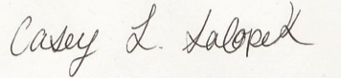Title: Project Manager Date: 3/6/2014

**Project Manager Approval:** Approval Denied, we will not be completing this scope change.

**Comments:** We find it unnecessary to add videos to the help screen for the user. We believe the user will be able to figure out their problems with the new help screen that we revised.

**Paging Change Request Form**

|  |  |  |  |
| --- | --- | --- | --- |
| **Sponsor Name** | Mike Edwards | **Change #** | 002 |
| **Project Name** | SQL Oracle System | **Date Submitted** | 2/27/2014 |
| **Requested By** | Dr. Rajkumar | **Date Reply Due** | 3/6/2014 |

**Description of Change:**

Add paging to the display table.

**Justification:**

This will allow the user to navigate the display table with ease. They will be able to scale down the table search for the data they need.

|  |  |  |  |  |
| --- | --- | --- | --- | --- |
| **Effect on Schedule, Deliverables, and Project Cost** | | | | |
| No. | Deliverable / Item | Revised End Date | Net Change, Hours  Increase or (Decrease) | Net Change, Cost  Increase or (Decrease) |
| 001 | Add videos to main screen help page | N/A | 0 | 0 |
| 002 | Add paging to display table | N/A | 0 |  |
|  |  |  |  |  |
|  | Totals |  | 0 |  |
|  | Revised Project End Date | 5/6/2014 |  |  |

Signature: 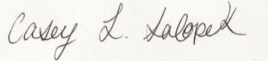Title: Project Manager Date: 3/6/2014

**Project Manager Approval:** Approval Denied

**Comments:** We found it unnecessary to include paging for the table because the benefits of the functionality did not outweigh the cost.

**Full Name Display Change Request Form**

|  |  |  |  |
| --- | --- | --- | --- |
| **Sponsor Name** | Mike Edwards | **Change #** | 003 |
| **Project Name** | SQL Oracle System | **Date Submitted** | 4/3/2014 |
| **Requested By** | Dr. Rajkumar | **Date Reply Due** | 4/10/2014 |

**Description of Change:**

On the work screen, display full name of student along with their userid.

**Justification:**

This will allow teachers to verify (if screenshots were taken) that the student is not cheating and did their own individual work. Also, it is an indicator to the student that they are logged in to their own account.

|  |  |  |  |  |
| --- | --- | --- | --- | --- |
| **Effect on Schedule, Deliverables, and Project Cost** | | | | |
| No. | Deliverable / Item | Revised End Date | Net Change, Hours  Increase or (Decrease) | Net Change, Cost  Increase or (Decrease) |
| 001 | Add videos to work screen help page | N/A | 0 | 0 |
| 002 | Add paging to display table | 3/6/2014 | 0 |  |
| 003 | Display full name of student on work screen | 5/6/2014 | 2 hours |  |
|  | Totals |  | 2 hours |  |
|  | Revised Project End Date | 5/6/2014 |  |  |

Signature: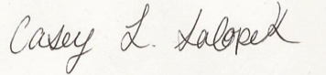Title: Project Manager Date: 4/10/2014

**Project Manager Approval:** Approval Confirmed

**Comments:** This will allow professors to increase the validation of a student’s work and reduce the possibility of cheating.

**Full Name Display Revisions and Distribution Form**

|  |  |  |  |  |  |  |  |  |  |  |  |  |  |
| --- | --- | --- | --- | --- | --- | --- | --- | --- | --- | --- | --- | --- | --- |
| **Revision** | **Release date** | **Distributed to\*** | | | | | | | | | | | |
| Client | Consultant | Head office(s) | All project dept. | Sub-contractors | Suppliers |  |  |  |  |  |  |
| Rev. 1 | 3/6/2014 | x |  |  | x |  |  |  |  |  |  |  |  |
| Rev. 2 | 4/10/2014 | x |  |  | x |  |  |  |  |  |  |  |  |
|  |  |  |  |  |  |  |  |  |  |  |  |  |  |
|  |  |  |  |  |  |  |  |  |  |  |  |  |  |
|  |  |  |  |  |  |  |  |  |  |  |  |  |  |
|  |  |  |  |  |  |  |  |  |  |  |  |  |  |
|  | | | | | | | | | | | | | |

**Drop Down Box Change Request Form**

|  |  |  |  |
| --- | --- | --- | --- |
| **Sponsor Name** | Mike Edwards | **Change #** | 004 |
| **Project Name** | SQL Oracle System | **Date Submitted** | 4/17/2014 |
| **Requested By** | Mike Edwards | **Date Reply Due** | 4/24/2014 |

**Description of Change:**

Delete the drop down menu for the option to choose what database the user may utilize.

**Justification:**

It is unnecessary for the user to choose a database, since Miami University only works with one.

|  |  |  |  |  |
| --- | --- | --- | --- | --- |
| **Effect on Schedule, Deliverables, and Project Cost** | | | | |
| No. | Deliverable / Item | Revised End Date | Net Change, Hours  Increase or (Decrease) | Net Change, Cost  Increase or (Decrease) |
| 001 | Add videos to work screen help page | N/A | 0 | 0 |
| 002 | Add paging to display table | 3/6/2014 | 0 |  |
| 003 | Display full name of student on work screen | 5/6/2014 | 2 hours |  |
| 004 | Delete the drop down box for databases | 5/6/2014 | (1 hour) |  |
|  | Totals |  | 1 hour |  |
|  | Revised Project End Date | 5/6/2014 |  |  |

Signature: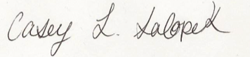Title: Project Manager Date: 4/24/2014

**Project Manager Approval:** Approval Confirmed

**Comments:** The dropdown box is unnecessary to the user and serves no purpose.

**Drop Down Box Revisions and Distribution Form**

|  |  |  |  |  |  |  |  |  |  |  |  |  |  |
| --- | --- | --- | --- | --- | --- | --- | --- | --- | --- | --- | --- | --- | --- |
| **Revision** | **Release date** | **Distributed to\*** | | | | | | | | | | | |
| Client | Consultant | Head office(s) | All project dept. | Sub-contractors | Suppliers |  |  |  |  |  |  |
| Rev. 1 | 3/6/2014 | x |  |  | x |  |  |  |  |  |  |  |  |
| Rev. 2 | 4/10/2014 | x |  |  | x |  |  |  |  |  |  |  |  |
| Rev. 3 | 4/24/2014 | x |  |  | x |  |  |  |  |  |  |  |  |
|  |  |  |  |  |  |  |  |  |  |  |  |  |  |
|  |  |  |  |  |  |  |  |  |  |  |  |  |  |
|  |  |  |  |  |  |  |  |  |  |  |  |  |  |
|  | | | | | | | | | | | | | |

**Run Multiple Queries Change Request Form**

|  |  |  |  |
| --- | --- | --- | --- |
| **Sponsor Name** | Mike Edwards | **Change #** | 005 |
| **Project Name** | SQL Oracle Database | **Date Submitted** | 4/24/2014 |
| **Requested By** | Dr. Rajkumar | **Date Reply Due** | 5/1/2014 |

**Description of Change:**

The system shoud be able to run multiple queries in the textbox at one time.

**Justification:** This will increase ease for the users to run multiple queries in one text box instead of having to do it individually.

|  |  |  |  |  |
| --- | --- | --- | --- | --- |
| **Effect on Schedule, Deliverables, and Project Cost** | | | | |
| No. | Deliverable / Item | Revised End Date | Net Change, Hours  Increase or (Decrease) | Net Change, Cost  Increase or (Decrease) |
| 001 | Add videos to work screen help page | N/A | 0 | 0 |
| 002 | Add paging to display table | 3/6/2014 | 0 |  |
| 003 | Display full name of student on work screen | 5/6/2014 | 2 hours |  |
| 004 | Delete the drop down box for databases | 5/6/2014 | (1 hour) |  |
| 005 | Run Multiple Queries | 5/6/2014 | 2-3 hours |  |
|  | Totals |  | 4-5 hours |  |
|  | Revised Project End Date | 5/6/2014 |  |  |

Signature:Title: Project Manager Date: 5/1/2014

**Project Manager Approval:** Approval Confirmed

**Comments:** The user should be able to run multiple queries in the text area to enhance productivity.

**Run Multiple Queries Revisions and Distribution Form**

|  |  |  |  |  |  |  |  |  |  |  |  |  |  |
| --- | --- | --- | --- | --- | --- | --- | --- | --- | --- | --- | --- | --- | --- |
| **Revision** | **Release date** | **Distributed to\*** | | | | | | | | | | | |
| Client | Consultant | Head office(s) | All project dept. | Sub-contractors | Suppliers |  |  |  |  |  |  |
| Rev. 1 | 3/6/2014 | x |  |  | x |  |  |  |  |  |  |  |  |
| Rev. 2 | 4/10/2014 | x |  |  | x |  |  |  |  |  |  |  |  |
| Rev. 3 | 4/24/2014 | x |  |  | x |  |  |  |  |  |  |  |  |
| Rev. 4 | 5/1/2014 | x |  |  | x |  |  |  |  |  |  |  |  |
|  |  |  |  |  |  |  |  |  |  |  |  |  |  |
|  |  |  |  |  |  |  |  |  |  |  |  |  |  |
|  | | | | | | | | | | | | | |