Part 1

Wednesday Practice

1. Where is each value stored in memory? In the call stack or in the memory heap? Where in the memory heap?

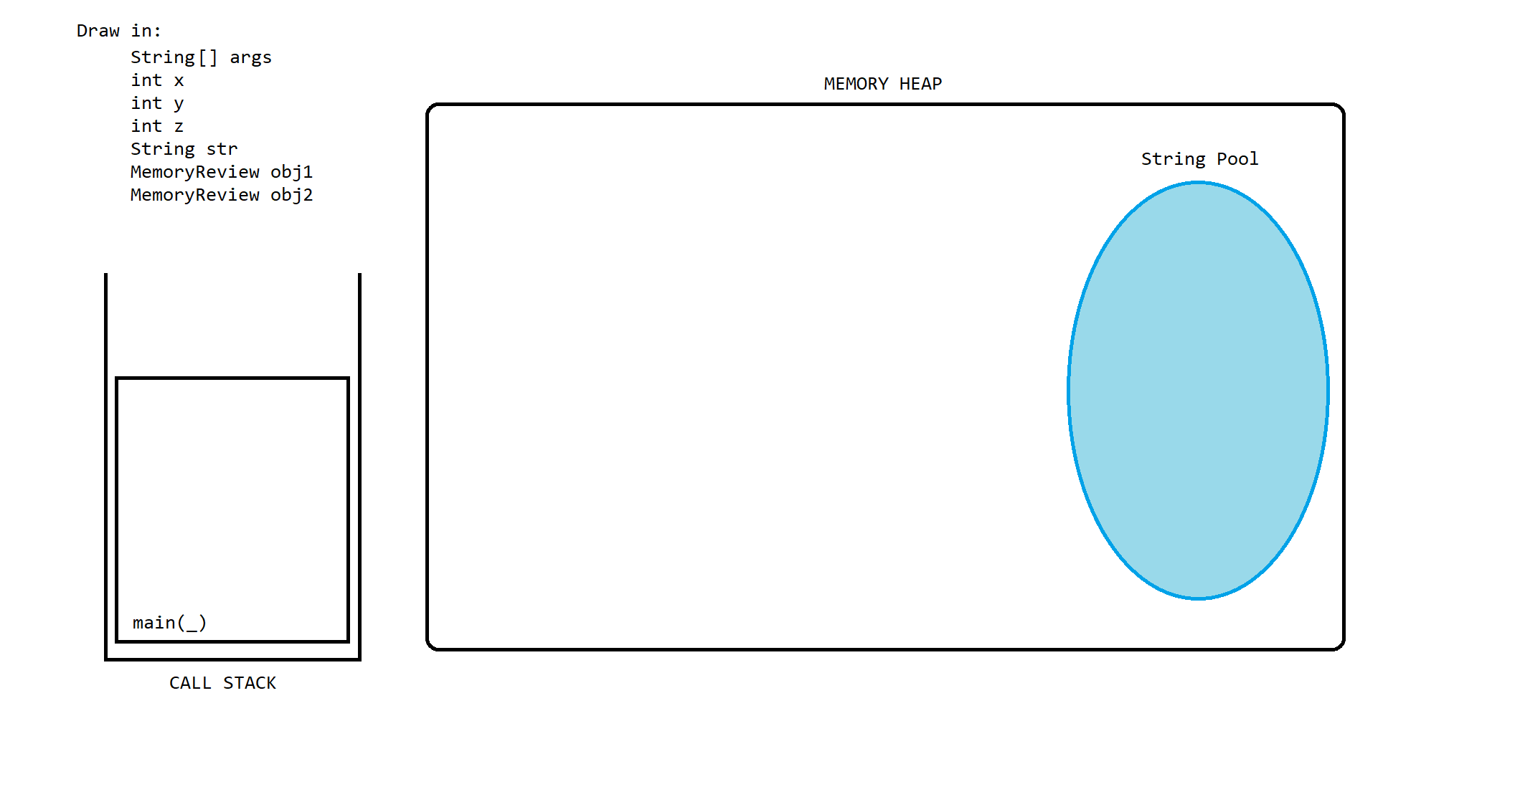public class MemoryReview {  
      int x = 1;  
      static int *y* = 10;  
  
      public static void main(String[] args) {  
            int z = 100;  
            String str = “Hello”;  
            MemoryReview obj1 = new MemoryReview();  
            MemoryReview obj2 = new MemoryReview();  
      }  
}

MemoryReview

X=1

y

MemoryReview

X =1

y

10

Main()

Args

Z = 100

Str

Obj1

Obj2

“Hello”

|  |  |
| --- | --- |
| **Value** | **Memory Location  (Stack or Heap)** |
| x | heap |
| y | heap |
| z | stack |
| args | stack |
| str | heap |
| obj1 | heap |
| obj2 | heap |

2. Where is each value stored in memory? In the call stack or in the memory heap? Where in the memory heap?

public class MemoryReviewWrapper {  
  
      Integer x = 1;  
      static Integer y = 2;  
  
      public static void main(String[] args) {  
            Integer x = 100; // non-primitive bc of autoboxing  
            Integer y = 200;  
            Integer z = Integer.*valueOf*(200); // not new Integer(200);  
  
            y = 300; // autoboxing (wrapper classes are IMMUTABLE)  
            MemoryReviewWrapper obj = new MemoryReviewWrapper();  
      }  
}

|  |  |
| --- | --- |
| **Value** | **Memory Location  (Stack or Heap)** |
| x | heap |
| y | heap |
| args | stack |
| x | heap |
| y | heap |
| z | heap |
| obj | heap |

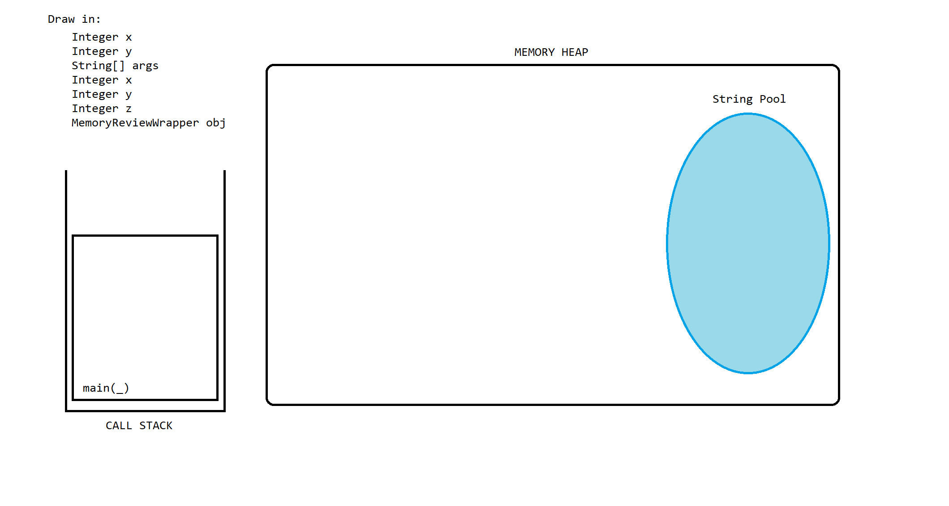

2

1

200

100

MemoryReviewWrapper

X

Y

Main()

Args

X

Y

Z

Obj