Testing for Module 100: Image Processing Project (Andrew Park, Priyanka Dangol)

For this project, we decided to test the functions separately. Following are the images we obtained from the aforementioned tests:

The left side represents the original picture while the right side represents the picture after the function has been called.

I) PixelStrip
1. Stripped of Green

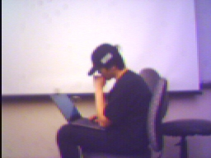
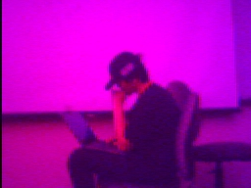

2. Stripped of Red
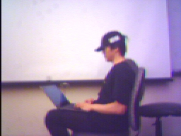
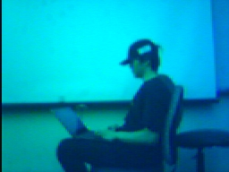

3. Stripped of Blue

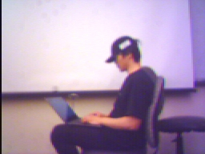
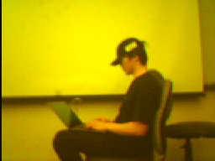

For the three functions where we increase the red, green and blue intensity of the pictures, we had to loop the specific function that increases the intensity of the color in the main program for a 100 times to clearly show the effects as the function, when repeated just once, increased red by a very small amount.

ii) Picture Redder
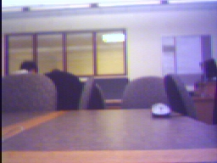
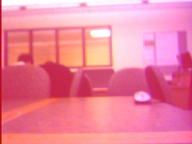

iii) Picture Greener
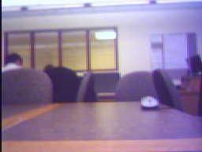
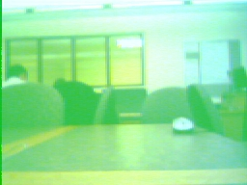

iv) Picture Bluer
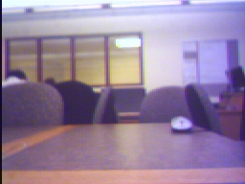
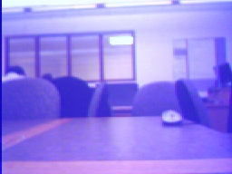

v) selectCircle
For this program, we entered the x-value as 126 and the y-value as 96 with a radius of 70 so that the circle would be approximately in the middle of the picture. As you can see below, the circle that was specified does have corresponding gray-scale colors within the circle.
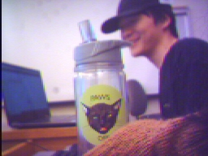
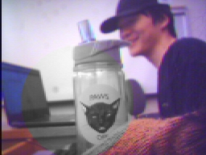

vi) Creative function (Merge pictures): Here the program is designed to merge two pictures (the left half of the first picture and the right half of the second picture are merged together). We made the robot move in between taking the first picture and the second picture to clearly show that the merged feature was working properly.
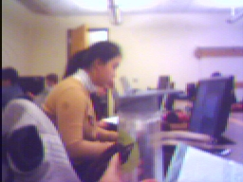
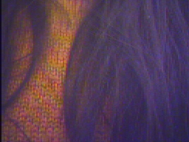

Original Picture # 1 Original Picture #2
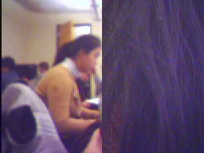

Original Picture #3

