-- Q1) Total Revenue

Select sum(sales_amount) as Tot
from orders

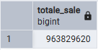

-- Q2) Total Number of Orders

Select Count(order_id) As Total_Orders
From orders

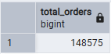

-- Q3) Average Order Value (AOV)

Select ROUND(AVG(sales_amount),2) AS AOV
From orders
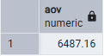

-- Q4) Revenue by City

select r.city,SUM(o.sales_amount) as City_Revenue
from orders as o
join restaurants as r
on o.restaurant_id = r.restaurant_id
group by r.city
order by City_Revenue Desc;

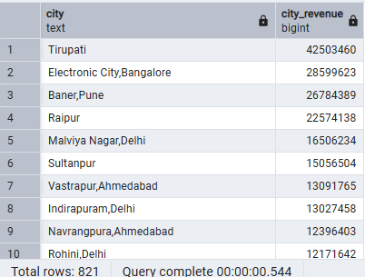

-- Q5) Top 5 Restaurants by Revenue

select r.name,SUM(o.sales_amount) as Restaurant_Revenue
from orders as o
join restaurants as r
on o.restaurant_id = r.restaurant_id
group by r.name
order by Restaurant_Revenue Desc
limit 5;
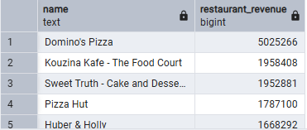

-- Q6) Revenue by Cuisine

select r.cuisine,SUM(o.sales_amount) as cuisine_Revenue
from orders as o
join restaurants as r
on o.restaurant_id = r.restaurant_id
group by r.cuisine
order by cuisine_Revenue Desc ;

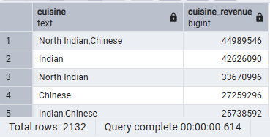

-- Q7) Revenue by Gender

select u.gender,SUM(o.sales_amount) as gender_Revenue
from orders as o
join users as u
on o.user_id = u.user_id
group by u.gender
order by gender_Revenue Desc ;

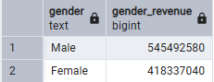

-- Q8) Revenue by age

select u.age,SUM(o.sales_amount) as Revenue
from orders as o
join users as u
on o.user_id = u.user_id
group by u.age
order by Revenue Desc ;

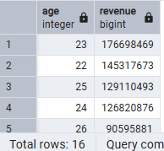

-- Q9) Revenue by occupation

select u.occupation,SUM(o.sales_amount) as Revenue
from orders as o
join users as u
on o.user_id = u.user_id
group by u.occupation
order by Revenue Desc ;

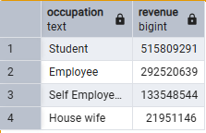

-- Q10) Revenue by marital_status

select u.marital_status,SUM(o.sales_amount) as Revenue
from orders as o
join users as u
on o.user_id = u.user_id
group by u.marital_status
order by Revenue Desc ;

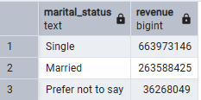

-- Q11) Repeat Customers

SELECT user_id,
COUNT(order_id) AS total_orders
FROM orders
GROUP BY user_id
HAVING COUNT(order_id) > 1;

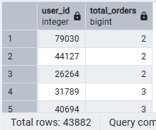

-- Q12) Monthly Revenue Trend

select
date_trunc('month',order_date) as months,
sum(sales_amount) as Monthly_Revenue
FROM orders
group by months
order by months ;

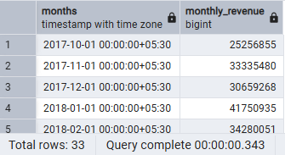

-- Q13) Average Rating by City

SELECT city,round(avg(rating),2) AS Avg_Rating
From restaurants
WHERE rating IS NOT NULL
group by city
order by Avg_Rating desc ;

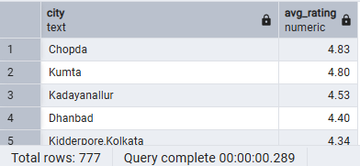

-- Q14) Revenue Contribution % by Restaurant

SELECT r.name,
SUM(o.sales_amount) AS revenue,
ROUND(
100.0 * SUM(o.sales_amount)
/ SUM(SUM(o.sales_amount)) OVER (),
2) AS revenue_percentage
FROM orders o
JOIN restaurants r
ON o.restaurant_id = r.restaurant_id
GROUP BY r.name
ORDER BY revenue DESC;

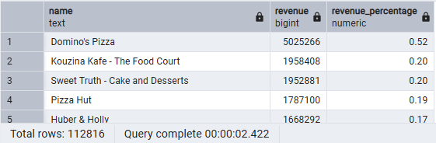

-- Q15) Top Revenue Restaurant Per City (Using RANK)

SELECT *
FROM (
SELECT r.city,
r.name,
SUM(o.sales_amount) AS revenue,
RANK() OVER (PARTITION BY r.city
ORDER BY SUM(o.sales_amount) DESC) AS rank_in_city
FROM orders o
JOIN restaurants r
ON o.restaurant_id = r.restaurant_id
GROUP BY r.city, r.name
) ranked
WHERE rank_in_city = 1;

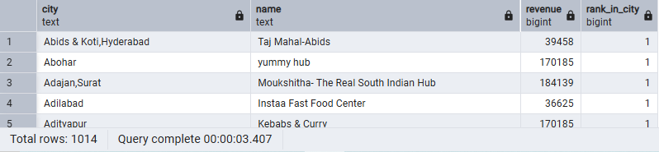

-- Q16) Cumulative Revenue (Running Total Over Time)

SELECT
order_date,
SUM(sales_amount) AS daily_revenue,
SUM(SUM(sales_amount)) OVER (
ORDER BY order_date
) AS cumulative_revenue
FROM orders
GROUP BY order_date
ORDER BY order_date;

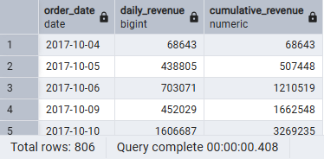

-- Q17) Customer Lifetime Revenue

Select u.user_id,
u.name,
sum(o.sales_amount) as Lifetime_Rev
From users as u
join orders o
on u.user_id = o.user_id
group by u.user_id,u.name
order by Lifetime_Rev DESC

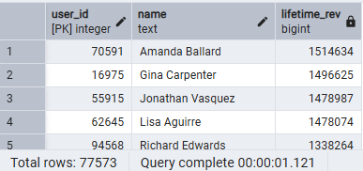

-- Q18) Age Group Revenue Segmentation

SELECT
CASE
WHEN age < 25 THEN 'Under 25'
WHEN age BETWEEN 25 AND 40 THEN '25-40'
ELSE 'Above 40'
END AS age_group,
SUM(o.sales_amount) AS revenue
FROM orders o
JOIN users u
ON o.user_id = u.user_id
GROUP BY age_group
ORDER BY revenue DESC;

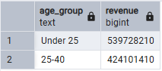

-- Q19) Revenue vs Rating Correlation View

SELECT r.name,
r.rating,
SUM(o.sales_amount) AS revenue
FROM orders o
JOIN restaurants r
ON o.restaurant_id = r.restaurant_id
WHERE rating IS NOT NULL
GROUP BY r.name, r.rating
ORDER BY r.rating DESC;
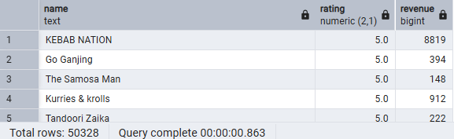

-- Q20) Revenue Per Order

SELECT
r.name,
ROUND(SUM(o.sales_amount)::NUMERIC
/ COUNT(o.order_id), 2) AS avg_order_revenue
FROM orders o
JOIN restaurants r
ON o.restaurant_id = r.restaurant_id
GROUP BY r.name
ORDER BY avg_order_revenue DESC;

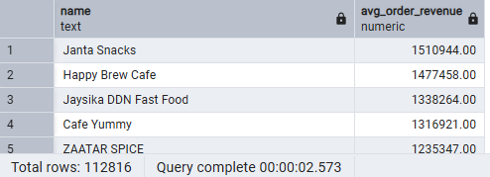

-- Q21) Top 20% Restaurants Driving Revenue

WITH restaurant_revenue AS (
SELECT r.name,
SUM(o.sales_amount) AS revenue,
SUM(SUM(o.sales_amount)) OVER () AS total_revenue
FROM orders o
JOIN restaurants r
ON o.restaurant_id = r.restaurant_id
GROUP BY r.name
),
ranked AS (
SELECT *,
SUM(revenue) OVER (
ORDER BY revenue DESC
) AS cumulative_revenue
FROM restaurant_revenue
)
SELECT *
FROM ranked
WHERE cumulative_revenue <= 0.8 * total_revenue;

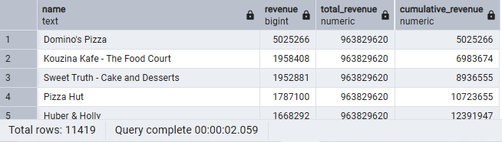

-- Q22) Monthly Active Users (MAU)

SELECT
DATE_TRUNC('month', order_date) AS month,
COUNT(DISTINCT user_id) AS monthly_active_users
FROM orders
GROUP BY month
ORDER BY month;

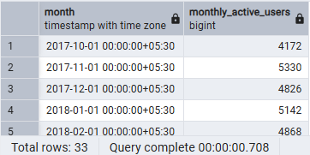

-- Q23) New Users Per Month (Growth Indicator)

SELECT
TO_CHAR(first_order_date, 'MM/YYYY') AS month_year,
COUNT(user_id) AS new_users
FROM (
SELECT
user_id,
MIN(order_date) AS first_order_date
FROM orders
GROUP BY user_id
) AS user_first_orders
GROUP BY month_year, DATE_TRUNC('month', first_order_date)
ORDER BY DATE_TRUNC('month', first_order_date);

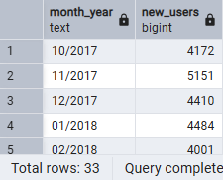

-- Q24) Repeat vs One-Time Users

SELECT
customer_type,
COUNT(*) AS total_users
FROM (
SELECT
user_id,
CASE
WHEN COUNT(order_id) = 1 THEN 'One-Time'
ELSE 'Repeat'
END AS customer_type
FROM orders
GROUP BY user_id
) AS user_categories
GROUP BY customer_type;

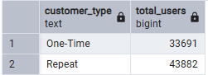

-- Q25) First Order Revenue vs Repeat Revenue

WITH user_orders AS (
SELECT *,
ROW_NUMBER() OVER (PARTITION BY user_id
ORDER BY order_date) AS order_rank
FROM orders
)
SELECT
CASE
WHEN order_rank = 1 THEN 'First Order'
ELSE 'Repeat Order'
END AS order_type,
SUM(sales_amount) AS revenue
FROM user_orders
GROUP BY order_type;

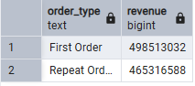

-- Q26) Revenue Volatility (Monthly Growth %)

WITH monthly_revenue AS (
SELECT DATE_TRUNC('month', order_date) AS month,
SUM(sales_amount) AS revenue
FROM orders
GROUP BY month
)
SELECT month,
revenue,
ROUND(
100.0 * (revenue - LAG(revenue) OVER (ORDER BY month))
/ LAG(revenue) OVER (ORDER BY month),
2) AS growth_percentage
FROM monthly_revenue
ORDER BY month;

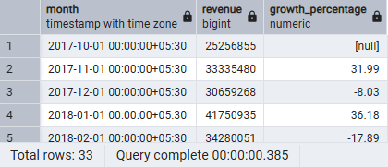

-- Q27) Restaurant Revenue Stability

SELECT r.name,
COUNT(DISTINCT DATE_TRUNC('month', o.order_date)) AS active_months
FROM orders o
JOIN restaurants r
ON o.restaurant_id = r.restaurant_id
GROUP BY r.name
ORDER BY active_months DESC;

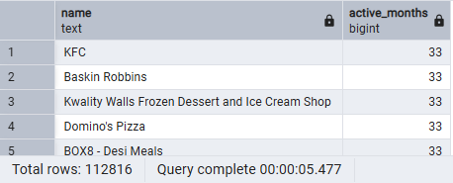

-- Q28) Revenue Concentration Among Users (Pareto Users)
WITH user_revenue AS (
SELECT user_id,
SUM(sales_amount) AS revenue
FROM orders
GROUP BY user_id
),
ranked AS (
SELECT *,
SUM(revenue) OVER (ORDER BY revenue DESC) AS cumulative_revenue,
SUM(revenue) OVER () AS total_revenue
FROM user_revenue
)
SELECT *
FROM ranked
WHERE cumulative_revenue <= 0.8 * total_revenue;

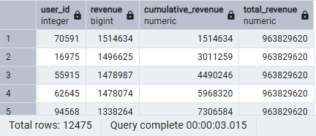
-- Q29) Price Sensitivity (Revenue vs Price Tier)

SELECT
CASE
WHEN price < 200 THEN 'Low'
WHEN price BETWEEN 200 AND 500 THEN 'Medium'
ELSE 'Premium'
END AS price_category,
SUM(o.sales_amount) AS revenue
FROM menu m
JOIN orders o ON o.restaurant_id = m.restaurant_id
GROUP BY price_category
ORDER BY revenue DESC;
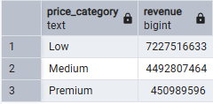

-- Q30) Full Business Health Summary (Identify strongest market & strongest partner)

WITH city_revenue AS (
SELECT r.city,
SUM(o.sales_amount) AS revenue
FROM orders o
JOIN restaurants r
ON o.restaurant_id = r.restaurant_id
GROUP BY r.city
),
top_city AS (
SELECT city
FROM city_revenue
ORDER BY revenue DESC
LIMIT 1
)
SELECT r.name,
SUM(o.sales_amount) AS revenue
FROM orders o
JOIN restaurants r
ON o.restaurant_id = r.restaurant_id
WHERE r.city = (SELECT city FROM top_city)
GROUP BY r.name
ORDER BY revenue DESC
LIMIT 1;

