**UNIT TESTING DOCUMENT**

**Scenario** : Read only List report UI

**Executed By** : Paramesh Akkenapally

**Result** : Success

Run the App:

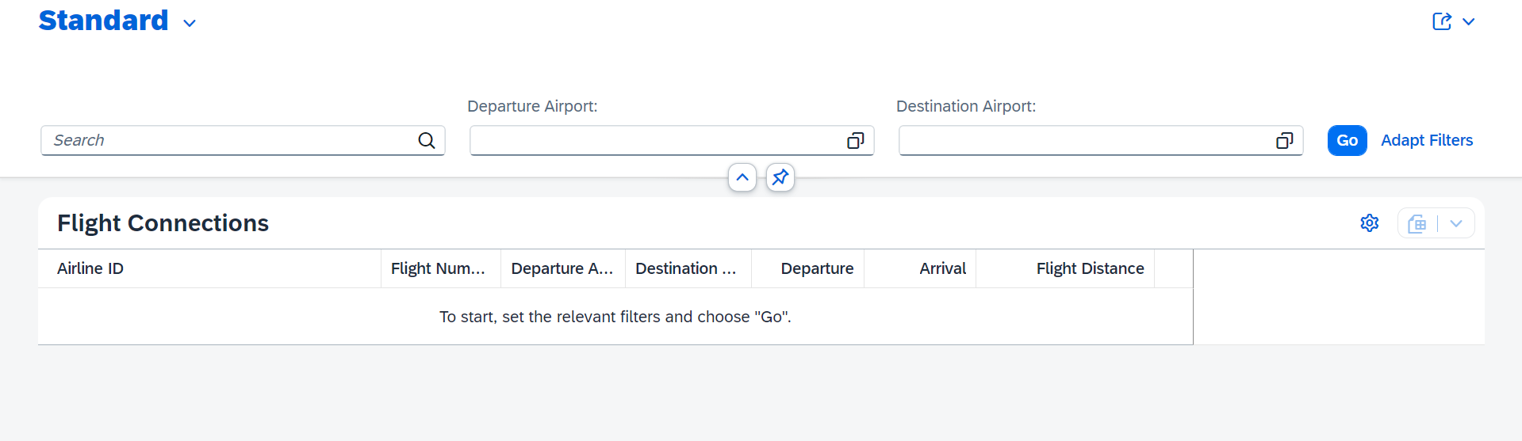

Click on go:

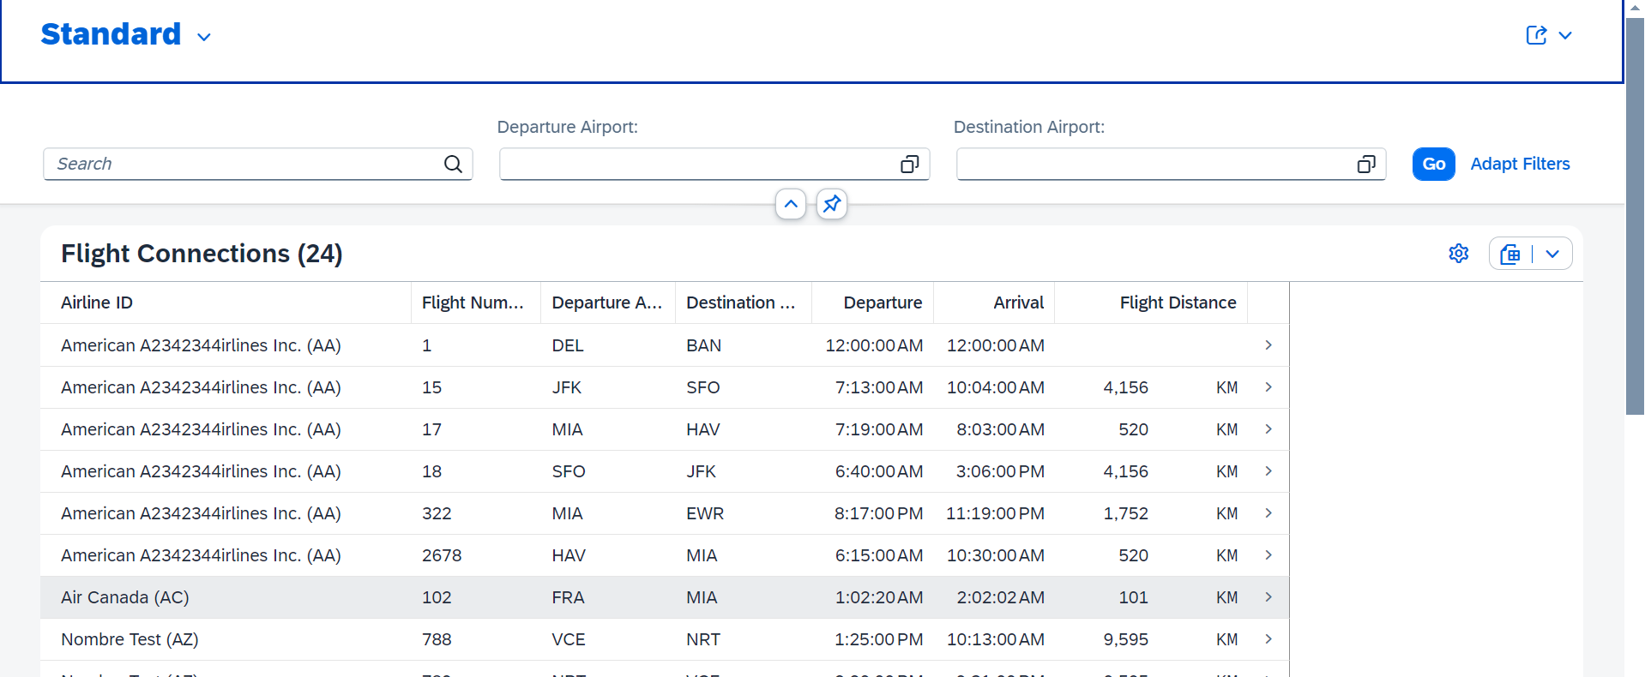

Fuzzy Search :

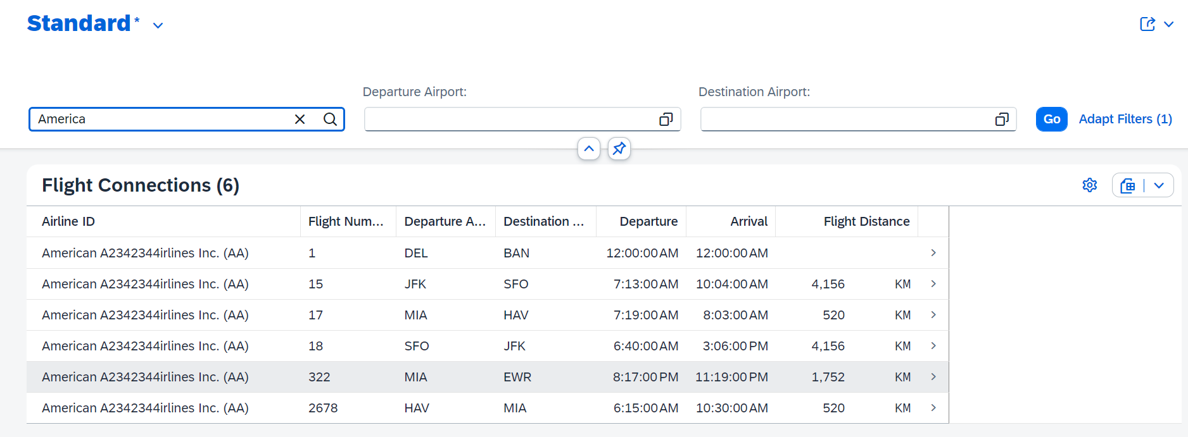

Search on Airport ID:

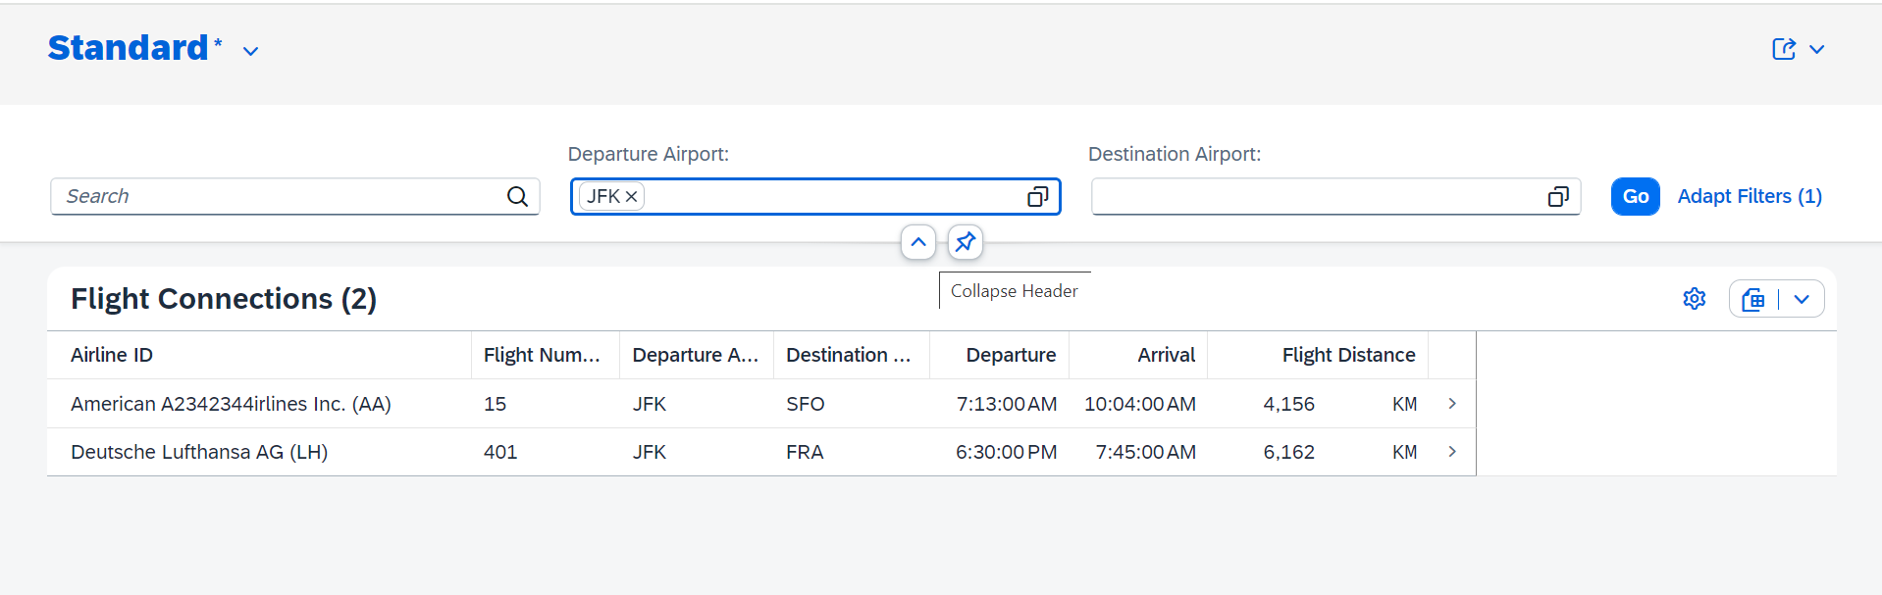

F4 help :

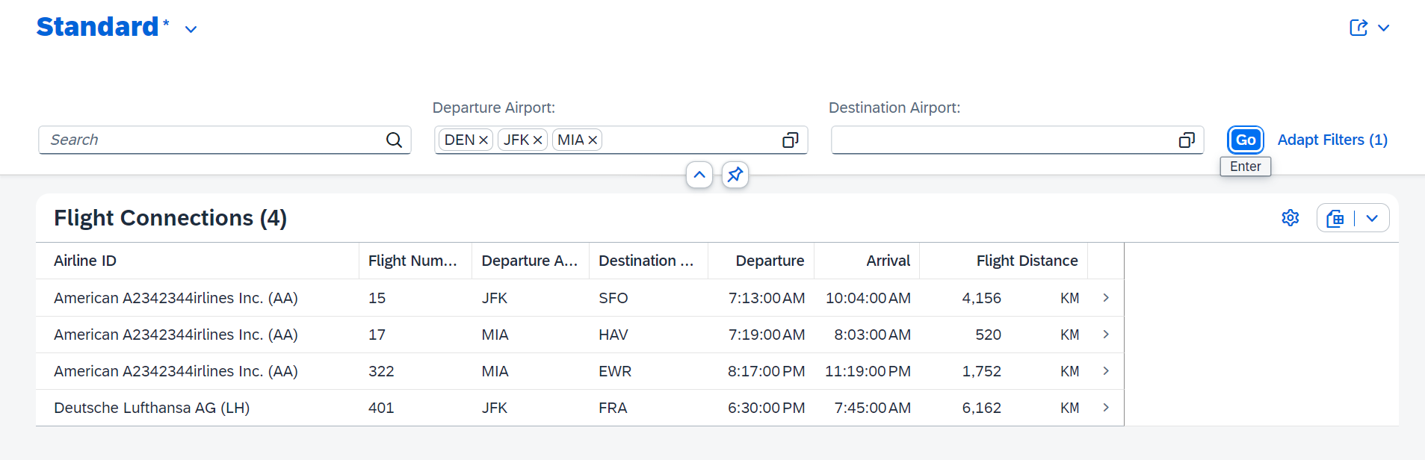

Object Page :

