RAP :

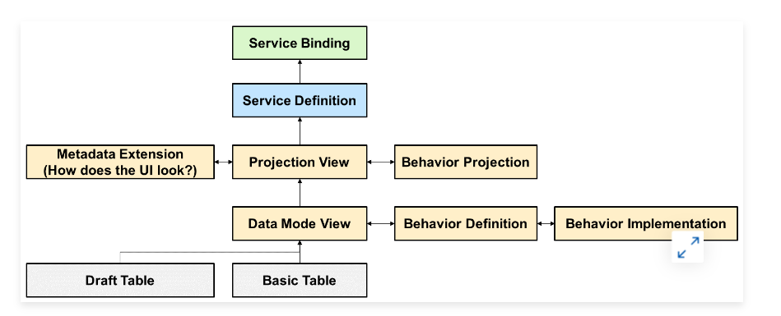

Data Model:

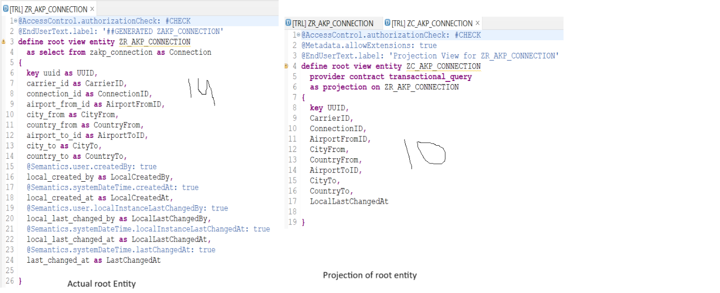

Behaviour definition

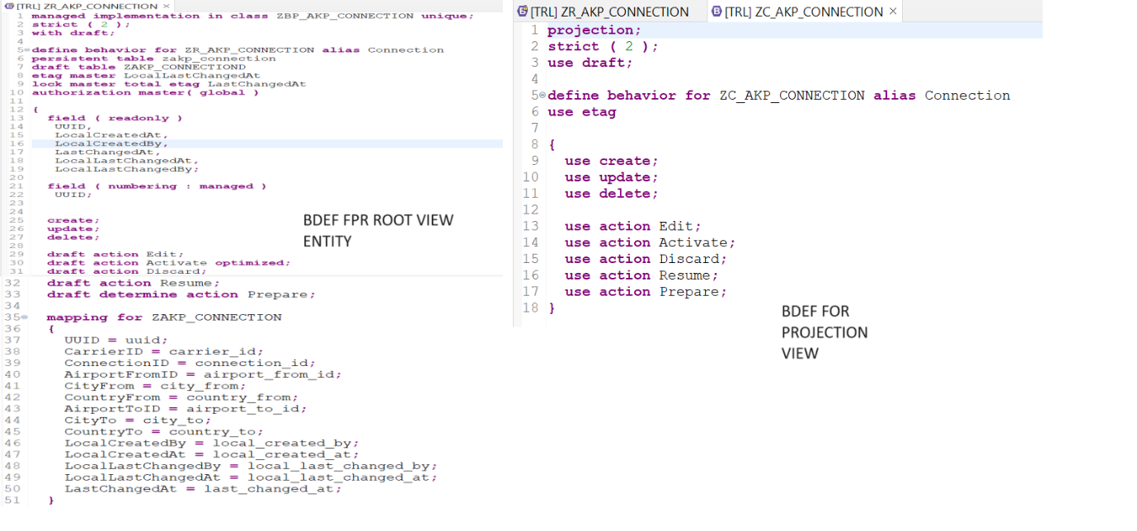

Metadata Extension:

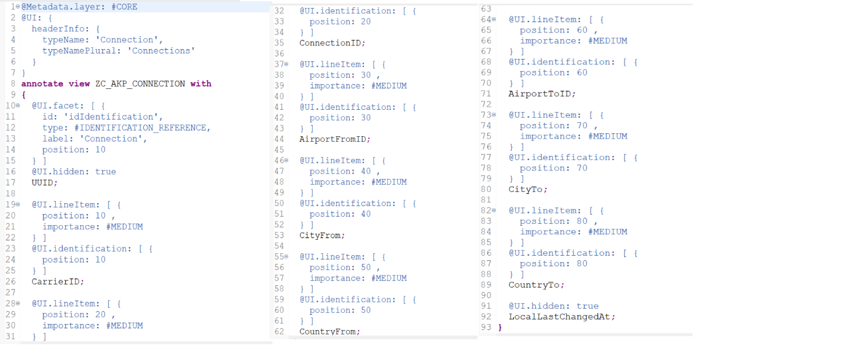

Service Definition:

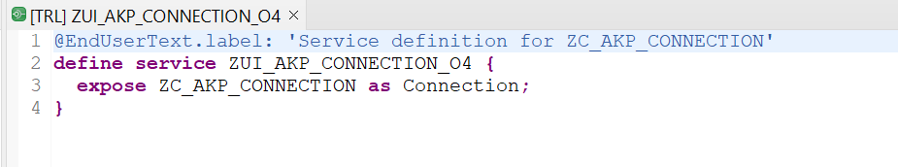

Service Binding:

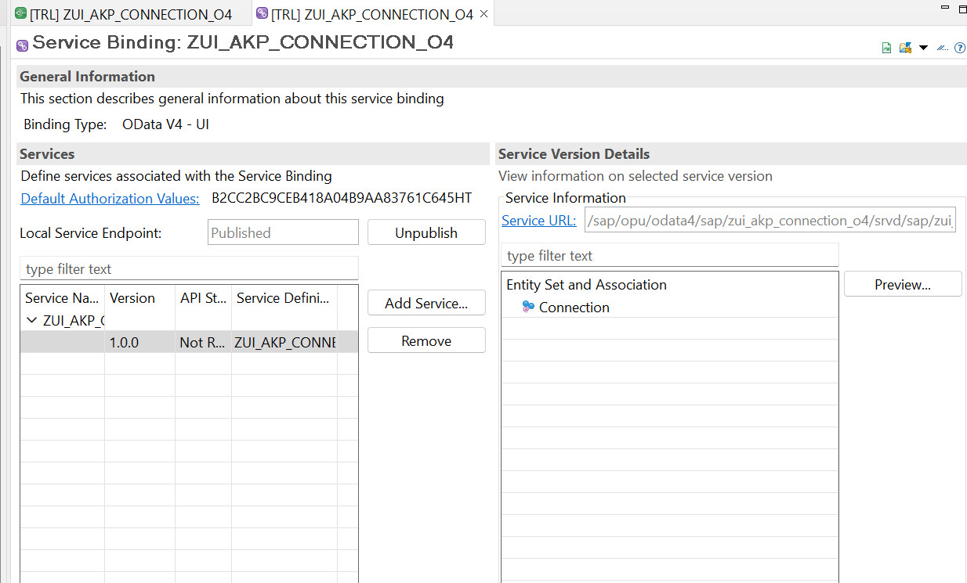

Over all Project:

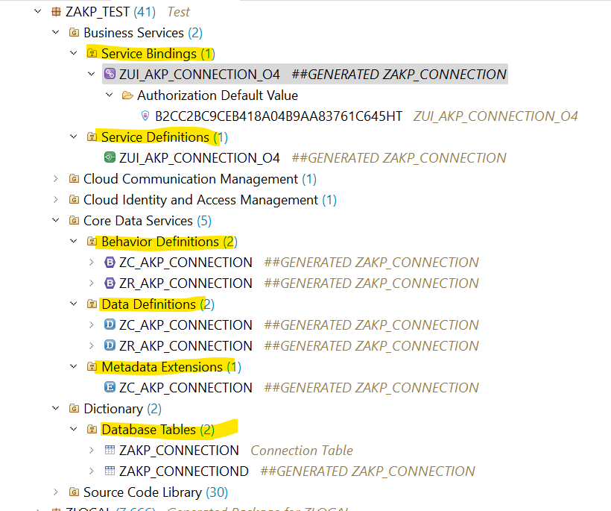

RAP Query report:

Data Model:

@AbapCatalog.viewEnhancementCategory: [#NONE]

@AccessControl.authorizationCheck: #NOT_REQUIRED

@EndUserText.label: 'Connection Details'

@Metadata.ignorePropagatedAnnotations: true

@ObjectModel.usageType:{

serviceQuality: #X,

sizeCategory: #S,

dataClass: #MIXED

}

@UI: { //Header Information on Line Items

headerInfo: {

typeName: 'Connection',

typeNamePlural: 'List of Connections'

}

}

@Search.searchable: true

**define** **view** **entity** ZRAKP_DEMO_CONNECTION

**as** **select** **from** /dmo/connection

**association** **[**1**..*]** **to** ZIAKP_DEMO_FLIGHT **as** _flight **on** **$projection.**CarrierId **=** _flight**.**CarrierId

**and** **$projection.**ConnectionId **=** _flight**.**ConnectionId

**association** **[**1**]** **to** ZIAKP_DEMO_CARRIER **as** _carrier **on** **$projection.**CarrierId **=** _carrier**.**CarrierId

**{**

@UI.facet: [ {

id: 'Connection',

type: #IDENTIFICATION_REFERENCE,

label: 'Connection Details',

position: 10

},

{

id : 'Flight',

type: #LINEITEM_REFERENCE,

label: 'Flight Details',

position: 20,

targetElement: '_flight'

}]

@UI.lineItem: [{ position: 10 , label: 'Airline_ID'}] //To Display the Line Items

@UI.identification: [{ position: 10 }] //To Dispaly the Object page Line Items

//@UI.selectionField: [{ position: 10 }] //Selection Field - Filter Option

@ObjectModel.text.association: '_carrier' //Get the details from _carrier association Carrier Name based on Carrier ID

//@Search.defaultSearchElement: true

**key** carrier_id **as** CarrierId**,**

@UI.lineItem: [{ position: 20}]

@UI.identification: [{ position: 20 }]

//@UI.selectionField: [{ position: 20 }]

//@Search.defaultSearchElement: true

**key** connection_id **as** ConnectionId**,**

@UI.lineItem: [{ position: 30 }]

@UI.identification: [{ position: 30 }]

@UI.selectionField: [{ position: 30 }]

@Search.defaultSearchElement: true

@Consumption.valueHelpDefinition: //Value help addition

[

{ entity :

{

name: 'ZIAKP_DEMO_AIRPORT_VH',

element: 'AirportId'

}

}

]

airport_from_id **as** AirportFromId**,**

@UI.lineItem: [{ position: 40 }]

@UI.identification: [{ position: 40 }]

@UI.selectionField: [{ position: 40 }]

@Search.defaultSearchElement: true

@Consumption.valueHelpDefinition:

[

{ entity :

{

name: 'ZIAKP_DEMO_AIRPORT_VH',

element: 'AirportId'

}

}

]

airport_to_id **as** AirportToId**,**

@UI.lineItem: [{ position: 50 ,label:'DepartureTime'}]

@UI.identification: [{ position: 50 ,label:'DepartureTime' }]

departure_time **as** DepartureTime**,**

@UI.lineItem: [{ position: 60 ,label:'ArrivalTime'}]

@UI.identification: [{ position: 60 ,label:'ArrivalTime'}]

arrival_time **as** ArrivalTime**,**

@Semantics.quantity.unitOfMeasure: 'DistanceUnit'

@UI.lineItem: [{ position: 70 }]

@UI.identification: [{ position: 70 }]

distance **as** Distance**,**

distance_unit **as** DistanceUnit**,**

@Search.defaultSearchElement: true //Assocation is searchbale - The respective View should be searchble

_flight**,** //Public Expose

@Search.defaultSearchElement: true

_carrier

**}**

**Flight:**

@AbapCatalog.viewEnhancementCategory: [#NONE]

@AccessControl.authorizationCheck: #NOT_REQUIRED

@EndUserText.label: 'Flight details'

@Metadata.ignorePropagatedAnnotations: true

@ObjectModel.usageType:{

serviceQuality: #X,

sizeCategory: #S,

dataClass: #MIXED

}

@Search.searchable: true

**define** **view** **entity** ZIAKP_DEMO_FLIGHT

**as** **select** **from** /dmo/flight

**association** **[**1**]** **to** ZIAKP_DEMO_CARRIER **as** _carrier **on** **$projection.**CarrierId **=** _carrier**.**CarrierId

**{**

@UI.lineItem: [{ position: 20}]

@ObjectModel.text.association: '_carrier'

**key** carrier_id **as** CarrierId**,**

@UI.lineItem: [{ position: 30}]

**key** connection_id **as** ConnectionId**,**

@UI.lineItem: [{ position: 40}]

**key** flight_date **as** FlightDate**,**

@UI.lineItem: [{ position: 50}]

@Semantics.amount.currencyCode: 'CurrencyCode'

price **as** Price**,**

currency_code **as** CurrencyCode**,**

@UI.lineItem: [{ position: 60}]

@Search.defaultSearchElement: true

plane_type_id **as** PlaneTypeId**,**

@UI.lineItem: [{ position: 70}]

seats_max **as** SeatsMax**,**

@UI.lineItem: [{ position: 80}]

seats_occupied **as** SeatsOccupied**,**

_carrier

**}**

Carrier:

@AbapCatalog.viewEnhancementCategory: [#NONE]

@AccessControl.authorizationCheck: #NOT_REQUIRED

@EndUserText.label: 'Carrier Data'

@Metadata.ignorePropagatedAnnotations: true

@ObjectModel.usageType:{

serviceQuality: #X,

sizeCategory: #S,

dataClass: #MIXED

}

@Search.searchable: true

**define** **view** **entity** ZIAKP_DEMO_CARRIER **as** **select** **from** /dmo/carrier

**{**

**key** carrier_id **as** CarrierId**,**

@Search.defaultSearchElement: true

@Search.fuzzinessThreshold: 0.8

@Semantics.text: true

name **as** Name

**}**

Airport:

@AbapCatalog.viewEnhancementCategory: [#NONE]

@AccessControl.authorizationCheck: #NOT_REQUIRED

@EndUserText.label: 'Value Help for departure and desination'

@Metadata.ignorePropagatedAnnotations: true

@ObjectModel.usageType:{

serviceQuality: #X,

sizeCategory: #S,

dataClass: #MIXED

}

@Search.searchable: true

**define** **view** **entity** ZIAKP_DEMO_AIRPORT_VH

**as** **select** **from** /dmo/airport

**{**

@Search.defaultSearchElement: true

**key** airport_id **as** AirportId**,**

@Search.defaultSearchElement: true

@Search.fuzzinessThreshold: 0.8

name **as** Name**,**

@Search.defaultSearchElement: true

city **as** City**,**

@Search.defaultSearchElement: true

country **as** Country

**}**

Service Definition:

@EndUserText.label: 'Service Definition'

**define** **service** ZSDAKP_DEMO_CONNECTION **{**

**expose** ZRAKP_DEMO_CONNECTION**;**

**expose** ZIAKP_DEMO_FLIGHT**;**

**}**

Service Binding:

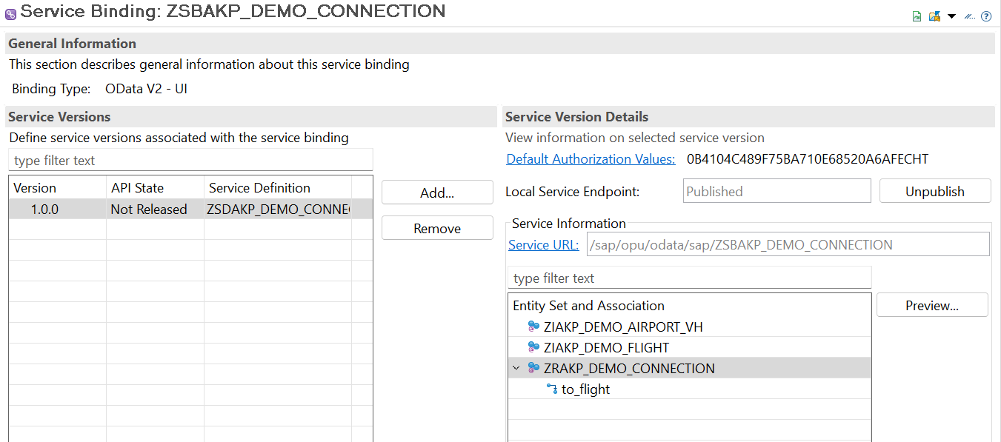

Report:

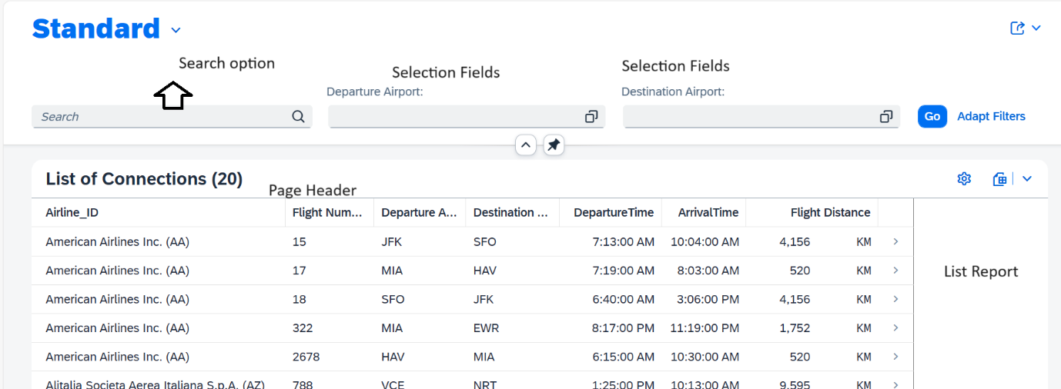

Object Page:

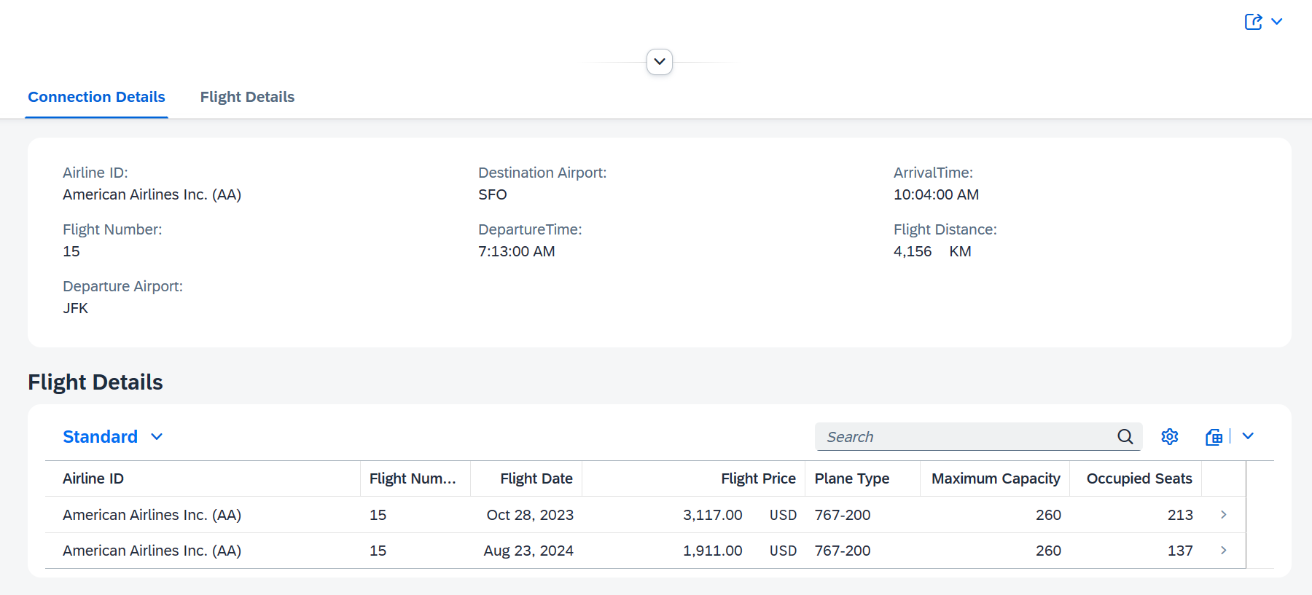

Managed scenario:

Travel Table:

/DMO/TRAVEL_M

/DMO/BOOKING_M

/DMO/BOOKSUPPL_M

/DMO/TRAVEL_M

1 n 1 n

/DMO/BOOKSUPPL_M

/DMO/BOOKING_M

Interface Views:

ZAKP_I_TRAVEL_M -- To Provide Travel details

ZAKP_I_BOOKING_M --To Provide booking details

ZAKP_BKINGSUPLL_M -- To Provide booking supplement details

Other Standard Interface view are :

/DMO/I_AGENCY – Agency details

/DMO/I_CUSTOMER – Customer Details

/DMO/I_CURRENCY --- Currency Codes

/DMO/I_OVERALLSTATUS_VH – Overall Status