* **Submission Name:** HealthBot Assistant
* **Short Description:**

**What’s the problem?**

In the current crisis of COVID – 19, where WHO have advised to practice social distancing, it is becoming a risky decision to visit the doctor for generic health issues.

**How can technology help**

Providing virtual assistance for generic health issues with the help of AI which will really help users in current crisis situation.

**The idea**

Through a series of questions about symptoms, provide the generic OTC medicines and advice user on when to reach to a doctor.

* **Demo Video**

<https://youtu.be/NfNjSohto9Q>

* **The architecture**

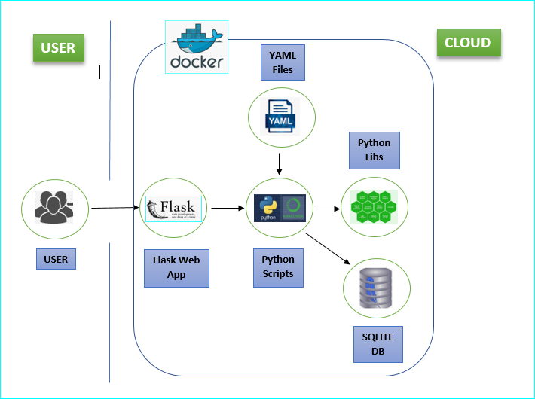

1. User access the website and uses the Healthchatbot.
2. Chatterbot is the python library used to build heathbot.
3. Python scripts train the data in the form of yaml files.
4. User interactions are saved in SQlite3

* **Long Description**

Healthcare is essential in daily life. Unfortunately, consultation with a doctor can be difficult to obtain, especially if we need advice on non-life-threatening problems. The proposed idea is to create a system that can meet the patient’s requirements.

Chatbots are useful for patients and for those who want to learn more about health issues. The real benefit of the chatbot is to provide advice and information for an healthy life. A text-to-text diagnosis engages patients in conversation about their medical issues and provides a personalized diagnosis based on their symptoms and also sets appointment for the user. Hence, people will have an idea about their health and have the right protection and prevention.

Here is the application URL:

<https://healthbot4lives.eu-gb.cf.appdomain.cloud/>

* **The Roadmap**
* Using IBM discoveries, Integrate network of hospitals and doctors availability
* Train bot to book appointments for user