INTERNSHIP PROJECT REPORT
Retail Sales Data Analysis and
Revenue Forecasting Using AI

Submitted by: Abhishek
Program: IBM SkillsBuild Data Analytics with AI Academic Internship
Conducted by: BharatCares in association with AICTE
Academic Year: 2026
Project Type: Data Analytics and Machine Learning

Declaration
I, Abhishek, declare that this project report titled “Retail Sales Data Analysis and Revenue Forecasting Using AI” has been prepared for academic learning as part of the IBM SkillsBuild Data Analytics with AI Academic Internship. The work demonstrates data preparation, exploratory analysis, visualization and a basic machine-learning workflow. The dataset used in this demonstration is synthetic and was generated for educational purposes; it does not represent a real organization's records.
I understand that a project should be reviewed by the assigned mentor or faculty guide before final submission. Any institution-specific declarations, signatures, certificate pages or formatting requirements should be added as directed by the institution.

Acknowledgement
I would like to express my gratitude to the organizers of the IBM SkillsBuild Data Analytics with AI Academic Internship, BharatCares and AICTE for providing a structured learning opportunity. I am thankful to the mentors, instructors and learning resources that support the development of practical skills in Python, data analysis and artificial intelligence.
I also acknowledge the open-source Python ecosystem, especially pandas, NumPy, Matplotlib, scikit-learn and Jupyter, whose documentation and tools make data analysis education accessible. The synthetic data and analysis in this report are designed to be reproducible and transparent.

Abstract
Retail organizations collect sales records that can be used to understand product demand, regional performance, profitability and seasonal patterns. This project demonstrates a complete introductory analytics pipeline using a synthetic daily retail dataset covering 2023 to 2025. Each date contains product-level observations with units sold, unit price, discount, revenue, cost and profit across five regions.
The workflow includes data loading, data-quality checks, descriptive statistics, key performance indicator calculation, product and regional comparisons, monthly trend visualization and machine-learning experimentation. A Random Forest regression model estimates daily revenue from calendar features and lagged revenue features. The model is evaluated on a later time period using mean absolute error (MAE), root mean squared error (RMSE) and R-squared.
Because the dataset is simulated, the results are illustrative rather than evidence about a real retailer. The project’s main outcome is a reproducible template for converting raw tabular data into interpretable summaries and a testable predictive model. Recommendations emphasize data validation, baseline comparisons, responsible interpretation and future validation on authorized real-world data.

Table of Contents
- 1. Introduction
- 2. Background and Problem Statement
- 3. Aim, Objectives and Scope
- 4. Literature and Conceptual Background
- 5. Dataset and Data Dictionary
- 6. Methodology and Work Plan
- 7. Tools and Technologies
- 8. Data Preparation and Quality Assurance
- 9. Exploratory Data Analysis
- 10. KPI and Business Analysis
- 11. Visualization and Interpretation
- 12. Machine-Learning Approach
- 13. Model Evaluation
- 14. Results and Discussion
- 15. Practical Recommendations
- 16. Limitations, Ethics and Risk
- 17. Conclusion
- 18. Future Scope
- References
- Appendix A: Reproduction Instructions
- Appendix B: Data Dictionary
- Appendix C: Validation Checklist

1. Introduction
Data analytics is the systematic process of collecting, preparing, examining and communicating data to support decisions. Retail sales are a useful learning domain because they contain measurable outcomes such as units sold, revenue, costs and profit, while also changing over time and across product groups.
Modern analytics combines descriptive methods, visualization and predictive modeling. Descriptive analysis answers questions about what happened; diagnostic exploration helps identify patterns that may explain differences; predictive modeling estimates what may happen next. These approaches should be combined carefully, because a correlation or model feature importance does not by itself prove causation.
This project builds a compact educational example of those stages. A synthetic dataset makes the workflow repeatable without exposing private commercial information. It also allows the report to explain the limitations of simulated evidence rather than presenting invented figures as actual business facts.

2. Background and Problem Statement
Retail managers often need to compare product contribution, understand periods of high or low demand, and estimate near-term sales. Looking at individual transaction rows is not enough; records must be cleaned, aggregated and visualized before useful patterns can be communicated.
The problem addressed here is methodological: how can a beginner construct a transparent analysis pipeline that turns a tabular retail dataset into reliable summaries and a baseline revenue forecast? The project demonstrates a sequence of quality checks, summaries, plots and model evaluation.
The work does not claim to solve a real company's sales planning problem. The dataset is generated from defined assumptions and random variation, so the model can learn patterns embedded in those assumptions. Real-world adoption would require new data, stakeholder requirements and rigorous testing.

3. Aim, Objectives and Scope
The main aim is to demonstrate retail sales analytics and introductory AI-based revenue estimation using Python.
Specific objectives are to load and validate the data; inspect missing values, duplicate rows and data types; calculate revenue, profit, units and margin KPIs; compare products and regions; visualize monthly revenue; build a Random Forest regression model; evaluate predictions using a chronological test set; and document limitations and future improvements.
The scope covers a synthetic three-year dataset, five product types and five regions. It includes daily product-level observations and does not include customer identifiers, marketing campaigns, inventory availability, returns, tax treatment or external economic variables. The scope is intentionally manageable for an internship project.

4. Literature and Conceptual Background
Exploratory data analysis, popularized by John W. Tukey, encourages analysts to examine distributions, summaries and visual patterns before formal modeling. In practice, this includes checking data types, looking for outliers and comparing grouped metrics.
Python libraries provide an accessible implementation environment. pandas supports table manipulation and aggregation; NumPy supports numerical operations; Matplotlib supports charts; scikit-learn provides consistent model fitting and evaluation interfaces; and Jupyter Notebook combines code, outputs and explanation in one document.
Random Forest is an ensemble method that combines many decision trees. For regression, predictions are aggregated across trees. It can represent nonlinear relationships and interactions, but it is not automatically superior to a simple baseline. Time series require particular care: random shuffling can leak future information into training, so this project uses a time-ordered split.
Forecasting performance should be judged on data not used to fit the model. MAE is easy to interpret in the target unit, RMSE penalizes larger misses, and R-squared summarizes explained variation relative to a mean baseline. No single metric should be interpreted without context.

5. Dataset and Data Dictionary
The included CSV contains synthetic daily records from 1 January 2023 through 31 December 2025. Each date has one row per product, producing a balanced product-by-date structure. The generator uses fixed random seed 42 so the same environment can reproduce the data.
Products include Laptop, Smartphone, Headphones, Smartwatch and Tablet. Each product is mapped to a broad category. Regions are North, South, East, West and Central. Unit quantities are simulated using a Poisson process with seasonal and weekend multipliers; prices vary slightly around illustrative base prices; discounts are selected from a small set of rates; and cost is estimated using product-specific cost ratios.
Revenue is calculated as units multiplied by unit price after discount. Cost is calculated using a product-specific rate, and profit is revenue minus cost. These formulas are educational assumptions and do not include operating overheads, shipping, taxes, refunds or other accounting adjustments.

Field definitions
- date: calendar date of the observation.
- product and category: product label and its broad product family.
- region: simulated sales region.
- units_sold: non-negative count of units.
- unit_price_inr: approximate unit price before discount, in INR.
- discount_rate: discount proportion between 0 and 0.20.
- revenue_inr: units × unit price × (1 − discount rate).
- cost_inr: modeled product cost.
- profit_inr: revenue minus modeled cost.

6. Methodology and Work Plan
The project follows a sequential workflow. First, the data is loaded from CSV, with a regeneration pathway if the file is absent. Second, structure and quality are inspected. Third, key metrics are calculated and records are aggregated by product, region and month. Fourth, plots are created to reveal comparative performance and time trends.
Fifth, daily total revenue is prepared for prediction. Calendar features include day of week, month, day of year and weekend status. Lag features use the previous day's revenue, revenue seven days earlier, and a seven-day rolling mean calculated using prior observations only. Rows without a full lag history are excluded.
Finally, the earlier 80 percent of the time-ordered modeling table is used for training and the later 20 percent for testing. A Random Forest regressor is fitted, then predictions are compared with actual values. The notebook displays evaluation metrics and a chart of actual versus predicted revenue.

Workflow summary
- Load or generate data
- Validate types, nulls and duplicates
- Aggregate and visualize
- Engineer lagged features
- Train on earlier dates and test on later dates
- Interpret metrics and document limitations

7. Tools and Technologies
Python is the primary programming language. Its ecosystem supports fast iteration and reproducibility. The notebook uses pandas for tabular operations, NumPy for numerical generation, Matplotlib for visualizations and scikit-learn for model training and metrics.
Jupyter Notebook is used to combine narrative, executable code and output. The requirements file lists the packages needed to reproduce the workflow. A virtual environment is recommended for isolation and to reduce conflicts with other Python projects.
CSV is used for portable data storage, Markdown for the README, and Microsoft Word DOCX for the report. These formats match the project submission structure requested in the internship instructions.

8. Data Preparation and Quality Assurance
Data preparation begins by parsing the date column as a datetime value and checking the shape, types, missing values and duplicate rows. Validation assertions check that dates exist and that units and revenue are non-negative. Such checks are simple but valuable because invalid data can distort totals and models.
Derived metrics are checked for logical consistency. Revenue is expected to equal discounted selling price multiplied by units; profit is expected to equal revenue minus modeled cost. In real projects, reconciliation against source-system totals and business definitions is also required.
The dataset is generated in a controlled way, so major data defects are not expected. This should not be confused with evidence that the workflow will automatically clean arbitrary data. Production datasets may require handling inconsistent product labels, missing dates, currency conversion, returns, duplicate transactions and changing schemas.

9. Exploratory Data Analysis
Exploratory analysis begins with summary statistics and grouped totals. Product-level aggregation compares revenue, profit and units sold. Regional aggregation offers a similar view across geography. Sorting the summaries helps identify the highest-contributing groups within this generated dataset.
Monthly aggregation reduces daily noise and makes broad seasonal movement easier to see. The line chart supports inspection of long-term movement, recurring seasonal peaks and unusual deviations. Because the data generator explicitly includes seasonal and fourth-quarter demand multipliers, seasonal structure is partly built into the example.
Exploration should generate questions rather than premature conclusions. For example, a product with high revenue may also have high costs; a region with the most units may not have the highest revenue; and a high-discount product may have volume effects that cannot be inferred without an appropriate comparison design.

10. KPI and Business Analysis
Total revenue is the sum of revenue across all rows. Total profit is the sum of modeled profit. Units sold are summed across products and dates. Average row revenue provides a simple average at the product-date-region observation level; it should not be called average basket value because there are no customer orders or basket identifiers.
Profit margin is calculated as total modeled profit divided by total revenue, multiplied by 100. This is a simplified margin based on the generated cost assumptions. A real financial margin would need agreed definitions of revenue and cost and may include overheads or other accounting categories.
KPIs become more useful when compared over time, against targets, or across comparable segments. A dashboard could show headline metrics with product and regional filters. This project keeps the output in notebook tables and charts to focus on transparent analysis rather than interface development.

11. Visualization and Interpretation
Visualizations communicate information more quickly than long tables when chosen appropriately. A horizontal bar chart is useful for ranking product revenue because product names remain readable. A regional bar chart compares the same metric across regions. A line chart is appropriate for revenue across time because chronological order matters.
Chart titles, axis labels, units and grid lines are included to reduce ambiguity. Currency is expressed in Indian rupees. If this project were extended, the analyst could add a profit margin chart, distribution plots, a weekday profile and a seasonal heatmap.
Visual inspection should be supported by numerical summaries. Charts can hide scale differences or make random variation look meaningful. Analysts should avoid implying causation and should state the dataset's simulated nature when sharing the results.

12. Machine-Learning Approach
The target variable is daily total revenue. Features describe the calendar and recent history. A Random Forest regressor is chosen as an approachable nonlinear model that requires relatively little feature scaling and can model interactions between inputs.
Lag features are constructed after sorting by date. The seven-day rolling mean is shifted so that it uses only previous observations, not the current target. This helps prevent direct target leakage. The split is chronological rather than random to mimic the practical task of predicting a later period from earlier history.
The model's parameters include a fixed random seed and a bounded tree depth. These choices make the run repeatable and help control complexity, but they are not the result of exhaustive hyperparameter tuning. A production project would compare multiple models and tune parameters using time-series cross-validation.

13. Model Evaluation
MAE measures the average absolute difference between actual and predicted daily revenue. Because its unit is rupees, it is often easy to explain to a nontechnical audience. RMSE is the square root of mean squared error and gives larger errors greater influence, which can be useful when large misses matter.
R-squared compares the model's residual variation with the variation around the target mean. It is not a percentage accuracy score and can be negative on a test set. A good evaluation should report all selected metrics alongside plots and a baseline comparison.
The test period is later than the training period. This is more realistic than random splitting for time-dependent data, but a single split can be sensitive to the selected period. Rolling-origin evaluation over multiple test windows is recommended for stronger evidence.

Evaluation checklist
- Report MAE in the target unit
- Report RMSE to reveal large misses
- Interpret R-squared carefully
- Plot actual versus predicted values
- Compare against a baseline before claiming improvement

14. Results and Discussion
The notebook computes exact metrics when executed and shows tables and plots derived from the reproducible synthetic dataset. This report intentionally avoids hard-coding potentially environment-dependent model metrics; the notebook output is the authoritative calculation for the installed package versions.
The analysis demonstrates how product and regional rankings can be derived, how monthly patterns can be displayed, and how a predictive model can be assessed without using future observations in training. Since the synthetic generator controls seasonality, price ranges and product volumes, results primarily validate the code pipeline rather than a commercial hypothesis.
The central result is a reusable analytical process. A project is not complete merely because a model runs: data lineage, assumptions, metrics, limitations and a clear explanation of what the results do and do not establish are equally important.

15. Practical Recommendations
Use the product and region summaries to identify segments that merit further investigation, rather than making operational changes directly from synthetic results. In a real retail setting, combine revenue with profit, stock availability, returns and customer service measures.
Establish consistent definitions for sales, discounts, costs and profit. Track data-quality checks in every refresh and document changes in the source system. Use time-based validation and compare models with simple baselines such as last week's value or a seasonal average.
Present forecasts with uncertainty and review them with domain experts. Monitor errors over time and retrain only when there is sufficient evidence that the data or business pattern has changed. Preserve privacy by avoiding unnecessary personal information and controlling access to real sales data.

16. Limitations, Ethics and Risk
The most important limitation is that the dataset is simulated. It does not include real transactions, customer behavior, holidays, advertising, inventory constraints or economic conditions. Therefore, the report cannot claim actual market insights or production-grade forecast accuracy.
Random Forest feature importance describes model behavior but not causality. A predictive relationship may reflect a generator assumption, a proxy feature or a spurious pattern. Model outputs should not be presented as certain facts, and decisions with material consequences should receive human review.
Responsible analytics also requires lawful data use, appropriate access controls, clear documentation and protection of sensitive information. This demonstration contains no customer-level identifiers. If real data is substituted, organizational data-governance and privacy requirements must be followed.

Risk controls
- Label simulated data clearly
- Do not infer causality from feature importance
- Use authorized data only
- Review predictions with humans
- Monitor quality and performance over time

17. Conclusion
This project demonstrates a complete introductory retail analytics workflow using Python. It creates or loads a structured dataset, checks data quality, calculates key metrics, compares product and regional performance, visualizes time trends and evaluates a Random Forest revenue estimator.
The work illustrates the importance of reproducibility and honest interpretation. The notebook, requirements file, README and report are designed to work together as a submission package. The synthetic data makes the project safe and repeatable for learning, while also limiting the claims that can be made.
The project objectives are met at a demonstration level. Before any real operational use, the approach should be tested with authorized real data, compared against baselines, validated across multiple time periods and reviewed by stakeholders.

18. Future Scope
Future extensions could replace synthetic data with a public or organization-approved dataset, add holidays and promotion indicators, include inventory and returns, and compare Random Forest with linear regression, gradient boosting and seasonal forecasting methods.
A dashboard could be created in Power BI, Tableau or a Python web application. The dashboard could include date filters, product and region comparisons, profit margin trends and forecast-versus-actual monitoring.
Further research should focus on forecasting intervals, rolling validation, model drift, explainability and reproducible deployment. A mature version would record dataset versions, package versions, parameters and evaluation dates so results can be audited.

19. Visual Results
The figures below are generated from the supplied synthetic dataset. They are included to demonstrate the type of visual evidence that should accompany the notebook analysis.
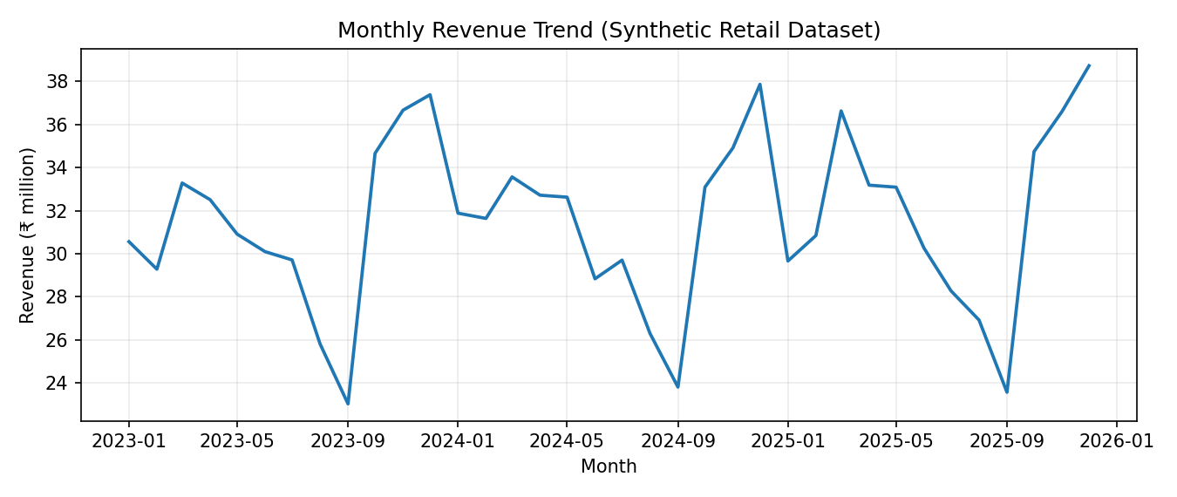
Figure 1. Monthly revenue trend for the synthetic dataset.
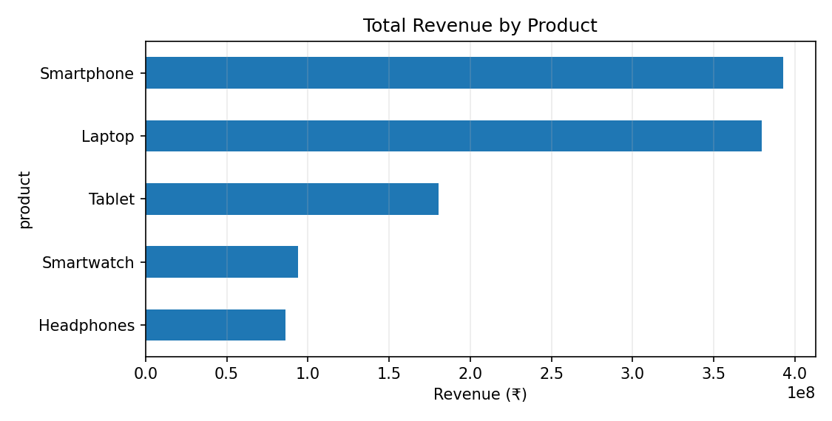
Figure 2. Total revenue by product for the synthetic dataset.

20. References
- McKinney, W. (2022). Python for Data Analysis (3rd ed.). O’Reilly Media.
- VanderPlas, J. (2016). Python Data Science Handbook. O’Reilly Media.
- Breiman, L. (2001). Random Forests. Machine Learning, 45, 5–32.
- Pedregosa, F., et al. (2011). Scikit-learn: Machine Learning in Python. Journal of Machine Learning Research, 12, 2825–2830.
- pandas documentation. https://pandas.pydata.org/docs/
- NumPy documentation. https://numpy.org/doc/
- Matplotlib documentation. https://matplotlib.org/stable/
- scikit-learn documentation. https://scikit-learn.org/stable/
- Project dataset: retail_sales_dataset.csv, generated synthetically for this educational project; no external dataset URL applies.

Appendix A: Reproduction Instructions
To reproduce the analysis, install Python 3.10 or newer and install all listed dependencies from requirements.txt. Keep the notebook and CSV in the same directory. Open the notebook using Jupyter and run cells from top to bottom. The data generation process uses a fixed random seed to make the dataset reproducible.
If the CSV is absent, the notebook creates a dataset with the same schema and generation rules. Outputs may vary slightly across library versions, so record the Python and package versions used for a formal evaluation.

Suggested run commands
python -m venv .venv
source .venv/bin/activate # macOS/Linux; use .venv\\Scripts\\activate on Windows
python -m pip install -r requirements.txt
jupyter notebook

Appendix B: Data Dictionary
Column | Type | Description
date | Date | Observation date
product | Text | Product name
category | Text | Product family
region | Text | Simulated sales region
units_sold | Integer | Units sold in product-date record
unit_price_inr | Float | Price before discount, INR
discount_rate | Float | Discount fraction
revenue_inr | Float | Revenue after discount, INR
cost_inr | Float | Modeled cost, INR
profit_inr | Float | Revenue less modeled cost, INR

Appendix C: Submission Validation Checklist
- Notebook filename follows the requested naming convention and opens in Jupyter.
- Notebook cells run from top to bottom without missing local files.
- requirements.txt lists the necessary Python libraries.
- Project report is saved as a Microsoft Word DOCX file.
- README includes project description, dataset note, technologies and setup instructions.
- Dataset is included and clearly identified as synthetic.
- Figures have captions and axes include labels and units.
- Model evaluation uses a time-ordered split and explains its limitations.
- Mentor or institution-specific certificate/signature pages are added if required.
- Before final submission, confirm whether the mentor requires a specific topic, font or report template.

