University Course Registration Portal

Software Requirements Specification

Version <4.0>

Revision History
Date | Version | Description | Author
<03/02/2026> | <1.0> | SRS 1.0 | Group-1
 |  |  | Group-1
 |  |  | Group-1
 |  |  | Group-1

Table of Contents
Introduction
1.1 Purpose
1.2 Document Conventions
1.3 Intended Audience
1.4 Project Scope
1.5 References

Overall Description
2.1 Product Perspective
2.2 Product Functions
2.3 User Classes, Characteristics, and Needs
2.4 Operating Environment
2.5 Design and Implementation Constraints
2.6 User Documentation
2.7 Assumptions and Dependencies

System Features and Functional Requirements
3.1 User Management and Authentication
3.2 Course Catalog Management
3.3 Registration Management
3.4 Schedule Management
3.5 Academic Advising Support
3.6 Waitlist Management
3.7 Payment Integration
3.8 Reporting and Analytics
3.9 Notification System
3.10 Content Management
External Interface Requirements
4.1 User Interfaces
4.2 Hardware Interfaces
4.3 Software Interfaces
4.4 Communications Interfaces

Non-Functional Requirements
5.1 Performance Requirements
5.2 Security Requirements
5.3 Reliability and Availability
5.4 Usability and Accessibility
5.5 Maintainability and Portability
5.6 Legal and Compliance Requirements
5.7 Operational Requirements

Other Requirements
6.1 Data Migration
6.2 Internationalization Requirements
6.3 Training Requirements

Appendices
Appendix A: Analysis Models
Appendix B: Issues List

Software Requirements Specification
1. Introduction
1.1 Purpose
- This Software Requirements Specification (SRS) document provides a comprehensive description of the Course Registration Portal to be developed for [University Name]. The document details the functional and non-functional requirements for the portal, which aims to streamline the course registration process, improve student experience, reduce administrative burden, and provide real-time access to course availability and academic planning tools.
- This SRS will serve as the foundation for the system design and development phases, ensuring that all stakeholders have a clear understanding of what the system will do and how it will operate.
1.2 Document Conventions
- This document follows these conventions:
- TermDescriptionSHALLRefers to a mandatory requirement that must be fulfilled during Phase 1 of platform development. The vendor/developer is required to cover this feature in the current implementation phase.SHOULDIndicates a requirement that will take place in Phase 2 and the developer should take it into consideration for future scalability.MAYRefers to a requirement anticipated for Phase 3 or subsequent phases. The developer is encouraged to consider this requirement generally, keeping future scalability in mind.TBDTo Be Determined, indicates information that is not yet available but will be provided in future versions.NoteProvides additional information or clarification.
- Requirements are categorized as follows:
- Requirement NumberDescriptionFR-XXFunctional RequirementsNFR-XXNon-Functional RequirementsIR-XXInterface RequirementsDR-XXData RequirementsSR-XXSecurity Requirements
1.3 Intended Audience
- This document is intended for the following stakeholders:
- StakeholderRoleUniversity AdministrationOfficials who will review and approve the requirements and serve as solution ownersAcademic Affairs DepartmentDepartment responsible for academic policies and registration oversightIT DepartmentTechnical team who will implement, maintain, and support the systemDevelopment TeamVendors or internal developers who will design and build the systemFaculty MembersAcademic advisors who will use the system for student advisingStudentsPrimary end-users who will register for coursesRegistrar's OfficeStaff who will manage course offerings and registration policies
1.4 Project Scope
- The Course Registration Portal will serve as the primary system for students to browse, plan, and register for courses each academic term. The system will integrate with existing university systems to provide a seamless registration experience while supporting academic advising, prerequisite checking, and schedule conflict resolution.
In Scope
- The portal will include the following key components:
- User Management System: Authentication and profile management for students, faculty advisors, and administrators
- Course Catalog Management: Comprehensive course listings with detailed information, prerequisites, and availability
- Registration Management: Complete registration workflow including add/drop functionality, waitlist management, and prerequisite validation
- Schedule Builder: Interactive tools for students to plan and visualize their academic schedules
- Academic Advising Support: Tools for advisors to review and approve student registration plans
- Degree Audit Integration: Display of degree requirements and progress tracking
- Payment Integration: Connection with university financial systems for tuition calculation and payment processing
- Reporting and Analytics: Dashboards for monitoring registration trends, course demand, and system usage
- Notification System: Multi-channel notifications for registration reminders, waitlist updates, and important announcements
- Mobile Responsive Design: Full functionality across desktop and mobile devices

Out of Scope
- The following items are explicitly excluded from this phase of the project:
- Full Learning Management System (LMS) functionality
- Grade submission and management
- Faculty workload management
- Room scheduling and resource management
- Comprehensive student information system replacement
- Alumni or applicant portals
- Financial aid management beyond integration with existing systems
- Native mobile application development (mobile-responsive web only)

1.5 References
- This SRS is based on the following documents and sources:
- University Academic Policies and Procedures Manual
- Current Registration System Documentation
- Student Information System (SIS) Technical Specifications
- University Strategic Plan 2024-2029
- IT Security and Data Privacy Policies
- FERPA Compliance Guidelines
- Existing student and faculty feedback surveys
- Best practices from peer institutions
- Meetings with stakeholders including students, faculty, registrar staff, and IT personnel
2. Overall Description
2.1 Product Perspective
The Course Registration Portal is a new web-based system being developed to replace or supplement the existing course registration process at [University Name]. It will operate as a critical component of the university's academic ecosystem and interface with multiple existing systems.
The portal will interface with:
- Student Information System (SIS): For student demographic data, academic records, and enrollment status
- Financial System: For tuition calculation, payment processing, and financial hold verification
- Learning Management System (LMS): For course materials access post-registration
- Degree Audit System: For requirement tracking and academic progress
- Academic Advising Systems: For advisor assignment and advising notes
- Identity Management System: For authentication and single sign-on

2.2 Product Functions
The Course Registration Portal will provide the following major functions:

1. User Authentication and Profile Management:
- Single sign-on integration with university credentials
- Student profile viewing and limited updates
- Faculty advisor access management
- Administrator role management

2. Course Discovery and Planning
- Comprehensive course catalog browsing
- Advanced search and filtering capabilities
- Course prerequisite and corequisite display
- Schedule builder for planning future terms
- Course comparison tools

3.Registration Processing:
- Real-time course registration
- Prerequisite validation
- Schedule conflict detection
- Credit hour limit enforcement
- Registration hold verification
- Add/drop course functionality
- Course withdrawal processing

4.Waitlist Management:
- Automatic waitlist enrollment when courses are full
- Priority-based waitlist processing
- Automated notifications when seats become available
- Waitlist position tracking

5.Academic Advising Support:
- Advisor-student communication tools
- Registration approval workflow (when required)
- Degree progress tracking
- Academic plan review

6.Financial Integration:
- Tuition and fee calculation
- Payment status verification
- Financial hold checking
- Integration with payment gateway

7.Reporting and Analytics:
- Registration statistics and trends
- Course demand analysis
- Student enrollment patterns
- Waitlist analytics
- System usage metrics

8.Administrative Functions:
- Course catalog management
- Registration period configuration
- System parameter settings
- User access management
- Registration overrides and exceptions

2.3 User Classes, Characteristics, and Needs
The portal will serve the following user classes:
1. Students
Characteristics:
- Undergraduate and graduate students
- Varying levels of technical proficiency
- May access from various devices and locations
- Range from first-year to senior students
- May include part-time and full-time enrollment statuses

Primary Needs:
- Easy course discovery and exploration
- Clear understanding of prerequisites and requirements
- Simple registration process
- Real-time schedule visualization
- Mobile access for on-the-go registration
- Clear error messages and guidance

2. Faculty Advisors
Characteristics:
- Academic faculty assigned as student advisors
- Moderate to high technical proficiency
- Need to support multiple advisees
- Require comprehensive student academic information

Primary Needs:
- View advisee registration plans
- Approve or provide feedback on course selections
- Monitor advisee academic progress
- Access to degree requirements and student transcripts
- Efficient workflow for managing multiple students

3. Registrar Staff
Characteristics:
- Administrative staff with high system expertise
- Responsible for registration policy enforcement
- Handle exception cases and student issues
- Manage course catalog and scheduling

Primary Needs:
- Course catalog management tools
- Registration override capabilities
- Comprehensive reporting and analytics
- Waitlist management
- Exception handling workflows

4. System Administrators
Characteristics:
- IT staff responsible for system operation
- High technical proficiency
- Focus on system availability and performance
Primary Needs:
- System monitoring and maintenance tools
- User access management
- Configuration management
- Security and audit capabilities
- Integration management

5. Department Administrators
Characteristics:
- Academic department staff
- Manage courses for specific departments
- Moderate technical proficiency

Primary Needs:
- Department-specific course management
- Enrollment monitoring for departmental courses
- Capacity planning support
- Reporting on departmental course demand

2.4 Operating Environment
The portal will operate in the following environment:
1. Technical Environment
- Web-based application accessible via standard browsers
- Responsive design for tablets and smartphones
- Cloud-hosted or on-premises infrastructure (TBD)
- High availability architecture for peak registration periods

2. Hardware Environment
- Server infrastructure capable of handling concurrent load during peak registration
- Load balancing for distribution of traffic
- Database servers with high-performance capabilities
- Backup systems for disaster recovery
- Network infrastructure with sufficient bandwidth

3. Software Environment
- Modern web frameworks (e.g., React, Angular, or Vue.js for frontend)
- Robust backend framework (e.g., Java Spring, .NET, Node.js)
- Relational database management system
- Integration middleware for connecting with existing university systems
- Security software for authentication and data protection

4. User Environment
- Various devices: desktop computers, laptops, tablets, smartphones
- Multiple browsers: Chrome, Firefox, Safari, Edge
- Different operating systems: Windows, macOS, iOS, Android
- Varying internet speeds: campus network, home connections, mobile data
- Accessibility needs: screen readers, keyboard navigation, high contrast modes

2.5 Design and Implementation Constraints
The following constraints will impact the design and implementation:
1. Technical Constraints
- Must integrate with existing university systems (SIS, financial, LMS)
- Must support legacy data formats from current registration system
- Must maintain compatibility with university identity management system
- Must function on university network infrastructure
- Must comply with university IT standards and approved technology stack

2. Regulatory Constraints
- Must comply with FERPA regulations for student data privacy
- Must adhere to accessibility standards (Section 508, WCAG 2.1 AA)
- Must meet university data retention and archival policies
- Must comply with payment card industry (PCI) standards for financial transactions

3. Business Constraints
- Must be implemented before next academic year registration period
- Must be maintainable by existing IT staff
- Must fit within allocated budget constraints
- Must minimize disruption to ongoing academic operations during implementation

4. User Constraints
- Must accommodate users with varying technical skills
- Must support accessibility for users with disabilities
- Must provide multilingual support if required by student population
- Must work on devices students already own

2.6 User Documentation
The following user documentation will be developed:
1. Online Help System
- Context-sensitive help throughout the portal
- Searchable knowledge base
- FAQ section for common questions
- Video tutorials for key processes

2. User Guides
- Student User Guide: Complete guide for course registration, schedule planning, and waitlist management
- Advisor User Guide: Guide for reviewing student plans and providing advising support
- Administrator User Guide: Comprehensive guide for system configuration and management
- Department Administrator Guide: Guide for managing department-specific courses

3. Quick Reference Materials
- Registration quick start guide
- Schedule builder tips
- Troubleshooting common issues
- Mobile access guide

4. Training Materials
- Interactive tutorials
- Step-by-step walkthroughs
- System demonstration videos
- Training presentation slides

2.7 Assumptions and Dependencies
Assumptions
- University will provide timely access to existing systems for integration
- Existing student and course data is accurate and complete
- Network infrastructure can support expected concurrent user load
- Students have basic computer and internet literacy
- University policies regarding registration will remain stable during implementation
- Adequate technical support resources will be available for system launch

Dependencies
- Availability of accurate data from Student Information System
- Integration APIs from financial and degree audit systems
- University identity management system for authentication
- Approval of registration business rules and policies
- Availability of test environment that mirrors production
- Cooperation from registrar's office and academic departments during testing
- Timely procurement of necessary hardware and software infrastructure

3. System Features and Functional Requirements
This section details the functional requirements of the Course Registration Portal, organized by major system features. Each requirement is identified with a unique ID (FR-XX) for traceability and reference.
3.1 User Management and Authentication
3.1.1 Student Authentication and Profile
ID | Requirement
FR-01 | The system SHALL integrate with the university’s single sign-on (SSO) system for student authentication.
FR-02 | The system SHALL display student profile information including name, student ID, program, and academic level.
FR-03 | The system SHALL retrieve student academic data from the Student Information System.
FR-04 | The system SHALL display any academic or financial holds on the student account.
FR-05 | The system SHALL display assigned academic advisor information to students.
FR-06 | The system SHALL allow students to securely log out of the system.
FR-07 | The system SHALL implement secure session management with automatic timeout.
FR-08 | The system SHALL maintain audit logs for authentication activities.
FR-09 | The system SHALL provide role-based authentication for faculty advisors, registrar staff, department administrators, and system administrators.
FR-10 | The system SHALL integrate with the university’s employee authentication system.
FR-11 | The system SHALL implement role-based access control (RBAC) to restrict system features based on user roles.

3.2 Course Catalog & Search:
ID | Requirement
FR-12 | The system SHALL display a comprehensive course catalog for the selected academic term.
FR-13 | The system SHALL display detailed course information including credits, instructor, schedule, and location.
FR-14 | The system SHALL display course prerequisites and corequisites.
FR-15 | The system SHALL indicate courses that fulfill degree requirements.
FR-16 | The system SHALL provide course search functionality.
FR-17 | The system SHALL support filtering courses by department, time, and credit hours.
FR-18 | The system SHALL support keyword-based course search.
FR-19 | The system SHALL allow sorting of course search results.
FR-20 | The system SHALL display real-time course availability status.

3.3Course Registration Management
ID | Requirement
FR-21 | The system SHALL allow eligible students to register for courses during their assigned registration period.
FR-22 | The system SHALL enforce registration time slots based on student priority.
FR-23 | The system SHALL validate prerequisite completion before course registration.
FR-24 | The system SHALL detect and prevent schedule conflicts during registration.
FR-25 | The system SHALL enforce minimum and maximum credit limits per term.
FR-26 | The system SHALL verify registration holds before course enrollment.
FR-27 | The system SHALL confirm successful course registration immediately.
FR-28 | The system SHALL update course seat availability in real time.

3.4Add / Drop / Withdrawal
ID | Requirement
FR-29 | The system SHALL allow students to add courses during the add/drop period.
FR-30 | The system SHALL allow students to drop courses during the add/drop period.
FR-31 | The system SHALL enforce add/drop deadlines as configured by the registrar.
FR-32 | The system SHALL allow students to withdraw from courses within the withdrawal period.
FR-33 | The system SHALL maintain a history of add, drop, and withdrawal transactions.

3.5Schedule Management
ID | Requirement
FR-34 | The system SHALL provide an interactive schedule builder for students.
FR-35 | The system SHALL display student schedules in a weekly calendar view.
FR-36 | The system SHALL visually indicate time conflicts in schedules.
FR-37 | The system SHALL calculate total registered credit hours for the term.

3.6Academic Advising
ID | Requirement
FR-38 | The system SHALL allow faculty advisors to view student registration plans.
FR-39 | The system SHALL display student degree progress information.
FR-40 | The system SHALL support advisor approval before registration when required.
FR-41 | The system SHALL notify students of advisor approval or rejection.

3.7Waitlist Management
ID | Requirement
FR-42 | The system SHALL automatically place students on a waitlist when courses are full.
FR-43 | The system SHALL assign waitlist positions based on request time.
FR-44 | The system SHALL display waitlist position to students.
FR-45 | The system SHALL notify students when a waitlisted seat becomes available.
FR-46 | The system SHALL automatically enroll students from the waitlist when seats open.

3.7 Notifications & Administration
ID | Requirement
FR-47 | The system SHALL send email notifications for registration-related events.
FR-48 | The system SHALL provide in-application notifications to users.
FR-49 | The system SHALL allow administrators to post system-wide announcements.
FR-50 | The system SHALL generate basic registration and enrollment reports.

4. External Interface Requirements
4.1 User Interfaces
The system shall provide user interfaces for the following user types:
1. Students
- Dashboard showing registration status, upcoming deadlines, and recommended actions
- Course search and catalog browsing interface
- Interactive schedule builder with calendar visualization
- Registration shopping cart for course selection
- Academic progress and degree audit display
- Profile management interface
- Payment and financial information display
2. Faculty Advisors
- Advisee list and management interface
- Student registration plan review interface
- Degree progress tracking for advisees
- Advising notes and communication tools
- Approval workflow interface
3. Registrar Staff
- Course catalog management interface
- Registration period configuration
- Student account management
- Override and exception processing interface
- Comprehensive reporting dashboard
4. Department Administrators
- Department-specific course management
- Enrollment monitoring for department courses
- Department-level reporting
5. System Administrators
- User and role management interface
- System configuration console
- Integration monitoring dashboard
- Audit log viewer
- Performance monitoring tools
All user interfaces shall adhere to the following requirements:
ID | Requirement
IR-01 | The system SHALL provide responsive design that works on desktop, tablet, and mobile devices.
IR-02 | The system SHALL support modern web browsers (Chrome, Firefox, Safari, Edge - current and previous major version).
IR-03 | The system SHALL implement accessible design following WCAG 2.1 Level AA standards.
IR-04 | The system SHALL provide consistent navigation and design patterns across all interfaces.
IR-05 | The system SHALL use university branding including colors, logos, and typography.
IR-06 | The system SHALL provide clear, informative error messages and validation feedback.
IR-07 | The system SHALL offer keyboard navigation for all functionality.
IR-08 | The system SHALL provide breadcrumb navigation for complex multi-step processes.
4.2 Hardware Interfaces
The system shall interface with the following hardware components:
1. Server Infrastructure
- Application servers (web tier)
- Database servers
- Integration middleware servers
- File storage systems
- Backup storage systems
2. Network Infrastructure
- Load balancers for traffic distribution
- Firewalls for security
- SSL/TLS termination points
- Network monitoring devices
3. Client Devices
- Desktop and laptop computers (Windows, macOS, Linux)
- Tablets (iOS, Android)
- Smartphones (iOS, Android)
- Assistive technology devices (screen readers, alternative input devices)
The system shall be designed to minimize hardware dependencies and function across a wide range of client device configurations.
4.3 Software Interfaces
The system shall interface with the following software systems:
1. Student Information System (SIS)
ID | Requirement
IR-09 | The system SHALL integrate with the SIS to retrieve student demographic and academic data.
IR-10 | The system SHALL synchronize enrolled courses back to the SIS.
IR-11 | The system SHALL retrieve course catalog information from the SIS.
IR-12 | The system SHALL use RESTful APIs or SOAP services for SIS integration.
2. Financial System
ID | Requirement
IR-13 | The system SHALL integrate with the financial system to retrieve student account balances and holds.
IR-14 | The system SHALL send enrollment data to the financial system for billing purposes.
IR-15 | The system SHALL integrate with the payment gateway for tuition payment processing.
3.Learning & Identity Systems
ID | Requirement
IR-16 | The system SHALL send enrollment information to the Learning Management System after registration.
IR-17 | The system SHALL support single sign-on integration with the Learning Management System.
IR-18 | The system SHALL integrate with the university identity management system for authentication.
IR-19 | The system SHALL support SAML 2.0 or OAuth 2.0 for single sign-on.

4.4 Communications Interfaces
The system shall support the following communication interfaces:
1. Network Protocols
ID | Requirement
IR-20 | The system SHALL use HTTPS (TLS 1.3 or higher) for all web communications.
IR-21 | The system SHALL support HTTP/2 for improved performance.
2. API Communications
ID | Requirement
IR-22 | The system SHALL provide RESTful APIs for integration with external systems.
IR-23 | The system SHALL use JSON as the primary data exchange format for APIs.
IR-24 | The system SHALL implement OAuth 2.0 for API authentication and authorization.
IR-25 | The system SHALL provide comprehensive API documentation (e.g., OpenAPI/Swagger).

5. Non-Functional Requirements
This section specifies the quality attributes and constraints that the Course Registration Portal must satisfy.
5.1 Performance Requirements
ID | Requirement

NFR-01 | The system SHALL provide page load times of less than 2 seconds under normal operating conditions.

NFR- 02 | The system SHALL complete course registration transactions within 3 seconds.

NFR-03 | The system SHALL support at least 2,000 concurrent users during normal operation.

NFR-04 | The system SHALL support at least 10,000 concurrent users during peak registration periods.

NFR-05 | The system SHALL handle peak registration traffic without system failure.

5.2 Security Requirements
ID | Requirement
NFR-06 | The system SHALL encrypt all sensitive data in transit using secure communication protocols.
NFR-07 | The system SHALL encrypt sensitive data at rest using industry-standard encryption techniques.
NFR-08 | The system SHALL implement role-based access control to protect system resources.
NFR-09 | The system SHALL automatically log out inactive users after a configurable timeout period.
NFR-10 | The system SHALL maintain audit logs for all critical security-related activities.

5.3 Reliability and Availability
ID | Requirement
NFR-11 | The system SHALL maintain at least 99.5% availability during the academic term.
NFR-12 | The system SHALL maintain 99.9% availability during peak registration periods.
NFR-13 | The system SHALL minimize downtime during planned maintenance activities.
NFR-14 | The system SHALL support automatic recovery from system failures.
NFR-15 | The system SHALL perform automatic daily backups of critical system data.
5.4 Usability & Accessibility
ID | Requirement
NFR-16 | The system SHALL provide an intuitive and user-friendly interface for all users.
NFR-17 | The system SHALL comply with WCAG 2.1 Level AA accessibility standards.
NFR-18 | The system SHALL support screen readers and keyboard-only navigation.
NFR-19 | The system SHALL provide clear and user-friendly error messages.
NFR-20 | The system SHALL provide responsive design for desktop, tablet, and mobile devices.

5.5 Maintainability and Portability
ID | Requirement
NFR-21 | The system SHALL use a modular architecture to simplify maintenance and updates.
NFR-22 | The system SHALL support deployment in cloud and on-premise environments.
NFR-23 | The system SHALL be scalable to accommodate future growth in users and data.
NFR-24 | The system SHALL generate system logs for monitoring and troubleshooting.
NFR-25 | The system SHALL provide technical and user documentation for system operation.

UML diagram of university course registration portal.
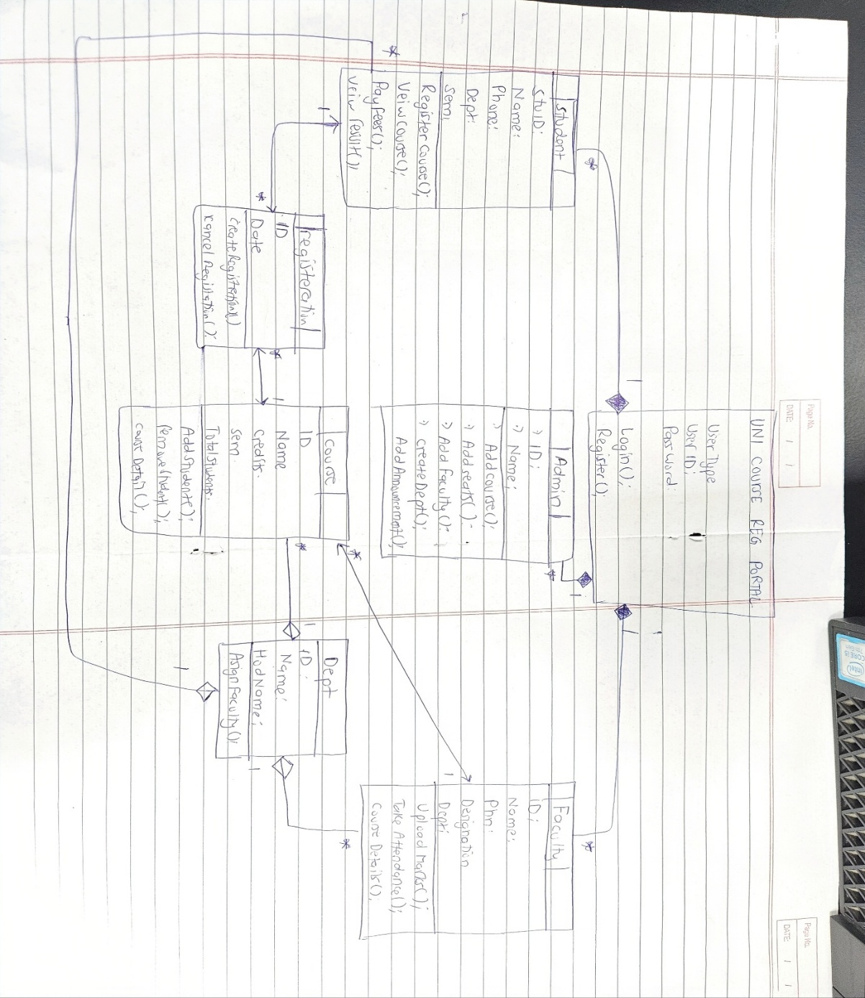
Sequence diagram of university course registration process
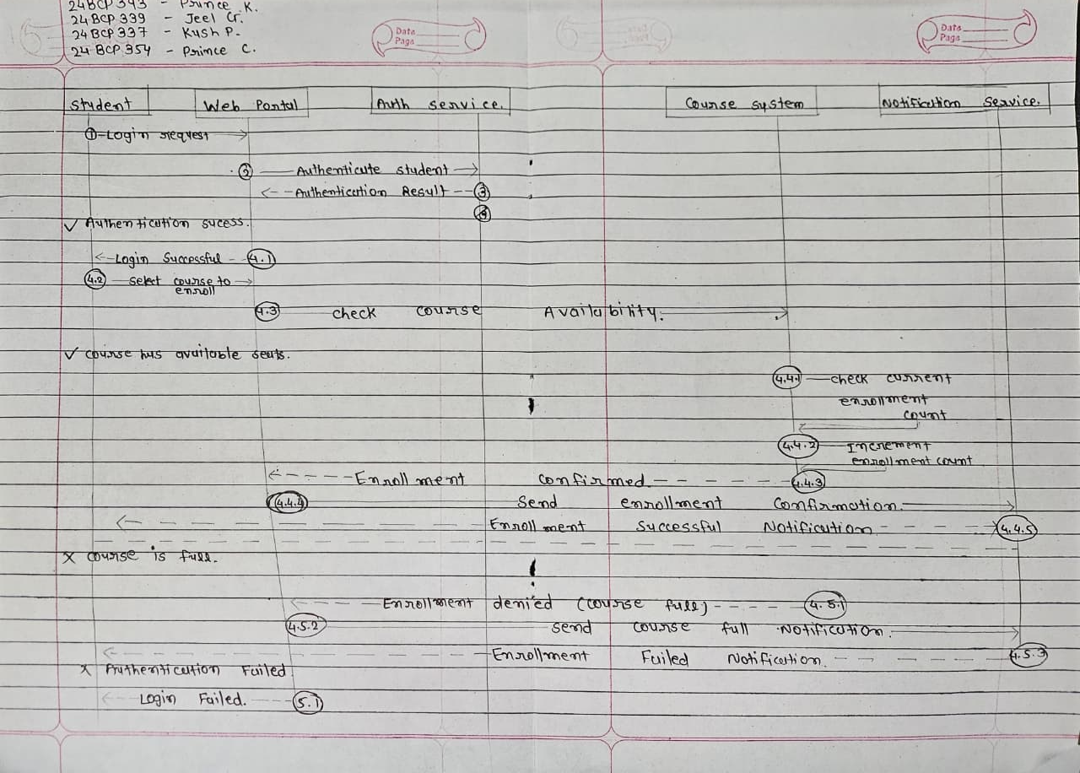

Activity Diagram
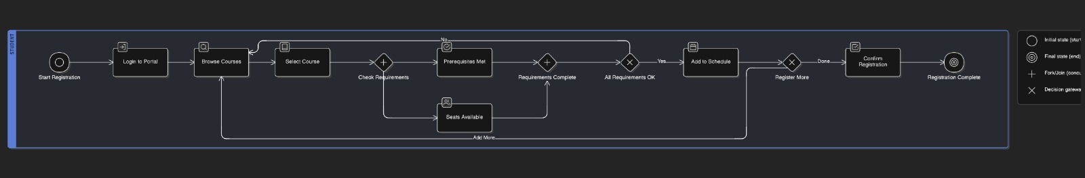
Component Diagram
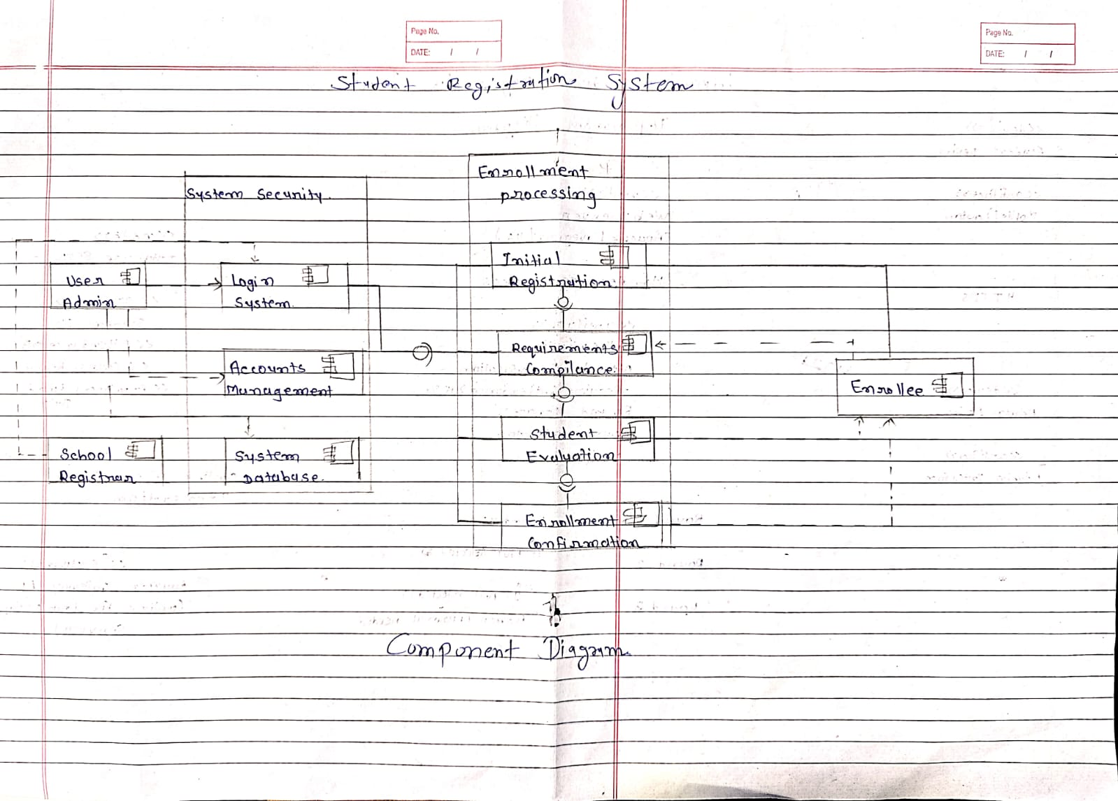
Deployment Diagram
