To receive all points, the written report presents a cohesive written analysis that:

* Summarises the analysis.
* Draws two correct conclusions or comparisons from the calculations.

Using the data provided for the schools whether they are independent and government, we did the following:

* 1. Local Government Area Summary:
* Calculated all the schools (15) provided in the data and overall number of students (39,170)
* Calculated the total budget spans all the schools ($24,649,428)
* Calculated the average maths score (70.34) for all of fifteen schools.
* Calculated the average readings score (69.98) for all of fifteen schools.
* Calculated the % of students passed in maths (86.08) for the fifteen schools.
* Calculated the % of students passed in reading (84.43) for the fifteen schools.
* Calculated the % of students passed in both maths and reading (72.81) for the fifteen schools.
  1. School Summary

Calculated the below metrics according to the School Name, School Type

* Total Students in each of the school and name of the school and type of the school as Independent or Government
* Total School Budget allocated.
* Student Budget as per the students in the school
* Average Maths Score: students passed the maths exam as per school.
* Average Reading Score: students passed the reading exam as per school.
* % Passing Maths of students passing the maths per school.
* % Passing Reading of students passing the reading per school.
* % Overall Passing (The percentage of students that passed maths **and** reading.)

* 1. Based on the school summary now we can have the top and bottom performing schools according to the percentage of students that passed maths **and** reading.
     + **Top Performing School**

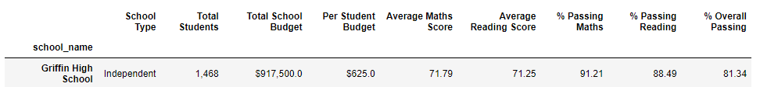

* + - **Bottom Performing School**

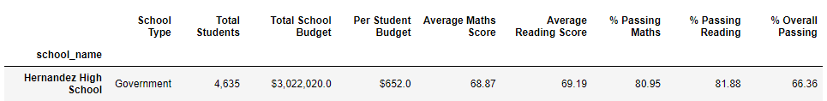

* 1. Based on the student data for each school we can easily concluded which school having the top performer in maths and reading scores according to the Year 9, 10, 11 and 12 students

Here we can analyse: (Figure1)

* **Year 9**
  + **Shelton High School,** average maths is more than any other school.
  + **Figueroa High School** having the lowest average in reading.
* **Year10**
* **Shelton High School,** average reading score highest than rest of the schools.
* **Johnson High School** having the lowest average in reading.
* **Year11**
  + **Wright High School** has highest reading average.
  + **Wilson High School** having the lowest average in reading.
* **Year12**
  + **Holden High School** have higher average reading scores.
  + **Ford High School** having the lowest average in reading.

**Figure1**

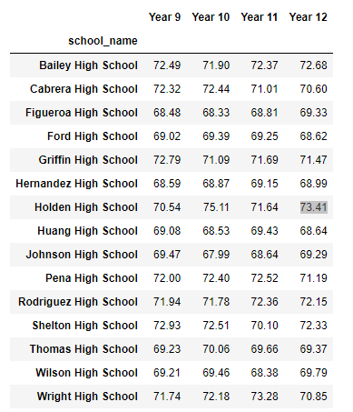

Here we can analyse: (Figure2)

* **Year 9**
  + **Wright High School,** average reading is more than any other school.
  + **Hernandez High School** having the lowest average in reading.
* **Year10**
* **Pena High School,** average reading score highest than rest of the schools.
* **Figueroa High School** having the lowest average in reading.
* **Year11**
  + **Griffin High School** has highest reading average.
  + **Hernandez High School** having the lowest average in reading.
* **Year12**
  + **Bailey High School** have higher average reading scores.
  + **Huang High School** having the lowest average in reading.

**Figure2**

3)Spending range summary

We can conclude how much the school is spending per students and what will be the outcome, as in the below figure the schools who spend in between **$585-630 per student have highest percentage of maths and reading.**

4)Based on the school size summary

We can conclude the school which have lesser than **1000** students as per below figure **have highest percentage of maths and reading.**

5) Based on school type summary

We can conclude the school which are independent in nature have as per the below figure **have highest percentage of maths and reading.**

**Conclusion**

In conclusion, I can say the schools which have highest number of students enrolled have some issues and become bottom performing schools. Out of 5 there were 4 government schools who are worst performer. We can say this is all because of the school size as there might be other factors included such as number of sections per class, teachers per students etc. If we can take an example of the **Hernandez High School,** the passing percentage of maths and reading is over 80% but overall percentage is 66.36% so there will be various factors might be students are not trying to work hard on both subjects. I can see there is only 10 to 15% of variance in the budget allocated per student per school might be that the contributing factor where school couldn’t be able to provide all of the resources to the students.

**Figure**

