**Analysis**

The employee “Charmane Griswold” is having highest salary as 129492 whereas so many employees are working on the minimum salary that is 40000.

**Scenario 1**

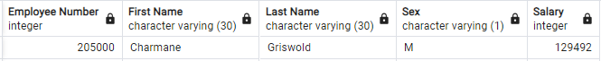

**Scenario 2**

The Development department has maximum number of employees that is 85707 followed by Production as “73485” and Sales as “52245” whereas Finance has least number of employees that is 17346.

**Scenario3**

As we can see the number of employees being hired by the company decreases as year passed by this can be dependent on various factors as follows:

1. The old employees do not leave the company so there is lesser vacancy of the jobs.
2. Technologically growth can be factor as the more advancement in technology and implementation in the workplace so lesser number of people required.

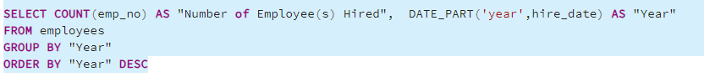

**Limitations:**

We have only hire_date so we can’t say how many workers retained by each department, so we need more columns of data so that we can draw our analysis.