***Exp. 2 Design an LED chaser***

**Circuit Diagram:**

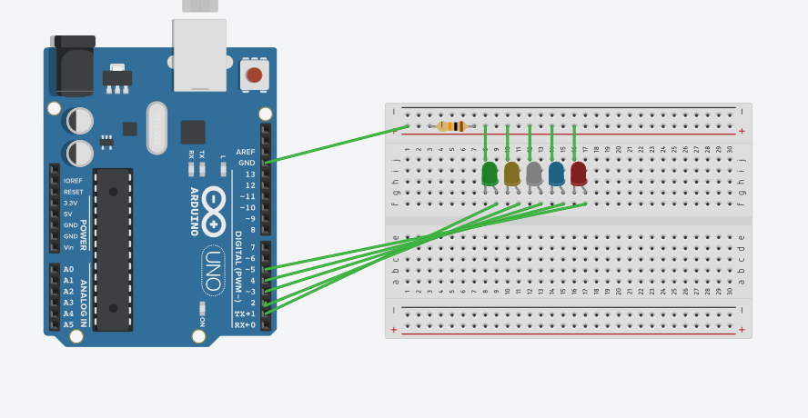

**Theory**

Concept Used: Making a LED glow using Arduino Board in chasing motion.

Learning & Observations: LED is firstly first two LEDs are switched on and then delayed for 250 milliseconds then both are turned off and then next two LEDs are switched on.

Problems & Troubleshooting: LED was found to be fused and Arduino may be faulty and it may be resolved by changing the elements or changing the Arduino board

Precautions: Resistor ought to be connected to LED so the flow of current remains low and preserves LED from damaging. Do not short-circuit Arduino , it might harm microprocessor.

Learning Outcomes: LED is a diode having 2 ends P-type and N-type and glows with a really less amount of current. Arduino IDE is employed to program the chip in bound method given.