***Exp. 1 Design an LED flasher***

**Circuit Diagram:**

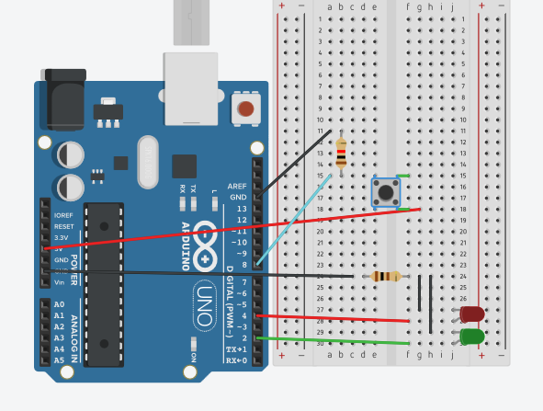

**Theory**

Concept Used: Design a system for LPG gas burners such that, whenever it is turned on, a green LED starts blinking and if it stays on for more than 2000 millis, instead of the green LED, a Red LED starts blinking.

Learning & Observations: when the button is pressed for more than 2 seconds the red LED will start blinking else the green LED will blink.

Problems & Troubleshooting: LED was found to be fused and Arduino can be faulty and it can be resolved by changing the elements

Precautions: Resistor should be connected to LED so that the flow of current remains low and preserves LED from damaging.

Learning Outcomes: LED is a diode having two ends P-type and N-type and glows with a very less amount of current. Arduino IDE is used to program the microprocessor in certain way given.