**Introduction :**

We are living in a country and generation which saw a huge change in its day to day monetary affairs. From a simple food ordering to a transaction worth a zillion bucks, each and every give-take affair is going through a stringent and complicated process of cashless transaction. As a result of this we are made to hold on to our dear credit/debit cards or net banking login details for life. Using cards/net banking has its own pros and cons. Well, cons more than pros. Firstly it’s difficult to remember a 16 digit card number to an even more confusing CVV number + a 4 digit PIN number or if its net banking then username and complicated passwords. And it’s risky storing your card pins and login details in your phone because it can be easily stolen or hacked. These systems are more vulnerable to theft than cash handling. Sometimes even though we have a lot of money in our account we may not have access to our cards or login details thus get into difficult situation because of such a complicated process. For this we came up with a solution using that one vital information in our lives that we might not forget at any cost that is our mobile numbers, we are purposing a solution through which one can do a payment just by remembering his/her mobile number (no one ever forgets his/her mobile number) for both cases that are net banking as well as card payment. Since there is a huge scope for building a Digital India, we thought we could give transactions an entire different angle by making it digital, cashless, secure and simple.

**Problem Statement:**

The problem we are facing with cashless transactions happen in two cases, ie, Offline mode of Payments and Online mode of Payments. We’ll take two situations for both of these two forms of transactions.

1. Suppose a person walks into a departmental store with no cash in his hands but his debit/credit card, he has to remember each and every small details regarding his card. If one of the digit of his PIN goes wrong the entire transaction fails. Moreover, it is difficult maintaining PIN discrepancy in such a situation. Anyone can have an overlook of that person’s PIN. In such POS machines, the card details can be easily recorded and stored which can be easily manipulated and misused. Plus, if the person has more than one card it’s difficult for him to separately remember every minor detail related to his multiple cards. Cards make our wallets so full, it’s always difficult handling all the cards together. This is one kind of difficulty we face in cashless transaction using Debit/Credit cards.

2) Now let’s move on to online transactions. Again, let’s suppose the same person is trying to order something online. Online transaction starts from typing all the 16 digits of a card, the CVV and PIN number. If the system authenticates it, then that person must keep his registered mobile number working and next to him. He’ll receive an OTP, which cannot be copy pasted onto the laptop/PC screen since both are on different devices. Receiving an OTP depends on how fast the servers are (mostly they are good enough).Now, if the person has a net banking account and not a card that’s an entire different issue altogether. He has to remember username and all kinds of complicated passwords. If one thing goes wrong his transaction fails. Again this net banking ends up with the OTP hassles. Since government decided we had enough of good time with cash before digitalizing each and every corner of our country, net banking mostly doesn’t work in most of the places in India. Finding bank everywhere is difficult which makes already complicated cashless transactions more complicated using cards and net banking. Metropolitan cities can cope up with cashless transaction issues but it’s not feasible in most other parts of India. This issues pops up opting for net banking.

**OUR SOLUTION:**

So here we came up with a simpler system for cashless and hassle less online and offline transactions using one vital information that’s etched into our minds for life i.e. our mobile numbers. We’ll take a hypothetical situation to explain how our solution, Remember that guy who went to a departmental store without cash in case 1?  Well, let’s say he doesn’t have his card with him either. But whatever he wants to buy is quite urgently required. What will he do with the present rigid cashless transaction system? How would it feel to carry nothing but your mobile and get everything you want? Your pockets won’t be full all the time, your mind won’t be crammed with all kind of numbers and passwords and PINs. How can that even be possible you might ask? That’s exactly what the implementation of this idea would do to you.

Your mobile number is linked with your bank accounts and your identity cards like Adhaar Card which in turn contains all your private and unique data like finger prints, thumb impressions and IRIS impressions. When you provide your mobile number for a particular transaction, the system checks for a match in the bank’s database and sends back the matching account details and Adhaar card number attached with the account number. If the match is found, then the system requests from the government’s database (some secured APIs) to provide the data like Finger prints, thumb impression or IRIS scan for continuing the transaction to completion.

Our Solution works in the following way for different conditions:

**OFFLINE TRANSACTIONS:**

1) The currently used POS machines will be updated with biometric reading system and IRIS scan in it.

2) First step in this flow will start with entering of a mobile number registered with the person’s bank account.

3) The system will check whether the number provided matches with any of the bank accounts and send back the match found along with authentication comparisons for next step.

4) The person will be asked to authenticate his/her identity by any of 3 means i.e. Thumb impression or IRIS impression or OTP.

5) If person chooses Thumb imp impression or IRIS impression, system will fetch these details from government database, with respect to the Adhaar number which is attached with the above account number.

5) If Thumb impression match or IRIS impression matches, it will directly complete the transaction.

6) OTP option is kept because someone in the family or friend might be using the person’s mobile number for some transaction. BUT what makes this OTP safe is, its sent to the mobile number attached with bank account and adhaar card which reaches the person to whom the number and bank account belongs to. No one can change the registered number as it creates a mismatch with the number attached to that particular account and bank database. Thus the person to whom the number belongs to can keep a tab on how and where his/her number is being used and this will prevent misuse of bank account details and money.

**ONLINE TRANSACTIONS:**

1) We usually make online transactions using our phones or Laptop/PC. We can easily introduce our solution even in online transactions. Most of our phones and laptops have front cameras. Which can be used for IRIS scan.

2) Transaction flow starts from the system asking us to enter our phone number instead of an extra-long 16 digit card number or ultra-complicated net banking password.

3) The system checks for match and if the match is found it sends back the data needed for next step of authentication.

3) If the device is compatible with a biometric system (some laptops , mobile phones come with it) like a thumb print unlock system, the person can choose a form of authentication from all the 3 options previously said, Thumb impression or IRIS scan or OTP.

4) If the device isn’t compatible with thumb impression unlock system, the person transacting can choose a form of authentication from two options, IRIS scan or OTP.

5) Incompatible devices may attach an extra biometric reading device and use Thumb impression as authentication option.

6) IRIS scan match or Thumb impression match completes the transactions immediately.

7) OTP is sent to the phone number attached to the bank account and thus to whomever the number and account belongs to is kept informed how and where the number and account is being used, which keeps the system secure.

**Summary:**

This system is a lot less complicated and can be easily executed. It is safe and secure because of biometric system being used and it cannot be hacked or copied. It’s also hassle-free as the customer doesn’t have to cram all kinds of numbers and passwords and only has to remember his/her phone number which is quite easy because phone numbers are integral part of personal and professional life of a person .

**Flow Chart:**

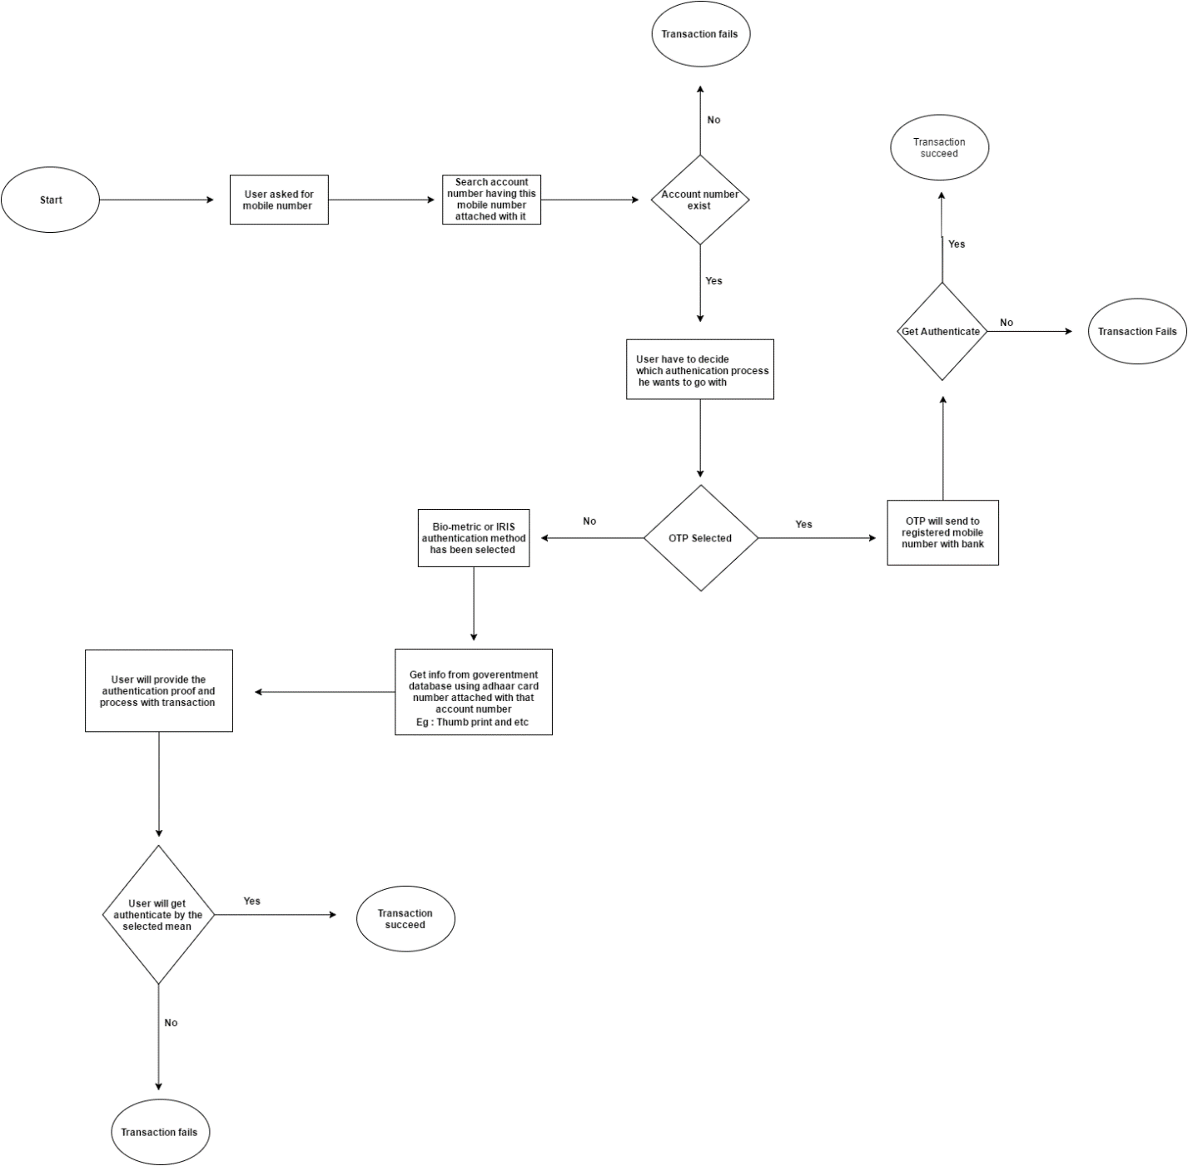

Technology we will be using:

* Web server
* Scripting language
* Hardwares : Biometric,Web cam and etc