Report
Of
JAVA PROGRAMMING INTERNSHIP

Development of Console-Based Java Application

Submitted
To
School of Computer Science and Engineering
IILM University, Greater Noida, U.P.

In partial fulfilment of the requirement of degree of
B.Tech CSE



By
Roll Number of Student:25SCS1003004866
Name of Student: ARYAN KUMAR
Batch: 2025-29

2026-27

CANDIDATE’S DECLARATION

I, ARYAN KUMAR do hereby declare that the internship report titled “Java Programming Internship: Development of Console-Based Java Applications” has been completed by me to fulfil the requirement for the award of the degree of Bachelor of Technology in CSE. All the references have been quoted and I have not taken as such any material from any other source. I affirm to you that this report is my own and has not been submitted to any other institute for any degree/diploma requirement and further I shall be solely responsible for any kind of copyright violation in this regard.

Signature
Student Name: ARYAN KUMAR
Roll No. 25SCS1003004866

ACKNOWLEDGEMENT

I am using this opportunity to express my gratitude to everyone who supported me throughout the Internship Program. I am thankful for their aspiring guidance, invaluably constructive criticism and friendly advice during this work. I am sincerely grateful to them for sharing their truthful and illuminating views on a number of issues related to this work.
I express my gratitude to my parents for their blessings.

Signature
Student Name: ARYAN KUMAR
Roll No. 25SCS1003004866

INTERNSHIP COMPLETION CERTIFICATE

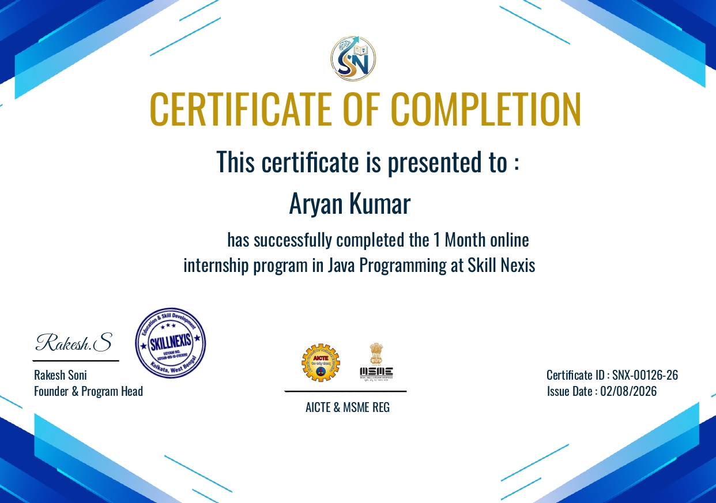

Certificate of Completion issued by Skill Nexis

TABLE OF CONTENTS

Chapter No. | Chapter Name | Page Nos.
 | Cover Page | ----
1. | Candidate’s Declaration | i
2. | Acknowledgment | ii
3. | Internship Completion Certificate | ----
4. | List of figures | iv
5. | List of Tables | V
4. | Project Description  4 .1 Introduction  4.2 Organization Profile  4.3 Problem Statement  4.4 Project Objectives  4.5 Scope of the Project  4.6 Technologies and Tools Used  4.7 System Architecture  4.8 Methodology  4.9 Expected Outcomes  4.10 Certificates of completion and other communication mail proof must be attached | 1.  1.  1.  2.  2.  3.  3.  4.  5.  6.  6.
5. | Bibliography/References | 7.

LIST OF FIGURES

Figure 4. 1: High-Level Architecture of the Week 4 ATM Simulation 4

LIST OF TABLES

Table 4. 1: Technologies and Tools Used During the Internship 3
Table 4. 2: Week-wise Development Methodology 5

4. PROJECT DESCRIPTION

4.1 Introduction
The Java Programming Internship at Skill Nexis was completed over one month, from 30 June 2026 to 30 July 2026. The internship followed a practical, project-oriented progression in which programming concepts were applied through small assignments and progressively larger console-based applications.
The work was organised into weekly repositories. Week 1 focused on basic Java programming through a Basic Calculator, Grade Evaluation program, and Bank Management mini-project. Week 2 introduced object-oriented programming through a Student assignment, Vehicle Inheritance assignment, and Library Management mini-project. Week 3 focused on collections and file handling through a Student Marks Record, a Word Frequency File I/O program, and an Employee Management mini-project. Week 4 concluded with the ATM Simulation capstone. The repositories publicly document this progression.

4.2 Organization Profile
Skill Nexis is an online internship and skill-development platform that aims to bridge the gap between academic learning and industry requirements through project-based learning, guided mentorship, and career-focused training. Its official platform describes four-week internship programs in multiple technology domains, including Java Programming, with structured learning material, weekly assignments, practical projects, and certification.
The Skill Nexis Java Programming track is designed to build Java knowledge through object-oriented programming concepts and practical projects. The official website lists Skill Nexis at Salt Lake Sector 5, Kolkata, West Bengal, and identifies Rakesh Soni as Founder & Internship Mentor. The completion certificate provided for this report identifies Rakesh Soni as Founder & Program Head and confirms completion of the one-month Java Programming internship.
The internship provided a structured environment for practising Java programming, completing weekly assignments, maintaining project repositories, and developing a final console-based application. The experience connected classroom programming concepts with hands-on implementation and testing.

4.3 Problem Statement
The primary purpose of the internship was to convert Java programming concepts into working applications rather than limiting learning to theoretical exercises. The challenge was to progressively develop programs that accept user input, apply programming logic, manage data, handle invalid inputs, and produce understandable console output.
Across the weekly work, the problem evolved from simple computational tasks to object-oriented and data-oriented applications. The final challenge was to integrate these skills into an ATM Simulation that could authenticate an account, perform banking operations, validate requests, maintain transaction records, and preserve account and transaction information using text files.

4.4 Project Objectives
- Develop practical proficiency in Java syntax, variables, operators, conditional statements, loops, methods, and console input/output.
- Apply object-oriented programming using classes and objects and practise concepts such as constructors, inheritance, encapsulation, and interfaces through the weekly assignments.
- Use ArrayList-based collections for managing records in the applications where collection-based storage was required.
- Practise file input/output using Java reader and writer classes for persistent text-based records.
- Implement input validation and exception handling so that invalid choices, amounts, account details, and other incorrect inputs are handled gracefully.
- Integrate the learned concepts in the Week 4 ATM Simulation capstone and organise the project using separate model, service, and application classes.

4.5 Scope of the Project
The scope of the internship covers command-line Java applications developed and maintained in four weekly GitHub repositories. The projects demonstrate a progression from basic programming exercises to object-oriented programming, collection handling, file input/output, and an integrated capstone application.
The Week 4 ATM Simulation is the principal capstone. Its repository documentation specifies PIN login with three attempts, balance enquiry, deposits, withdrawals, transfers, transaction history, account details, input/error handling, and persistent account and transaction data in text files. The implementation uses ArrayList collections and follows an MVC-style separation between model classes, the service/controller class, and the console application entry point.
The project is an educational console-based prototype rather than a production banking system. It does not connect to a live bank, payment gateway, or production database. Its main scope is to demonstrate Java programming, object-oriented design, validation, collections, file persistence, and structured application development.

4.6 Technologies and Tools Used

Table 4. 1: Technologies and Tools Used During the Internship
Technology / Tool | Use in the Internship | Key Outcome
Java | Primary programming language for all weekly assignments and projects. | Implemented basic, object-oriented and console-based applications.
JDK / javac | Compilation and execution of Java source files. | Used to build and run the programs during development and testing
Java Collections | ArrayList-based in-memory storage where required. | Managed records such as marks, accounts and transactions.
Java File I/O | BufferedReader, BufferedWriter, FileReader and FileWriter in file-based projects. | Read and wrote persistent text records.
Java Security API | MessageDigest with SHA-256 in the ATM Simulation. | Hashed PIN input before comparison with the stored PIN hash.
Visual Studio Code | Source-code editing and terminal-based Java development. | Used as the development environment for organising and running source files.
GitHub | Repository-based storage and submission of weekly work. | Maintained separate repositories for the our internship weeks.

4.7 System Architecture
The weekly programs were generally organised as console applications in which the user enters data, the Java program applies the required logic, and the result is displayed in the terminal. The Week 4 ATM Simulation applies a clearer separation of responsibilities. ATMApplication provides the entry point and console interaction, ATMService manages authentication, business rules and persistence, while Account and Transaction represent the main data models. The repository README explicitly identifies these as Model, Controller, and View/entry-point components.

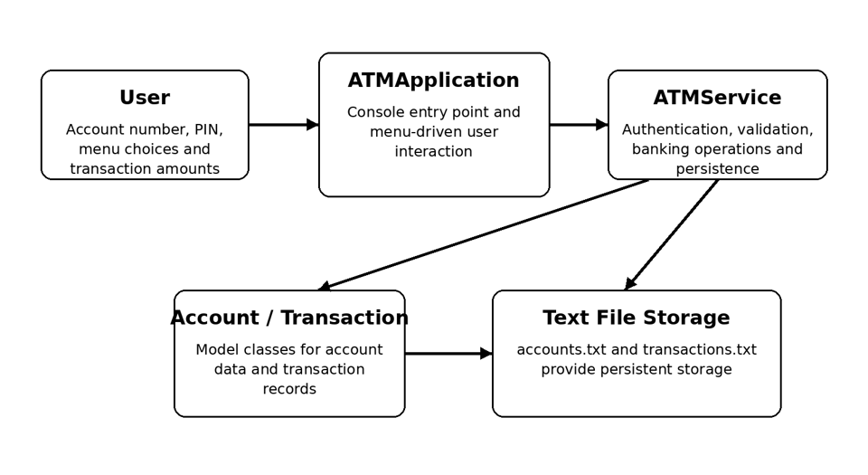
Figure 4. 1: High-Level Architecture of the Week 4 ATM Simulation
The ATMService class maintains ArrayList collections for accounts and transactions and uses accounts.txt and transactions.txt for persistent storage. The service authenticates users by comparing the SHA-256 hash of the entered PIN with the stored PIN hash. It then presents a menu for balance enquiry, deposit, withdrawal, transaction history, transfer, account details, and exit. Invalid menu selections and transaction errors are handled through validation and the custom ATMException mechanism.

4.8 Methodology
An iterative, practice-based methodology was followed throughout the internship. Each week introduced a focused group of concepts, followed by two assignments and one integrated mini-project. The work was developed in separate GitHub repositories so that the progression could be reviewed week by week. The repository structures confirm the three-project pattern for Weeks 1–3, while Week 4 contains the capstone ATM Simulation.
Table 4. 2: Week-wise Development Methodology
Week | Focus | Assignments | Integrated Project
1 | Java fundamentals | Basic Calculator; Grade Evaluation | Bank Management Console App
2 | Object-oriented programming | Student; Vehicle Inheritance | Library Management System
3 | Collections and file handling | Student Marks Record; Word Frequency File I/O | Employee Management System
4 | Integration and capstone development | ATM implementation, testing and documentation | ATM Simulation Project
Testing was performed by running the programs with normal and invalid inputs and checking whether the output and application behaviour matched the intended requirements. For the ATM project, the implementation includes validation for menu choices, account lookup, PIN authentication, transaction amounts, insufficient balance, and invalid transaction records. File loading also handles invalid saved records without stopping the complete application.
The development process therefore followed a cycle of understanding the requirement, writing the Java classes and methods, compiling and executing the program, testing normal and boundary cases, correcting errors, and storing the completed work in the relevant GitHub repository.

4.9 Expected Outcomes
- A structured portfolio of Java programs demonstrating progression from basic syntax and problem solving to object-oriented and integrated application development.
- Improved ability to translate simple real-world requirements into Java classes, methods, input rules, collections, and file-based storage.
- Practical understanding of object-oriented programming, including the use of separate classes and inheritance-based examples.
- Practical experience with ArrayList collections, file input/output, validation, and exception handling.
- A completed ATM Simulation capstone that demonstrates authentication, banking operations, transaction history, persistent storage, and modular Java design.
- A GitHub-based record of the weekly work that can be reviewed as evidence of project development and submission.

4.10 Certificates and Communication Proof
The internship completion certificate issued by Skill Nexis is attached in this report. The certificate records that Aryan Kumar successfully completed the one-month online internship program in Java Programming at Skill Nexis. It carries Certificate ID SNX-00126-26 and an issue date of 02/08/2026.
The weekly project repositories provide additional evidence of the practical work completed during the internship:
- Week 1 – Java fundamentals and Bank Management: https://github.com/parmodbanka-coder/week-1
- Week 2 – OOP and Library Management: https://github.com/parmodbanka-coder/week2
- Week 3 – Collections, File I/O and Employee Management: https://github.com/parmodbanka-coder/week-3-
- Week 4 – ATM Simulation Capstone: https://github.com/parmodbanka-coder/week-4

5. BIBLIOGRAPHY / REFERENCES
- Skill Nexis. Official Website and Internship Program Information. https://www.skillnexis.in/
- GitHub. parmodbanka-coder. Week 1 Java Internship Repository. https://github.com/parmodbanka-coder/week-1
- GitHub. parmodbanka-coder. Week 2 Java Internship Repository. https://github.com/parmodbanka-coder/week2
- GitHub. parmodbanka-coder. Week 3 Java Internship Repository. https://github.com/parmodbanka-coder/week-3-
- GitHub. parmodbanka-coder. Week 4 ATM Simulation Repository. https://github.com/parmodbanka-coder/week-4
- Oracle. Java Documentation. https://docs.oracle.com/en/java/
- Oracle. Java Platform, Standard Edition API Specification. https://docs.oracle.com/en/java/javase/
- Oracle. Java Tutorials: Essential Java Classes and Basic I/O. https://docs.oracle.com/javase/tutorial/essential/io/
- Cay S. Horstmann. Core Java, Volume I - Fundamentals. Pearson Education.
- Herbert Schildt. Java: The Complete Reference. McGraw-Hill Education.

