IT IN RAILWAYS
(WESTERN RAILWAY IT CELL)

A Project Report
Submitted in partial fulfilment of the requirements
for the award of the Degree of
BACHELOR OF SCIENCE (INFORMATION TECHNOLOGY)
SEMESTER III
By
Parnavi Prakash Janbhor
Roll Number: 25302B0042
Under the esteemed guidance of
Ms. Khushi Kunti

Assistant Professor,

Department of Information Technology and Data Science

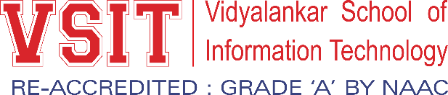

DEPARTMENT OF COMPUTING
VIDYALANKAR SCHOOL OF INFORMATION TECHNOLOGY
(Autonomous College, Affiliated to the University of Mumbai)
MUMBAI, 400037
MAHARASHTRA
2026 - 2027

VIDYALANKAR SCHOOL OF INFORMATION TECHNOLOGY
(Autonomous College, Affiliated to the University of Mumbai)
MUMBAI-MAHARASHTRA-400037

DEPARTMENT OF COMPUTING

CERTIFICATE
I hereby certify that Ms. Parnavi Prakash Janbhor(Roll Number: 25302B0042), Student of Vidyalankar School of Information Technology, studying in S.Y. B.Sc. (Information Technology), Division B, Semester III, has completed the field project titled “IT in Railways” in the area of Information Technology for the academic year 2026-27. To the best of my knowledge, the work of the student is original and the information included in the project is correct.

Internal Guide |  | Head of Department
Internal Examiner |  | External Examiner
Date: | College Seal |  | Principal

DECLARATION
I, Parnavi Prakash Janbhor, Student of Vidyalankar School of Information Technology, studying in S.Y. B.Sc. (Information Technology), Division B, Semester III, hereby declare that I have completed the field project entitled “IT in Railways” during the academic year 2026-27.
The report work is original and the information/data included in the report is true from the primary and/ secondary data gathered and analyzed as part of this project.
Due credit is extended on the work of Literature/Secondary Survey by endorsing it in the Bibliography as per prescribed format.

Signature of the Student with Date
Parnavi Prakash Janbhor

ACKNOWLEDGEMENT
We express our sincere gratitude to the University of Mumbai and Vidyalankar School of Information Technology for providing us with the opportunity to undertake this Field Project as part of the B.Sc. (Information Technology) curriculum. This project provided valuable practical exposure and helped us enhance our understanding of how Information Technology is applied in real-world railway operations.
We extend our heartfelt thanks to Western Railway IT Cell for granting us the opportunity to visit and study their IT-enabled operations. We are especially grateful to our guide, Ms. Khushi Kunti, for her constant guidance, encouragement, constructive feedback, and support throughout the project.
We are also thankful to the officers and staff of Western Railway IT Cell for sharing their knowledge, explaining the systems and workflows used in railway operations, and giving us meaningful exposure to practical applications of IT.
Lastly, we wish to thank our faculty members and peers for their support and motivation, which helped us complete this project successfully.
TABLE OF CONTENT
CHAPTER 1: INTRODUCTION 1
1.1 Purpose of Visit 1
1.2 Background 1
1.3 Scope 1
CHAPTER 2: LITERATURE REVIEW 2
CHAPTER 3: METHODOLOGY 3
3.1 Data Collection Methods 3
3.2 New Tools/ Technologies 3
CHAPTER 4: FIELD WORK DESCRIPTIONS, OBSERVATIONS AND ANALYSIS 4
4.1 Field work descriptions 4
4.2 Observations 4
4.3 Analysis 4
CHAPTER 5: PHOTOGRAPHS / VISIT PROOFS 5
CHAPTER 6: CONCLUSION AND RECOMMENDATIONS 6
6.1 Conclusion 6
6.2 Recommendations 6
REFERENCES 7
Research Papers 7
Books Referred 7
Website 7

TABLE OF FIGURES
Figure 1: Churchgate Railway Station, Mumbai 14
Figure 2: Letter of Intent 15
Figure 3: Guide Interaction Diary Form 16
Figure 4: Field Visit Evaluator Form 17
Figure 5: Group Photo with Railway Officers, Churchgate , Mumbai 19
Figure 6: Interview with Railway Officer, Churchgate, Mumbai 23

CHAPTER 1: INTRODUCTION

Purpose of Visit
The main purpose of the field visit was to gain a firsthand understanding of how Information Technology is applied within the Western Railway system through its IT Cell. The visit provided practical exposure to IT-enabled processes, tools, and workflows that support railway operations. We interacted with officers, observed their roles, and learned about the challenges involved in maintaining seamless operations. The visit helped bridge the gap between classroom concepts and their application in a large-scale public transportation environment.

Background
Indian Railways is one of the largest rail networks in the world and serves millions of passengers every day. To keep such a vast system running smoothly, robust IT solutions are used for ticketing, scheduling, resource management, freight operations, employee management, maintenance, and passenger information services. The Western Railway IT Cell plays an important role in supporting these technology-driven activities. The field visit was therefore relevant for understanding how IT systems operate in a large and complex organization.

Scope
The scope of the visit included understanding IT-supported railway processes, exploring software, databases, hardware and digital infrastructure, observing data flows between departments, learning about technical and operational challenges, and connecting classroom knowledge with real-world applications. The study focused on systems and tools such as PRS, IPAS, HRMS, MERS, TAMS and eOffice, as described during the field visit.

CHAPTER 2: LITERATURE REVIEW
Information Technology is a vital component in ensuring the smooth operation of modern railway systems. Existing literature, official railway resources and online material show that IT solutions are used in areas such as passenger reservation, train scheduling, asset management, freight operations, human resource management and data analytics. These resources helped us understand the background of the systems used by the Western Railway IT Cell and relate them to classroom concepts such as Information Systems, ERP, data flow and digital workflow.
References consulted included the Indian Railways official website, the IRCTC portal, literature on Indian Railways modernization, digitalization of human resource management, railway infrastructure optimization using AI, and studies on artificial intelligence applications in railway systems. These resources were used to understand the tools and technologies observed during the field visit.

CHAPTER 3: METHODOLOGY
The methodology adopted for this field project was systematic and collaborative. The visit was planned in consultation with the faculty mentor, and the focus areas included understanding IT implementation in railways, core processes, tools, data flows, challenges and performance metrics. A formal request for permission was prepared and submitted to the concerned officers of Western Railway IT Cell.

Data Collection Methods
Multiple data collection methods were used to gain a comprehensive understanding of IT implementation at the Western Railway IT Cell. A structured questionnaire was prepared in consultation with the faculty mentor. Interviews were conducted with officers and staff to understand their daily roles, IT systems and tools used, common challenges and methods used to maintain the systems. Direct observations were made during the visit, and available artifacts and explanations were reviewed to understand workflows and data flows.

New Tools/ Technologies
During the field visit, we observed several modern tools and technologies used to streamline railway operations and improve efficiency. These included IPAS (Integrated Payroll and Accounting System) for payroll and financial transactions; HRMS (Human Resource Management System) for employee records, attendance, leave and performance-related information; MERS for monitoring maintenance and equipment-related activities; TAMS (Train and Asset Management System) for train schedules, resource allocation and operational performance; eOffice for paperless workflows, file management and official correspondence; and digital dashboards for real-time monitoring.
The exposure to these tools helped bridge classroom concepts with real-world practices. TAMS and MERS demonstrated information systems used for operational management, while IPAS and HRMS showed how integrated software can streamline administrative and financial activities. eOffice demonstrated digital process automation and paperless workflow management. Overall, the fieldwork showed how IT transforms traditional railway operations into more efficient, transparent and data-driven processes.
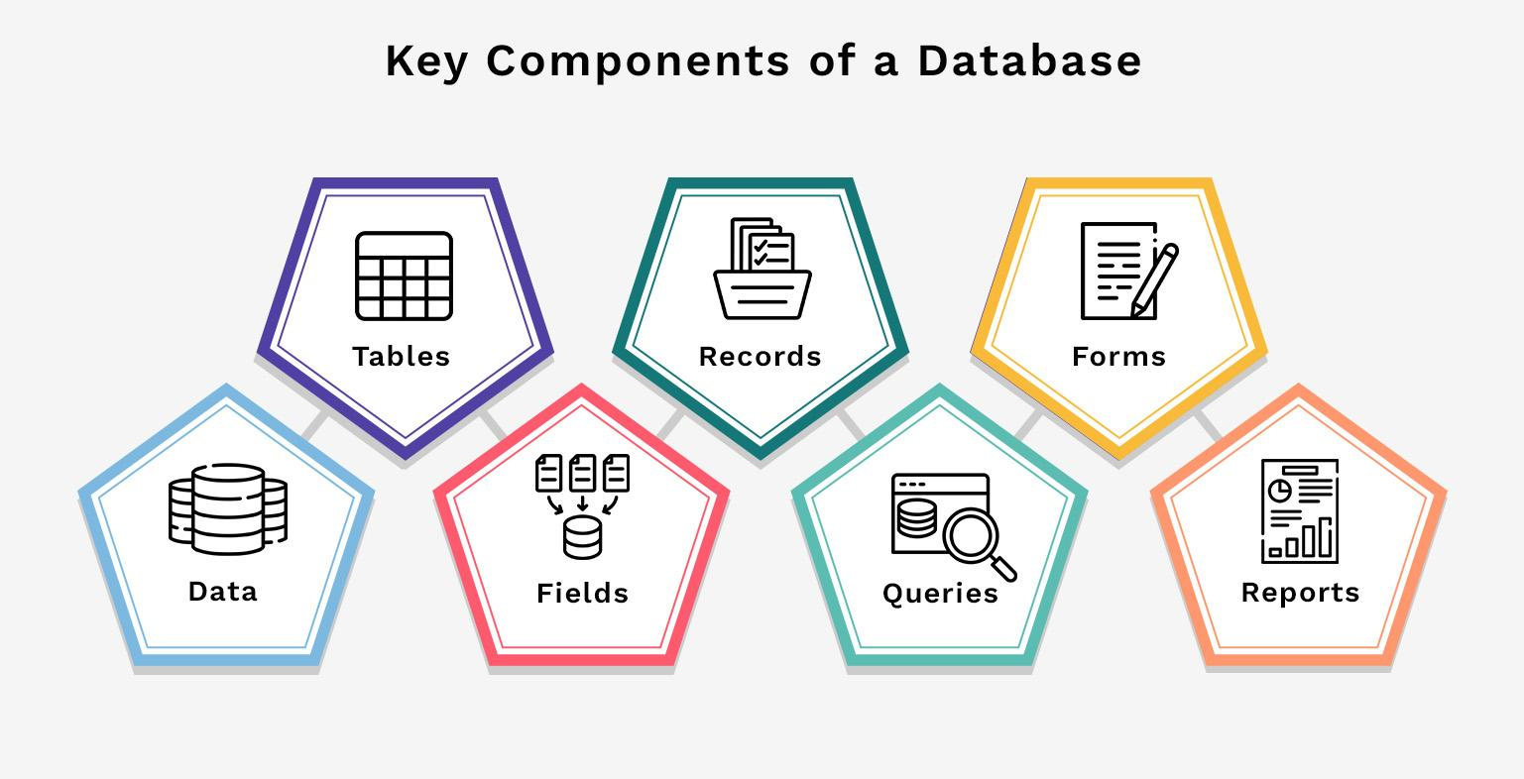
Figure 1: Western Railway IT Cell, Churchgate, Mumbai

CHAPTER 4: FIELD WORK DESCRIPTIONS, OBSERVATIONS AND ANALYSIS

4.1 Field work descriptions
The field visit to the Western Railway IT Cell included sessions in which railway IT systems and their practical applications were explained. According to the Field Visit Evaluator Forms, the sessions covered advanced railway software systems, railway pension and settlement modules, centralized systems, TAMS, e-Office and AIMS. The visit provided practical exposure to how computerized and centralized systems support railway operations, financial management, accounting and official documentation. The visit date recorded on the evaluator forms was 02 September 2026.

4.2 Observations
The field-visit evaluator information records that the visit covered advanced railway software systems and their applications in railway operations. The sessions included the Passenger Reservation System (PRS), pension and settlement modules, centralized systems, TAMS (Train Account Management System), e-Office, AIMS (Accounting Information Management System), and other computerized railway systems. The sessions helped us understand how centralized and computerized systems support railway operations, accounting, financial management and official documentation.

4.3 Analysis
The information collected during the field visit was analyzed in relation to the systems demonstrated. The sessions showed how centralized software supports railway operations and administration. TAMS was discussed in relation to railway account management, while AIMS demonstrated computerized accounting and digital financial transaction processing. e-Office showed how official documentation and workflows can be managed digitally. The pension and settlement modules demonstrated the use of centralized systems for employee-related processes. These observations connected classroom concepts such as information systems, centralized databases, digital workflows and computerized transaction processing with practical railway applications.
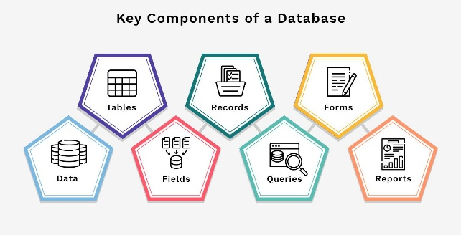
Figure 2: Churchgate Railway Station, Mumbai

CHAPTER 5: FIELD VIST DETAILS
1. Western Railway IT Cell / office or premises photograph —
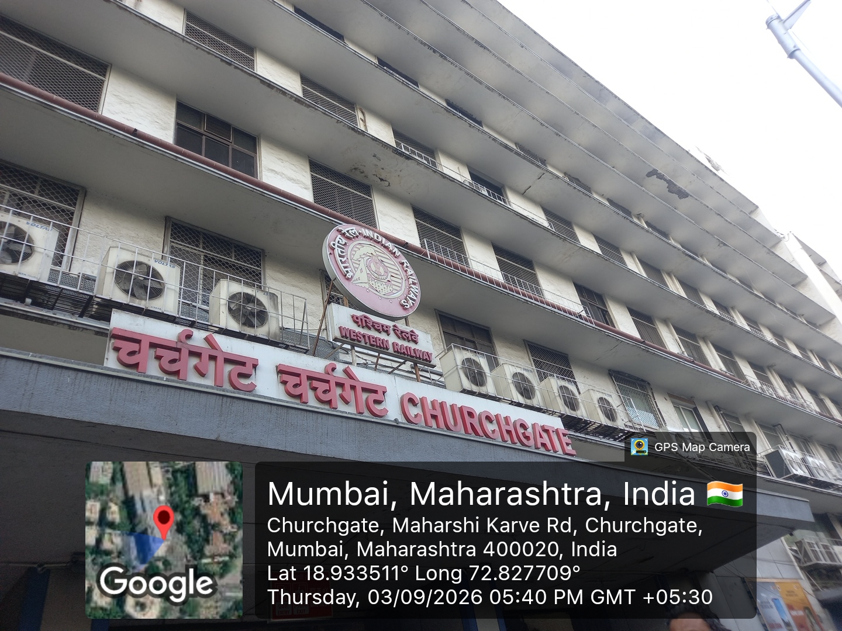

- 2. Field Visit Letter of Intent —
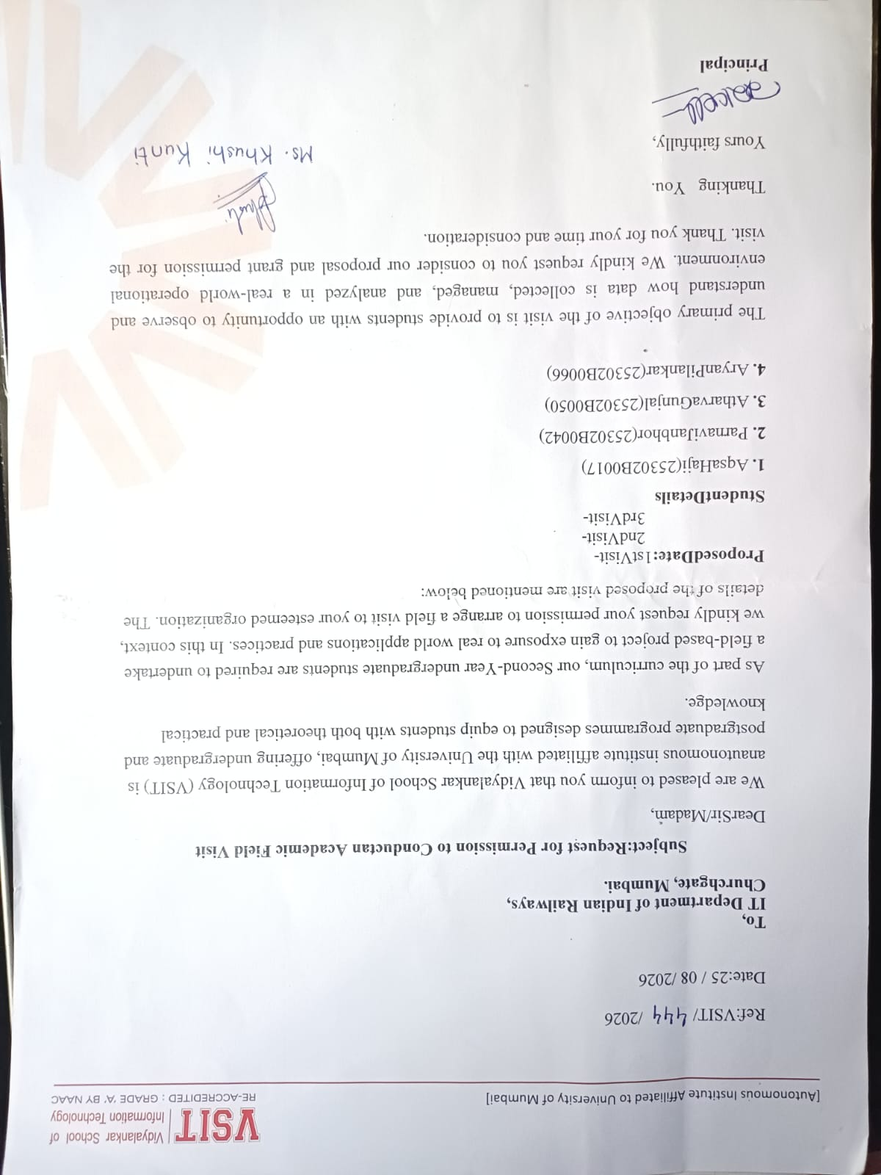

- 3. FP Guide Interaction Diary Form —

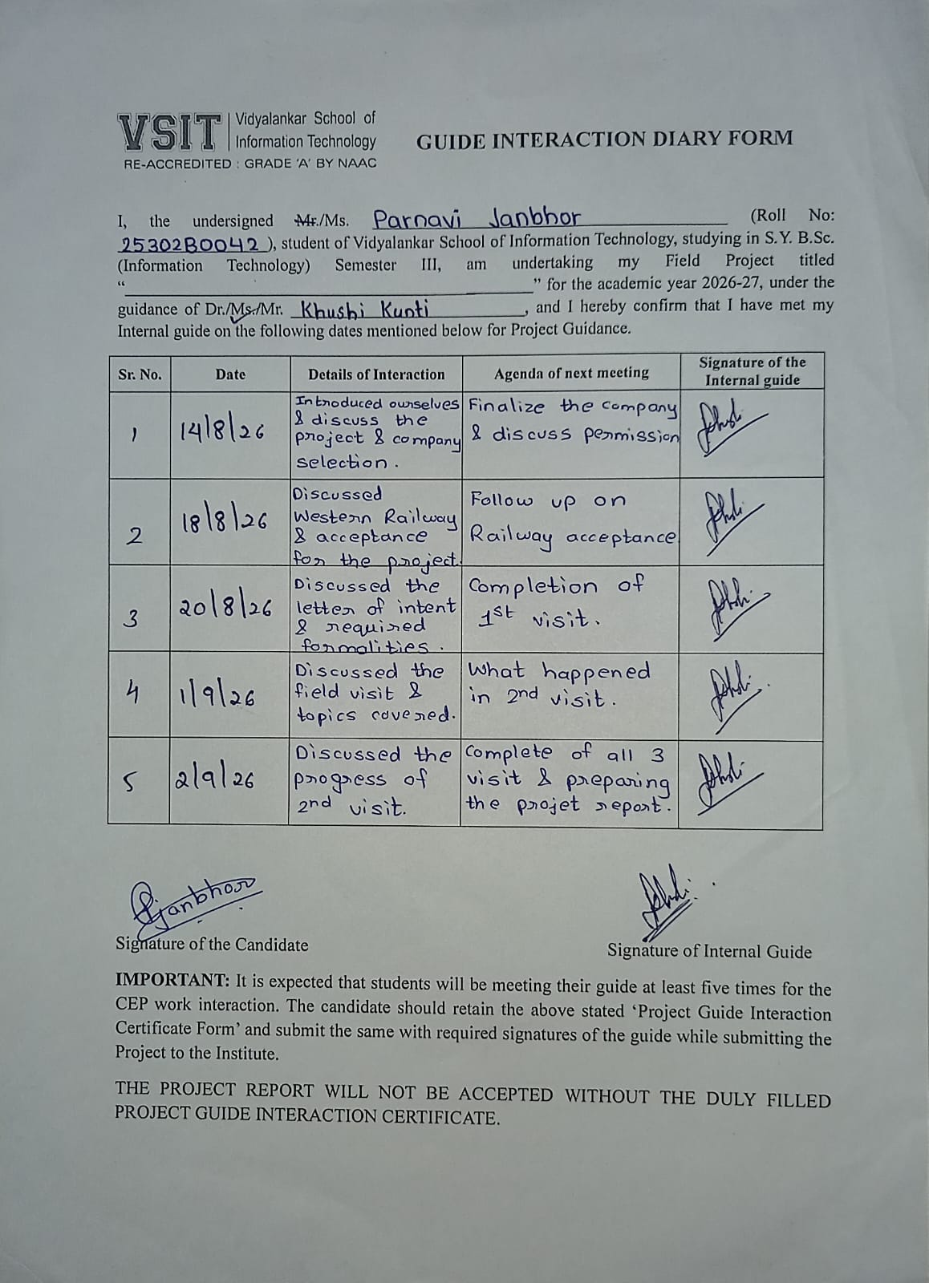

- 4. Field Visit Evaluator Form —

- 1st Visit
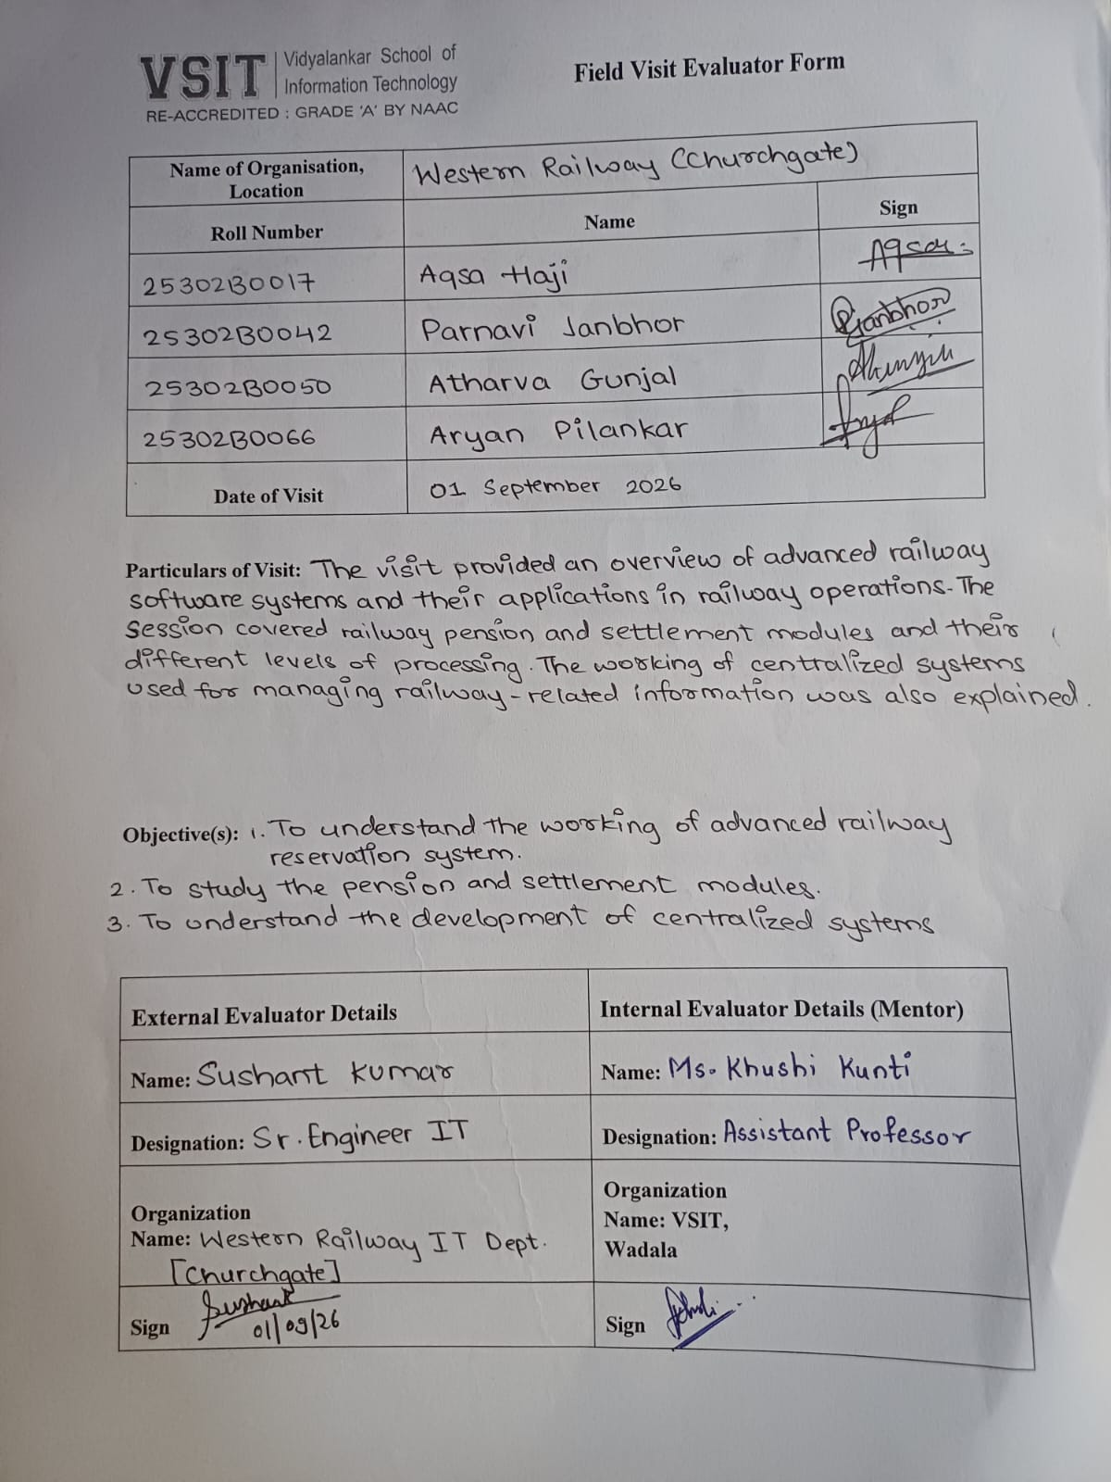

2. 2nd Visit
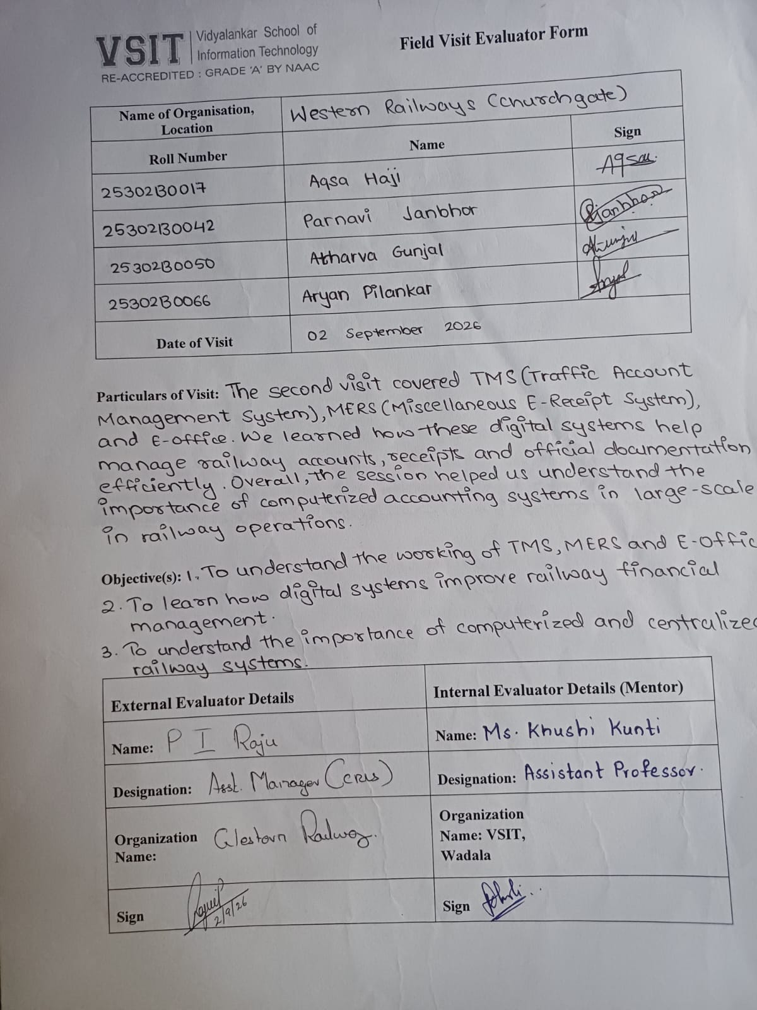

3. 3rd Visit
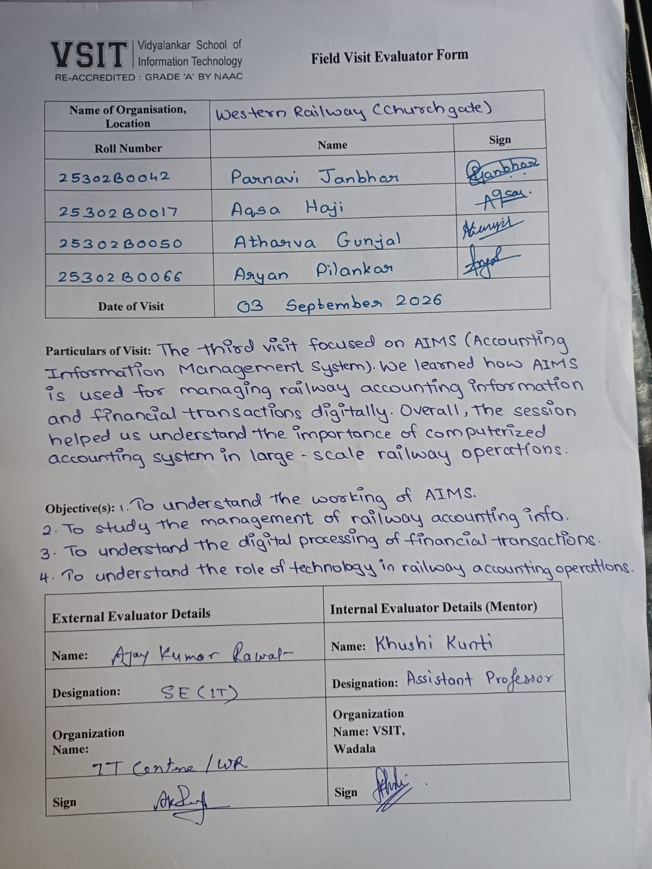

5. Group photograph with team members / Railway officers —
1. 1st Visit
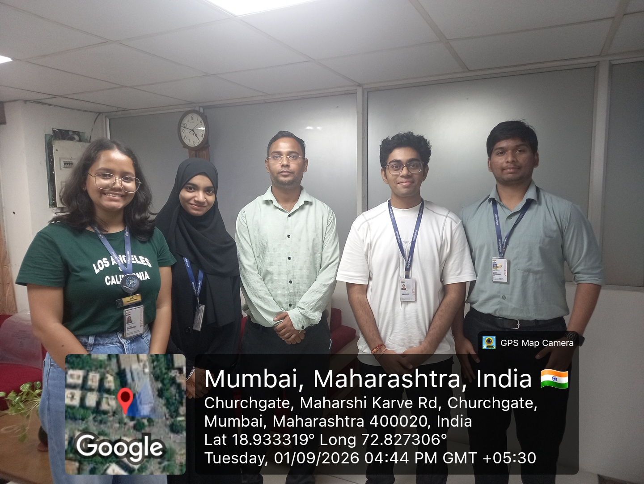

2. 2nd Visit
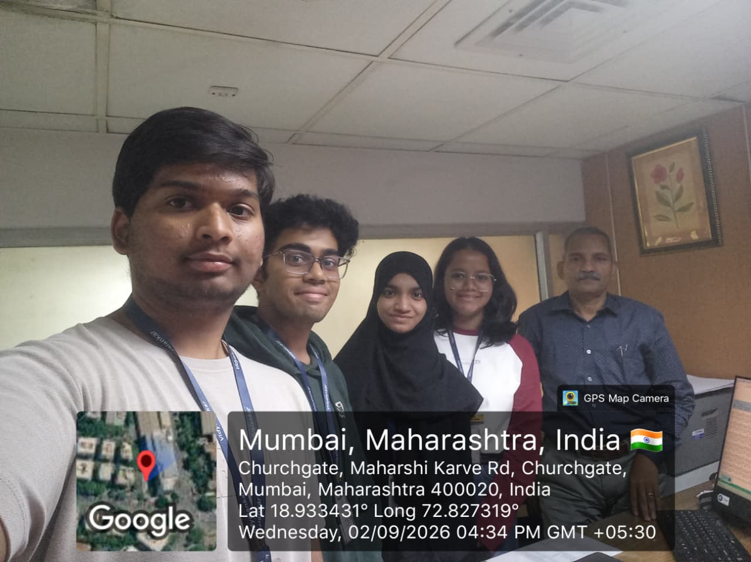

3. 3rd Visit
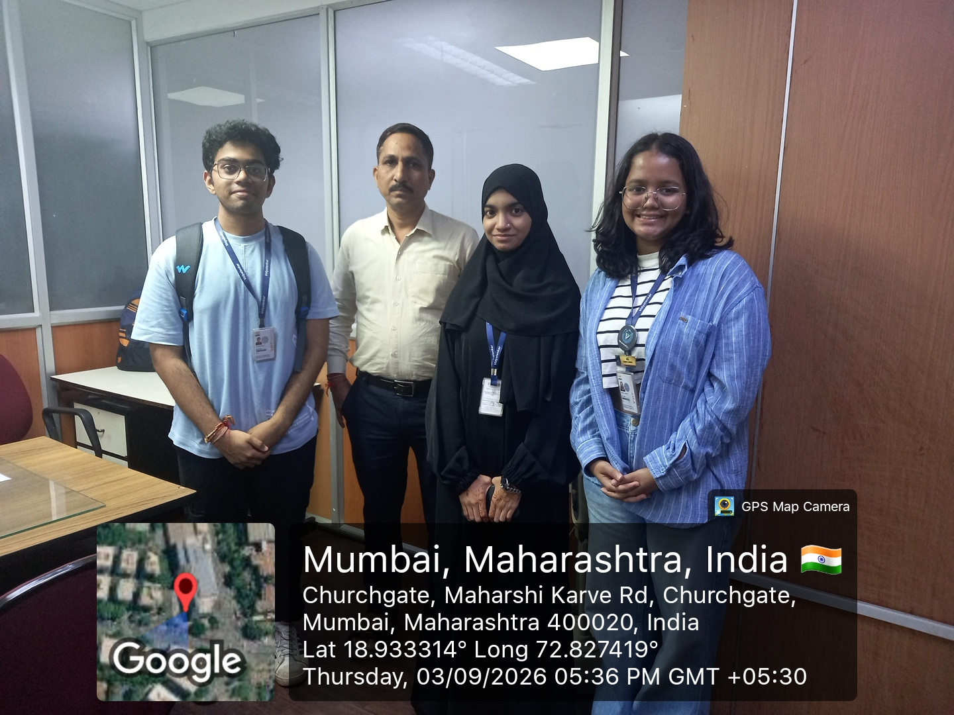

6. Interaction/interview with Railway officers —

1. 1st Visit
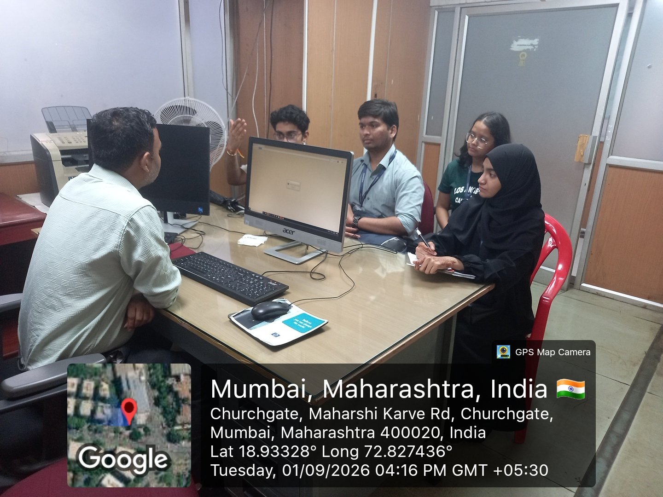

2. 2nd Visit

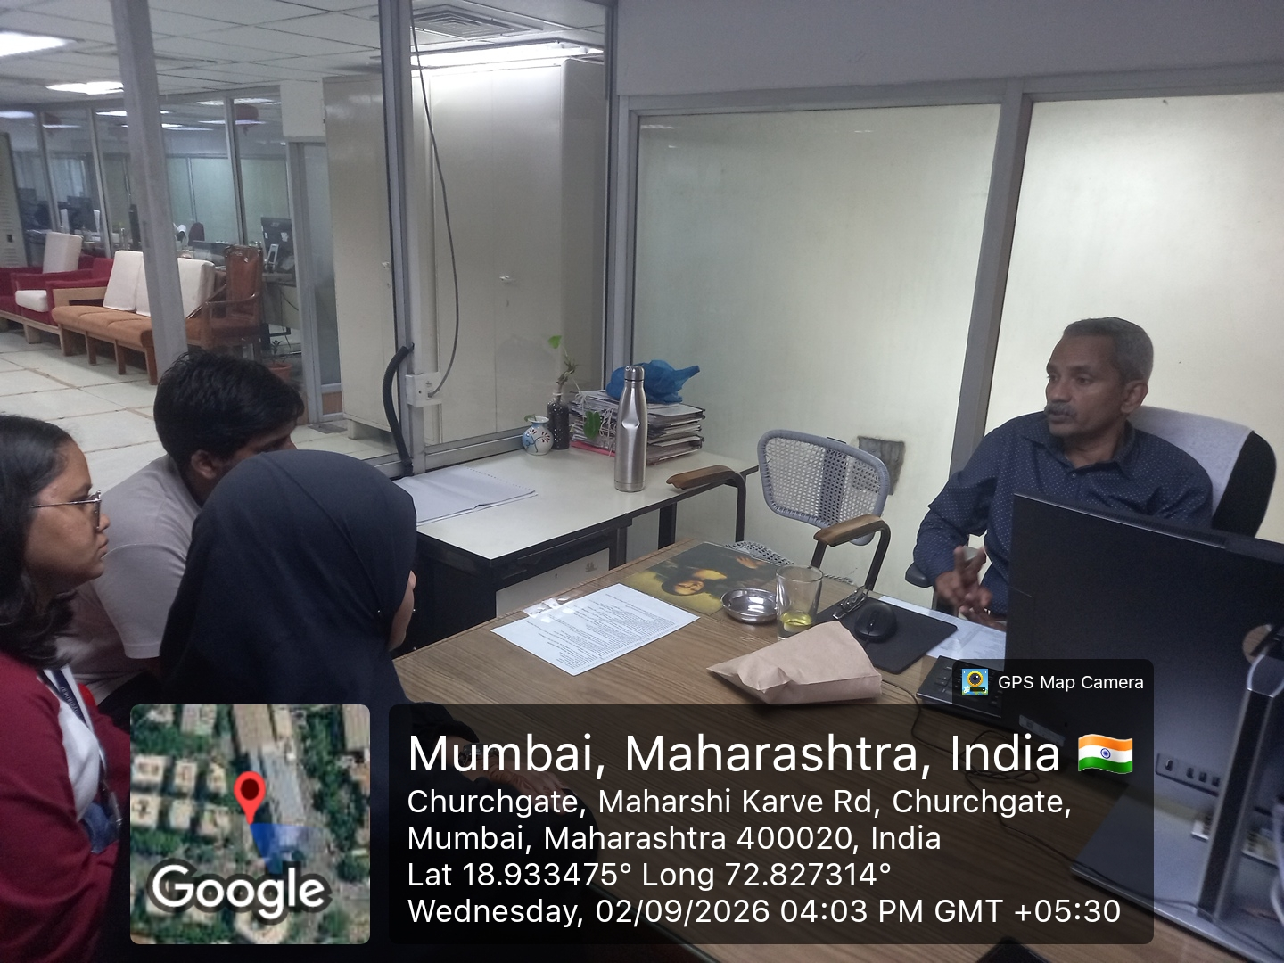

3. 3rd Visit

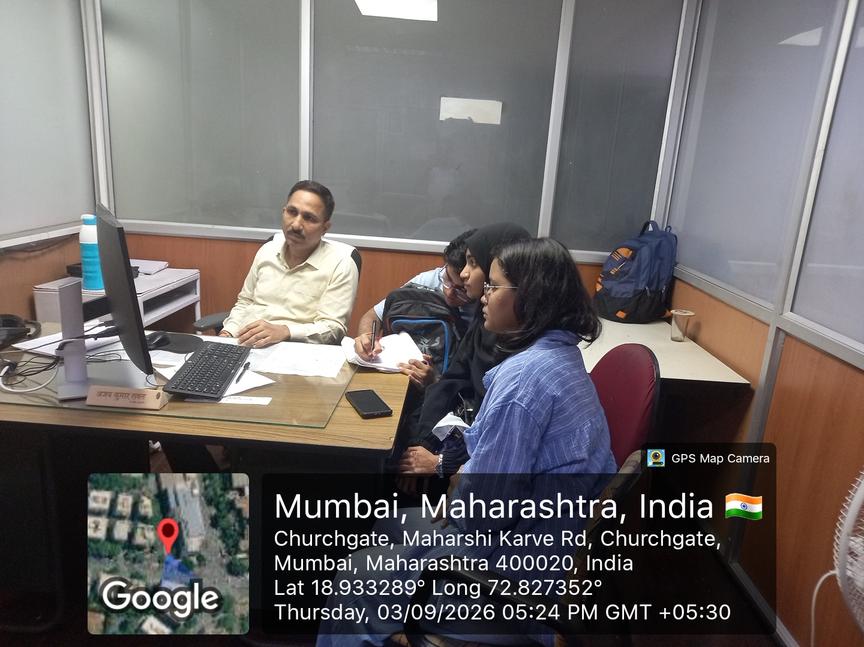

CHAPTER 6: CONCLUSION AND RECOMMENDATIONS

Conclusion
The field visit to the Western Railway IT Cell provided practical insight into how Information Technology supports large-scale railway operations. Systems such as PRS, IPAS, HRMS, MERS, TAMS, eOffice and digital dashboards contribute to ticketing, employee management, asset monitoring, workflow automation and data-driven decision making. The visit demonstrated the importance of reliable, secure and integrated IT systems in maintaining smooth railway services. It also helped connect academic concepts with practical industry applications and provided a better understanding of the challenges involved in operating IT systems at such a large scale.

Recommendations
Based on the observations documented during the field visit, the following recommendations were identified: modernize legacy systems to improve security, scalability and performance; strengthen cybersecurity through regular audits, encryption and multi-factor authentication; provide regular staff training and cross-training; use predictive maintenance and analytics to identify problems early; explore AI and machine learning for train scheduling, crew management, grievance handling and forecasting; and continue improving system integration and digital workflows for future-ready railway operations.

REFERENCES

Research Papers
1. Indian Railways in the Past Twenty Years: Issues, Performance and
Challenges
2. Modernization of Passenger Reservation System – Indian Railways
Dilemma
3. Ticket to Transformation – Digitalizing Human Resources
Management in Indian Railways
4. Human Resource Management Practices in Indian Railways

5. Optimising Indian Railways Infrastructure by AI — Chandrika Prasad
& Sudhanshu S. Jamuar

6. A Literature Review of Artificial Intelligence Applications in Railway
Systems — Transportation Research Part C, 2022

7. Exploring the Potential of AI & Emerging Technologies in Indian
Railways — Neha Mishra (2024)

Books Referred
1. Digital Railway Infrastructure — Ribeiro
2. Managing Indian Railways: The Future Ahead — V. K. Aggarwal

Website
1. Indian Railways Official Website — https://indianrailways.gov.in
2. IRCTC Portal — https://www.irctc.co.in

3. Western Railway Official Website — https://wr.indianrailways.gov.in

