Coding Practice
Name: Parnavi Janbhor
Roll.No: 25302B0042
SYIT Div: B

- Find Second Largest Element
numbers = list(map(int, input("Enter numbers: ").split()))

largest = second = float('-inf')

for num in numbers:
if num > largest:
second = largest
largest = num
elif num > second and num != largest:
second = num

print("Second largest:", second)

O/P:
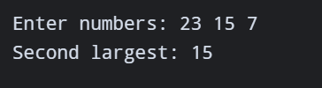

- Remove Duplicate Elements.
numbers = list(map(int, input("Enter numbers: ").split()))

unique = []

for num in numbers:
if num not in unique:
unique.append(num)

print("List after removing duplicates:", unique)

O/P:
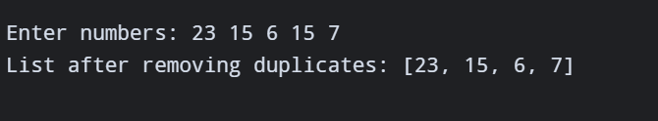

- Count Even and Odd Numbers.
numbers = list(map(int, input("Enter numbers: ").split()))

even = 0
odd = 0

for num in numbers:
if num % 2 == 0:
even += 1
else:
odd += 1

print("Even numbers:", even)
print("Odd numbers:", odd)

O/P:
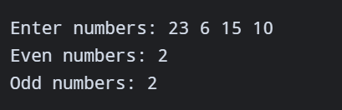

- Reverse a String.
text = input("Enter a string: ")

reverse = ""

for char in text:
reverse = char + reverse

print("Reversed string:", reverse)

O/P:
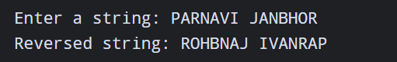

5.Check Palindrome Number.
num = input("Enter a number: ")

if num == num[::-1]:
print("Palindrome")
else:
print("Not Palindrome")

O/P:
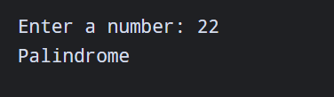

6.Calculate Sum and Average.
numbers = list(map(int, input("Enter numbers: ").split()))
total = 0
for num in numbers:
total += num
average = total / len(numbers)
print("Sum:", total)
print("Average:", average)

O/P:
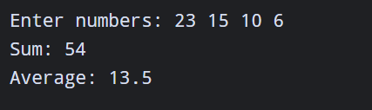

7. Count Vowels and Consonants.
text = input("Enter a string: ").lower()
vowels = 0
consonants = 0
for char in text:
if char.isalpha():
if char in "aeiou":
vowels += 1
else:
consonants += 1
print("Vowels:", vowels)
print("Consonants:", consonants)
O/P:
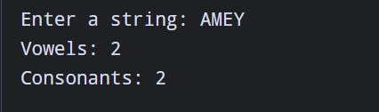

8. Print Multiplication Table.
num = int(input("Enter a number: "))
for i in range(1, 11):
print(num, "x", i, "=", num * i)

O/P:
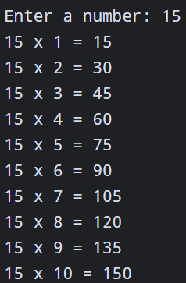

9. Find Common Elements in Two Lists.
list1 = list(map(int, input("Enter first list: ").split()))
list2 = list(map(int, input("Enter second list: ").split()))
print("Common elements:")
for num in list1:
if num in list2:
print(num, end=" ")

O/P:
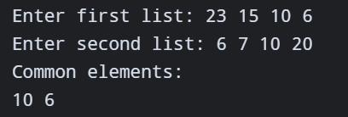

10. Simple Calculator.
a = float(input("Enter first number: "))
operator = input("Enter operator (+, -, *, /): ")
b = float(input("Enter second number: "))
if operator == "+":
print("Result:", a + b)
elif operator == "-":
print("Result:", a - b)
elif operator == "*":
print("Result:", a * b)
elif operator == "/":
if b != 0:
print("Result:", a / b)
else:
print("Cannot divide by zero")
else:
print("Invalid operator")

O/P:


