Annexure-I

CPP with OOPs Programming Language
Cipher Schools

Summer training report

Submitted in partial fulfilment of the requirements for the award of degree of

B.Tech. (Computer Science Engineering)

Submitted to
LOVELY PROFESSIONAL UNIVERSITY

PHAGWARA, PUNJAB



From June 4, 2025 to July 15, 2025

SUBMITTED BY

Name of student: Parnika Awasthi
Registration Number: 12309619
Signature of the student: Parnika
Annexure-II: Student Declaration

To whom so ever it may concern

I, Parnika Awasthi, Registration Number [12309619], hereby declare that the work done by me on “CPP with OOPs Programming Language” from June, 2025 to July, 2025, is a record of original work for the partial fulfilment of the requirements for the award of the
degree, B.Tech. in Computer Science Engineering.

Parnika Awasthi (12309619)
Dated: 15/08/2025
Training certificate from organization/ Company

https://cipher-other-assets.s3.ap-south-1.amazonaws.com/certificates/681f77030cf7337fa0977168_6470a742c1db0f70fd11b58e

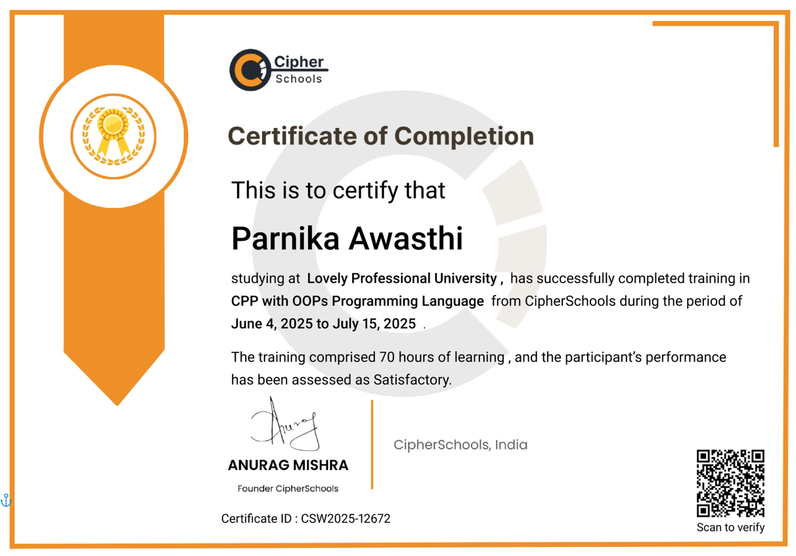


INTRODUCTION OF THE PROJECT UNDERTAKEN

Overview
➤ Objectives of the work undertaken:
The primary objective was to gain hands-on experience in developing a console-based application using C++ with Object-Oriented Programming (OOP) principles. The project, titled "Mental Health Check-In Simulator", focuses on helping users track their mental well-being through regular check-ins, assessments, and motivational guidance. This involved designing core classes, implementing data structures for mood tracking, and ensuring smooth user interaction through a menu-driven interface.

➤ Scope of the Work:
The scope included designing a modular and maintainable program using OOP concepts such as classes, objects, inheritance, polymorphism, and encapsulation. The application
allows user registration and login, mood tracking using stack/queue, storing mood history in a linked list, displaying motivational quotes, and conducting mental health
assessments. The project connects these features into a cohesive, functional, and userfriendly
console application.

➤ Importance and Applicability:
The project's importance lies in its practical application for promoting mental well-being through technology. It provides a safe, private, and interactive way for users to monitor their mood trends and get personalized encouragement. From a technical perspective, it demonstrates how OOP and data structures can be applied to build structured, scalable, and efficient C++ applications.

INTRODUCTION TO PROJECT

1. Introduction
Mental health is an integral part of human well-being, influencing how individuals think, feel, and behave in their daily lives. With the increasing pressures of academic, professional, and personal responsibilities, it has become essential to monitor emotional states regularly. However, many people struggle to keep track of their moods and often lack tools for self-reflection.
To address this, the project “Mental Health Check-In Simulator” has been developed using C++ programming language with a strong focus on Object-Oriented Programming (OOP) concepts and Data Structures.

The simulator allows users to:
- Register/Login into the system.
- Perform daily mood check-ins (Happy, Sad, Anxious, Angry, Neutral).
- View mood history stored using stacks, queues, and linked lists.
- Receive motivational quotes for encouragement.
- Take a mental health self-assessment questionnaire for awareness.
•
This project bridges the gap between theoretical learning of OOPs & DSA and real-world applications by demonstrating how programming can contribute towards mental health awareness.

2. Objectives

The main objectives of this project are:
- To design and implement a C++ application using Object-Oriented Programming principles.
- To provide a simple, interactive platform for users to record their daily moods.
- To demonstrate the use of data structures such as stack, queue, and linked list in storing and displaying mood history.
- To integrate a motivational quote system that supports emotional well-being.
- To design a mental health questionnaire that helps users in basic self-assessment.
6.To combine programming concepts with a practical real-life application that promotes mental health awareness.

3. Problem Statement
In today’s digital world, while technology has advanced significantly, mental health remains a neglected area. Many individuals do not have access to tools that help them reflect on their emotional well-being.
Traditional note-keeping methods are ineffective and lack interactivity.
The problem identified is the absence of a simple, user-friendly platform for mood tracking and self assessment, especially for students and working professionals who are prone to stress and anxiety.

Thus, this project aims to provide a lightweight, console-based simulator that enables users to:
- Track moods consistently.
- Reflect on emotional patterns over time.
- Stay motivated with positive affirmations.
- Gain awareness of their mental health status.

4. Tools and Technologies Used
- Programming Language: C++
- Concepts Applied:
  - Object-Oriented Programming (Classes, Objects, Encapsulation, Inheritance, Polymorphism) o Data Structures (Stack, Queue, Linked List, Vectors)
  - File Handling (storing user data, quotes, and mood history)
- IDE/Compiler: VS Code / g++ (MinGW)
- Operating System: Windows

5. System Features

1. User Management
- Registration and Login system with file-based storage.
- Ensures personalized mood tracking.
- Mood Check-In o Users can select from different moods. o Stores mood history with timestamps.
- Mood History o Stack & Queue: Displays recent mood check-ins.
  - Linked List: Shows complete history.
- Motivational Quotes o Randomly displayed daily quotes from quotes.txt.
  - Encourages positive thinking.
- Mental Health Assessment o A simple questionnaire with multiple-choice questions.
  - Provides feedback based on responses.

6. Data Structures Used
- Stack – To store and retrieve the most recent mood entries (LIFO).
- Queue – To maintain chronological order of moods (FIFO).
- Linked List – For flexible storage and display of complete mood history.
- Vector – For storing motivational quotes and user mood history.

7. Project Workflow
- User starts the application.
- Register/Login into the system.
- Dashboard options:
- Mood Check-In
- View Mood History
- Motivational Quote
- Mental Health Assessment
- Logout
- Mood entries are saved in text files and displayed using data structures.
- Quotes and assessments provide additional support.

8. Advantages
- Promotes mental health awareness in a simple way.
- Demonstrates practical application of OOPs & DSA concepts.
- Lightweight and console-based, no heavy dependencies.
- Provides personalized user experience with login & history.
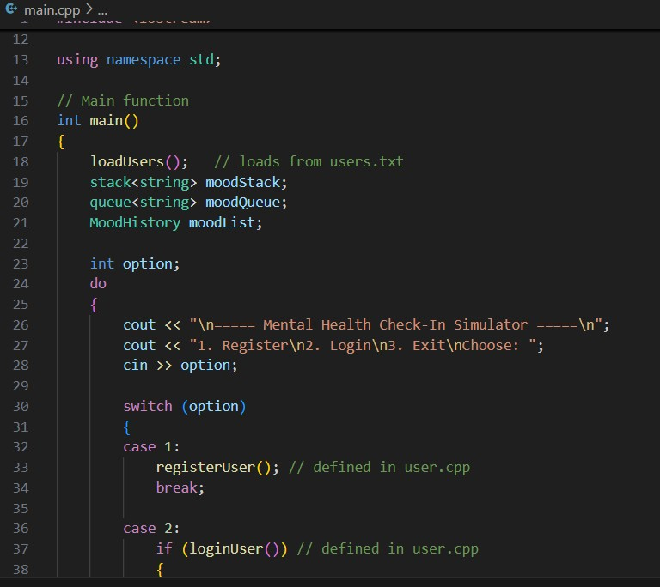

Some Screenshots of Project code:

Output:

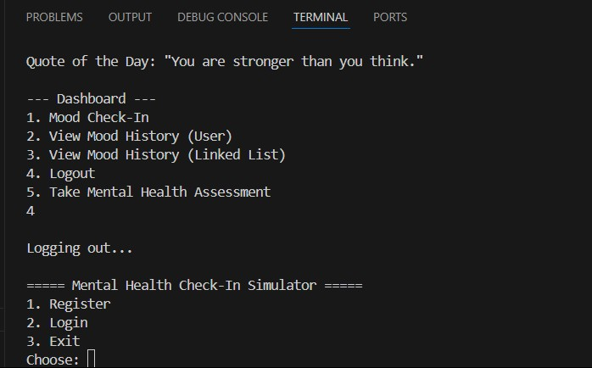

 INTRODUCTION OF THE COMPANY/WORK

- Company’s Vision and Mission: Cipher Schools is a leading ed-tech platform with a mission to make high-quality, practical skill development accessible to students globally. Their vision is to bridge the gap between academic knowledge and industry requirements by providing comprehensive training in cutting-edge technologies.

- Origin and growth of company: Founded to address the growing demand for skilled developers, Cipher Schools has experienced rapid growth, expanding its course offerings and building a community of learners.

- Various departments and their functions: While an online training platform, the company is structured with teams dedicated to content creation, technical support, student mentorship, and platform development to ensure a high-quality learning experience.

- Organization chart of the company: As an online platform, the organization chart is dynamic, but generally follows a structure with founders, content leads, and technical teams supporting the educational products.

Brief description of the work done

The primary task undertaken was the design and development of the “Mental Health Check-In
Simulator” application. The work involved analyzing requirements, designing the system architecture, and implementing it using C++ with Object-Oriented Programming (OOP) principles. Several classes were created to handle core functionalities such as user registration, login, mood tracking, motivational quotes, and mental health assessments. Data structures like stacks, queues, and linked lists were applied for managing user mood history, tracking daily inputs, and displaying motivational messages efficiently. Additionally, file handling was incorporated for persistent storage of user accounts and records. The final application provided an interactive, menu-driven interface for seamless user experience.

Activities/ equipment handled:
The main activity was the design and development of the simulator application. This involved creating multiple C++ classes for user registration, login, mood tracking, and mental health assessments. Data structures such as stacks, queues, and linked lists were implemented to manage mood entries, historical records, and motivational quotes. The primary “equipment” used was my personal computer and software environment for development, including C++ compilers (GCC), a code editor (VS Code), and terminal-based testing tools.

Challenges faced and how those were tackled:
One key challenge was ensuring smooth interaction between different program modules without breaking encapsulation. This was solved by carefully designing class relationships and using inheritance and polymorphism to extend functionality. Another challenge was implementing efficient data storage for mood history; this was addressed by using a linked list for dynamic storage and a stack/queue for real-time tracking. Logical debugging was done step-by-step to ensure program stability.

Learning outcomes:
I gained a deep practical understanding of applying OOP concepts to solve real-life problems, improved my ability to design reusable and modular code, and strengthened my problem-solving skills in data structure implementation. This project enhanced my understanding of how object oriented design can lead to cleaner, more maintainable applications.


CONCLUSION

The course experience has been a highly valuable and transformative journey that bridged the gap between theoretical learning and practical implementation. By working on the project Mental Health Check-In Simulator, I was able to explore the real-world applications of C++ Object-Oriented Programming (OOP) concepts and Data Structures in a structured and meaningful way.
Throughout the development process, I gained hands-on experience in designing classes, applying encapsulation, inheritance, and polymorphism, and integrating data structures such as stacks, queues, and linked lists to manage dynamic data. The use of file handling techniques further enhanced my understanding of persistent data storage, which is essential for developing real-world applications.
The project not only strengthened my technical skills but also improved my problem-solving ability, logical thinking, and coding discipline. It highlighted the importance of planning, modular programming, and debugging in building a functional system. Moreover, applying these concepts to a domain like mental health tracking made the work more impactful and demonstrated how technology can address socially relevant issues.
On a personal level, the project taught me how to approach software development systematically — from requirement analysis, design, coding, and testing, to documentation. It instilled confidence in my ability to work independently on end-to-end development while also preparing me for collaborative, real-world software engineering environments.
In conclusion, this course provided a comprehensive learning experience, equipping me with a strong foundation in C++ OOP and data structures, along with the practical ability to apply them in developing efficient, maintainable, and user-oriented applications. The knowledge and skills gained will not only support my academic growth but also serve as a solid stepping stone for my professional career in software development

REFERENCES
https://www.Cipher Schools.com/courses/cpp-with-oops-programming-language-b58e/lecture-0- brief-about-the-course-and-programming-124f (Accessed on July 15, 2025)

