Game Design Document

Fill up the Following document

1. Write the title of your project.

Ans. Silicon Valley Challenge

1. What is the goal of the game?

Ans. The goal of the game is to reach the white hat.

1. Write a brief story of your game?

The player has to collect the hats that come its way by crossing the obstacles.

1. Which are the playing characters of this game?

* Playing characters are the ones which respond to the user based on the input from the user
* Cars, monkeys, dinos, wizards etc, are the playing characters in the game.

|  |  |  |
| --- | --- | --- |
| Number | Character Name | What can this character do? |
| 1 | Boy | The boy will be walking |
| 2 |  |  |
| 3 |  |  |
| 4 |  |  |
| 5 |  |  |
| 6 |  |  |
| 7 |  |  |
| 8 |  |  |

1. Which are the Non Playing Characters of this game?

* Non Playing characters are the ones which don't have an action or a behaviour when the user interacts with the game.
* Hurdles, stones, bananas, coins, etc are non playing characters in the game.

|  |  |  |
| --- | --- | --- |
| Number | Character Name | What can this character do? |
| 1 | obstacles | These are the different barriers that the player has to cross |
| 2 | Hats | They will appear randomly and you have to collect all the hats. |
| 3 | Points | It will tell the number of hats collected |
| 4 |  |  |
| 5 |  |  |
| 6 |  |  |
| 7 |  |  |
| 8 |  |  |

Draw your imagination of this game. What does this game look like?

* Draw the game either on your computer or on paper,
* Add images of scenes of the game to show each of the playing and non-playing haracters at least once.

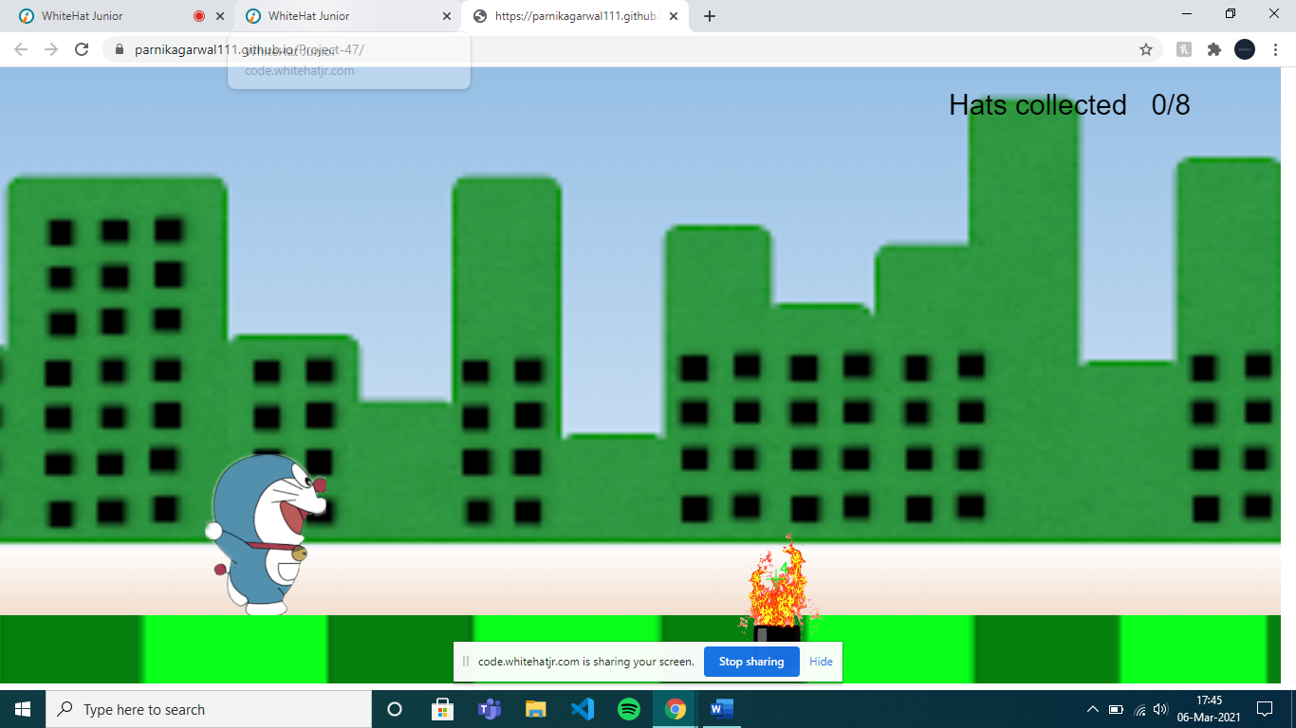

How do you plan to make your game engaging?

By spawning hats