Kathmandu University
Department of Computer Science and Engineering
Dhulikhel, Kavre



A Project Proposal
on
"Banking Management System"

[Code No.: ENGG 102]
(For partial fulfillment of Year I / Semester II in Computer Engineering)

Submitted by
TRILOCHAN SHARMA(Roll No 37.)
UJJWAL UPADHAYA (Roll No 60.)
Aadarsh prasad (Roll No 18.)
SAURAV SHAH (Roll No 32.)

Submitted to
Coordinator's Name
Department of Computer Science and Engineering

April 2026

Abstract

Banking operations form the backbone of any modern economy, and the software systems that support them must be accurate, reliable, and easy to use. In Nepal and across the developing world, a large number of financial institutions — particularly cooperative banks and community savings groups — still rely on manual record-keeping or outdated systems that are difficult to maintain and prone to human error. There is a clear need for accessible, well-designed software that can handle everyday banking tasks efficiently.
The aim of this project is to design and implement a console-based Banking Management System in C++17 that handles core banking operations such as account creation, deposits, withdrawals, fund transfers, and transaction history retrieval. The system is intended to serve as a practical demonstration of how Object-Oriented Programming principles can be applied to model real-world financial workflows.
The system is implemented entirely in C++17 using classes, inheritance, polymorphism, and encapsulation. It supports two account types — Savings and Current — and two user roles: Customer and Administrator. All data is persisted to plain text files so that records survive program restarts without the need for a database engine.
The expected outcome is a fully functional command-line banking application that allows customers to log in securely, manage their accounts, and view their transaction history, while administrators can create and remove accounts and monitor overall system activity. The system will be validated through structured manual test cases covering all major operations and known edge cases.
This project establishes a strong foundation for understanding how real banking software is structured. It is recommended that future versions of this system explore graphical interfaces, database integration, and multi-user concurrency support.

Keywords: Banking System, C++17, Object-Oriented Programming, Inheritance, Polymorphism, File Persistence, CLI

Contents

Chapter 1: Introduction 4
1.1 Background 4
1.2 Objectives 4
1.3 Motivation and Significance 5
1.4 Expected Outcomes 5
Chapter 2: Related Works 6
Chapter 3: Procedure and Methods 7
3.1 Development Approach 7
3.2 System Architecture 7
3.3 Class Hierarchy and OOP Design 8
3.4 Withdrawal Process Flow 9
3.5 Role-Based Access 10
3.6 File Persistence Strategy 10
3.7 Exception Handling 11
Chapter 4: System Requirement Specifications 12
4.1 Software Specifications 12
Use Case Overview 12
Functional Requirements 12
Non-Functional Requirements 13
4.2 Hardware Specifications 14
Chapter 5: Project Planning and Scheduling 15
5.1 Team Roles and Responsibilities 15
5.2 Tasks 15
5.3 Detailed Weekly Schedule 15
5.4 Key Milestones 16
References 18

Chapter 1: Introduction
This chapter introduces the Banking Management System, explains the context in which the project is being undertaken, and outlines the objectives, motivation, and expected outcomes of the work.

1.1 Background
The banking sector is one of the most heavily computerized industries in the world, yet the underlying concepts that drive banking software — account management, transaction logging, role-based access, and data persistence — are surprisingly approachable when studied from first principles. At their core, these systems are about reliably storing and updating structured data in response to user actions, which makes them an excellent candidate for a university-level software project.
In Nepal, the rapid growth of cooperative banks, savings and credit organizations, and rural financial institutions has created a demand for lightweight software tools that can run without expensive infrastructure. Many small institutions continue to manage accounts using ledgers or basic spreadsheets, which are slow, hard to audit, and vulnerable to data loss. A simple but well-structured software system can address these problems directly.
C++ is particularly well suited to this kind of project because it forces the developer to think carefully about data layout, memory, and program structure. Building a banking system in C++ using Object-Oriented Programming gives students a hands-on understanding of how classes model real-world entities, how inheritance captures the relationship between account types, and how polymorphism allows a single interface to handle different behaviors depending on context.

1.2 Objectives
- To design and implement a console-based Banking Management System in C++17 that supports core operations including account creation, deposit, withdrawal, fund transfer, and transaction history display.
- To apply Object-Oriented Programming concepts — specifically inheritance, polymorphism, and encapsulation — through a class hierarchy that models real banking entities such as Account, SavingsAccount, CurrentAccount, Customer, and Transaction.
- To implement a role-based access system that distinguishes between Customer and Administrator users, each with their own set of permitted operations.
- To persist all account and transaction data to files so that information is retained across program sessions without requiring an external database.

1.3 Motivation and Significance
The choice of a banking system as a project topic was driven by two things: relevance and technical richness. Virtually everyone interacts with a bank at some point, which means the problem domain is immediately understandable — there is no need to explain what a deposit or a balance check means. This makes it easier to reason about correctness and to write meaningful test cases.
From a technical standpoint, a banking system touches almost every major concept covered in an introductory C++ course. Account types map naturally to a class hierarchy. The distinction between what a customer can do and what an administrator can do calls for role-based logic. The requirement to preserve data between sessions introduces file I/O. The need to prevent invalid operations — withdrawing more than the balance, accessing another user's account — makes exception handling not just a nice addition but a necessity.
The project is also significant because it produces something demonstrably useful. Unlike many academic exercises that exist purely for assessment, this system could, with modest extension, serve as the foundation for a real small-scale banking tool.

1.4 Expected Outcomes
- A working command-line banking application that compiles and runs on any Linux or macOS machine with a C++17-capable compiler.
- A class hierarchy covering a base Account class and derived SavingsAccount and CurrentAccount classes, each implementing type-specific behavior such as interest calculation and overdraft handling.
- A two-role user system where customers manage their own accounts and administrators manage the overall system, with PIN-based authentication separating the two.
- A file-based persistence layer that reads account and transaction records on startup and writes them on every state change, so no data is lost between sessions.
- A documented test report covering all major features and edge cases, submitted alongside the final source code and project report.

Chapter 2: Related Works
A number of prior projects and published works have explored the design of banking and financial management software, both as industrial systems and as academic exercises. The following review situates this project within that broader context.
Gamma et al. (1994) introduced the concept of design patterns in software engineering, several of which apply directly to banking system design. The Strategy pattern is useful for switching between interest calculation policies across account types, while the Observer pattern can model transaction notification systems. Although design patterns are not the explicit focus of this project, the class hierarchy and virtual function design draws from principles discussed in that foundational work.
Stroustrup (2013) provides the theoretical and practical grounding for the C++17 features used in this project, including virtual dispatch, constructor chaining across inheritance hierarchies, and the standard file stream library. The account class hierarchy in this project is structured in line with the examples of polymorphic type hierarchies discussed in that text.
A commonly referenced academic banking project is the Bank Account Management System described by Singh and Verma (2018), implemented in Java using similar OOP principles. Their system supports savings and current accounts, transaction logging, and user authentication — a scope that closely mirrors this project. The primary difference is the implementation language and the absence of a graphical interface in our version.
Pandey and Karmacharya (2020) developed a cooperative bank management tool for small financial institutions in Nepal, also using C++. Their work highlighted the importance of file-based persistence in environments where database servers are not available — a constraint directly applicable to this project. Their approach to storing account records as delimited text files informed the file format design used here.

Chapter 3: Procedure and Methods
This chapter describes how the system is designed and built — the class structure, the data flow between components, the file persistence strategy, and the overall development approach followed across the ten-week timeline.

3.1 Development Approach
The project follows an incremental development model. Rather than attempting to build all features at once, the team works layer by layer: the class hierarchy and core data structures are established first, then individual features are added and tested one at a time. Each team member owns a specific functional area for the full duration of the project. All code is committed to a shared Git repository, and no code is merged to the main branch without a passing build and at least one peer review.

3.2 System Architecture
The system is organized into four functional layers. The CLI Interface Layer handles all user interaction — it reads input, validates it, and routes requests to the Bank Engine. The Bank Engine contains the core business logic and acts as the coordinator for all modules. Below it sit four independent modules: the Account Manager, the Auth Module, the Transaction Manager, and the Admin Module. All four modules read and write data through a shared File I/O Layer that manages the two persistence files.

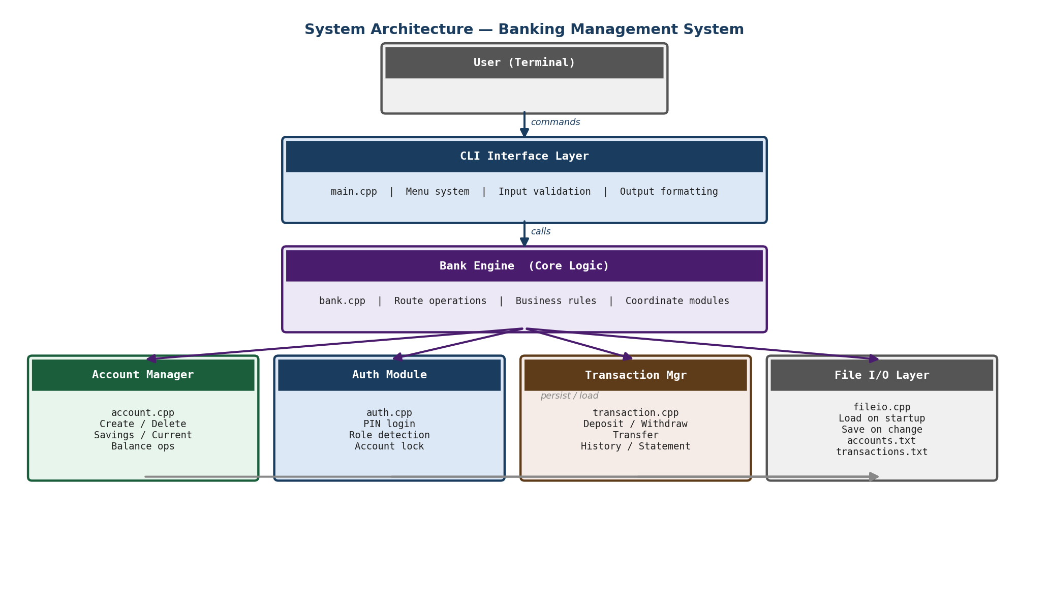
Figure 3.1: System Architecture Diagram

3.3 Class Hierarchy and OOP Design
The system is built around a core class hierarchy. The base class Account holds attributes common to all account types: account number, holder name, balance, PIN, and creation date. Two derived classes extend this base. SavingsAccount adds an interest rate and enforces a minimum balance requirement on withdrawals. CurrentAccount adds an overdraft limit, allowing the balance to go negative up to a defined threshold.
The withdraw() and calculateInterest() methods are declared virtual in the base class, allowing the correct version to be called at runtime depending on the actual account type. This is the central application of polymorphism in the system. The Customer class holds a reference to an Account object and encapsulates the operations a customer is permitted to perform. The Transaction class records every financial event with a timestamp, amount, type, and resulting balance. The Bank class acts as the top-level container, managing all accounts and transactions and owning the persistence logic.

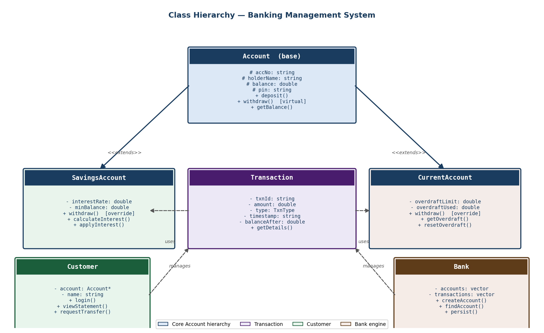
Figure 3.2: Class Hierarchy Diagram

3.4 Withdrawal Process Flow
Every operation in the system follows a structured flow of validation steps before any state change is made. The withdrawal operation is the most representative of this pattern as it involves authentication checking, account-type-specific rule evaluation, state update, and persistence — all in sequence. The flowchart below illustrates this complete process for both Savings and Current account types.

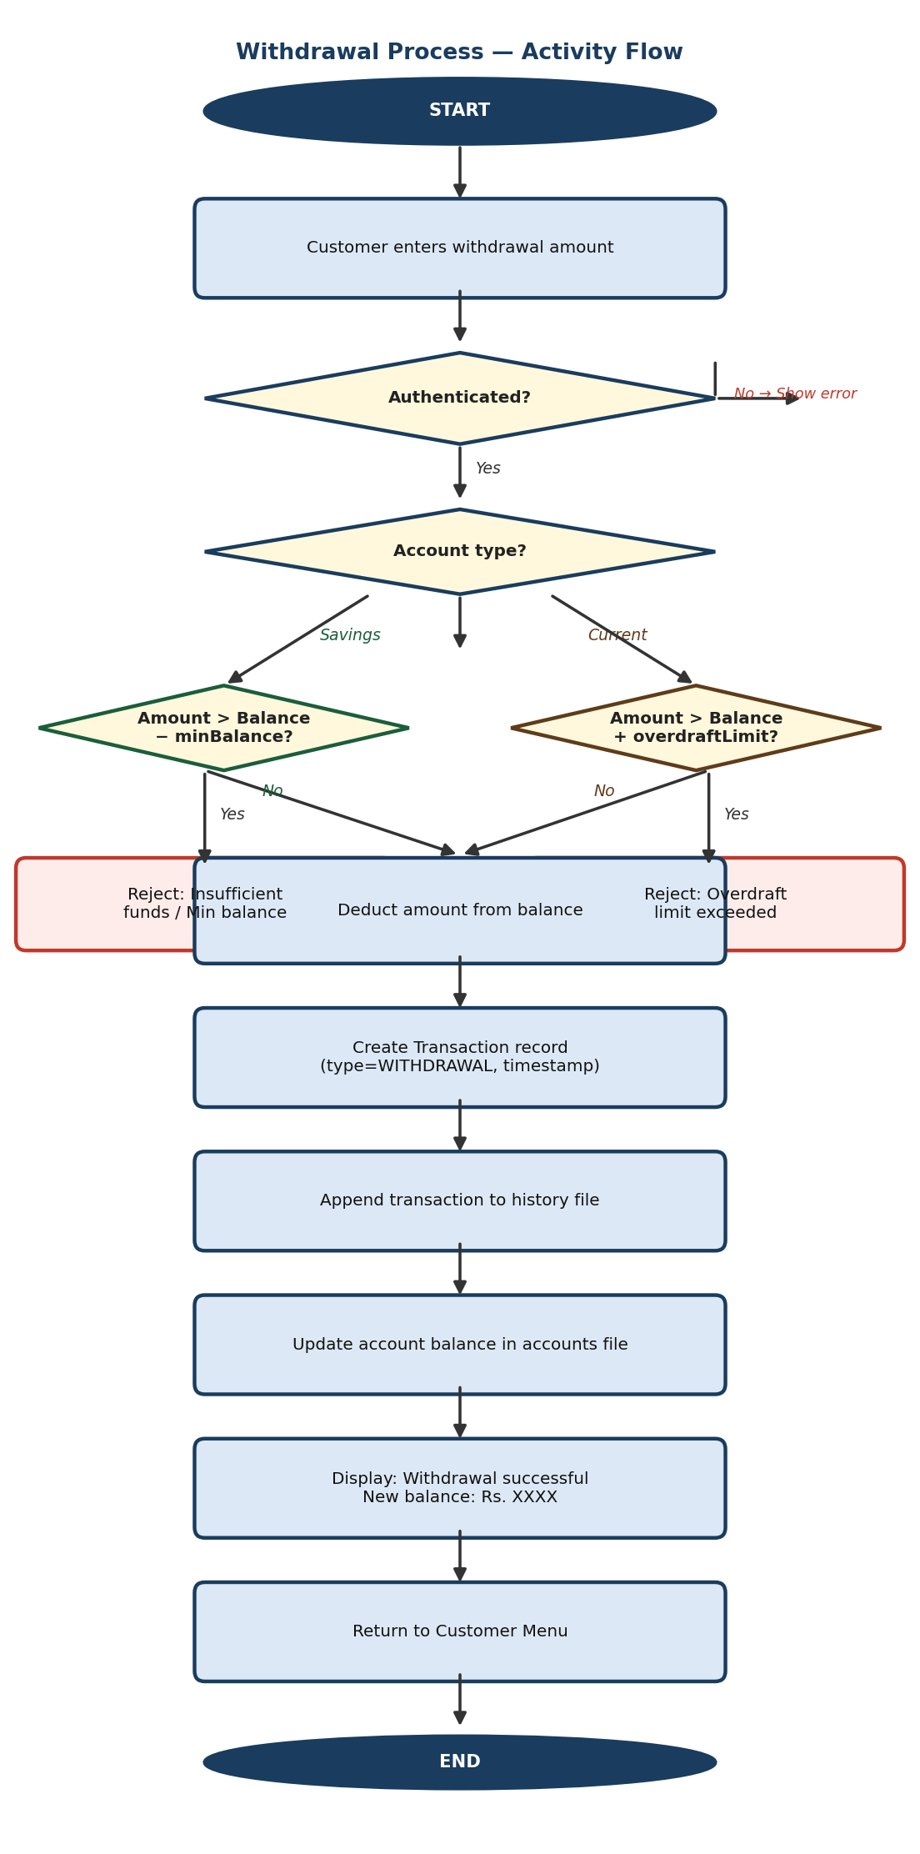
Figure 3.3: Withdrawal Process — Activity Flowchart

3.5 Role-Based Access
The system supports two user roles. A Customer can log in using their account number and PIN, view their balance, deposit or withdraw funds, transfer to another account, and print a mini statement of their last ten transactions. An Administrator logs in with a separate admin PIN and can create new accounts, delete existing accounts, search for any account by number, and view a summary of all accounts in the system. Neither role can access the functions of the other.

3.6 File Persistence Strategy
All account records are stored in a plain text file, with one account per line and fields separated by a delimiter character. When the program starts, it reads this file and reconstructs all Account objects in memory. Whenever an account is created, modified, or deleted, the file is rewritten in full. Transaction history is stored in a separate file, one transaction per line, identified by account number. This approach requires no external database and works reliably on any system with a standard filesystem.

3.7 Exception Handling
The system uses C++ exception handling throughout to manage invalid operations cleanly. Attempting to withdraw more than the available balance throws an InsufficientFundsException. Entering an incorrect PIN repeatedly triggers an AccountLockedException. Accessing a nonexistent account number throws an AccountNotFoundException. These exceptions are caught at the menu level and displayed as readable error messages without crashing the program.

Chapter 4: System Requirement Specifications
This chapter details the functional and non-functional requirements of the Banking Management System, along with the software and hardware environment in which it will be developed and run.

4.1 Software Specifications

Use Case Overview
The diagram below summarizes all operations available to each user role. Customer operations are grouped on the left; administrator operations on the right. Both roles share the login use case.

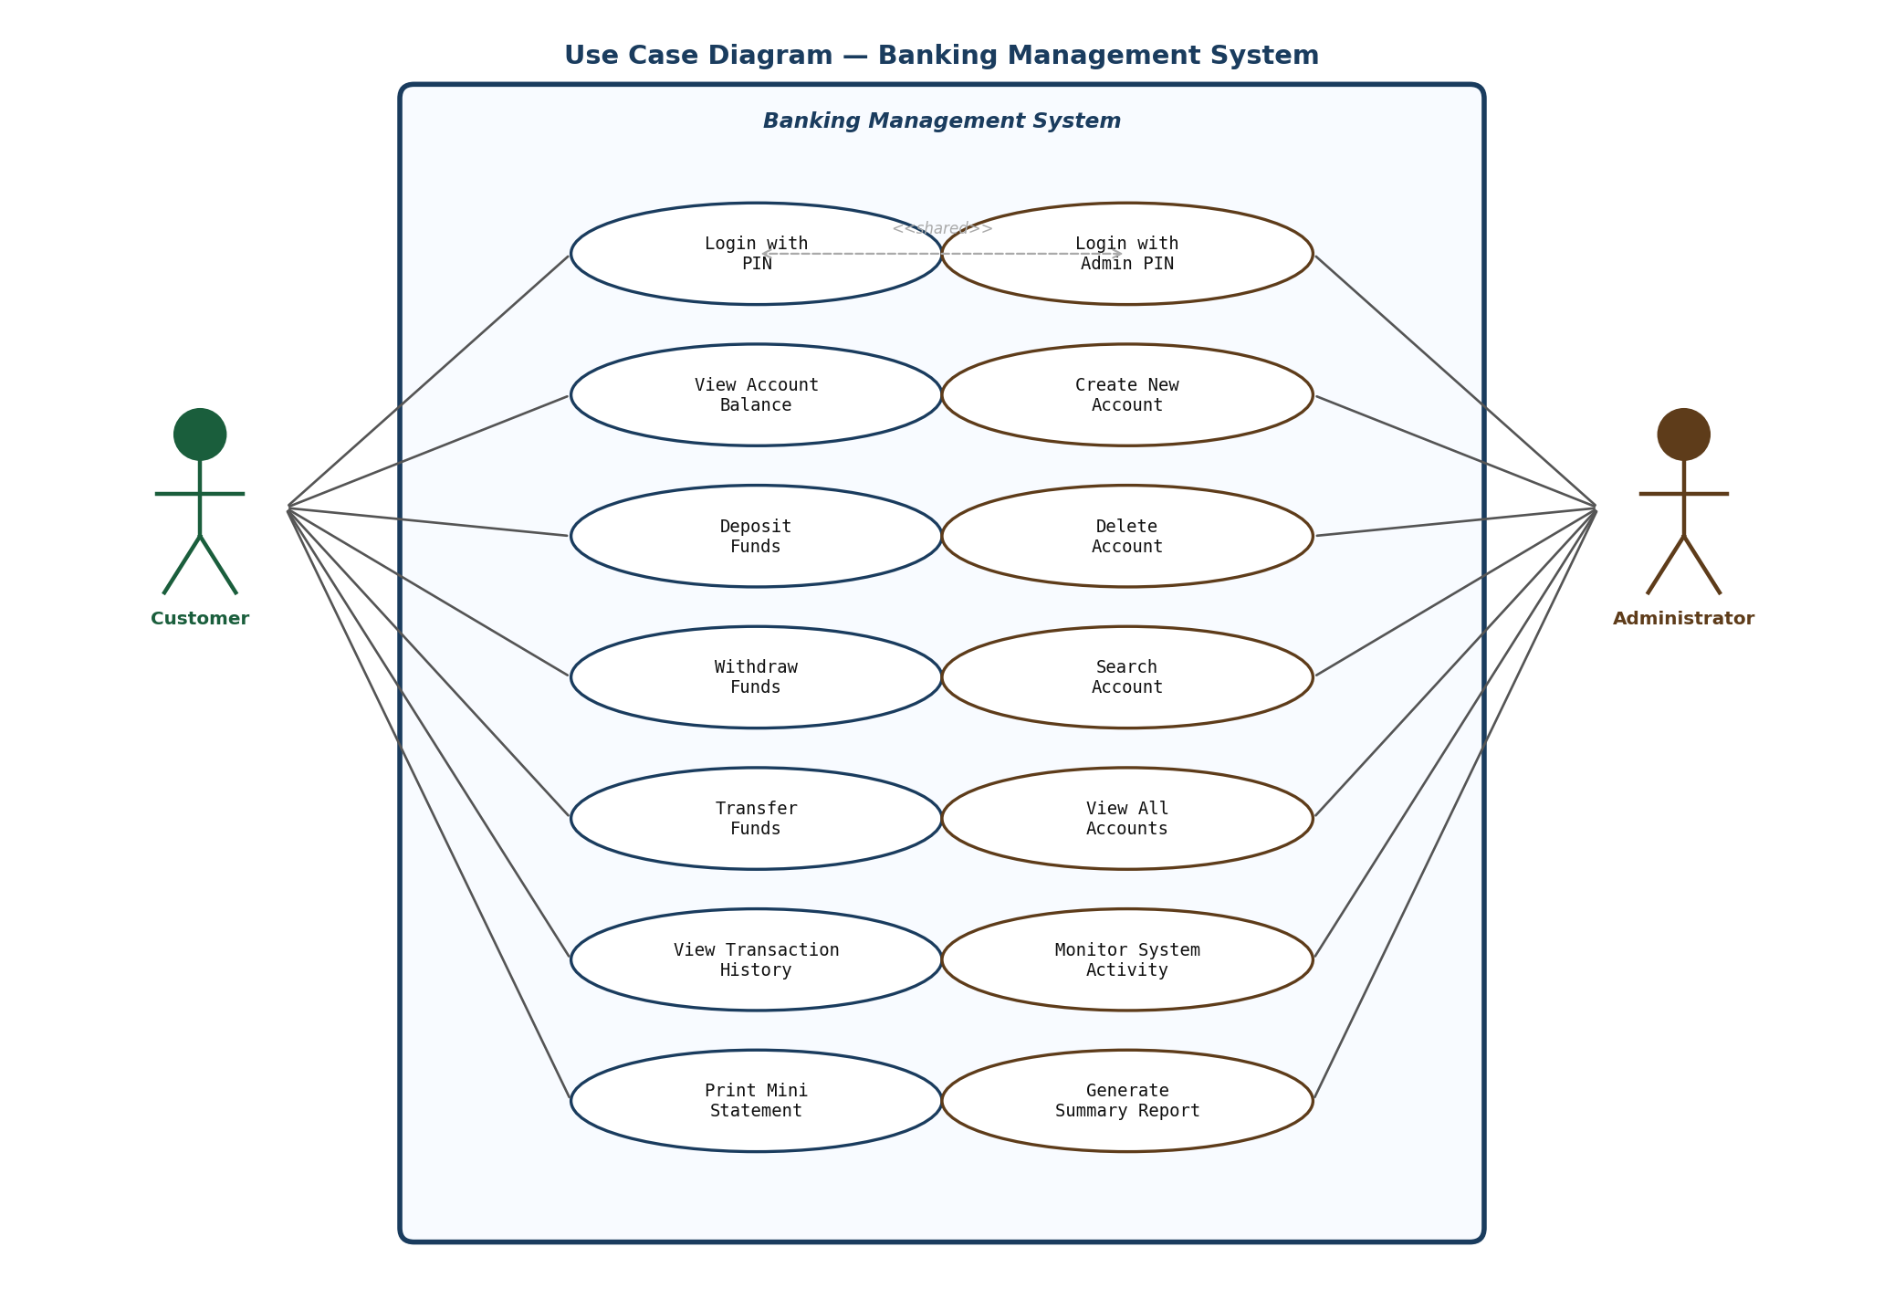
Figure 4.1: Use Case Diagram — Banking Management System

Functional Requirements
- The system shall present a login menu on startup, allowing the user to authenticate as a Customer or Administrator using a numeric account number and PIN.
- A Customer shall be able to deposit funds into their own account, with the balance updated immediately and the transaction recorded with a timestamp.
- A Customer shall be able to withdraw funds, subject to available balance for SavingsAccount holders and the overdraft limit for CurrentAccount holders.
- A Customer shall be able to transfer funds to any other valid account number in the system, with both accounts updated atomically.
- A Customer shall be able to view a mini statement listing their most recent ten transactions, including date, type, amount, and running balance.
- A SavingsAccount shall enforce a configurable minimum balance; withdrawals that would breach this minimum shall be rejected with a clear error message.
- A CurrentAccount shall support a configurable overdraft limit; withdrawals beyond the limit shall be rejected.
- An Administrator shall be able to create a new account by entering holder name, account type, initial deposit, and PIN.
- An Administrator shall be able to close an account by account number, provided the account balance is zero at the time of closure.
- An Administrator shall be able to search for and display the details of any account in the system.
- All account and transaction data shall be written to file on every state change so that no data is lost if the program exits unexpectedly.

Non-Functional Requirements
- The system shall be implemented in C++17 and compile without warnings using g++ with the -std=c++17 and -Wall flags.
- No external libraries or database engines shall be used; all persistence shall rely on the C++ standard file stream library.
- The system shall handle invalid inputs — non-numeric entries, out-of-range values, incorrect PINs — without crashing, displaying a clear error and returning to the appropriate menu.
- After three consecutive failed PIN attempts, the account shall be temporarily locked and the user returned to the main login screen.
- The compiled binary shall run on Linux and macOS without modification.

Component | Tool / Technology | Purpose
Language | C++17 (g++ 11+) | Core implementation language
Build System | GNU Make | Compilation and linking of all modules
File Storage | Plain text files (.txt) | Persistent storage for accounts and transactions
Version Control | Git | Team source code management and collaboration
Testing | Manual test scripts | Validation of all features and edge cases
OS | Linux / macOS | Target development and execution environment

4.2 Hardware Specifications
The system has no specialized hardware dependencies. Any personal computer or laptop capable of running a modern C++ compiler is sufficient for both development and demonstration purposes.

Component | Minimum Requirement
Processor | Any x86-64 CPU
RAM | 2 GB (4 GB recommended)
Storage | 200 MB free disk space
Operating System | Linux (Ubuntu 20.04+) or macOS 12+
Compiler | g++ 11+ or clang++ 13+

Chapter 5: Project Planning and Scheduling
The project is carried out over ten weeks. Work is divided into five phases — planning, design, implementation, integration and testing, and documentation — with each week having specific deliverables assigned to each team member. A weekly sync meeting is held every Monday, chaired by the Team Leader.

5.1 Team Roles and Responsibilities

ID | Role | Primary Responsibility
TRILOCHAN SHARMA | Team Leader / Supervisor | Bank engine, file persistence, architecture decisions, code reviews, Authentication module, Admin features, testing and test documentation
SAURAV SHAH | Developer | CLI menu system, login flow, user-facing output and formatting
Aadarsh prasad | Developer | Account class hierarchy — base Account, SavingsAccount, CurrentAccount
UJJWAL UPADHAYA | Developer | Transaction system, transfer logic, interest calculation, mini statement

5.2 Tasks
- Problem identification, scope definition, and requirement gathering
- System architecture design and class hierarchy planning
- Core infrastructure — base classes, file I/O layer, build system setup
- Account management — create, view, delete, save and load from file
- Deposit and withdrawal operations with balance validation
- Fund transfer between accounts and transaction history recording
- Authentication system — PIN login, account lock after failed attempts
- Admin module — account creation, deletion, search, system summary
- Integration testing, error handling hardening, and edge case fixes
- Documentation — project report, user manual, final submission

5.3 Detailed Weekly Schedule

Week | Phase | Key Deliverables
1 | Kickoff & Planning | Roles assigned, shared repository created, requirements documented, development environment verified on all machines
2 | Architecture & Design | Class hierarchy finalized, data structures defined (Account, Transaction, Customer), header files drafted, Makefile created
3 | Core Infrastructure | Base Account class implemented, file read/write layer working, Bank engine skeleton, CLI dispatcher routing to stubs
4 | Account Management | Create account, view account, delete account fully working; account data correctly saved to and loaded from file
5 | Deposit & Withdrawal | Deposit and withdrawal working with full balance validation; SavingsAccount minimum balance and CurrentAccount overdraft enforced
6 | Transfer & History | Fund transfer between accounts working; transaction log recording all events with timestamps; mini statement display
7 | Auth & Admin Module | PIN login working, three-strike account lock implemented, Admin menu complete with all admin operations functional
8 | Integration & Hardening | Full system integration tested end-to-end; all known bugs fixed; invalid input handling verified; regression suite run
9 | Documentation | Project report drafted (all chapters); user manual written with examples; all source code commented
10 | Final Submission | Final build verified on clean machine; demo walkthrough prepared and rehearsed; all deliverables submitted

5.4 Key Milestones

Deadline | Milestone
End of Week 2 | Full class hierarchy on paper; all header files committed; project compiles with stubs
End of Week 4 | Account creation, deletion, and file persistence working correctly
End of Week 5 | Deposit and withdrawal complete with type-specific validation passing
End of Week 6 | Fund transfer working; transaction history correctly recorded and displayed
End of Week 7 | Authentication and Admin module complete; full feature set implemented
End of Week 8 | All integration tests passing; error handling hardened; no known critical bugs
End of Week 9 | Project report and user manual complete; code fully commented and reviewed
End of Week 10 | Final release build ready; demonstration prepared; all deliverables submitted on time

References
Gamma, E., Helm, R., Johnson, R. and Vlissides, J. (1994). Design Patterns: Elements of Reusable Object-Oriented Software. Addison-Wesley.
Pandey, R. and Karmacharya, A. (2020). Development of a cooperative bank management system for small financial institutions. Journal of Computer Science and Information Technology, Nepal, 8(1), 45–53.
Singh, A. and Verma, R. (2018). Bank account management system using object-oriented programming. International Journal of Engineering Research and Technology, 7(4), 112–118.
Stroustrup, B. (2013). The C++ Programming Language (4th ed.). Addison-Wesley.
Schildt, H. (2014). C++: The Complete Reference (4th ed.). McGraw-Hill Education.

