
23CSE203
DATA STRUCTURES AND ALGORITHM

Submitted by
Name | Akepati Parnitha
Roll.no | AV.SC.U4CSE25002
Section | CSE-A

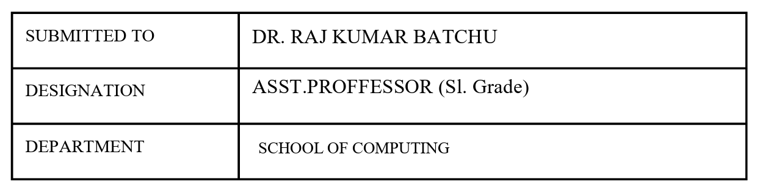
Credit | 5

Index
S.no | Title | Page.no | Remark
1. | A) A rocket launch system displays a countdown before launch. Instead of using loop, implement the countdown using recursion. Write a recursive program to display a countdown from n to 1 followed by launch.  B) Bank calculates the growth of an investment using compound intrest. The formula requires calculating powers, which can be implemented recursively. Write a recursive program to calculate p^{n}(power), where P=principal growth factor, n=no.of years.  C) Write a recursive progrsm to print the first n terms of fibanocci series  D) An hr department stores employee ids in a list develop a recursive program to search for a given employee id. Write a recursive function to search for an employee id in the list.  E) In a logistics the no.of possible ways to arrange n different parcels calculate using the factorial (n!). develop a recursive program to calculate the factorial of given number. | 4-13
2. | A) write a python program to perform linear search on the given input  B) Write a python program to perform binary search on the given input. Verify by taking sorted array and unsorted array as a list. | 14-18

Week - 1

Aim: A rocket launch system displays a countdown before launch. Instead of using loop, implement the countdown using recursion. Write a recursive program to display a countdown from n to 1 followed by launch.
Program:
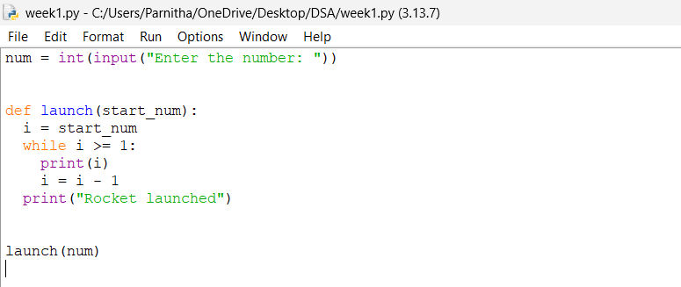
Output:
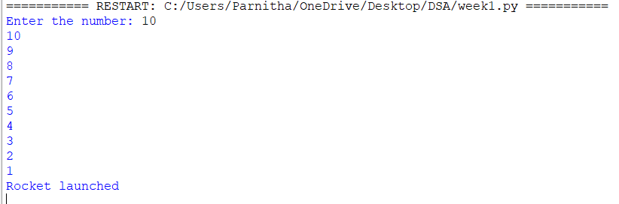
Explanation:
- It takes a number as input from the user and stores it in num.
- It creates a function named launch().
- It starts the countdown from 10 by assigning i = 10.
- It prints the value of i as long as num <= i.
- It decreases the value of i by 1 after each iteration.
- When the loop ends, it prints "Rocket launched" and executes the function using launch().
Error table:
s.no | Error obtained | Rectification
1. | Infinite loop | Iteration at correct place
2. | Calling function at wrong place | Placed with correct syntax

Aim: Bank calculates the growth of an investment using compound intrest. The formula requires calculating powers, which can be implemented recursively. Write a recursive program to calculate p^{n}(power), where P=principal growth factor, n=no.of years.
Program:
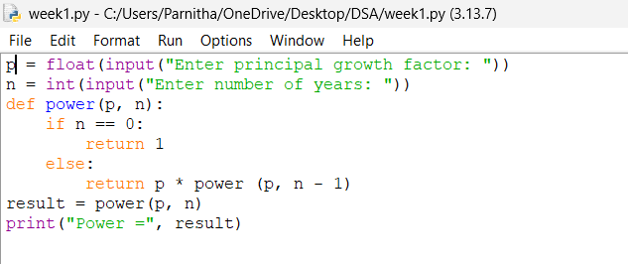
Output:
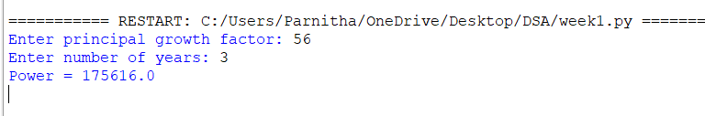

Explanation:
- The program takes the principal growth factor p and number of years n as input.
- It defines a recursive function power(p, n).
- If n is 0, the function returns 1 (base case).
- Otherwise, it returns p * power(p, n-1).
- The recursive calls continue until n becomes 0.
- The final value of pⁿ is displayed as the output.
- Error table:
s.no | Error obtained | Rectification
1. | Return 0 | Return 1
2. | print | return

Aim: Write a recursive progrsm to print the first n terms of fibanocci series
Program:
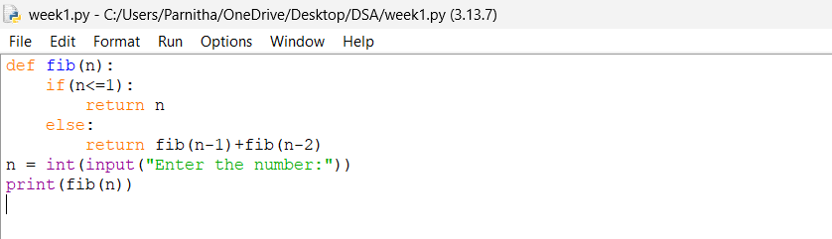
Output:
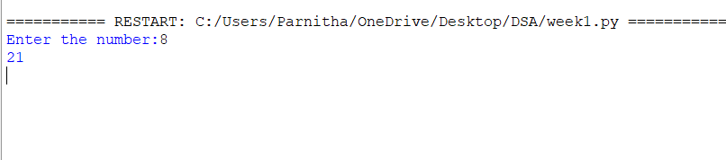
Explanation:
- For entering the number as input from user we defined as n
- We declared variable for formula.
- If input number is less than one then it return “1”
- Or it will goes under fibanocci iteration.
Error:
s.no | Error obtained | Rectification
1. | Forgot to declare n<=1 | rectified
2. | Formula mistake | rectfied

Aim: An hr department stores employee ids in a list develop a recursive program to search for a given employee id. Write a recursive function to search for an employee id in the list.
Program:
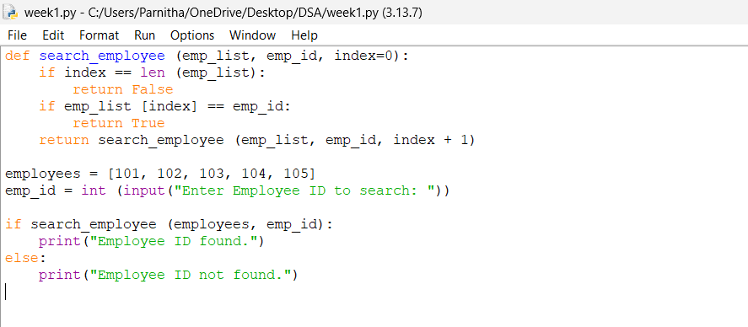
Output:
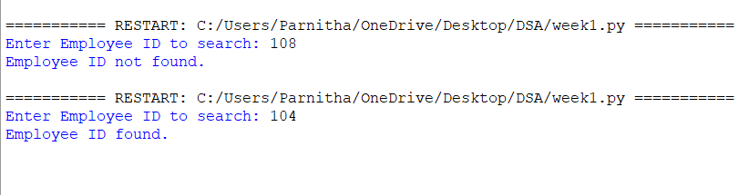

Explanation:
- The program creates a function to search for an employee ID in a list.
- It checks one employee ID at a time, starting from the first ID.
- If the entered employee ID matches the current ID, it returns True.
- If it does not match, the function moves to the next ID using recursion.
- If all employee IDs are checked and no match is found, it returns False.
- Finally, the program displays "Employee ID found." if the ID exists; otherwise, it displays "Employee ID not found."
- Error:
s.no | Error obtained | Rectification
1. | Emp lst | Emp_list
2. | print | Return

Aim: In a logistics the no.of possible ways to arrange n different parcels calculate using the factorial (n!). develop a recursive program to calculate the factorial of given number.
Program:
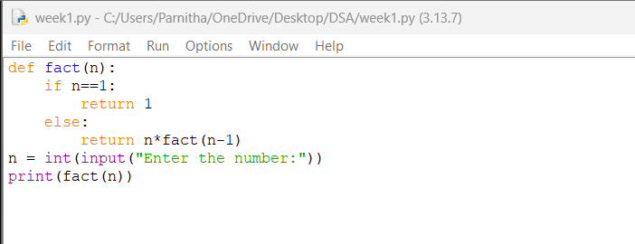
Output:
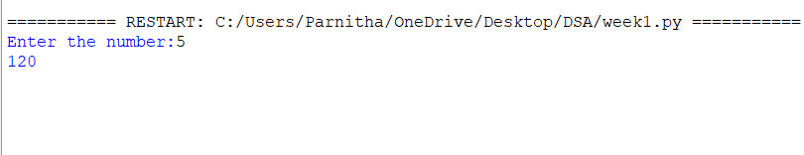

Explanation:
- The program defines a recursive function fact() to calculate the factorial of a number.
- It takes a number as input from the user.
- If the number is 1, the function returns 1 (base case).
- Otherwise, it multiplies the number by the factorial of the previous number (n-1).
- The recursive calls continue until the number becomes 1.
- Finally, the program prints the factorial of the given number.
Error table:
s.no | Error obtained | Rectification
1. | n+1 | n-1
2. | Syntax error | Rectified

WEEK-2
- AIM: Write a python programm to perfor linear search on the given input.
Program:
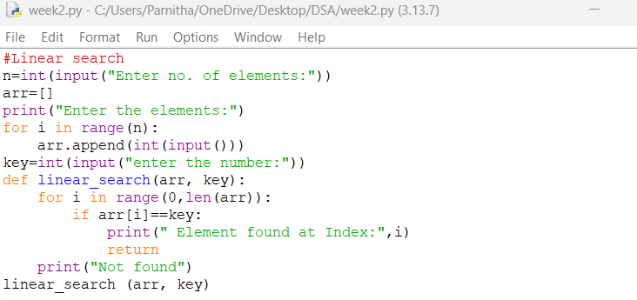
Output:
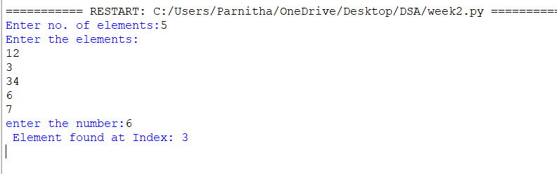

Explanation:
- In linear search we can append elements in sorted or unsorted way also.
- After placing the target we need to check the all the elements in a order.
- The time complixity is O(n).
- The target element may be found at beginning or last or at middle.
Error table:
s.no | Error obtained | Rectification
1. | Return placed in wrong place | Corrected later
2. | Calling the function | Rectified

B) Aim: Write a python program to perform binary search on the list.
Program: Unsorted
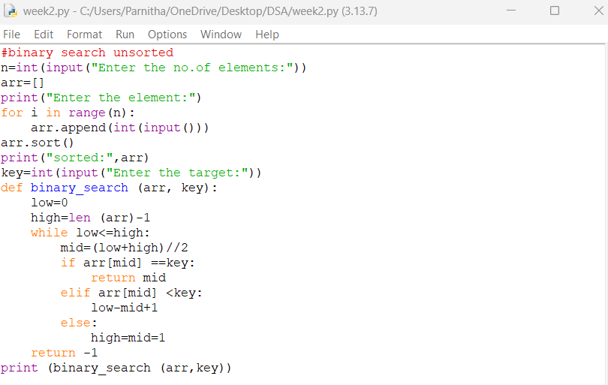
Output:
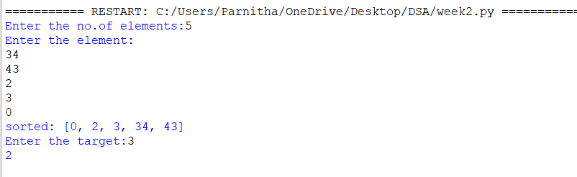

Program: Sorted
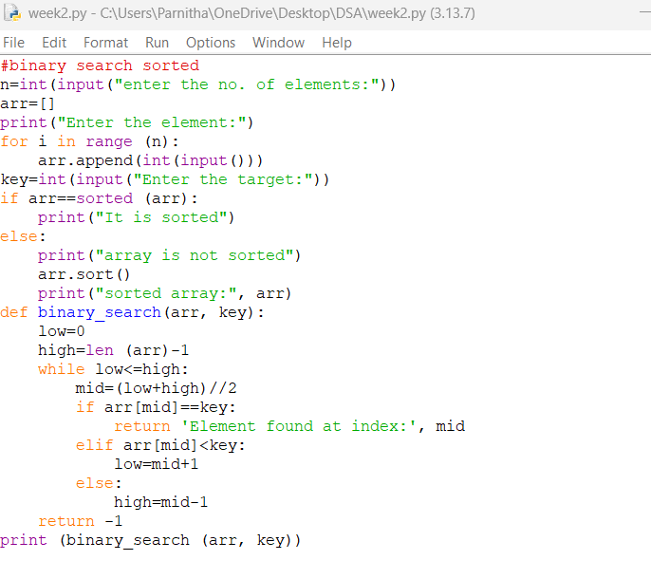
Output:
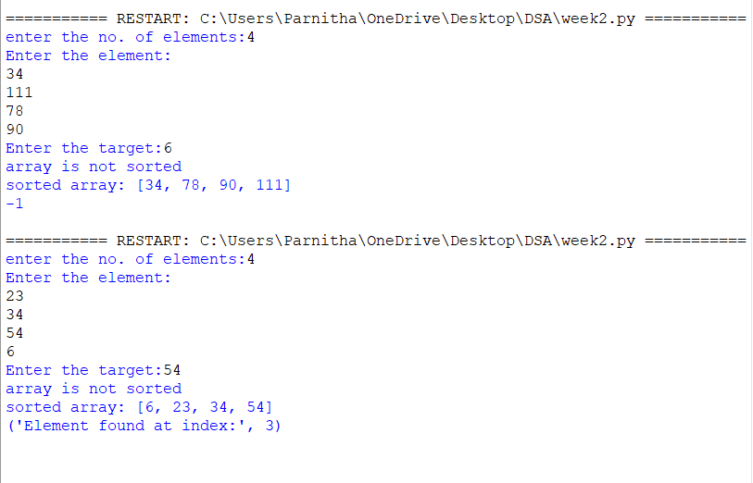

Explanation:
- The binary search should always executed in sorted order.
- Either it can be ascending or descending order.
- So the program is in unsorted order so we need to do sorting first later the binary search is executed.
- Error table:
s.no | Error obtained | Rectification
1. | Mistakes in main logic | Rectified
2. | Errors in conditions | Rectified

WEEK-3
- AIM: write a python program to implement bubble sort, where the elements are taken from user.
Program:

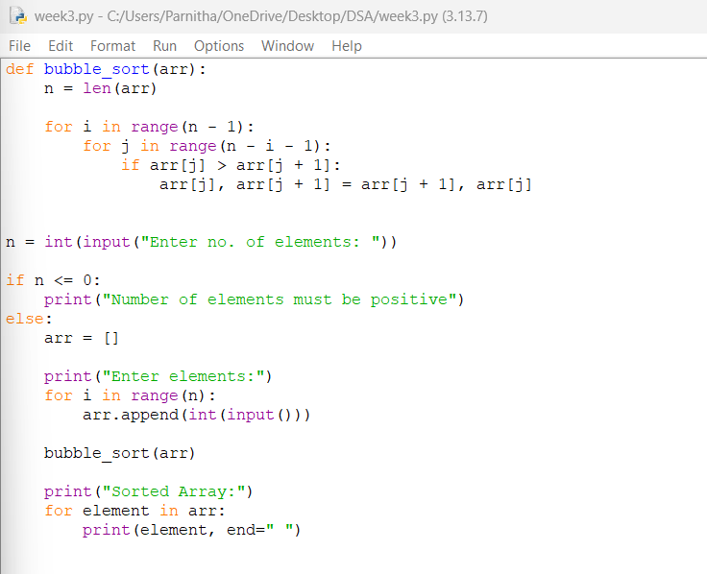

Output:
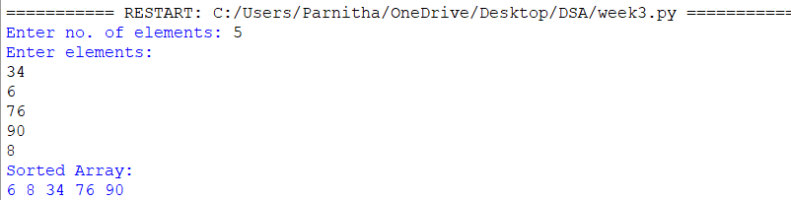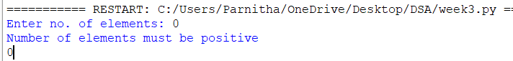

Explanation:
  - Bubble sort is a sorting technique used to arrange elements in ascending or descending order.
  - The program may contain elements in unsorted order, so
adjacent elements are compared and swapped if they are in the wrong order.
  - This process is repeated for multiple passes until the entire array is sorted.
  - For n = 0, the program now prints the error message without trying to use an undefined arr.

Error table:

s.no | Error obtained | Rectification
1. | Mistakes in main logic | Rectified
2. | Errors in conditions | Rectified

- AIM: write a python program to implement insertion sort, where the elements are taken from user.
Program:

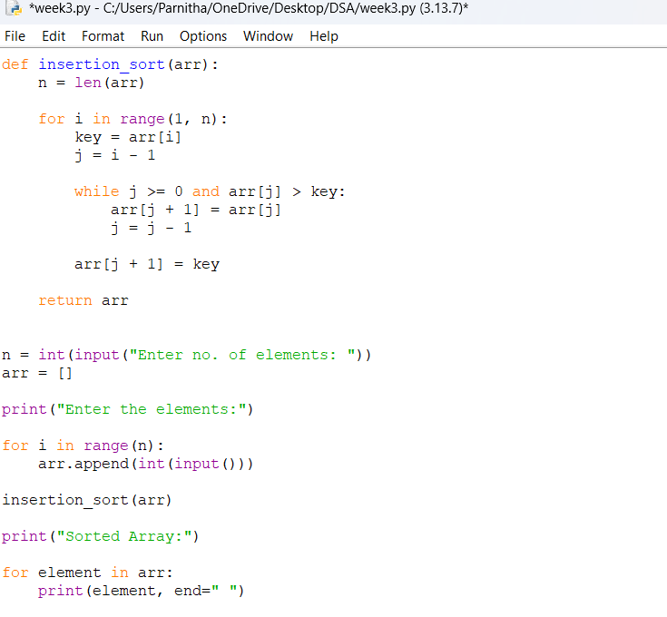

Output:
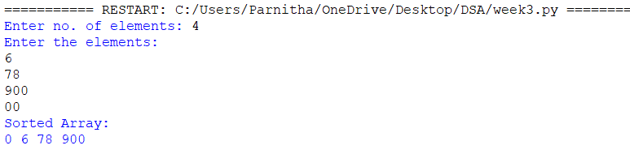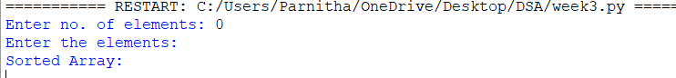

Explanation:
  - Insertion sort is a sorting technique used to arrange elements in ascending or descending order.
  - The program takes one element at a time and inserts it into its correct position in the already sorted part.
  - This process is repeated until all elements are sorted.
  - When the number of elements is zero, the array is empty and insertion sort simply performs no iterations.

Error table:

s.no | Error obtained | Rectification
1. | Mistakes in main logic | Rectified
2. | Errors in conditions | Rectified

- AIM: write a python program to implement selection sort, where the elements are taken from user.
Program:

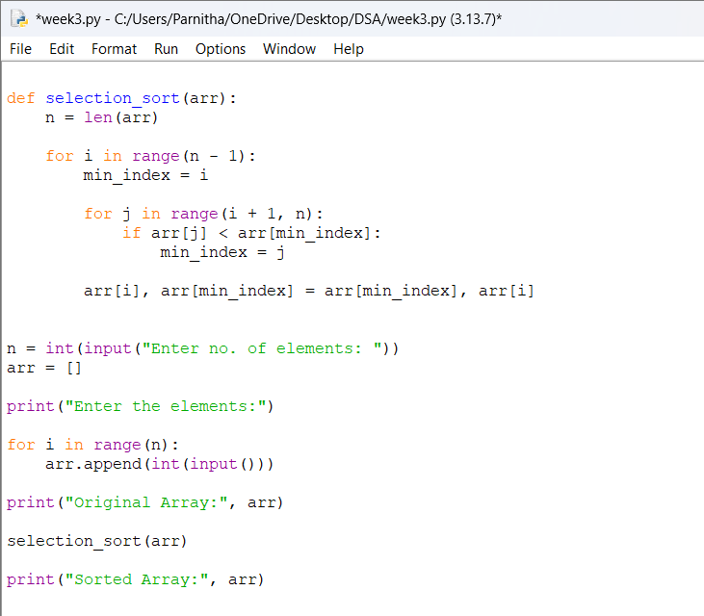

Output:
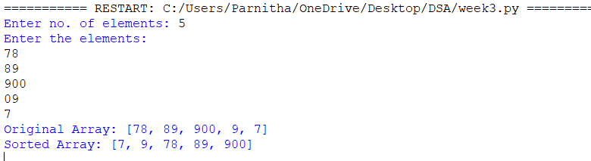

Explanation:

  - Selection sort is a sorting technique used to arrange elements in ascending or descending order.
  - The program finds the smallest element from the unsorted part and swaps it with the first element of that part.
  - This process is repeated until the entire array is sorted.
  - When n = 0, the array is empty and selection sort performs no iterations, so the program runs normally.

Error table:

s.no | Error obtained | Rectification
1. | Mistakes in main logic | Rectified
2. | Errors in conditions | Rectified

WEEK-4
- AIM: write a python program to implement merge sort, where the elements are taken from user.
Program:

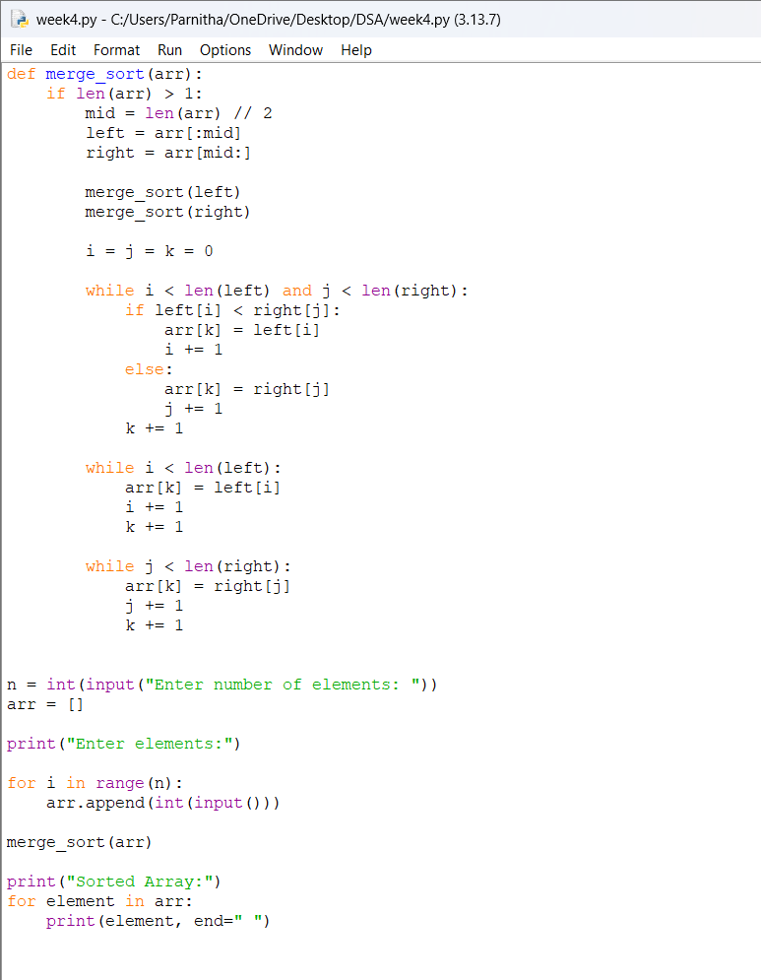

Output:

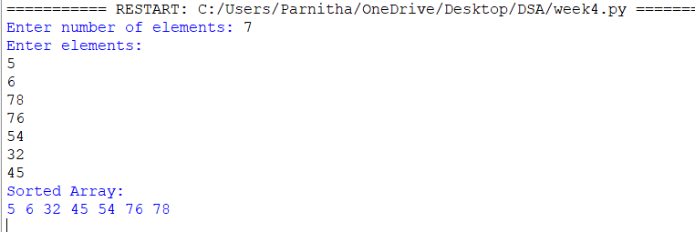

Explanation:
  - Merge Sort divides the array into two halves repeatedly until each part has one element.
  - The smaller arrays are then sorted recursively.
  - The while loop compares elements of the left and right arrays.
  - The smaller element is placed into the original array in sorted order.
  - Finally, the remaining elements are added, giving the completely sorted array.

Error table:

s.no | Error obtained | Rectification
1. | Mistakes in main logic | Rectified
2. | Errors in conditions | Rectified

- AIM: write a python program to implement Quick sort, where the elements are taken from user.
Program:

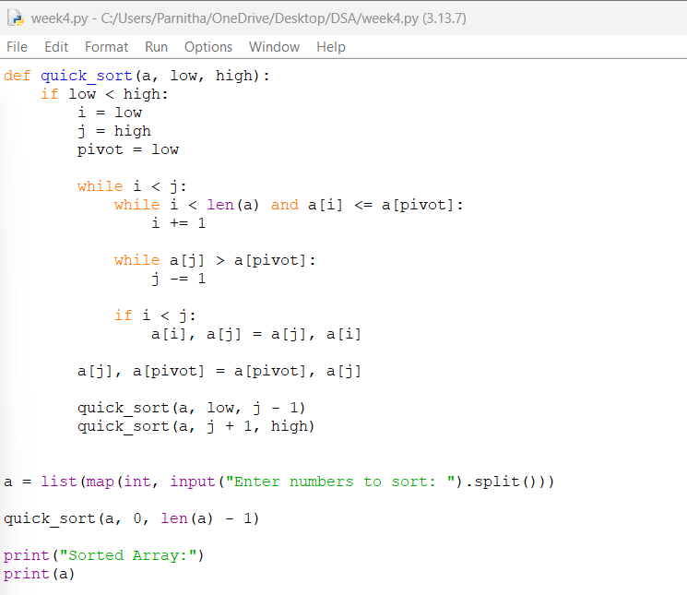

Output:
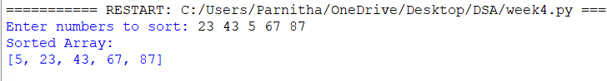

Explanation:
  - Quick Sort selects an element as the pivot and divides the array around it.
  - Elements smaller than the pivot are moved to the left, and larger elements to the right.
  - The pivot is placed in its correct position.

  - Quick Sort is then applied recursively to the left and right parts.
  - This process continues until the entire array is sorted.

Error table:

s.no | Error obtained | Rectification
1. | Mistakes in main logic | Rectified
2. | Errors in conditions | Rectified

Week-4
4. AIM: Write a python program to implement a single linked list which would perform the below operations, by taking an input from the user.
a. Create a linked list. b. Insert at beginning. c. Insert at end.
d. Insert at a specific index. e. Delete by value. f. Delete 1st node. g. Delete last node. h. Count no. of nodes i. Display.
j. Exit.
Programme:
23CSE203
DATA STRUCTURES AND ALGORITHM

Submitted by
Name | Venkateswari. G
Roll.no | AV.SC.U4CSE25029
Section | CSE-A

Credit | 5

Index
S.no | Title | Page.no | Remark
1. | A) A rocket launch system displays a countdown before launch. Instead of using loop, implement the countdown using recursion. Write a recursive program to display a countdown from n to 1 followed by launch.  B) Bank calculates the growth of an investment using compound intrest. The formula requires calculating powers, which can be implemented recursively. Write a recursive program to calculate p^{n}(power), where P=principal growth factor, n=no.of years.  C) Write a recursive progrsm to print the first n terms of fibanocci series  D) An hr department stores employee ids in a list develop a recursive program to search for a given employee id. Write a recursive function to search for an employee id in the list.  E) In a logistics the no.of possible ways to arrange n different parcels calculate using the factorial (n!). develop a recursive program to calculate the factorial of given number. | 4-13
2. | A) write a python program to perform linear search on the given input  B) Write a python program to perform binary search on the given input. Verify by taking sorted array and unsorted array as a list. | 14-18
3. | A) write a python program to sort the elements using a bubble sort technique. Take an input elements from the user.  B) Insertion sort  C)selection sort  D)Merge sort  E) Quick sort | 19-28
4. | A)Write a python program to implement a single linked list which would perform the below operations, by taking an input from the user.  a. create a linked list  b. Insert at beginning. c. Insert at end. d. Insert at a specific index.  e. Delete by value.  f. Delete 1st node.  g. Delete last node.  h. Count no. of nodes i. Display.  j. Exit.  B)Doubly linked list  C) circular linked list | 29-53
5. | A) stack using array  B) stack using linked list | 54-59

Week-1
A) Aim: A rocket launch system displays a countdown before launch. Instead of using loop, implement the countdown using recursion. Write a recursive program to display a countdown from n to 1 followed by launch.
Program:
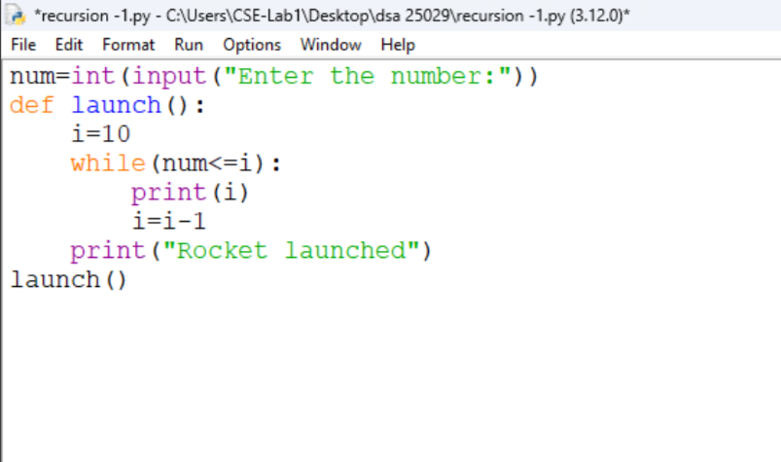
Output:
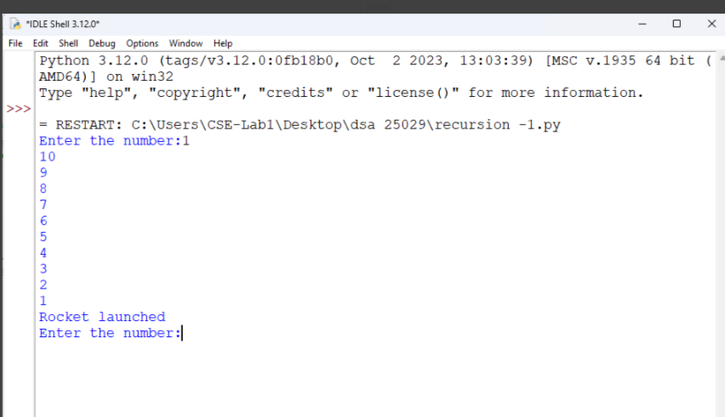
Explanation:
- It takes a number as input from the user and stores it in num.
- It creates a function named launch().
- It starts the countdown from 10 by assigning i = 10.
- It prints the value of i as long as num <= i.
- It decreases the value of i by 1 after each iteration.
- When the loop ends, it prints "Rocket launched" and executes the function using launch().
Error table:
s.no | Error obtained | Rectification
1. | Infinite loop | Iteration at correct place
2. | Calling function at wrong place | Placed with correct syntax

B) Aim: Bank calculates the growth of an investment using compound intrest. The formula requires calculating powers, which can be implemented recursively. Write a recursive program to calculate p^{n}(power), where P=principal growth factor, n=no.of years.
Program:
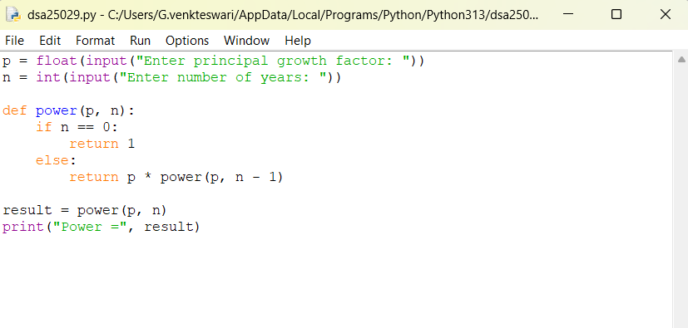
Output:
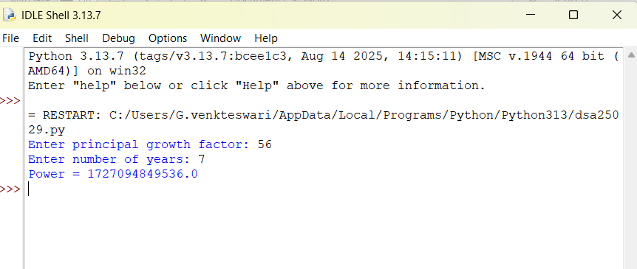

Explanation:
- The program takes the principal growth factor p and number of years n as input.
- It defines a recursive function power(p, n).
- If n is 0, the function returns 1 (base case).
- Otherwise, it returns p * power(p, n-1).
- The recursive calls continue until n becomes 0.
- The final value of pⁿ is displayed as the output.
- Error table:
s.no | Error obtained | Rectification
1. | Return 0 | Return 1
2. | print | return

C) Aim: Write a recursive progrsm to print the first n terms of fibanocci series
Program:
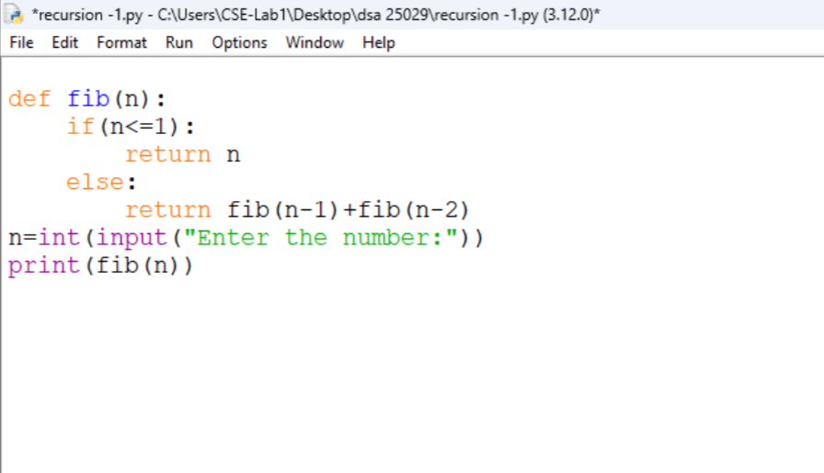
Output:
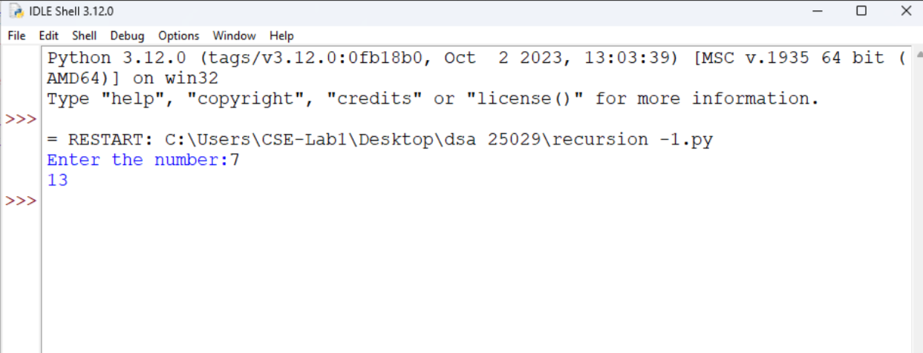

Explanation:
- For entering the number as input from user we defined as n
- We declared variable for formula.
- If input number is less than one then it return “1”
- Or it will goes under fibanocci iteration.
Error:
s.no | Error obtained | Rectification
1. | Forgot to declare n<=1 | rectified
2. | Formula mistake | rectified

D) Aim: An hr department stores employee ids in a list develop a recursive program to search for a given employee id. Write a recursive function to search for an employee id in the list.
Program:
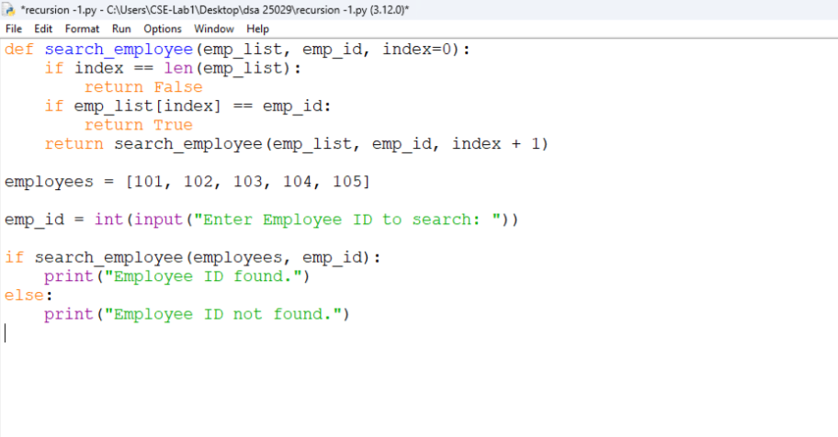
Output:
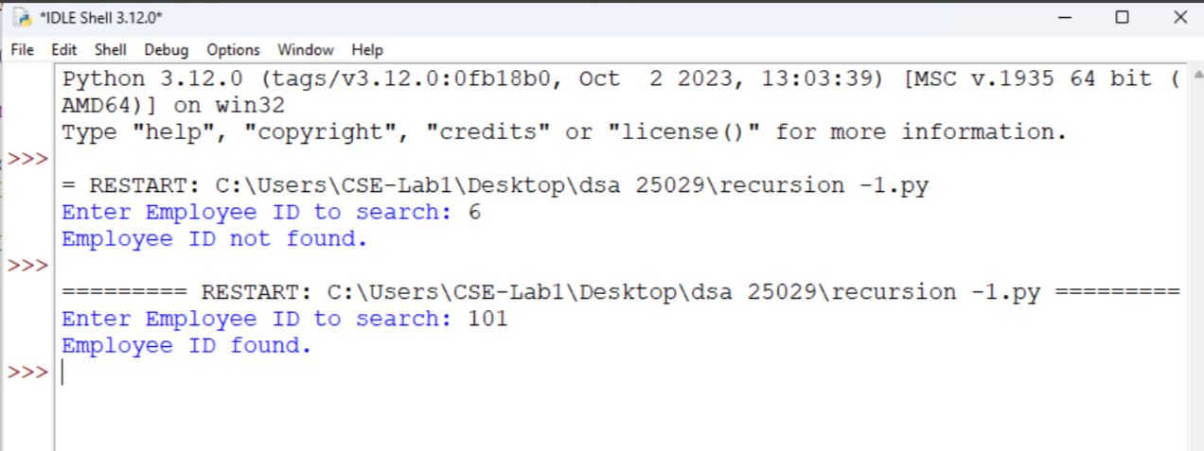

Explanation:
- The program creates a function to search for an employee ID in a list.
- It checks one employee ID at a time, starting from the first ID.
- If the entered employee ID matches the current ID, it returns True.
- If it does not match, the function moves to the next ID using recursion.
- If all employee IDs are checked and no match is found, it returns False.
- Finally, the program displays "Employee ID found." if the ID exists; otherwise, it displays "Employee ID not found."
- Error:
s.no | Error obtained | Rectification
1. | Emp lst | Emp_list
2. | print | Return

E) Aim: In a logistics the no.of possible ways to arrange n different parcels calculate using the factorial (n!). develop a recursive program to calculate the factorial of given number.
Program:
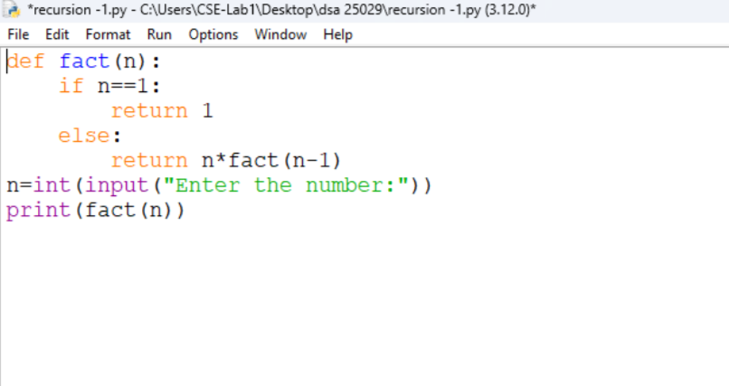
Output:
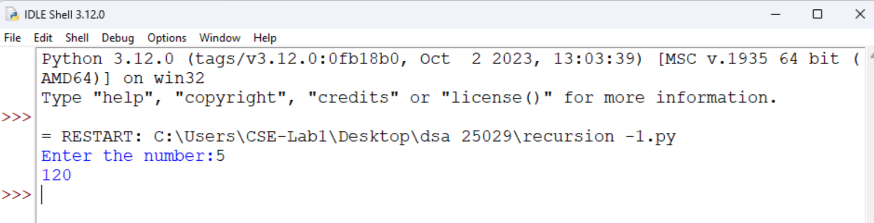

Explanation:
- The program defines a recursive function fact() to calculate the factorial of a number.
- It takes a number as input from the user.
- If the number is 1, the function returns 1 (base case).
- Otherwise, it multiplies the number by the factorial of the previous number (n-1).
- The recursive calls continue until the number becomes 1.
- Finally, the program prints the factorial of the given number.
Error table:
s.no | Error obtained | Rectification
1. | n+1 | n-1
2. | Syntax error | Rectified

WEEK-2
- AIM: Write a python programm to perfor linear search on the given input.
Program:
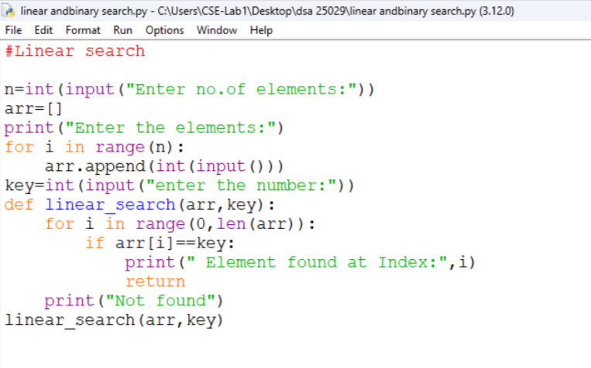
Output:
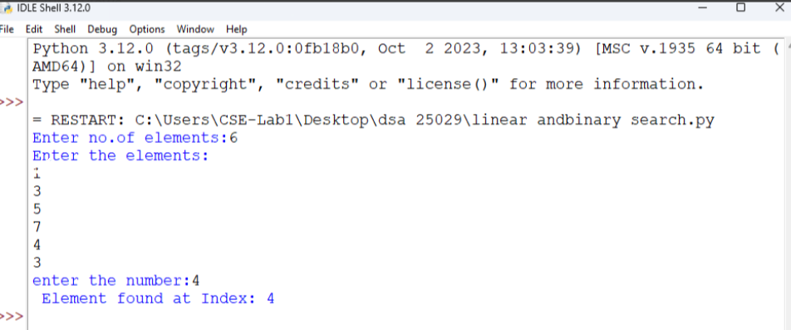

Explanation:
- In linear search we can append elements in sorted or unsorted way also.
- After placing the target we need to check the all the elements in a order.
- The time complixity is O(n).
- The target element may be found at beginning or last or at middle.
Error table:
s.no | Error obtained | Rectification
1. | Return placed in wrong place | Corrected later
2. | Calling the function | Rectified

B) Aim: Write a python program to perform binary search on the list.
Program: Unsorted
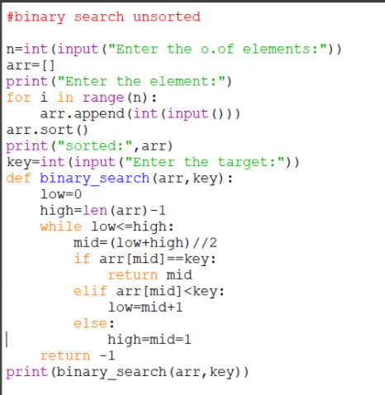
Output:
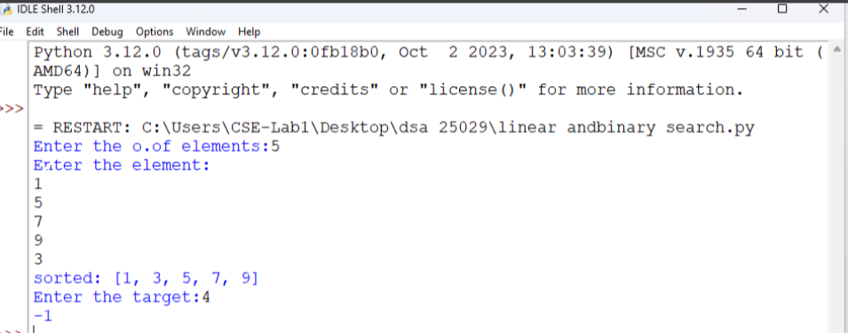

Program: Sorted
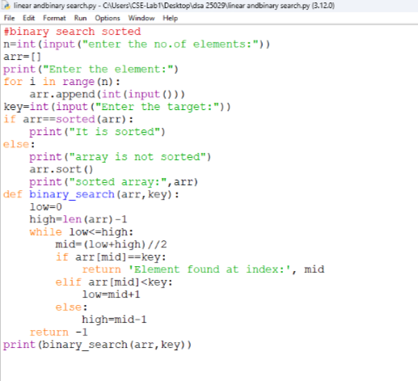
Output:
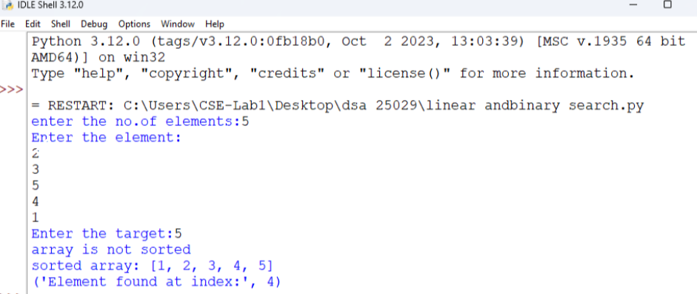

Explanation:
- The binary search should always executed in sorted order.
- Either it can be ascending or descending order.
- So the program is in unsorted order so we need to do sorting first later the binary search is executed.
- Error table:
s.no | Error obtained | Rectification
1. | Mistakes in main logic | Rectified
2. | Errors in conditions | Rectified

WEEK-3
A)Aim: Write a python programme to sort the elements using a bubble sort technique. Take an input elements from the users.
Programme:
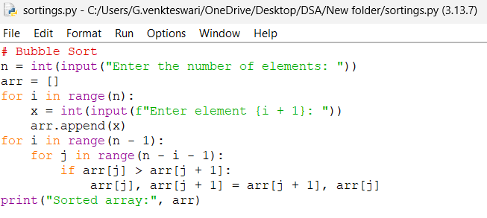
Output:
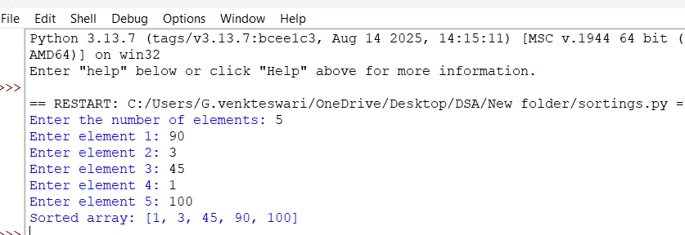
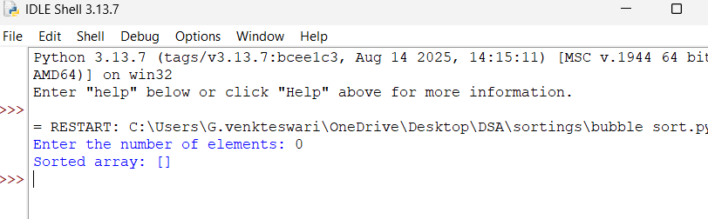

Explanation:
- n stores the number of elements, and an empty list arr is created.
- The first for loop takes n numbers from the user and adds them to arr.
- The second loop controls how many times the sorting process is repeated.
- The inner loop compares two neighboring elements: arr[j] and arr[j+1].
- If the first element is bigger, they are swapped using arr[j], arr[j+1] = arr[j+1], arr[j].
- Finally, print() displays the array in ascending order.
Error table:
s.no | Error obtained | Rectification
1. | Mistakes in main logic | Rectified
2. | Errors in conditions | Rectified

B)Aim: Write a python programme to sort the elements using a insertion sort technique. Take an input elements from the users.
Programme:
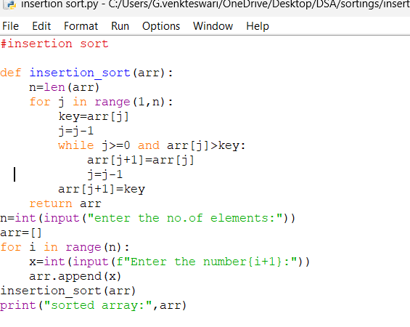
Output:
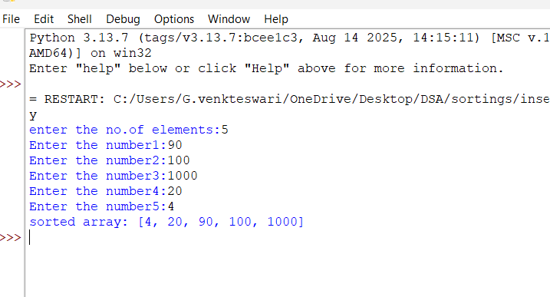

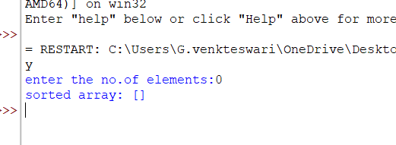
Explanation:
- insertion_sort(arr) takes the array and finds its length using n = len(arr).
- The for loop starts from the second element because the first element is considered already sorted.
- key = arr[j] stores the current element that we want to place in the correct position.
- The while loop moves bigger elements one position to the right.
- arr[j+1] = key places the current element in its correct position.
- Finally, the function returns the sorted array, and print() displays it in ascending order.
Error table:
S.no | Errors | Rectification
1. | Error in main logic | Rectified
2. | Errors in condition | rectified

C)Aim: Write a python programme to sort the elements using a selection sort technique. Take an input elements from the users.
Programme:
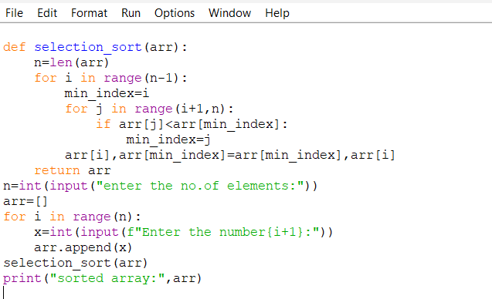
Output:
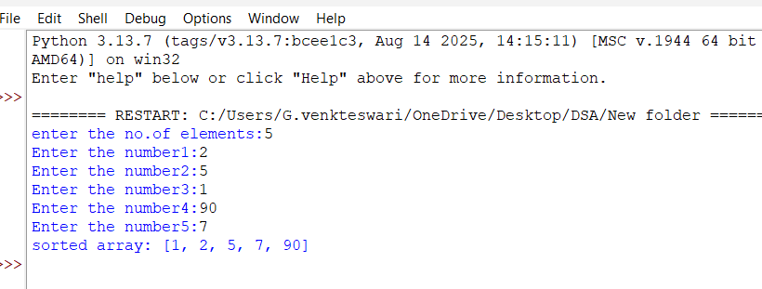

Explanation:
- n = len(arr) finds the total number of elements in the array.
- The outer for loop selects each position where the smallest element should be placed.
- min_index = i assumes that the current position contains the smallest element.
- The inner for loop compares the remaining elements and finds the smallest element's index.
- arr[i], arr[min_index] = arr[min_index], arr[i] swaps the smallest element with the current element.
- After all iterations, the array is sorted in ascending order and print() displays it.

Error table:
S.no | Errors | Rectification
1. | Error in main logic | Rectified
2. | Errors in condition | rectified

D)Aim: Write a python programme to sort the elements using a merge sort technique. Take an input elements from the users.
Programme:
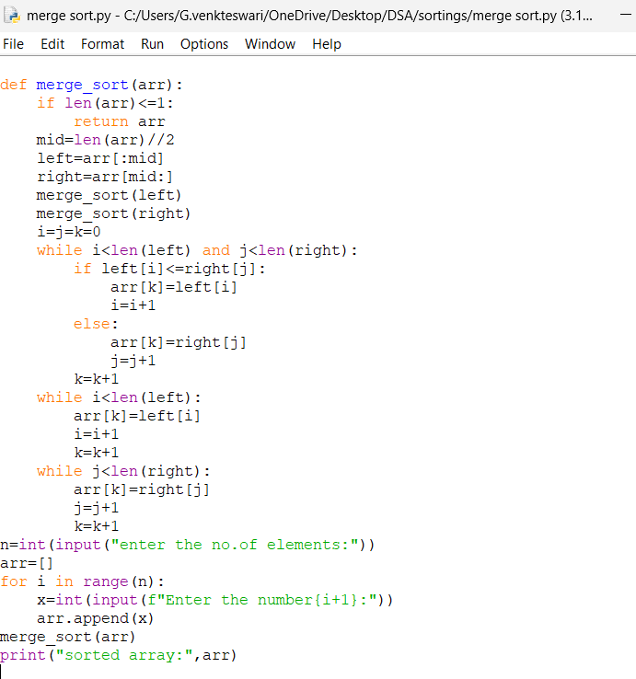
Output:
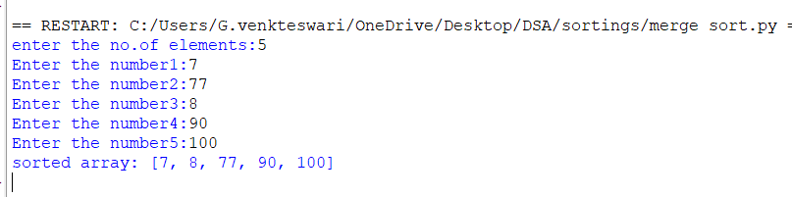
Explanation:
- if len(arr) <= 1 checks if the array has 0 or 1 element; if yes, it is already sorted.
- mid = len(arr)//2 finds the middle and divides the array into left and right parts.
- merge_sort(left) and merge_sort(right) recursively divide both parts into smaller parts.
- i = j = k = 0 creates indexes to compare elements from the left part, right part, and original array.
- The while loops compare elements and put the smaller element first into the original array.
- Finally, the remaining elements are added, and print() displays the sorted array in ascending order.
Error table:
S.no | Errors | Rectification
1. | Error in main logic | Rectified
2. | Errors in condition | rectified

E)Aim: Write a python programme to sort the elements using a merge sort technique. Take an input elements from the users.
Programme:
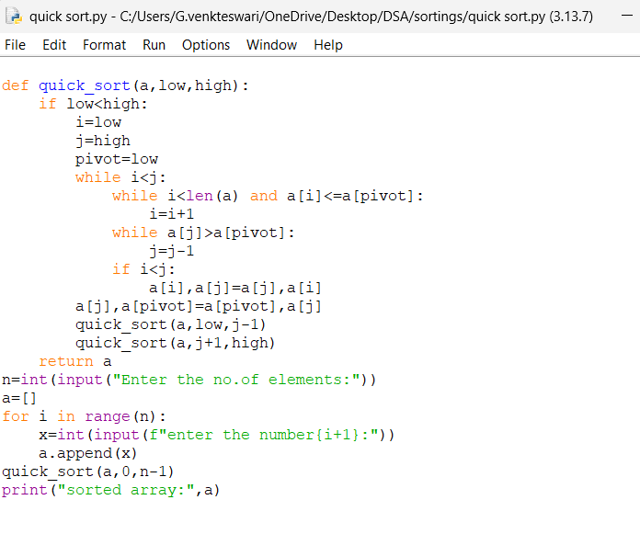
Output:
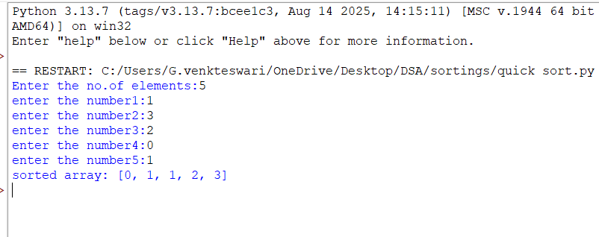
Explanation:
- quick_sort(a, low, high) sorts the elements between the low and high indexes.
- pivot = low selects the first element as the pivot.
- i moves from the left and finds an element greater than the pivot, while j moves from the right and finds an element smaller than or equal to the pivot.
- If i < j, a[i] and a[j] are swapped.
- After the loop, a[j] and the pivot are swapped, putting the pivot in its correct position.
- quick_sort() is called again for the left and right parts, and finally the array is printed in sorted order.
Error table:
S.no | Errors | Rectification
1. | Error in main logic | Rectified
2. | Errors in condition | rectified

Week-4
4. AIM: Write a python program to implement a single linked list which would perform the below operations, by taking an input from the user.
a. Create a linked list. b. Insert at beginning. c. Insert at end.
d. Insert at a specific index. e. Delete by value. f. Delete 1st node. g. Delete last node. h. Count no. of nodes i. Display.
j. Exit.
Programme:
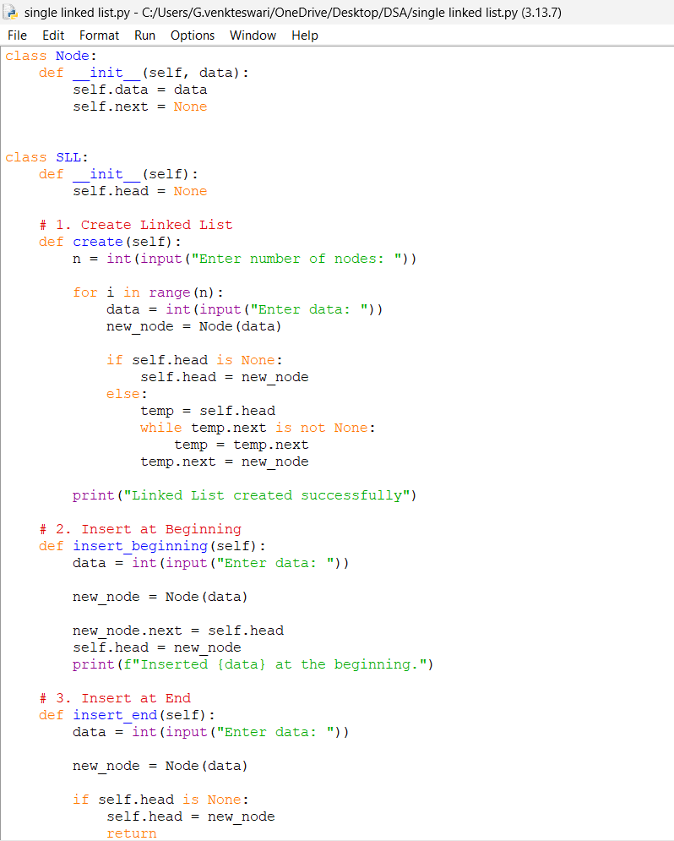
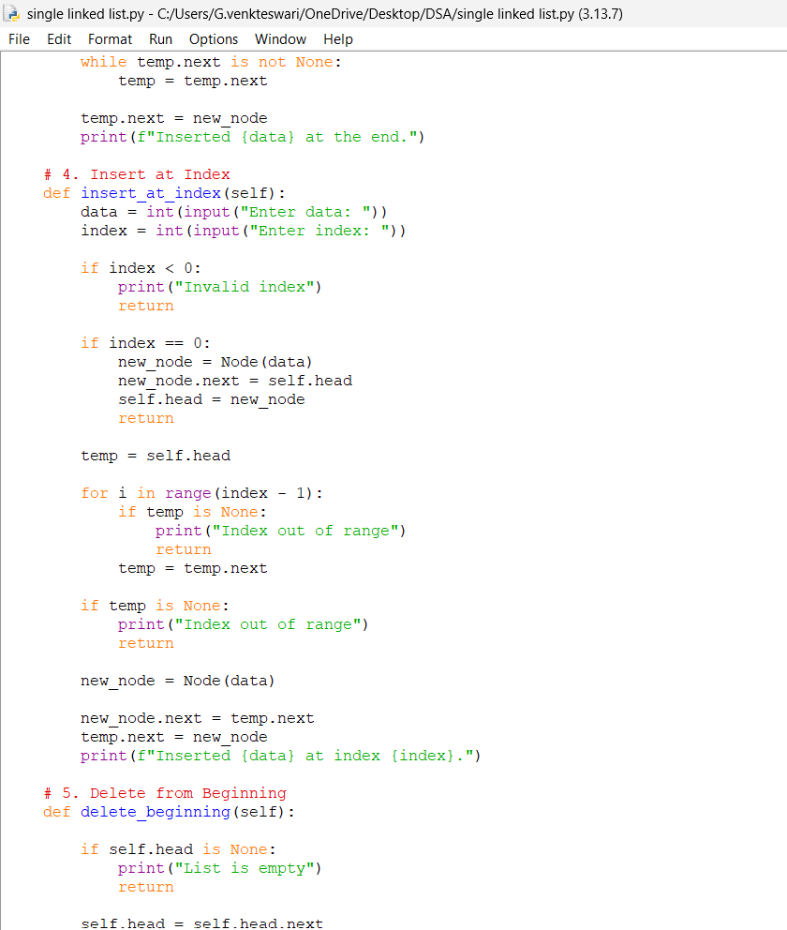
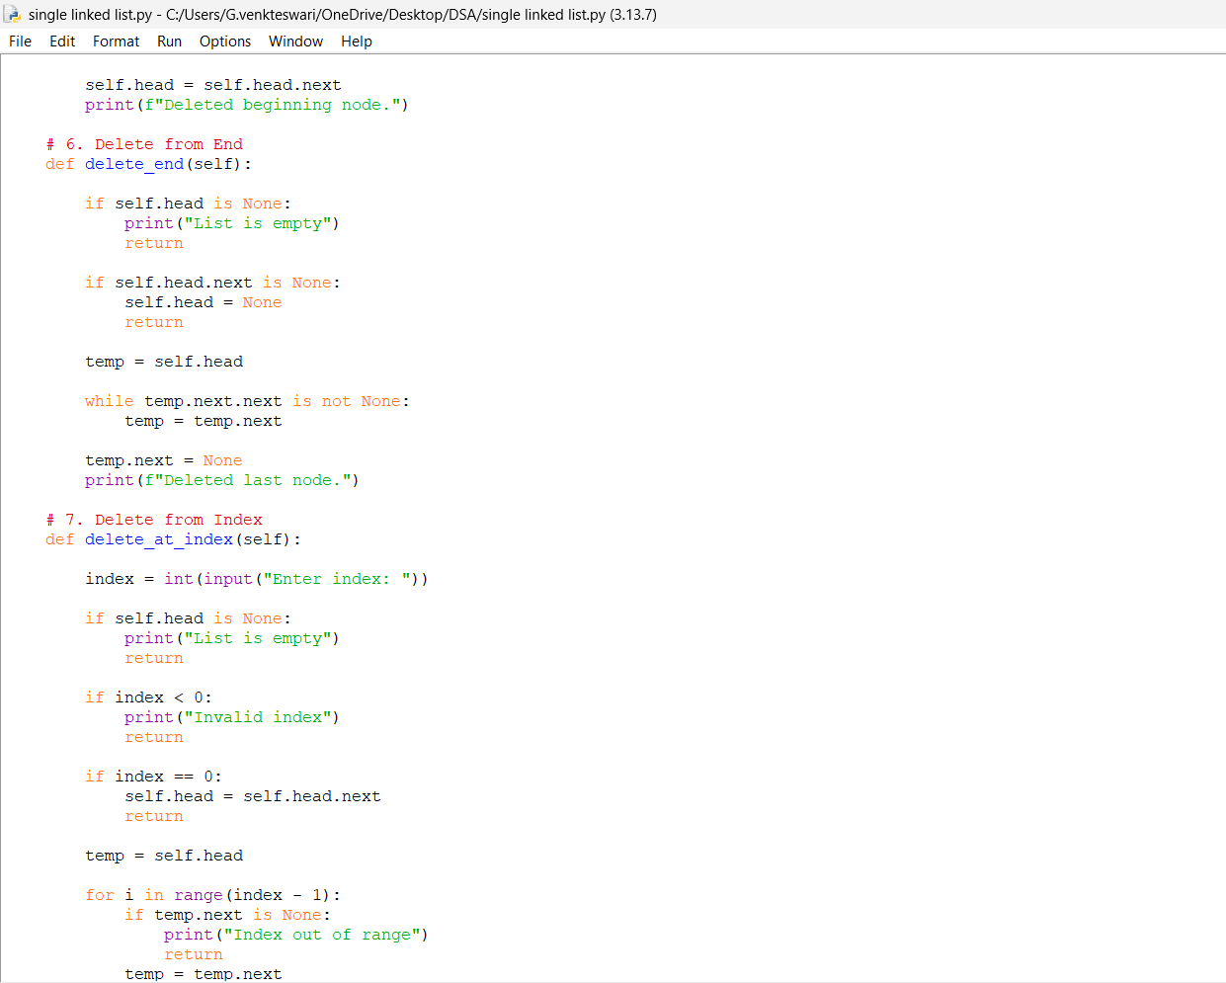
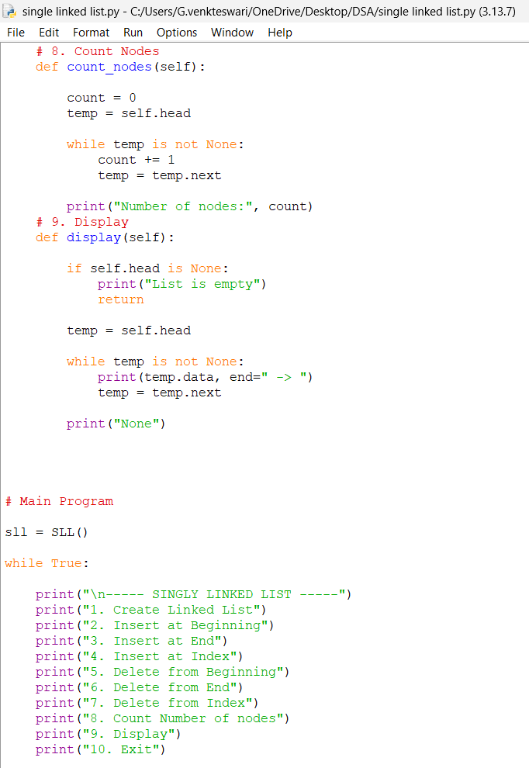
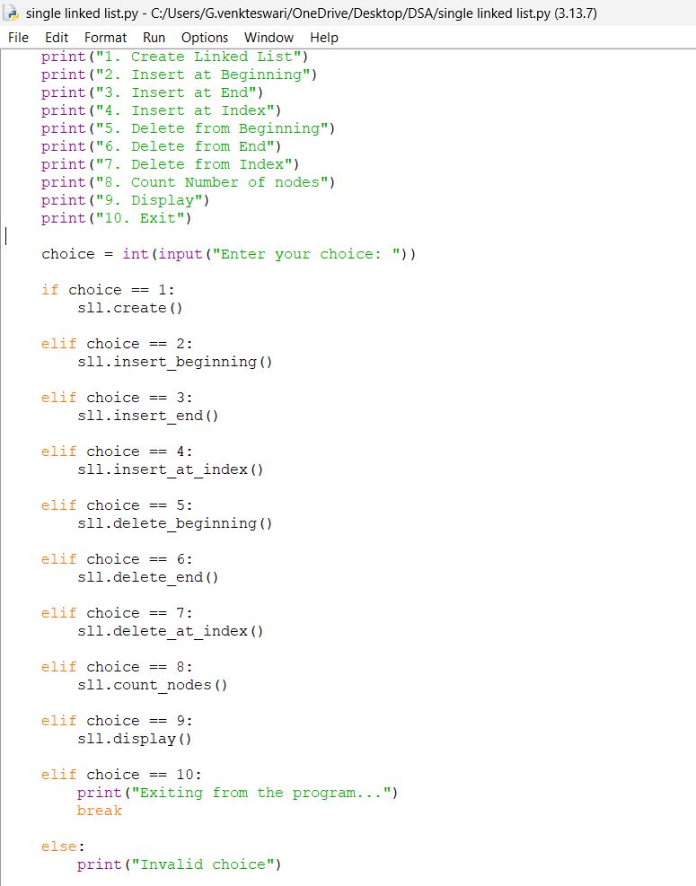
Output:
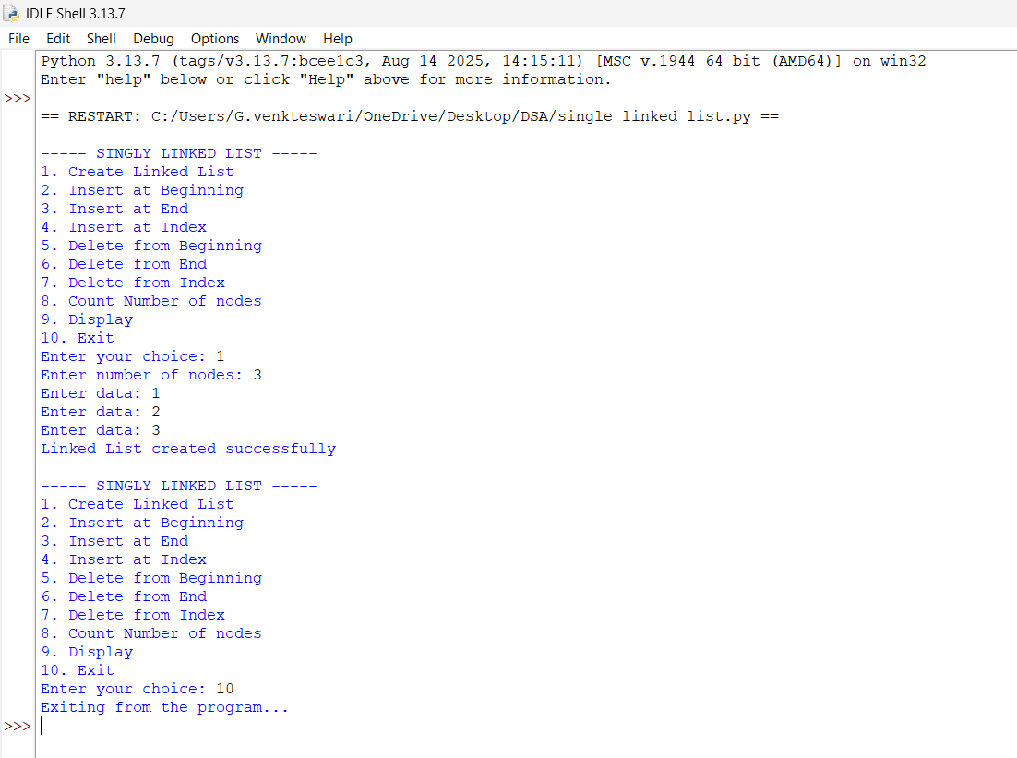
Negative case:
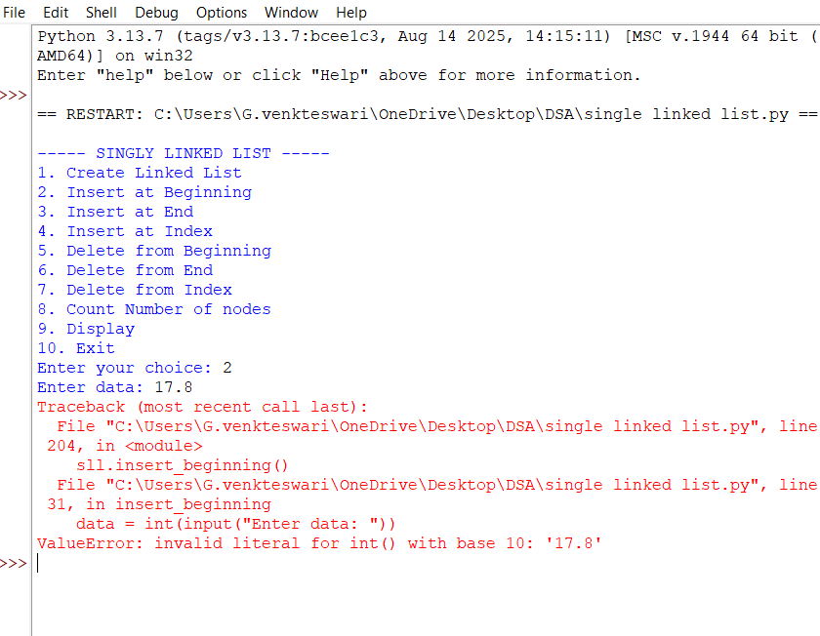
Explanation:
1)Class Definitions:
- Node class o Represents a single node in the linked list. o Each node has:
▪ data → stores the value.
▪ next → pointer to the next node (initially None).
- SLL class o Manages the linked list operations. Has a head pointer (initially None) that points to the first node.
2)Insert at Beginning:
• Creates a new node.
• Points its next to current head.
• Updates head to new node.
3)Insert at End
• Creates a new node.
• If list is empty → new node becomes head.
• Otherwise → traverses to last node and attaches new node.
4) Insert at Index
• Asks for index and data.
• If index = 0 → behaves like "insert at beginning".
• Otherwise → traverses to (index-1) node and inserts new node in between.
5) Delete from Beginning
• Moves head to head.next.
• Effectively removes the first node.
6) Delete from End
• If list empty → prints "List is empty".
• If only one node → sets head = None.
• Otherwise → traverses to second-last node and sets its
next= None.
7) Delete from Index
• Asks for index.
• If index = 0 → removes head.
• Otherwise → traverses to (index-1) node and skips the next node.
8) Count Nodes
• Traverses through list.
• Counts nodes until None.
9) Display
• Traverses from head to end.
• Prints each node’s data in data -> data -> None format.
Error table:
sno | error | rectification
1. | Index out of rangeWhen inserting/deleting at an index greater than the number of nodes. | Traverse carefully,if temp becomes None before reaching index, print "Index out of range" and stop.
2. | Logical error in insertion if index is negative. | Validate index: if index < 0: print ("Invalid index").
3. | Indentation Error In the Count node part | It was rectified later, By maintaining proper indentation.

Aim: Write a python program to implement a doubly linked list which would perform the below operations, by taking an input from the user.
a. Create a linked list. b. Insert at beginning. c. Insert at end.
d. Insert at a specific index. e. Delete by value. f. Delete 1st node. g. Delete last node. h. Count no. of nodes i. Display.
j. Exit.
Programme:
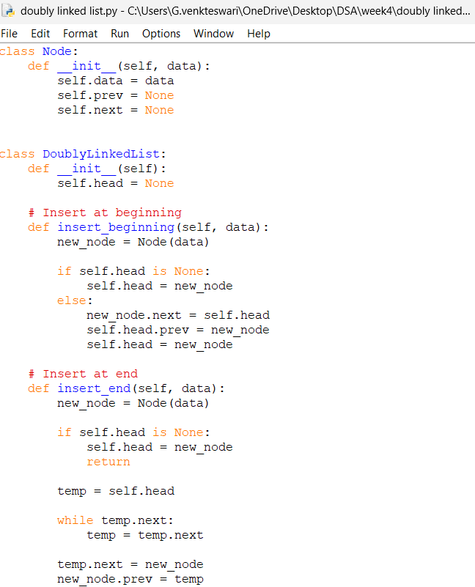

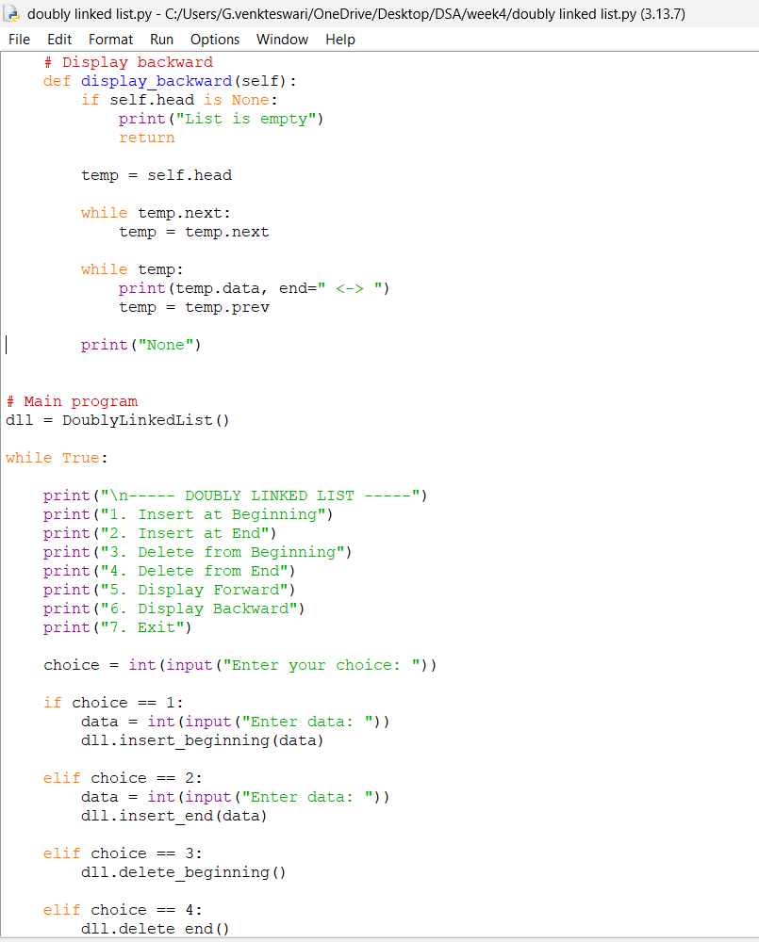
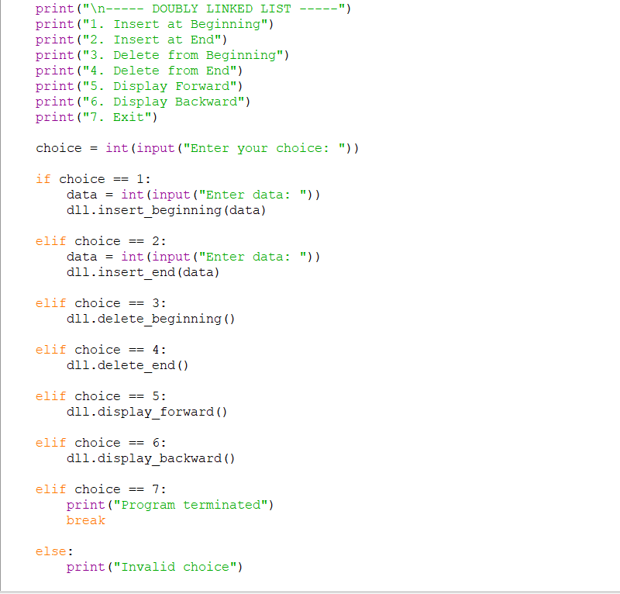
Output:
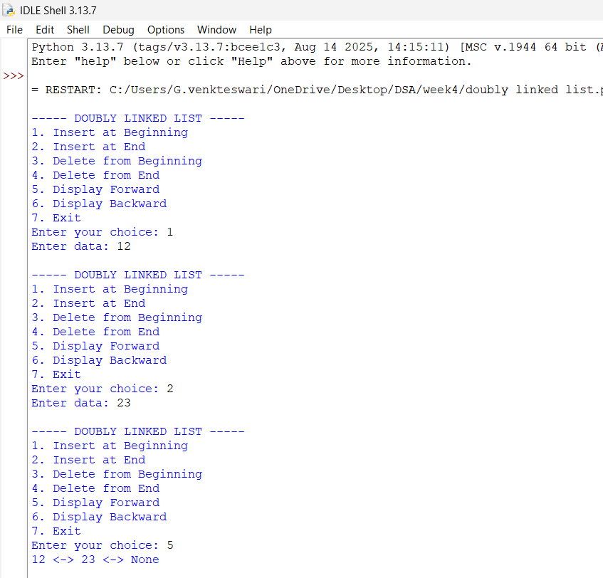
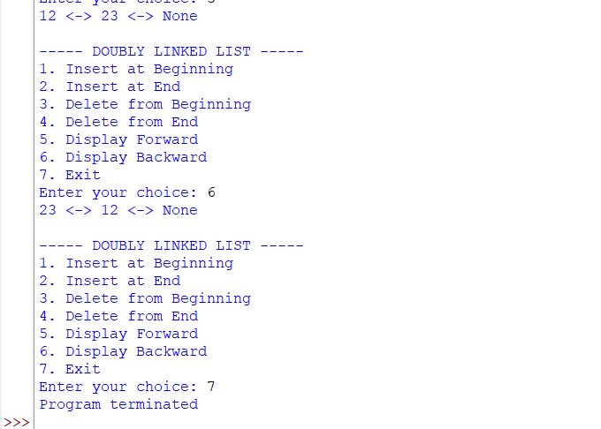
Explanation:
- Node has 3 parts:
  - data → stores value
  - prev → points to previous node
  - next → points to next node
- Doubly Linked List:
  - Each node can move in both directions.
  - First node's prev is None.
  - Last node's next is None.
  - Example: None ← 10 ↔ 20 ↔ 30 → None
Operations
- Insert at Beginning
  - Create a new node.
  - New node points to the current head.
  - Current head's prev points to new node.
  - New node becomes the head.
- Insert at End
  - Traverse to the last node.
  - Last node's next points to new node.
  - New node's prev points to the last node.
- Delete from Beginning
  - Move head to the next node.
  - Set new head's prev to None.
  - If only one node exists, list becomes empty.
- Delete from End
  - Traverse to the last node.
  - Set the previous node's next to None.
  - If only one node exists, list becomes empty.
- Display Forward
  - Start from head.
  - Move using next.
  - Continue until None.
- Display Backward
  - First move to the last node.
  - Move backward using prev.
  - Continue until None.
- Main Program
  - Create a doubly linked list.
  - Display the menu.
  - Take user's choice.
  - Perform the selected operation.
  - Choice 7 exits the program.
Error table:
sno | error | rectification
1. | Index out of rangeWhen inserting/deleting at an index greater than the number of nodes. | Traverse carefully,if temp becomes None before reaching index, print "Index out of range" and stop.
2. | Logical error in insertion if index is negative. | Validate index: if index < 0: print ("Invalid index").
3. | Indentation Error In the Count node part | It was rectified later, By maintaining proper indentation.

Aim: Write a python program to implement a circular linked list which would perform the below operations, by taking an input from the user.
a. Create a linked list. b. Insert at beginning. c. Insert at end.
d. Insert at a specific index. e. Delete by value. f. Delete 1st node. g. Delete last node. h. Count no. of nodes i. Display.
j. Exit.
Programme:

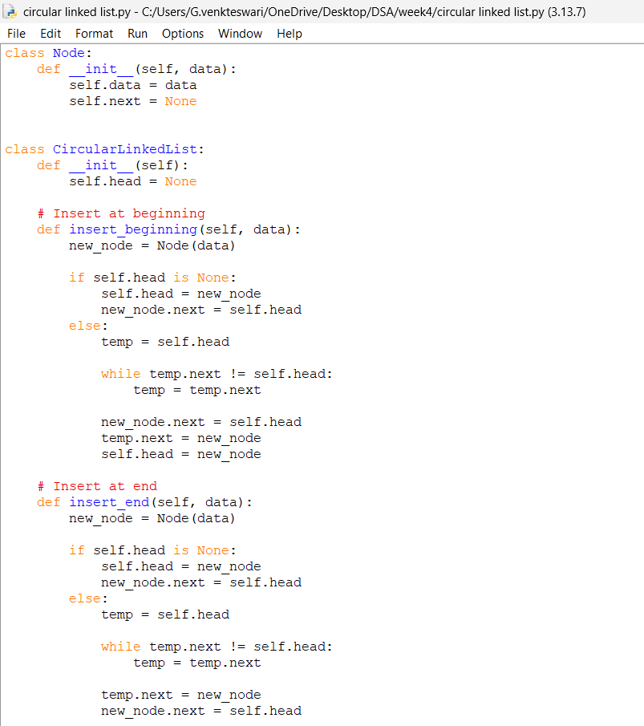

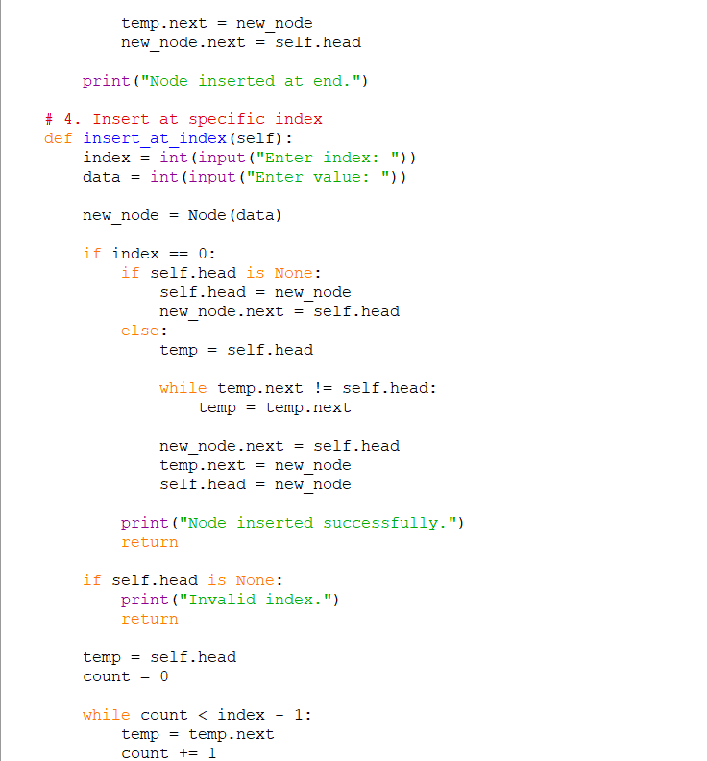
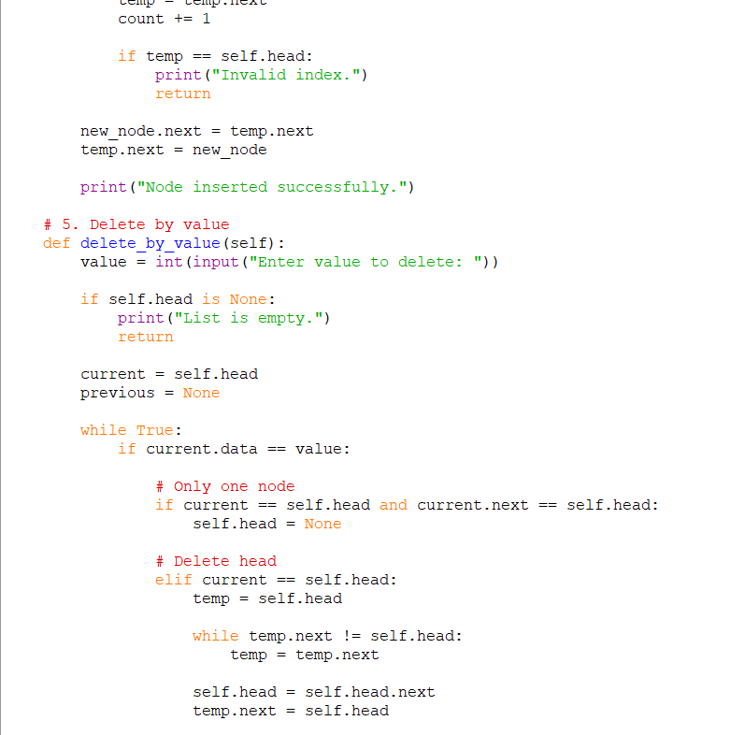
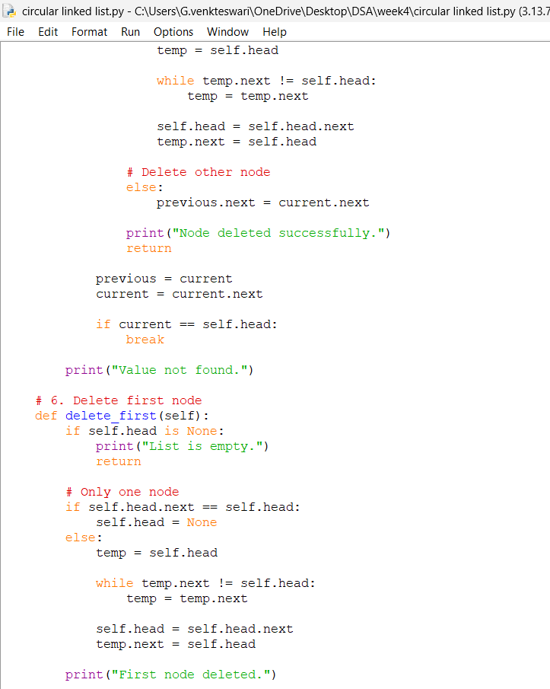
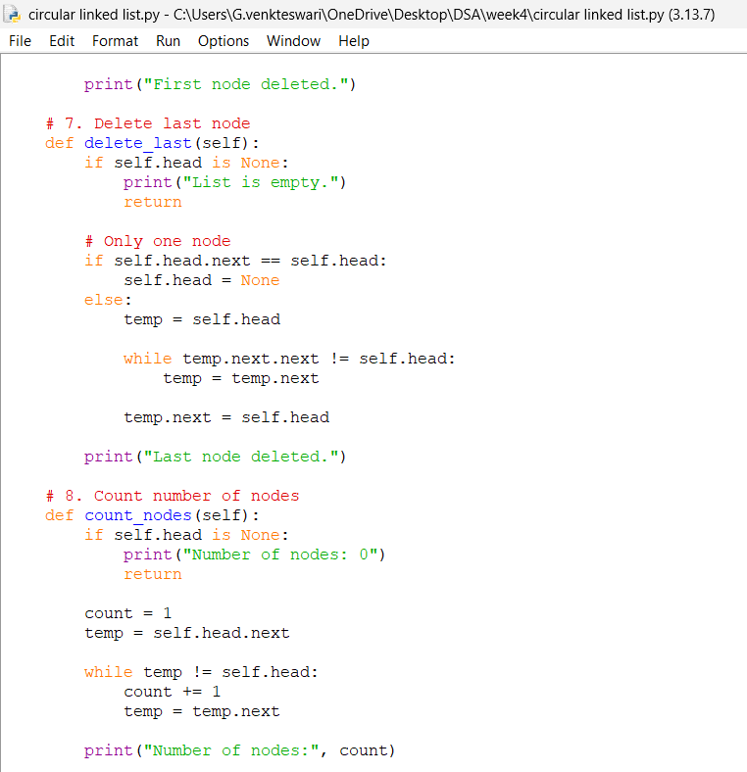
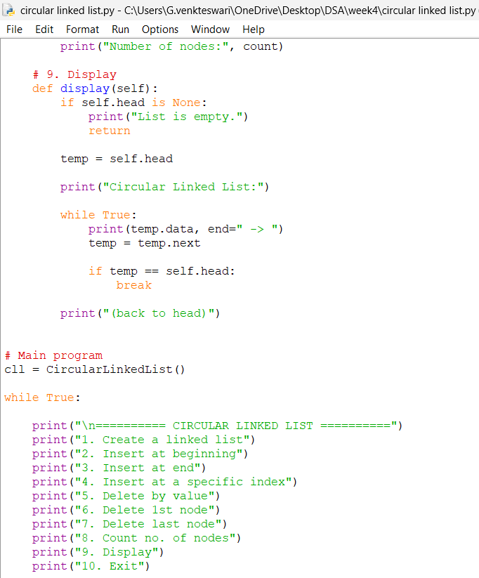
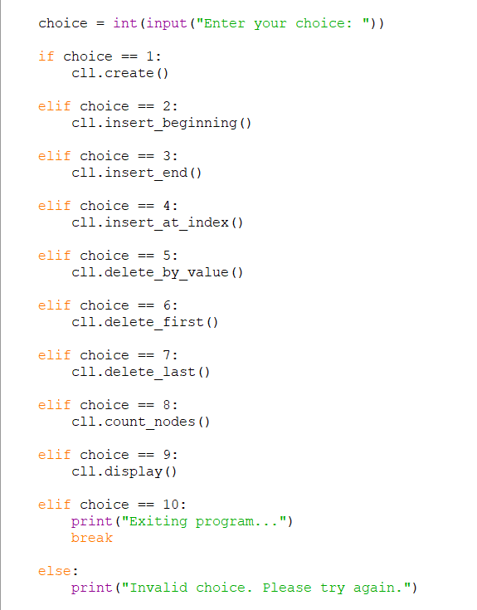
Output:
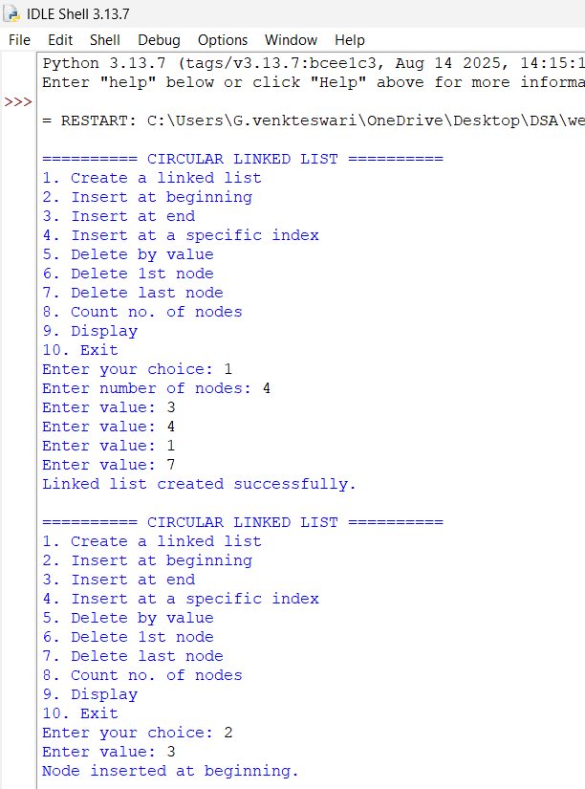
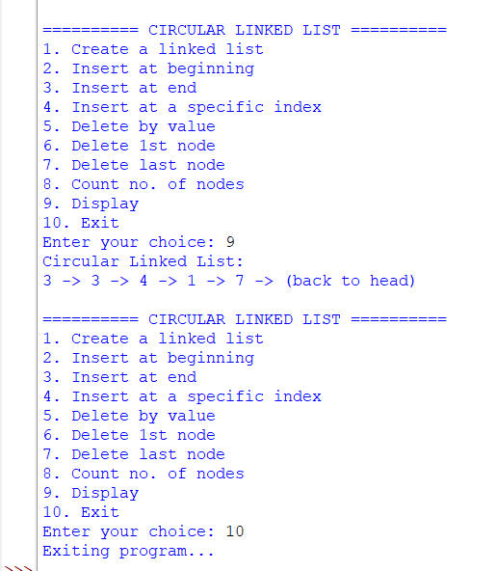
Explanation:
- Node contains two parts:
  - data → stores the value.
  - next → stores the reference of the next node.
- Circular Linked List:
  - Last node points back to the first node (head).
  - There is no None at the end.
  - Example: 10 → 20 → 30 → 10
Operations
- Create
  - Creates n nodes.
  - First node becomes head.
  - Last node points to head.
- Insert at Beginning
  - Create a new node.
  - New node points to current head.
  - Last node points to new node.
  - New node becomes the new head.
- Insert at End
  - Traverse until the last node.
  - Last node points to the new node.
  - New node points to head.
- Insert at Specific Index
  - Move to the node before the required index.
  - Connect the new node between two nodes.
  - Newnode.next = temp.next
  - temp.next = new.node
- Delete by Value
  - Search for the required value.
  - If found, remove that node.
  - Previous node is connected to the next node.
  - Special cases: only node or deleting the head.
- Delete First Node
  - Move head to the second node.
  - Last node is connected to the new head.
- Delete Last Node
  - Find the second-last node.
  - Make its next point to head.
- Count Nodes
  - Start from head.
  - Traverse until reaching head again.
  - Count each node.
- Display
  - Start from head.
  - Print each node.
  - Stop when head is reached again.
Error table:
sno | error | rectification
1. | Index out of rangeWhen inserting/deleting at an index greater than the number of nodes. | Traverse carefully,if temp becomes None before reaching index, print "Index out of range" and stop.
2. | Logical error in insertion if index is negative. | Validate index: if index < 0: print ("Invalid index").
3. | Indentation Error In the Count node part | It was rectified later, By maintaining proper indentation.

WEEK-5
AIM: Write a programe of stack using array
Programme:
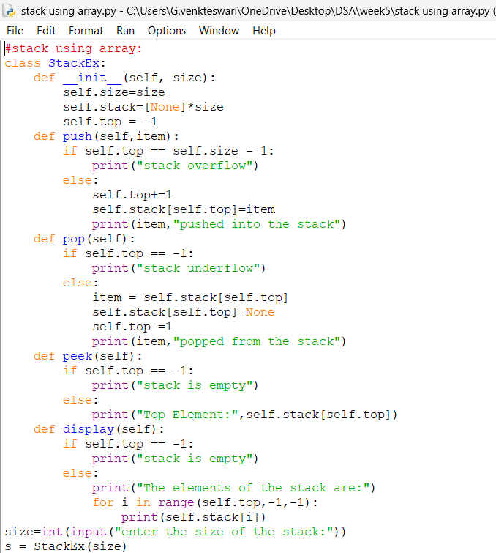
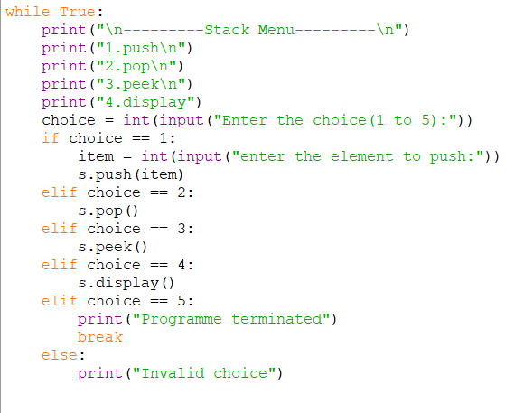
Output:
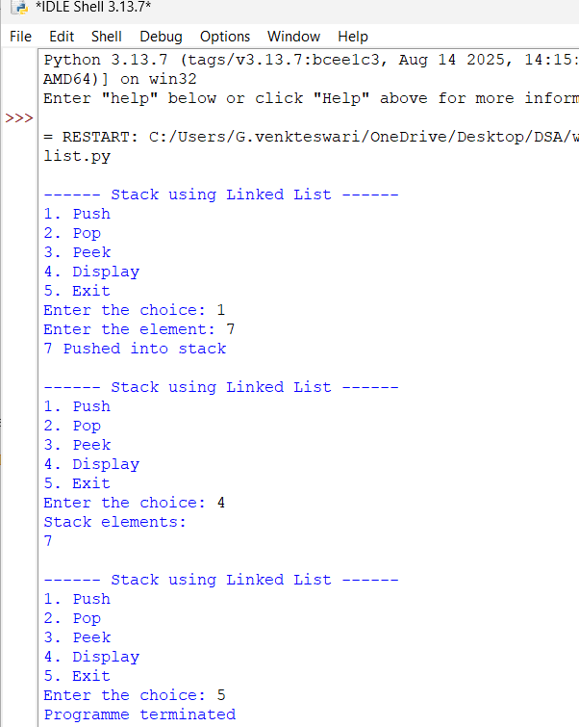
Explanation:
- Stack is a linear data structure.it follows the LIFO (last in first out).
- Elements are stored in the array
- Push is used to insert an element. The element is added at the top. If the stack is full, Stack Overflow occurs.
- Pop is used to remove an element.
- The top element is removed.
- top is decreased. If the stack is empty, Stack Underflow occurs.
- Peek is used to view the top element.
- It does not remove the element.
- Display is used to show all elements.
- Elements are displayed from top to bottom.
Error table:
Error | Rectified
Forget to keep (_ _) in constructor | Rectified by keep double underscore.
Forgot to decrease the top in pop | rectified

AIM: Stack using Linked list.
Programme:
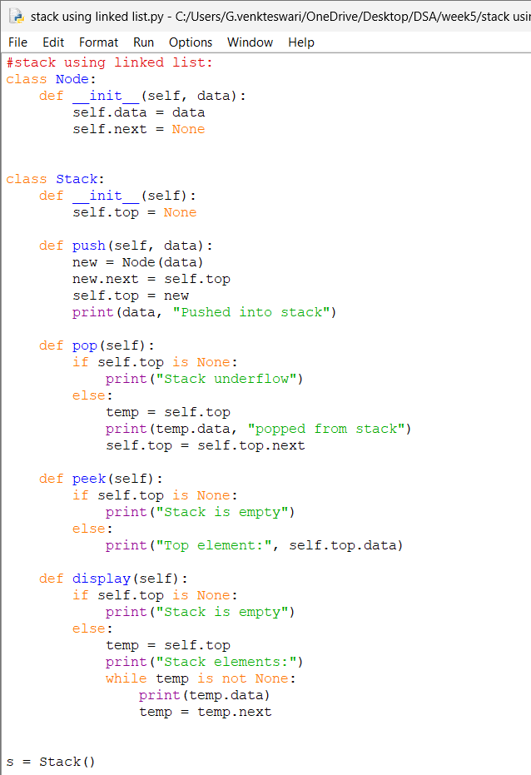

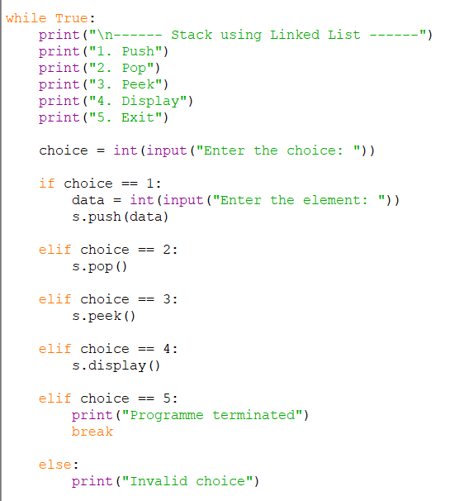
Output:
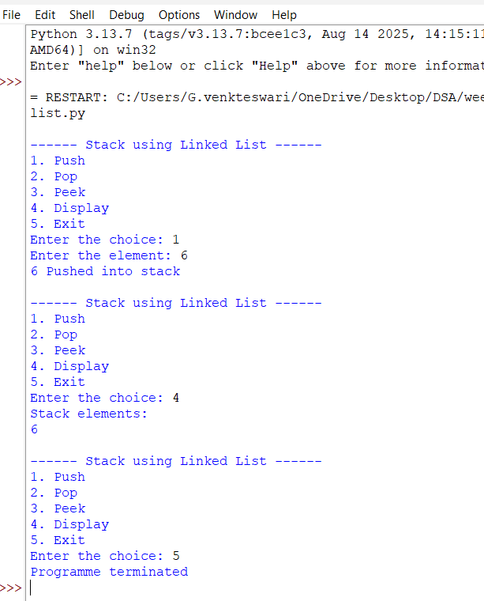
Explanation:
- A stack using linked list is a linear data structure that follows the LIFO (Last In, First Out) principle.
- In a linked-list stack, each element is stored in a node, and each node contains data and a link to the next node.
- A variable called top is used to point to the first node, which represents the top of the stack.
- Push operation is used to insert a new element. A new node is created and added at the top of the stack.
Pop operation is used to remove an element. The node pointed to by top is removed and top moves to the next node.
- Peek operation is used to view the top element without removing it from the stack.
- Display operation is used to traverse the linked list from top to None and display all the elements.
- A linked-list stack has dynamic size, so memory is allocated as needed. Stack Underflow occurs when we try to remove an element from an empty stack.
Error Table:
Error | Rectified
new. next = None | new. next = self.top
self. top = self.top | self. top = self. top. next

WEEK – 6
AIM: Write a python programme to implement queue and its operations such as inqueue, dequeue, peek and display using array.
Programme:
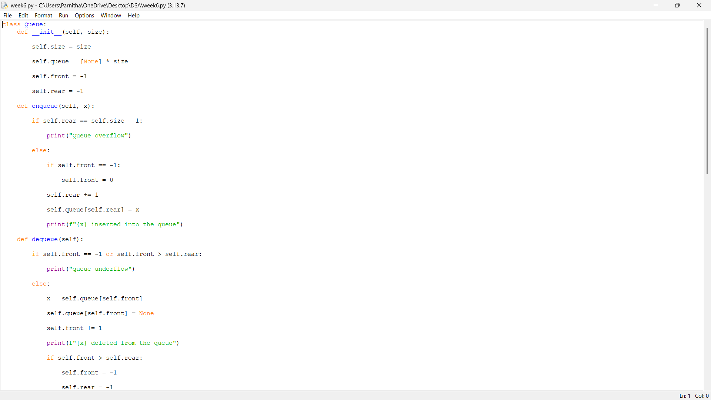
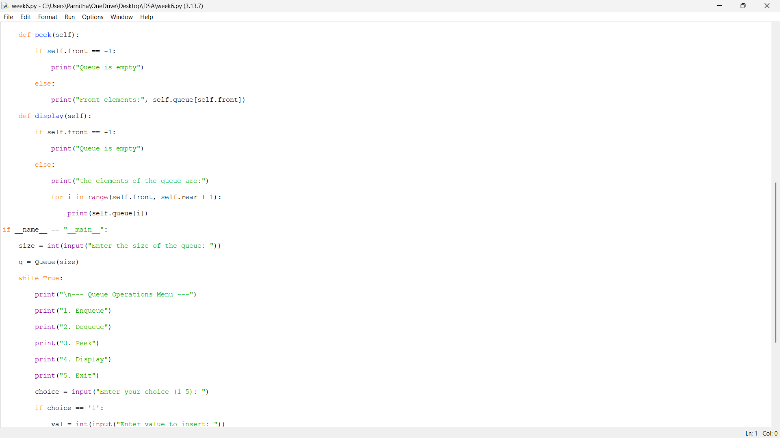

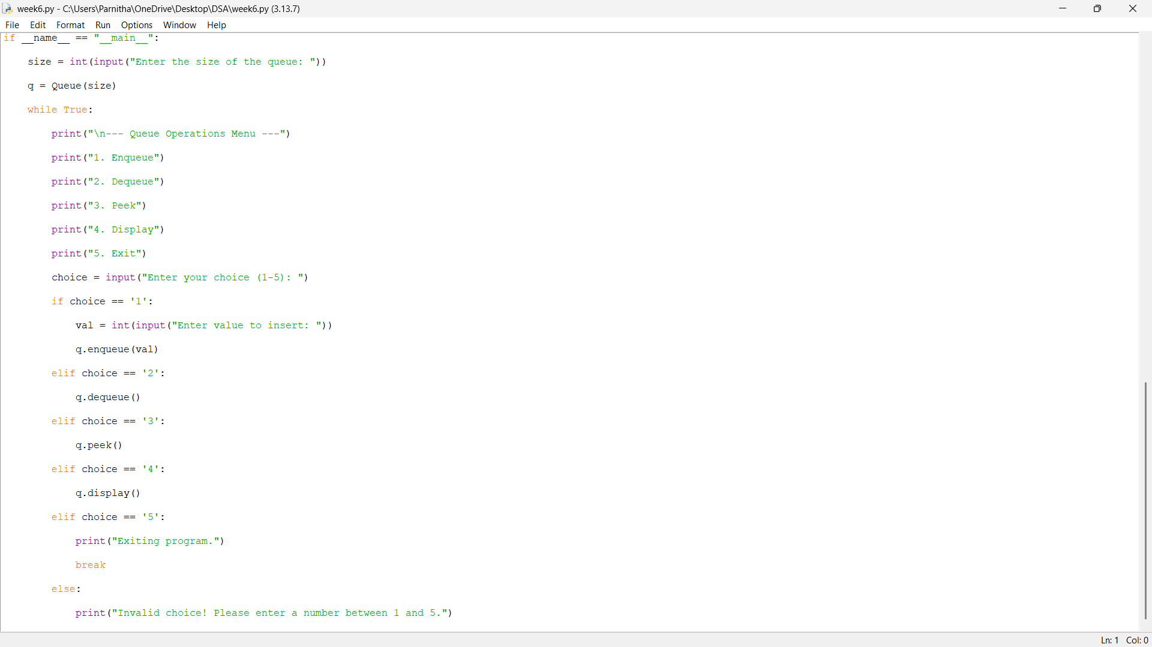
OUTPUT:
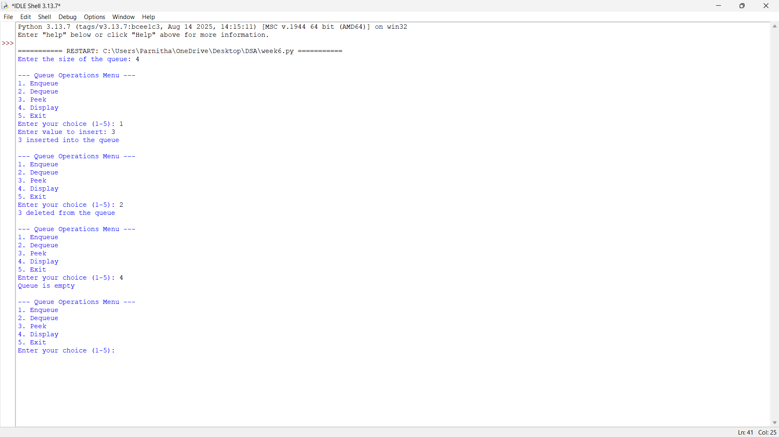

Explanation:
- Queue is the linear data structure. It follows first in first out rule.
- In queue for insertion we enqueue and for deletion we use dequeue.
- Before inserting an element we check whether the queue is filled or if it is filled then it is queue overflow.
- Before deletion we will check whether any element is present in the queue or not if any element is not present then it is queue underflow.
- For seeking the top most element we use peek.
- And for inserting, deleting, peek and for display we use menu driven system.
- Users choice will be considerable.
Error table:
S.no | Errors | Rectified
1. | Forgetting the placing of semicolons | Rectified
2. | Indentation errors | Rectified

AIM: Write a python programme to implement queue and its operations such as enqueue, dequeue, peek and display using Linked list data structure.
Programme:

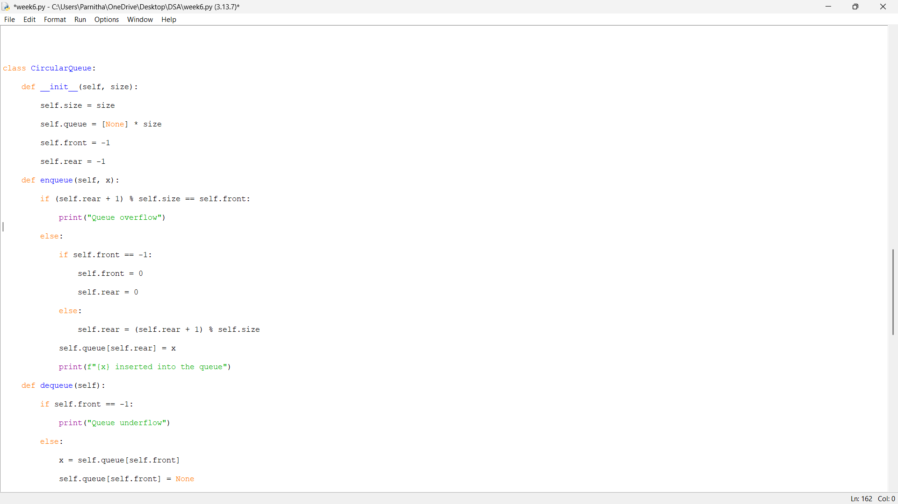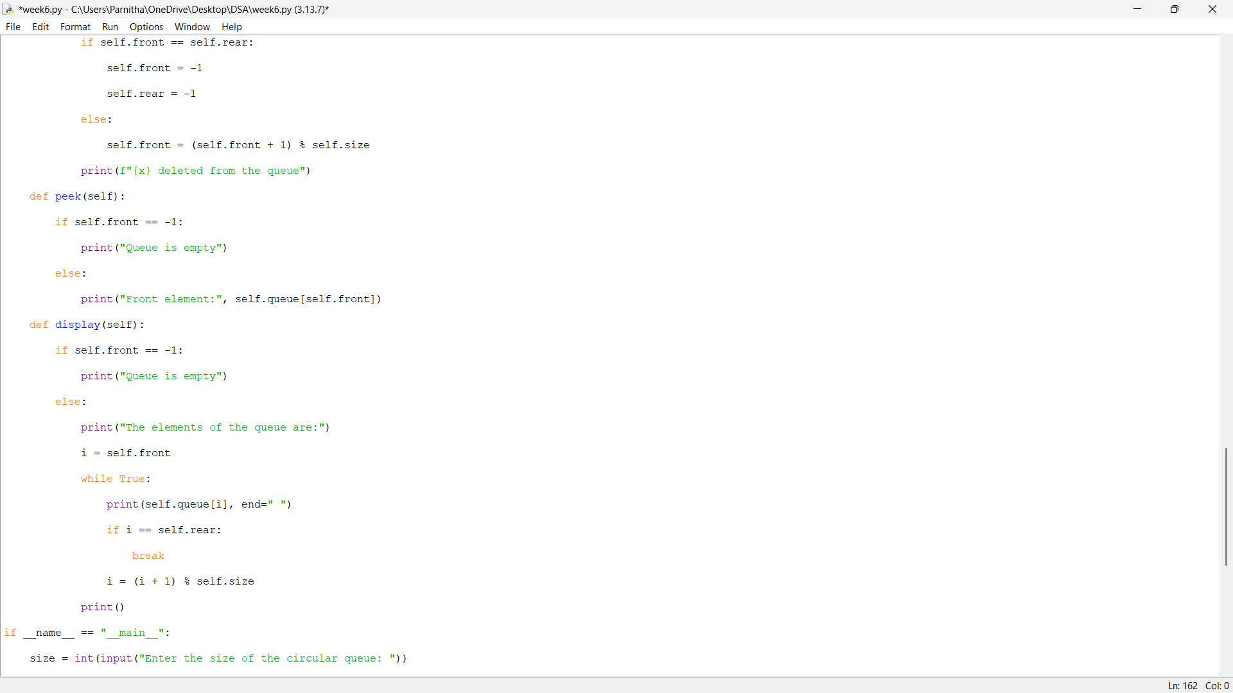

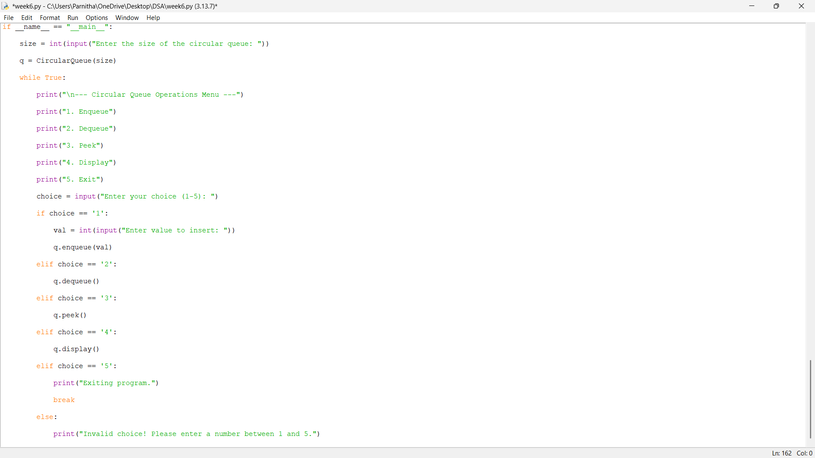

Output:

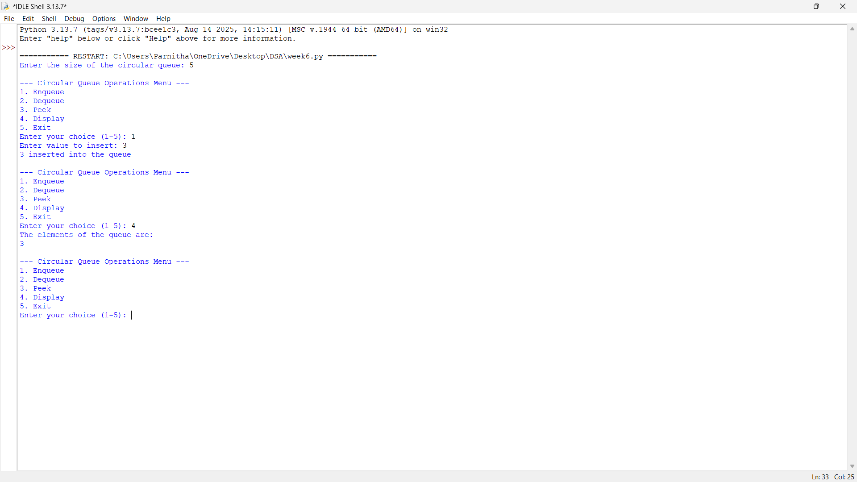

Explanation:
- Each node stores data and a link (next) to the next node.
- Has two pointers: front (start of queue) and rear (end of queue).
- Creates a new node.
- If queue is empty → both front and rear point to this node.
- Otherwise → attaches new node at the end and moves rear.
- Removes the node at front.
- Moves front to the next node.
- If queue becomes empty → rear also set to None.
- Shows the data at front without removing it.
- If empty → prints Queue is empty.
- Starts from front and prints each node until the end.
- Shows elements in order with arrows (->).
- Enqueue works fine on empty queue.
- Dequeue, Peek, Display all check if queue is empty before acting.
- Unlike array-based queue, linked list queue grows/shrinks as needed.
- No fixed size or overflow problem (only limited by memory).
- User chooses operations: Enqueue, Dequeue, Peek, Display, Exit.
- Runs in a loop until Exit is chosen.
Error table:
S.no | Errors | Rectification
1. | Indentation errors | Rectified
2. | Forgetting of placing semi colon. | Rectified

AIM: Write a python programme to implement queue and its operations such as enqueue, dequeue, peek and display using Linked list data structure.
Programme:
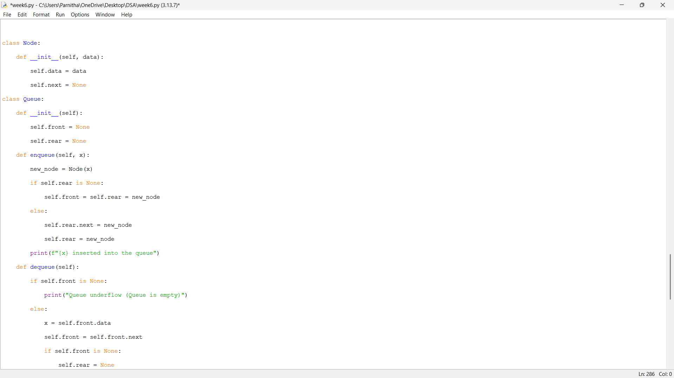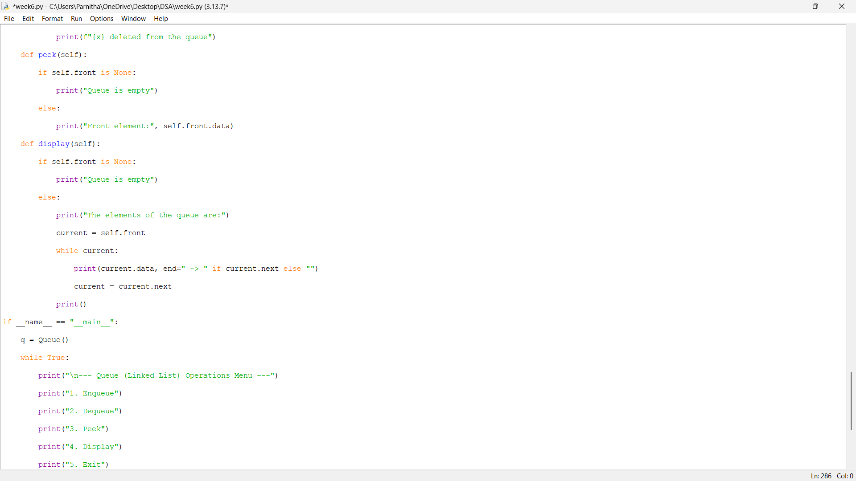

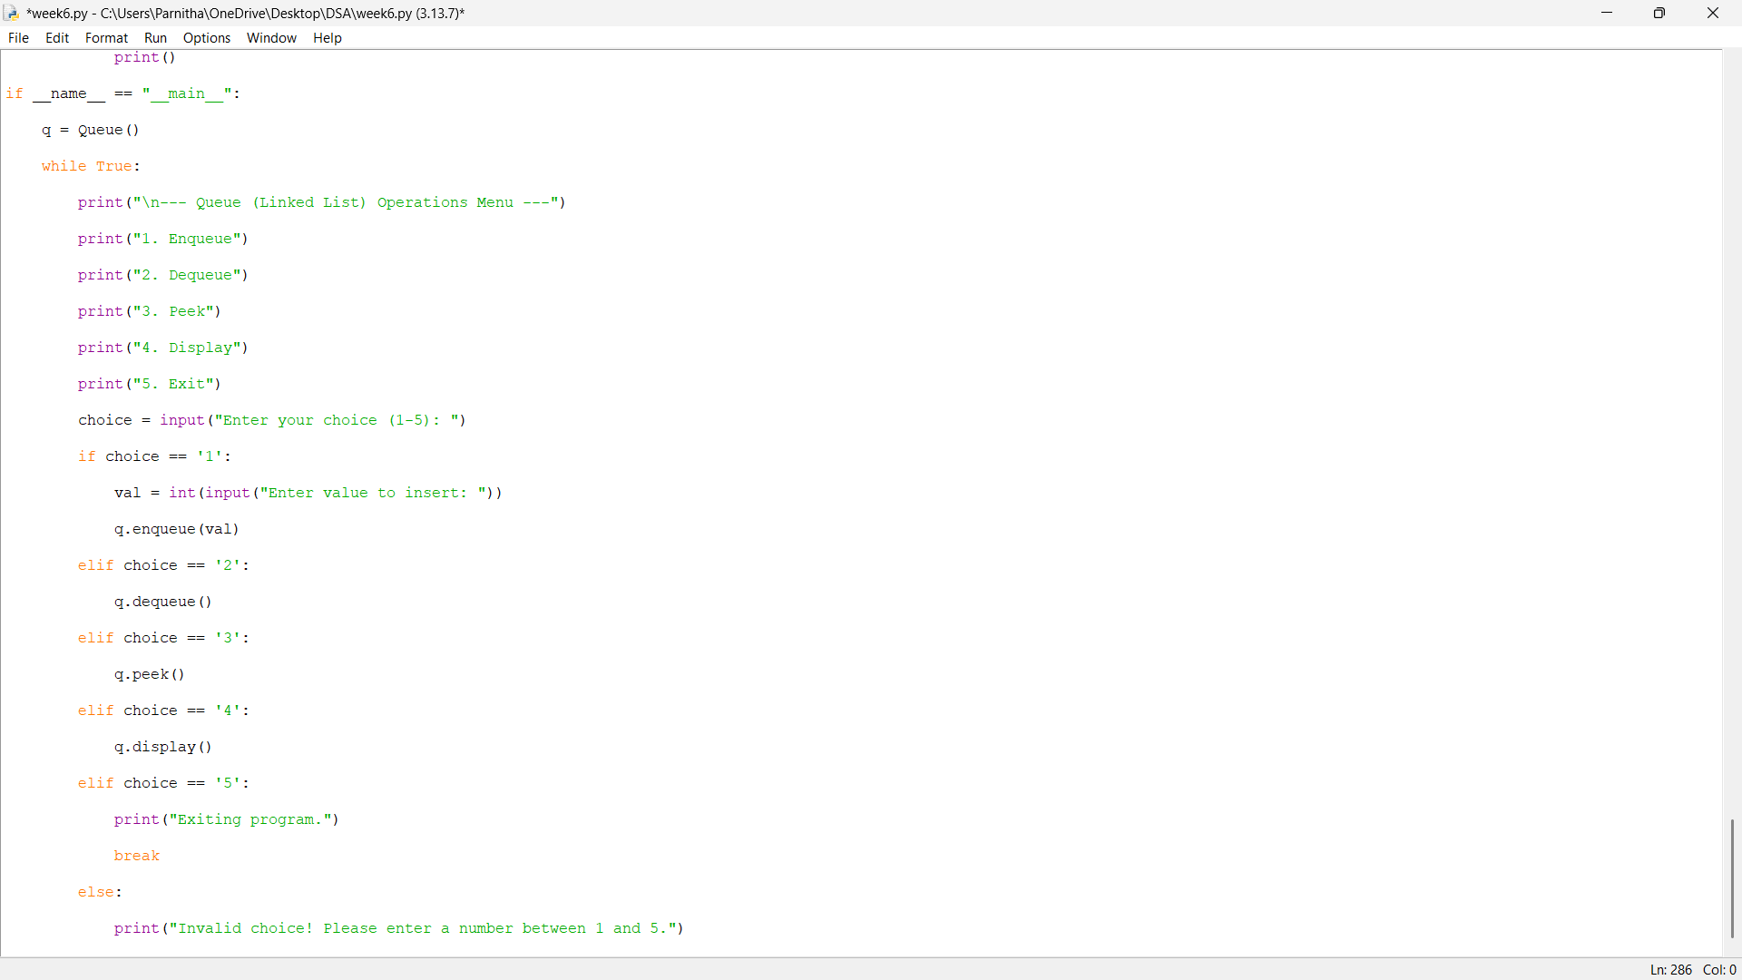
Output:
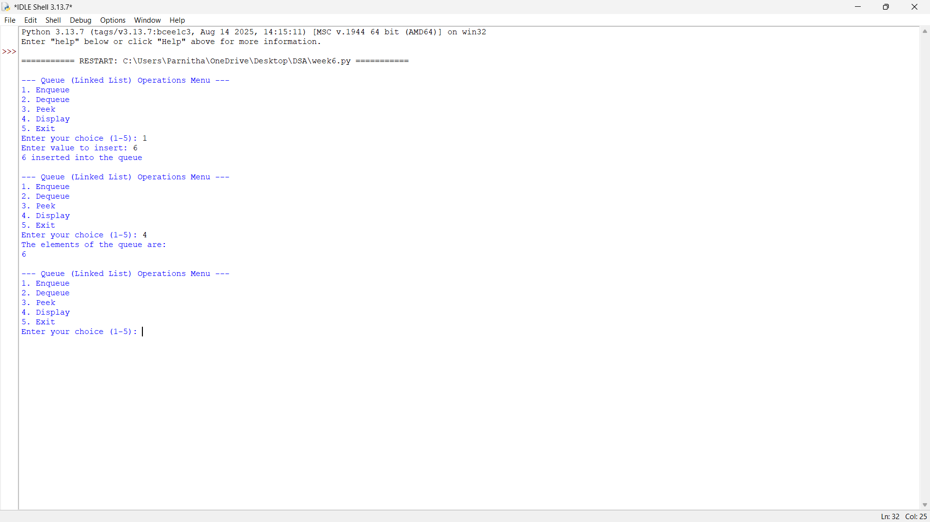
Explanation:
- A circular queue uses a fixed-size list but connects the end back to the start, so space is reused.
- front and rear keep track of where elements are removed and added.
- When inserting, if (rear + 1) % size == front, the queue is full → overflow.
- If the queue is empty, both front and rear are set to 0 before inserting the first element.
- On enqueue, rear moves forward in a circular way using (rear + 1) % size.
- On dequeue, the element at front is removed, and front moves forward in a circular way.
- If after removing, front == rear, the queue becomes empty again (front = rear = -1).
- Display prints elements starting from front and looping until rear, showing the circular order.
Error table:
S.no | Errors | Rectified
1. | Indentation error | Rectified
2. | Forgetting to place front==rear | Rectified

