
USER INTERFACE DESIGN
23CSE113 LAB MANUAL
Submitted by
NAME | Parnitha.A
ROLL.NO | AV.SC.U4CSE25002
YEAR/SEM/SECTION | 1ST YEAR/SEM-2/CSE-A

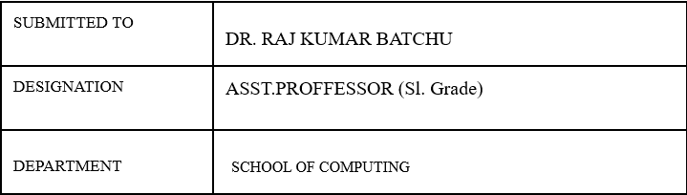
ASSIGNMENT

Task: Developing Online book store webpage using HTML, CSS, javascript.
Input:
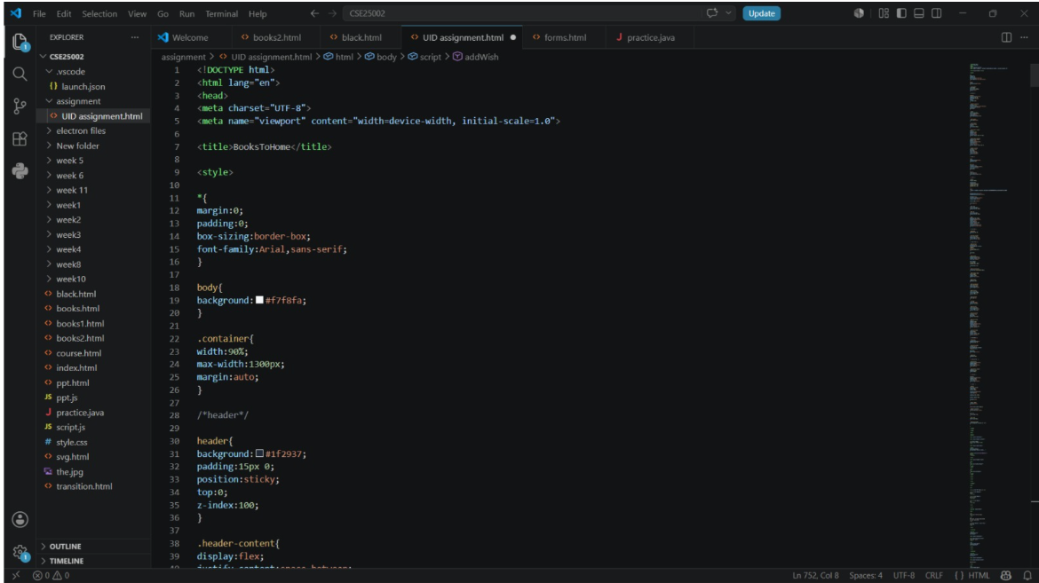
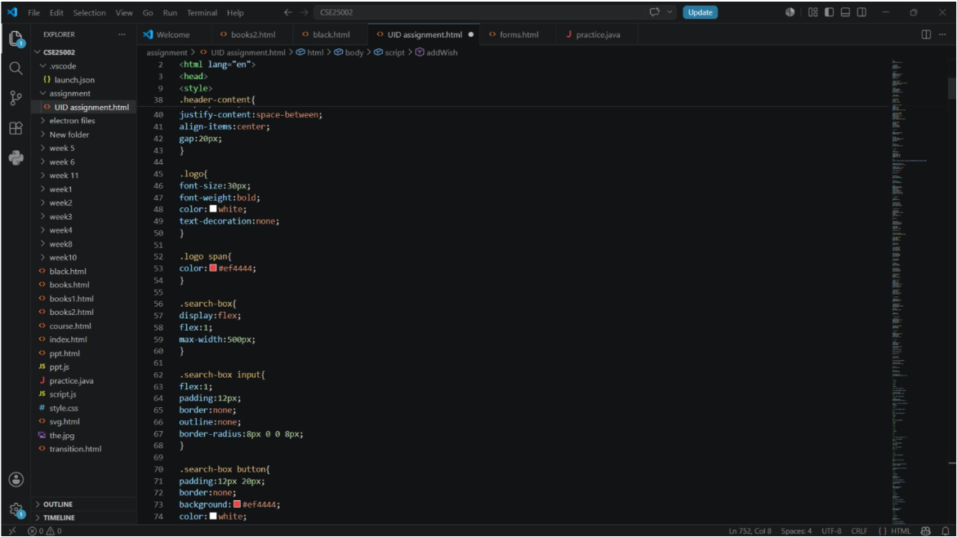
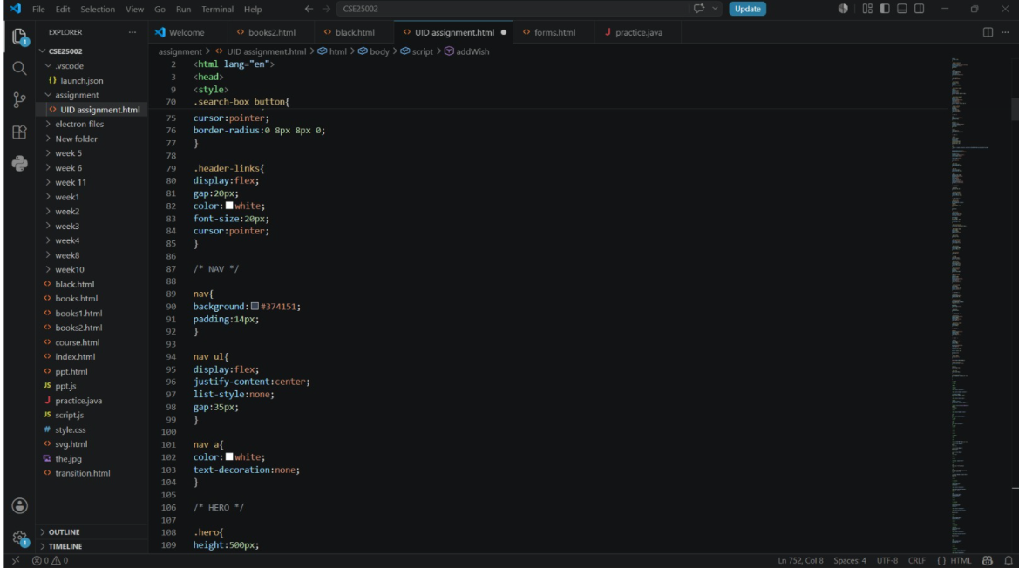
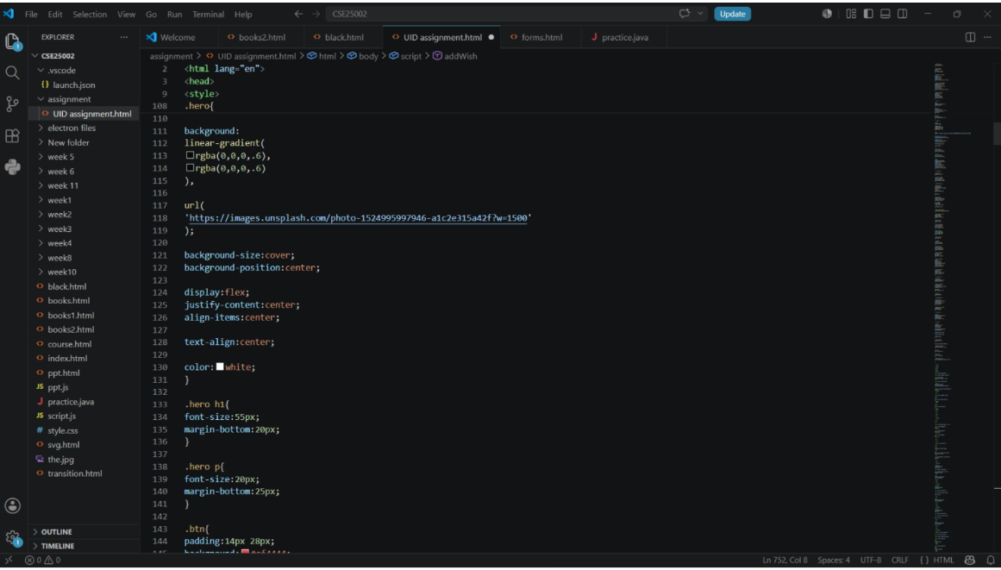
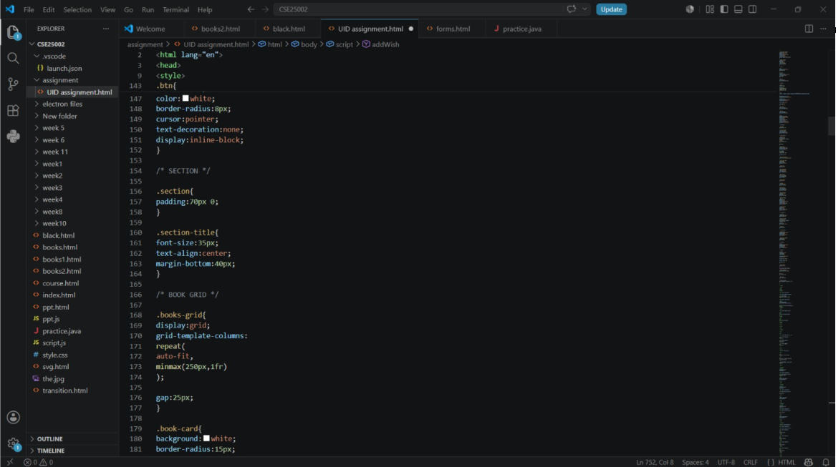
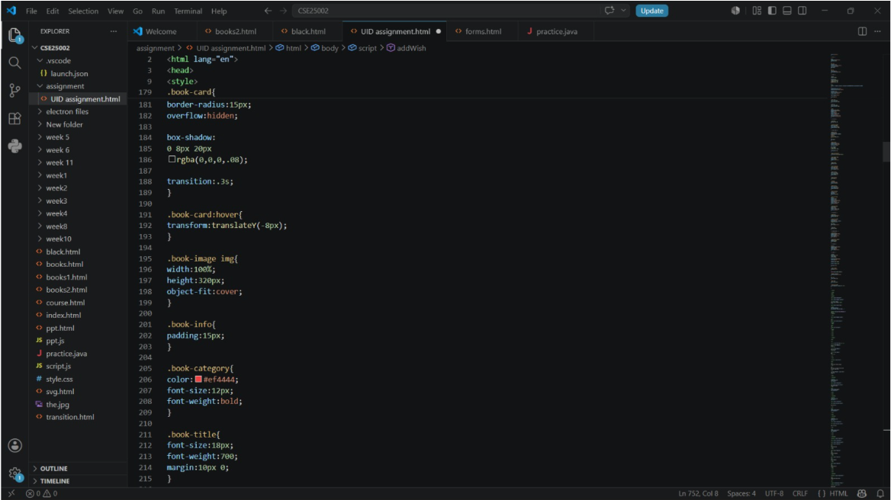
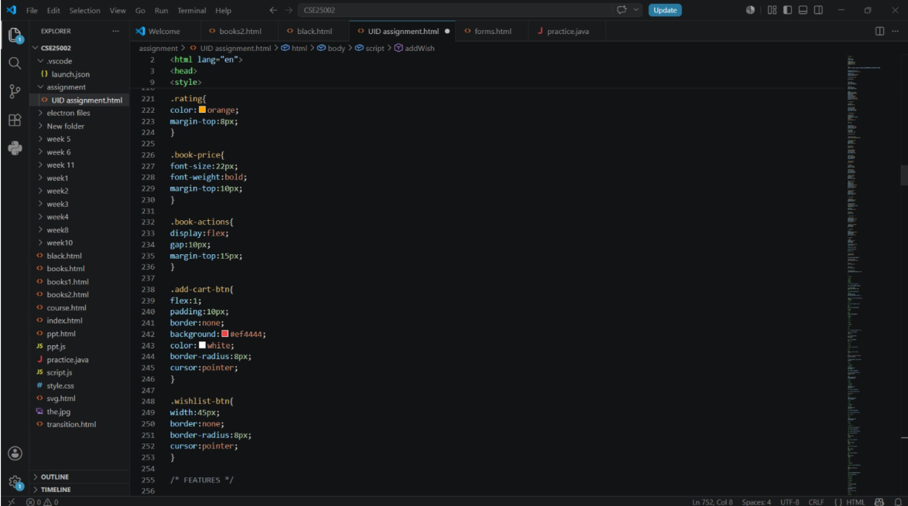
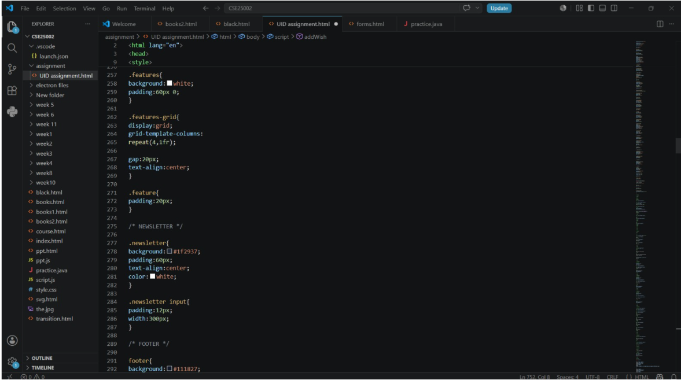
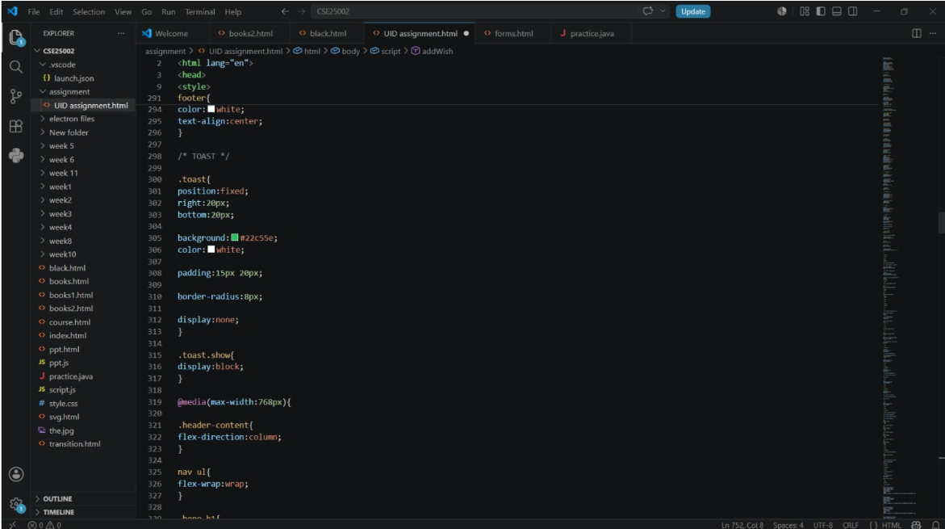
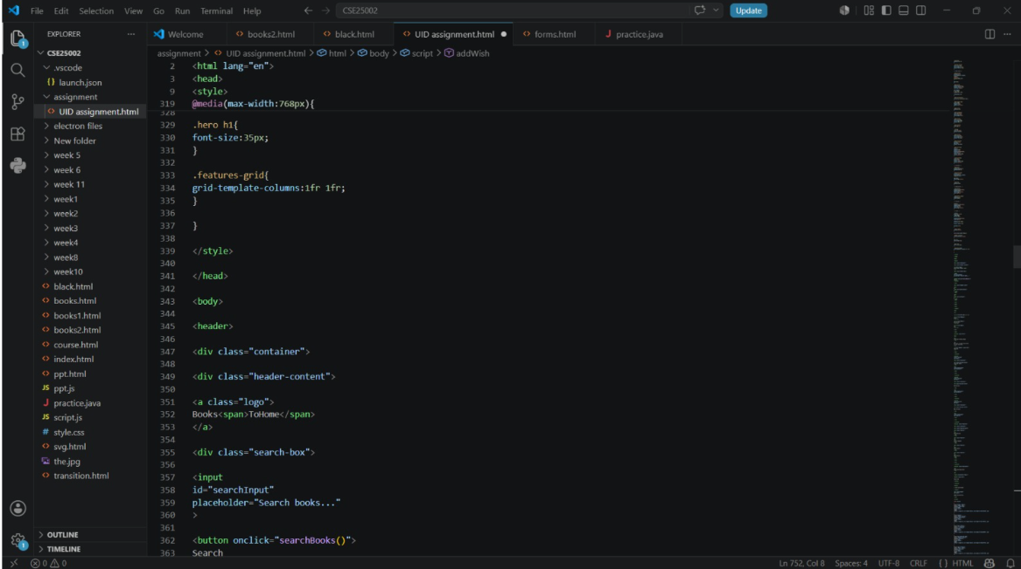
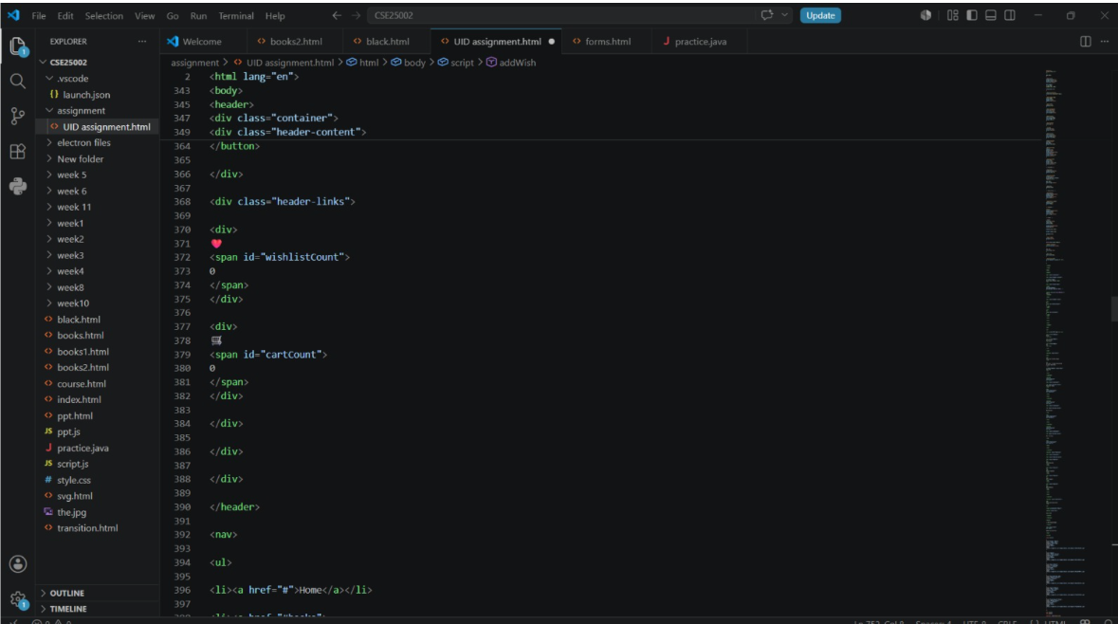
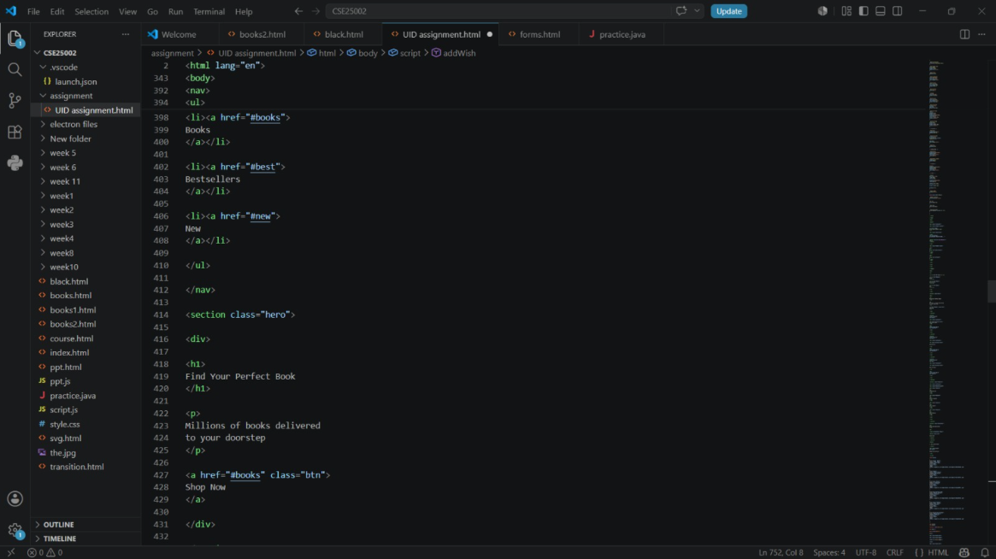
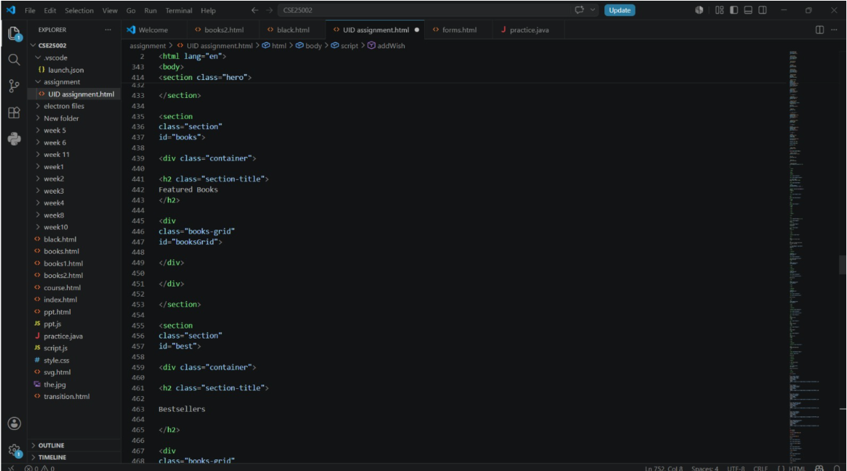
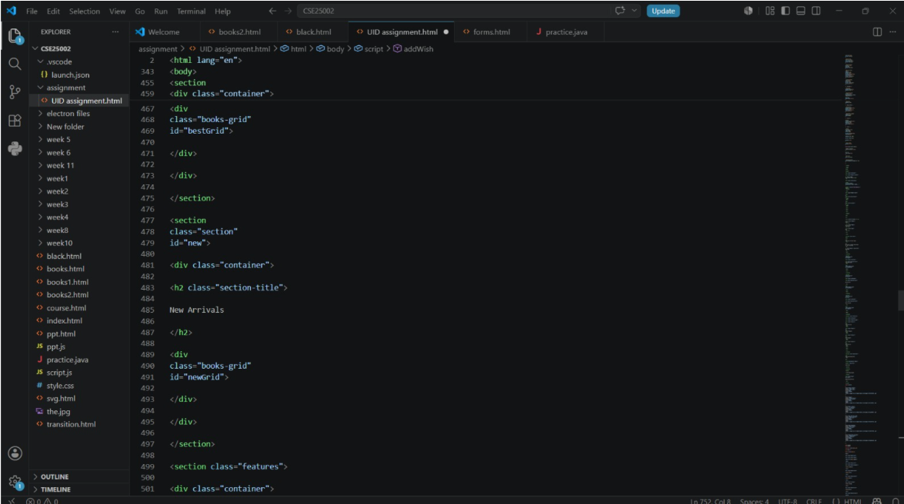
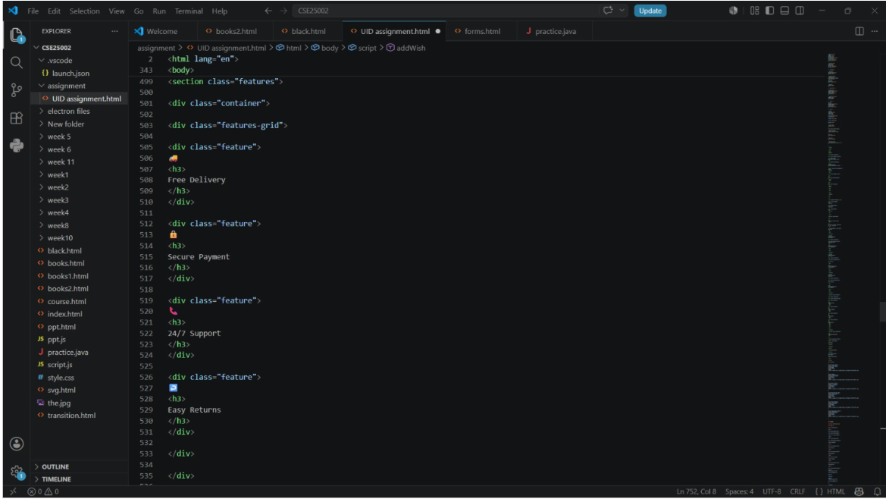
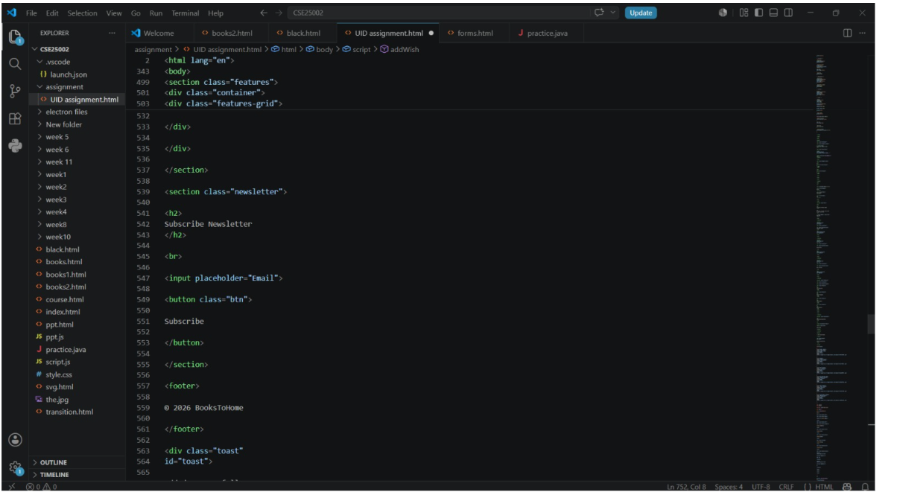
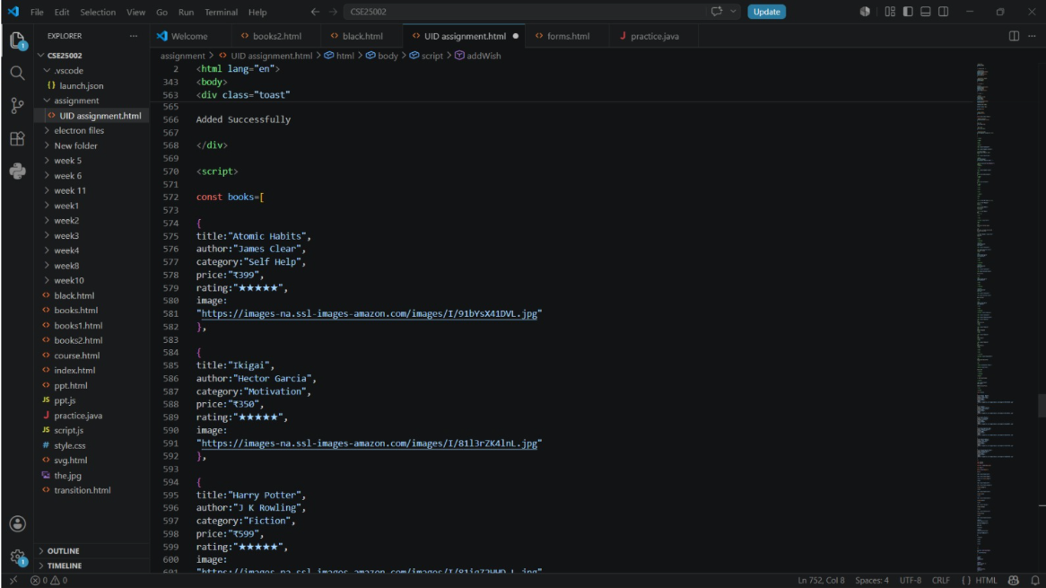
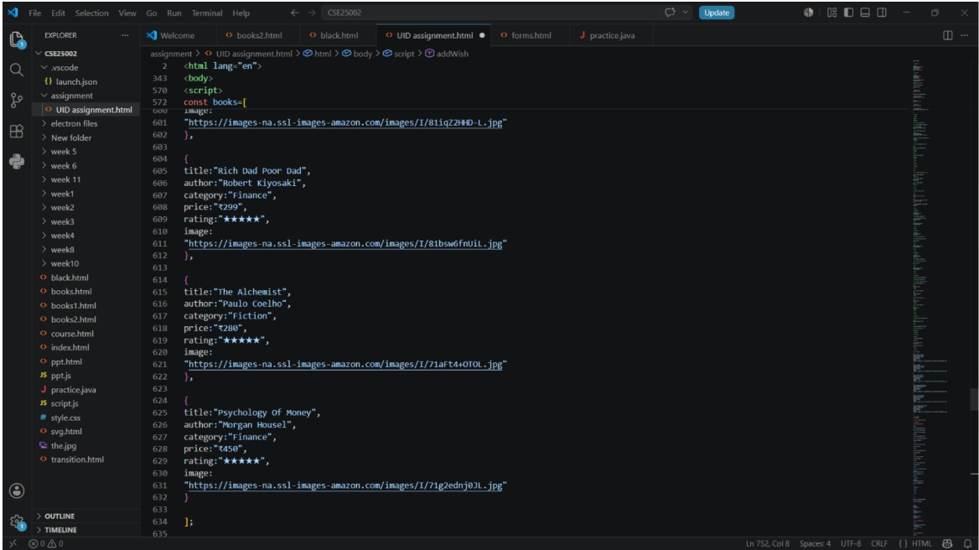
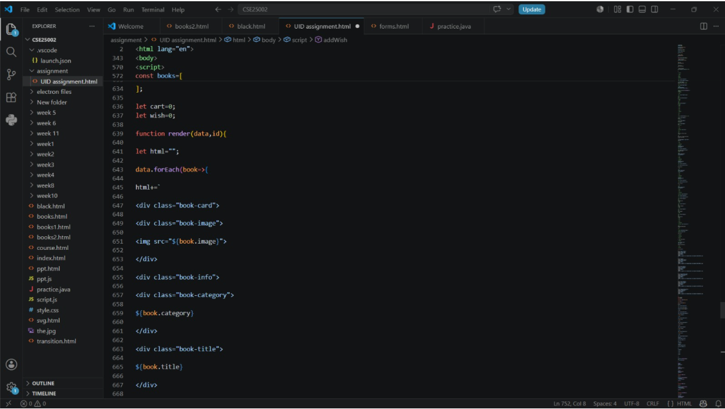
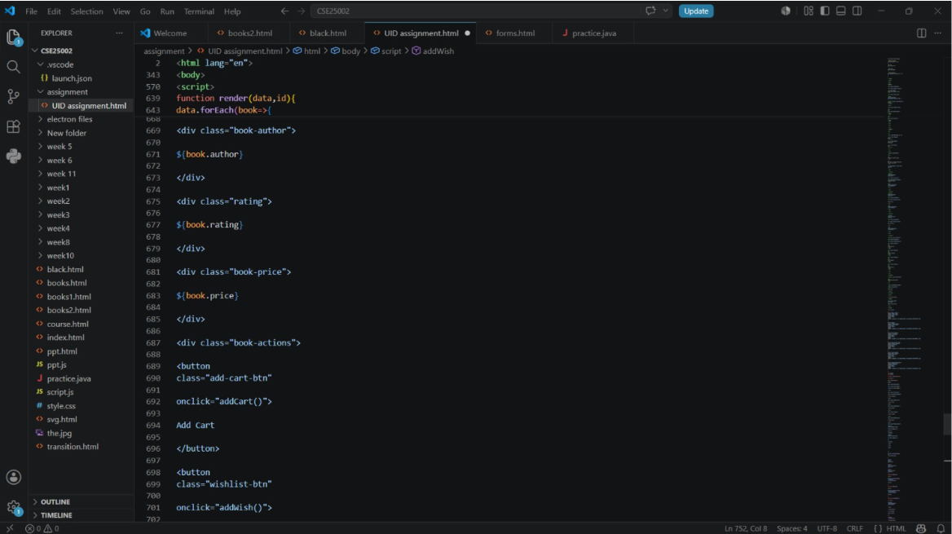
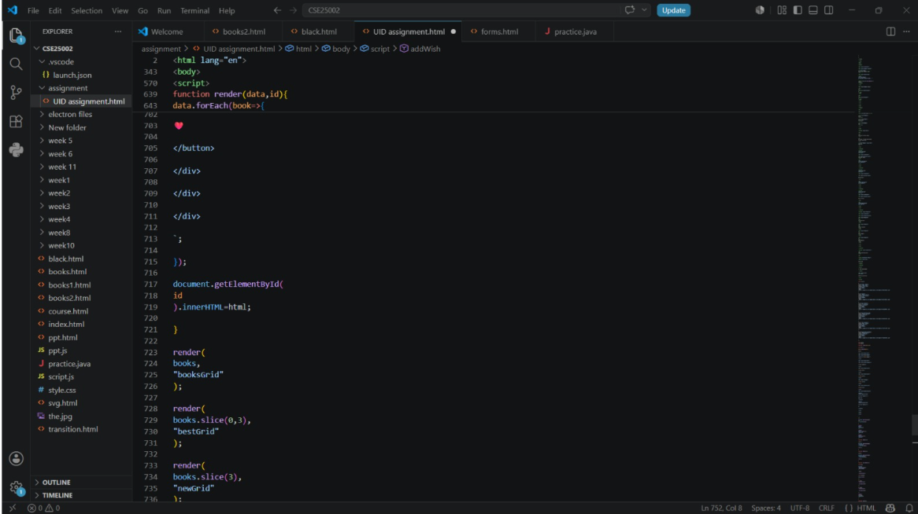
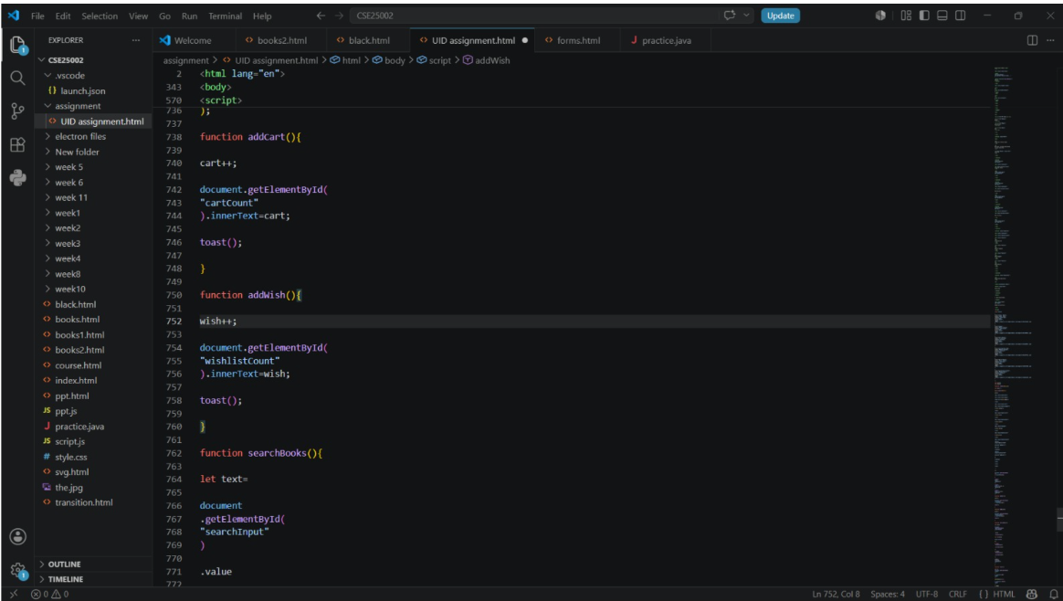
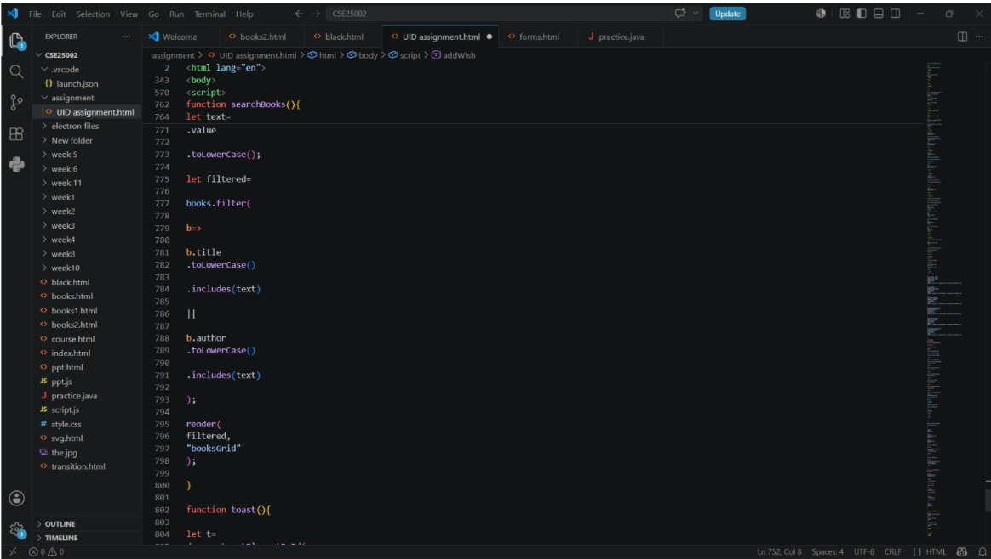
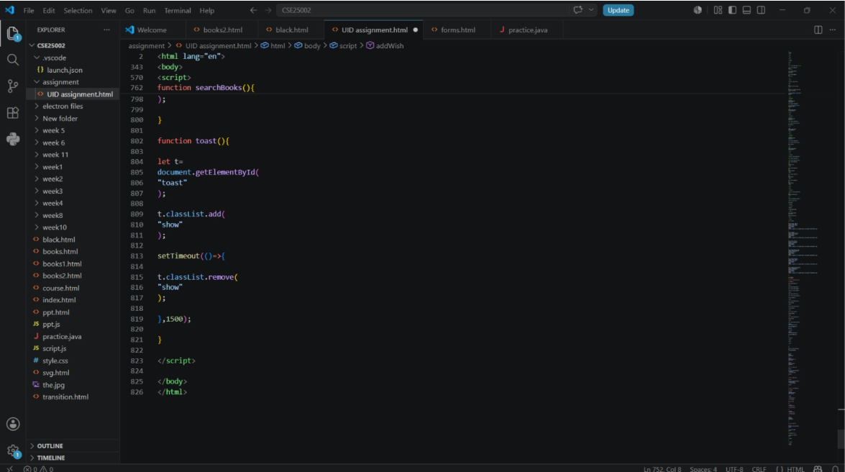

Output:
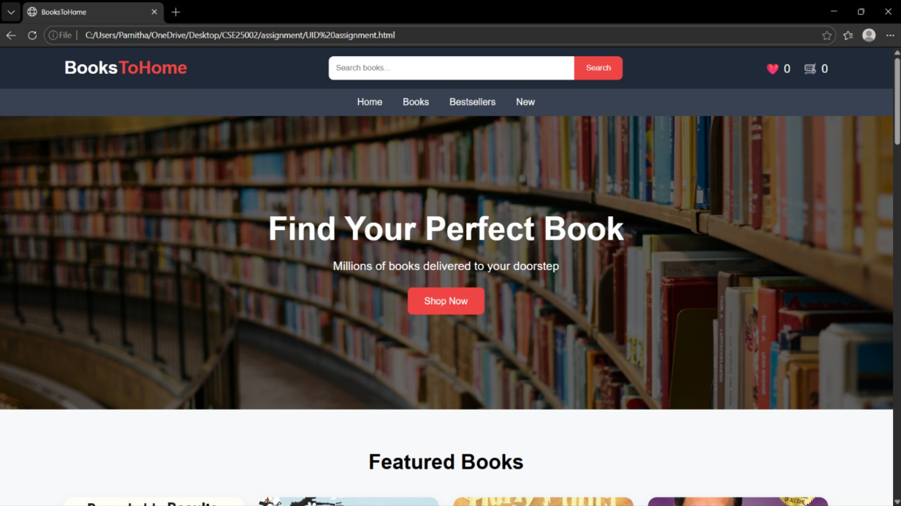
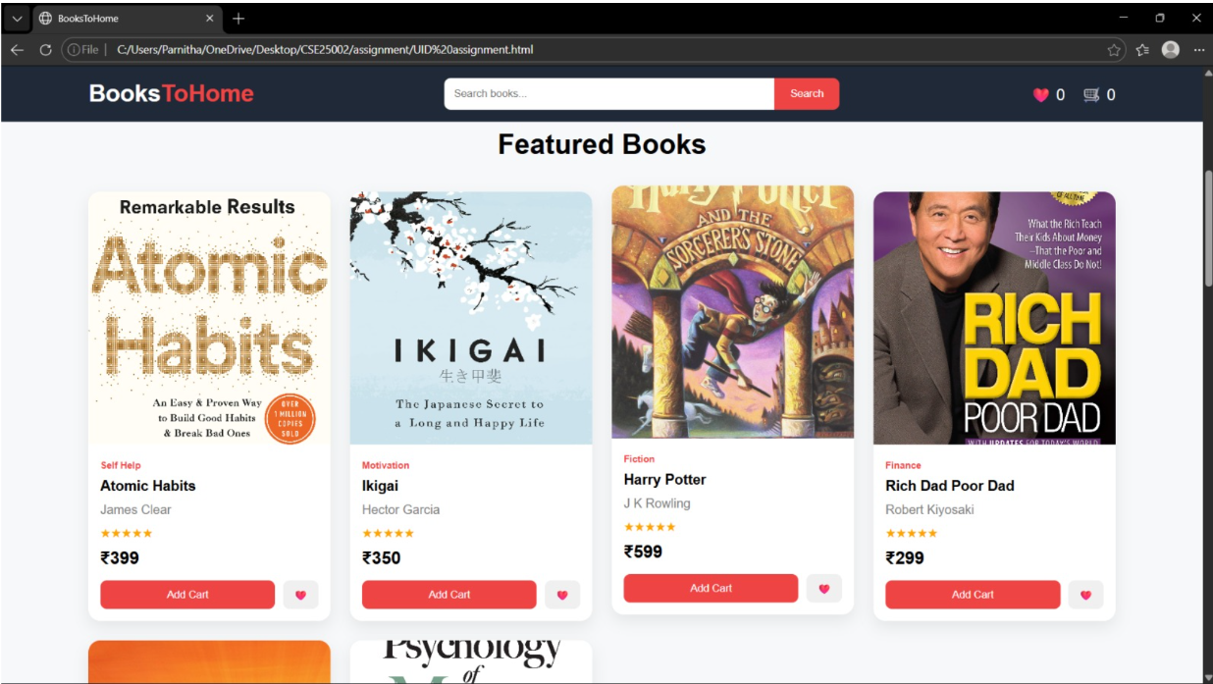
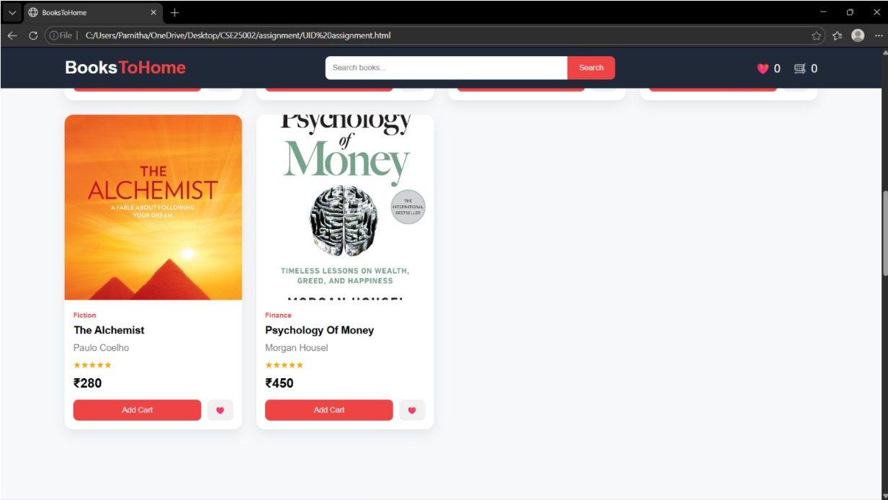
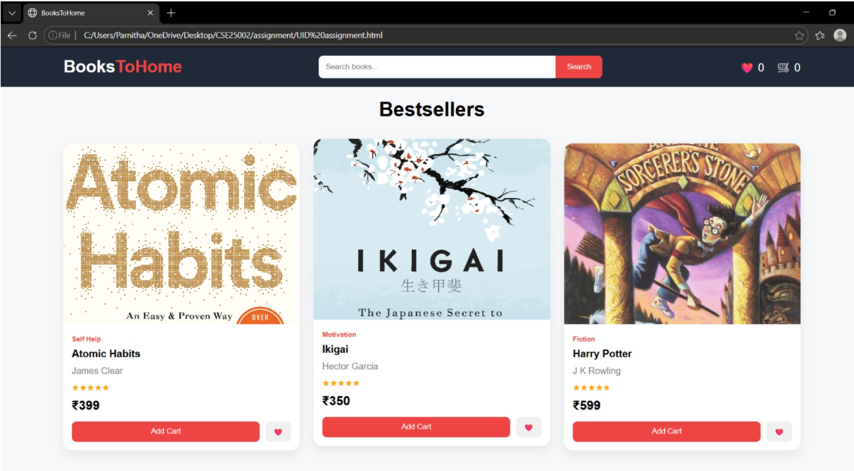
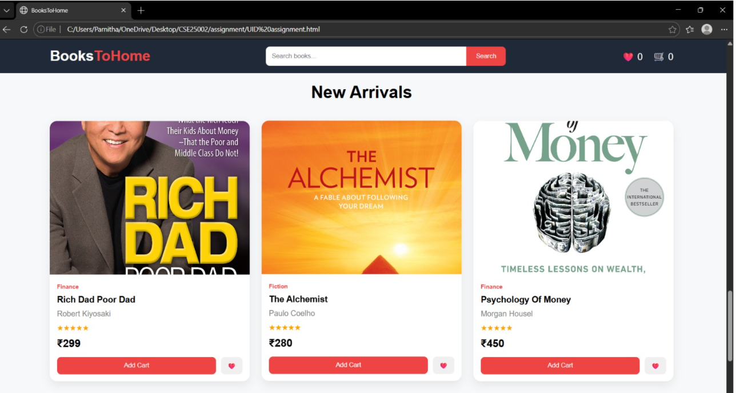
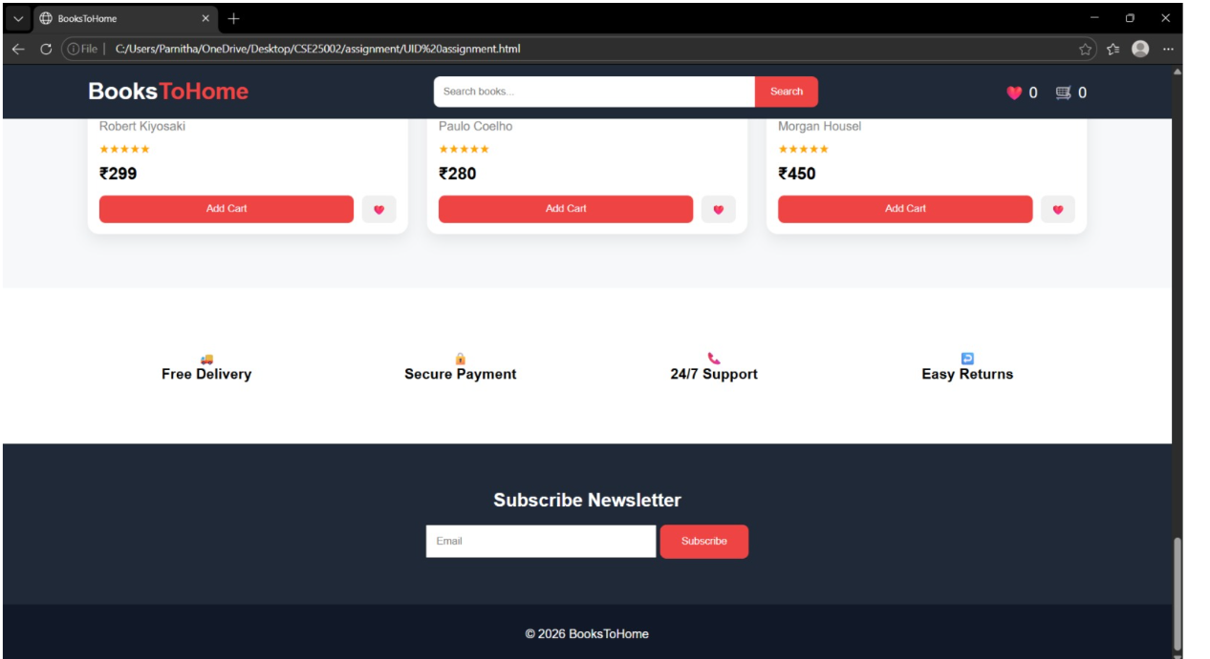

Explanation of tags:
The website focuses on clean UI design, responsiveness, and interactive user experience. BooksToHome is a responsive online bookstore website developed using HTML, CSS, and JavaScript.
- <header>: Used to create the top section of the website containing like logo, search bar, wish list.
- <nav>: It is used for the navigation menu like home, books, best seller.
- <section>: Used to divide the webpage into different content areas such as like Featured books, Bestseller books, Newsletter section.
- <div>: Used as a container element to group related content and apply styling.
- <img>: Used to display book cover images.
- Attributes Used:
- src → specifies image URL
- alt (recommended) → describes image
- <button>: Used for: Search, Add to Cart, Wishlist, Subscribe.
- <input>: It is used for newsletter email field, search attributes are placeholder, od.
- Flexbox
- Used in: Header alignment, Navigation bar, Book action buttons, Property Used: display:flex;
- Grid Layout: Properties (display: grid;).
- The render () function dynamically displays books from the array into different sections.
- The searchBooks() function filters books based on Book title, author name.
- Cart and wishlist counter:
- Functions:
- Addcart(), addwish().
- The toast () function shows a temporary success message when a user adds a book.
- Data structured used for: An array of objects is used to store book details.
- Website Features are:
- Responsive design
- Search functionality
- Dynamic book display
- Cart and wishlist system
- Bestseller and new arrival sections
- Newsletter subscription section
- Interactive animations
The BooksToHome website project helped in understanding front-end web development concepts using HTML, CSS, and JavaScript.

