LAB 1(Distance Learning)

<https://forms.office.com/Pages/ResponsePage.aspx?id=b2eGyTmbCE20-KZo4OjGpUuEByNrdW9NgP_Cnu_gV79URDZNSkVaWERYQ1lGUUg5RDFaVDlIQlBCTy4u>

original data

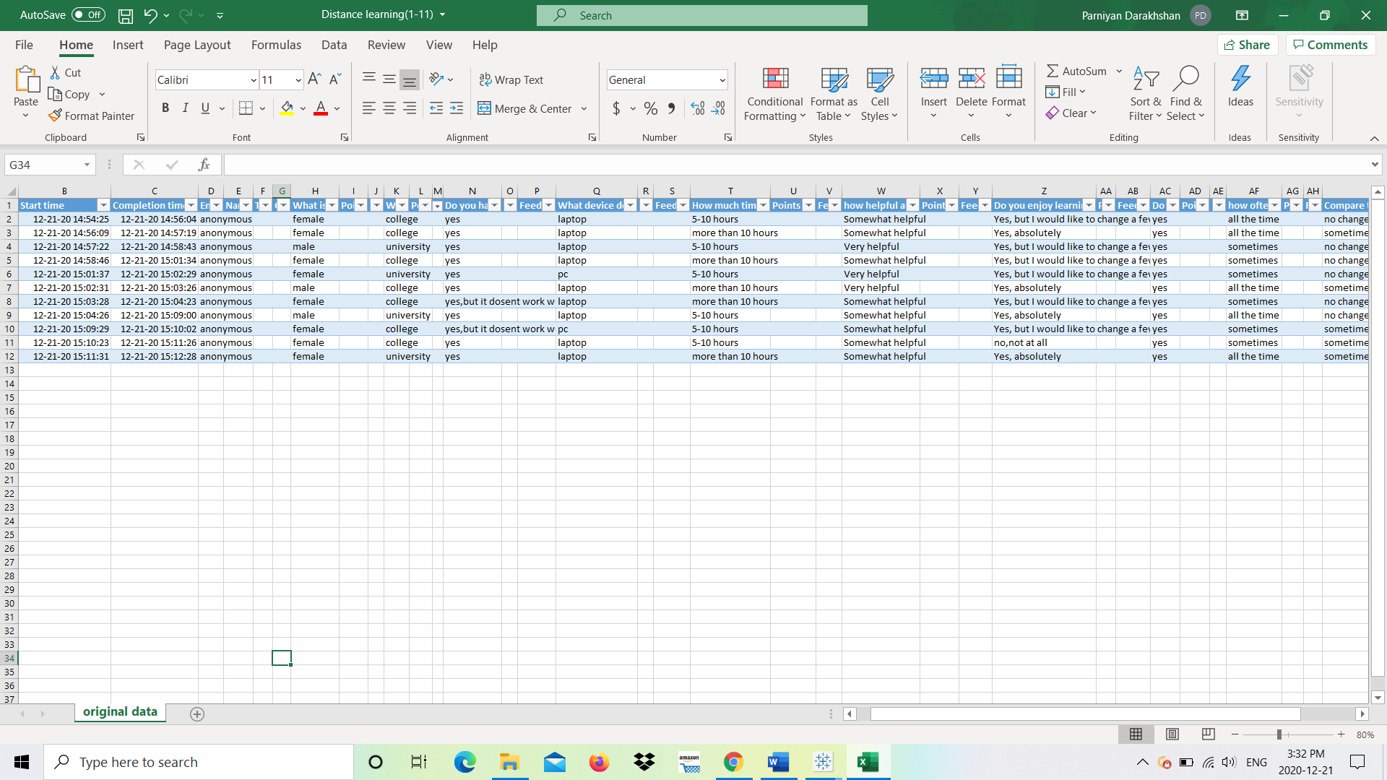

Clean data

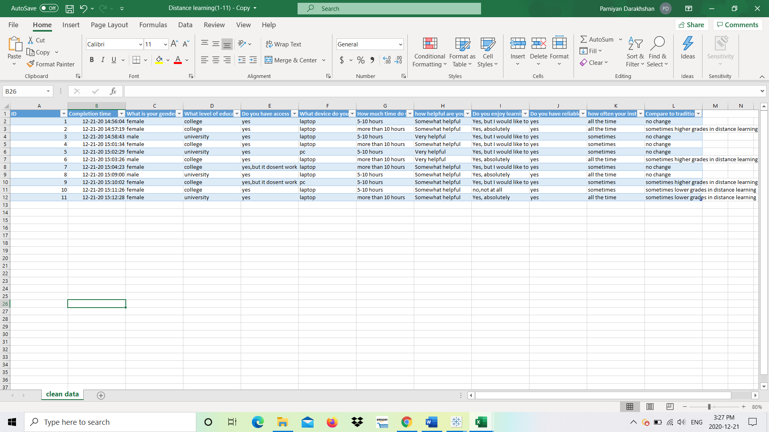

My analysis in Tableau

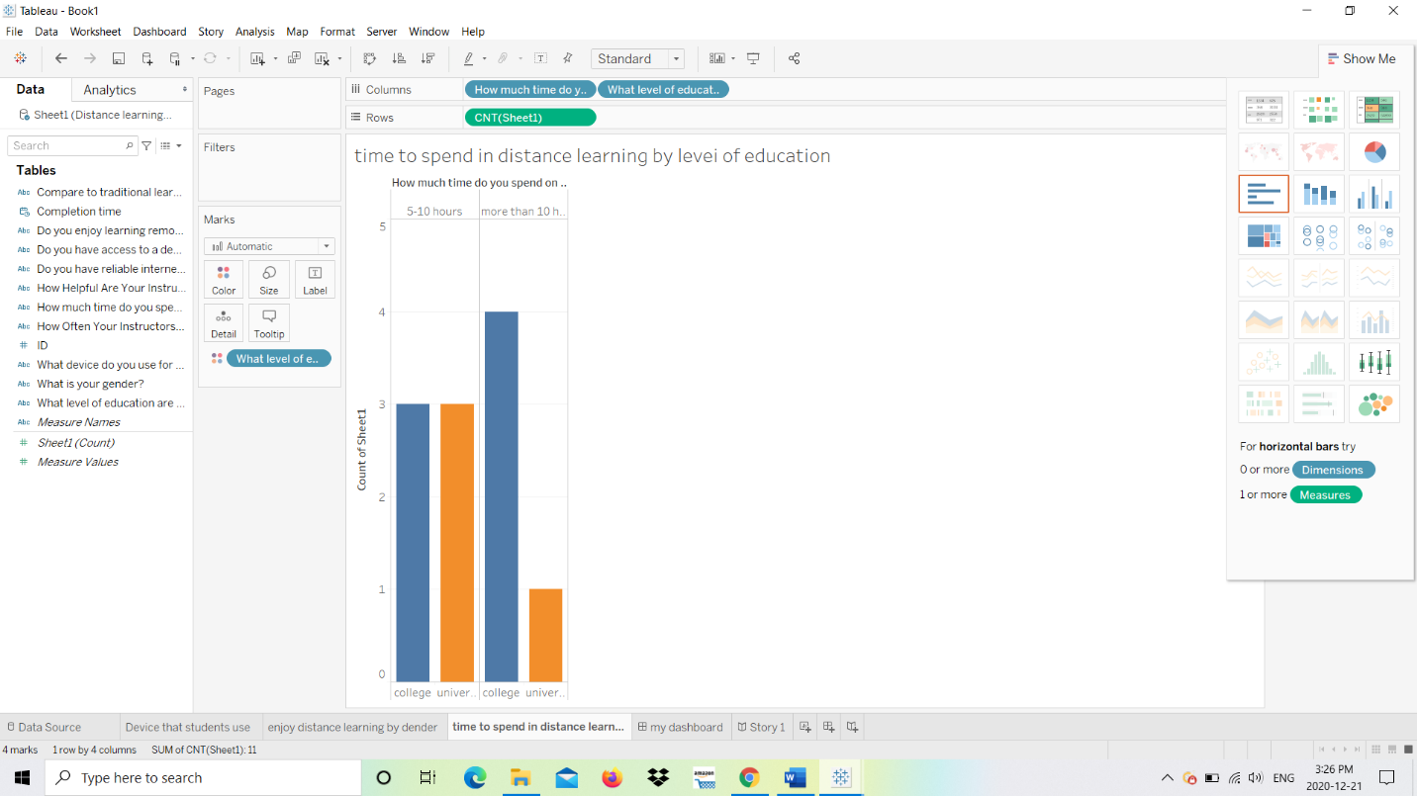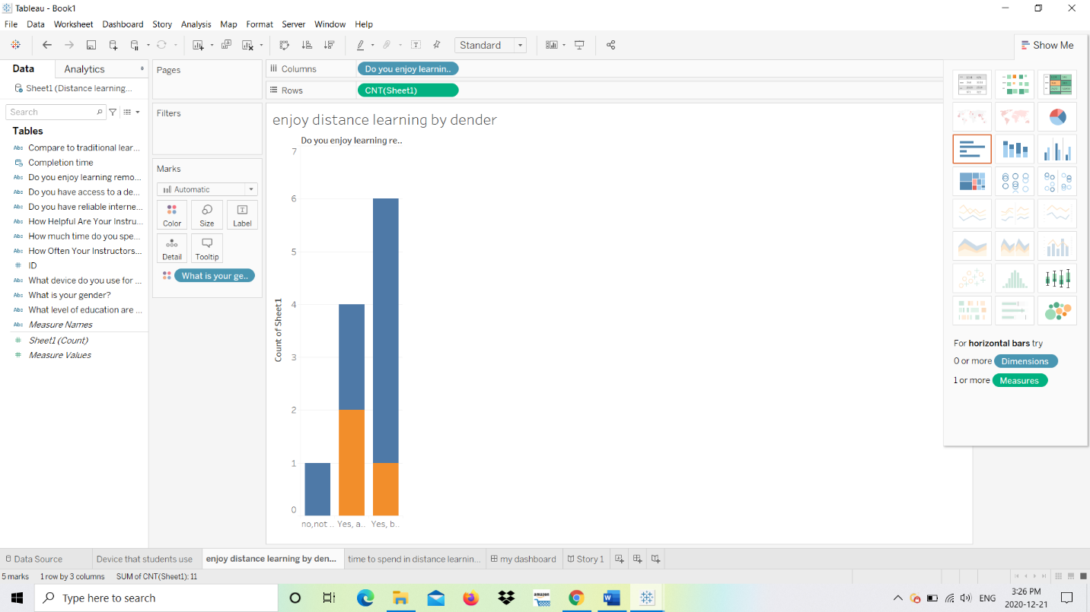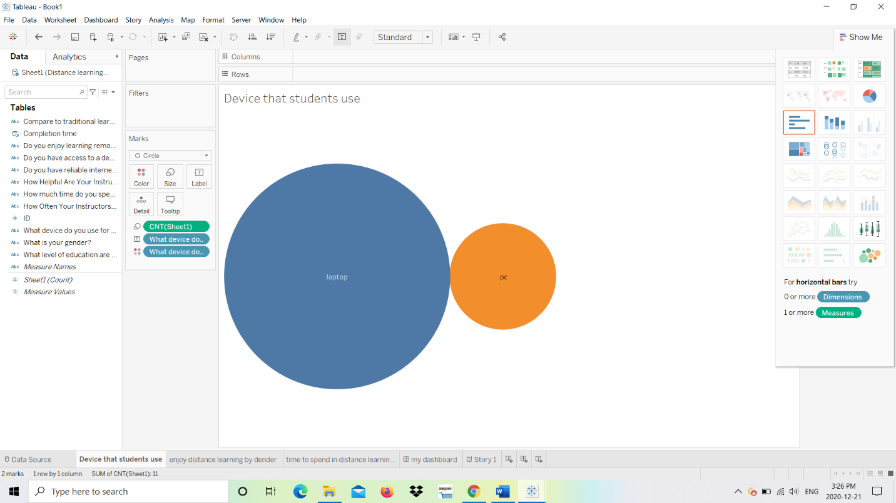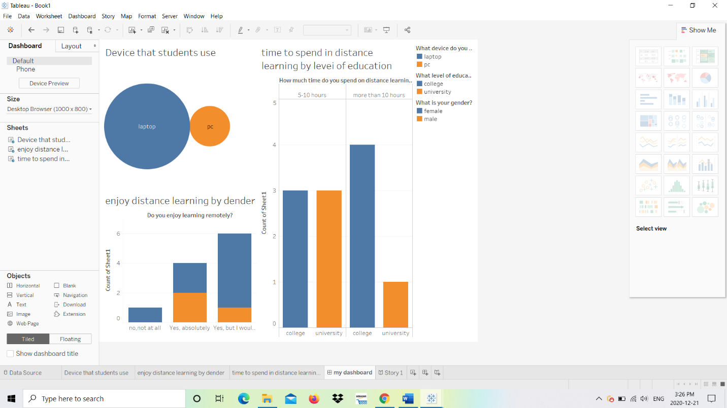

Survey result summary:

