**Mobile App development, Project Proposal** Parniyan Roosta, 414950

For my final project, I’ve decided to work on a Buy/Sell handmade Art work App. As I’ve background in making handmade art, and selling them online, I thought it will be more convenient to have a mobile app for that.

My app will be mainly composed of three sections:

**Main (Home) page**

Which includes the name of the app, a short description, and the list of all categories of all available items.

**Login Section**

Which will direct the users to the login page (if I find more time, I will also work for the sign up page, so that new users can join). For this project, I’m thinking of adding some users in the DB, to be able to demonstrate that the app actually works. After pressing the submit button, the user will be directed to the profile page, where they can input some of their biography, the picture of their art work, as well as a short description and the price of the item.

**Categories Section**

When the category of interest is clicked by the user in the main page, he will be directed to another page which contains all the pictures, and descriptions of the items available in that category. When clicked on the image of interest, the user will be directed to the page, specific for that item, where he can see the larger image, as well as the full description of the item.

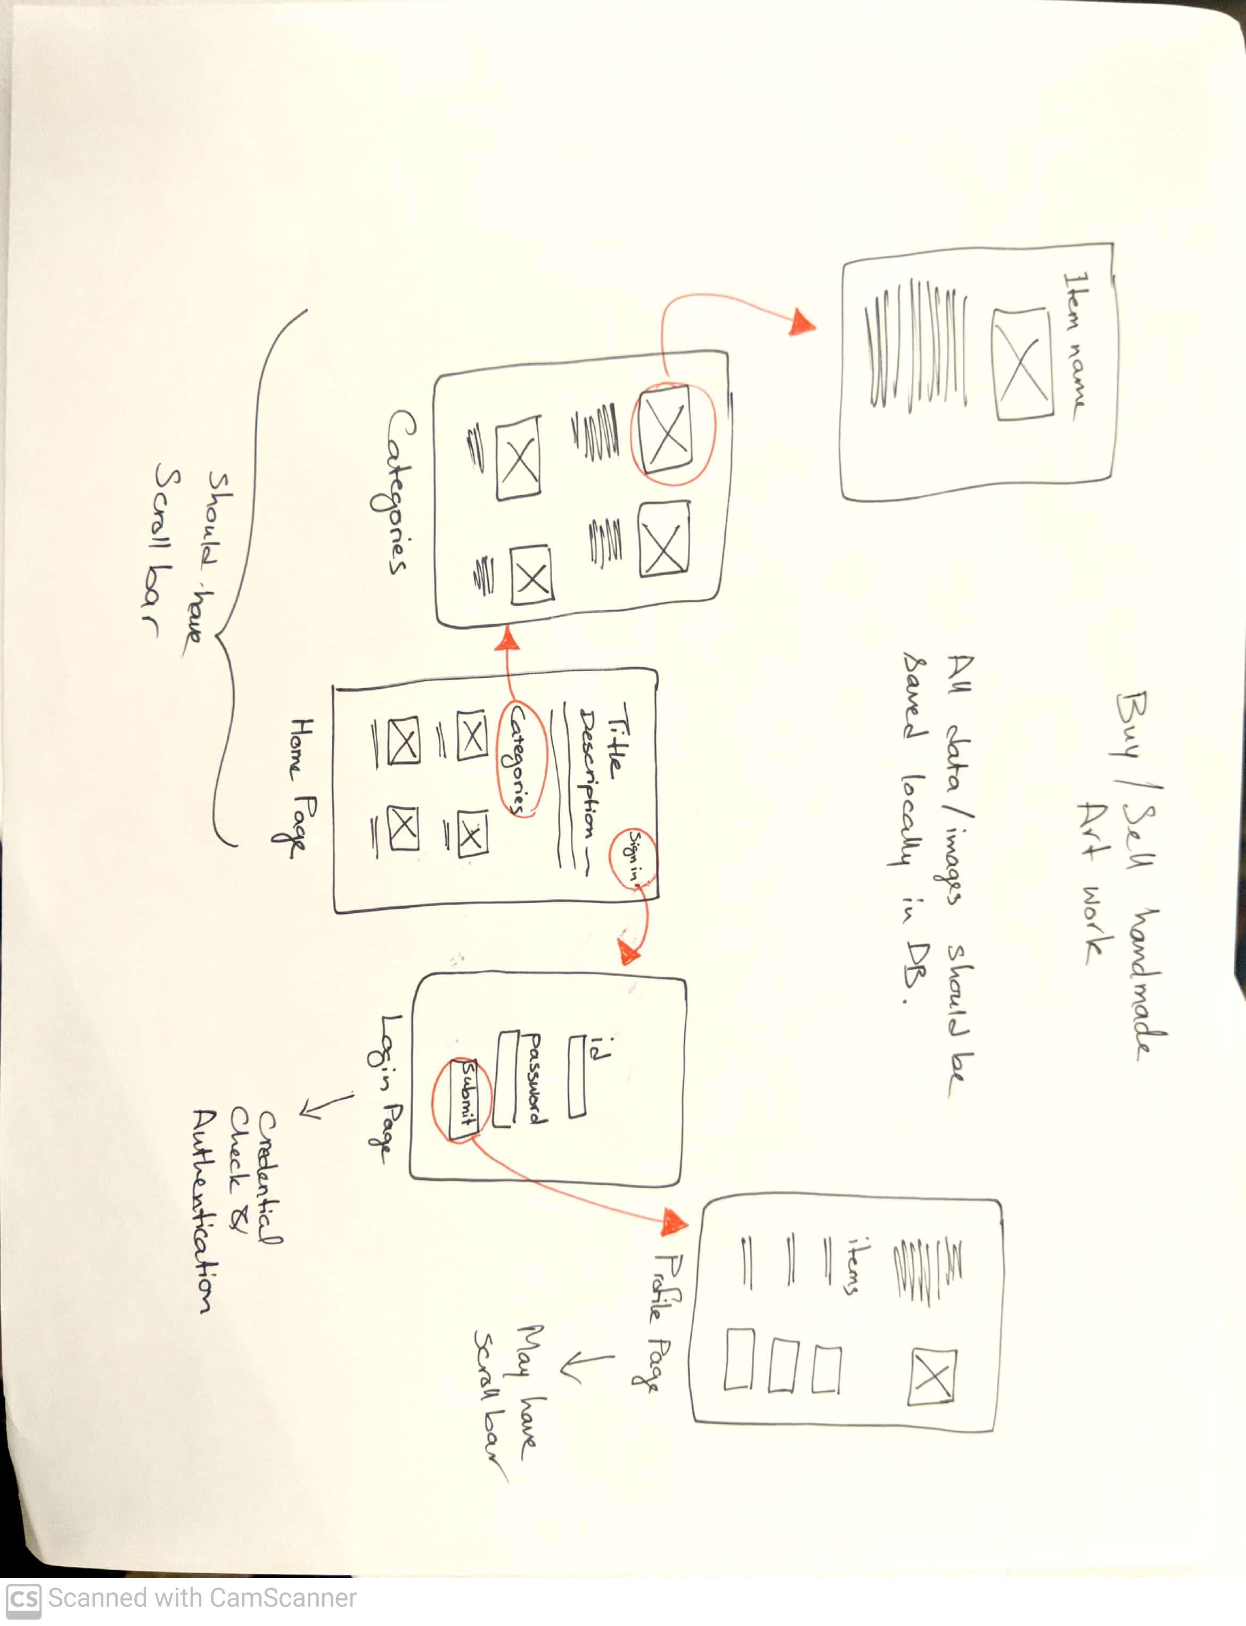

The link to the Wirerame.cc website, where my wireframes are, is:

<https://wireframe.cc/pro/pp/34a7d7235517304>