Voxeliens

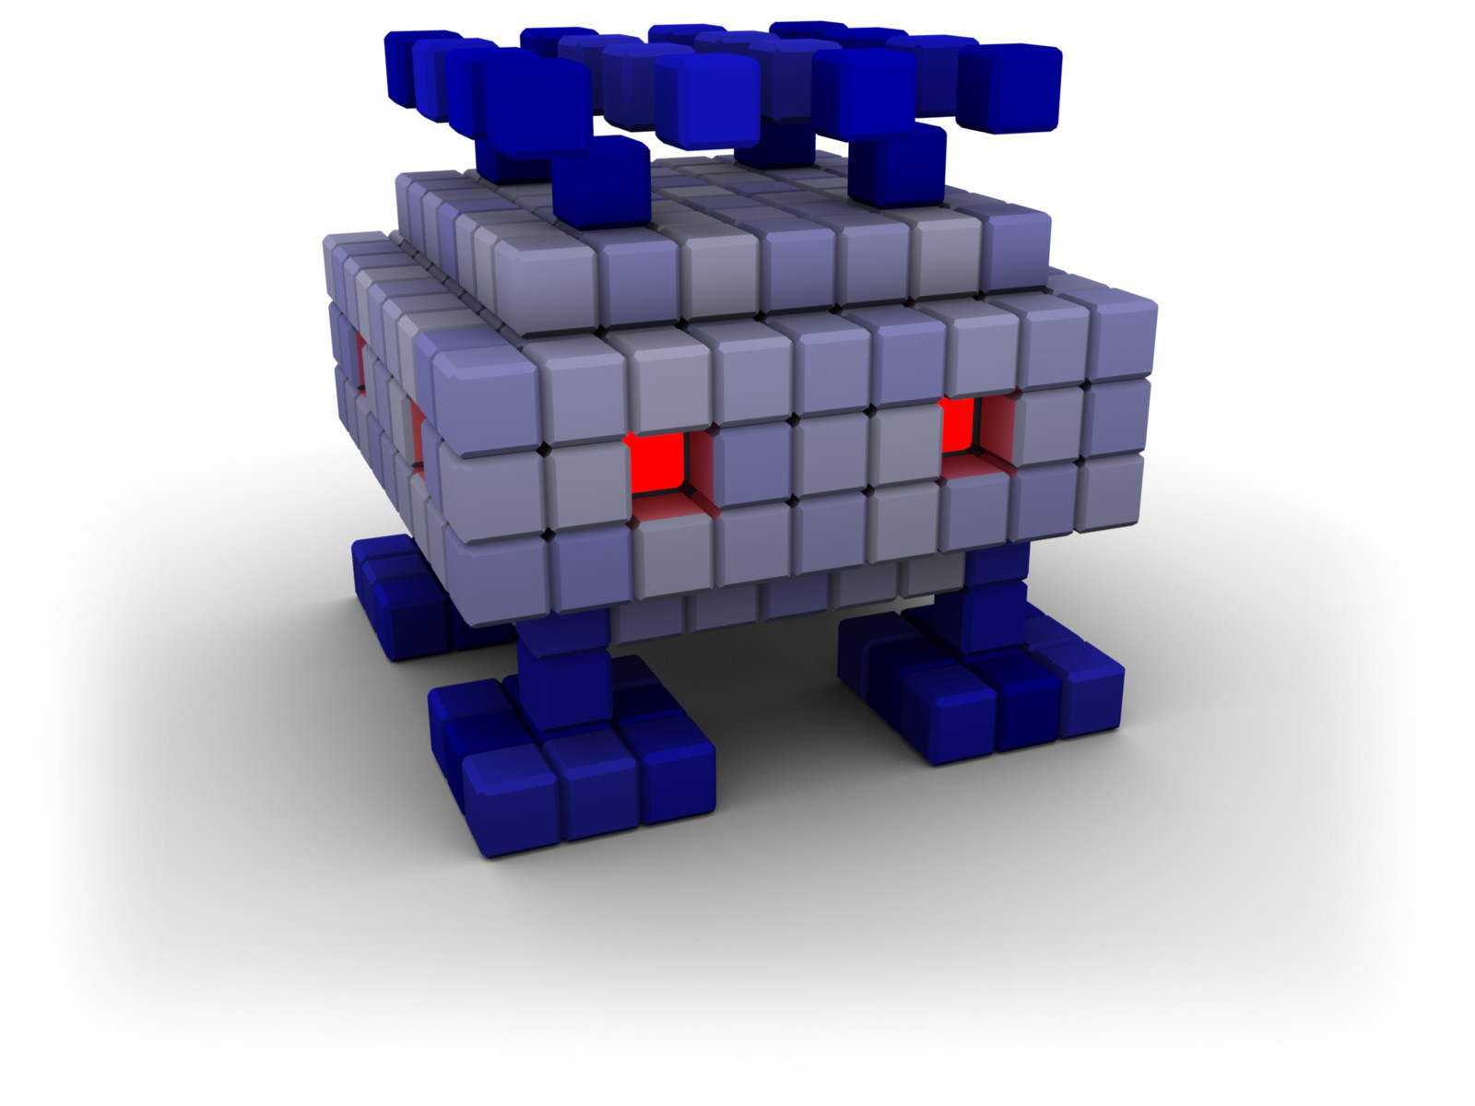

Contents

Installing and running Voxeliens 3

Windows 3

Using the installer 3

From the Zip file 3

Linux 3

MacOS 3

The Main Menu 4

How to Play 6

Controls: 6

Tips: 7

Troubleshooting 7

General problems 7

Specific problems 7

Further support 7

Credits 8

Development 8

Music 8

Sound effects 8

Artwork 8

Software and libraries used 8

# Installing and running Voxeliens

Please follow the instructions for your platform below.

## Windows

The Windows version of Voxeliens is provided as an installer and also as a ZIP file. You can choose which one to use, but the installer is recommended because it ensures the required libraries are present on your system. The main reason you may wish to use the ZIP file instead is if you do not have administrator permissions on your machine.

### Using the installer

Please run the installer and follow the instructions on the screen. You will need to accept the license and choose an install location for the game. Generally the default settings are recommended.

The installer will create a shortcut called ‘Voxeliens’ in your Windows Start menu. You can use this to launch the game.

### From the Zip file

Please locate the zip file you received. You can extract it to the current folder by right clicking and selecting ‘Extract all…’ from the context menu, or alternatively you can use another program to extract to your preferred location.

Before you run the game you should ensure that you have the correct version of DirectX installed. You can do this by going to the ‘DirectXRedist’ folder in the location where you extracted the ZIP file, and then running DXSETUP.exe.

You can then run the game by launching ‘Voxeliens.exe’ from the extracted location.

## Linux

At the time of writing, Voxeliens is not available for Linux. Please check our website (<http://www.volumesoffun.com>) for the latest information about this.

## MacOS

At the time of writing, Voxeliens is not available for MacOS. Please check our website (<http://www.volumesoffun.com>) for the latest information about this.

# The Main Menu

On running Voxeliens you should be presented with a menu screen like that shown below:

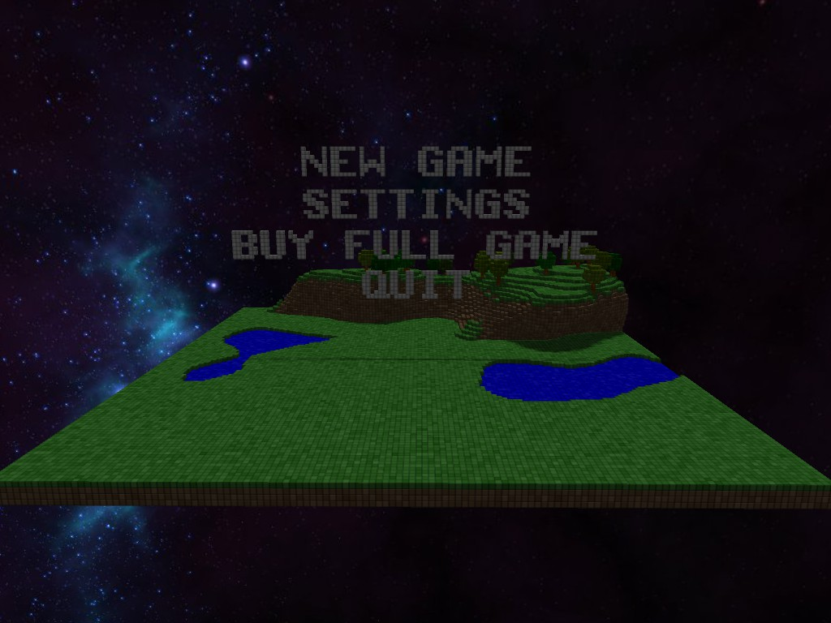

You can use the mouse to select the desired option, or alternatively you can use the arrow keys and press ‘Enter’ to select. The available options are:

|  |  |
| --- | --- |
| **New Game:** | This begins a new game of Voxeliens. |
| **Settings:** | Configure several aspects of Voxeliens such as the controls and the difficulty. More details are available below. |
| **Buy Full Game:** | This option is only available in the demo, and it launches a web browser allowing you to purchase the full version of Voxeliens. |
| **Quit:** | Leaves the game. |

The only one of these options which requires further elaboration is ‘Settings’. Selecting this option will present you with the following dialog:

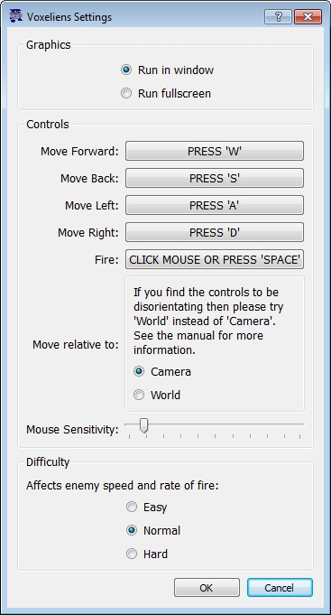

From here you can:

**Set fullscreen/windowed:** Set to fullscreen to have Voxeliens take over your desktop, or leave as windowed for access to the taskbar.

**Change the keyboard controls:** Use this option to set which keys are bound to in game actions such as movement and shooting. You can click any of the buttons to set a new key binding.

**Move relative to:** The default mode of ‘Camera’ means that when you press ‘forward’ your tank will move away from the camera and into the screen. Therefore the direction in which your tank moves will change depending on the angle from which you are viewing the world. Most players will find this quite natural, but if you get disoriented then you can try ‘World’ instead. In this case the movement directions will be fixed regardless of how you rotate the camera.

**Adjust the mouse sensitivity:** Mouse movements are used to rotate the camera around the world. If you find the camera moves at the wrong speed then you can adjust it here.

**Difficulty:** If you are finding the game too easy or too hard then you can adjust the difficulty.

# How to Play

The aim of Voxeliens is simply to survive as many waves of attacking enemies as possible, and to obtain the highest score. You do this by controlling a tank on the ground and using it to shoot down the enemies while avoiding the bombs they drop on the terrain. Successive waves of enemies both move and shoot more quickly.

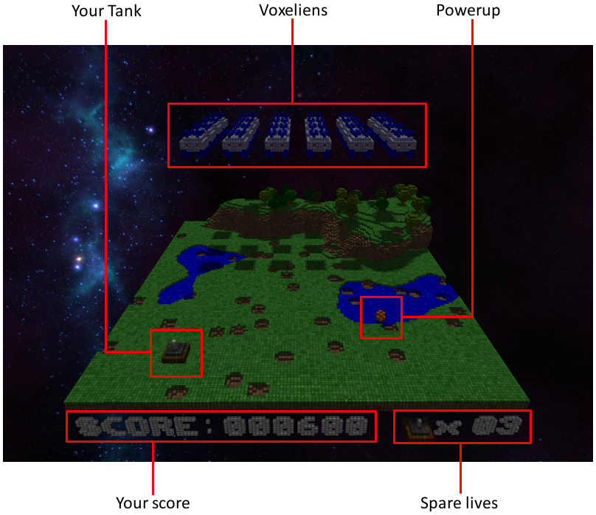

## Controls:

The default controls are as follows:

|  |  |  |
| --- | --- | --- |
| Action | Binding 1 | Binding 2 |
| Move forwards: | W (configurable) | Up arrow |
| Move backwards: | S (configurable) | Down arrow |
| Move left: | A (configurable) | Left arrow |
| Move right: | D (configurable) | Right arrow |
| Shoot: | Any mouse button | Space (configurable) |
| Rotate camera: | Move mouse | N/A |
| Zoom camera | Mouse scroll wheel | N/A |
| Pause/Quit: | Esc | N/A |

Remember that you can change them by selecting ‘Settings’ from the main menu.

## Tips:

There are a number of additional points to keep in mind when playing the game:

* Destroyed enemies will occasionally drop powerups which enhance your weapon for a short period of time. You can collect these by touching them with your tank, but you only a few seconds to do this before they disappear!
* You have a limited number of lives and will lose one each time you are hit by a falling bomb. However, you will get an additional life each time your score reaches a multiple of 10000.
* The Voxeliens will slowly descend during the course of a level. If they reach the same height as your tank then it is game over so don’t let them get too low. As they descend some may crash into trees or hill which will blast a big hole in the landscape… this isn’t game over but you will lose a lot of points as you are supposed to be defending your planet!
* There are time bonuses available for completing each level in less than the expected time.

If you do well then you will be able to add your name to the high score table, thereby cementing your place in history.

# Troubleshooting

## General problems

* The most common reason that the game will not run is that the version of DirectX on your system is not up to date. You can get the latest version of DirectX from Microsoft’s site by visiting the following link: <http://www.microsoft.com/download/en/details.aspx?id=35>
* If you experience and graphical problems then please update your graphics drivers to the latest version before reporting the issue to us.
* The game will create two log files in the games directory called ‘Ogre.log’ and ‘Voxeliens.log’. Please include these files when requesting support via our forums or email. If you cannot find these files you may need to run the game as administrator to have them created (right click on the executable and select ‘Run as Administrator’).

## Specific problems

* We are aware that the game can have problems running in fullscreen mode on an AMD Crossfire system. If you have Crossfire then you may need to disable it or run the game in windowed mode.
* If you have multiple monitors then be aware that we have had reports of the game not running in fullscreen on the second display. In this case you should try running the game on your primary display.
* Some antivirus systems may incorrectly identify the Voxeliens installer as a threat. You can simply ignore this, or download the ZIP file instead.

## Further support

If you are still having problems with the game then please contact us. You can look in our online forum to see if anyone else is having the same problem, or alternatively you can email us directly at [support@volumesoffun.com](mailto:support@volumesoffun.com). When doing this, please give as much information as you can about the problem and your system configuration. It would be great if you could also run 'dxdiag' from a command line, select 'Save All Information', and send us the resulting file.

# Credits

## Development

David Williams and Matthew Williams

## Music

Background music is from the album 'Resistor Anthems' by Eric Skiff, licensed under the Creative Commons Attribution 3.0 Unported license. Eric's webpage is available at www.ericskiff.com, and the full terms of the license are included in the 'audio/music/' folder of this distribution.

## Sound effects

All sound effects were obtained from FreeSound (http://www.freesound.org). The following sounds are used by Voxeliens:

* DSGETPOW.WAV by wildweasel (<http://www.freesound.org/people/wildweasel/sounds/39017/>)
* Chip054.wav by HardPCM (<http://www.freesound.org/people/HardPCM/sounds/32954/>)
* click 1 d.wav by TicTacShutUp (<http://www.freesound.org/people/TicTacShutUp/sounds/406/>)
* granulazer.wav by NoiseCollector (<http://www.freesound.org/people/NoiseCollector/sounds/5636/>)
* Lazer_01_HIT_03.wav by Koops (<http://www.freesound.org/people/Koops/sounds/12504/>)
* whatever.wav by aust_paul (<http://www.freesound.org/people/aust_paul/sounds/30937/>)
* btn107.wav by junggle (<http://www.freesound.org/people/junggle/sounds/28917/>
* Missile Strike.wav by digifishmusic -- <http://www.freesound.org/people/digifishmusic/sounds/42024/>
* laser_weapon_02.wav by cormi -- <http://www.freesound.org/people/cormi/sounds/93979/>

## Artwork

The background skybox was used with permission of Alex Peterson (http://alexcpeterson.com), who created it as a sample for his program 'Spacescape'.

## Software and libraries used

The rendering engine of Voxeliens is built upon [Ogre3D](http://www.ogre3d.org/), an open souce graphics engine which offers a lot of power and flexibility. Nokia’s [Qt](http://qt.nokia.com/) toolkit was used for most other aspects of the game including audio and input handling.

We were also dependent upon an number of open source asset creation tools including [Blender](http://www.blender.org/), [the Gimp](http://www.gimp.org/), [Sproxel](http://sproxel.blogspot.co.uk/), [Audacity](http://audacity.sourceforge.net/), [VirtualDub](http://www.virtualdub.org/) and [MeshLab](http://meshlab.sourceforge.net/). These all performed superbly at their respective tasks.

The Voxeliens installer is based on NSIS, a professional open source system to create Windows installers. See <http://nsis.sourceforge.net> for details. We also make use of the Graphical Installer addon for skinning. Please see <http://graphical-installer.com>