CONNECT4
With
ARTIFICIAL INTELLIGENCE

DISSERTATION

Submitted in partial fulfillment of the
Requirements for the award of the degree

Of

Bachelor of Technology

In

Information Technology

By:

NITIN RAIZADA (1121323107/2007/IT-2)
PUNEET ARORA (1341323107/2007/IT-2)
PRABHJOT SINGH (1161323107/2007/IT-2)
PULKIT SINGH (1231323107/2007/IT-2)
GURPREET SINGH (0711323107/2007/IT-2)

Under the guidance of:

Mr. Pranav Dass



Department of Computer Science & Engineering
Guru Tegh Bahadur Institute of Technology
Guru Gobind Singh Indraprastha University
Kashmere Gate, New Delhi, Year 2010-2011

DECLARATION

We hereby declare that all the work presented in the dissertation entitled “CONNECT4 with “ARTIFICIAL INTELLIGENCE” in the partial fulfillment of the requirement for the award of the degree of Bachelor of Technology in Information Technology, Guru Tegh Bahadur Institute of Technology, Guru Gobind Singh Indraprastha University Delhi is an authentic record of our own work carried out under the guidance of Mr.Pranav Dass.

Date: 28/04/2011
NITIN RAIZADA(20/2007/IT-2)
PUNEETARORA(40/2007/IT-2)
PRABHJOT SINGH(23/2007/IT-2)
PULKIT SINGH(30/2007/IT-2)
GURPREET SINGH(04/2007/IT-2)

CERTIFICATE

This is to certify that dissertation entitled “CONNECT4 with ARTIFICIAL INTELLIGENCE”, which is submitted by Mr. Nitin Raizada, Mr. Prabhjot Singh, Mr. Puneet Arora , Mr. Pulkit Singh and Mr. Gurpreet Singh in partial fulfillment of the requirement for the award of the degree of Bachelor of Technology in Information & Technology, Guru Tegh Bahadur Institute of Technology, New Delhi is an authentic record of the candidates’ own work carried out by them under our guidance. The matter embodied in this thesis is original and has not been submitted for the award of any other degree.

Mr. Pranav Dass Mr. MunshiYadav
(Project Guide ) (Head of Department,
Information Technology)

Date: 28th APRIL 2011

ACKNOWLEDGEMENT

We would like to express our great gratitude towards our supervisor, Mr. Pranav Dass who has given us support and suggestions. Without their help we could not have presented this dissertation up to the present standard. We also take this opportunity to give thanks to all others who gave us support for the project or in other aspects of our study at Guru Tegh Bahadur Institute of Technology.

Date: 28/4/2011

NITIN RAIZADA(1121323107/2007/IT-2)
nitin11aug@gmai.com

PUNEETARORA(1341323107/2007/IT-2)
arora.puneet777@gmail.com

PRABHJOT SINGH (1161323107 / IT-2)
prabhjot.s89@gmail.com

PULKIT SINGH(1231323107/2007/IT-2)
pulkit632@gmail.com

GURPREET SINGH( 0711323107/IT-2)
gurpreet.020@gmail.com

ABSTRACT

Board games have constituted a popular computer science research area for decades, and many
Exciting results have emerged, e.g., IBM's chess computer Deep Blue, playing chess at a
Grandmaster level. When attempting to create skilled game-playing algorithms, numerous methods are available, e.g., brute force search algorithms, hard-coded rules based on human expert knowledge, training neural networks on recorded game databases, and so on. The possible methods, and combinations of them, are seemingly only limited by the human imagination, and new methods continue to emerge. Connect Four (also known as Four Up, Plot Four, Find Four, Four in a Row, and Four in a Line) is a two-player game in which the players first choose a color and then take turns dropping their colored discs from the top into a seven-column, six-row vertically-suspended grid. The pieces fall straight down, occupying the next available space within the column. The object of the game is to connect four of one's own discs of the same color next to each other vertically, horizontally, or diagonally before one's opponent can do so. There are many variations on the board size, the most commonly used being 7×6, followed by 8×7, 9×7, and 10×7.
As we know the connect 4 board is a 2d array of dimension 6x7 (6- horizontal rows and 7 vertical columns) .Each cell in board is used to contain chips of two different color based on the turn of the player involved in this turn based multiplayer game. The pieces fall straight down, occupying the next available space within the column.

LIST OF TABLES AND FIGURES

  - 1.6.1 connect 4 board
  - 1.6.2Horizontal, vertical and diagonal winning lines
  - 1.6.3Example of Zugzwang
  - 1.6.4 Using minimax with cutoff depth 1 and IBEF evaluation function to determine which move to make .
  - 1.6.5 board layout
  - 1.6.6 Original software design flow chart
  - 1.6.6 Software flow of start and difficulty screens
  - 1.6.6 Software flow for two player easy mode
  - 1.6.6 Software flow for two player hard mode
  - 1.6.6 Software flow for the one player easy/medium
  - 1.6.6 Software flow for the one player hard.
  - 2.2.3 Table showing the assignment of chips to players
  - 3.1.2 Flow chart representing actions
  - 3.1.3 Deciding Winner algorithm
15 3.1.4 Message decoding algorithm
16 3.1.5 Main game loop
17 3.1.6 Flowchart showing play again loop
18 3.2.1 Relationship between player and game server
19. 3.2.2 Relationship between game server and code

.

Table of Contents

DECLARATION ii
CERTIFICATE iii
ACKNOWLEDGEMENT iv
ABSTRACT v
LIST OF TABLES AND FIGURES vi
Table of Contents vii
CHAPTER ONE: 1
INTRODUCTION 1
1.1 INTRODUCTION 2
1.2 HISTORY OF CONNECT4 2
1.3 THE GAME OF CONNECT4 3
1.3.1. Game details 3
1.3.2. Complexity of the game 5
1.3.3. The optimal strategy 6
1.3.4. Evaluating the Connect4 board 7
1.4 APPLYING MINIMAX TO CONNECT4 8
1.5 MATERIALS AND METHODS 10
CHAPTER TWO: 20
SYSTEM DESIGN 20
2.1 Modules Used 21
2.2 Module Description 21
2.2.1 Board 21
2.2.2 Board Status 23
2.2.3 Chip 23
2.2.4 Action Classes 24
CHAPTER THREE: 26
PROJECT DICTIONARY 27
3.1 FLOW CHARTS 28
3.1.1 FLOW CHART REPRESENTING OCCURRENCE OF FUNCTIONS WITHIN ACTION CLASSES 28
3.1.2 DECIDING WINNER ALGORITHM. 29
3.1.3 MESSAGE DECODING ALGORITHM 30
3.1.4 MAIN GAME LOOP 31
3.1.5 FLOWCHART REPRESENTING PLAY AGAIN LOOP 32
3.2 ER DIAGRAMS 33
3.2.2 ER DIAGRAM REPRESENTING RELATIONSHIP BETWEEN MAIN GAME CODE AND LOCAL MACHINE 33
CHAPTER 4: 35
CODING USED IN THE PROJECT 35
4.1 BOARD 36
4.2 CHIP 45
4.3 ACTION INTERFACE 46
4.4 ACTION DROPCHIP 47
4.5 ACTION READY 49
4.6 ACTION MAKING MOVE 52
4.7 ACTION WAITING FOR TURN 56
4.8 MAIN APPLET 58
4.9 ACTION PLAY AGAIN 68
4.10 ACTION GAME OVER 69
CHAPTER: FIVE 72
TESTING 72
5.1 UNIT TESTING 73
5.1.1 Testing ActionReady 74
5.1.2 Testing ActionPlayerMakingMove 74
5.1.3 Testing ActionDropChip 74
5.1.4 Testing ActionWaitingForTurn 74
5.1.5 Testing ActionGameOver 74
5.1.6 Testing ActionPlayAgain 75
5.2 Testing of evaluation function 75
5.2.1 Evaluation function and its parameters 75
5.2.1 Testing parameter 1 i.e. Number of winning lines 76
5.2.2 Testing parameter 2 i.e. How many pieces in a row will a user get when he/she moves here? 77
5.2.3 Testing of parameter 3 i.e. Do user block a good path for the enemy by moving here? 78
5.2.4 Testing of parameter 4 i.e. Does the space above gives the opponent advantage? 79
5.3 Statistical testing 80
5.4 Evaluator 81
CHAPTER SIX: 82
SCREENSHOTS 82
CHAPTER SEVEN: 92
PLATFORM DESCRIPTION AND FUTURE SCOPE 92
7.1 Benefits of Java 93
CHAPTER EIGHT: 95
SYSTEM REQUIREMENTS 95
Backend 96
REFERENCES 97

CHAPTER ONE:

INTRODUCTION

1.1 INTRODUCTION

Connect Four (also known as Four Up, Plot Four, Find Four, Four in a Row, and Four in a Line) is a two-player game in which the players first choose a color and then take turns dropping their colored discs from the top into a seven-column, six-row vertically-suspended grid. The pieces fall straight down, occupying the next available space within the column. The object of the game is to connect four of one's own discs of the same color next to each other vertically, horizontally, or diagonally before one's opponent can do so. There are many variations on the board size, the most commonly used being 7×6, followed by 8×7, 9×7, and 10×7.

1.2 HISTORY OF CONNECT4

Connect Four is a board games which players try to align four disks to win. The game is played on a board, in which one drops a disc to the lowest unoccupied square. Discs stack up on top of one another, white both players compete in this game to align four discs first.
Winning occurs if four adjacent disks align vertically, horzontally, or diagonally. If the board is filled with no player aliging four, the game is automatically draw.
The game looks simple but surprisingly challenging amatuars, but might get boring after a while. It is proved that the first player has a better chance to win.
The term Connect Four originated as a registered trademark of Milton Bradley, who published this game in 1974.
Connect-Four is also known as The Captain's Mistress. There is a legend on a storythat said on his three major voyages, in the H.M.S Endeavour, and two in the H.M.S. Resolution, Captain James Cook was absent on an evening so the crew joked that he must have a mistress in the cabin. Then the crew recognized that he was playing this game with the ship's naturalist Sir Joseph Banks and botanist Daniel Solander. Cook spent excessively amounts of time playing this game; it became known as "The Captain's Mistress". Connect-Four has also been commonly called connect 4, and 4 in a row. However, it is rarely called "The Captain's Mistress".

1.3 THE GAME OF CONNECT4

This thesis is based on an attempt to create adept game-playing algorithms, using machine learning techniques. The game which has been used in the experiments described in the thesis is Connect4, which is based on the classic child's game Tic-Tac-Toe. Other games considered were minesweeper, yatzee, mastermind, battleship and hearts. Connect4 was chosen because its degree of complexity seemed to be suitable for the purposes of this thesis; although Connect4 is far less complex than games like chess or backgammon, it is complex enough to represent a serious challenge for human players. In addition to this, its state space is much too vast for brute-force search techniques to be applied successfully.

1.3.1. Game details

Connect4 (aka Connect Four or Plot Four) was published in 1974, and is a 2-player game governed by very few and simple rules. The game consists of a game board with 42 circular holes in it (ironically, often called squares), arranged in 6 rows and 7 columns, as shown in Figure 4. The game board is placed in an upright position. In other words, Figure 4 shows the board as seen from the front, and not as seen from above. On the top of each of the 7 columns, is a slot. Two sets of 21 small circular discs are given to the two opposing players. The disc sets are colored differently, in order to separate the two players from each other on the game board. The players will now alternate in dropping one disc at a time into one of the 7 slots on top of the columns, providing the column in question is not already filled up. When a disc is dropped into a slot, the disc will drop down to the lowest vacant square in the corresponding column. Thus, gravity is implicitly a key factor in the game. The gameplay consists of the two players alternating in dropping discs into slots of vacant columns. The objective of the game is for a player to connect 4 of his discs in a straight, uninterrupted line on the board. The line can be horizontal, vertical or diagonal. When a player 19

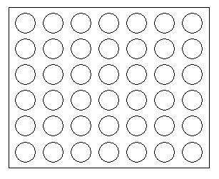
Figure 1. Connect4 board

achieves this, he has won the game. If, however, the game board is filled (all discs are used), and neither of the players have connected 4 discs, the game is a draw. The illustrations in Figure 2 show player 1 (gray player), winning three different games against player 2 (black player), by connecting
4 discs in a horizontal, vertical and diagonal manner. From here on, player 1 will be called the Xplayer, and player 2 will be called the O-player. When the X-player drops a disc on the board, this is called placing an X, and when the O-player drops a disc, this is called placing an O. Given the structure of the board, we can easily see that squares residing near the middle of the board
are more desirable than those closer to the edges. The reason for this is that central squares are much more likely to be part of a winning row. One basic strategy of the game is to somehow try to achieve a double threat to the adversary, i.e., to reach a state in the game where the opponent has to block
two squares at the same time in order to prevent you from winning. Clearly, this is impossible, and you are therefore guaranteed a win in such situations.
Another important aspect of the game is the concept of forcing the opponent to make a move he would rather not take if he was given a choice. This feature is prevalent in Connect4 since moves are made in a strictly alternating fashion, and moves cannot be forfeited. The fact that gravity plays an important part in the game (discs are dropped down to the lowest vacant square of the row), often leads to situations where a player is forced to make a move, effectively preparing the win for his opponent. Consider the board shown in Figure 6.
20

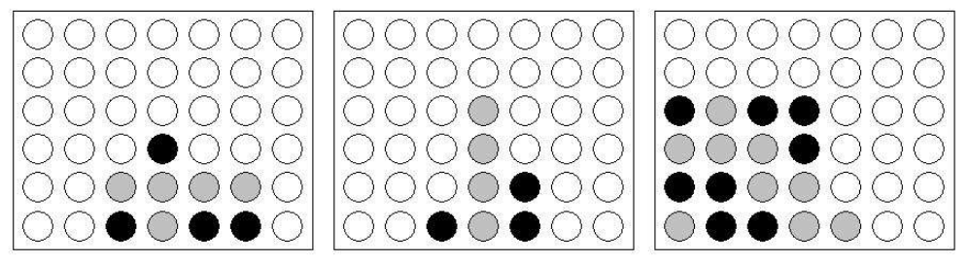
Figure 2. Horizontal, vertical and diagonal winning lines.
Gray is the beginning player (X-player), and since an even number of squares are filled, this means that it is gray's turn to move. Gray has to make a move, and can choose between the second and the sixth column. Clearly, this is no real choice, since either alternative leads to preparing the victory for the O-player. Although the rules of the game are very simple, becoming a skilled Connect4 player is not a trivial task. More sophisticated strategies consist of planning ahead by counting vacant squares, placing
threats on odd and even squares, following your opponent by placing your discs directly on top of his, and so on.

1.3.2. Complexity of the game

Considering that the Connect4 board consists of 42 squares, and each of these can be in one of three states: empty, occupied by the X-player or occupied by the O-player, we have an upper bound of 342 (>= 1020) possible board configurations. However, this rough estimate includes many illegal configurations, which cannot occur when playing the game according to the rules. By excluding some of these states, an upper bound of 7.1 * 1013 possible states has been found, according to [Allis, 1988]. This makes a brute-force search approach infeasible.

1.3.3. The optimal strategy

Despite of this, Connect4 has been solved. This happened in 1988, when Victor Allis and James D. Allen solved the game independently of each other. The solution shows that the starting player can always force a win by starting in the center column, i.e., the 4th column, and playing perfectly thereafter. If the starting player starts in columns 2, 3, 5 or 6, the second player will reach a draw by playing perfectly. Finally, if the starting player starts in columns 1 or 7, the second player can force

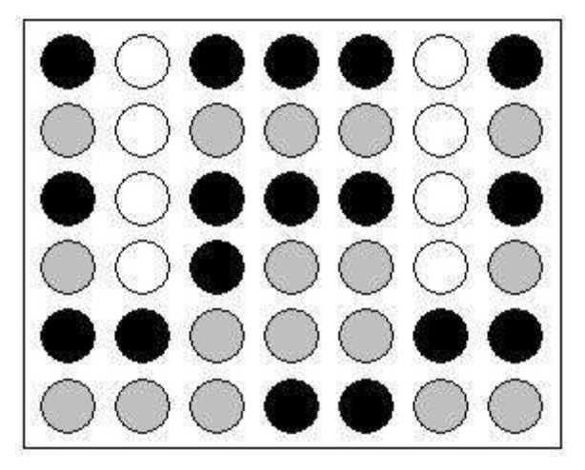
Figure 3. Example of Zugzwang.
a win through perfect play. Victor Allis wrote a Connect4-playing program based on his solution [Allis, 1988]. This program was called Victor, and its gameplay used a knowledge-based approach, instead of game tree search. More specifically, it played according to a set of mathematically proven
strategic rules. A successor of Victor, called Velena, is available as freeware. Other strong players also exist, which, in contrast to Victor/Velena, employ different combinations of game tree search, heuristic board evaluation functions and stored databases of moves. Examples of these players are
Mustrum and TioT. In our experiments, we have chosen to respectfully disregard the optimal strategy, and concentrate on using machine learning methods to synthesize board evaluation functions and combine them with game tree search algorithms. The primary objective being, as stated earlier, to examine how well these methods are suited to be used in the game-playing domain.

1.3.4. Evaluating the Connect4 board

When it comes to game tree search, there are numerous ways to improve the tree searching algorithm itself, in terms of search speed. An example of this is using alpha-beta pruning, as mentioned in section 2. A faster algorithm will then be able to search deeper in the game tree in the same amount of time. This will in turn typically improve the player using the algorithm. However, if the evaluation function is poor, the performance of the corresponding search algorithm will suffer. It is therefore important to find a good evaluation function, i.e., a function which takes a Connect4 board as input, and outputs a numerical value indicating the desirability of the board state for the moving player. Considering the relative simplicity of Connect4, an efficient search algorithm, coupled with an evaluation function which captures relevant characteristics of the game board, should be able to play a strong game of Connect4. How does one construct a good board evaluation function for Connect-4? This is not easily answered, but intuitively the following function description makes sense: The Connect4 game board is essentially a 7*6 grid (7 columns, 6 rows). There are 69 unique possible winning “lines” on the board. 24 of these are horizontal, 21 are vertical and 24 are diagonal. Given a specific board configuration, each of these 69 lines are examined and given a value, in the following way: for each of the four squares in the line: if the square is occupied by the maximizing player, it is given a value of 1 if the square is occupied by the minimizing player, it is given a value of -1 if the square is empty, it is given a value of 0 The value of each line is the sum of the values of its 4 individual squares, and the value of the board is the sum of the values of the 69 potential winning lines. In other words, each square is weighted 22 according to the number of unique winning lines it can be a member of, illustrated by Figure 7. This evaluation function, combined with a search algorithm, is able to play a quite good game of Connect4. As an example, if we let the minimax algorithm using cutoff depth 1 and this function at the cutoff points, play X, against an opponent making random moves, the X-player will win about 98% of the time. If we let the minimax algorithm using cutoff depth 1 and this function at the cutoff
points, play O, against an opponent making random moves, the O-player will win about 90% of the time. In both cases, the winning percentage increases along with the cutoff depth used by the minimax algorithm.
From this point on in the thesis, we will often make the following simplification when describing the playing result of an evaluation function: Instead of writing “the minimax algorithm using cutoff depth n and evaluation function f at the cutoff points” we will write “the evaluation function f using cutoff depth n” In other words, it is always implied that an evaluation function is associated with the minimax algorithm. Although technically imprecise, we have found that this simplification makes the explanations in this thesis clearer and easier to understand.

1.4 APPLYING MINIMAX TO CONNECT4

The game tree search algorithm used in our experiments is the classic minimax algorithm, extended with alpha-beta pruning. As discussed earlier, Connect4 is too complex for its game tree to be completely traversed by a search algorithm, in a reasonable amount of time. To circumvent this problem, the use of board evaluation functions is introduced. The application of minimax to the game tree of Connect4 is carried out in the same way described in chapter 2, with one notable exception: The minimax function is, in addition to its other parameters, supplied with a value indicating a maximal search depth, or cutoff depth. If this cutoff depth is reached at a non-leaf node in the game tree, the algorithm will not continue the search to the subtree of the node in question, even though the node does not represent a terminal game state. Instead, the algorithm will apply its evaluation function to this node, and return the resulting value, which will serve as a replacement for the real minimax value of the node. As a simple example, consider Figure 8.
In Figure 8, the cutoff depth is set to just 1, which means that the minimax algorithm only examines the immediate board states resulting from the possible moves in the current situation. In this example, the board is empty, and it is therefore the X-player's turn to move. The minimax function is called with the empty board and a cutoff depth of 1. Simply put, he minimax
function places an X in the leftmost column, and calls itself with the resulting board. In this new activation of the minimax function, the cutoff depth is reached, and thus the evaluation function is applied to the board with an X in the leftmost column. In this case, let us assume that the IBEF evaluation function is used. This means that the board with an X in the leftmost column is assigned a value of 3, according to the diagram shown in Figure 7. This value is returned to the first activation of the minimax function, and is retained in order to compare it to the values of the remaining 6 possible resulting states. Next, the minimax function removes the X from the leftmost column of the board,

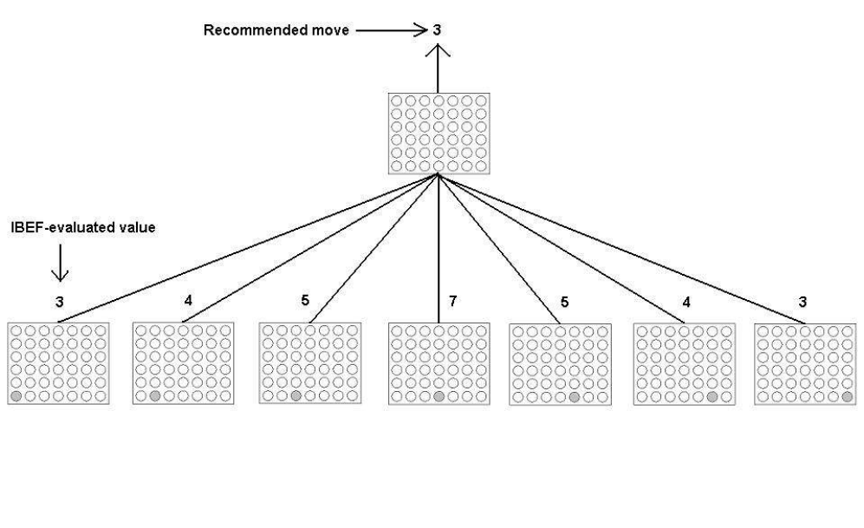
Figure 4. Using minimax with cutoff depth 1 and IBEF evaluation function to determine which move to make.
and puts it in the second column from the left instead. Then it calls itself with this board, the new activation of minimax applies the IBEF function, returns the resulting value, and so on. As we can see, placing the X in the middle column will result in the highest evaluated resulting board, which is assigned a value of 7. Thus, the minimax algorithm using the IBEF evaluation function and a cutoff depth of 1, will choose to put the first X of the game in the middle column, which is indexed 3. This choice is consistent with the optimal strategy mentioned earlier.

1.5 MATERIALS AND METHODS

The algorithm used in this study is based on using heuristics with influence mapping. This was chosen because it is the method that fits in with the original code for the game. It is a greedy algorithm and may not return the optimal move, but it meets the requirements of the system without too much overhead. In[4], there are influence maps and heuristics of Tic-Tac-Toe and Pente, a larger scale Tic-Tac-Toe. These methods look at and evaluate the entire board, whereas in Connect 4, only the top available spot in each column needs to be looked at. The algorithm used in this study uses the basics from, transforms them into use for Connect 4 and integrates the aggressive, defensive and random AI from.
The layout is a grid of six rows by seven columns. This layout is shown in Fig. 1 and the original design flow is shown in Fig. 2. When it is the player’s turn to play, he will click on one of the boxes

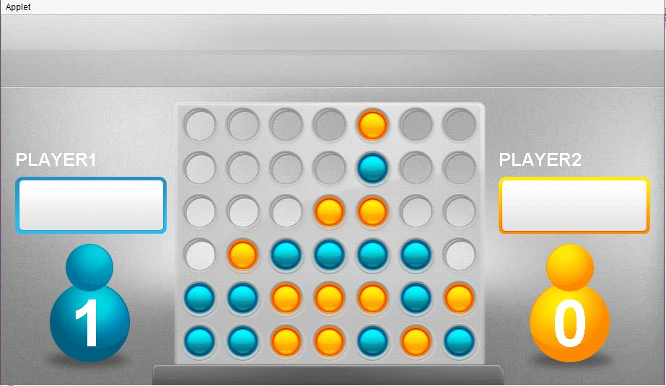
Fig. 5: Board layout

Above the circle LEDs to select the column for chip placement. The chip will then be placed at the bottom of the chosen column. After each play, the program checks for a winner or a tie. The program starts with the screen shown in Fig. 3. This screen gives the player (s) a choice of one player, two players, or to quit the game. Fig. 4 shows the flow of start and difficulty screens. The program allows the players to choose to have a timer or not to have one.

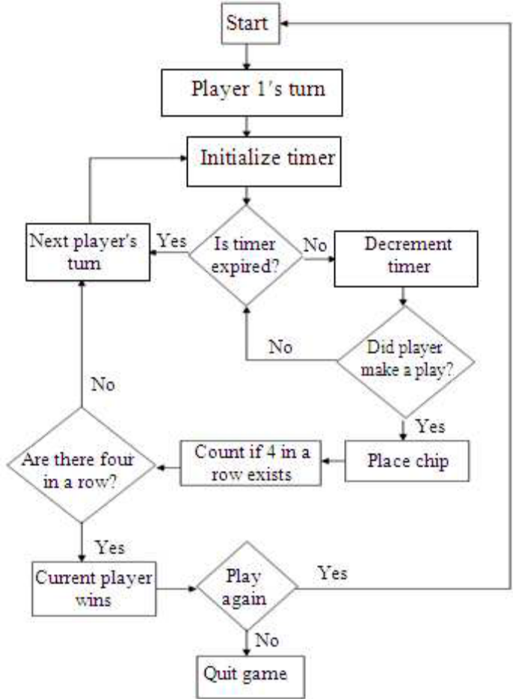
Fig. 6: Original software design flow chart

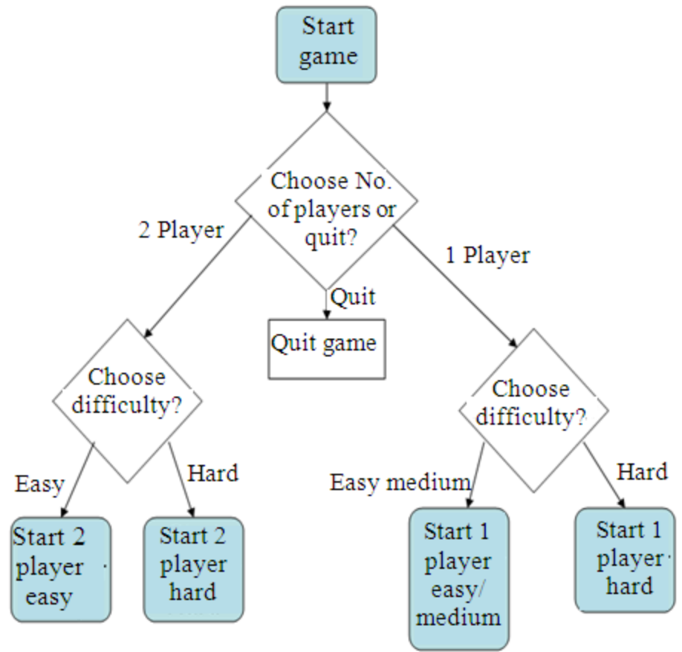
Fig. 7: Software flow of start and difficulty screens

Figure 7 shows the difficulty choice screen and Fig. 6 and 7 show the flow of the Easy and Hard modes, respectively. The easy level has no timer and allows for a more leisurely game. In this mode, the timer is invisible and disabled. The program will wait until the current player makes a move or selects quit. After a play is made, it checks if that player has won or caused a tie The hard level, on the other hand, initiates the timer and makes it visible to the players. It plays the same as the two player easy mode except for the lost turn when the timer expires. The one-player game has three levels to choose from. The difficulty screen for the one-player option is shown in Fig. 8. It allows the player to choose from an easy, medium and hard levels. The Easy mode has an AI that is easier to beat. The Medium mode includes the AI from the easy level and is modified, as shown in Fig. 9, making it harder to beat.
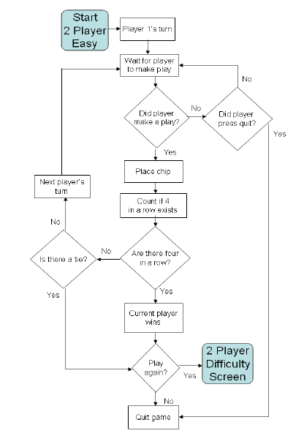
Fig. 8: Software flow for two player easy mode
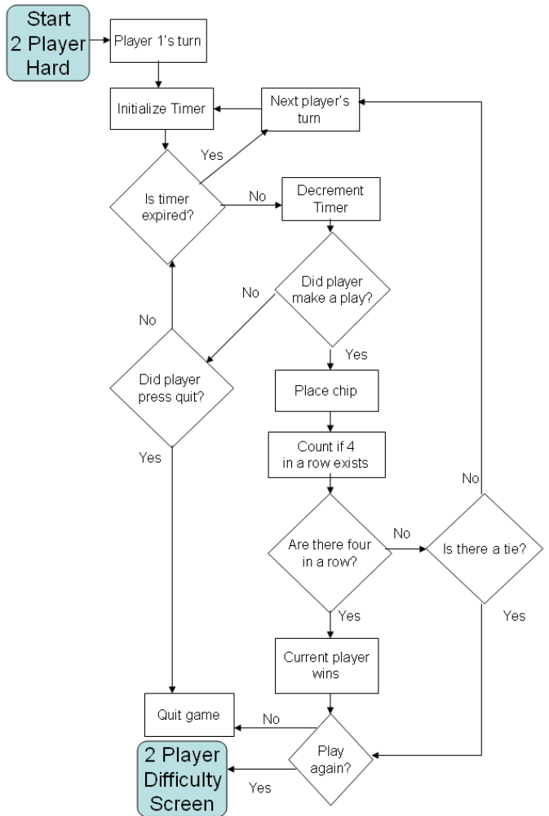
Fig. 9: Software flow for two player hard mode

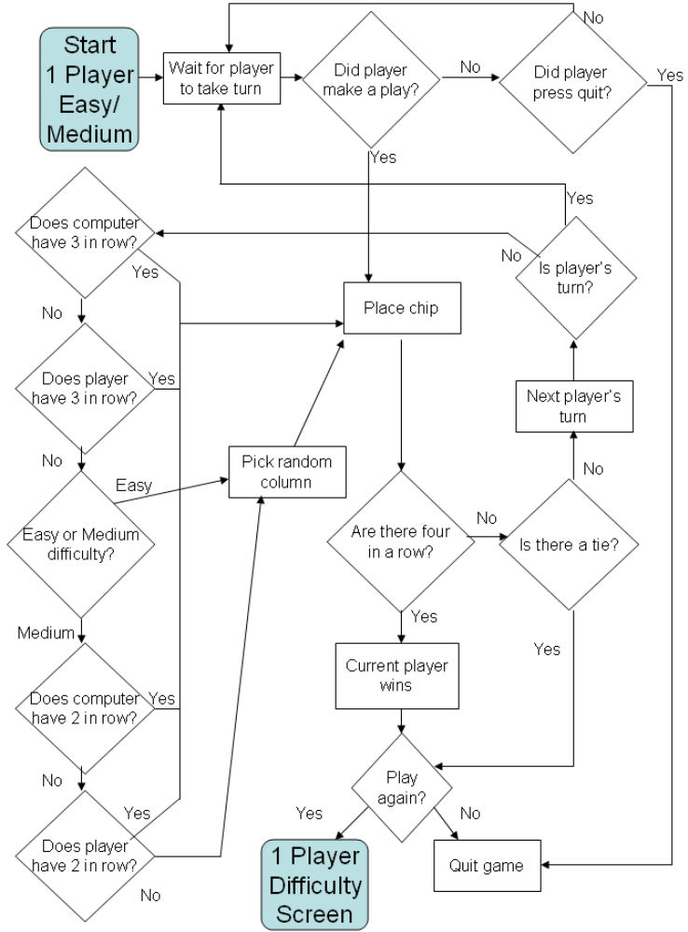
Fig. 10: Software flow for the one player easy/medium

Mode The Hard level has the same AI as in the Medium level, in addition to a timer to step-up the skill level needed to beat the computer, as shown in Fig. 10. All of the difficulty levels have the same algorithm to score the possible moves. There are only seven possible moves, the bottom spot available for each column. The score is stored in a double array and it keeps track of both the computer player’s score and the human player’s score for each available move.
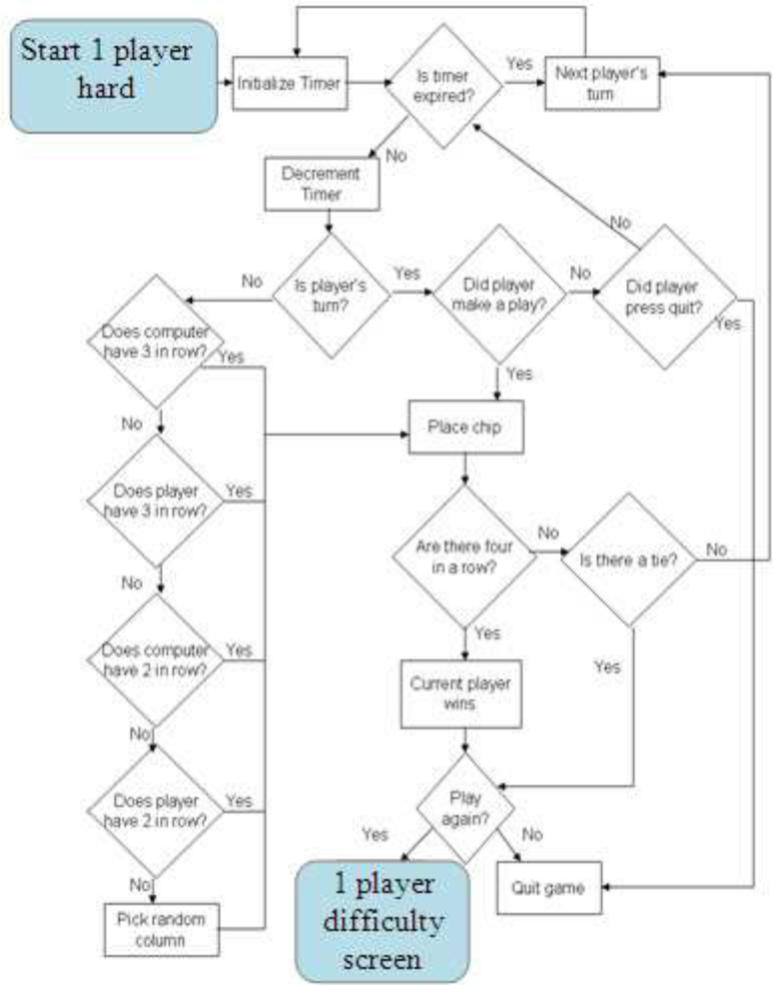
Fig. 10: Software flow for the one player hard

Fig. 10: Software flow for one player hard mode It starts by looking at the horizontal direction for the move it is scoring. It examines the space to the left of the move (as long as the spot is on the board, it does not check spots that are off the board) and sees if the player it is scoring has a chip there. If that player has a chip there, the count is increased. It continues to count until either the space is not occupied for the player being scored or it reaches the end of the board. It then looks to the right and does the same thing. For example, while scoring the computer player, the move it is examining has a chip to the left that is the computer's and a chip to the right that is the human player's. It sees the chip on the left and increases the count to 1. It then looks another space to the left and sees it empty and stops looking left. It then looks right and sees that the other player has a chip there, so it stops looking to the right. The score for this move is 1. Scoring is then done in the vertical direction. Each possible move looks down until it hits the other players chip or the bottom of the board. If the score for this column is higher than the score for the horizontal direction, the horizontal score is replaced with the vertical score. The moves are then scored in the left and right diagonal directions. The scoring algorithm checks down and up the diagonal for the number of chips in a row that are connected to that move until they hit the other player's chip, an empty space, or the end of the board. The AI for the easy level starts with an aggressive move. It takes the scores for the computer and checks if there is a score of 3 or more, which would be a win the game. If there is a score of 3, it picks that column. If there is no move, it makes a defensive move by looking at the score of the player to see if they have a score of 3 or more. If neither the computer nor the player has a score of 3 or more, a random column is selected. The medium level is built off the easy level. Like the easy level, it first looks for the computer or the player to have a score of 3 or more. If a move is not found yet, the AI will make another aggressive move by looking to see if the computer has a score of 2 anywhere. This will allow the computer to get closer to a win and force the player to block instead of working toward a win. If that move does not exist, it will then play another defensive move by blocking the 2 in a row that the player has. Finally, if neither player has 2 in a row, a random column is chosen. Fig. 9 shows the software flow for the easy and the medium levels. Picking the hard level gives you the same AI that the medium level has. What makes it harder is that a 5 sec timer is added. The player has 5 sec to make a play after the computer plays. This requires quick thinking in order to beat the computer. A delay was added for the computer player so that the move could be seen easily by the human player. Fig. 10 shows the software flow for the hard-level.

CHAPTER TWO:

SYSTEM DESIGN

2.1 Modules Used

- BOARD
- CHIPS
- ACTION CLASSES
  - ACTION READY
  - ACTION PLAYER MAKING MOVE
  - ACTION DROP CHIP
  - ACTION WAITING FOR TURN
  - ACTION GAME OVER
  - ACTION PLAY AGAIN

2.2 Module Description

2.2.1 Board

As we know the connect 4 board is a 2d array of dimension 6x7 (6- horizontal rows and 7 vertical columns) .Each cell in board is used to contain chips of two different color based on the turn of the player involved in this turn based multiplayer game. The pieces fall straight down, occupying the next available space within the column.
A single, infinite loop is executed to obtain continual responses of the players.
Game Loop is responsible for execution of different game ‘Actions’ during the whole period of play.
Every iteration of game loop produces a different output frame.

Any player is declared winner when any 4 chips of same color are detected by the computer code on four consecutive cell spaces. Four consecutive cell spaces may be:

- Horizontal
- Vertical
- Forward Diagonal
- Backward Diagonal

For identifying the four consecutive cell spaces that contains chips of same color following algorithms are used-
Algorithm for checking horizontal cell spaces- CheckConnectHor()
Algorithm for checking horizontal cell spaces- CheckConnectVer()
Algorithm for checking horizontal cell spaces- CheckConnectD1r()
Algorithm for checking horizontal cell spaces- CheckConnectD2()

CheckConnectHor-
This function is used to check all the possible horizontal combinations of cell spaces. After each turn computer code is made to evaluate board status starting from bottom left of the board ie 1st row and 1st column. Represented in computer language as boardStatus[0][0].

CheckConnectVer-
This function is used to check all the possible vertical combinations of cell spaces. After each turn computer code is made to evaluate board status starting from bottom left of the board ie 1st row and 1st column. Represented in computer language as boardStatus[0][0].

CheckConnectD1-
This function is used to check all the possible diagonal combinations of cell spaces. After each turn computer code is made to evaluate board status starting from bottom left of the board ie 1st row and 1st column. Represented in computer language as boardStatus[0][0].

CheckConnectD2-
This function is used to check all the possible diagonal combinations of cell spaces. After each turn computer code is made to evaluate board status starting from bottom left of the board ie 1st row and 1st column. Represented in computer language as boardStatus[0][0].

2.2.2 Board Status

As a human we are enriched with a ability to distinguish between two different colors but a computer needs an algorithm to differentiate between emptiness and player’s chip colours. So we have used the concept of 2-d array that implements the physical connect4 board.

BOARDS STATUS used is as follow:
If :

- Cell empty -> Board status = 9
- Cell occupied by player 1’s chip -> Board status = 0
- Cell occupied by player 2’s chip -> Board status = 1
- Cells Containing Player 1’s winning chips -> Board=100
- Cells Containing Player 2’s winning chips -> Board=101

2.2.3 Chip

Each player is assigned a chip of different color. Player 1 is assigned a blue colored chip and second player is assigned the chip of orange color.

S.no | Player | Color assigned | Board status | Updated Board status
1 | Player 1 | Blue | 0 | 100
2 | Player 2 | Orange | 1 | 101
3 | None | Background color | 9 | 9

In the Chip Class there is the most important function named draw Chip. It displays the chip on the screen and accepts the player type as an argument. The current player is assigned an instance of the chip class.

2.2.4 Action Classes

In this code we developed an action interface that is implemented in various action classes.
Overview of action interface

public interface Action {
public boolean process();
public void draw(Graphics g);
public void preDraw(Graphics g);
public void messageIn(String s);
}

An action interface consists of four important functions
- Process
- Draw
- PreDraw
- MessageIn

Process
This function takes care of the user responses which may vary from clicking on any row or column to sending different strings to the opponent over the internet.

Draw
This function is used to display the outcome of the user response.

PreDraw
This function is used to give the illusion to the player that the board is a 3-D image and not a 2-D array by making the falling chip appear to be behind the first layer of the board.

Message In
While working on the internet our code needs to check and keep track of any incoming or any message sent through the system.Message IN function is responsible for checking of any incoming traffic of strings. Decoding is also done with the help of this function.

The above ACTION interface is implemented by seven different ACTION classes based on there functionality there names are:

- ACTION READY
- ACTION PLAYER MAKING MOVE
- ACTION DROP CHIP
- ACTION WAITING FOR TURN
- ACTION GAME OVER
- ACTION PLAY AGAIN

CHAPTER THREE:

PROJECT DICTIONARY

3.1 FLOW CHARTS

3.1.1 FLOW CHART REPRESENTING OCCURRENCE OF FUNCTIONS WITHIN ACTION CLASSES

Add Action

Check Message

Call Action.Draw

Call Action.Process

PopAction

3.1.2 DECIDING WINNER ALGORITHM.
Winner
Flag true ?

Check Horizontal
YES

NO

Winner
Flag true ?

Check Vertical
YES

NO

Winner
Flag true ?

Check Diagonal 1
YES

NO

Check Diagonal 2
Winner
Flag true ?

Winner=true

YES

3.1.3 MESSAGE DECODING ALGORITHM

Incoming message
Receive Message

If
Msg=(Start Game)

ActionReady

If
Msg=(Drop Chip)

ActionDropChip

If
Msg=(Game Over)

ActionPlayAgain

If
Msg=(Play Again)

ActionMakingMove

3.1.4 MAIN GAME LOOP
START

ActionGameOver
INFIN-ITE LOOP

ActionPlayAgain

ActionReady

STOP
ActionMakingMove

ActionDropChip

ActionWaiting

3.1.5 FLOWCHART REPRESENTING PLAY AGAIN LOOP

Action Game Over

Update My Response

Check Other Player’s Response

Responses
Are TRUE

YES NO

ActionPlayAgain

STOP

3.2 ER DIAGRAMS

3.2.2 ER DIAGRAM REPRESENTING RELATIONSHIP BETWEEN MAIN GAME CODE AND LOCAL MACHINE

Interacts with
CHIP
BOARD

LOCAL MACHINE

MAIN GAME CODE

ACTION READY

ACTIONS
ACTION MAKING MOVE
ACTION PLAY AGAIN

ACTION GAME OVER
ACTION DROP CHIP
ACTION WAITING

CHAPTER 4:

CODING USED IN THE PROJECT

4.1 BOARD

import java.awt.Color;
import java.awt.Graphics;
import java.awt.Rectangle;
import java.awt.image.BufferedImage;

/*
* To change this template, choose Tools | Templates
* and open the template in the editor.
*/
/**
*
* @author Prabhjot */
public class Board {

public int boardStatus[][] = new int[6][7];
public int boardX[][] = new int[6][7];
public int boardY[][] = new int[6][7];
public int blinker = 0;
public int cycle = 80;
public boolean boardEmpty = true;
public boolean winner = false;
public String boardStatusString;
public static BufferedImage boardImage, chipB, chipO;

public Board() {

int y = 122;

for (int i = 0; i < 6; i++) {

int x = 243;

for (int j = 0; j < 7; j++) {
boardStatus[i][j] = 9;//\\\\\\\\\\\\
boardX[i][j] = x;
boardY[i][j] = y;
x = x + 60;
}
y = y + 60;
}
}

public void draw(Graphics g) {
if (boardImage == null) {

boardImage = GrTools.getFastResourceImage("board.png", c4.game, true);

chipB = GrTools.getFastResourceImage("Chip-Blue.png", c4.game, true);
chipO = GrTools.getFastResourceImage("Chip-Orange.png", c4.game, true);
}
c4.game.preDraw(g);
g.drawImage(boardImage, 213, 125, null);

Color BoardColor = new Color(156, 102, 31);
g.setColor(BoardColor);
Color GreenBack = new Color(61, 145, 64);
g.setColor(GreenBack);
for (int i = 0; i < 6; i++) {
for (int j = 0; j < 7; j++) {

if (boardStatus[i][j] == 0) {

g.drawImage(chipB, boardX[i][j] + 7, boardY[i][j] + 7, null);
}
if (boardStatus[i][j] == 1) {

g.drawImage(chipO, boardX[i][j] + 7, boardY[i][j] + 7, null);
}

if (boardStatus[i][j] == 100) {

blinker++;

if ((blinker > (6 * cycle)) | (blinker % (2 * cycle)) > cycle) {
g.setColor(Color.blue);
g.drawImage(chipB, boardX[i][j] + 7, boardY[i][j] + 7, null);

}
}
if (boardStatus[i][j] == 101) {
blinker++;
if ((blinker > (6 * cycle)) | (blinker % (2 * cycle)) > cycle) {
g.setColor(Color.red);
g.drawImage(chipO, boardX[i][j] + 7, boardY[i][j] + 7, null);

}
}
}
}

c4.game.preDraw(g);

g.drawImage(boardImage, 460 - 250, 122, null);

if (blinker > (6 * cycle)) {

c4.game.drawPlayAgainBox(g);

}
}

public int getColumn(int x) {
int col = -1;
if ((x >= 241) & (x < boardX[0][1])) {
col = 0;
}
if ((x >= boardX[0][1]) & (x < boardX[0][2])) {
col = 1;
}
if ((x >= boardX[0][2]) & (x < boardX[0][3])) {
col = 2;
}
if ((x >= boardX[0][3]) & (x < boardX[0][4])) {
col = 3;
}
if ((x >= boardX[0][4]) & (x < boardX[0][5])) {
col = 4;
}
if ((x >= boardX[0][5]) & (x < boardX[0][6])) {
col = 5;
}
if ((x >= boardX[0][6]) & (x < 671)) {
col = 6;
}
return col;

}

public int getRow(int column) {
int row = -1;
if (column > -1) {
for (int j = 0; j < 6; j++) {
if (boardStatus[j][column] != 9) {
row = j - 1;
break;
} else {
row = 5;
}
}
}
return row;
}

public void boardStatusUpdate(int row, int col) {

boardStatus[row][col] = c4.game.currentPlayer;
checkConnectVer(row, col);
checkConnectHor(row, col);
checkConnectD1(row, col);
checkConnectD2(row, col);

for (int i = 0; i < 7; i++) {

if (boardStatus[0][i] == 9) {
boardEmpty = true;
break;
}

if (i == 6) {
boardEmpty = false;
}
}

for (int i = 0; i < 6; i++) {

for (int j = 0; j < 7; j++) {
boardStatusString += boardStatus[i][j];

}
}

if (winner) {
c4.game.players.get(c4.game.currentPlayer).wins++;
}
c4.game.currentPlayer = 1 - c4.game.currentPlayer;
}

public void checkConnectVer(int row, int col) {
int connectV = 0;
boolean thisWinner = false;
int j;
int Vbeg, Vend;

if (row < 3) {

for (j = row; j
< 6; j++) {

if (boardStatus[j][col] == c4.game.currentPlayer | boardStatus[j][col] == (c4.game.currentPlayer + 100)) {
connectV++;
} else if (connectV < 4) {
connectV = 0;
break;
}
}
}

if (connectV >= 4) {
Vbeg = row;
Vend = row + 3;
winner = true;
thisWinner = true;
for (int r = Vbeg; r
<= Vend;
++r) {
boardStatus[r][col] = c4.game.currentPlayer + 100;
}
}
}

public void checkConnectHor(int row, int col) {
int connectH = 0;
boolean thisWinner = false;
int j;
int Hbeg, Hend;

for (j = 0; j < 7; j++) {
if (boardStatus[row][j] == c4.game.currentPlayer | boardStatus[row][j] == c4.game.currentPlayer + 100) {
connectH++;
} else {
if (connectH >= 4) {
Hend = j - 1;
Hbeg = j - connectH;

for (int r = Hbeg; r
<= Hend;
++r) {
boardStatus[row][r] = c4.game.currentPlayer + 100;
}
winner = true;
thisWinner = true;
break;
} else {
connectH = 0;
}
}
}

if (connectH >= 4 & thisWinner == false) {
Hend = j - 1;
Hbeg = j - connectH;
for (int r = Hbeg; r
<= Hend;
++r) {
boardStatus[row][r] = c4.game.currentPlayer + 100;
}
winner = true;
thisWinner = true;
}
}

public void checkConnectD1(int row, int col) {
int connectD1 = 0;
boolean thisWinner = false;
int k = 0, l = 0;
int D1begX, D1begY, D1endX, D1endY;
if (col < 7) {
k = row;
l = col;
while (k != 0 & l != 0) {
k--;
l--;
}
while (k < 6 & l < 7) {
if (boardStatus[k][l] == c4.game.currentPlayer | boardStatus[k][l] == (c4.game.currentPlayer + 100)) {
connectD1++;
} else {
if (connectD1 >= 4) {
k--;
l--;
D1endX = k;
D1endY = l;
D1begX = k - (connectD1 - 1);
D1begY = l - (connectD1 - 1);
int p = D1begY;
for (int r = D1begX; r
<= D1endX; ++r) {
boardStatus[r][p] = c4.game.currentPlayer + 100;
p++;
}
winner = true;
thisWinner = true;
connectD1 = 0;
break;
} else {
connectD1 = 0;
}
} k++; l++;
}
if (connectD1 >= 4 & thisWinner == false) {
k--;
l--;
D1endX = k;
D1endY = l;
D1begX = k - (connectD1 - 1);
D1begY = l - (connectD1 - 1);
int p = D1begY;
for (int r = D1begX; r <= D1endX; ++r) {
boardStatus[r][p] = c4.game.currentPlayer + 100;
p++;
}
winner = true;
thisWinner = true;
}
}
}
public void checkConnectD2(int row, int col) {
int connectD2 = 0;
boolean thisWinner = false;
int k = 0, l = 0;
int D2begX, D2endX, D2begY, D2endY;
if (col < 7) {
k = row;
l = col;
while (k != 0 & l != 6) {
k--;
l++;
}
while (k < 6 & l >= 0) {
if (boardStatus[k][l] == c4.game.currentPlayer | boardStatus[k][l] == (c4.game.currentPlayer + 100)) {
connectD2++;
} else {
if (connectD2 >= 4) {
k--;
l++;
D2endX = k;
D2endY = l;
D2begX = k - (connectD2 - 1);
D2begY = l + (connectD2 - 1);
int p = D2begY;
for (int r = D2begX; r <= D2endX; ++r) {
boardStatus[r][p] = c4.game.currentPlayer + 100;
p--;
}
winner = true;
thisWinner = true;
connectD2 = 0;
break;
} else {
connectD2 = 0;
}
}
k++;
l--;
}
if (connectD2 >= 4 & thisWinner == false) {
k--;
l++;
D2endX = k;
D2endY = l;
D2begX = k - (connectD2 - 1);
D2begY = l + (connectD2 - 1);
int p = D2begY;
for (int r = D2begX; r <= D2endX; ++r) {
boardStatus[r][p] = c4.game.currentPlayer + 100;
p--;
}
winner = true;
thisWinner = true;
}
}
}
}

4.2 CHIP

import java.awt.Color;
import java.awt.Graphics;
import java.awt.Rectangle;

/*
* To change this template, choose Tools | Templates
* and open the template in the editor.
*/
/**
*
* @author Prabhjot
*/
public class Chip {

public Rectangle ChipArea;
Board board = new Board();

public Chip() {
ChipArea = new Rectangle(0, 0, 0, 0);

}

public void draw(Graphics g, int x, int y, int playerType) {
if (playerType == 1) {
g.drawImage(Board.chipO, board.boardX[0][x] + 7, y + 7, null);
} else {
g.drawImage(Board.chipB, board.boardX[0][x] + 7, y + 7, null);
}

}

public void drawSample(Graphics g, int x, int y, int playerType) {

if (playerType == 1) {
g.drawImage(Board.chipO, x, y, null);
} else {
g.drawImage(Board.chipB, x, y, null);
}
//g.fillOval(x, y, 31, 31);
}
}

4.3 ACTION INTERFACE

import java.awt.Graphics;

/*
* To change this template, choose Tools | Templates
* and open the template in the editor.
*/
/**
*
* @author Prabhjot
*/
public interface Action {

public boolean process();

public void draw(Graphics g);

public void preDraw(Graphics g);

public void messageIn(String s);
}

4.4 ACTION DROPCHIP

import java.awt.Graphics;
import java.awt.image.BufferedImage;

/*
* To change this template, choose Tools | Templates
* and open the template in the editor.
*/
/**
*
* @author Prabhjot
*/
public class ActionDropChip extends GrTools implements Action {

int col = -1;
int row = -1;
double ycor = 80.0;

//Adjust these to where it looks nice.

double vel = 6;
double acc = 20.0;
boolean done = false;

public boolean process() {

if (done) {

if (!c4.game.board.winner & c4.game.board.boardEmpty) {
if (c4.game.thisPlayer == c4.game.currentPlayer) {
c4.game.addAction(new ActionPlayerMakingMove());
} else {
c4.game.addAction(new ActionWaitingForTurn());
}
}

else {
c4.game.sendGameOver();
c4.game.addAction(new ActionGameOver());
}

return false;
}
//If we aren't done dropping the chip, then this is what we do...

if ((row > -1) & (col > -1)) {// only for DEMO MODE..
vel += 6; //assume 50 fps
ycor += acc/50.0 * vel;

if (ycor > c4.game.board.boardY[row][col]) {

done = true;
//Chip hit the bottom, now update

c4.game.board.boardStatusUpdate(row, col);
}

}

return true;

}
Chip chip = new Chip();

public void draw(Graphics g) {
}

public void preDraw(Graphics g) {

if (!done) {
chip.draw(g, col, (int) ycor, c4.game.currentPlayer);
}

// if (done) {
// chip.draw(g, col, (int) ycor, 1 - c4.game.currentPlayer);
//
}
}
public void messageIn(String s) {
}
ActionDropChip() {
// col = c4.game.getColumn(c4.game.clickX);
// row = c4.game.getRow(col);
}
ActionDropChip(int R, int C) {
col = C;
row = R;
}
}

4.5 ACTION READY

import java.awt.Graphics;
import java.awt.image.BufferedImage;

/*
* To change this template, choose Tools | Templates
* and open the template in the editor.
*/
/**
*
* @author Prabhjot
*/
public class ActionDropChip extends GrTools implements Action {

int col = -1;
int row = -1;
double ycor = 80.0;
//Adjust these to where it looks nice.
double vel = 6;
double acc = 20.0;
boolean done = false;

public boolean process() {

if (done) {

if (!c4.game.board.winner & c4.game.board.boardEmpty) {

if (c4.game.thisPlayer == c4.game.currentPlayer) {
c4.game.addAction(new ActionPlayerMakingMove());
}
else {
c4.game.addAction(new ActionWaitingForTurn());
}
}
else {
c4.game.sendGameOver();
c4.game.addAction(new ActionGameOver());
}

return false;
}

//If we aren't done dropping the chip, then this is what we do...

if ((row > -1) & (col > -1)) {// only for DEMO MODE..
vel += 6; //assume 50 fps
ycor += acc/50.0 * vel;

if (ycor > c4.game.board.boardY[row][col]) {

done = true;

//Chip hit the bottom, now update
c4.game.board.boardStatusUpdate(row, col);

}
}

return true;

}
Chip chip = new Chip();

public void draw(Graphics g) {
}

public void preDraw(Graphics g) {

if (!done) {
chip.draw(g, col, (int) ycor, c4.game.currentPlayer);
}

// if (done) {

// chip.draw(g, col, (int) ycor, 1 - c4.game.currentPlayer);

//}

}

public void messageIn(String s) {
}

ActionDropChip() {

// col = c4.game.getColumn(c4.game.clickX);
// row = c4.game.getRow(col);
}

ActionDropChip(int R, int C) {
col = C;
row = R;
}
}

4.6 ACTION MAKING MOVE

import java.awt.Graphics;
import java.awt.event.MouseEvent;
import java.awt.event.MouseListener;
import java.awt.event.MouseMotionListener;

/*
* To change this template, choose Tools | Templates
* and open the template in the editor.
*/
/**
*
* @author Prabhjot
*/
public class ActionPlayerMakingMove implements Action, MouseListener, MouseMotionListener {

boolean done = false;
int C;
int clicked;
int moved;
int row, col;
boolean hover=false;

public boolean process() {
// c4.game.addMouseListener(this);
//c4.game.addMouseMotionListener(this);

if (done) {

//c4.game.sendMessage("PTDropChip|getColoumn()|getRow()");

c4.game.addAction(new ActionDropChip(row, col));
return false;
} else {
return true;
}

}

public void preDraw(Graphics g) {
//c4.game.drawGameBase();
if (hover) {
c4.game.chip.draw(g, C, 70, c4.game.currentPlayer);
}

}

public void messageIn(String s) {
}

public ActionPlayerMakingMove() {
c4.game.addMouseListener(this);
c4.game.addMouseMotionListener(this);

}

public void draw(Graphics g) {
}

public void mouseClicked(MouseEvent e) {
//throw new UnsupportedOperationException("Not supported yet.");
}

public void mousePressed(MouseEvent e) {
}

public void mouseReleased(MouseEvent e) {

synchronized (c4.mouseLock) {
if (!done) {
if ((e.getX() >= 241) & (e.getX() < 671)) {
clicked = e.getX();
System.out.println(clicked);
col = c4.game.board.getColumn(clicked);
row = c4.game.board.getRow(col);
if (row >= 0) {
String mes = "PTDROP|" + c4.game.thisplayerName + "|" + c4.game.tNum + "|" + col;
c4.game.sendMessage(mes);
done = true;
}
}
}

}

}

public void mouseEntered(MouseEvent e) {
//throw new UnsupportedOperationException("Not supported yet.");
}

public void mouseExited(MouseEvent e) {
//throw new UnsupportedOperationException("Not supported yet.");
}

public void mouseDragged(MouseEvent e) {
//throw new UnsupportedOperationException("Not supported yet.");
}

public void mouseMoved(MouseEvent e) {
synchronized (c4.mouseLock) {

hover=false;
if ((e.getX() >= 241) & (e.getX() < 671)) {
moved = e.getX();
C = c4.game.board.getColumn(moved);
hover=true;
}
}
}
}

4.7 ACTION WAITING FOR TURN

import java.awt.Color;
import java.awt.Graphics;
import java.awt.event.KeyEvent;
import java.awt.event.KeyListener;
import java.util.Random;
import java.util.logging.Level;
import java.util.logging.Logger;

/*
* To change this template, choose Tools | Templates
* and open the template in the editor.
*/
/**
*
* @author Prabhjot
*/
public class ActionWaitingForTurn implements Action, KeyListener {

static Random randGen = new Random();
boolean done = false;
boolean demodone = false;
int col = 0;
int row = 0;

public ActionWaitingForTurn() {
if (c4.demoMode) {
c4.game.addKeyListener(this);
}
}

public void preDraw(Graphics g) {
}

public boolean process() {
if (!done) {

return true;
} else {
c4.game.addAction(new ActionDropChip(row, col)); // will access row and col from message received.
return false;
}
}

public void draw(Graphics g) {
}
public void messageIn(String s) {
if (s.startsWith("PTDROP|")) {
String[] args = s.split("\\|");
String drop = args[3];
col = Integer.parseInt(drop);
row = c4.game.board.getRow(col);
done = true;
c4.game.popmessage();
}
}

public void keyTyped(KeyEvent e) {
}
public void keyPressed(KeyEvent e) {
// throw new UnsupportedOperationException("Not supported yet.");
}
public void keyReleased(KeyEvent e) {
// throw new UnsupportedOperationException("Not supported yet.");
synchronized (c4.mouseLock){
if (!demodone & c4.game.demoMode) {
if (e.getKeyCode() == e.VK_1) {
c4.game.messages.add("PTDROP|GOGA|7|0");
}
if (e.getKeyCode() == e.VK_2) {
c4.game.messages.add("PTDROP|GOGA|7|1");
}
if (e.getKeyCode() == e.VK_3) {
c4.game.messages.add("PTDROP|GOGA|7|2");
}
if (e.getKeyCode() == e.VK_4) {
c4.game.messages.add("PTDROP|GOGA|7|3");
}
if (e.getKeyCode() == e.VK_5) {
c4.game.messages.add("PTDROP|GOGA|7|4");
}
if (e.getKeyCode() == e.VK_6) {
c4.game.messages.add("PTDROP|GOGA|7|5");
}
if (e.getKeyCode() == e.VK_7) {
c4.game.messages.add("PTDROP|GOGA|7|6");
}
demodone = true;
}
}
}
}

4.8 MAIN APPLET
* To change this template, choose Tools | Templates
* and open the template in the editor.
*/

import java.applet.Applet;
import java.awt.Color;
import java.awt.Font;
import java.awt.Graphics;
import java.awt.event.MouseEvent;
import java.awt.event.MouseListener;
import java.awt.event.MouseMotionListener;
import java.awt.image.BufferedImage;
import java.util.ArrayList;
import java.util.logging.Level;
import java.util.logging.Logger;
import javax.swing.JApplet;

/**
*
* @author Prabhjot
*/

public class c4 extends Applet implements OtherMessage, Runnable,
MouseListener, MouseMotionListener {

//Thread Lock

public static final Object mouseLock = new Object();
Thread t;
public static c4 game = null;
public Board board = new Board();
public Chip chip = new Chip();
int currentPlayer = 0;
int thisPlayer = 0;
public static final int APPLICATION_WIDTH = 920;
public static final int APPLICATION_HEIGHT = 520;
public BufferedImage backImage = GrTools.getFastAlphaImage(920, 520);
public Graphics backGraph = backImage.createGraphics();
public BufferedImage bg;
public Color BoardColor = new Color(156, 102, 31);
public Color GreenBack = new Color(0, 0, 0);
ArrayList<Action> actions = new ArrayList<Action>();
ArrayList<String> messages = new ArrayList<String>();
public boolean allready = false;
String thisplayerName;
public static boolean demoMode = false;

/**
* Initialization method that will be called after the applet is loaded
* into the browser.
*/

/* Demo mode section */

public void init() {

if (t == null) {
t = new Thread(this);
t.start();
int i = 0;
addMouseListener(this);
addMouseMotionListener(this);
}
}

public void run() {

game = this;
bg = GrTools.getFastResourceImage("Background.jpg", this, true);

try {
String temp = this.getAppletContext().toString();
System.out.println(temp);
if (temp.contains("AppletViewer")) {
//testChatPlayers();
demoMode = true;
}

} catch (Exception e) {

Debug.show(e.toString());
}

if (demoMode) {
Intercom.addReference("ChatApplet", new fakeChat());
messages.add("PLSTARTGAME|trellend|2|Goga,1100,5,1,0|trellend,1200,5,1,0| | | | ");
}

Graphics g = getGraphics();

Intercom.addReference("LobbyApplet", this);

addAction(new ActionReady());
setSize(920, 520);

while (true) {

try {
Thread.sleep(10); //10 ms
} catch (InterruptedException ex) {
}

synchronized (mouseLock) {

drawGameBase();

if (actions.size() > 0) {
setSize(920, 520);
Class c = actions.get(0).getClass();
backGraph.setColor(Color.white);
checkMessage();//------------------^^code for receiving message ^^------------------------------------------------------
backGraph.drawString(c.getName(), 700, 250);
Action temp = actions.get(0);
boolean res = temp.process();

if (!(messages.isEmpty())) {
temp.messageIn(messages.get(0));
}
temp.draw(backGraph);

if (!res) {
if (temp instanceof MouseListener) {
this.removeMouseListener((MouseListener) temp);
}

if (temp instanceof MouseMotionListener) {
this.removeMouseMotionListener((MouseMotionListener) temp);
}
popAction();
}
}

g.drawImage(backImage, 0, 0, null);
}
}
}

//============================================================================================================================
//--------------------FUNCTIONS DIRECTORY STARTS HERE-------------------------------------------------------------------------
//============================================================================================================================

public void drawGameBase() {
backGraph.drawImage(bg, 0, 0, null);
board.draw(backGraph);
// backGraph.drawString("" + clickX + ".." + getColumn(clickX) + ".." +
getRow(getColumn(clickX)) + ".." + thisPlayer + ".." + currentPlayer, 100, 100);
backGraph.setColor(BoardColor);
}

public void drawPlayAgainBox(Graphics g) {
//Graphics g = this.getGraphics();

String msg;
String score = players.get(0).name + "[" + players.get(0).wins + "]-------" + players.get(1).name + "[" + players.get(1).wins + "]";
if (c4.game.board.winner) {
if (thisPlayer == (1 - currentPlayer)) {

msg = " YOU WIN ----- Play Again ?";
} else {
msg = "YOU Lose ----- Play Again";
}
} else {
msg = "Game Draw ----- Play Again ?";
}
backGraph.setColor(BoardColor);
backGraph.fill3DRect(227, 50, 500, 150, true);
backGraph.setColor(Color.yellow);
backGraph.drawString(score, 320, 105);
backGraph.drawString(msg, 320, 120);

backGraph.drawString("YES", 300, 170);
backGraph.drawString("NO", 550, 170);
g.drawImage(backImage, 0, 0, null);
}

public void addAction(Action a) {
System.out.println(a.getClass().getName());
actions.add(a);
}

public void insertAction(Action a) {
actions.add(0, a);
}

public void popAction() {
if (actions.size() > 0) {

actions.remove(0);
}
}

public void sendGameOver() {

if (thisPlayer == (1 - currentPlayer)) {
c4.game.sendMessage("PTGAMEOVER|" + thisplayerName + "|" + tNum + "| 0 |" + players.get(1 - c4.game.currentPlayer).name);
}
}

public void sendLeaveTable() {
System.out.println("Player wants to LEAVE");

sendMessage("TABLELEAVE|" + thisplayerName);
}

public void sendABstart() {
String mes = "PTGAMESTART|" + thisplayerName + "|" + players.get(1).name;
sendMessage(mes);
}

public void addmessage(String s) {
messages.add(s);
}

public void preDraw(Graphics g) {
for (Action a : actions) {
a.preDraw(g);
}
}

public void popmessage() {
if (messages.size() > 0) {

messages.remove(0);
}
}

public void sendMessage(String mess) {
//ChatApplet temp = ((ChatApplet)

Intercom.getReference("ChatApplet"));
//otherMessageIn(mess);
// temp.connection.send(mess);
SendMessage temp = ((SendMessage)

Intercom.getReference("ChatApplet"));
//otherMessageIn(mess);

if (!demoMode) {
temp.sendMessage(mess);
} else {

//PTMsgs.add(mess);
}
}

public void otherMessageIn(String mes) {
messages.add(mes);
//throw new UnsupportedOperationException("Not supported yet.");
}
// message sending definitions

public void checkMessage() {
if (messages.isEmpty()) {
return;

}
String mes = messages.get(0);

if (mes.startsWith("PTDROP|")) {

} else if (mes.startsWith("PLSTARTGAME|")) {
PLSTARTGAME(mes);
popmessage();

} else if (mes.startsWith("PTPLAYAGAIN|")) {

} else if (mes.startsWith("PLSTARTVIEW|")) {

PLSTARTVIEW(mes);

popmessage();

} else if (mes.startsWith("PTREQUEST|")) {
//PTREQUEST(mes);
popmessage();

} else if (mes.startsWith("PTREPLY|")) {
// PTREPLY(mes);
popmessage();

} else {
popmessage();
}

}

private int tableNum = 0;
public ArrayList<UserData> players = new ArrayList<UserData>();
public int tNum;

public void PLSTARTGAME(String message) {

try {
String[] args = message.split("\\|");
thisplayerName = args[1];
tableNum = Integer.parseInt(args[2]);
tNum = tableNum;
players.clear();
for (int i = 3; i

< 5; i++) {
String[] ply = args[i].split(",");
if (ply[0].trim().length() > 0) {
int irating = Integer.parseInt(ply[1]);
int itype = Integer.parseInt(ply[2]);
//In the case of watchers.

int iwins = Integer.parseInt(ply[4]);
UserData ptemp = new UserData(0, ply[0], irating, itype);
ptemp.wins = iwins;
players.add(ptemp);
}

}
//Args[7] contains other data specific to a game.
//Set the current player
//currentPlayer = 1;

// thisPlayer = 1;

for (int i = 0; i < players.size(); i++) {

if (players.get(i).name.equals(thisplayerName)) {
break;
}

thisPlayer++;
}

allready = true;

} catch (Exception e) {

}
}

public void PLSTARTVIEW(String message) {
try {
String[] args = message.split("\\|");
thisplayerName = args[1];
tableNum = Integer.parseInt(args[2]);
tNum = tableNum;
players.clear();
for (int i = 3; i
< 5; i++) {
String[] ply = args[i].split(",");

if (ply[0].trim().length() > 0) {
int irating = Integer.parseInt(ply[1]);
int itype = Integer.parseInt(ply[2]);
//In the case of watchers.

int iwins = Integer.parseInt(ply[4]);
UserData ptemp = new UserData(0, ply[0], irating, itype);
ptemp.wins = iwins;
players.add(ptemp);
}
}
thisPlayer = 2;
sendMessage("PTREQUEST|" + thisplayerName + "|" + tNum);

} catch (Exception e) {

}

}

public boolean isMute() {

return false;
//throw new UnsupportedOperationException("Not supported yet.");
}

public void mouseClicked(MouseEvent e) {
//throw new UnsupportedOperationException("Not supported yet.");

}

public void mousePressed(MouseEvent e) {

//throw new UnsupportedOperationException("Not supported yet.");
}

public void mouseReleased(MouseEvent e) {
//throw new UnsupportedOperationException("Not supported yet.");

}

public void mouseEntered(MouseEvent e) {
//throw new UnsupportedOperationException("Not supported yet.");
}

public void mouseExited(MouseEvent e) {
//throw new UnsupportedOperationException("Not supported yet.");
}

public void mouseDragged(MouseEvent e) {
//throw new UnsupportedOperationException("Not supported yet.");
}

public void mouseMoved(MouseEvent e) {
//throw new UnsupportedOperationException("Not supported yet.");
}
// TODO overwrite start(), stop() and destroy() methods

class fakeChat extends JApplet implements SendMessage {

public void sendMessage(String s) {
}

public boolean isMuted() {
return false;
}

4.9 ACTION PLAY AGAIN

import java.awt.Graphics;
import java.util.logging.Level;
import java.util.logging.Logger;

/*
* To change this template, choose Tools | Templates
* and open the template in the editor.
*/
/**
*
* @author Prabhjot
*/
public class ActionPlayAgain implements Action {

int response;

public void preDraw(Graphics g) {
}

public boolean process() {
c4.game.board.winner = false;
c4.game.board = new Board();
if (c4.game.thisPlayer == c4.game.currentPlayer) {
c4.game.addAction(new ActionPlayerMakingMove());
} else {
c4.game.addAction(new ActionWaitingForTurn());
}
return false;
}

public void draw(Graphics g) {
//throw new UnsupportedOperationException("Not supported yet.");
}

public void messageIn(String s) {
}
}

4.10 ACTION GAME OVER

import java.awt.Graphics;
import java.awt.Rectangle;
import java.awt.event.MouseEvent;
import java.awt.event.MouseListener;
import java.awt.event.MouseMotionListener;
import java.util.logging.Level;
import java.util.logging.Logger;

/*
* To change this template, choose Tools | Templates
* and open the template in the editor.
*/
/**
*
* @author Prabhjot
*/
public class ActionGameOver implements Action, MouseListener, MouseMotionListener {

boolean indone = false;
int response = 0;
int thisresponse = 0;
boolean outdone = false;

public void preDraw(Graphics g) {
}

public boolean process() {

c4.game.addMouseListener(this);
c4.game.addMouseMotionListener(this);
if (indone & outdone) {
if (response == 1 & thisresponse == 1) {
c4.game.addAction(new ActionPlayAgain());
}

return false;
} else {
return true;
}
}

public void draw(Graphics g) {

c4.game.drawGameBase();

}

public void messageIn(String s) {
if (s.startsWith("PTPLAYAGAIN|")) {
String[] args = s.split("\\|");
response = Integer.parseInt(args[3]);
indone = true;
c4.game.popmessage();
}
}

public ActionGameOver() {
c4.game.addMouseListener(this);
c4.game.addMouseMotionListener(this);

}

public void mouseClicked(MouseEvent e) {
//throw new UnsupportedOperationException("Not supported yet.");
}

public void mouseReleased(MouseEvent e) {
synchronized (c4.mouseLock) {
if (!outdone) {

if (e.getX() >= 300 & e.getX() <= 450 & e.getY() <= 300) {

thisresponse = 1;
outdone = true;

} else if (e.getX() >= 450 & e.getX() <= 650 & e.getY() <= 300) {
//No=0
thisresponse = 0;
c4.game.sendLeaveTable();
outdone = true;
}

if (outdone) {
c4.game.sendMessage("PTPLAYAGAIN|" + c4.game.thisplayerName + "|" + c4.game.tNum + "|" + thisresponse);
}
}
}
}

public void mousePressed(MouseEvent e) {
//throw new UnsupportedOperationException("Not supported yet.");
}

public void mouseEntered(MouseEvent e) {
//throw new UnsupportedOperationException("Not supported yet.");
}

public void mouseExited(MouseEvent e) {
//throw new UnsupportedOperationException("Not supported yet.");
}

public void mouseDragged(MouseEvent e) {
//throw new UnsupportedOperationException("Not supported yet.");
}

public void mouseMoved(MouseEvent e) {
//throw new UnsupportedOperationException("Not supported yet.");
}
}

CHAPTER: FIVE

TESTING

TESTING

Software testing is an investigation conducted to provide stakeholders with information about the quality of the product or service under test.Software testing also provides an objective, independent view of the software to allow the business to appreciate and understand the risks of software implementation. Test techniques include, but are not limited to, the process of executing a program or application with the intent of finding software bugs (errors or other defects).

5.1 UNIT TESTING
In computer programming, unit testing is a method by which individual units of source code are tested to determine if they are fit for use. A unit is the smallest testable part of an application. In procedural programming a unit may be an individual function or procedure. In object-oriented programming a unit is usually a method. Unit tests are created by programmers or occasionally by white box testers during the development process.
Ideally, each test case is independent from the others: substitutes like method stubs, mock objects. fakes and test harnesses can be used to assist testing a module in isolation. Unit tests are typically written and run by software developers to ensure that code meets its design and behaves as intended. Its implementation can vary from being very manual (pencil and paper) to being formalized as part of build automation

UNIT TESTING RELATED TO CONNECT 4

Unit testing in context of CONNECT 4 with ARTIFICIAL INTELLIGENCE means testing at the lowermost level which is various “ACTIONS” used in the programming code which are

ActionReady
ActionPlayerMakingMove
ActionWaitingForTurn
ActionDropChip
ActionGameover
ActionPlayAgain

5.1.1 Testing ActionReady

Testing of this action required to test the initialization of game that is whenever the game of connect 4 is run Action ready is the first one to be added to the list of Action Array.

5.1.2 Testing ActionPlayerMakingMove

Testing of this action required to test the flow of actionReady to action player making move. This action is responsible for the turn of user so all click events were tested keeping in mind the limited domain of clicking coordinates.

5.1.3 Testing ActionDropChip

After the click event was completed and ActionPlayerMakingMove was successfully popped out ActionDropChip pops in. testing this action was confined to test the event of dropping of chip exactly where the user intended it to drop.

5.1.4 Testing ActionWaitingForTurn

This is the most important action when “artificial intelligence “ is talked about. This action was responsible for CPU’s move and was handling all AI related code. Testing of this action is a continuous process and will be discussed throughout the report.

5.1.5 Testing ActionGameOver

After the winner is decided or the game cells are completely filled ( that is when the winner flag is raised TRUE after code finds any 4 of same color together) action game over is called. Testing of this action required us to check the aptness of “IF” condition in our winner deciding program code.

5.1.6 Testing ActionPlayAgain

This action was responsible for drawing of a menu bar that has the option of playing again or quitting. Testing such action require us to check the correctness of the return value after the clicking of any of the buttons.

5.2 Testing of evaluation function

5.2.1 Evaluation function and its parameters

One possible function would be to go through every possible way of getting four in a row in the game, and giving a score based on how close each player is to completing that particular 4-in-a-row. For example, if the current player is 'x' and the opponent is 'o', you could do something like:
4 x's = 1000 points
3 x's, 1 blank = 100 points
2 x's, 2 blank = 10 points
1 x, 3 blanks = 1 point
all blank, or if there is at least one x and one o = 0 points
1 o, 3 blanks = -1 point
2 o's, 2 blanks = -10 points
3 o's, 1 blank = -100 points
4 o's = -1000 points
Then add up the score for each of the possible ways of getting 4-in-a-row to get the total score for the board.
Parameters used

- Number of winning lines.
- How many pieces in a row will a user get when he/she moves here?
- Do user block a good path for the enemy by moving here?
- Does the space above gives the opponent advantage?

5.2.1 Testing parameter 1 i.e. Number of winning lines

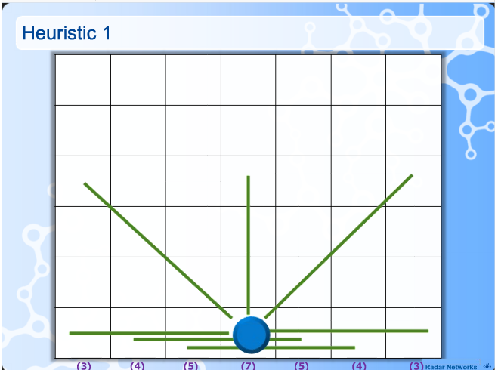

ANALYSIS:

Number of winning lines represent the winning possibilities for player. In case of column 1 its is 3, column 2 it is 4 and so on moving to the middle it increases to seven. Hence column 4 should be given more priority than any of the other column according to above parameter. Testing only this parameter the winning percentage was not very high resulting into testing of other parameters.

5.2.2 Testing parameter 2 i.e. How many pieces in a row will a user get when he/she moves here?

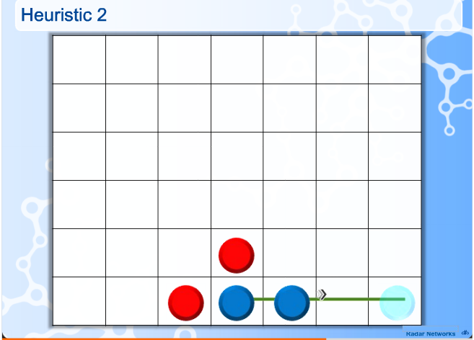

ANALYSIS

This parameter tells about the probability of user getting more chips of his/her own color. Hence increasing the possibility of user winning. As you can see in the figure dropping chip in the last column gave the user possibility of securing 4 chips in a row but if the user had moved in the any other column the possibility of winning would have been less as compared to this case

5.2.3 Testing of parameter 3 i.e. Do user block a good path for the enemy by moving here?

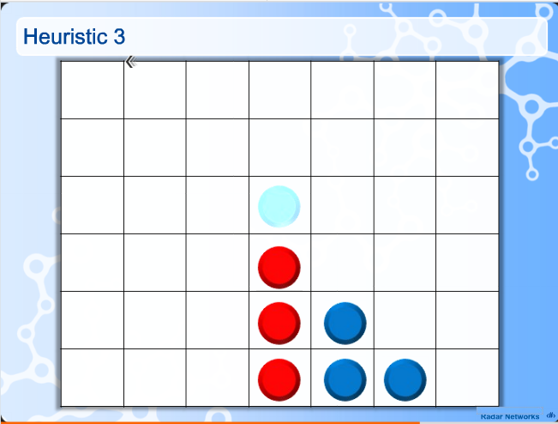

ANALYSIS

In order to avoid the opponent’s four in a row, we need to block whenever the opponents has three chips in a particular row which is exactly shown in the figure above. Column 4 has three chips in a row, hence making a move here will avoid opponent’s win. This parameter when used with other parameter gave a higher win percentage as shown in the testing table

5.2.4 Testing of parameter 4 i.e. Does the space above gives the opponent advantage?

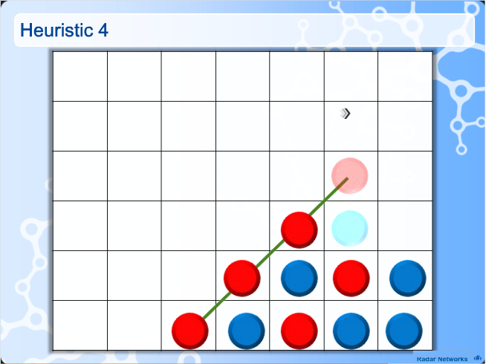

ANALYSIS

This parameter plans one step ahead of the current move and checks whether moving at a certain place will give advantage to the opponent or not? As shown in the figure moving a column 3 by the user might result in his/her loss as the space above gives opponent a clear advantage giving him/her chance to make 4 in a row successful

5.3 Statistical testing

A: Number of winning lines.

B: How many pieces in a row will a user get when he/she moves here?

C: Do user block a good path for the enemy by moving here?

D: Does the space above gives the opponent advantage?

CASE1: When user moves first

S.no | Parameter Used | Program Win % (per 100 games) | Program Loss % (per 100 games)
1 | A | 42 | 58
2 | B | 30 | 70
3 | C | 35 | 65
4 | D | 37 | 63
5 | A+B | 61 | 39
6 | A+B+C | 74 | 26
7 | A+B+C+D | 87 | 13

CASE2: When CPU(with an artificial intelligence) moves first

S.no | Parameter Used | Program Win % (per 100 games) | Program Loss % (per 100 games)
1 | A | 48 | 52
2 | B | 33 | 67
3 | C | 39 | 61
4 | D | 43 | 57
5 | A+B | 68 | 32
6 | A+B+C | 78 | 22
7 | A+B+C+D | 91 | 9

5.4 Evaluator

The Connect4Evaluator class implements the Evaluator interface from the strategy game framework to provide the means for scoring the state of the board, which is used when searching a game tree to determine the best move. Evaluation is based purely on maximizing the number of pieces a player has in unbroken possible winning groups, whilst minimizing the same count for the opponent. Different weights are given to unbroken possible winning groups depending on the number of the player's pieces in the group, as follows:

* If any group has all four squares filled with the player's pieces, the board is given a constant score of 5000.

* Otherwise, the score is (4 * 2 ^ n3) + (2 * 2 ^ n2) + (2 * n1), where n3 is a count of the number of unbroken possible winning groups that have three squares filled with the player's pieces (and therefore one open), n2 is a count of the number of unbroken possible winning groups that have two squares filled with the player's pieces (and therefore two open) and n1 is a count of the number of unbroken possible winning groups that have one square filled with the player's pieces (and therefore three open).

This strategy is based on the premise that unbroken groups containing increasing numbers of the player's pieces become exponentially more valuable. The above calculation is done for the player and for the opponent and the final score for the board is the player's score minus the opponent's score.

CHAPTER SIX:

SCREENSHOTS



BACKGROUND

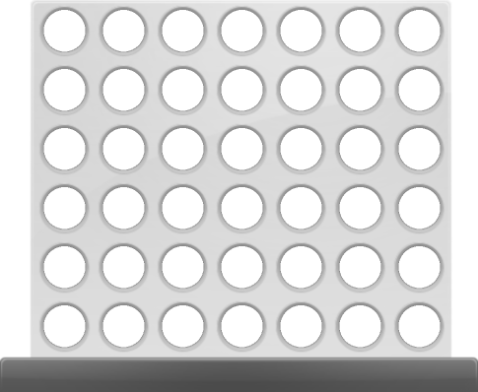
GAME BOARD


PLAYER 1 PLAYER 2


PLAYER1 AVATAR PLAYER2 AVATAR

SCREENSHOT OF INITIALIZATION OF GAME

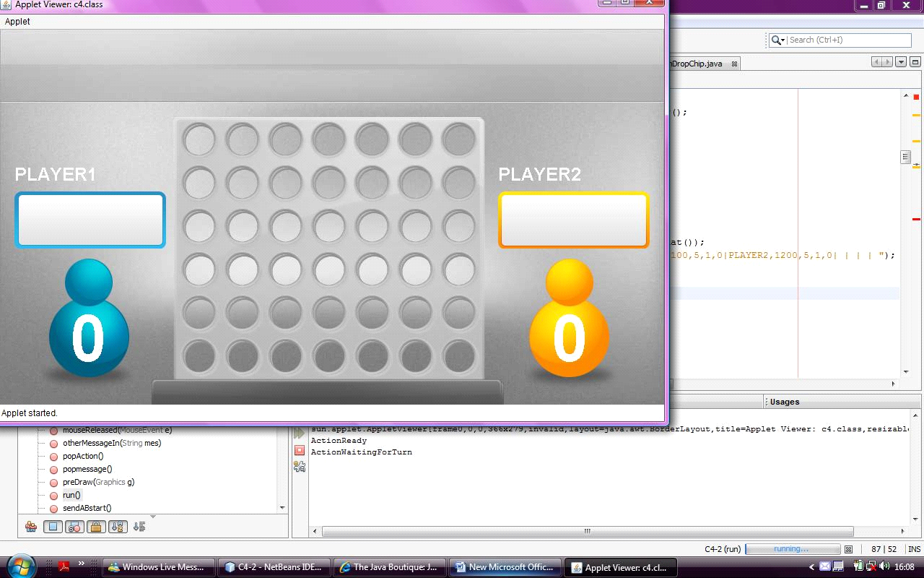
Receiving Message
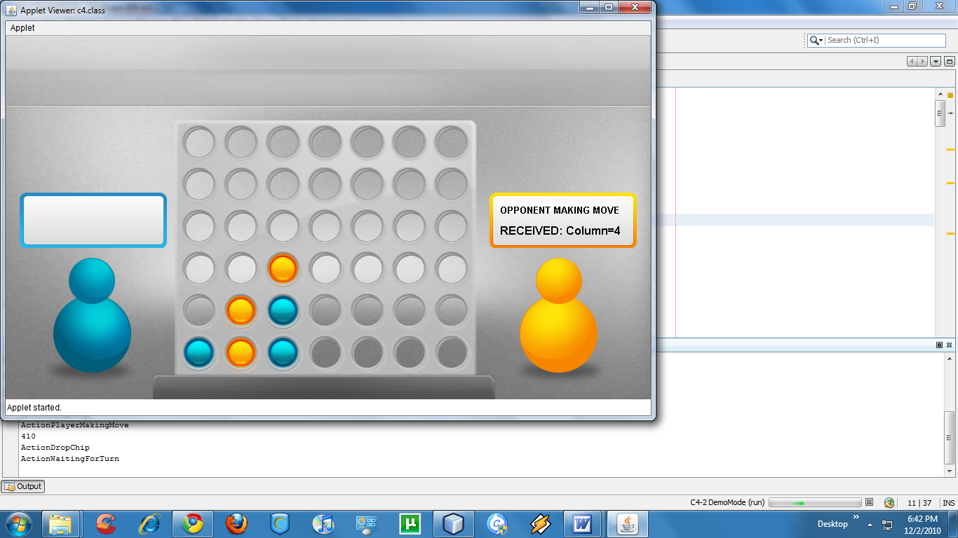
Sending the Message
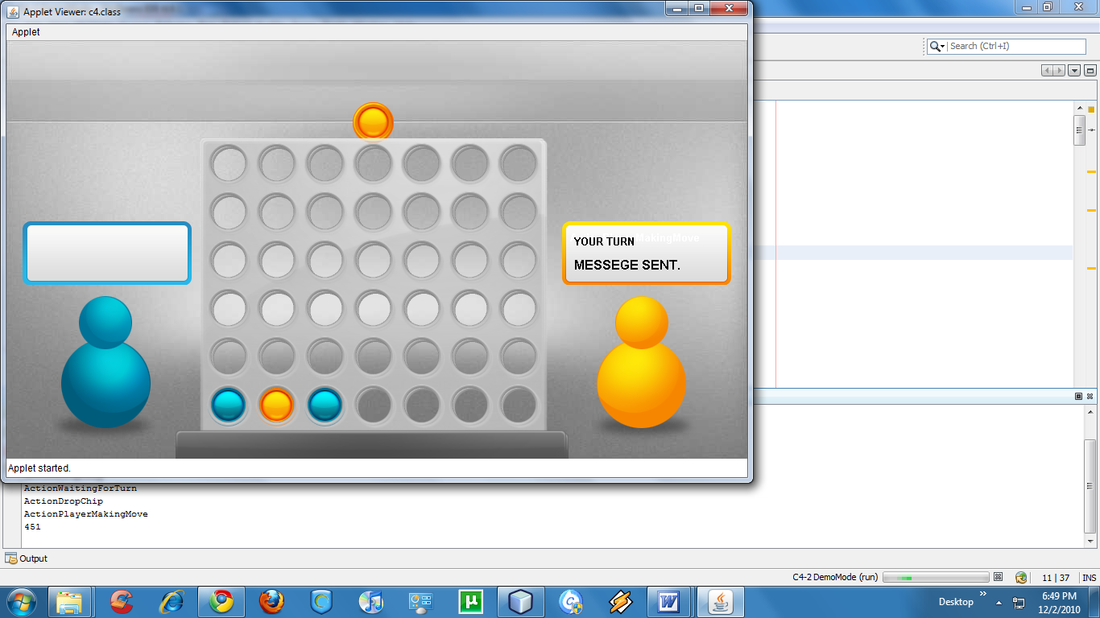

Dropping Chip

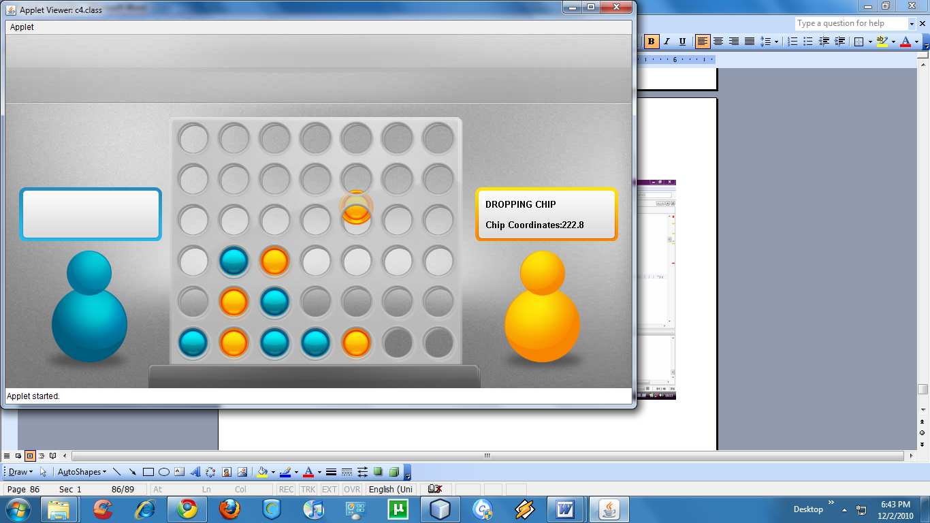

AFTER THE GAME IS WON

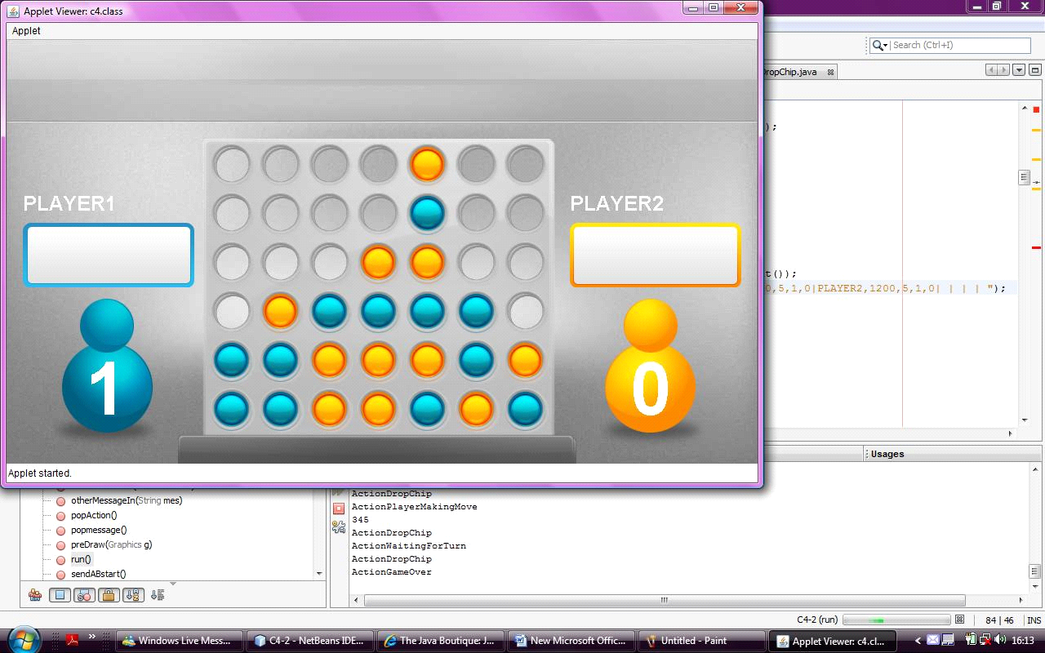

PLAY AGAIN

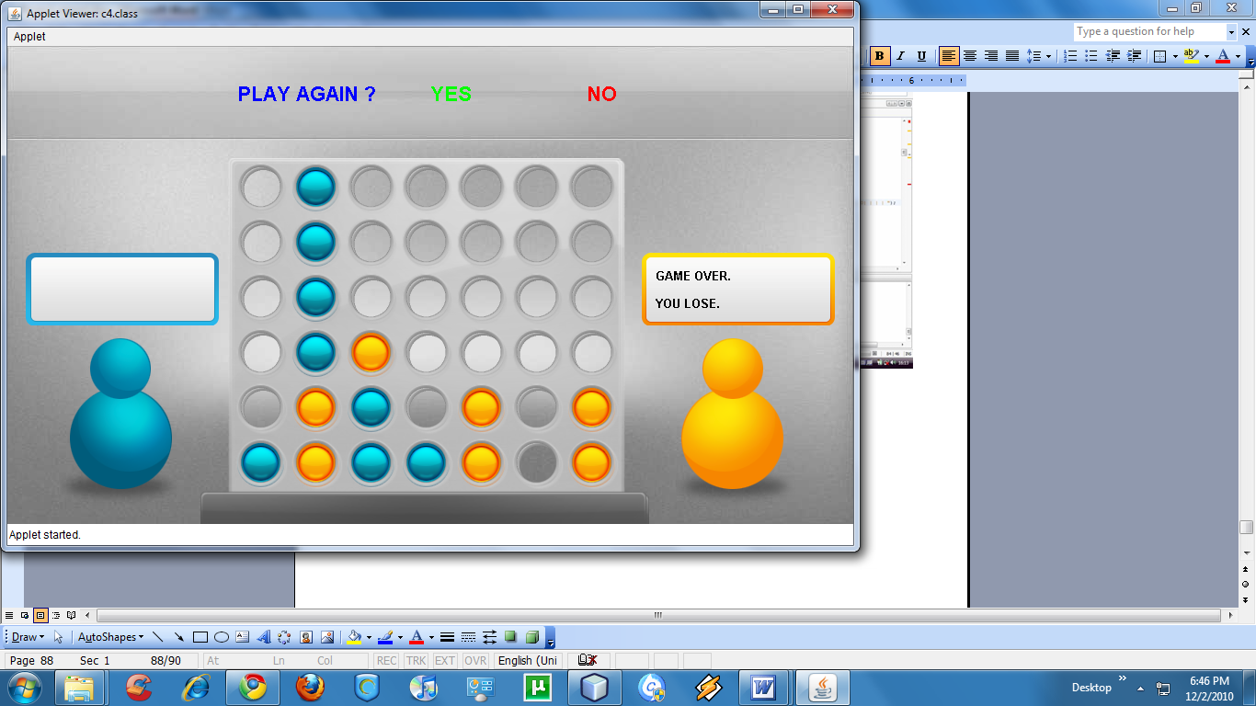

CHAPTER SEVEN:

PLATFORM DESCRIPTION AND FUTURE SCOPE

7.1 Benefits of Java
1. Complex dynamic web applications are possible in Java programming.
2. Java is multi threaded programming language so is used in high performance applications.
3. As Java applets are platform independent, it can easily be accessed by software developers.
4. Users do not keep the fear for heavy license fees as Java is an open source language.
5. EJB (Enterprise Java Beans) and RMI (Remote method Invocation) are the globally recognized Java architecture for distributed applications.
6. Automatic garbage collection is possible in Java applications.
7. As Java is a platform independent language, the codes which is written Java, can be run in different platforms.
8. Java is a highly secured, robust and portable programming language in nature.
9. In the database end, Java can use all kind of databases (free and paid) according to the client's requirements.
10. DAO, CORBA, Hibernate are widely recognized Java architectures which supports internationalization (i18n) for business enterprise applications.
11. Java has the set of well-designed, intuitive and multi tasking APIs which help the Java programmers to do better coding without any hassle.
The computer world currently has many platforms. This has its pros and cons. On the one hand it gives more choices to people; on the other hand it becomes more and more difficult to produce software that runs on all platforms. With its Java Virtual Machine and API, the Java Platform provides an ideal solution to this. The Java Platform is designed for running highly interactive, dynamic, and secure applets and applications on networked computer systems.
Being interactive, dynamic and architecture-neutral, the Java Platform has benefits not only for the developer and support personnel, but also for the end user. For the end users, the platform provides live, interactive content on the World Wide Web, with just-in-time software access. Applications are readily available on all operating systems at once. Users do not have to choose operating systems based on the applications, they can run the applications on their favorite machines.
Developers can develop applications on one platform to deliver to that same platform -- the Java Platform, which is available on a wide variety of OS and hardware platforms. This much reduces the developing cost. For support personnel, version control and upgrades are much simplified because Java-enabled application can be kept in a central repository and served from there for each individual use.

CHAPTER EIGHT:

SYSTEM REQUIREMENTS

Backend
- NetBeans.
- Java-J2EE.
- Asp.NET.
- C#.
- Sql Server.

Frontend
- Internet Browser supporting Java plugins (Firefox, IE v4 or higher, etc).
- Java 1.6 or higher.
- Windows


REFERENCES

The following books were referred extensively for the project development and implementation.

1.David Flaganan, Java in a Nut Shell, O’Rielly Media
ISBN No-978-0-596-00773-7
2.Herbert Schildt, The Complete Reference Java2, Tata McGraw-Hill
ISBN No-9780070495432
3. Roger S. Pressman, Software Engineering, A Practitioner’s Approach, Tata McGraw-Hill
ISBN No-10: 007301933X
4. Milton Bradley, 1974. Connect Four (also known as Plot Four, Find Four, Four in a Row and Four in a line), Wikipedia; http://en.wikipedia.org/wiki/Connect_Four
5. Pomakis, K., 2005. Connect-4 Algorithm;
http://www.pomakis.com/c4/connect_generic/c4.txt
6. Labib, B., 2003. Connect4 using Alpha-Beta
Search algorithm.
http://www.codeproject.com/KB/mobile/Connect4AB.aspx
7. Wikipedia, 2009. Waterfall Model. http://en.wikipedia.org/wiki/Waterfall_model

