Fitts’s Law Replication

HW3

Parneet Kaur - 668912766

**Fitts's Law**

Fitts's Law is a predictive model of human movement established by Paul Fitts in 1954. In Human Computer Interaction, it is typically applied to the movement through user interface using a cursor or any type of pointer. The law predicts that the time required to move to a target is a function of the distance to the target divided by the size of the target. Fitts Law is also used for comparison and evaluation of novel pointing devices. The equation for the Fitts Law is given as:

$$MT=a+b*ID$$

where MT is Movement Time and ID is Index of difficulty. As the index of difficulty increases i.e. the distance to target increases and width of target decreases, the movement time increases. Fitts proposed the index of difficulty (ID) of the task which depends on the distance to the target and the width of target. Fitts's ID is given by:

$$ID=\log_{2}{\frac{2D}{W}}$$

The form most frequently used in the Human-Computer Interaction was given by Scott MacKenzie and is called Shannon formulation given by:

$$ID=\log_{2}({\frac{D}{W}+1)}$$

where **D** is the distance to the target, **W** is the target's width, and **ID** is the Index of Difficulty.

**Experiment**

**Developing the experimental apparatus1**

The experiment apparatus is designed using HTML, Javascript and D3.

Experiment is designed according to below conditions:

* Input modality for the experiment is mouse. User will click on the target using a mouse.
* Experiment includes a 2D pointing task complying with ISO 9241-9:2000
* Experiment has 2 different target sizes (10 and 60 pixels) and 3 different distances (100,250 and 400 pixels) to the target. Each user will hit the target 15-25 times for each of the conditions (target width and distance pair). ID value of 2 to 8 are usually sufficient for most situations**2**
* Index of difficulty is calculated using Shannon’s formulation of Fitts Law.
* For accuracy, D in Shannon’s equation is the effective distance to the target and is calculated as the mean movement from the start position to the end position (point which user actually hits on target). For the effective width of the target, the standard deviation(σ) of the points where user hits the target is calculated and the width is given by 4.133σ. For this experiment I have calculated effective D but to keep the calculations simple, I have not calculated effective W and have used the actual width of the target.

Given below are the screenshots for the 6 different conditions:

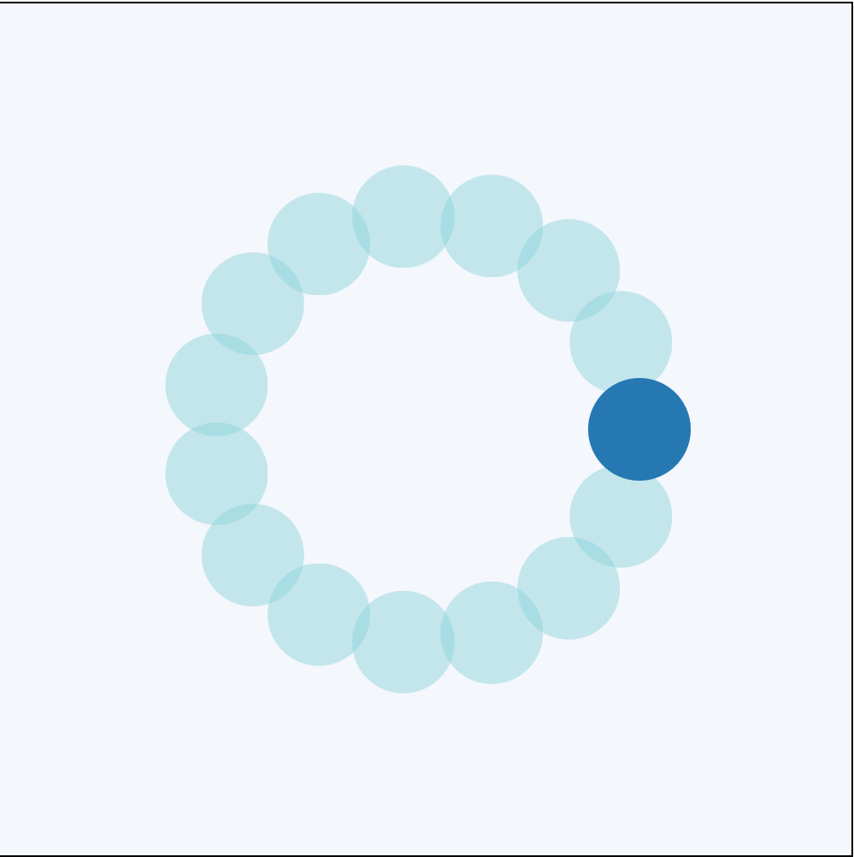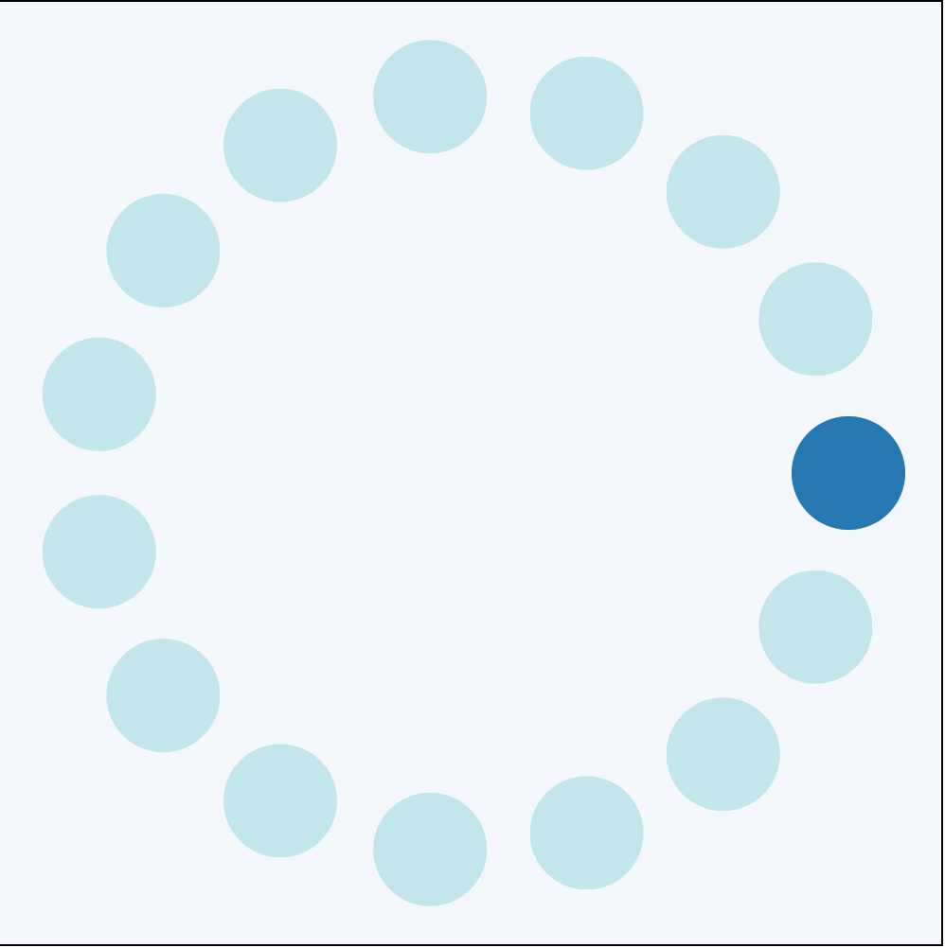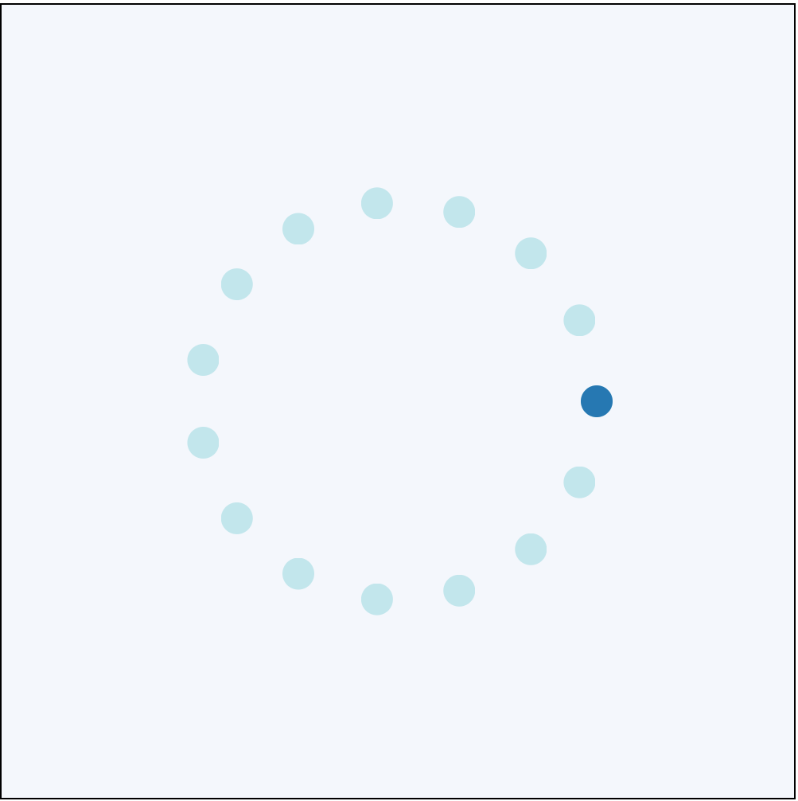

*Note: Above snapshots are not according to scale.*

**Data collection**

Experiment was performed by 2 users including myself. The width and distance to the target was randomly selected. Each condition was presented to user at least 15 times. For every movement in each condition, the below data is collected:

|  |  |
| --- | --- |
| * Distance to the target * Width of target * Movement Time to hit the target (MT) | * Position of Start Point * Position of Target End Point * Position of Actual Hit |

**Data Analysis**

After data collection, the data was separated into 6 categories based on the experiment condition. To calculate the Index of difficulty (ID) for each condition, the effective distance is calculated as the mean movement from the start position to the actual hit position (for accuracy) for the data points corresponding to the condition.

Throughput for each data point is calculated as Index of Difficulty/Movement Time. Average throughput for each experiment condition is calculated as mean of throughput for all data points for given ID**3**.

Least Squares Fitting4 Linear Regression is used to calculate the intercept a and slope b for the scatter data points. Below are the coefficient values for the 2 users:

|  |  |  |  |  |  |  |  |  |
| --- | --- | --- | --- | --- | --- | --- | --- | --- |
| User | Time Over ID | | Throughput Over ID | | Average Time over ID | | Average Throughput over ID | |
| a | b | a | b | a | b | a | b |
| Blue | 217.51 | 158.52 | 2.70 | 0.53 | 229.04 | 154.71 | 2.62 | 0.56 |
| Orange | 517.01 | 194.27 | 1.40 | 0.41 | 530.71 | 192.47 | 1.44 | 0.41 |

Plots for movement time over Index of Difficulty and throughput over Index of Difficulty for the 2 users are given below:

Below 2 plots give **individual time and throughput for each data point over ID**.

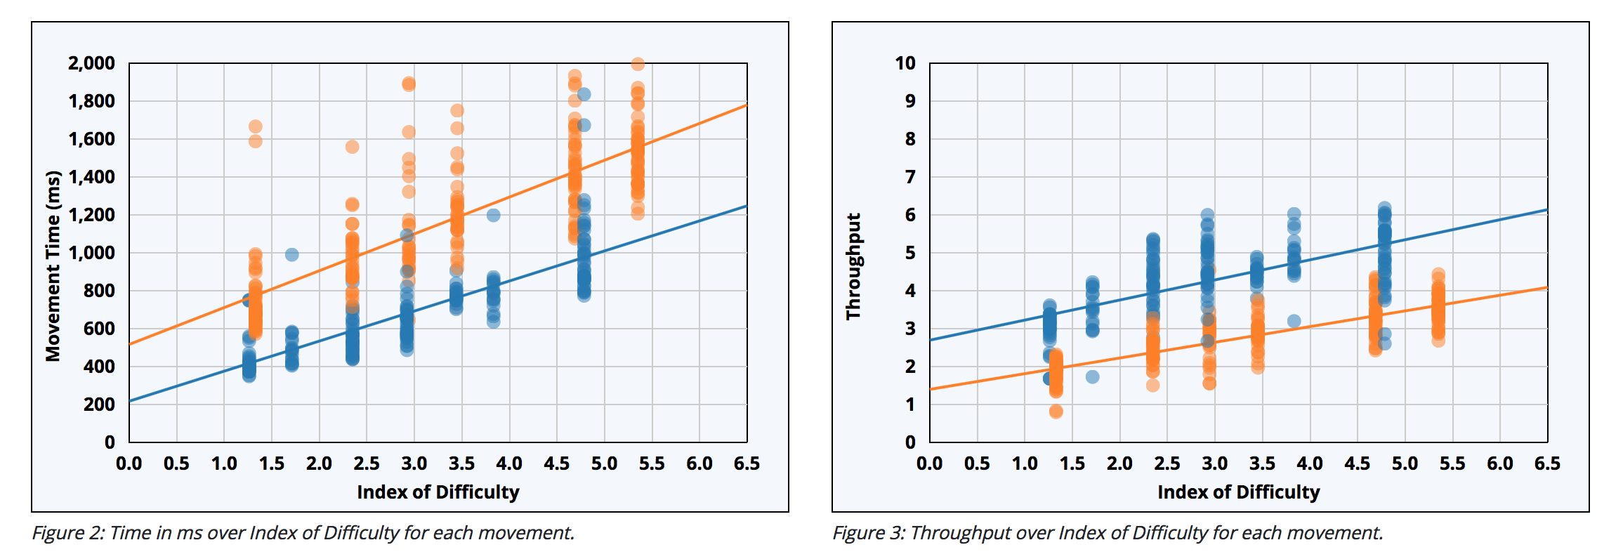

Below 2 plots give **mean time and mean throughput over ID**.

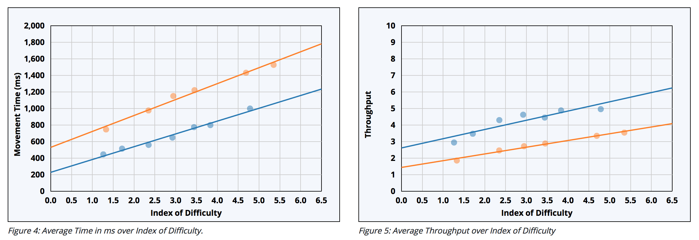

**Conclusion:**

It is clear from the plots that as the index of difficulty increases, i.e. increase in distance to target and decrease in width of target, the movement time increases which is what Fitts’s law states. The throughput is lesser for orange user as compared to blue because orange user takes more time for the movement as compared to blue user.

**References:**

1. http://simonwallner.at/ext/fitts/
2. Soukoreff, R. W., & MacKenzie, I. S. (2004). Towards a standard for pointing device evaluation: Perspectives on 27 years of Fitts' law research in HCI. *International Journal of Human-Computer Studies*, *61*, 751-789.
3. From above mentioned paper for throughput calculation- *“If the purpose of this analysis is the comparison of two or more experiment conditions, then throughput (TP) is calculated first for each subject (as the mean throughput achieved by the subject over all x movement conditions), and these subject throughputs are averaged to produce the grand throughput,*

|  |  |  |
| --- | --- | --- |
|  |  | *(10)* |

*where y is the number of subjects, and x represents the number of movement conditions. The units of throughput are bits per second (or bps).”*

1. http://mathworld.wolfram.com/LeastSquaresFitting.html