**[](http://rdmservice.ru/news/)**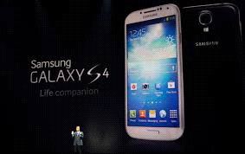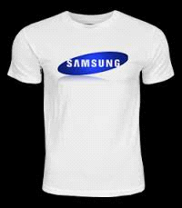

**PO BOX 1010, LIVERPOOL   
L70 1NL, UNITED KINGDOM**

**EMAIL ID: (samsunguk.claim@hotmail.com)**

**WEB SITE//:** [www.samsung.com/music/en_Uk/125year/postlive.html?lang=en](http://www.samsung.com/music/en_Uk/125year/postlive.html?lang=en)

**These are your identification numbers:**

**Ticket Number: 011425896/2016**

**Serial Number: 3872/506**

**Lucky Numbers: 7/4/88/28/01/40.**

**Dear: Lucky Winner:**

CONGRATULATION! CONGRATULATION!! CONGRATULATION!!!

**This is to inform you that your Email have won (3.6 CRORES RUPEES) from the Samsung Mobile Company United Kingdom which is organized by Samsung Mobile Company in conjunction with Chevron Texaco Oil and Gas Company, “Your Email Address" were selected through a computer ballot system drawn from Nine hundred thousand email from Canada, Australia, United States, Asia, Europe, Middle East, Africa and Oceanic as part of our international program which is conducted annually, 20 people was selected as our winners, Through electronic ballot System without the winner applying.**

**FILL THIS FORM FOR PRIZE RELEASE:-**

**KINDLY SEND YOUR DETAILS TO EMAIL ID:(** samsunguk.claim@hotmail.com**)FOR THE RELEASE OF YOUR FUND IN TIME:**

**1. Full Name:**

**2. Full Address:**

**3. Occupation:**

**4. Age:**

**5. Sex:**

**6. Mobile Number:**

**7. State:**

**8. Country:**

**9. Winning Email:**

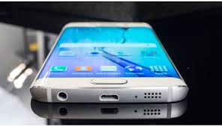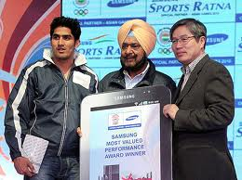

**DR HENRY KEN**

**EVENT – MANAGER**

**SAMSUNG MOBILE COMPANY**

**EMAIL: (**samsunguk.claim@hotmail.com

**[](http://www.androidbeat.com/2013/10/samsung-publishes-q3-results/)**

