Technical Architecture
AI-Native Billing & Outcome Settlement Platform
MVP Stack: Sui • Walrus • Nautilus • Next.js + TypeScript

1. Architectural Overview
The platform is built on a three-plane architecture, each plane mapped to the component of the Sui stack best suited for it. This separation is not cosmetic. It enforces a clean trust model and lets us scale each plane independently.
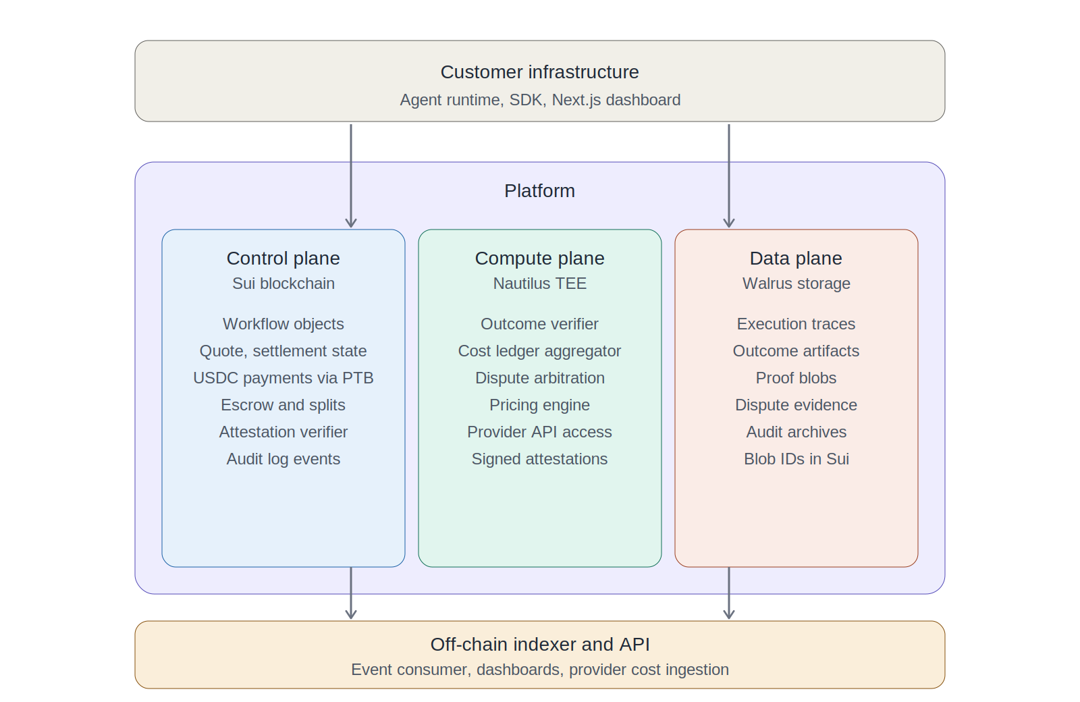
Three-plane architecture: control, compute, and data planes

1.1 The three planes
Plane | Technology | Responsibilities
Control plane | Sui blockchain | Workflow state machine, quote and settlement objects, USDC escrow, atomic multi-party splits via PTBs, attestation verification, audit event emission. Source of truth for what was billed, to whom, against what outcome.
Compute plane | Sui Nautilus (AWS Nitro Enclaves) | Outcome verification against success criteria, cost ledger aggregation from off-chain provider APIs, pricing engine, dispute arbitration. Anything that requires reading sensitive customer data or external APIs with cryptographic integrity guarantees.
Data plane | Walrus | Execution traces (potentially megabytes per workflow), outcome artifacts (PDFs, transcripts, generated files), proof blobs, dispute evidence, long-term audit archives. Sui holds blob IDs as object references.
Off-chain services | Our infrastructure | Event indexer, customer-facing API, dashboards, SDK runtime, provider cost ingestion workers, webhook delivery. Stateless services that derive views from on-chain state.

1.2 Why this split
Sui handles what must be trustless. Customer payments, multi-party splits, settlement guarantees, and audit history all need cryptographic verifiability. Sui's object model maps directly to our schema — each Workflow, Quote, Execution, Outcome, and Settlement becomes a Move object with ownership and lifecycle rules enforced by the chain.
Nautilus handles what must be verifiable but private. Customers will not put sensitive workflow inputs on-chain. Model provider API keys cannot be exposed to smart contracts. But the verification of outcomes against success criteria still needs to be trustless. Nautilus solves this by running our verifier inside an AWS Nitro Enclave that generates a cryptographic attestation. Sui smart contracts verify this attestation before unlocking settlement. The agent itself runs wherever the customer wants — we attest the verifier, not the agent.
Walrus handles what is large and must be auditable. Execution traces and outcome artifacts can be megabytes per workflow. Storing them on Sui would be prohibitively expensive at ~$100 per MB. Walrus provides decentralized blob storage with $0.02 per MB cost and erasure-coded durability. Crucially, Walrus blobs are Sui objects, so our Move contracts can reference them by blob ID and use them in dispute proofs.

2. Data Model
Every billable workflow has five first-class Move objects on Sui, linked through object IDs. The objects are designed for parallel execution where possible — Sui's object-centric model means workflows for different customers can be processed simultaneously by validators.

2.1 Move object definitions

Workflow object
public struct Workflow has key {
id: UID,
customer: address,
product_id: ID,
status: u8, // 0=quoted, 1=executing, 2=verified, 3=settled, 4=disputed, 5=refunded
quote_id: Option<ID>,
execution_id: Option<ID>,
outcome_id: Option<ID>,
settlement_id: Option<ID>,
total_revenue: u64, // in USDC base units
total_cost: u64,
margin: u64,
created_at: u64,
updated_at: u64,
}

Quote object
public struct Quote has key, store {
id: UID,
workflow_id: ID,
customer: address,
price: u64, // committed price in USDC
pricing_model: u8, // 0=fixed, 1=capped, 2=success_fee, 3=hybrid
success_criteria: vector<u8>, // CBOR-encoded structured criteria
success_criteria_hash: vector<u8>, // for tamper detection
expires_at: u64,
issuer_attestation: vector<u8>, // Nautilus signature over quote
}

Execution object
public struct Execution has key, store {
id: UID,
workflow_id: ID,
started_at: u64,
completed_at: u64,
trace_blob_id: vector<u8>, // Walrus blob ID for full trace
cost_items: vector<CostItem>, // itemized costs by provider
total_cost: u64,
}

public struct CostItem has store, copy, drop {
provider: address, // who gets paid for this line item
category: u8, // 0=model, 1=tool, 2=human, 3=compute
units: u64, // tokens, calls, minutes etc.
amount: u64,
}

Outcome object
public struct Outcome has key, store {
id: UID,
workflow_id: ID,
success: bool,
artifact_blob_id: vector<u8>, // Walrus blob ID for deliverable
proof_blob_id: vector<u8>, // Walrus blob ID for verification proof
tee_attestation: vector<u8>, // AWS Nitro signature from Nautilus
enclave_measurement: vector<u8>, // PCR values for reproducibility
verified_at: u64,
dispute_window_ends: u64,
}

Settlement object
public struct Settlement has key, store {
id: UID,
workflow_id: ID,
splits: vector<Split>,
total_settled: u64,
platform_fee: u64,
settled_at: u64,
}

public struct Split has store, copy, drop {
recipient: address,
amount: u64,
role: u8, // 0=agent_company, 1=model_provider, 2=tool, 3=human, 4=platform
}

2.2 Schema rationale
- Object capability per workflow: Each Workflow object has a unique owner and lifecycle. This enables parallel execution on Sui — independent workflows do not block each other.
- Optional references for staged state: quote_id, execution_id, outcome_id, settlement_id are Option types. The Workflow object exists from the moment of quote and accumulates references as the workflow progresses.
- Walrus blob IDs as foreign keys: Execution traces, outcome artifacts, and proofs live on Walrus. Sui only stores the blob ID and a hash. This keeps gas costs bounded regardless of artifact size.
- Cost items embedded, not external: CostItem is a value type stored inside Execution. The full cost breakdown is on-chain because it's small and frequently accessed for margin attribution. The verbose trace is on Walrus.
- Attestation as bytes: TEE attestations are AWS Nitro signatures over enclave output. We verify these on-chain via a Move contract that implements Nitro attestation verification.

3. Workflow Lifecycle
A single billable workflow moves through seven discrete stages. Each stage is a state transition on Sui, accompanied by data movement to Walrus and computation in Nautilus where required.
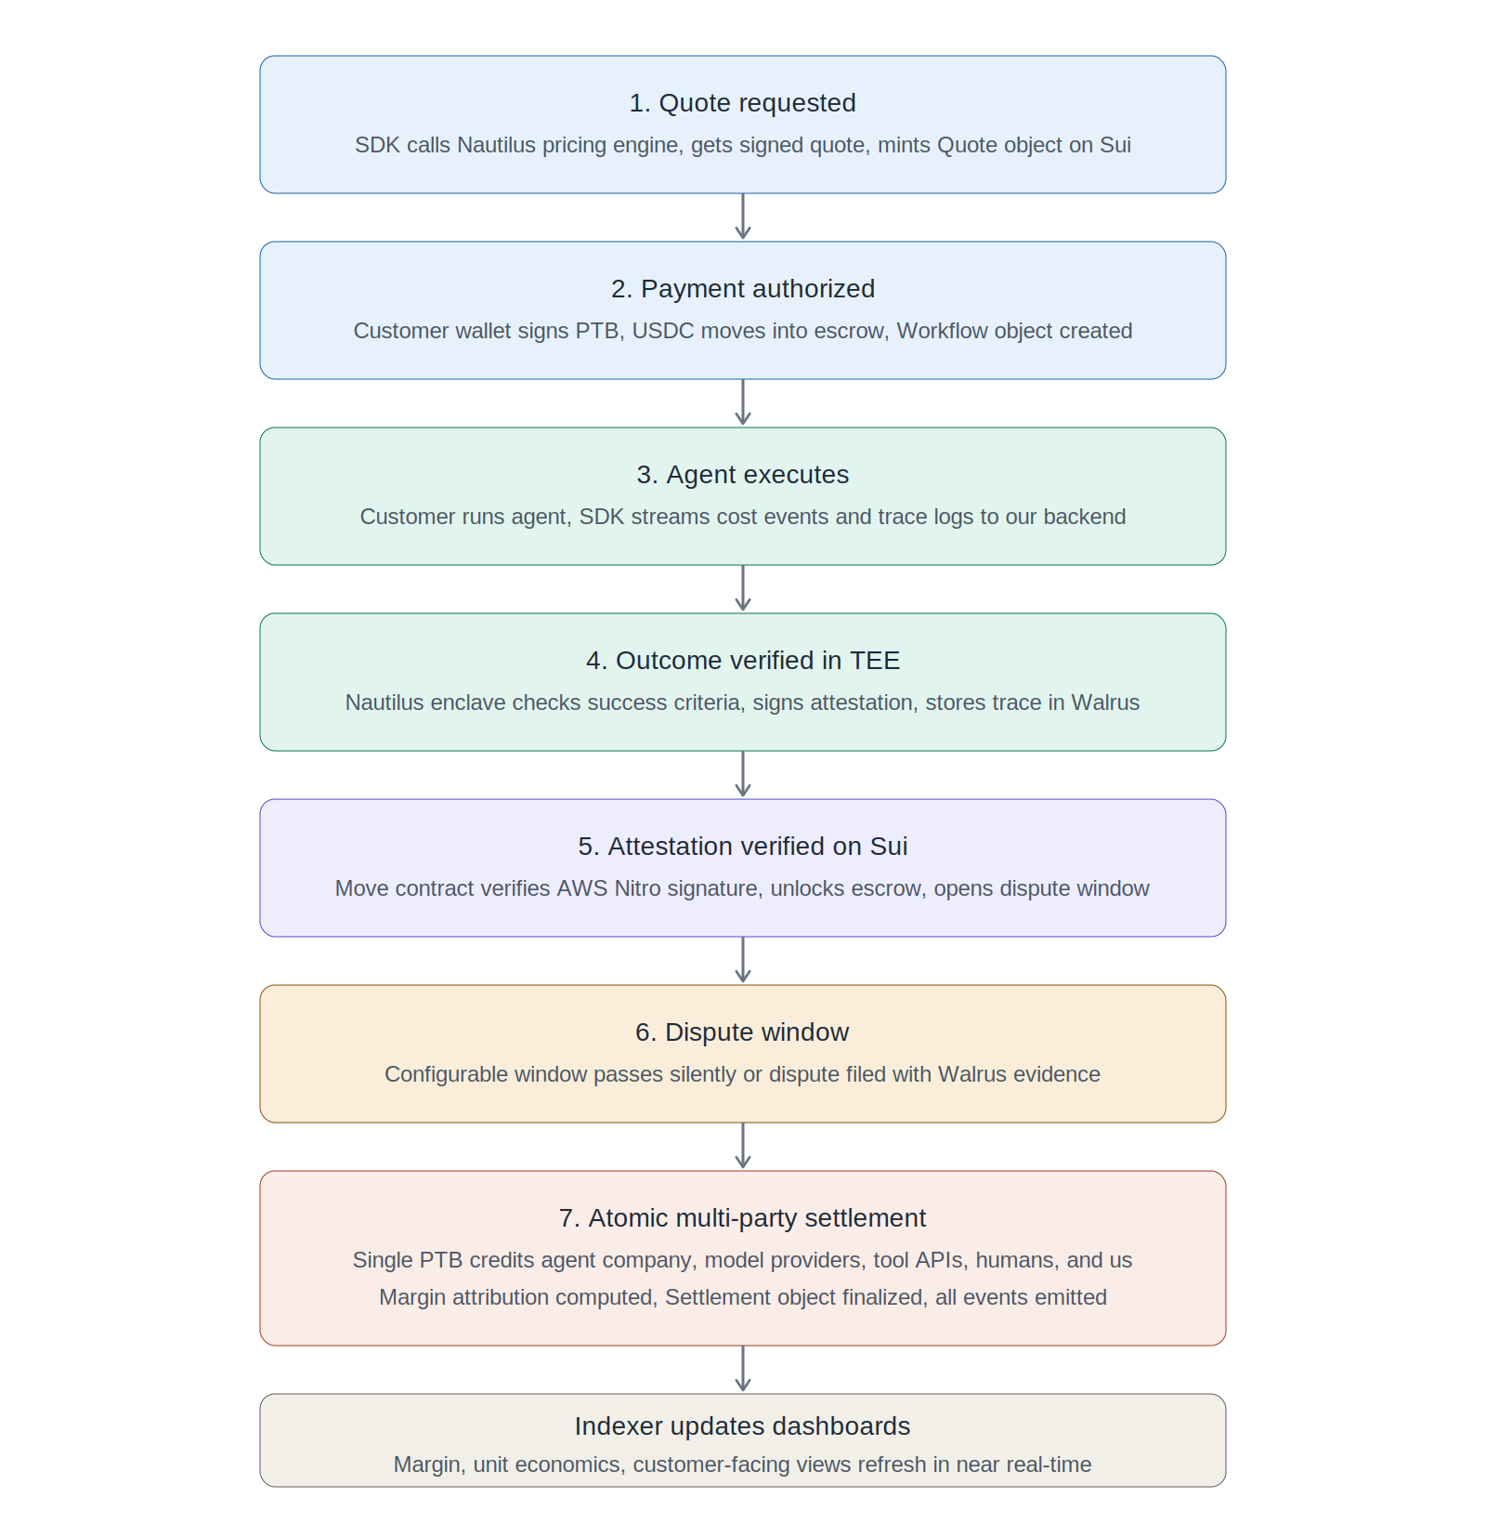
Workflow lifecycle from quote to atomic multi-party settlement

3.1 Stage 1: Quote request
Customer SDK calls the pricing intelligence engine running in a Nautilus enclave. The enclave reads customer pricing rules, historical cost data, and current provider rates, then computes a quoted price and signs it with the enclave key.
The SDK then submits a transaction to Sui that creates the Quote object with the enclave's signature attached. This signature is verified on-chain before the Quote is accepted, ensuring no manipulation of the quote by the customer or anyone else.

3.2 Stage 2: Payment authorization
Customer signs a Programmable Transaction Block (PTB) that does three things atomically:
- Locks USDC equal to the quoted maximum into an escrow object owned by the Workflow
- Creates the Workflow object referencing the Quote
- Emits a WorkflowCreated event for the indexer
Sponsored transactions can be used here so customers do not need to hold SUI for gas — only USDC. Our platform sponsors gas and recovers the cost in the settlement step.

3.3 Stage 3: Agent execution
The agent runs wherever the customer hosts it. The SDK streams cost events to our off-chain backend as they happen — each model call, each tool invocation, each human-in-the-loop event. Provider API receipts and timestamps accumulate in a structured trace.
This stage produces no on-chain transactions. The cost trace is buffered off-chain to avoid gas overhead on high-frequency cost events. The full trace gets committed to Walrus and referenced on Sui in the next stage.

3.4 Stage 4: Outcome verification
When the agent reports completion, the SDK submits the outcome record (the actual deliverable, structured) plus the cost trace to a Nautilus enclave running our verifier.
The enclave performs four operations:
- Hashes the outcome and writes it to Walrus, obtaining a blob ID
- Hashes the cost trace and writes it to Walrus, obtaining a second blob ID
- Evaluates the outcome against the success_criteria stored in the Quote
- Signs the verification result, Walrus blob IDs, and cost totals with the enclave key
Why this needs a TEE: The outcome verification may need to inspect proprietary data, compare against provider responses, or evaluate fuzzy success criteria. We need cryptographic proof that the verification ran correctly without exposing the inputs to the chain or to us as the platform operator. AWS Nitro Enclaves provide both isolation and remote attestation that Sui can verify.

3.5 Stage 5: On-chain attestation verification
The customer SDK submits the signed verification to Sui. A Move contract performs AWS Nitro attestation verification: it checks the signature against AWS root certificates, validates the enclave measurement (PCR values) against the registered measurement for our verifier, and confirms the verification was produced by a known good enclave version.
Once attestation is verified, the contract creates the Outcome object, sets the dispute window expiry, and updates Workflow status to verified. No funds move yet.

3.6 Stage 6: Dispute window
A configurable dispute window opens — typically 24 to 168 hours depending on the product. During this window:
- Customer can challenge the outcome by submitting evidence to Walrus and calling the dispute_workflow function
- Disputes trigger a re-verification by a different Nautilus enclave running the dispute arbitration logic
- If no dispute is filed, the workflow auto-progresses to settlement
This window is what makes outcome-based billing trustworthy. Without it, the customer has no recourse if the agent reports false success.

3.7 Stage 7: Atomic multi-party settlement
After the dispute window closes (or a dispute resolves in favor of completion), settlement executes as a single PTB:
- Escrow USDC is debited
- Agent company receives revenue minus platform fee minus provider costs
- Each model provider in the cost trace receives their share
- Each tool API provider receives their share
- Human-in-the-loop participants receive their share
- Platform fee is credited to us
- Settlement object is created with the full split breakdown
- WorkflowSettled event is emitted
This is one transaction. Either all parties get paid correctly or nothing changes. This is the critical advantage of Sui's PTB model over chains where multi-party payments would require sequential transactions or a custodial intermediary.

4. Component Detail

4.1 Sui Move contracts
The on-chain logic is implemented as a set of Move modules:
Module | Responsibility
billing::workflow | Workflow object lifecycle, state transitions, status updates, event emission.
billing::quote | Quote creation with enclave signature verification, expiry checks, success criteria storage.
billing::escrow | USDC locking on quote authorization, holding during execution, release on settlement.
billing::execution | Execution record creation referencing Walrus blob IDs, cost item validation.
billing::outcome | Outcome object creation, dispute window management, dispute filing and resolution.
billing::settlement | Atomic multi-party settlement via PTB, fee calculation, split validation.
billing::attestation | AWS Nitro attestation verification using on-chain root certificates and PCR allowlist.
billing::registry | Customer registration, product configuration, success criteria templates, fee schedules.

4.2 Nautilus enclave services
Three distinct services run in separate Nautilus enclaves, each with its own attestation measurement registered on-chain:

Pricing engine
- Reads customer pricing rules, historical workflow data from our DB, current provider rate cards
- Computes quoted price for a given workflow request
- Signs the quote with the enclave key, returns to SDK
- Aggregates pricing benchmark data (anonymized) for the market intelligence layer

Outcome verifier
- Receives outcome record and cost trace from customer SDK
- Writes both to Walrus, obtains blob IDs
- Evaluates success criteria — exact match, regex, schema validation, or fuzzy comparison depending on workflow type
- Signs verification result for on-chain submission

Dispute arbitrator
- Activated only when a dispute is filed during the dispute window
- Reads original outcome, original trace, and dispute evidence from Walrus
- Re-evaluates with stricter criteria, may call out to designated arbitration oracles
- Produces a final verdict that updates the Workflow status to settled or refunded
Enclave management: All three services use the reproducible build template provided by Nautilus. Source code is publicly auditable. Enclave measurements (PCR0, PCR1, PCR2 from AWS Nitro) are registered on-chain in the billing::attestation module. Customers can verify that the enclave they are talking to runs exactly the code they audited.

4.3 Walrus storage strategy
Walrus stores data in epochs — 2 weeks per epoch on mainnet, with a maximum of 53 epochs (approximately 2 years). This means storage has a finite lifetime that must be managed.
Data tier | Walrus epochs | Strategy
Active (dispute window open) | 1 epoch | Recently-completed workflows. Must be available for dispute evidence. Higher availability requirements.
Recent (90 days) | 7 epochs | Frequently queried for dashboards and reconciliation. Standard Walrus storage.
Audit (2 years) | 53 epochs | Regulatory and audit access. Compressed and deduplicated before Walrus storage.
Archive (beyond 2 years) | N/A | Migrated to S3 Glacier with cryptographic proof of integrity. Walrus blob hashes preserved in Sui for verifiability.

4.4 Off-chain services

Event indexer
Subscribes to Sui events from our package: WorkflowCreated, ExecutionCompleted, OutcomeVerified, DisputeFiled, WorkflowSettled. Writes to Postgres for dashboards. Latency target: under 2 seconds from on-chain to indexed.

Cost ingestion workers
Pull cost data from provider APIs (OpenAI usage API, Anthropic Console API, Modal billing, cloud provider billing). Match against execution traces. Catch any underreported costs from the SDK and reconcile. Run hourly.

Webhook delivery
Customers subscribe to workflow lifecycle webhooks. Standard webhook signing, retries with exponential backoff, dead letter queue. Built on a job queue with at-least-once delivery.

Customer API
REST and GraphQL API for SDK interactions and direct integration. JWT auth with API keys mapped to Sui addresses. Rate limited per customer.

5. Frontend (Next.js + TypeScript)

5.1 Application structure
Two distinct applications share a monorepo:

Customer dashboard
- Workflow list with status, margin, cost breakdown
- Real-time unit economics — margin per workflow, per product, per customer cohort
- Quote inspector for understanding pricing
- Dispute filing UI with Walrus evidence upload
- Settings: API keys, webhook endpoints, pricing rules
- Finance views: invoice export, revenue recognition, COGS reports

Admin console
- Customer onboarding and KYB workflows
- Enclave measurement registration and rotation
- Provider integration configuration
- Platform-wide observability and SLA monitoring

5.2 Tech stack
Layer | Choice
Framework | Next.js 15+ with App Router, React Server Components for data-heavy views
Language | TypeScript strict mode across the board
Sui interaction | @mysten/sui SDK for read queries and PTB construction
Wallet integration | @mysten/dapp-kit for wallet connection, supporting Sui Wallet, Suiet, Phantom, zkLogin for social auth
Walrus interaction | @mysten/walrus SDK for blob upload and retrieval
Styling | Tailwind CSS, shadcn/ui component primitives
Data fetching | TanStack Query for client state, RSC for server state
Charts | Recharts for dashboards, lightweight and React-native
Auth | zkLogin for end users (Google, Apple), enterprise SSO for admin
API client | tRPC for internal type-safe APIs, OpenAPI-generated client for public API

5.3 Wallet and signing UX
Three wallet flows the dashboard must support:
- zkLogin (default for SMB customers): Sign in with Google. Sui address derived from JWT. No seed phrase, no extension. Critical for converting non-crypto-native teams.
- Sponsored transactions: Customer signs the intent but does not pay gas. We sponsor it and recover via platform fees. Removes the need for customers to hold SUI.
- Multi-sig for enterprise: Treasury wallets require multiple signers for settlements above configurable thresholds. Implemented via Sui's native multi-sig.

6. SDK Design
The SDK is the customer's primary integration point. Designed to make billing instrumentation feel like logging, not like blockchain integration.

6.1 Core API surface
import { Billing } from '@platform/sdk';

const billing = new Billing({
apiKey: process.env.BILLING_API_KEY,
customerAddress: '0x...',
});

// 1. Request a quote
const workflow = await billing.workflows.start({
productId: 'ticket-resolution',
customerId: 'cus_abc123',
inputs: { ticket_id: 'T-1024' },
successCriteria: { type: 'resolved_status', value: 'closed' },
});

// 2. Record costs as the agent runs
await workflow.recordCost({
provider: 'anthropic',
category: 'model',
units: 12450, // tokens
amount: 0.187, // USD
metadata: { model: 'claude-opus-4.7', purpose: 'classification' },
});

await workflow.recordCost({
provider: 'zendesk-api',
category: 'tool',
units: 3, // API calls
amount: 0.015,
});

// 3. Submit outcome
await workflow.complete({
outcome: { ticket_status: 'closed', resolution: 'refund_issued' },
artifact: pdfBuffer, // optional, gets stored on Walrus
});

6.2 SDK responsibilities
- Buffer cost events locally, batch-submit to our backend to avoid latency overhead
- Construct PTBs for quote acceptance and settlement on customer's behalf
- Handle TEE communication for quote requests and outcome submission
- Upload artifacts to Walrus when the workflow completes
- Provide hooks for webhook validation in customer code
- TypeScript-first with strong types for product schemas and success criteria

6.3 Language support
Phase 1 ships TypeScript and Python SDKs. Phase 2 adds Go and Rust. The TypeScript SDK is the reference implementation. All SDKs share a common API design and protocol buffer schemas for transport.

7. Security & Trust Model

7.1 Trust assumptions
Component | Trusted for | Not trusted for
Customer SDK | Reporting agent activity, signing on behalf of customer | Reporting accurate costs (verified via provider API reconciliation)
Sui validators | Transaction ordering, finality, object state | Reading customer business logic (kept off-chain)
Nautilus enclave | Verifying outcomes, computing quotes, holding short-term secrets | Long-term key custody (use Seal for persistent keys)
Walrus nodes | Storing blobs for the committed epoch duration | Maintaining data beyond epoch expiry (we re-extend or archive)
Our platform | Indexing, dashboards, support, dispute UX | Settlement authority (governed by Move contracts and TEE attestations)

7.2 Attack vectors and mitigations

Customer underreports costs
Reconciliation workers pull provider invoices (OpenAI, Anthropic, etc.) and match against reported costs. Discrepancies above threshold trigger an alert and a correction transaction. Repeat offenders are rate-limited or suspended.

Customer disputes a legitimate outcome
Dispute arbitration runs in a separate Nautilus enclave with stricter criteria. Customer must stake a dispute bond. If dispute is found frivolous, bond is forfeited to the agent company.

Agent company manipulates outcomes
Outcome verification runs in Nautilus, not on the agent company's infra. Success criteria are stored in the immutable Quote object. Outcome record is signed by the enclave, not by the agent company. Attestation prevents tampering.

TEE compromise
AWS Nitro Enclaves have a strong security model but are not infallible. Mitigations: enclave measurements registered on-chain so we can rotate to a new measurement if a vulnerability is discovered; dispute window provides time for community to catch issues; critical operations require multiple independent enclaves to agree (M-of-N attestation).

Walrus data loss
Walrus tolerates up to 1/3 of shards being malicious or faulty. For critical artifacts (high-value outcomes, disputed evidence), we replicate to a secondary store. The Sui-stored blob hash means we can detect tampering if the blob is recovered.

8. Deployment & Operations

8.1 Environments
Environment | Sui network | Purpose
dev | localnet | Engineering, fast iteration, ephemeral state
staging | testnet | Integration testing, customer sandboxes, design partner pre-production
production | mainnet | Real customer workloads, real USDC, production SLAs

8.2 Infrastructure
- Nautilus enclaves: AWS Nitro Enclaves on EC2 m5a.xlarge instances. Auto-scaled per enclave service. Minimum 3 replicas for HA. Geo-distributed across at least 2 AWS regions.
- Indexer and API: Kubernetes on EKS, multi-region active-active. Postgres on Aurora for indexed state. Redis for caching and queues.
- Walrus integration: Use public Walrus aggregator and publisher endpoints initially. Move to self-hosted publisher once volume justifies it.
- Frontend: Next.js on Vercel for fast global delivery. Static assets cached aggressively. Server actions for Sui transactions.

8.3 Observability
- OpenTelemetry traces from SDK to backend to Sui calls
- Datadog dashboards for service health, latency, error rates
- Sui event monitoring for transaction success rates and gas usage
- Per-customer cost and margin SLA tracking
- On-call rotation with PagerDuty, runbooks for common incidents

9. MVP Scope
Cut down from the full architecture to what we ship first. The goal: prove the trunk works for real workflows on testnet, then mainnet, with 5 design partners by month 6.

9.1 In scope for MVP
- Move contracts: workflow, quote, escrow, execution, outcome, settlement, attestation modules
- One Nautilus enclave: outcome verifier (skip pricing engine and dispute arbitrator initially)
- Walrus integration for trace and artifact storage
- TypeScript SDK
- Customer dashboard with workflow list, margin views, manual dispute filing
- USDC payments on Sui testnet, then mainnet
- Single-tier pricing: fixed price per workflow with manual success criteria
- Cost ingestion from OpenAI and Anthropic APIs only
- Webhook delivery for workflow lifecycle events

9.2 Out of scope for MVP
- Pricing intelligence layer (Phase 2)
- Automated dispute arbitration (manual review during MVP)
- Multi-currency support (USDC only)
- Python and Go SDKs (TypeScript only)
- Enterprise features: SSO, audit logs export, custom integrations
- Pricing benchmarks and market data
- Outcome settlement protocol — public-facing escrow product (Phase 4)

9.3 MVP milestones
Week | Milestone | Detail
1-3 | Move contracts on devnet | Workflow, quote, escrow, execution, outcome, settlement modules. Unit and integration tests passing.
4-6 | Nautilus verifier | Outcome verifier enclave running locally and deployed to AWS Nitro. Attestation verification working on-chain.
7-9 | Walrus integration + SDK alpha | TypeScript SDK with cost recording, workflow lifecycle. Walrus uploads for traces and artifacts.
10-12 | Dashboard alpha | Next.js app with workflow list, margin views, wallet integration. Internal dogfooding.
13-16 | Testnet end-to-end | Full workflow lifecycle on Sui testnet. First design partner integration. Iterate on SDK ergonomics.
17-20 | Mainnet launch | Audit completed, mainnet deployment, 3 design partners running production workflows.
21-24 | Scale to 5+ partners | Hardening, observability, cost ingestion reliability. Prep for Phase 2.

10. Technical Open Questions
Decisions to make before or during MVP build:

Sui network choice for high-frequency workflows
If workflow volume is very high (10K+ per day per customer), individual on-chain transactions become expensive. Options: batch settlement (commit-reveal style), use Sui's checkpoint structure for amortized cost, or build an L2-style aggregation layer. Decide based on early customer volume.

USDC vs USDT vs SUI-native stablecoins
USDC-Sui (native) is the default. But some customers may prefer USDT. Multi-stablecoin support adds complexity. Start with native USDC, add USDT in Phase 2 if customer demand exists.

Self-hosted vs Mysten-hosted Walrus publisher
Public publisher is rate-limited. At scale we need self-hosted. Decision point: when monthly Walrus operations exceed the public limit, run our own publisher node.

Enclave key management
Nautilus enclaves are stateless and lose keys on restart. Use Seal for persistent key storage with attestation-gated access. Need to design key rotation procedure for enclave version upgrades.

Move contract upgrade strategy
Sui supports upgradable packages, but state migrations are non-trivial. Need versioned objects and migration helpers from the start. Plan for at least 2 protocol upgrades in the first year.

— End of technical architecture v1 —

