2. Second Question
A) Perceptron Learning Algorithm
Let's assume the initial weight vector $w$is equal to:
$$w\left(0\right)={\left[w_{1} w_{2} b\right]}^{T}={\left[0 0 0\right]}^{T}$$
The output $\hat{y}$ is equal to:
$$z=\left[x_{1} x_{2} 1\right], \hat{y}=\left\{\begin{aligned}{1 w}^{T}z>0 \\ 0 w^{T}z≤0\end{aligned}\right.$$
So, by substituting any desired $z$ into the relation above, $\hat{y}$ will become $0$. Therefore, to correct $w$, we use the following relation:
$$e=y-\hat{y}, w\left(k+1\right)=w\left(k\right)+ezη$$
where $η$ is the learning rate and we consider it to be $1$.
By substituting the point $x=\left(x_{1},x_{2}\right)=(1,1)$ into the above relations, we have:
$$\left(x_{1},x_{2},y\right)=\left(1,1,1\right)⇒\hat{y}=0⇒e=1-0=1⇒w\left(1\right)=\left[\begin{matrix}0 \\ 0 \\ 0\end{matrix}\right]+\left[\begin{matrix}1 \\ 1 \\ 1\end{matrix}\right]=\left[\begin{matrix}1 \\ 1 \\ 1\end{matrix}\right]$$
Now we substitute the rest of the points in the same manner, and if there is an error, we correct $w$:
$$\left(x_{1},x_{2},y\right)=\left(1,1,1\right)⇒\hat{y}=1⇒e=1-1=0$$
$$\left(x_{1},x_{2},y\right)=\left(0,2,1\right)⇒\hat{y}=1⇒e=1-1=0$$
$$\left(x_{1},x_{2},y\right)=\left(3,0,1\right)⇒\hat{y}=1⇒e=1-1=0$$
$$\left(x_{1},x_{2},y\right)=\left(0,2,1\right)⇒\hat{y}=1⇒e=1-1=0$$
$$\left(x_{1},x_{2},y\right)=\left(-2,-1,0\right)⇒\hat{y}=0⇒e=0-0=0$$
$$\left(x_{1},x_{2},y\right)=\left(0,0,-2\right)⇒\hat{y}=0⇒e=0-0=0$$
Since in the above relations, we have no error for all training samples, there is no need to change $w$. Thus, the equation of the separating line will be as follows:
$$w^{T}x=\left[1 1 1\right]\left[\begin{matrix}x_{1} \\ x_{2} \\ 1\end{matrix}\right]=x_{1}+x_{2}+1$$

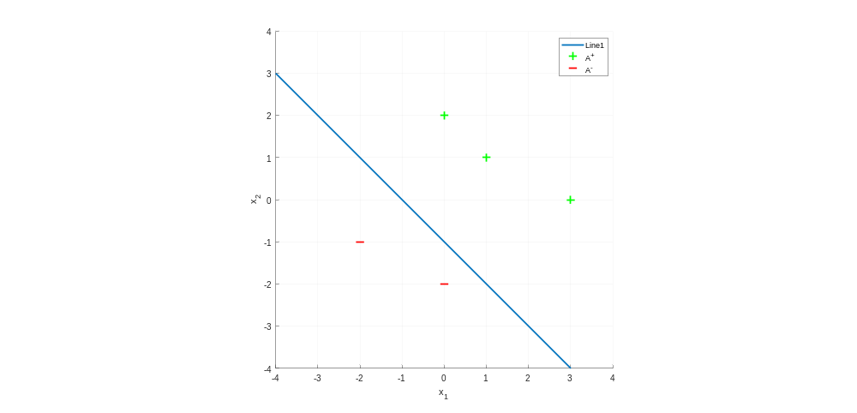
The curve of the resulting line is visible in Picture 2.1:
Picture 2.1. Line classifier with perceptron algorithm

B) Minimum Squared Error (MSE) Method
To find $w$ with the MSE method, we use the following formula:
$$X=\left[\begin{matrix}x^{1} & 1 \\ x^{2} & 1 \\ ⋮ & ⋮ \\ x^{N} & 1\end{matrix}\right], w={\left(x^{T}x\right)}^{-1}x^{T}y$$
By substitution, we have:
$$X=\left[\begin{matrix}1 & 1 & 1 \\ 0 & 2 & 1 \\ 3 & 0 & 1 \\ -2 & -1 & 1 \\ 0 & -2 & 1\end{matrix}\right], y=\left[\begin{matrix}1 \\ 1 \\ 1 \\ -1 \\ -1\end{matrix}\right]$$
$$w={\left(x^{T}x\right)}^{-1}x^{T}y=\left[\begin{matrix}0.3089 \\ 0.5073 \\ 0.0764\end{matrix}\right]$$
$$⇒w^{T}x=\left[0.3089 0.5073 0.0764\right]\left[\begin{matrix}x_{1} \\ x_{2} \\ 1\end{matrix}\right]={0.3089x}_{1}+0.5073x_{2}+0.0764$$

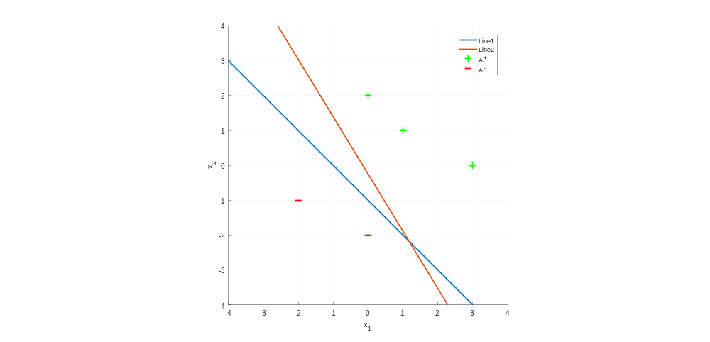
The curve of the resulting line is visible in Picture 2.2:

Picture 2.2. Line classifiers with 1) Perceptron algorithm 2) MSE

C) Fisher's Linear Discriminant (FLD) Method
According to the Fisher method, to find $w$ we have:
$$S_{w}=\sum_{i∈A^{+}}{\left(x_{i}-m_{1}\right)}{\left(x_{i}-m_{1}\right)}^{T}+\sum_{i∈A^{-}}{\left(x_{i}-m_{2}\right){\left(x_{i}-m_{2}\right)}^{T}}$$
$${w'=S}_{w}^{-1}\left(m_{1}-m_{2}\right), b=-\frac{1}{2}{w^{'}}^{T}\left(m_{1}+m_{2}\right), w={\left[w^{'}b\right]}^{T}$$
where $m_{i}$ is the mean corresponding to the $i$th class. Now by substituting the data given in the problem statement, we obtain $w$:
$$m_{1}={\left[\frac{4}{3} 1\right]}^{T}, m_{2}={\left[-1,-\frac{3}{2}\right]}^{T},S_{w}=[\begin{matrix}6.6667 & -4 \\ -4 & 2.5\end{matrix}]$$
$$w^{'}={\left[23.75 39\right]}^{T}, b=5.7917⇒w={\left[23.75 39 5.7917\right]}^{T}$$

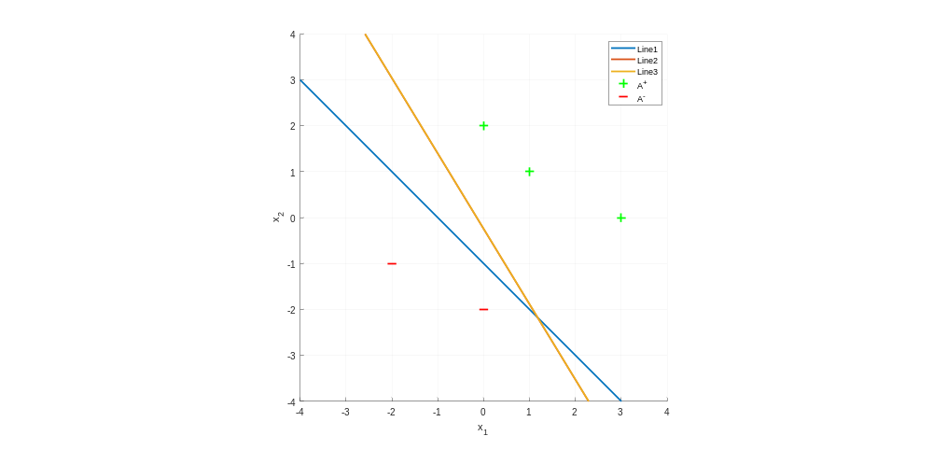
The curve of the resulting line is visible in Picture 2.3:
Picture 2.3 Line classifiers with 1) Perceptron algorithm 2) MSE 3) Fisher

As observed, Line 2 and Line 3 are congruent (overlap), and all 3 lines have successfully achieved complete separation of the classes. However, Line 1 is closer to the negative class and has a smaller margin compared to Line 2 and 3. Therefore, the best line is Line 2 and 3.

