4. Fourth Question

4.1. Exploratory Data Analysis (EDA)
First, we read the dataset provided in the question using read_csv, and display the first five rows of the dataset using the head method:
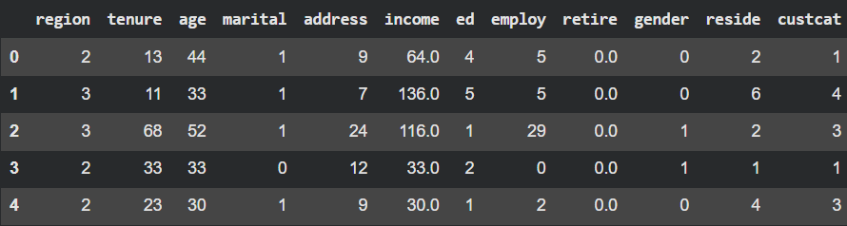
Now, we obtain the overall structure of the data using the info method:
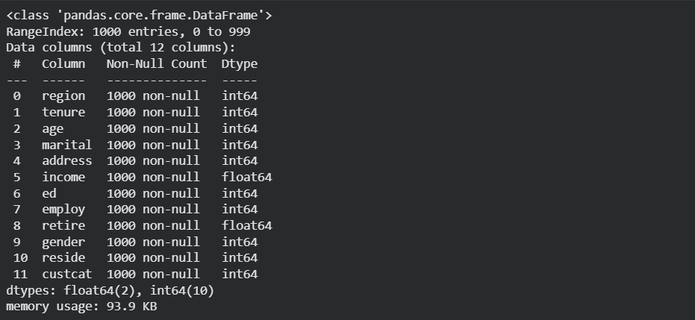
From the output of the info method, we find that since we have 1000 samples in the dataset and 1000 non-null values for each sample, there are no NaN values in the dataset. Also, based on the output of the head and info methods, we find that all features and the output are numerical, and the features tenure, age, address, and income are continuous, while the remaining features are categorical.

Using the describe method, we obtain the statistical summary of the data:
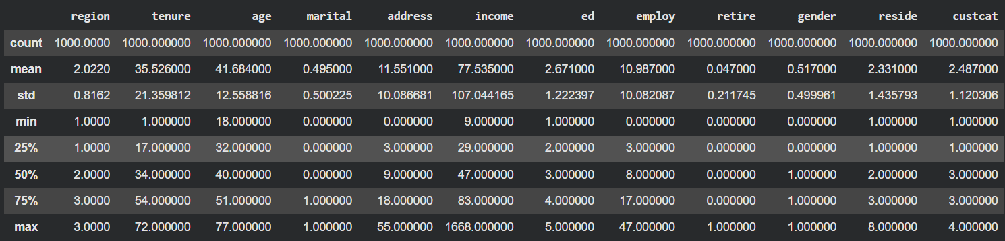
The explanation of each row is as follows:
- Count: The number of available samples for each feature.
- Mean: The average value of each feature.
- Std: The standard deviation of each feature.
- Min: The minimum observed value for each feature.
- 25%: First quartile.
- 50%: Median.
- 75%: Third quartile.
- Max: The maximum observed value for each feature.

Now, we plot the correlation between the data using a Heatmap. This plot can be seen in Picture 4.1.

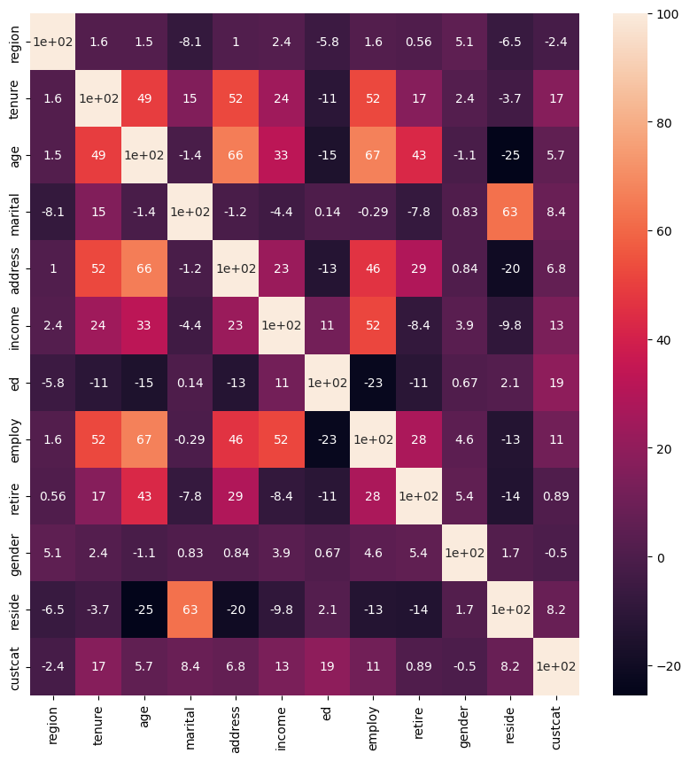
Picture 4.1. Heatmap of correlation of dataset

According to Figure 4.1, the features with the highest correlation with the target variable (custcat) are the ed feature with 19 percent, the tenure feature with 17 percent, the income feature with 13 percent, and the employ feature with 11 percent.
Using the pairplot function, we plot the scatter plot between the mentioned features, considering the classes. This plot can be seen in picture 4.2.
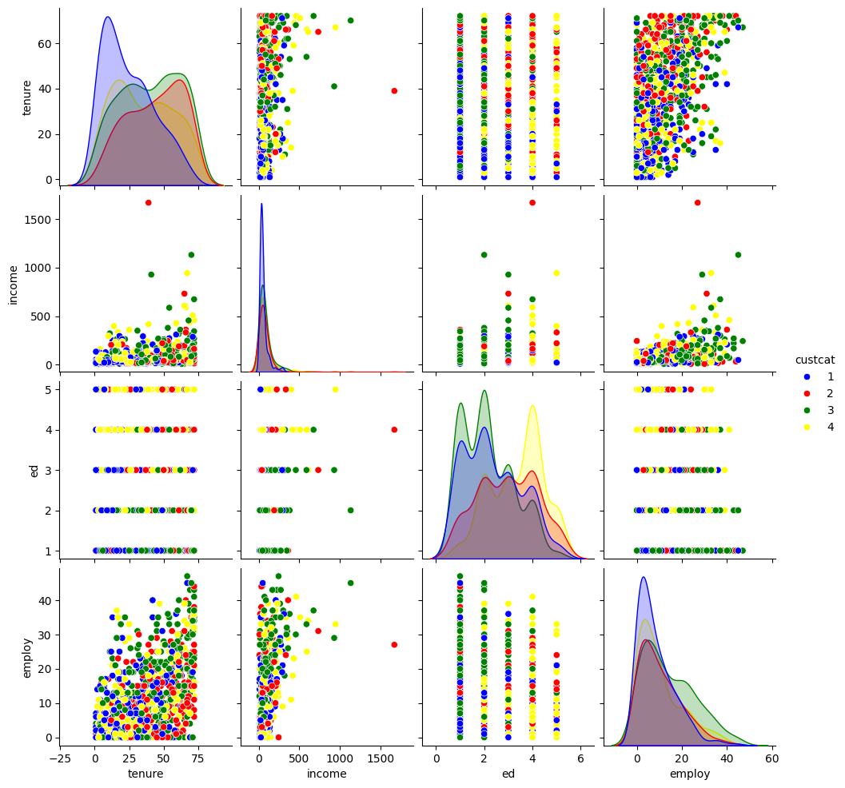
Picture 4.2. Scatter plot for important features

Then, we plot the hexbin chart for the tenure and income features. This plot can be seen in picture 4.3.
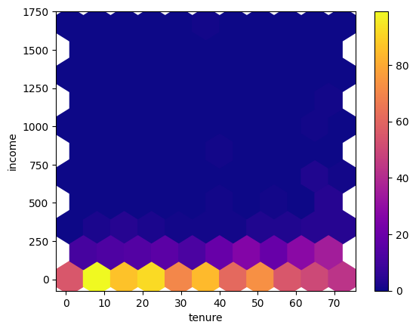
Picture 4.3. Hexbin plot for tenure and income feature
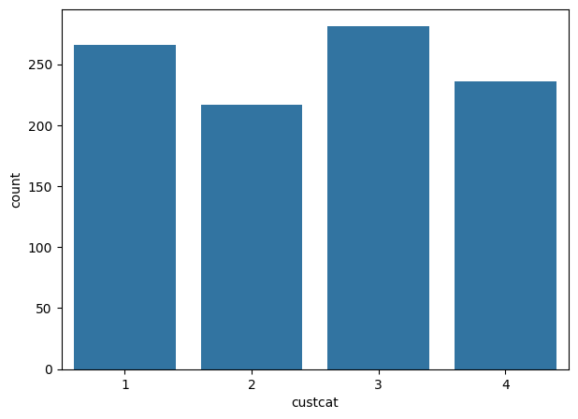
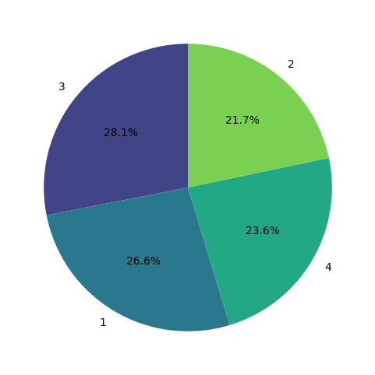
Picture 4.4 shows the class distribution using a countplot and a pie chart.

b)
a)
Picture 4.4. a) countplot b) piechart
The distribution among the classes is well-balanced. The largest share of the data belongs to Class 3 with 28.1 percent, and the smallest share belongs to Class 1 with 21.7 percent, which have a difference of about 7 percent, and this difference is small.

4.2. Data Preprocessing
First, we separate the features from the dataset and store them in the variable X. The target is stored in the variable y. Since the classes in the dataset start from number 1 and we want them to start from number 0 for model training, we subtract one from the output³³.
Then, we perform preprocessing on the categorical data. This preprocessing can be done in two ways:
- Label Encoding: In this method, a unique number is assigned to each category³⁵. This method is suitable for features where there is a logical order among their categories³⁶. If used for unordered categories, the model might suffer from a misleading interpretation of the relationship between categories.
- One-Hot Encoding: In this method, a new column is created for each category, which receives a value of 1 if the sample belongs to that category and 0 otherwise³⁸. This method is suitable for features whose categories lack order³⁹. Although it increases the dimensionality of the data, multicollinearity can be avoided by dropping one of the new columns.
In this dataset, the suitable method for transforming these features is One-Hot Encoding, which we implement using the get_dummies function. Therefore, we implement the One-Hot Encoding method on the region, reside, and ed features, and implement the label encoding method on the other categorical features. Since the dataset itself is numerical, there is no need to use label encoding.
Then, we randomly split the data into training and testing sets.
Standardization and normalization are used so that the numerical features are on the same scale and the models can use them correctly.
- Normalization method for numerical features: Using the following formula, we limit the data range to the interval [0, 1]:
$$\frac{X-X_{min}}{X_{max}-X_{min}}$$
where $X_{min}$and $X_{max}$ are the minimum and maximum values for the training data, respectively.

Standardization: Using the following formula, we transform the data to a distribution with a mean of 0 and a standard deviation of 1:
$$\frac{X-μ}{σ}$$
where $μ$ and $σ$ are the mean and standard deviation of the training data, respectively.
In this dataset, we use standardization.
Feature Selection and Classical Modeling

4.3. Feature selection and classical modeling
For feature selection, we use two methods: Lasso regression and RFE (Recursive Feature Elimination).
- Using Lasso Regression: For this purpose, a Logistic Regression model equipped with the L1 penalty technique is used. The L1 penalty is a powerful mechanism for model regularization. This penalty intelligently drives the coefficients of features that have little effect on the prediction exactly to zero. Thus, by training the model with the dataset, we eliminate features that have zero coefficients. The following output shows us which features were selected by the model:
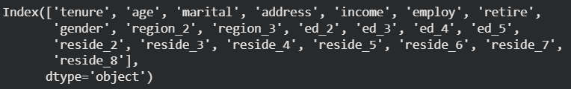
As we can see in the output above, no features were eliminated, and all features were selected.
- Using RFE (Recursive Feature Elimination): RFE is a model-based method that iteratively eliminates features. The operation of this method is as follows:
  - Base Model Training: First, a Logistic Regression model is trained on the entire set of features.
  - Importance Assessment: The importance of each feature (typically based on its coefficient or feature importance score) is evaluated in the trained model.
  - Eliminating Least Important Features: The feature or features with the least importance are eliminated.
  - Iteration: These steps are repeated iteratively until the desired number of features is reached.

The following output shows us which features were selected by the model:
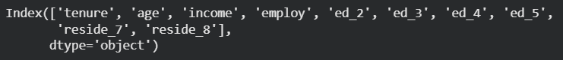
As we can see in the output above, RFE has successfully eliminated several features from the dataset.
Therefore, we use the features selected by RFE to train the Logistic Regression model. After training the training data on the Logistic Regression model, we evaluate the model. The following output shows the model's accuracy for the training and testing data:
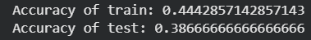
The following output also shows the Confusion Matrix for the training and testing data:
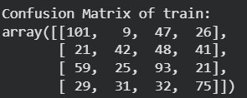
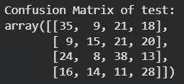

We also plot the ROC curve for the training and testing data separately using the One vs Rest approach. Figure 4.4 shows these plots along with the AUC values.
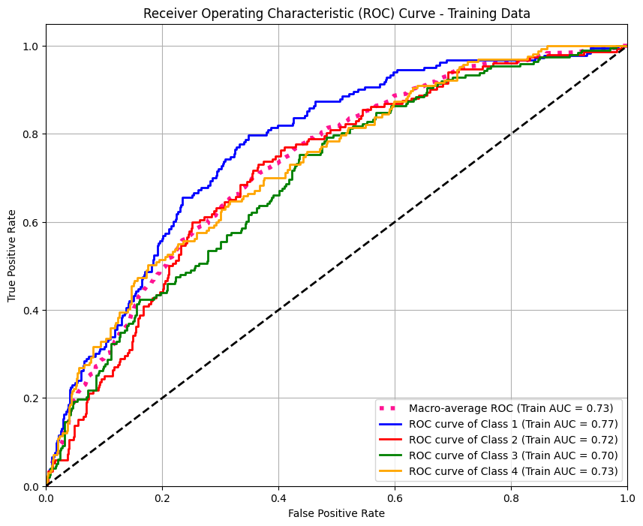
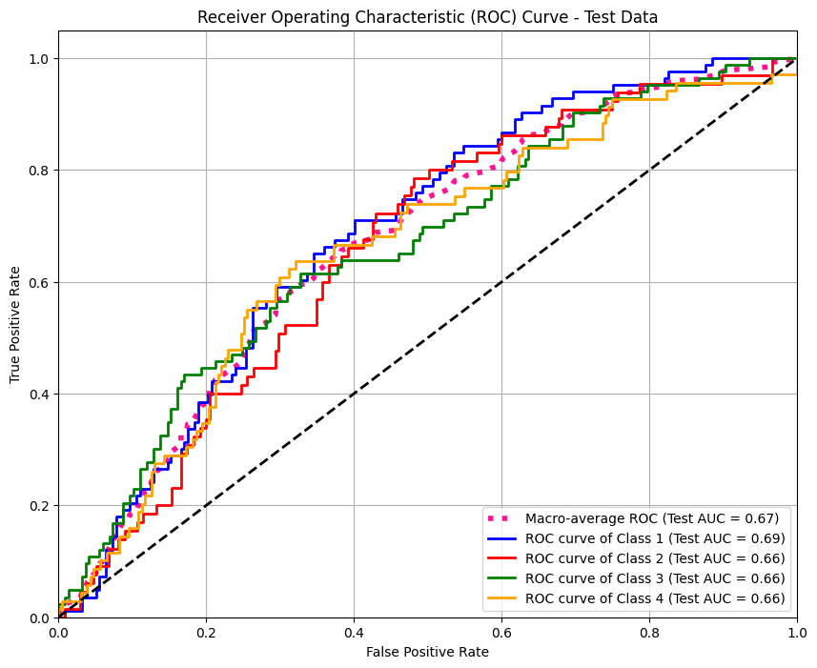
Picture 4.5. ROC curve for the training and testing data
The table below also shows the model coefficients for each class:
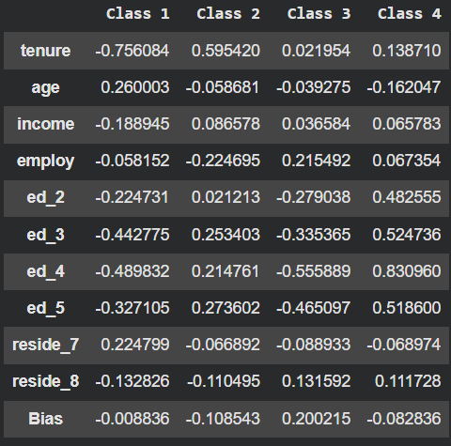
According to the table above, the tenure feature has the most influence on Class 1 and Class 2. If the value of tenure increases, the probability of belonging to Class 1 decreases but the probability of belonging to Class 2 increases. The ed_4 feature also has the most influence on Class 3 and Class 4. If the value of ed_4 increases, the probability of belonging to Class 3 decreases but the probability of belonging to Class 4 increases.

4.4. Feature Visualization using Dimensionality Reduction
In this section, we train each model with the training data so that it reduces the features to two dimensions. Then, by feeding the training and testing samples to the model and receiving the output, we show their scatter plot.
- To train PCA, it is sufficient to only provide the features to the model.
- However, since LDA learns in a supervised manner, the target data must also be provided to the model in addition to the features.

Picture 4.5 shows the plot of the mapped features by PCA and LDA.
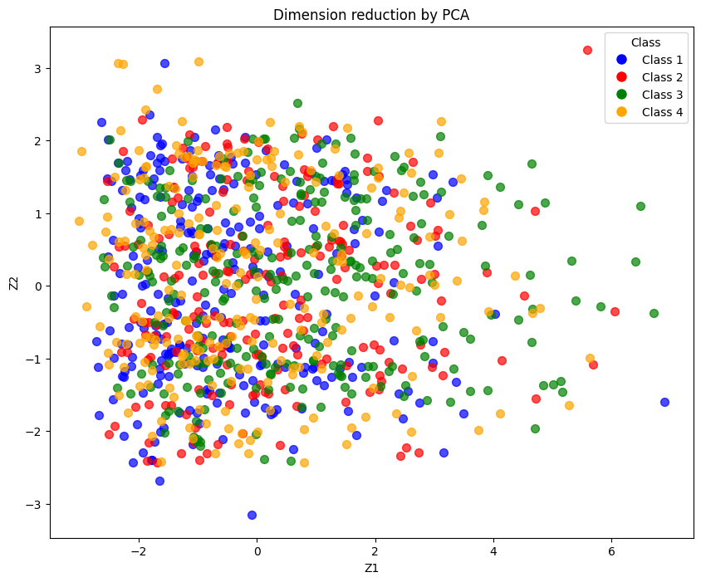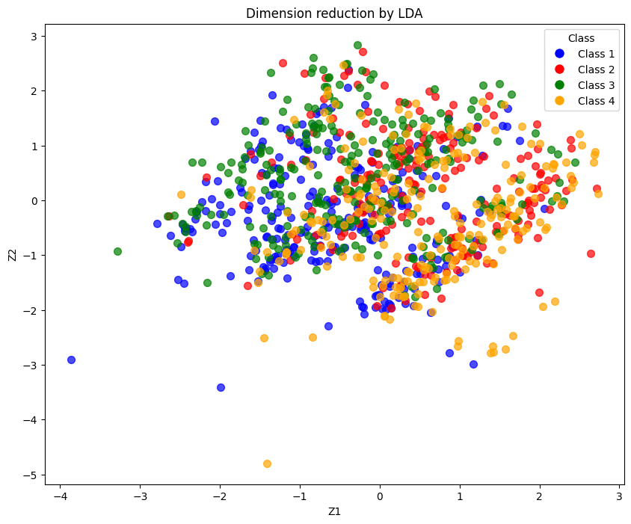
Picture 4.5. Dimension reduction with PCA and LDA
For the MLP (Multi-Layer Perceptron) neural network, we used the following architecture:
21(input dimension) $→$ 128 (relu) $→$ 64(relu) $→$ 32(relu) $→$ 2(Number of Features) $→$ 4(Number of classes)
This neural network is designed to be supervised. This means that the target must also be provided to the model in addition to the features.

Picture 4.7 shows the plot of the mapped features by MLP.
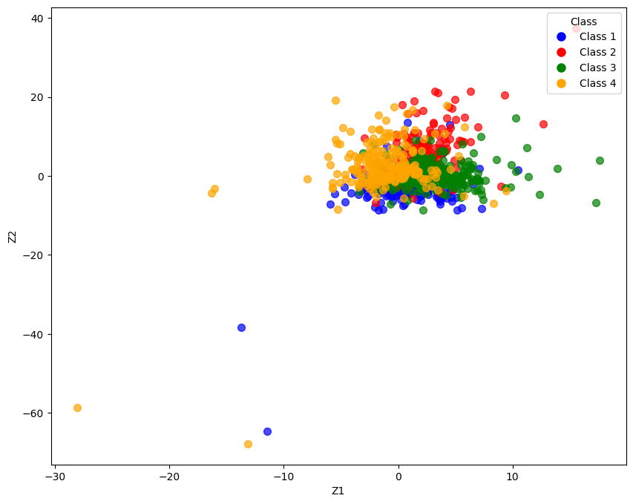
Picture 4.6. Dimension reduction with PCA and LDA

The PCA and LDA models could not perform the separation. This is because the features lack linear separability. However, since MLP applies a nonlinear mapping to the data, unlike the other two models, it has almost succeeded in performing the separation.

