Pumpkins Coding Challenge Report (Python)

Mohammad Parsa Faraji
Student ID: 20805029
Allocated Dataset: pumpkins_14.csv

What I was asked to do

For this coding challenge I worked with the pumpkin dataset (pumpkins_14.csv). My goal was to:
- load and check the data,
- find the heaviest pumpkin and report its details,
- create new columns (weight_kg and weight_class),
- filter the dataset to three chosen countries,
- save the filtered dataset and a summary table,
- create three plots to include in the report.

Methods

Loading the dataset:
I loaded the file using pandas.read_csv() and printed the column names to make sure the dataset contained the columns I needed (especially weight_lbs, est_weight, country, city, and variety).

Finding the heaviest pumpkin:
To find the heaviest pumpkin, I calculated the maximum of the weight_lbs column and then selected the row(s) that matched that maximum. I then took the first row (in case of ties) and extracted the variety and location (city and country).

Heaviest pumpkin (from my output):
- Weight: 2813.3105 lbs
- Variety: Casper
- Location: Semproniano, Italy

Converting pounds to kilograms:
I created a new column called weight_kg by converting pounds to kilograms using:
\text{weight\_kg} = \text{weight\_lbs} \times 0.453592
I printed the first few rows of weight_lbs and weight_kg to confirm the calculation worked.

Creating weight classes (light/medium/heavy):
I then created a new column called weight_class. I did this by looping through each value in weight_kg and assigning:
- light if kg < 200
- medium if 200 ≤ kg < 400
- heavy if kg ≥ 400
I printed a few rows of weight_kg and weight_class to check the labels were being added correctly.

Filtering to three countries:
I printed the country counts in the dataset and then chose three countries:
- Spain
- Portugal
- Poland
I filtered the dataset to keep only those three countries and saved the result as pumpkins_filtered.csv.

From my output, the filtered dataset contains:
- Spain = 165 rows
- Portugal = 109 rows
- Poland = 46 rows
Total = 320 rows

Summary table (mean weight by country and variety):
Using the filtered dataset, I calculated mean pumpkin weight (kg) grouped by both country and variety:
- df_filtered.groupby(["country","variety"])["weight_kg"].mean()
I printed the summary table and saved it to pumpkins_summary.csv for use in the report.

3. Plots (results)
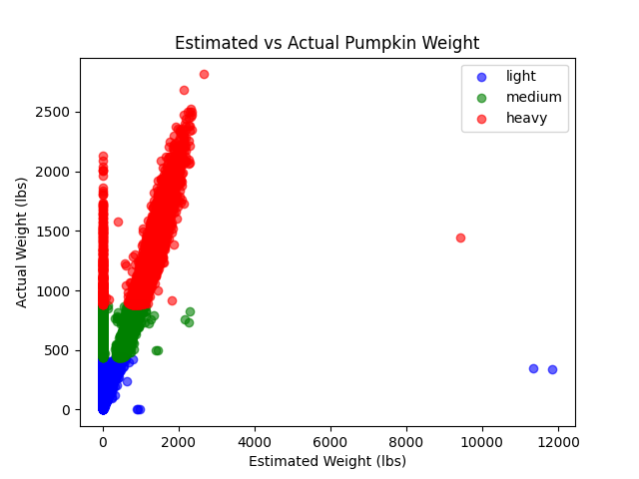
Figure 1.Estimated vs Actual Pumpkin Weight (scatter plot)
This plot compares estimated weight (est_weight, lbs) against actual measured weight (weight_lbs, lbs), coloured by weight class. Overall, there is a clear positive relationship: when estimated weight increases, actual weight usually increases too. However, there are some strong outliers where the estimated weight is extremely high compared to the actual weight, suggesting some estimates may not be accurate for every record.
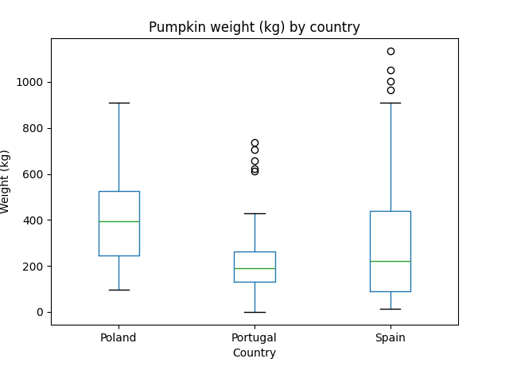
Figure 2.Pumpkin weight (kg) by country (boxplot)
This boxplot compares the distribution of pumpkin weights (kg) across Spain, Portugal, and Poland. The medians and spreads are different between countries. Spain shows several very high outliers (very heavy pumpkins), while Portugal appears to have lower typical weights in this subset. Poland’s distribution is between the two, although Poland has fewer records than the other two countries.

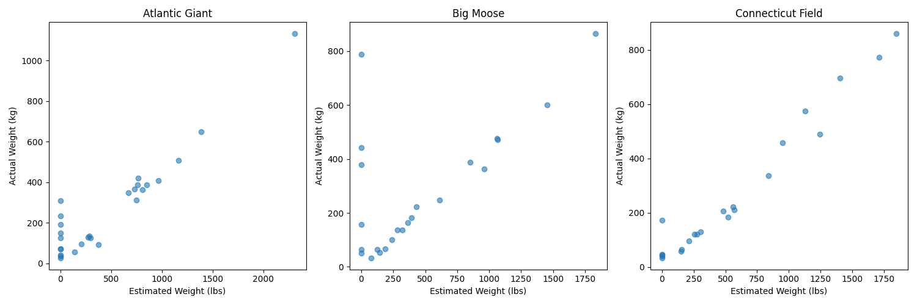
Figure 3.Faceted plots for top 3 varieties (scatter plots)
This figure shows estimated vs actual weight for the top three most common varieties in my filtered dataset (Atlantic Giant, Big Moose, Connecticut Field). All three plots still show a positive relationship between estimated and actual weight. One limitation is that the x-axis is estimated weight in lbs while the y-axis is actual weight in kg, so the units are different. Even so, the trend is still clear.

4. Files I produced
Running my script creates:
- pumpkins_filtered.csv (filtered dataset for Spain/Portugal/Poland)
- pumpkins_summary.csv (mean weight in kg by country and variety)
- plot_est_vs_actual.png
- boxplot_weight_by_country.png
- faceted_plot_variety.png

5. How to run my code
- Install packages:
pip install -r requirements.txt
- Run the script:
python3 script.py

Conclusion

In this challenge I successfully extracted the heaviest pumpkin record, converted weights into kilograms, classified pumpkins by weight class, filtered the dataset to three countries, and produced a summary table and three plots. The plots show that estimated weight generally increases with actual weight, but there are some clear outliers. The country boxplot suggests differences in the weight distributions across Spain, Portugal, and Poland, and the variety plots show similar estimated–actual trends across the most common varieties.

