PDS_PBL_PROJECT
Topic: Restaurant Billing System
Code:
import pandas as pd
import matplotlib.pyplot as plt

# ==========================================
# RESTAURANT BILLING SYSTEM - DATA ANALYSIS
# ==========================================

# Load dataset
df = pd.read_csv("tips.csv")

print("========================================")
print(" RESTAURANT BILLING SYSTEM")
print(" DATA ANALYSIS")
print("========================================")

# ------------------------------------------
# BASIC DATA ANALYSIS
# ------------------------------------------

print("\n1. DATASET INFORMATION")
print("-----------------------")
print("Number of Rows:", df.shape[0])
print("Number of Columns:", df.shape[1])
print("Columns:", list(df.columns))

print("\nMissing Values:")
print(df.isnull().sum())

print("\nStatistical Summary:")
print(df.describe())

# ==========================================
# MODULE 1: BILL ANALYSIS + BAR GRAPH
# ==========================================

print("\n\nMODULE 1: BILL ANALYSIS")
print("-----------------------")

print("Total Bill Sum:", round(df["total_bill"].sum(), 2))
print("Average Bill:", round(df["total_bill"].mean(), 2))
print("Maximum Bill:", round(df["total_bill"].max(), 2))
print("Minimum Bill:", round(df["total_bill"].min(), 2))

print("\nAverage Bill by Day:")
print(df.groupby("day")["total_bill"].mean().round(2))

plt.figure(figsize=(7,5))
df.groupby("day")["total_bill"].mean().plot(kind="bar")
plt.title("Average Bill by Day")
plt.xlabel("Day")
plt.ylabel("Average Bill")
plt.tight_layout()
plt.show()

# ==========================================
# MODULE 2: CUSTOMER ANALYSIS + BAR GRAPH
# ==========================================

print("\n\nMODULE 2: CUSTOMER ANALYSIS")
print("---------------------------")

print("Total Customers:", len(df))

print("\nCustomers by Day:")
print(df["day"].value_counts())

print("\nAverage Group Size:",
round(df["size"].mean(), 2))

print("\nMaximum Group Size:",
df["size"].max())

plt.figure(figsize=(7,5))
df["day"].value_counts().plot(kind="bar")
plt.title("Number of Customers by Day")
plt.xlabel("Day")
plt.ylabel("Number of Customers")
plt.tight_layout()
plt.show()

# ==========================================
# MODULE 3: TIP ANALYSIS + BAR GRAPH
# ==========================================

print("\n\nMODULE 3: TIP ANALYSIS")
print("----------------------")

print("Total Tip:", round(df["tip"].sum(), 2))
print("Average Tip:", round(df["tip"].mean(), 2))
print("Maximum Tip:", round(df["tip"].max(), 2))
print("Minimum Tip:", round(df["tip"].min(), 2))

print("\nAverage Tip by Day:")
print(df.groupby("day")["tip"].mean().round(2))

plt.figure(figsize=(7,5))
df.groupby("day")["tip"].mean().plot(kind="bar")
plt.title("Average Tip by Day")
plt.xlabel("Day")
plt.ylabel("Average Tip")
plt.tight_layout()
plt.show()

# ==========================================
# MODULE 4: TIME ANALYSIS + PIE GRAPH
# ==========================================

print("\n\nMODULE 4: TIME ANALYSIS")
print("-----------------------")

print("Lunch Customers:",
(df["time"] == "Lunch").sum())

print("Dinner Customers:",
(df["time"] == "Dinner").sum())

print("\nAverage Bill by Time:")
print(df.groupby("time")["total_bill"].mean().round(2))

plt.figure(figsize=(7,5))
df["time"].value_counts().plot(
kind="pie",
autopct="%1.1f%%"
)
plt.title("Lunch vs Dinner")
plt.ylabel("")
plt.show()

# ==========================================
# MODULE 5: GENDER ANALYSIS + PIE GRAPH
# ==========================================

print("\n\nMODULE 5: GENDER ANALYSIS")
print("-------------------------")

print("Customers by Gender:")
print(df["sex"].value_counts())

print("\nAverage Bill by Gender:")
print(df.groupby("sex")["total_bill"].mean().round(2))

plt.figure(figsize=(7,5))
df["sex"].value_counts().plot(
kind="pie",
autopct="%1.1f%%"
)
plt.title("Customers by Gender")
plt.ylabel("")
plt.show()

# ==========================================
# MODULE 6: BILL-TIP RELATIONSHIP
# + SCATTER GRAPH
# ==========================================

print("\n\nMODULE 6: BILL AND TIP RELATIONSHIP")
print("-----------------------------------")

correlation = df["total_bill"].corr(df["tip"])

print("Correlation between Total Bill and Tip:",
round(correlation, 3))

print("\nHighest Bill:")
print(df.loc[df["total_bill"].idxmax()])

print("\nHighest Tip:")
print(df.loc[df["tip"].idxmax()])

plt.figure(figsize=(7,5))
plt.scatter(df["total_bill"], df["tip"])
plt.title("Total Bill vs Tip")
plt.xlabel("Total Bill")
plt.ylabel("Tip")
plt.tight_layout()
plt.show()

# ==========================================
# FINAL ANALYSIS
# ==========================================

print("\n\n========================================")
print(" FINAL ANALYSIS")
print("========================================")

print("Total Revenue/Bill Amount:",
round(df["total_bill"].sum(), 2))

print("Average Bill:",
round(df["total_bill"].mean(), 2))

print("Total Tip:",
round(df["tip"].sum(), 2))

print("Average Tip:",
round(df["tip"].mean(), 2))

print("Most Frequent Day:",
df["day"].mode()[0])

print("Most Common Time:",
df["time"].mode()[0])

print("Most Common Group Size:",
df["size"].mode()[0])

print("\nData Analysis Completed Successfully!")

Output:
========================================
RESTAURANT BILLING SYSTEM
DATA ANALYSIS
========================================

1. DATASET INFORMATION
-----------------------
Number of Rows: 244
Number of Columns: 7
Columns: ['total_bill', 'tip', 'sex', 'smoker', 'day', 'time', 'size']

Missing Values:
total_bill 0
tip 0
sex 0
smoker 0
day 0
time 0
size 0
dtype: int64

Statistical Summary:
total_bill tip size
count 244.000000 244.000000 244.000000
mean 19.785943 2.998279 2.569672
std 8.902412 1.383638 0.951100
min 3.070000 1.000000 1.000000
25% 13.347500 2.000000 2.000000
50% 17.795000 2.900000 2.000000
75% 24.127500 3.562500 3.000000
max 50.810000 10.000000 6.000000

MODULE 1: BILL ANALYSIS
-----------------------
Total Bill Sum: 4827.77
Average Bill: 19.79
Maximum Bill: 50.81
Minimum Bill: 3.07

Average Bill by Day:
day
Fri 17.15
Sat 20.44
Sun 21.41
Thur 17.68
Name: total_bill, dtype: float64
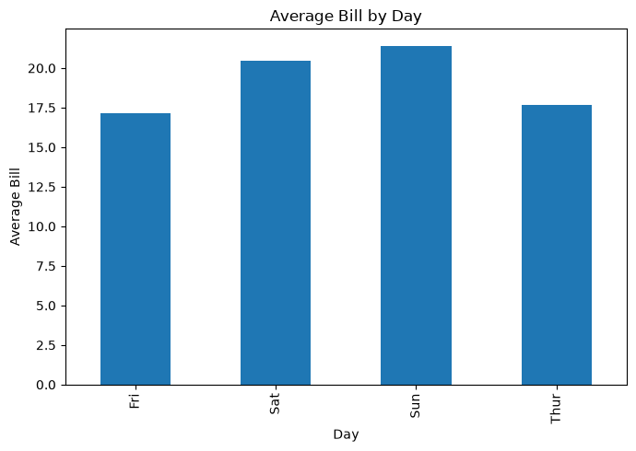

MODULE 2: CUSTOMER ANALYSIS
---------------------------
Total Customers: 244

Customers by Day:
day
Sat 87
Sun 76
Thur 62
Fri 19
Name: count, dtype: int64

Average Group Size: 2.57

Maximum Group Size: 6
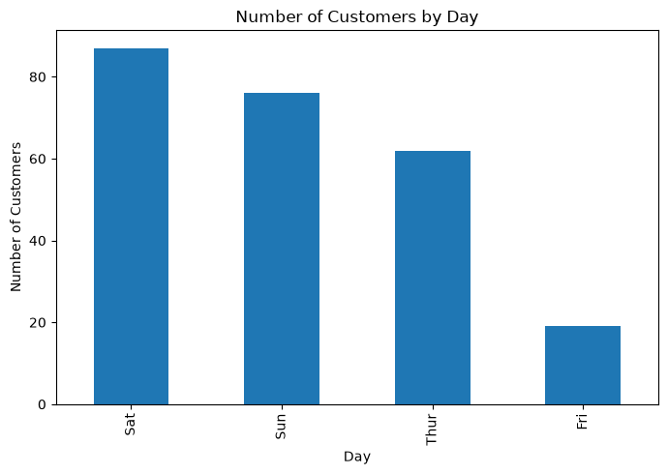

MODULE 3: TIP ANALYSIS
----------------------
Total Tip: 731.58
Average Tip: 3.0
Maximum Tip: 10.0
Minimum Tip: 1.0

Average Tip by Day:
day
Fri 2.73
Sat 2.99
Sun 3.26
Thur 2.77
Name: tip, dtype: float64
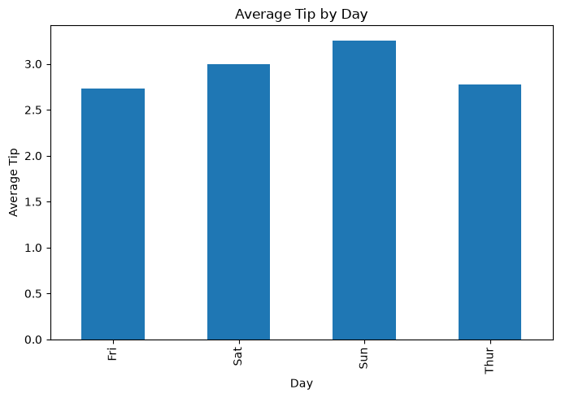

MODULE 4: TIME ANALYSIS
-----------------------
Lunch Customers: 68
Dinner Customers: 176

Average Bill by Time:
time
Dinner 20.80
Lunch 17.17
Name: total_bill, dtype: float64
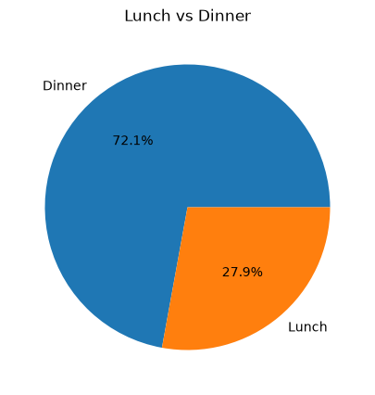

MODULE 5: GENDER ANALYSIS
-------------------------
Customers by Gender:
sex
Male 157
Female 87
Name: count, dtype: int64

Average Bill by Gender:
sex
Female 18.06
Male 20.74
Name: total_bill, dtype: float64
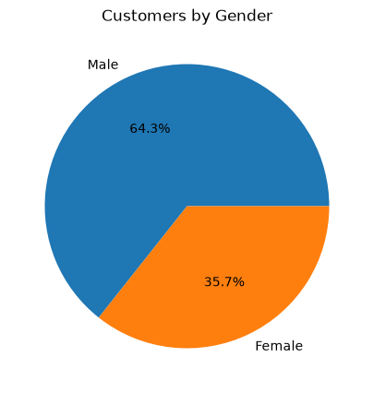

MODULE 6: BILL AND TIP RELATIONSHIP
-----------------------------------
Correlation between Total Bill and Tip: 0.676

Highest Bill:
total_bill 50.81
tip 10.0
sex Male
smoker Yes
day Sat
time Dinner
size 3
Name: 170, dtype: object

Highest Tip:
total_bill 50.81
tip 10.0
sex Male
smoker Yes
day Sat
time Dinner
size 3
Name: 170, dtype: object
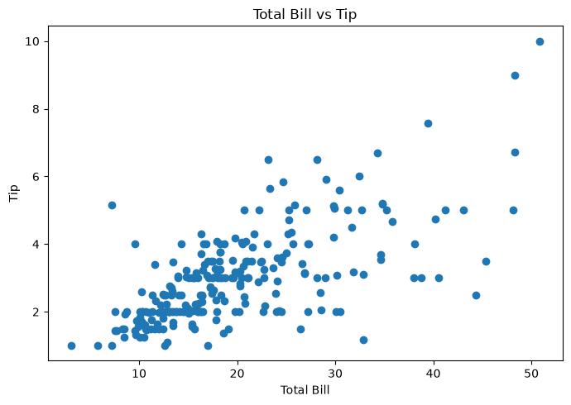

========================================
FINAL ANALYSIS
========================================
Total Revenue/Bill Amount: 4827.77
Average Bill: 19.79
Total Tip: 731.58
Average Tip: 3.0
Most Frequent Day: Sat
Most Common Time: Dinner
Most Common Group Size: 2

Data Analysis Completed Successfully!

