|  |  |
| --- | --- |
|  | **DAV SCHOOL PALLIKARANI**  2023-2024 |

**ENGLISH PORTFOLIO**

**TEMPLES IN WEST BENGAL**

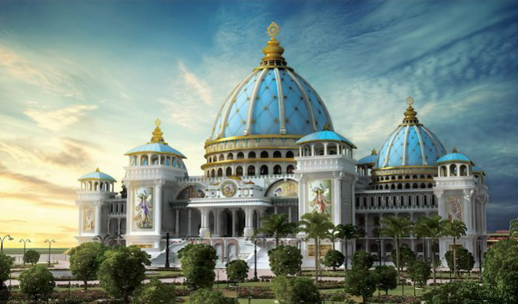

**P MIRUTHULA**

**IX – D**

**KALIGHAT TEMPLE**

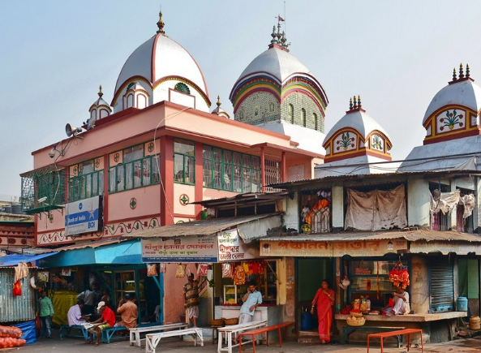

**GHOOM MONASTERY**

