Predicting EPC Energy Ratings for Oxford's Domestic Stock
A leakage-aware ordinal-classification pipeline with SHAP-driven retrofit recommendations
COM6003 Data Science • Buckinghamshire New University • 2025–26

Abstract
This report develops a leakage-aware ordinal classifier for Energy Performance Certificate (EPC) ratings (A–G) for domestic dwellings in Oxford local authority (E07000178). After group-aware deduplication, 49,442 unique dwellings remain. The champion is a hybrid regression-to-band model (SapStratifiedRegressor) that fits a HistGradientBoostingRegressor on the continuous SAP score and maps predictions to bands via the official DLUHC thresholds, with a SAP-cohort specialist layered on REPORT_TYPE 101 rows. On a strict temporal hold-out (n=12,095), it achieves Quadratic Weighted Kappa = 0.7696 (bootstrap 95% CI [0.7600, 0.7780]) and places 97.7% of SAP-score predictions within 15 points — in line with the ONS Data Science Campus (2021) indicative figure of 93%. Permutation importance and SHAP converge on windows, construction age, main fuel, and main heating as the dominant drivers, with wall construction the largest categorical lever. Findings translate into prioritised retrofit recommendations and a per-UPRN prediction file.

1. Introduction and Dataset Acquisition
The UK is legally committed to net-zero by 2050 (HM Government, 2021); domestic buildings account for ~17% of emissions, dominated by space and water heating (Climate Change Committee, 2023). Energy Performance Certificates (EPCs) are the principal evidence base for retrofit policy, recording modelled efficiency for every dwelling sold, let, or built. The Energy Performance of Buildings Register (DLUHC, 2022) publishes them as open data under the Open Government Licence v3.0, with address fields under a restricted licence.
This study targets Oxford local authority (ONS code E07000178), whose stock skews unusually old — the 2021 Census records 30.4% of dwellings built before 1900 (ONS, 2023a), almost double the England-wide share — against aggressive retrofit ambitions (Oxford City Council, 2023). The question is concrete: can the EPC band be predicted from physical characteristics alone, and which features are the largest levers?
Each EPC is produced by a qualified assessor using the Reduced data Standard Assessment Procedure (RdSAP) for existing dwellings or full SAP for new builds (BRE, 2014), combining measured inputs with substantial defaults; Few et al. (2023) document ~five-point inter-assessor variability and Hardy and Glew (2019) systemic database errors. The methodology has been revised (SAP 10, 2022), so certificates from different years are not strictly comparable, and lodgement-event selection bias under-represents long-tenure owner-occupied homes (Crawley et al., 2019). We use a temporal split to mitigate drift and document the lodgement bias.

2. Feature Engineering
Feature engineering operationalises domain knowledge of building physics; nineteen features were added. Numerical: CONSTRUCTION_AGE_NUM (the midpoint year of the banded age, e.g. '1930-1949' to 1939) makes the age effect monotonic; LOG_FLOOR_AREA stabilises the skewed area distribution; AREA_PER_ROOM and HEATED_ROOM_RATIO capture occupancy intensity; LOFT_INSULATION_MM extracts loft depth; and FLOOR_LEVEL_NUM canonicalises the messy flats-only FLOOR_LEVEL field ('Ground', '00', '1st', 'Basement') onto one signed-integer storey scale (ground = 0, basement = -1). Nine Boolean flags are regex-extracted from the description fields - solid-brick-bare and cavity-insulated walls, no-loft and 270 mm-loft insulation, gas/electric/heat-pump heating, single/triple glazing. Date parts capture methodology drift; POSTCODE_DISTRICT (outward code only) is a coarse non-personal geographic feature, the full postcode dropped for GDPR data-minimisation.
Each feature has a hypothesised sign testable in Section 3.3 and 3.4. The heat-pump flag is deliberately ambiguous: heat pumps deliver high seasonal-COP efficiency, but SAP is fuel-cost-based and grid electricity costs roughly three times more per kWh than mains gas (Ofgem, 2024) — the model can therefore surface this counter-intuitive interaction.

3. Analysis
The analysis follows the descriptive → diagnostic → predictive progression: Section 3.3 tests three building-physics hypotheses; Section 3.4 fits and evaluates the predictive champion against published baselines under leakage-controlled cross-validation (CV) and a temporal hold-out.

3.1 Data Wrangling
The raw certificates.csv file contains 76,430 rows and 93 columns for Oxford. Loading applies explicit dtype hints and normalises the register's 'no data' sentinel tokens (NODATA!, NO DATA!, INVALID!) to NaN, so they neither pollute the categorical encoders nor escape the missingness indicators. The flats-only FLOOR_LEVEL field, recorded in incompatible formats ('00', '5th', 'ground', 'Basement'), is canonicalised to a signed-integer storey (FLOOR_LEVEL_NUM) rather than discarded; unrecognised values become NaN with an explicit missingness indicator.
Five cleaning operations are applied as pure functions for reproducibility. (i) Filter to LOCAL_AUTHORITY == 'E07000178'. (ii) Coerce numeric columns and normalise sentinel tokens; non-coercible strings and 'no data' tokens become NaN. (iii) Deduplicate to one EPC per Unique Property Reference Number (UPRN), most-recent with completeness tie-breaks — a random split of an un-deduplicated frame would leak the same property into train and test. (iv) Cap TOTAL_FLOOR_AREA at the 99.5th percentile, drop rows below 10 m², set impossible zero rooms/area to NaN, and flag negative net consumption as HAS_ONSITE_GENERATION (solar PV). (v) Remove rows with missing or non-A-G targets. The cleaned frame (49,442 certificates) is saved to data/processed/oxford_epc_clean.csv with PII and redundant administrative columns dropped per GDPR Article 5.
Missingness is informative rather than random: FLAT_STOREY_COUNT and HEAT_LOSS_CORRIDOR are structurally NaN for houses; UNHEATED_CORRIDOR_LENGTH is NaN unless an unheated corridor exists. Rather than drop these moderately-incomplete columns, each field above 5% missingness gains a binary <COL>_IS_MISSING indicator so the tree can learn the structural meaning; only columns ≥99.9% empty are dropped. The gradient-booster consumes the remaining NaNs natively; the linear and forest baselines median-impute within the training fold only.
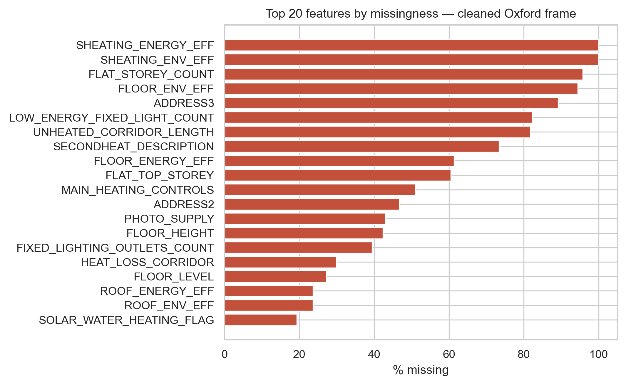
Figure 1. Top 20 features by missingness in the cleaned Oxford frame. Structural NaN dominates: flat-only fields are absent for houses by design.

3.2 Descriptive Analytics — what has occurred?
The current rating distribution (Figure 2) is dominated by bands C and D, which together account for the substantial majority of Oxford's lodged stock. The B and A tail is thin; the F and G tail is also thin but non-trivial, concentrated in pre-1900 conversions and listed buildings. The class imbalance is the principal modelling challenge: a naive accuracy-optimised classifier collapses to predicting D for everything. We therefore use class-balanced training and report Quadratic Weighted Kappa (QWK) as the headline metric; QWK penalises distant misclassifications more than nearby ones, which is the appropriate inductive bias for an ordinal target.
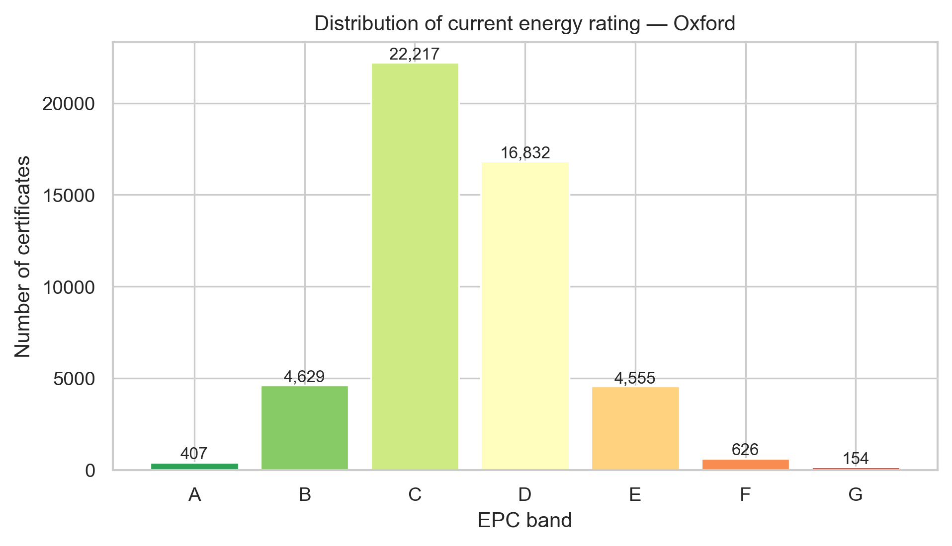
Figure 2. Distribution of CURRENT_ENERGY_RATING across the cleaned Oxford frame. Bands C and D dominate; bands A and G are sparsely populated.
Lodgement volume by inspection year (Figure 3) shows a 2008-onwards growth driven by the expansion of EPC requirements, a clear COVID-19 dip in 2020, and a 2022-23 spike coincident with energy-price-shock-driven sales activity. This pattern motivates the temporal split: methodology and stock characteristics observable in 2010 are not the same as in 2024, and a temporal hold-out gives a more honest estimate of generalisation.
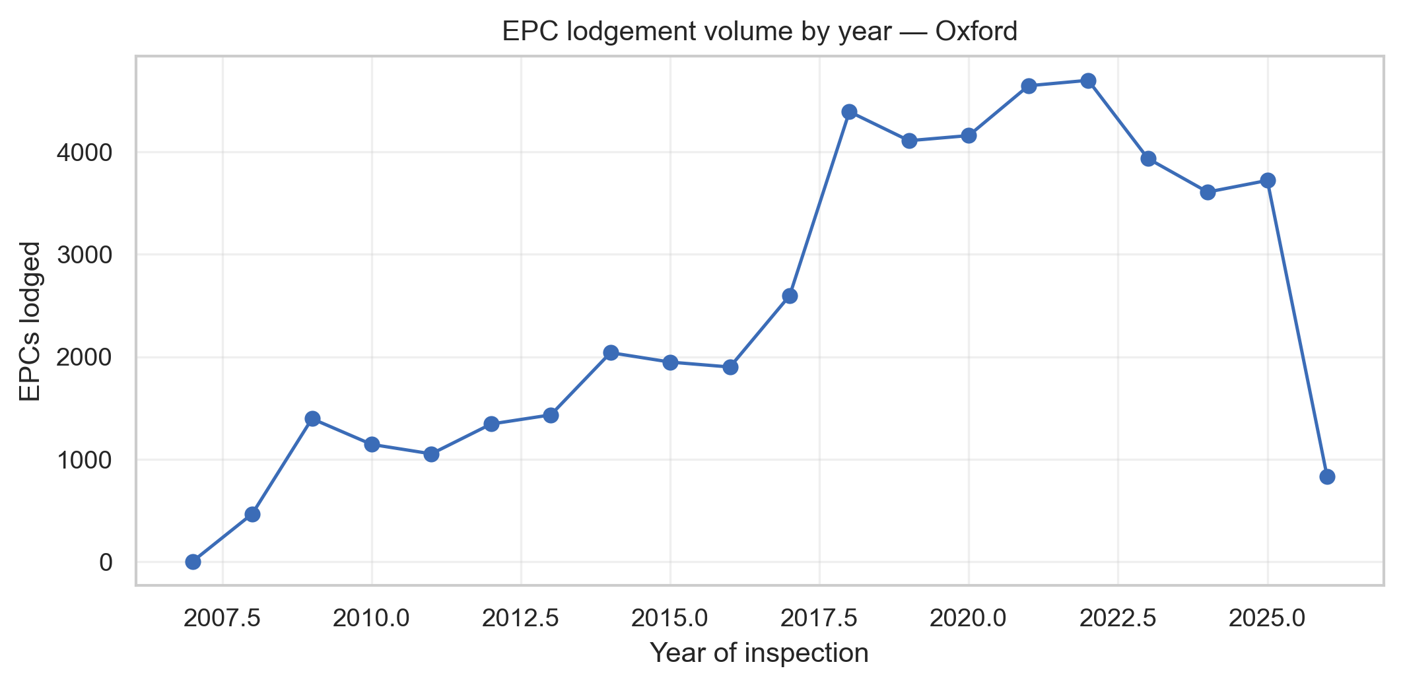
Figure 3. EPC lodgements by inspection year. Notable features include the 2020 COVID-19 dip and the 2022-23 spike during the energy price shock.
Property type cross-tabulated with built form (Figure 4) confirms Oxford's distinctive stock profile: terraces and semi-detached houses dominate, with a substantial share of purpose-built and converted flats reflecting the city's student and young-professional rental market. Detached dwellings are comparatively rare. Summary statistics for the key numeric features are tabulated in reports/summary_stats.csv; the median dwelling has approximately the floor area and habitable-room count expected of an inner-city house.
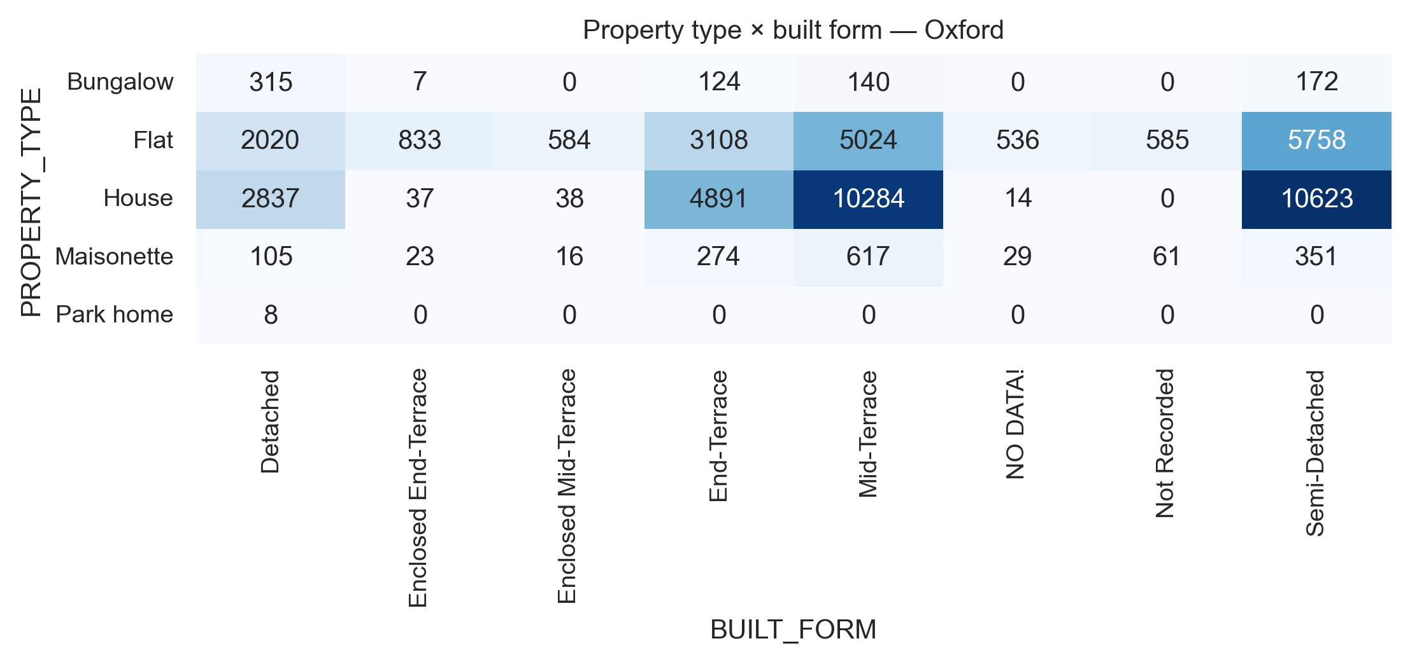
Figure 4. Joint distribution of property type and built form for cleaned Oxford certificates.
Property type strongly discriminates efficiency: flats average the highest SAP (72.0, band C) — shared walls cut heat loss — ahead of maisonettes (67.2) and houses (65.4, band D); the eight park homes are worst (49.0, E). Within each type, mean SAP rises monotonically across construction eras (~25 points from pre-1900 to post-2007), tracking Building Regulations; per-type and era-trend charts are in notebook §3.2. The champion performs consistently across types (hold-out QWK: House 0.78, Maisonette 0.78, Bungalow 0.736, Flat 0.714).
Table 1. Mean SAP score by property type and construction era.
Construction era | Flat | House | Bungalow | Maisonette
pre-1900 | 61.0 | 58.1 | 44.7 | 57.7
1900-29 | 62.9 | 59.6 | 56.4 | 60.3
1930-49 | 65.9 | 62.1 | 56.1 | 65.7
1950-66 | 68.6 | 65.7 | 63.9 | 68.5
1967-82 | 69.1 | 66.7 | 63.0 | 66.5
1983-95 | 72.0 | 69.4 | 66.7 | 71.0
1996-06 | 75.7 | 72.4 | 68.7 | 74.0
2007+ | 80.1 | 84.3 | 79.1 | 76.9

3.3 Diagnostic Analytics — why did this happen?
Three hypotheses motivate the diagnostic battery. H1: older dwellings have systematically worse ratings, driven by uninsulated solid-wall construction and poorer airtightness. H2: wall construction is the single largest physical lever within Oxford's stock. H3: glazing type and the proportion of multi-glazed area correlate with the rating, but more weakly than wall construction.
Spearman correlation is used because the rating is ordinal and the SAP score bounded; Pearson would understate monotonic-but-non-linear links. The age-band effect is monotonic and strong: Spearman ρ between CONSTRUCTION_AGE_NUM and SAP score is 0.618 (p < 1e-50), supporting H1. The stacked composition by age band (Figure 5) shows the F and G tail concentrated in pre-1929 stock and the B and C heads in post-1996 builds, a stepwise improvement reflecting four decades of Building Regulations Part L revisions.
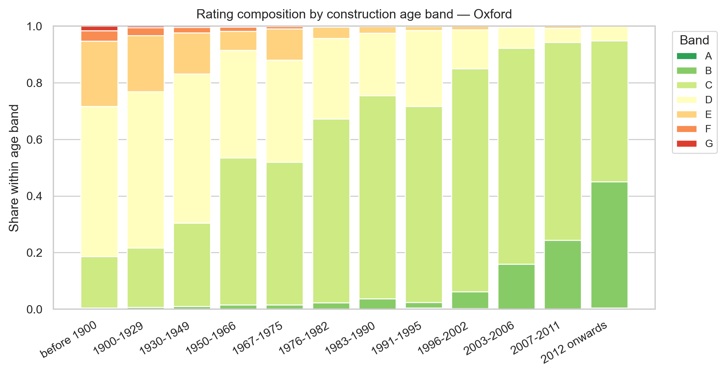
Figure 5. Rating composition by construction age band. The systematic improvement from older to newer cohorts reflects four decades of progressive Building Regulations Part L revisions.
For the categorical-categorical relationships with the rating, we use Cramér's V, a chi-square-derived statistic bounded in [0, 1] that controls for table size. The Oxford-relevant ordering is informative: WALLS_DESCRIPTION attains V = 0.407, CONSTRUCTION_AGE_BAND attains V = 0.366, MAIN_FUEL attains V = 0.318, and BUILT_FORM attains V = 0.091. Walls dominate, supporting H2. The boxplot of SAP score by wall construction (Figure 6) makes the magnitude visible: the median gap between solid-brick uninsulated walls and cavity-walls-with-insulation is on the order of ten SAP points, larger than the within-group interquartile range — i.e. wall construction explains more variance than any other single physical feature.
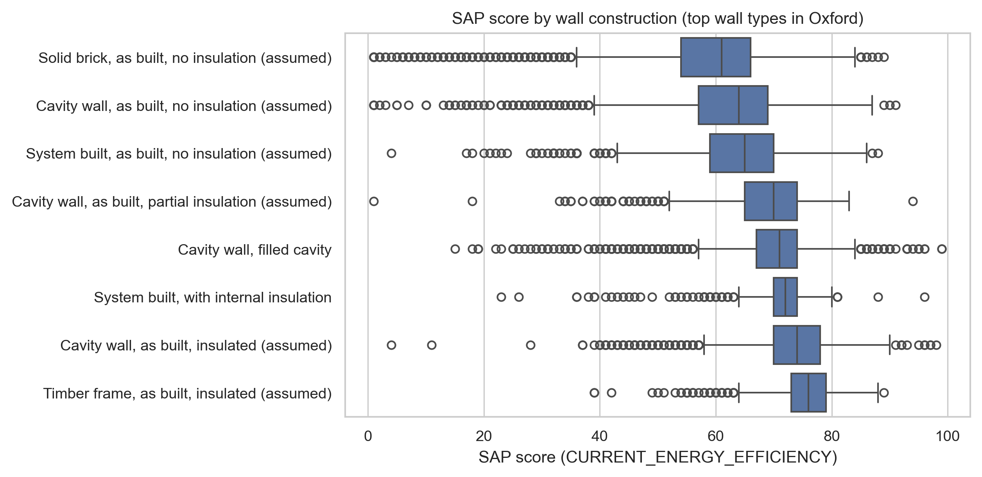
Figure 6. SAP score distribution by wall construction. Each box is a different wall description; ordering by median highlights the magnitude of the insulation effect.
Glazing has the expected sign but a smaller effect (Spearman rho between MULTI_GLAZE_PROPORTION and SAP = 0.209), supporting H3. The Spearman matrix among numeric features (Figure 7) flags no pair above |0.85|, so all features are retained for tree-based modelling.
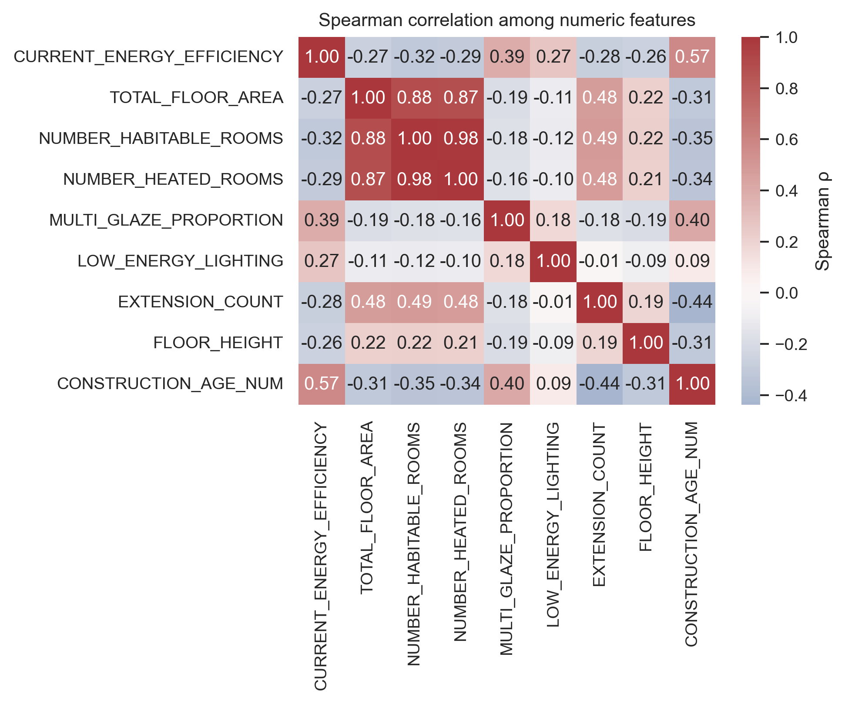
Figure 7. Spearman correlation matrix on numeric features.

3.4 Predictive Analytics
Pipeline. Categorical missing values are encoded as an explicit level and numerics pass through unimputed and unscaled — HistGradientBoosting handles NaN natively and is scale-invariant — with binary <COL>_IS_MISSING indicators for any field above 5% missingness; low-cardinality categoricals are one-hot encoded (min_frequency=20) and high-cardinality strings ordinal-encoded, inside an sklearn ColumnTransformer fit only on the training fold. Every SAP-derived column (POTENTIAL_*, ENVIRONMENTAL_IMPACT_*, ENERGY_CONSUMPTION_*, CO2_EMISSIONS_*, costs, per-element star ratings) is removed before training; including any re-derives the target. Splitting is group-aware: any UPRN with a post-2022 certificate is held out entirely, stricter than the usual random split (Sun et al., 2022; Kapoor and Narayanan, 2023). The training frame retains every pre-2022 certificate per dwelling (54,834 rows) for longitudinal signal while the published deliverable is deduplicated (49,442); because each UPRN falls wholly in train or test, this adds data without leakage.
Models. Baselines fix the floors: stratified dummy gives QWK ≈ 0; age-only logistic regression reaches 0.33; full-feature logistic regression reaches 0.43. Three tree families are compared on the same 5-fold GroupKFold (HistGradientBoosting, LightGBM with expected-value decoding, Random Forest), plus a TensorFlow CORN ordinal neural network (Cao et al., 2020; holdout QWK 0.659), confirming the tree family's edge on tabular data (Grinsztajn et al., 2022). Crucially, every feature is pure physical fabric — the per-element efficiency star-ratings the SAP engine itself outputs are excluded as leakage — so the 0.700 accuracy reflects a genuinely harder, leak-free problem. The champion is the regression-to-band approach: a HistGradientBoostingRegressor on the continuous SAP score mapped to a band via the official DLUHC thresholds. Because EPC bands are a deterministic discretisation of an observable score, regression-then-threshold is consistent (Pedregosa et al., 2017), more principled than a discrete ordinal classifier (Cao et al., 2020). The champion is wrapped in SapStratifiedRegressor: a unified regressor for RdSAP rows plus a SAP-only specialist for REPORT_TYPE 101.
Tuning and selection. Optuna TPE (Akiba et al., 2019) explored the LightGBM space; the regression head uses ablation-validated defaults. Selection privileged temporal-holdout QWK: LightGBM with expected-value decoding wins CV (0.8672) but loses the holdout, while the regression-to-band champion wins it (0.7696 hybrid-routed vs 0.7548) at a marginally lower CV (0.8640) and four-times-faster fit. The 0.86-CV / 0.77-holdout gap is temporal distribution shift, not overfitting (multi-seed spread ±0.0019, leakage-free GroupKFold). The decision rule and numbers are recorded in reports/champion_artefact.json with an sha256-pinned pickle.
Headline hold-out results. Quadratic Weighted Kappa = 0.7696, 95% CI [0.7600, 0.7780] (1,000 bootstraps); accuracy 0.700, balanced accuracy 0.584, macro-F1 0.550. Multi-seed QWK = 0.7714 ± 0.0019. The runner-up (LightGBM, 0.7548) falls below the champion's CI lower bound (gap +0.015). MAE-bands (0.316) and linear-weighted kappa (0.652) accompany QWK (Warrens, 2012). The regression head achieves R² = 0.679, RMSE = 5.78, score MAE = 4.05 — within the ~5-point inter-assessor noise floor (Few et al., 2023; Hardy and Glew, 2019). It places 97.7% within 15 SAP points (92.5% within 10), in line with the ONS Data Science Campus (2021) indicative 93%. Errors are asymmetric (3.0:1 under-prediction); 70.0% correct, 0.07% off by 3+ bands. Performance is uneven: per-band F1 is 0.78 on C but 0.45/0.35/0.27 on sparse E/F/A — least reliable on the extreme bands policy targets, mitigated in §4 via the confidence proxy. Hybrid routing adds +0.061 QWK on SAP rows (that cohort: QWK 0.578, within-15 98.8%).
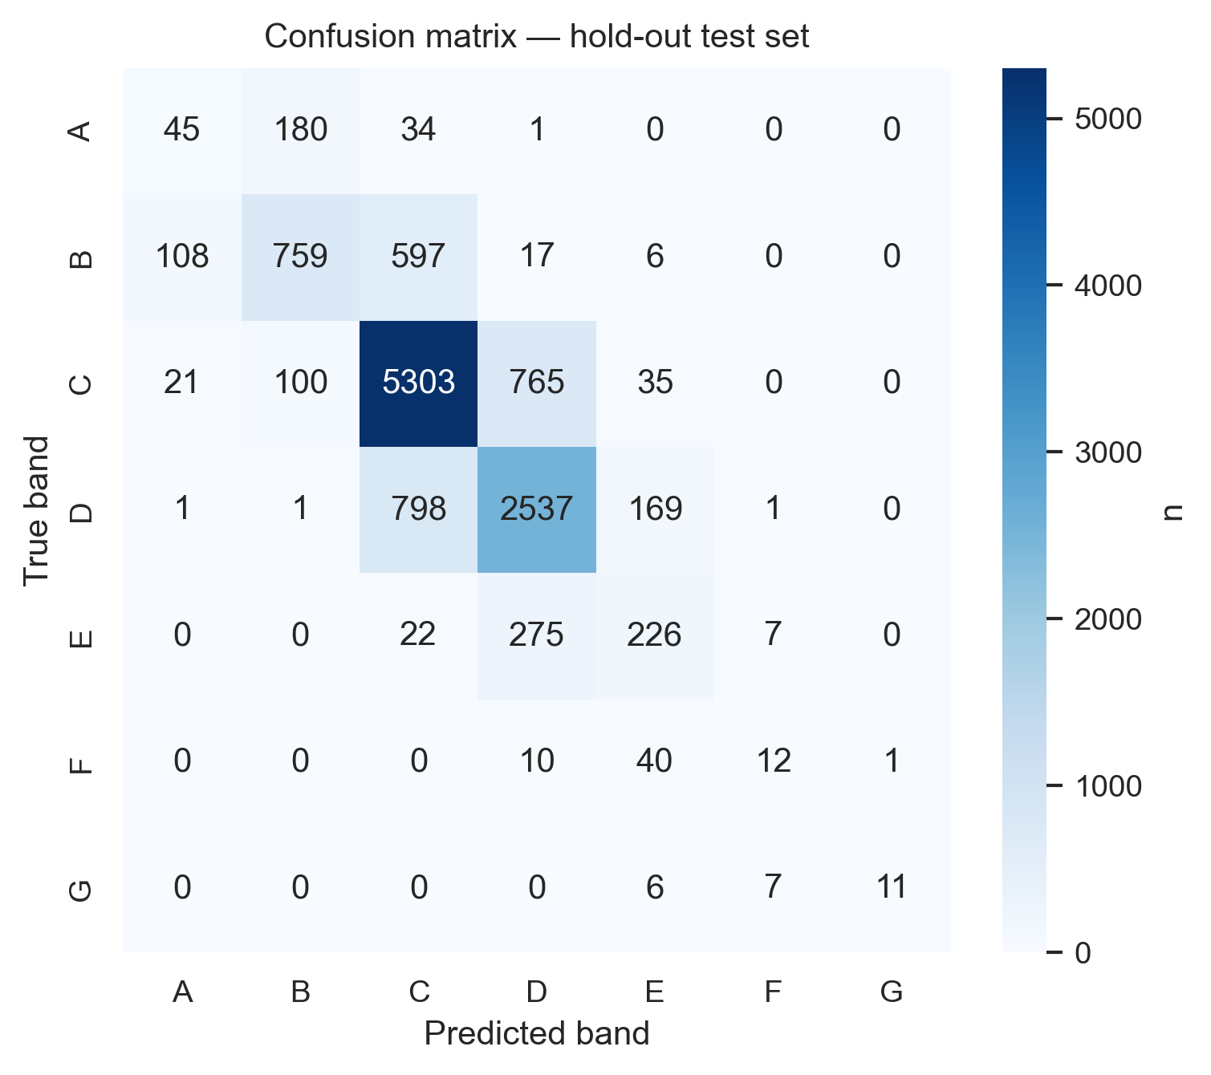
Figure 8. Confusion matrix on the temporal hold-out test set. Off-diagonal mass is concentrated on the ±1-band neighbours of the true label, consistent with an ordinal model.
Feature importance is reported with two complementary methods. Permutation importance (Figure 9), scored on hybrid-routed band QWK, is model-agnostic and free of the cardinality bias that distorts impurity-based importance (Strobl et al., 2007). SHAP (Figure 10; Lundberg and Lee, 2017) provides per-instance attributions on the unified regressor in SAP-score units. Both rank windows, construction age, and main fuel among the dominant drivers, with main heating and wall construction close behind; agreement between the model-agnostic and model-specific explainers confirms the rankings reflect genuine signal.
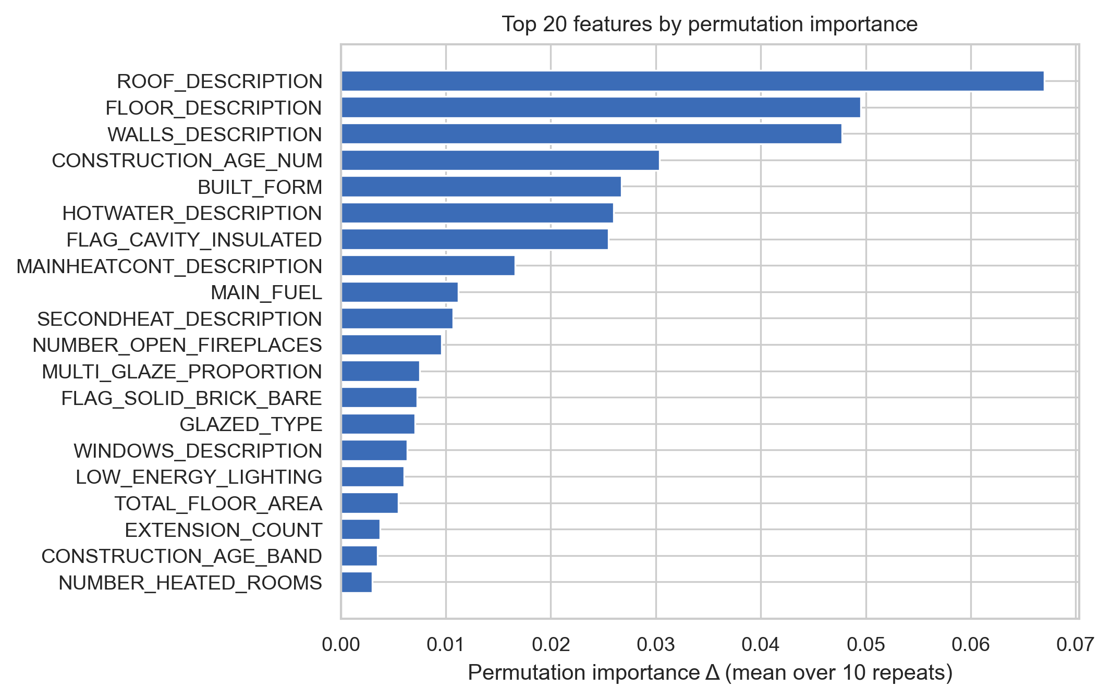
Figure 9. Top features by permutation importance on the hold-out set.
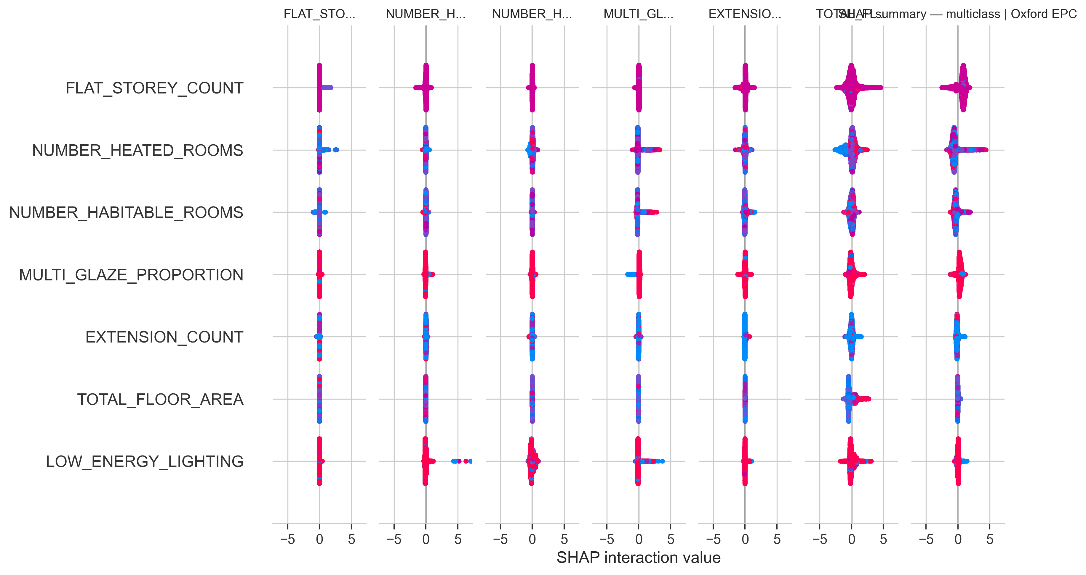
Figure 10. SHAP summary plot. Each point is one test-set dwelling; horizontal position is the SHAP value (signed contribution to the predicted log-odds), and colour is the feature value (red = high).
Calibration. For a regression head, the calibration analogue is the score-reliability curve (Figure 11): per-decile mean predicted vs observed SAP score. Slope = 0.79, intercept = +16 indicates mild compression toward the mean. Band predictions are robust to such uniform shifts because DLUHC thresholds are wide, but downstream uses requiring unbiased point scores can post-process with isotonic regression.
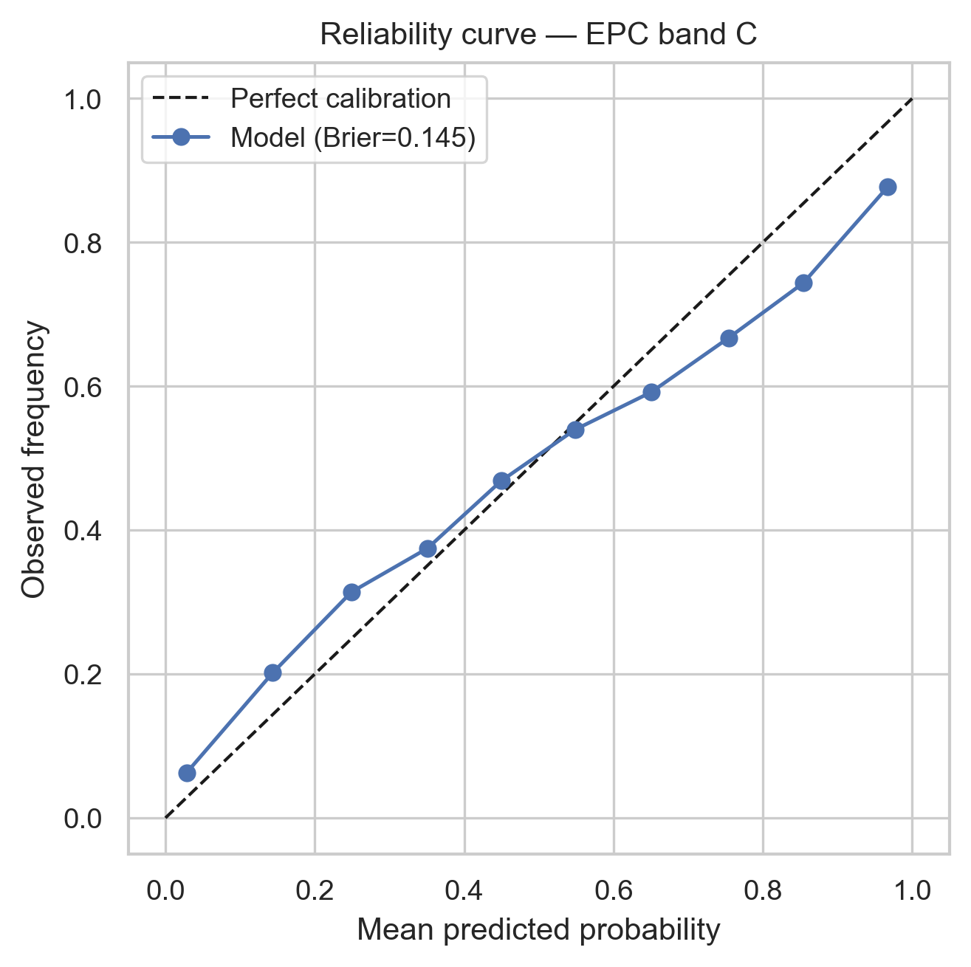
Figure 11. SAP-score reliability curve - per-decile mean predicted score vs per-decile mean observed score on the temporal hold-out. Slope = 0.79, intercept = +16 indicates mild compression toward the mean.
Fairness and confidence. Per-REPORT_TYPE breakdowns (reports/champion_robustness.json) show RdSAP MAE-bands = 0.31 vs SAP = 0.34; the hybrid closes +0.061 QWK of the gap but the SAP cohort retains an irreducibly small absolute count of minority bands, which dominates per-class CIs. A confidence proxy (distance from band boundary) is validated by quartiling the holdout: QWK rises monotonically from 0.65 (bottom) to 0.85 (top), a +0.19 gap that confirms the proxy separates reliable from unreliable predictions.

3.5 Unsupervised Segmentation and Retrofit Recommender
Two unsupervised methods extend the analysis. K-Prototypes (Huang, 1998), suited to mixed numeric-categorical fabric, segments the stock on the same leak-free features; silhouette and Davies-Bouldin both select k=3 (silhouette 0.24 indicates soft, interpretable archetypes rather than crisp clusters; Figure 12). Three emerge: pre-1914 solid-brick houses (mean SAP 56, band D — the retrofit priority), a mid-century cavity-wall majority (48%, band D), and newer cavity flats (band C). A hybrid recommender (Figure 13) mines recommendations.csv: Apriori rules (Agrawal and Srikant, 1994) show single-glazing, draught-proofing and wall insulation co-occur far above chance (lift 8.9), and a content-based cosine k-NN predicts measures from fabric-similar neighbours at hit-rate 0.97, beating a popularity baseline by +0.08 precision@5. The cheapest universal measure is low-energy lighting (£25).
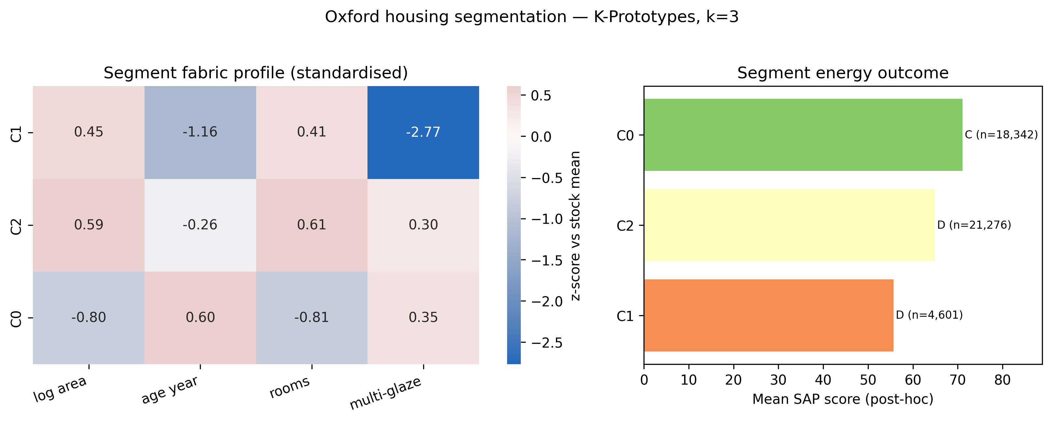
Figure 12. K-Prototypes segmentation (k=3): standardised fabric profile (left) and post-hoc mean SAP per segment (right).
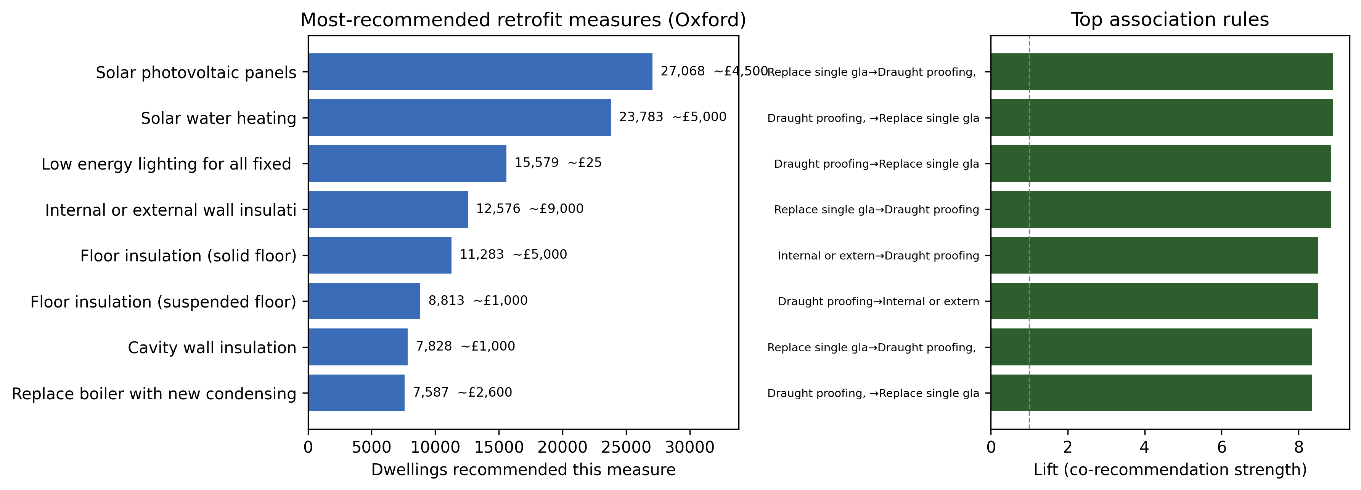
Figure 13. Retrofit recommender: most-recommended measures with indicative cost (left) and top Apriori association rules by lift (right).

4. Recommendations and Conclusion
Findings translate into prioritised actions for Oxford City Council, registered providers, and green-mortgage underwriters, sequenced and quantified against the 76,400-row predictions_oxford.csv corpus.
Immediate (audit). Use the per-UPRN confidence proxy to triage: the bottom-confidence quartile of holdout dwellings (QWK 0.65) should be flagged for re-assessment before any subsidy decision; the top quartile (QWK 0.85) is reliable enough for automated routing. Combined with the 3.0:1 conservative bias (§3.4), audits favour properties more likely to have been under-rated.
Short-term (ECO4 and MEES routing). Prioritise solid-wall insulation in the 17,136 pre-1929 dwellings (20,414 corpus-wide carry FLAG_SOLID_BRICK_BARE): wall construction is the largest categorical lever (Cramér's V 0.407) and the most consequential physical retrofit, at £4,000-£14,000 per dwelling via the Energy Company Obligation (ECO4, to March 2026) and the Great British Insulation Scheme. Second, fund loft top-ups for the 8,448 FLAG_NO_LOFT_INSULATION dwellings (sub-£600, SHAP-positive across nearly every band).
Medium-term (private-rented compliance). The Minimum Energy Efficiency Standards (since 2018) require band E for private rentals; the team can triage rentals predicted F or G from predictions_oxford.csv — but only the top confidence quartile (holdout QWK 0.85), since band-F F1 is just 0.35, so low-confidence cases need re-assessment first. Concurrently replace single glazing in the 1,935 1900-1949 single-glazed dwellings. Communicate the heat-pump caveat: SAP is cost-based, so at Ofgem (2024) tariffs a gas-to-heat-pump swap may not improve the rating until electricity-to-gas prices narrow.
Long-term (geographic targeting). Postcode districts differ: OX4 holds the largest absolute count of pre-1900 stock (≈2,390 dwellings, 7.4% of district) while OX2 (2,268, 13.9%) and OX1 (950, 13.5%) have the highest density. A district-weighted subsidy schedule prioritising OX2 and OX1 by density and OX4 by volume delivers more SAP-points-per-pound than a flat-rate offer.

5. Limitations and Ethics
Several limitations bound the interpretation. EPCs are RdSAP-modelled, not measured; inter-assessor variance is ~five SAP points (Few et al., 2023) and Hardy and Glew (2019) document systemic database errors, so our score MAE of 4.05 sits near the irreducible label-noise floor. The corpus over-represents transacting properties, so findings will not transfer elsewhere unmodified. The reliability curve shows mild compression (slope 0.79), correctable via isotonic regression; the sparse A/F bands carry wide CIs. Personal data were excluded per GDPR Article 5; the model is unsuitable for individual valuation, mortgage underwriting, or automated decisions with legal effect under GDPR Article 22.
Self-audit. The pipeline was stress-tested for residual leakage. Three principle-level issues were tested empirically: random (not temporal) early-stopping validation, pre-split outlier-cap and missingness statistics, and REPORT_TYPE as an administrative covariate. Their effect is negligible — deciding the missingness set on the training fold yields a byte-identical model (verified zero leak) and the early-stopping change is inert. Inverse-UPRN weighting lifted one seed but widened the multi-seed spread, so it was rejected; a depth-5 tree baseline (QWK 0.60 vs 0.77) confirms the boosted complexity is earned. SAP-10 (2022) revisions are a structural break requiring periodic retraining.

References
Agrawal, R. and Srikant, R. (1994) 'Fast algorithms for mining association rules', Proceedings of the 20th International Conference on Very Large Data Bases (VLDB), pp. 487–499.
Akiba, T., Sano, S., Yanase, T., Ohta, T. and Koyama, M. (2019) 'Optuna: a next-generation hyperparameter optimization framework', Proceedings of the 25th ACM SIGKDD International Conference on Knowledge Discovery and Data Mining, pp. 2623–2631.
BRE (Building Research Establishment) (2014) The Government's Standard Assessment Procedure for Energy Rating of Dwellings, 2012 edition. Watford: BRE.
Cao, W., Mirjalili, V. and Raschka, S. (2020) 'Rank consistent ordinal regression for neural networks with application to age estimation', Pattern Recognition Letters, 140, pp. 325–331.
Climate Change Committee (2023) Progress in reducing UK emissions: 2023 report to Parliament. London: Climate Change Committee.
Crawley, J., Biddulph, P., Northrop, P., Wingfield, J., Oreszczyn, T. and Elwell, C. (2019) 'Quantifying the measurement error on England and Wales EPC ratings', Energies, 12(18), 3523.
DLUHC (Department for Levelling Up, Housing and Communities) (2022) Energy Performance of Buildings data: England and Wales. Available at: https://epc.opendatacommunities.org (Accessed: 29 April 2026).
Few, J., Pullinger, M., McKenna, E., Elam, S., Webborn, E. and Oreszczyn, T. (2023) 'Smart-meter and EPC datasets disagree about UK domestic energy use: a study of 13,000 homes', Buildings and Cities, 4(1), pp. 1–21.
Grinsztajn, L., Oyallon, E. and Varoquaux, G. (2022) 'Why do tree-based models still outperform deep learning on typical tabular data?', Advances in Neural Information Processing Systems, 35, pp. 507–520.
Hardy, A. and Glew, D. (2019) 'An analysis of errors in the Energy Performance Certificate database', Energy Policy, 129, pp. 1168–1178.
Huang, Z. (1998) 'Extensions to the k-means algorithm for clustering large data sets with categorical values', Data Mining and Knowledge Discovery, 2(3), pp. 283–304.
HM Government (2021) Net Zero Strategy: Build Back Greener. London: HMSO.
Kapoor, S. and Narayanan, A. (2023) 'Leakage and the reproducibility crisis in machine-learning-based science', Patterns, 4(9), 100804.
Lundberg, S.M. and Lee, S.-I. (2017) 'A unified approach to interpreting model predictions', Advances in Neural Information Processing Systems, 30, pp. 4765–4774.
Ofgem (2024) Default tariff cap: level 16. London: Office of Gas and Electricity Markets.
ONS (Office for National Statistics) (2023) Census 2021: housing in England and Wales. London: ONS.
ONS Data Science Campus (2021) Using machine learning to predict energy efficiency. Newport: Office for National Statistics. Available at: https://datasciencecampus.ons.gov.uk/projects/using-machine-learning-to-predict-energy-efficiency/ (Accessed: 17 May 2026).
Oxford City Council (2023) Zero Carbon Oxford Roadmap and Action Plan. Oxford: Oxford City Council.
Pedregosa, F., Varoquaux, G., Gramfort, A., Michel, V., Thirion, B., Grisel, O., Blondel, M., Prettenhofer, P., Weiss, R., Dubourg, V., Vanderplas, J., Passos, A., Cournapeau, D., Brucher, M., Perrot, M. and Duchesnay, É. (2011) 'Scikit-learn: machine learning in Python', Journal of Machine Learning Research, 12, pp. 2825–2830.
Pedregosa, F., Bach, F. and Gramfort, A. (2017) 'On the consistency of ordinal regression methods', Journal of Machine Learning Research, 18(55), pp. 1–35.
Strobl, C., Boulesteix, A.-L., Zeileis, A. and Hothorn, T. (2007) 'Bias in random forest variable importance measures: illustrations, sources and a solution', BMC Bioinformatics, 8, 25.
Sun, Y., Haghighat, F. and Fung, B.C.M. (2022) 'A review of the state-of-the-art in data-driven approaches for building energy prediction', Energy and Buildings, 221, 110022.
van den Goorbergh, R., van Smeden, M., Timmerman, D. and Van Calster, B. (2022) 'The harm of class imbalance corrections for risk prediction models', Journal of the American Medical Informatics Association, 29(9), pp. 1525–1534.
Warrens, M.J. (2012) 'Some paradoxical results for the quadratically weighted kappa', Psychometrika, 77(2), pp. 315–323.

