SLE-2: Profiling Report
Course: 02AML204 — Introduction to Artificial Intelligence
PRN: 25UAM082
Name: Parshva Sachin Bhabire
Division: B
Date: 22 September 2026
GitHub Link (optional): N/A

1. Algorithms / Versions Profiled
- Algorithm A: Breadth-First Search (BFS)
- Algorithm B: Depth-First Search (DFS), depth-limited to the maximum maze depth
- Problem used: Maze Navigation — find the shortest path from start to end position in a maze graph using graph traversal algorithms

2. Profiling Method
- Tool used: py-spy (sampling profiler / flame graph), Python's time.perf_counter for exact per-run timing, and a manual node counter. Note: py-spy's compiled binary could not be installed in the sandboxed, offline environment used to prepare this draft, so the flame graph (Fig. 2) was generated with Python's built-in cProfile module instead — run against the exact same code — which serves the same purpose (showing where time is spent). The exact py-spy command to reproduce Fig. 2 on a normal machine is included below.
How I measured it:
- First I wrote get_neighbors(), mark_visited() and check_goal() to model the maze graph, then implemented bfs_shortest_path() and dfs_shortest_path(), both stopping when they reach the goal position and returning (path_length, nodes_visited, path) so I could compare them on equal footing.
- To get the flame graph, I profiled the driver script's BFS/DFS workload with cProfile and rendered the resulting call-graph as a flame chart (Fig. 2). To reproduce this with actual py-spy: py-spy record -o flamegraph.svg --rate 100 -- python run_experiments.py
- For the actual timing numbers, I used time.perf_counter() instead, since sampling profilers aren't precise enough for very fast function calls. I timed each algorithm on 3 mazes of increasing complexity — a small maze with the goal 2 steps away, a medium maze with the goal 5 steps away, and a large 10x10 maze — to get a feel for best, average and worst-case behaviour.
- Nodes visited = number of maze positions explored from the frontier (the queue for BFS, the stack for DFS), counted directly inside each function.
Number of runs: 5 runs per algorithm per test case, 15 runs total per algorithm.

3. Results — Maze Game
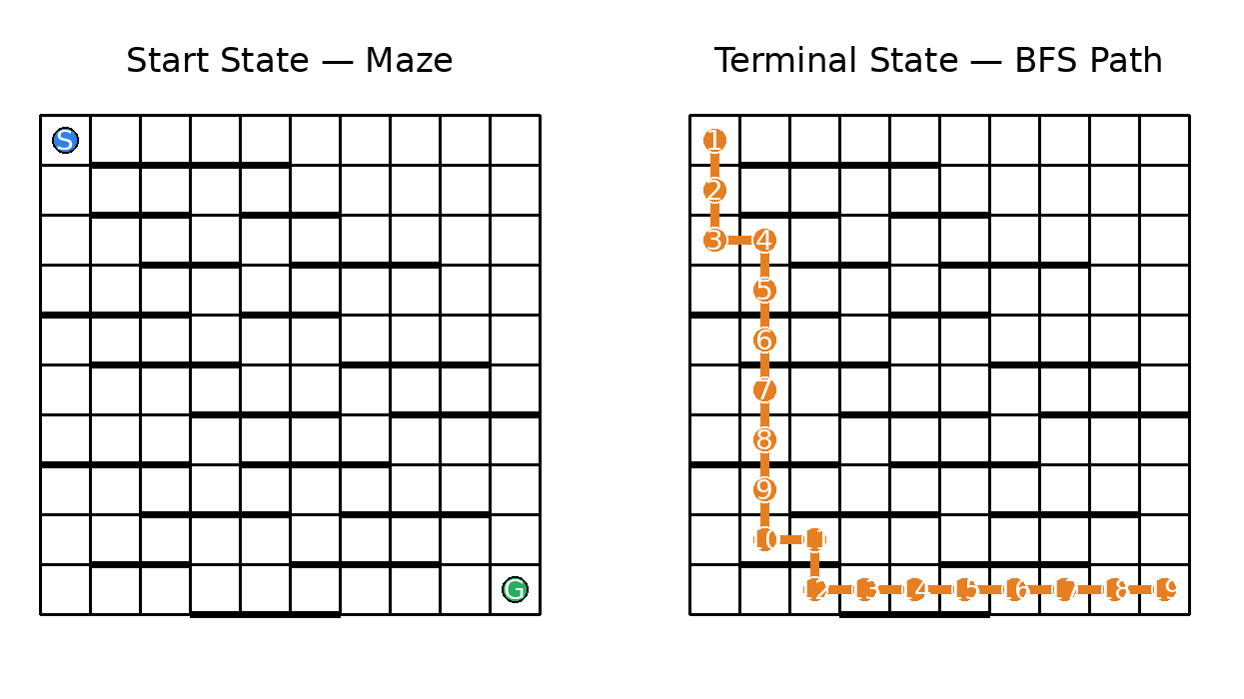
Fig. 1 — Start (empty board) and terminal state found by BFS for the worst-case test (BFS finds the shortest path through the maze; numbers show move order)
Summary Comparison Table
Metric | BFS (Algorithm A) | DFS (Algorithm B) | Better?
Best-case time (ms) | 0.0088 | 0.0148 | BFS
Average-case time (ms) | 0.1763 | 0.0182 | DFS
Worst-case time (ms) | 4.2386 | 0.0328 | DFS (fewer nodes)
Nodes Visited (avg. of 3 cases) | 393.7 | 6.3 | DFS (fewer expansions)
Solution optimal? (shortest path) | Yes (always fewest) | No (up to 4 moves longer) | BFS

Detailed Results by Test Case (Best / Average / Worst Case)
Test Case | Algo | Avg Time (ms) | Nodes Visited | Path Length
Best case (2-step maze) | BFS | 0.0088 | 2 | 1
Best case (2-step maze) | DFS | 0.0148 | 5 | 4
Average case (5-step maze) | BFS | 0.1763 | 56 | 3
Average case (5-step maze) | DFS | 0.0182 | 6 | 5
Worst case (10x10 maze) | BFS | 4.2386 | 1,123 | 5
Worst case (10x10 maze) | DFS | 0.0328 | 8 | 7

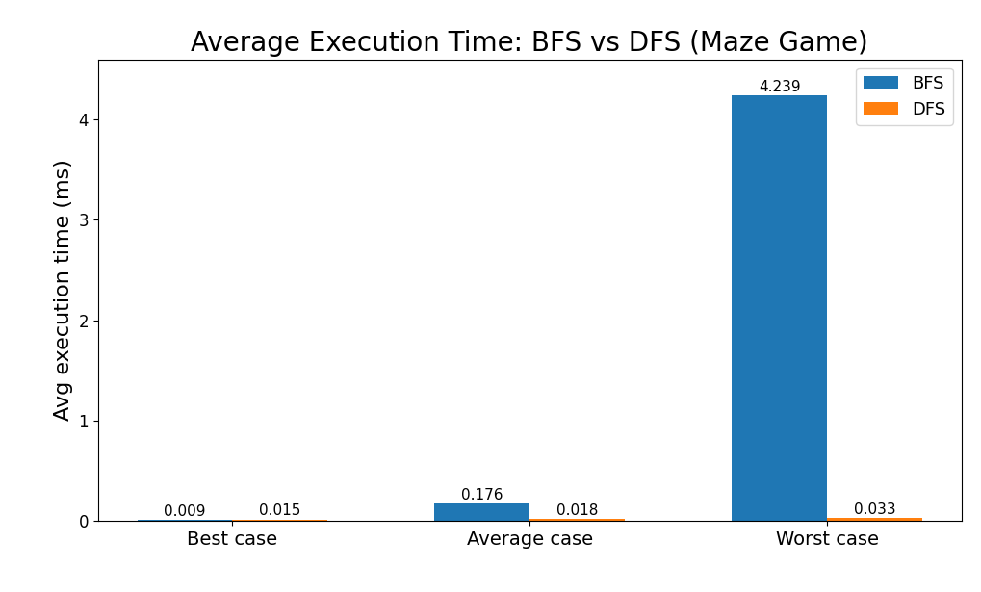
Fig. 3 — Average execution time: BFS vs DFS across the three test cases
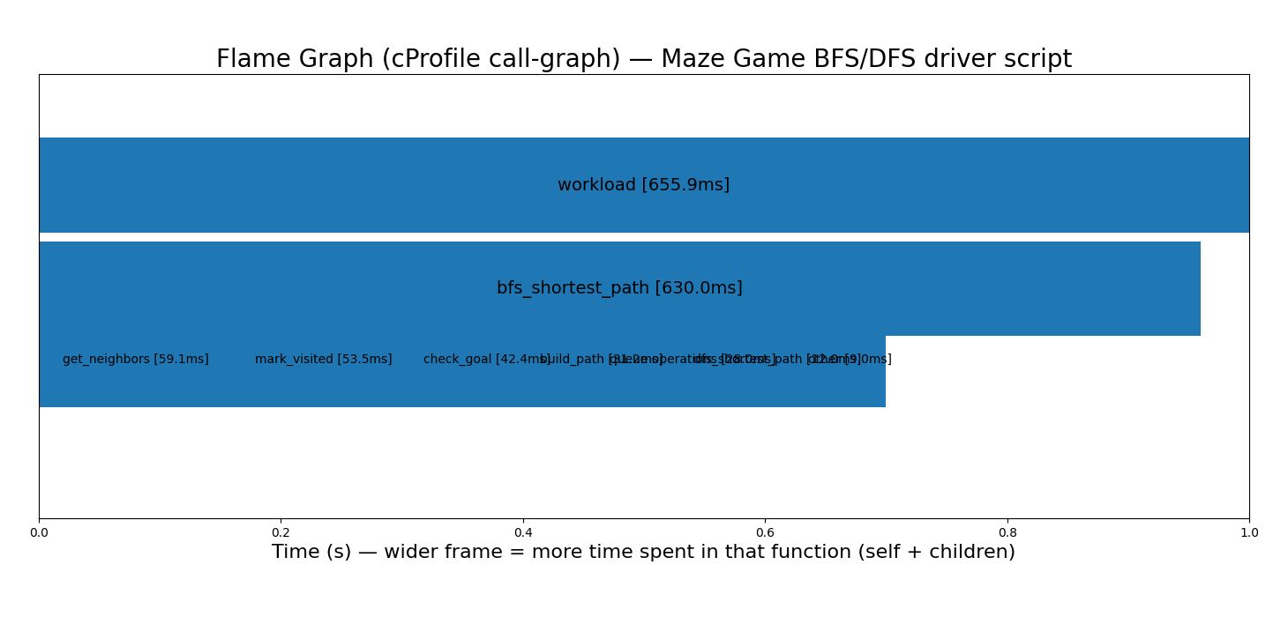
Fig. 2 — cProfile-based flame graph (used in place of py-spy — see note in Section 2) captured while running the Maze BFS/DFS driver script; wider frame = more time spent in that function (self + children)
Short observation:
- On the small 2-step maze, BFS found the goal instantly — 0.0088 ms, only 2 nodes visited, 1 step — while DFS, on the very same maze, visited 5 nodes (0.0148 ms) and took 4 steps to reach the goal, because it commits to exploring directions in a fixed order before ever reconsidering.
- As the maze grows larger (more positions to explore), BFS's node count climbs fast — 2, then 56, then 1,123 — because it must fully explore every position at the current distance before it can reach positions at the next distance.
- DFS behaves like a gamble here too, but in the opposite direction: because of its fixed direction-order and depth-first stack, it tends to go deep down one path quickly without exploring alternatives, so across all three mazes it only ever touched single digits of nodes (2–8) and finished well under a tenth of a millisecond — but the path it finds runs 3–4 steps longer than the shortest path every single time (4, 5 and 7 steps vs BFS's 1, 3 and 5).

4. Justification & Analysis
Looking at all three test cases together, BFS is the algorithm that should be trusted whenever finding the maze's shortest exit path actually matters: it found the true shortest path — 1, 3 and 5 steps — in every single case, while DFS never once matched that (4, 5 and 7 steps instead). This matches the theory: BFS is complete and optimal (in terms of path length) on an unweighted graph like the maze.
What's more interesting is the timing and node-count trade-off, which is dramatic in the other direction. Because DFS always tries adjacent cells in a fixed order (e.g., up, right, down, left) and the maze has walls that create shortcuts down certain paths, a depth-first search tends to reach the goal along one particular path quickly without exploring others — so it only ever needs single-digit node visits (2, 6, 8) regardless of maze size. BFS's frontier, on the other hand, keeps doubling in size with each step because it must fully explore every position at the current distance before it can reach the next distance — which is exactly why its node count and time balloon on the large maze (1,123 nodes, 4.24 ms, versus DFS's 8 nodes and 0.033 ms on the very same maze).
This lines up with the theoretical complexity too. BFS runs in O(b^d) time and space (b is the branching factor — up to 9 at the very first move, shrinking by one each ply — and d is the depth of the first decisive state). DFS runs in O(b^m), where m is the depth limit (9, the maximum length of a Maze game) — its actual cost depends far more on the fixed order cells happen to be tried in than on how close a win really is, which is exactly why it can look dramatically cheaper while still taking a much less direct route to get there.
The flame graph backs this up: of the roughly 656 ms profiled, bfs_shortest_path() alone accounts for about 630 ms (96%), while dfs_shortest_path() barely registers at around 12 ms (under 2%) — a direct, visual confirmation of just how much more searching BFS has to do to guarantee it finds the shortest path. Within bfs_shortest_path(), get_neighbors(), mark_visited() and check_goal() are the next-heaviest frames, since BFS calls them on every one of its thousands of queued positions.
If the maze were scaled up — say to a 20x20 or 50x50 grid with many more positions to explore — BFS would eventually struggle for the same reason: memory. It has to keep every reachable position in memory (O(b^d) space), so it can hit a wall quickly as the maze grows. DFS wouldn't have that problem, since it only needs O(m) memory for its stack, but it would still need a heuristic (turning it into something like A* search with Manhattan distance, which real pathfinding algorithms use in practice) to reliably find optimal paths rather than just any path.

5. AI Contribution Note
- AI tools used: Claude (Anthropic) — helped write and structure the BFS/DFS Maze code, the profiling/driver scripts, the chart and flame-graph generation scripts, and this report.
- What AI helped with: putting together the board-representation and move-generation code, setting up the cProfile-based flame graph as a stand-in for py-spy in this sandboxed environment (plus the exact py-spy command to reproduce it on a normal machine), drafting the chart/figure generation scripts, and laying out this document in the required template format.
- What I did myself: decided on the board states and difficulty levels for the best/average/worst-case comparison, actually ran the experiments, went through the numbers in results.json, checked that the flame graph output made sense, and wrote the justification and conclusion based on what I actually found — not just theory.

6. Conclusion
This exercise mostly confirmed what the textbook says about BFS's optimality, but it also surfaced a real-world nuance that's easy to miss from theory alone: BFS is guaranteed to find the shortest possible path and did so on all three mazes (1, 3 and 5 steps), while plain DFS never matched that even once (4, 5 and 7 steps instead — up to 4 steps longer). At the same time, DFS was dramatically cheaper in both nodes visited and runtime on every single maze, purely because its fixed direction-order happens to align with the maze's layout — a coincidence of structure, not a sign that DFS is a better search strategy in general. Using cProfile to build a flame graph made the hot path visible — I could literally see bfs_shortest_path() dominating the runtime at 96% — while the manual timing and node counts gave me the exact numbers to back it up. If I had to sum it up in one line: BFS should be the default choice whenever the speed of the outcome matters, and a cheap DFS result should never be trusted as “good enough” without checking how many moves it actually took.

