Astronomy is actually one of the best choices for what you're trying to do. It naturally sounds advanced, has stunning visuals, and many of the core ideas are surprisingly intuitive once you understand them.
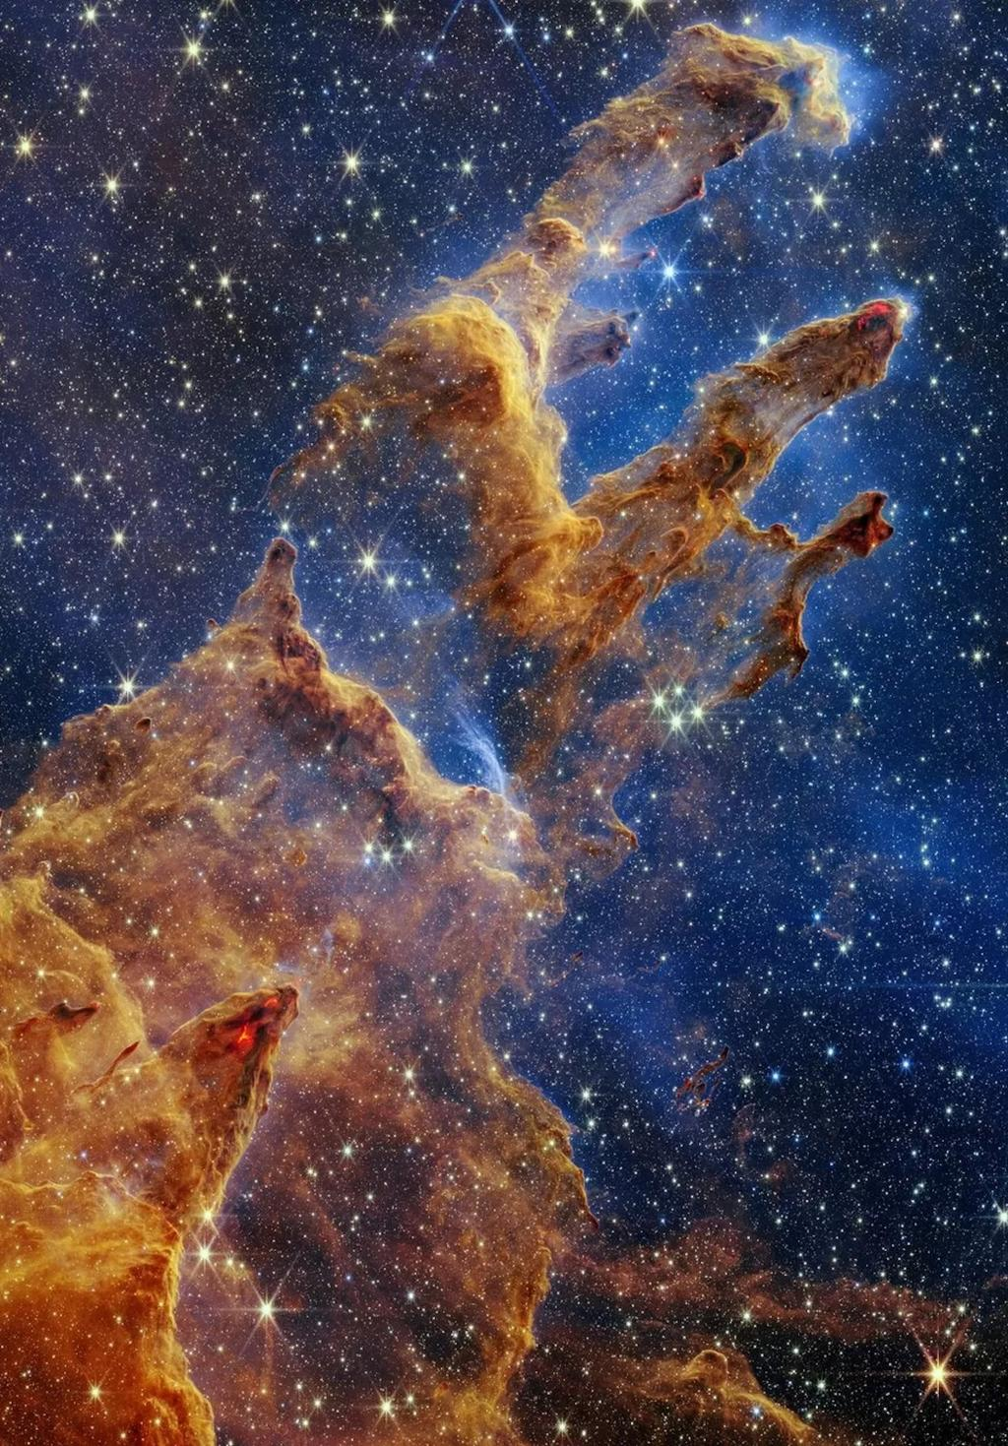
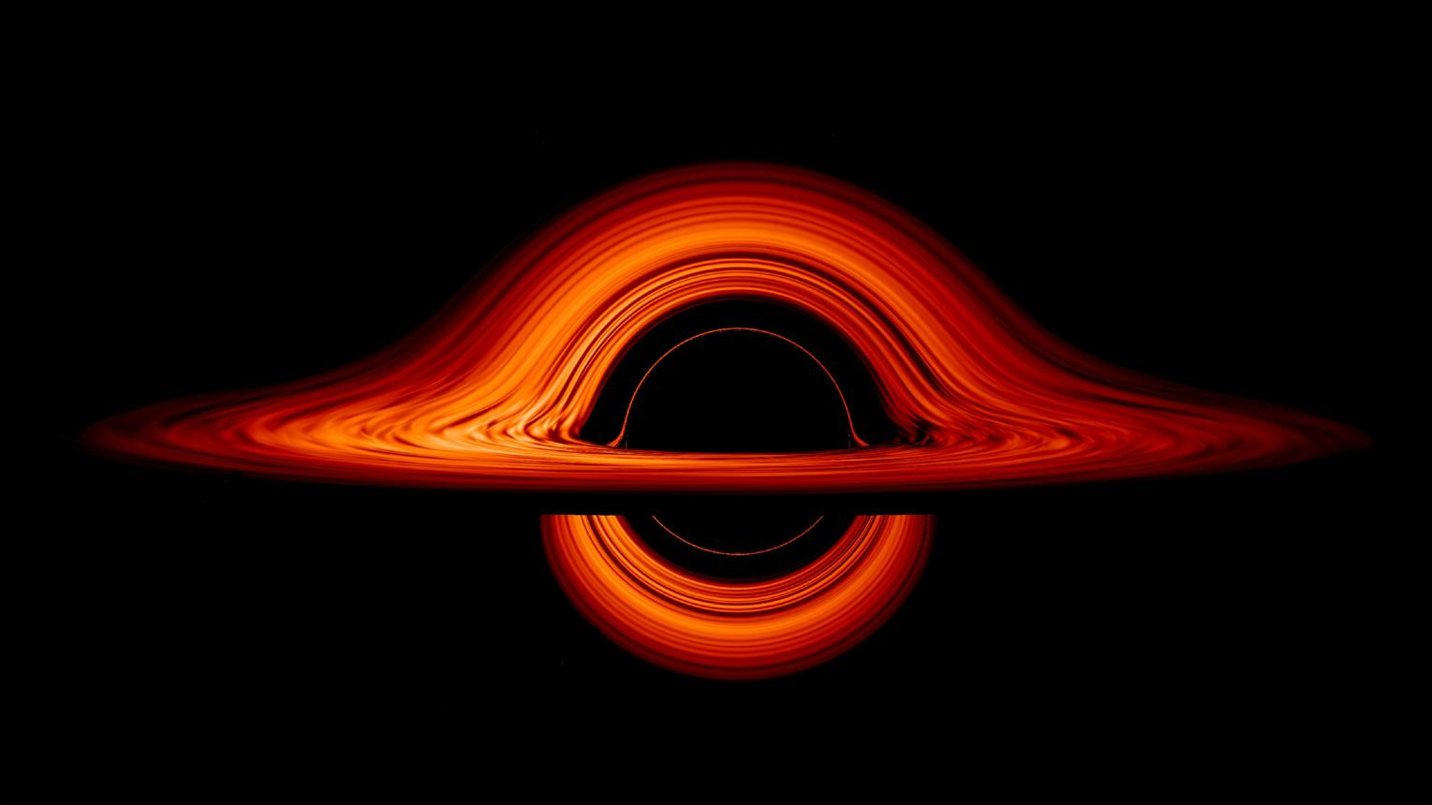
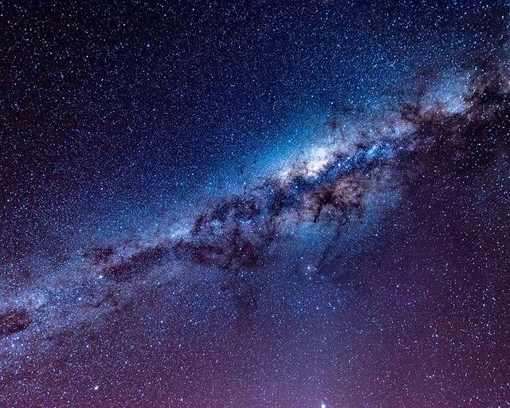
5
Here are some astronomy topics, ranked by how easy they are to learn and how impressive they sound.

⭐⭐⭐⭐⭐ 1. Black Holes (My top recommendation)
Everyone is curious about black holes, and you can explain them without advanced mathematics.
Topics you can cover:
- What a black hole is
- Event horizon
- Singularity (and why we don't fully understand it)
- Schwarzschild radius
- Time dilation
- Spaghettification
- Hawking radiation (briefly)
Why it looks "nerdy":
You can mention ideas from Einstein's General Relativity and explain that gravity is the curvature of spacetime.

⭐⭐⭐⭐⭐ 2. Exoplanets and the Search for Life
Questions like "Are we alone?" immediately grab attention.
You can discuss:
- Habitable zone ("Goldilocks zone")
- Transit method
- Radial velocity method
- Biosignatures
- Earth-like planets
It's a modern topic with lots of exciting discoveries.

⭐⭐⭐⭐☆ 3. Life Cycle of Stars
This is very visual and follows a clear story.
Cover:
- Nebula
- Protostar
- Main sequence
- Red giant
- White dwarf
- Neutron star
- Black hole
- Supernova
This is easy to explain because it's essentially the "life story" of a star.

⭐⭐⭐⭐☆ 4. The James Webb Space Telescope
A contemporary topic with incredible images.
Explain:
- Why it observes infrared light
- Why it's positioned at the Sun–Earth L2 point
- Its large segmented mirror
- Some of its discoveries

⭐⭐⭐⭐☆ 5. The Big Bang
This is one of the most famous topics in astronomy.
You can explain:
- Expansion of the universe
- Cosmic microwave background
- Redshift
- Formation of galaxies
- Dark matter
- Dark energy
Avoid saying the Big Bang was an explosion into empty space; instead, explain that space itself has been expanding.

⭐⭐⭐☆☆ 6. Space-Time and Relativity
This sounds very sophisticated.
Topics:
- Spacetime
- Time dilation
- Length contraction
- Gravity bending light
- GPS satellites and relativity
Simple examples with moving clocks can make these ideas accessible.

⭐⭐⭐⭐⭐ 7. Dark Matter and Dark Energy
This topic has a lot of mystery.
You can say:
- We can detect their effects.
- We don't yet know exactly what they are.
- Together, they make up most of the universe's mass-energy content.
That uncertainty actually makes the topic more interesting.

Free Resources
If you're looking for reliable, free material:
- NASA – beginner-friendly articles, animations, and images.
- ESA (European Space Agency) – excellent explanations and graphics.
- ESA/Hubble – beautiful Hubble and Webb images with educational content.
- OpenStax Astronomy – a complete, free university-level astronomy textbook.
- Crash Course Astronomy (YouTube) – 40+ engaging lessons.
- PBS Space Time (YouTube) – more advanced explanations if you want to dive deeper.
- MIT OpenCourseWare – free astronomy lectures.

How to make your presentation feel "expert-level"
Rather than just describing objects, explain how scientists know what they know.
For example:
- How do astronomers detect planets around other stars?
- How can they measure the mass of a black hole?
- How do we know the universe is expanding?
Answering these questions makes the presentation feel analytical rather than just descriptive.

If I were choosing one topic for a school class
I'd choose Black Holes: "How Gravity Breaks the Universe."
A simple outline could be:
- What is gravity?
- How stars are born and die.
- How black holes form.
- Event horizon and singularity.
- Time dilation near black holes.
- How astronomers detect invisible black holes.
- Real images and discoveries from the Event Horizon Telescope.
- Current unanswered questions.
It combines striking visuals, accessible explanations, and enough advanced terminology to sound sophisticated without requiring difficult mathematics.

