**Batch : T6**

**Practical No. 1**

**Title of Assignment:** Study of web and its basics

**Student Name: Parshwa Herwade**

**Student PRN: 22510064**

(P#: 1

PS#: 1)

**Problem Statement 1: Study and describe the following concepts in your words:**

1. Evolution of Web including web 3.0

Ans. The web has undergone significant transformations since its inception. Web 1.0 was the first generation of the web, characterized by static HTML pages and limited user interaction. Web 2.0 introduced dynamic content, social media, and user-generated content. Web 3.0 is the current generation, focusing on artificial intelligence, machine learning, and

blockchain technology to create a more intelligent and connected web.

1. Which ports and protocols are used by web? Describe those in detail

Ans. Ports are like designated doors for specific services. Common ports include:

- HTTP (port 80): default port for web servers

- HTTPS (port 443): secure port for encrypted data transfer

- FTP (port 21): port for file transfers

- SSH (port 22): secure port for remote access

Protocols define the communication rules. TCP/IP is the fundamental protocol suite for internet communication

1. Difference Between HTTP & HTTPS

Ans. HTTP (Hypertext Transfer Protocol) is an insecure protocol that transmits data in plain text, making it vulnerable to eavesdropping and tampering. HTTPS (Hypertext Transfer Protocol Secure) is an extension of HTTP, adding encryption to protect data in transit.

4. What is web developer tools and why it is needed?

Ans. Web developer tools are software applications that aid in building, testing, and debugging web applications. Examples include:

- Chrome DevTools: a set of debugging and testing tools built into Google Chrome

- Firefox Developer Edition: a version of Firefox with additional developer tools

- Visual Studio Code: a lightweight code editor with debugging and testing features

5. Elaborate with diagram client server architecture and MVC architecture. When to use which architecture?

Ans. Client-Server Architecture:

- Client: requests resources from the server

- Server: responds with requested resources

MVC Architecture:

- Model: represents data and business logic

- View: handles user interface and presentation

- Controller: manages interaction between Model and View

6. What is HTML and HTML5?

Ans. HTML (Hypertext Markup Language) is a markup language for structuring and presenting content on the web. HTML5 is the latest version, introducing new features like:

- Video and audio support

- Canvas element for dynamic graphics

- Web storage for local data storage

7. Which are the currently used versions of HTML and CSS for web development?

Ans. HTML5 and CSS3 are the current versions used for web development.

8. Which tools are available for front end development and back end development?

Ans. Front-end development tools:

- Code editors (Visual Studio Code, Sublime Text)

- Frameworks (React, Angular, Vue.js)

- Libraries (jQuery, Lodash)

Back-end development tools:

- Programming languages (Node.js, Python, Ruby)

- Frameworks (Express.js, Django, Ruby on Rails)

- Databases (MySQL, MongoDB, PostgreSQL)

9. What MERN stack includes? Why and when it is preferred for web development?

Ans. MERN is a popular web development stack consisting of:

- MongoDB: NoSQL database for storing data

- Express.js: Node.js framework for building web applications

- React: JavaScript library for building user interfaces

- Node.js: JavaScript runtime environment for server-side development

10. List out newly introduced input types, APIs, form elements, and elements that support media content in HTML5.

Ans. HTML5 introduced new features like:

- Input types: email, tel, search, url

- APIs: Geolocation, Web Workers, Web Storage

- Form elements: datalist, keygen, output

- Media elements: video, audio, canvas

11. Explain HTML5 Web storage.

Ans. HTML5 Web Storage allows web applications to store data locally within the user's browser, using either:

- LocalStorage: persistent storage with no expiration date

- SessionStorage: temporary storage that expires when the session ends

(P#: 1

PS#: 2)

**Problem Statement 2: Study of Different HTML and CSS tags:**

1. Study different tags of HTML and CSS

Ans. HTML Tags:

- Headings: h1, h2, h3, h4, h5, h6

- Paragraph: p

- Links: a

- Images: img

- Lists: ul, ol, li

- Containers: div, span

- Tables: table, tr, td

- Forms: form, input, textarea, select

- Semantic elements: header, nav, main, section, article, footer

CSS Tags:

- Selectors: .class, #id, tag

- Properties:

- Color: color, background-color

- Text: font-size, font-family, text-align

- Layout: width, height, margin, padding

- Border: border-style, border-width, border-color

- Background: background-image, background-repeat

2. Create a static web page for “Portfolio” of your own. Which will include photo, name, class, College name, Achievements/ Certificates, Extracurricular Activities, Courses Completed, hobbies, Technical expertise, etc

Ans. HTML:

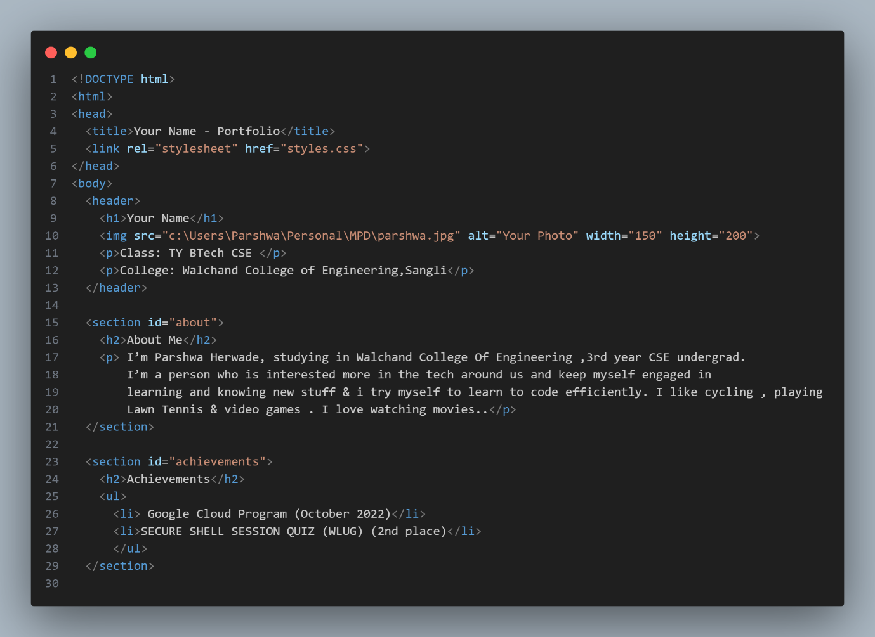

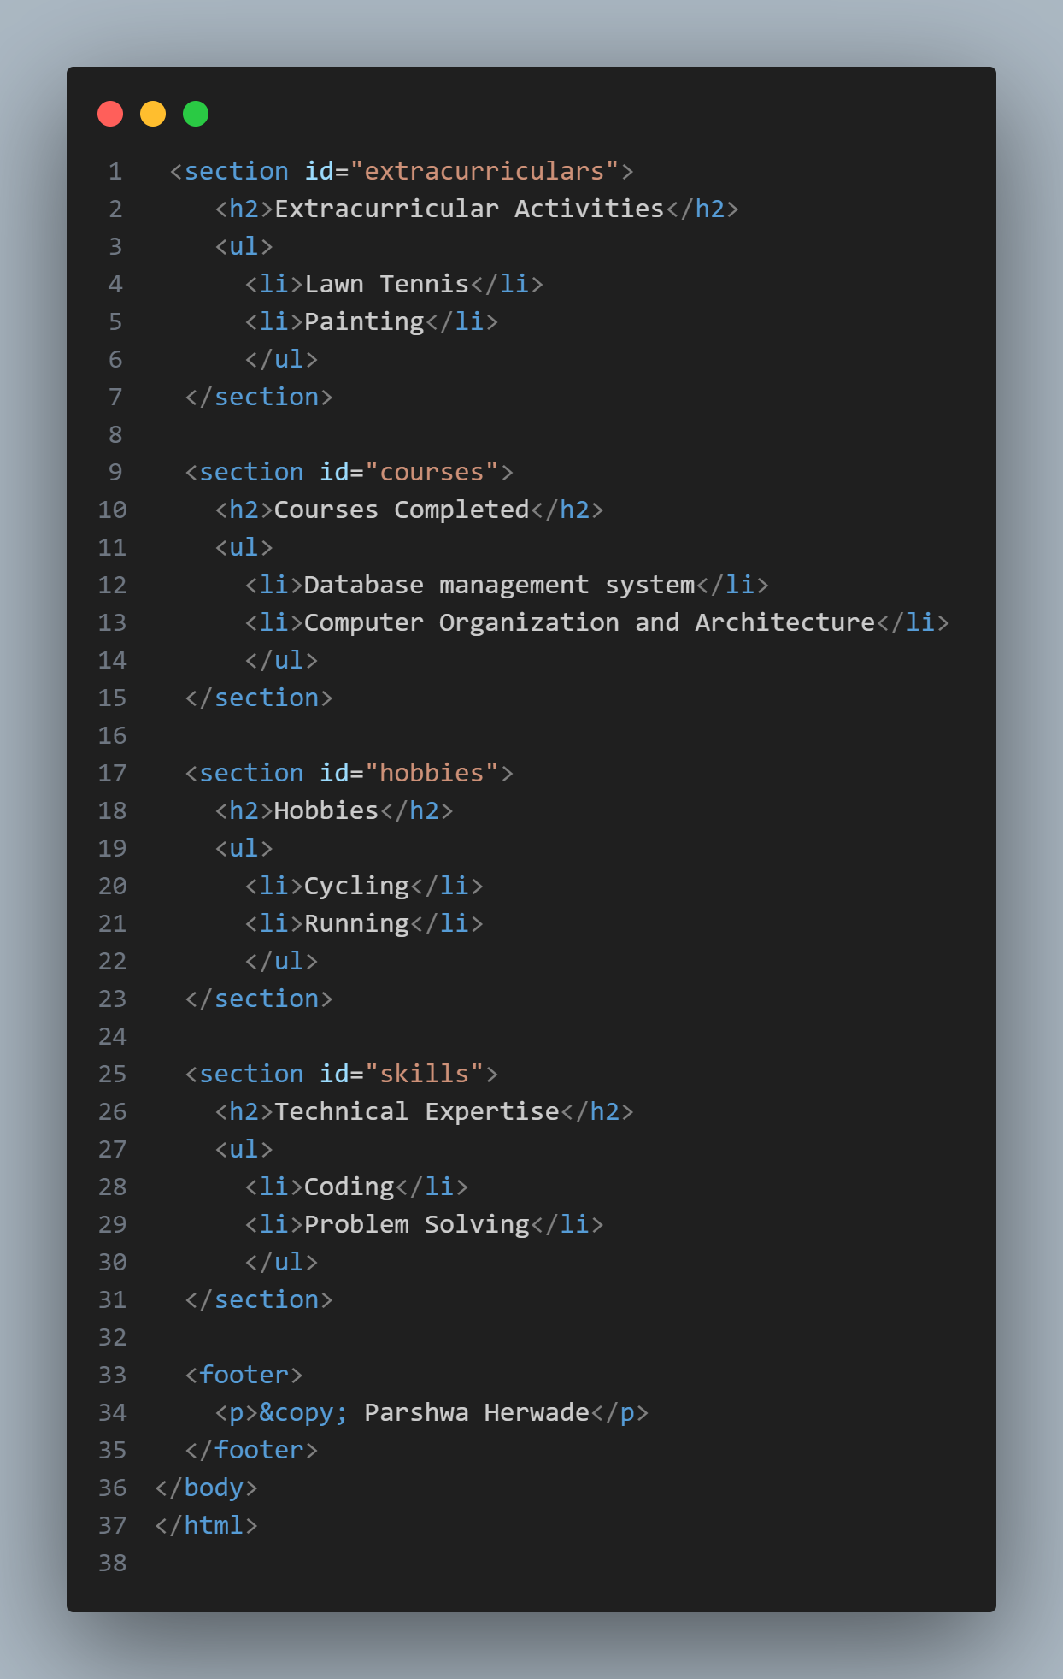  
CSS:

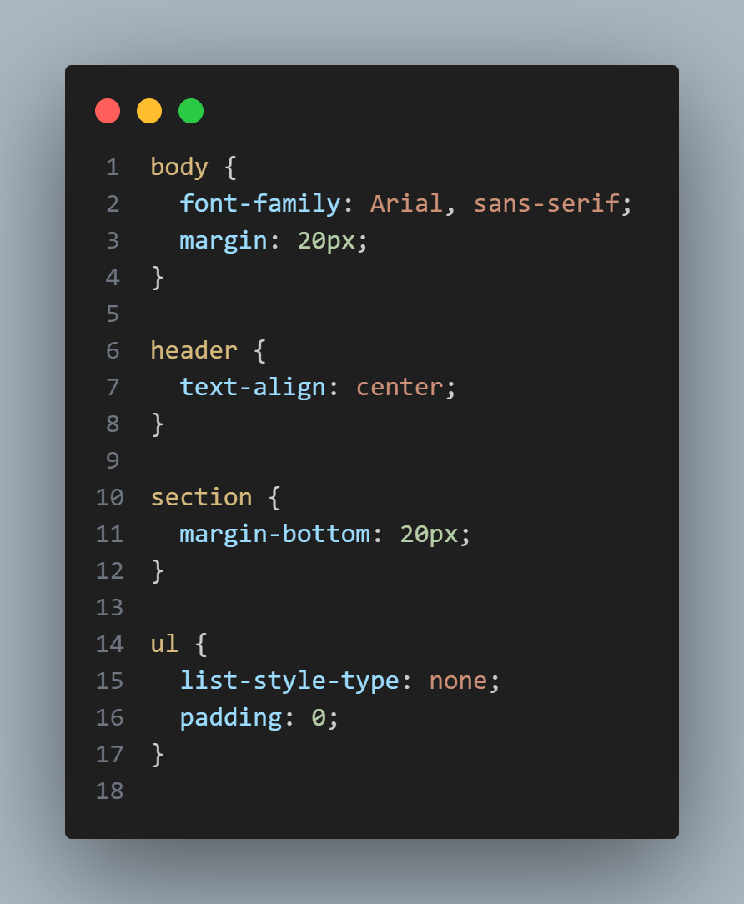  
  
Implementation:  
