**Batch: T6**

**Practical No. 10**

**Title of Assignment: Projects using MySQL, NodeJs and ExpressJs, Reacrjs**

**Student Name: Parshwa Herwade**

**Student PRN: 22510064**

Problem Statement 1: Personal Task Manager

• Develop a simple task manager where users can add, edit, and delete their

personal tasks. The tasks should have fields like title, description, dueDate, and

status (pending/completed).

• User authentication (JWT-based login/signup).

• CRUD operations for tasks (Create, Read, Update, Delete).

• Filtering tasks by status (pending/completed).

• Allow users to categorize tasks and set priorities (high, medium, low).

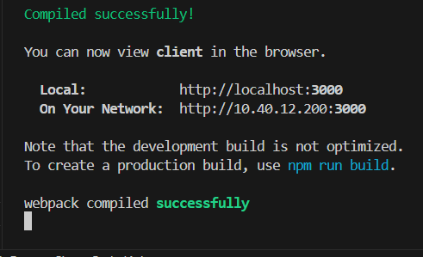

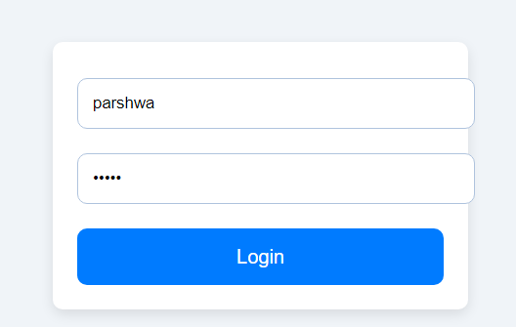

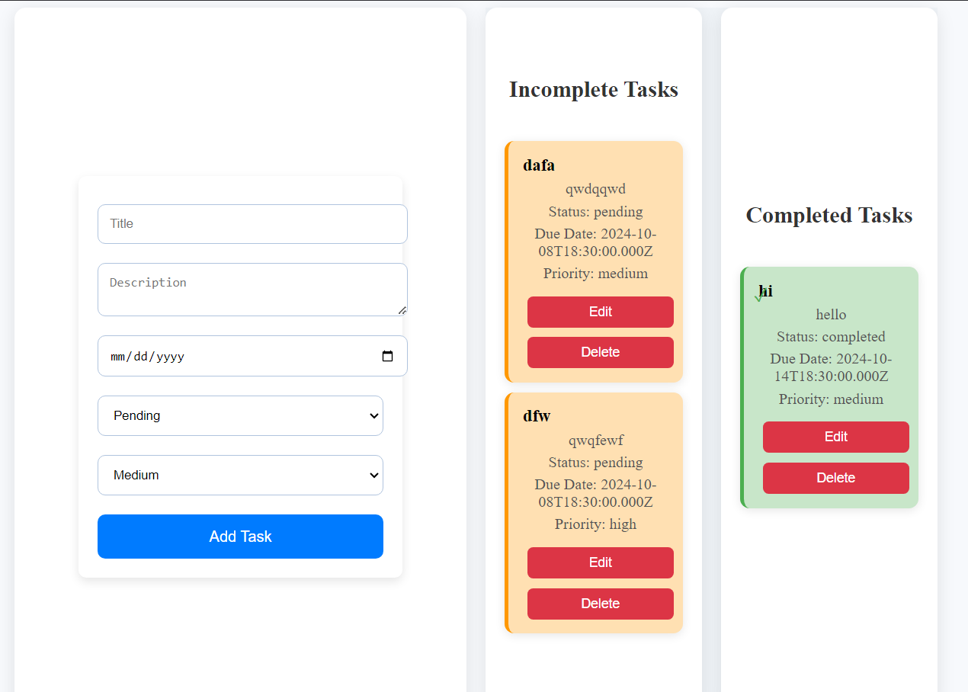

* Process:  
  npm init -y
* npm install express
* npm install cors
* npm install body-parser
* npm install mysql2
* connect to mysql2
* Run the react app and server for their repective localhost:3000 & 5000  
  Add tables:

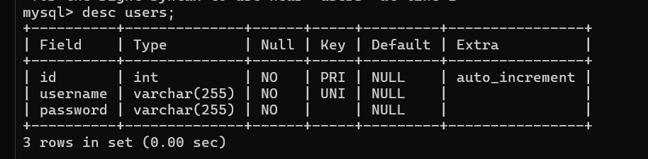

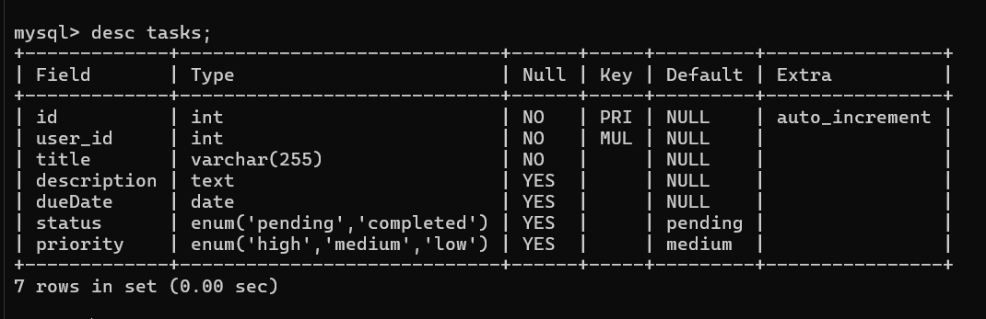

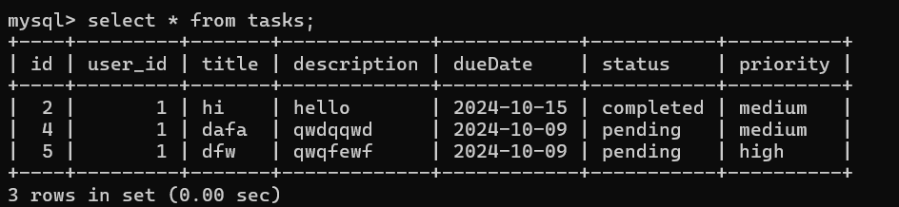

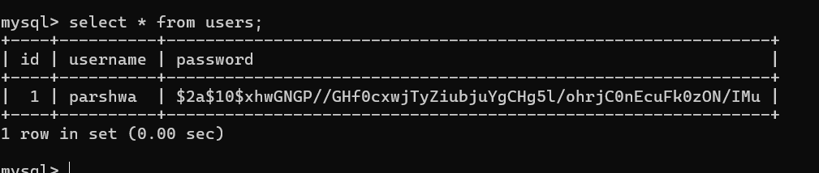

Application

• Create a simple blog platform where users can sign up, log in, and write, edit, or

delete their blog posts. Other users can view the blog posts but not edit or delete

them.

• User authentication (JWT).

• Blog post CRUD operations.

• Display all blog posts on the homepage, with individual post details accessible

through a unique URL.

• Add comm ent functionality where users can comment on blog posts.



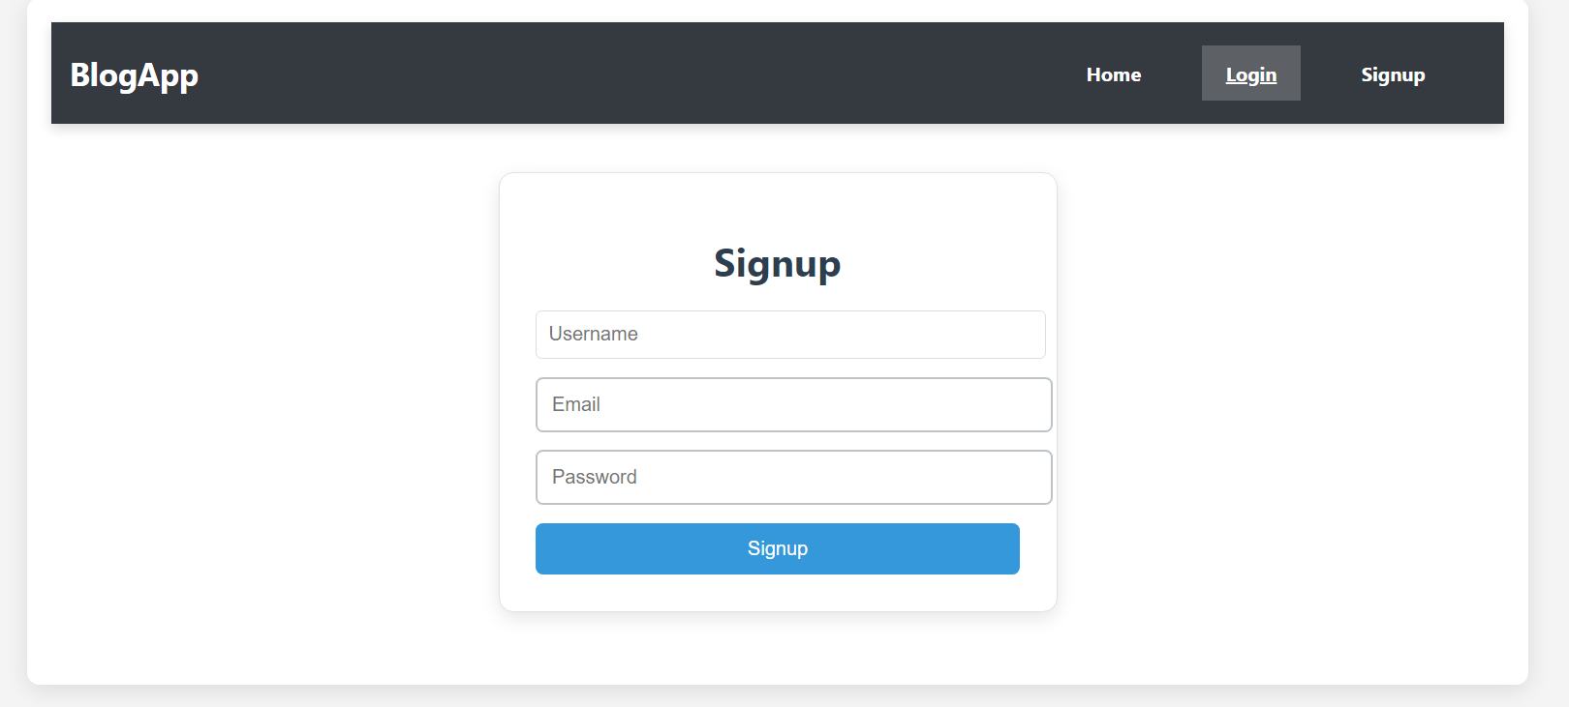

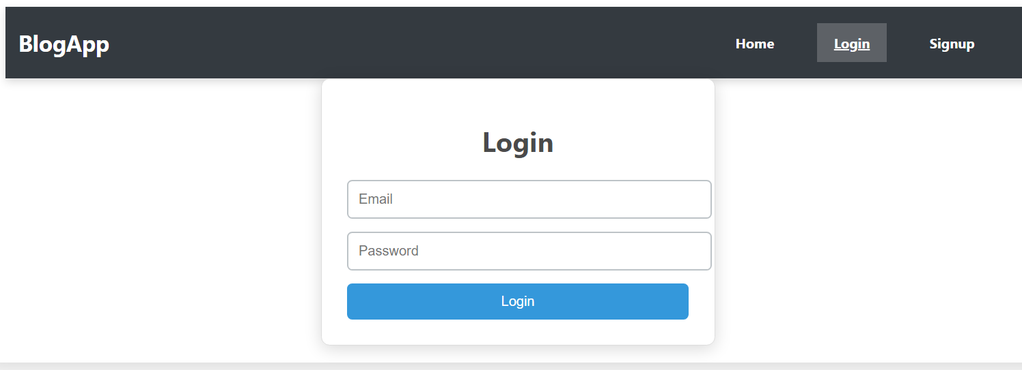

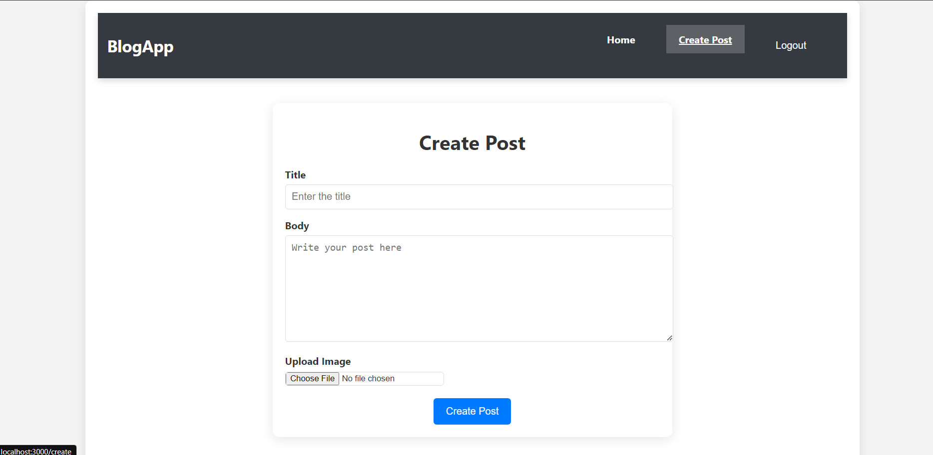

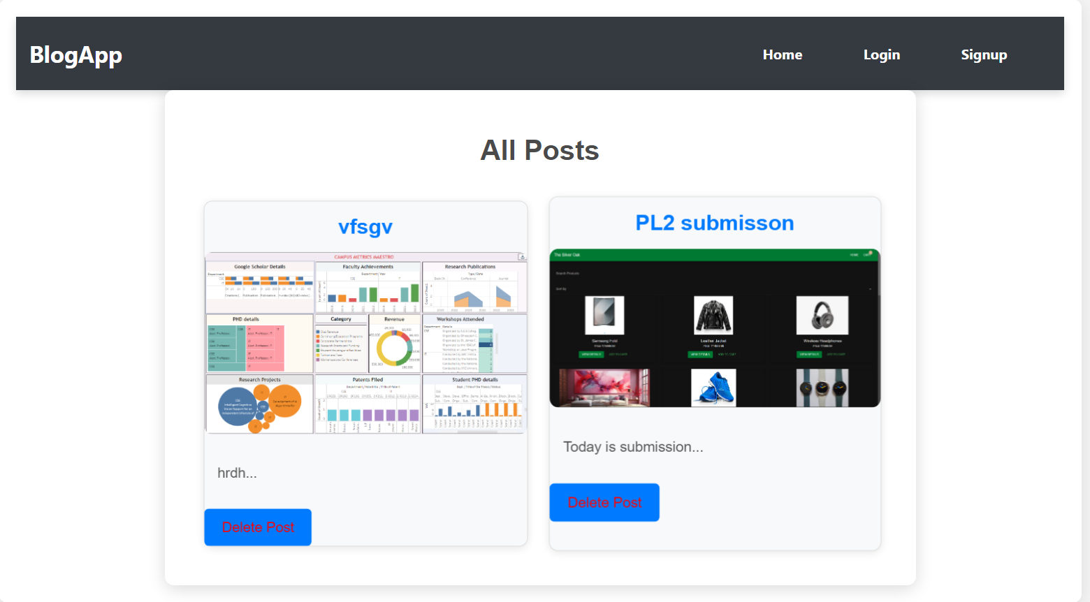

* Process:  
  npm init -y
* npm install express
* npm install cors
* npm install body-parser
* npm install mysql2
* connect to mysql2
* Run the react app and server for their repective localhost:3000 & 5000
* Add tables:

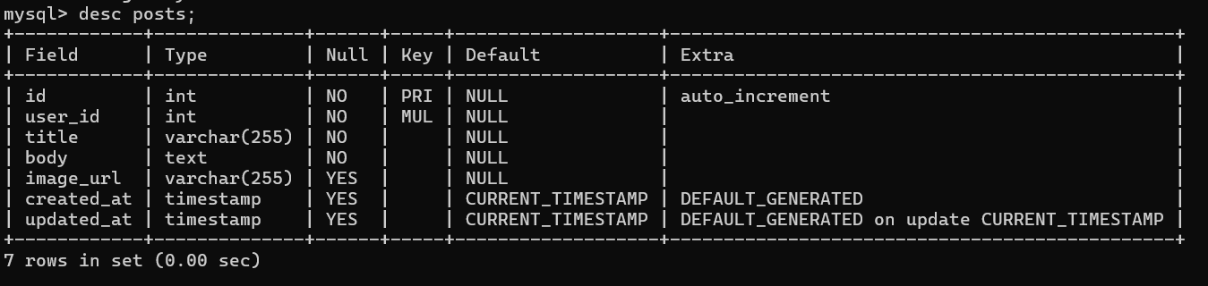

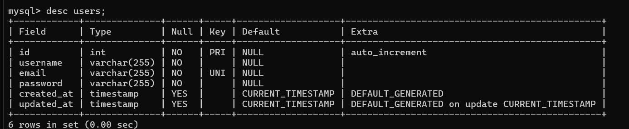

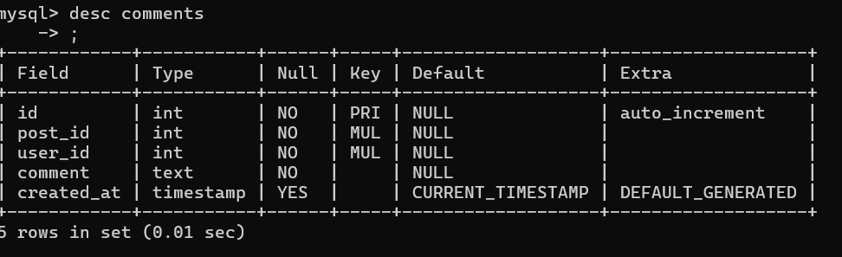

When u upload posts:  
