**Batch : T6**

**Practical No. 2**

**Title of Assignment:** Study of HTML and CSS. Create a website which displays the course information using static web pages

**Student Name: Parshwa Herwade**

**Student PRN: 22510064**

Problem Statement 1: Basic HTML • Create a HTML file named "course.html" with a proper document structure. • Add a title to the webpage: "Introduction to [Your Course Name] Course". • Create a header section with the course name as the main heading and a brief description as a subheading. • Design a navigation menu with links to different sections of the page: "About the Course," "Course Outline," and "Instructors." (For this you may create separate pages and link them or you can create it on single page. But when you click on the navigation menu only those particular contents will be displayed)

ANS. Problem Statement 1: Basic HTML:

HTML Document Structure: The foundation of any web page, defining the structure using elements like <!DOCTYPE html>, <html>, <head>, and <body>.

Semantic HTML: Using elements like <header>, <nav>, <section>, and <footer> to structure content meaningfully and improve accessibility.

Navigation Menu: Facilitates easy access to different sections of the page or external links, improving user experience.

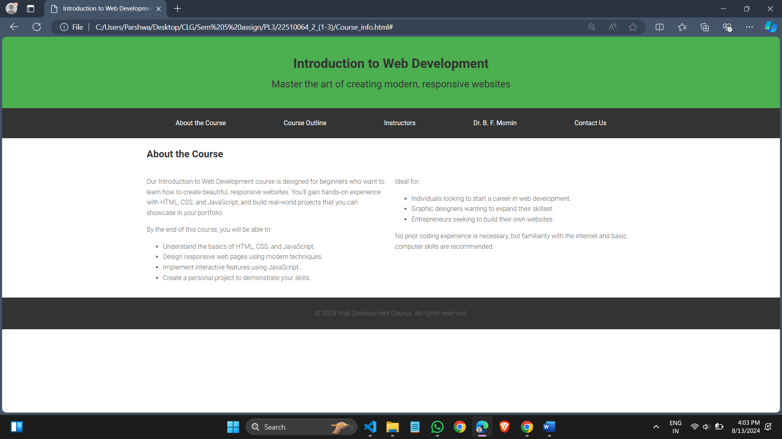

Problem Statement 2: Styling with CSS • Create a separate CSS file named "styles.css" and link it to the "course.html" file. • Style the header section with a background colour, white text colour, and proper padding. • Apply a font-family of your choice to the entire document. • Add a background colour to the navigation menu items when hovered over. • Style the course description text with a distinctive font style and colour. • Create a two-column layout for the "About the Course" and "Course Outline" sections using CSS Grid or Flexbox. • Apply a box-shadow to the instructor cards in the "Instructors" section. • Style the footer with a dark background colour, light text colour, and centred content.

ANS. Problem Statement 2: Styling with CSS

Technologies/Frameworks Used:

CSS3:

CSS Linking: Connecting a CSS file to an HTML document using the <link> tag in the <head> section.

Styling Elements: Customizing the appearance of HTML elements, such as colors, fonts, and layouts.

CSS Grid and Flexbox: Modern layout modules in CSS that allow for responsive and flexible two-dimensional layouts.

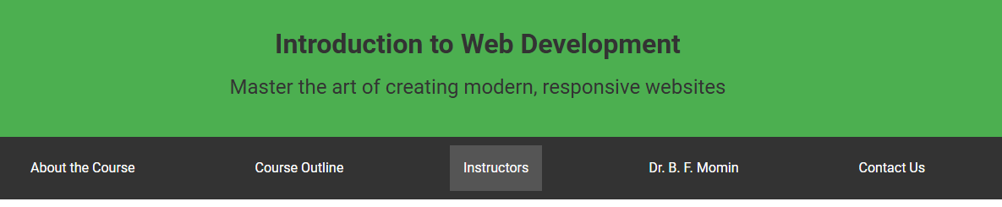Problem Statement 3: Course Content Display • In the "About the Course" section, provide a detailed description of the course, including its objectives and target audience. • Create an ordered or unordered list in the "Course Outline" section, outlining at least Six modules/topics covered in the course. • Display instructor information in the "Instructors" section, including their names, photos, and a brief bio.

ANS. Technologies/Frameworks Used:

HTML5:

Content Sections: Organizing content into clear sections like "About the Course," "Course Outline," and "Instructors" for readability.

Lists: Utilizing ordered (<ol>) or unordered (<ul>) lists to structure content hierarchically.

Instructor Cards: Presenting information in a visually appealing manner using images, names, and brief bios.

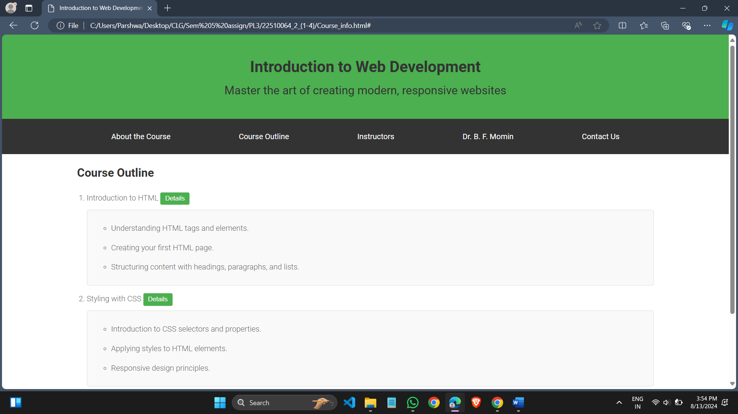

Problem Statement 4: Responsive Design • Implement responsive design techniques to make the website mobile-friendly. • Ensure that the navigation menu collapses into a hamburger menu on smaller screens. • Adjust the layout and font sizes for optimal viewing on various devices.

ANS. Responsive Design: Ensuring the website adapts to different screen sizes, enhancing usability on mobile devices.

Media Queries: CSS feature that applies styles based on device characteristics, like screen width.

Hamburger Menu: A compact navigation menu that improves mobile navigation by hiding and showing menu items as needed.

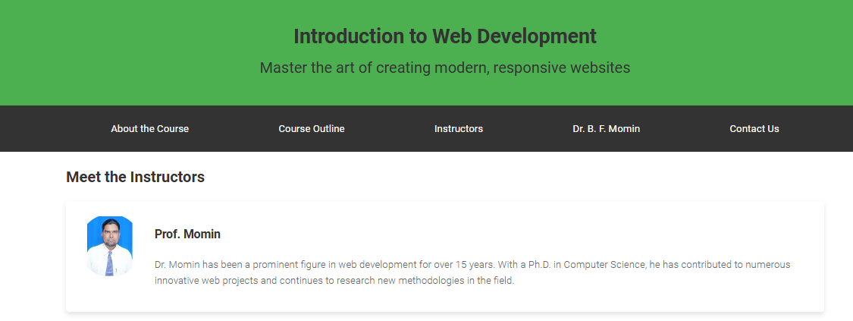

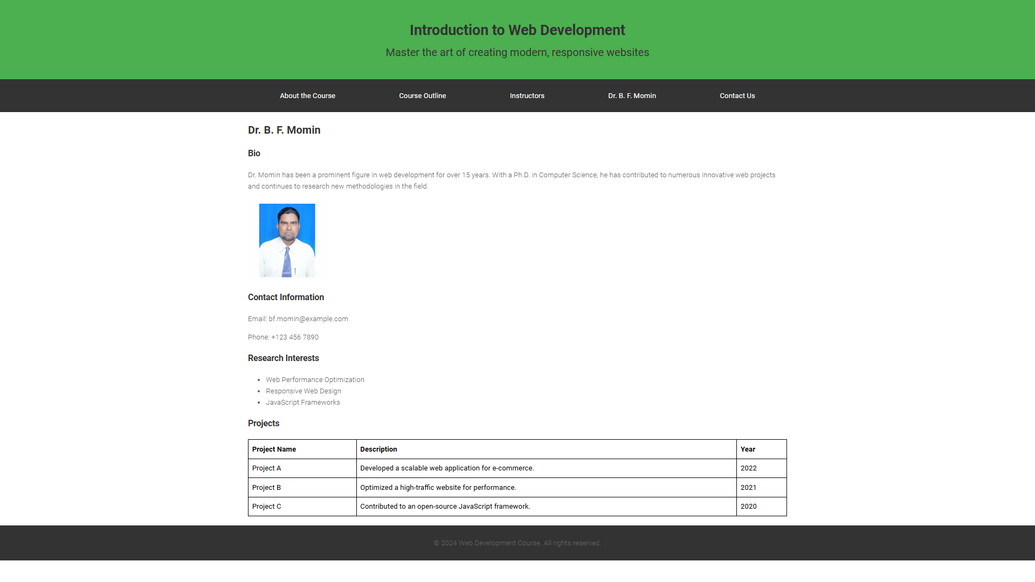

Problem Statement 5: Extra Enhancements • Create a hover effect for the instructor cards, such as changing the border colour or adding a shadow. • Add transition effects to navigation menu items and buttons. • Implement a Google Fonts integration to style the text fonts. Other than the above problem statements you may add some Interactive Elements as per your choice. Some of them are as follows: • Add a button in the "Course Outline" section that, when clicked, reveals additional details about each module. • Create a "Contact Us" section at the end of the page with a form for users to submit their inquiries.

ANS. CSS3 (for transitions and effects)

Google Fonts

HTML5 (for interactive elements like buttons and forms)

Hover Effects and Transitions: Enhancing user interaction by adding visual effects that respond to user actions.

Google Fonts Integration: Importing and using custom fonts to improve the aesthetic appeal of the website.

Interactive Elements: Adding features like buttons and forms to engage users and collect input.

