**Batch : T6**

**Practical No. 3**

**Title of Assignment:** Study of Java Script

**Student Name: Parshwa Herwade**

**Student PRN: 22510064**

**1. Technologies/Frameworks Used**

**HTML5**: For structuring the content of the web pages.

* **CSS3**: For styling the web pages, including layouts, fonts, colors, and responsive design.
  + **Flexbox** and **Grid** for layout management.
  + **Media Queries** for responsive design.
* **JavaScript**: For adding interactivity to the web pages.
  + **DOM Manipulation**: To interact with HTML elements dynamically.
  + **Event Handling**: For capturing user actions like button clicks.
  + **Regular Expressions**: For password validation.
* **Optional Frameworks/Libraries**:
  + **Bootstrap**: For faster, responsive design (if desired).
  + **jQuery**: For simpler DOM manipulation (optional, depending on preference).

**Problem Statement 1: Basics of JavaScript**

* **JavaScript Functions**: Understanding how functions work in JavaScript, particularly those that handle arrays, is essential. You'll work with array methods like forEach() and conditional logic to filter and sum even numbers.
* **User Input Handling**: Parsing user input from a text field and converting it into a usable data format (array of numbers) involves basic string manipulation and type conversion.

**Problem Statement 2: Password Validation**

* **Regular Expressions**: Regular expressions (RegEx) are crucial for validating password complexity. The regex pattern will ensure the password meets all specified criteria (length, uppercase, lowercase, digit, special character).
* **Form Validation**: This involves both client-side validation (with JavaScript) and understanding how to secure user input. Client-side validation is not a substitute for server-side validation but is essential for improving user experience.

**Problem Statement 3: Web Development**

* **HTML Structure**: Designing a clear and intuitive layout for the bookstore involves creating a semantically correct HTML structure. This includes the use of <header>, <nav>, <section>, <div>, and <footer> tags.
* **CSS for Styling**: CSS will be used to style the page, with a focus on creating a visually appealing interface. The use of Flexbox and Grid is recommended for creating responsive layouts.
* **JavaScript for Interactivity**: Implementing a shopping cart requires JavaScript to track the items added to the cart and update the cart total dynamically. Understanding the Document Object Model (DOM) is essential here.

**Problem Statement 4: Responsive Design**

* **Responsive Web Design**: This ensures the web page looks good on all devices, including desktops, tablets, and smartphones. Techniques like flexible grids, images, and CSS media queries will be used.
* **Hamburger Menu**: A popular pattern for responsive navigation on smaller screens. This can be implemented using CSS, JavaScript, or frameworks like Bootstrap.

Problem Statement 1: Basics of Java Script Write a JavaScript function that takes an array of numbers as input and returns the sum of all even numbers in the array. Additionally, create a simple HTML interface with an input field where the user can enter comma-separated numbers and a button to trigger the calculation. Display the result below the button.

Ans.

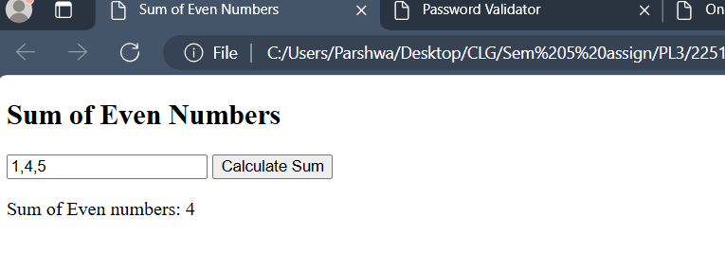

Problem Statement 2: Implement a function that validates a password based on the following criteria: • At least 8 characters long. • Contains at least one uppercase letter, one lowercase letter, one digit, and one special character. Create an HTML form with an input field for the password and a "Check Password" button. Display a message indicating whether the password is valid or not.

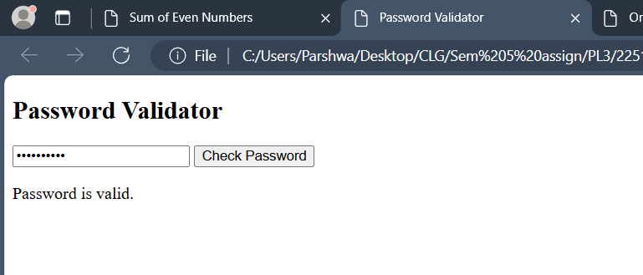

Problem Statement 3: Web Development Create a basic web page for a fictional online bookstore using HTML, CSS, and JavaScript. The web page should have the following features: • A header with the bookstore name and a navigation menu (Home, Books, Contact). • An area to showcase featured books with their titles, authors, and cover images. • A section where all available books are displayed in a grid format. Each book should have an image, title, author, and a button to "Add to Cart". • Implement a simple shopping cart functionality using JavaScript. Allow users to add books to their cart and display the total number of items in the cart on the navigation menu.

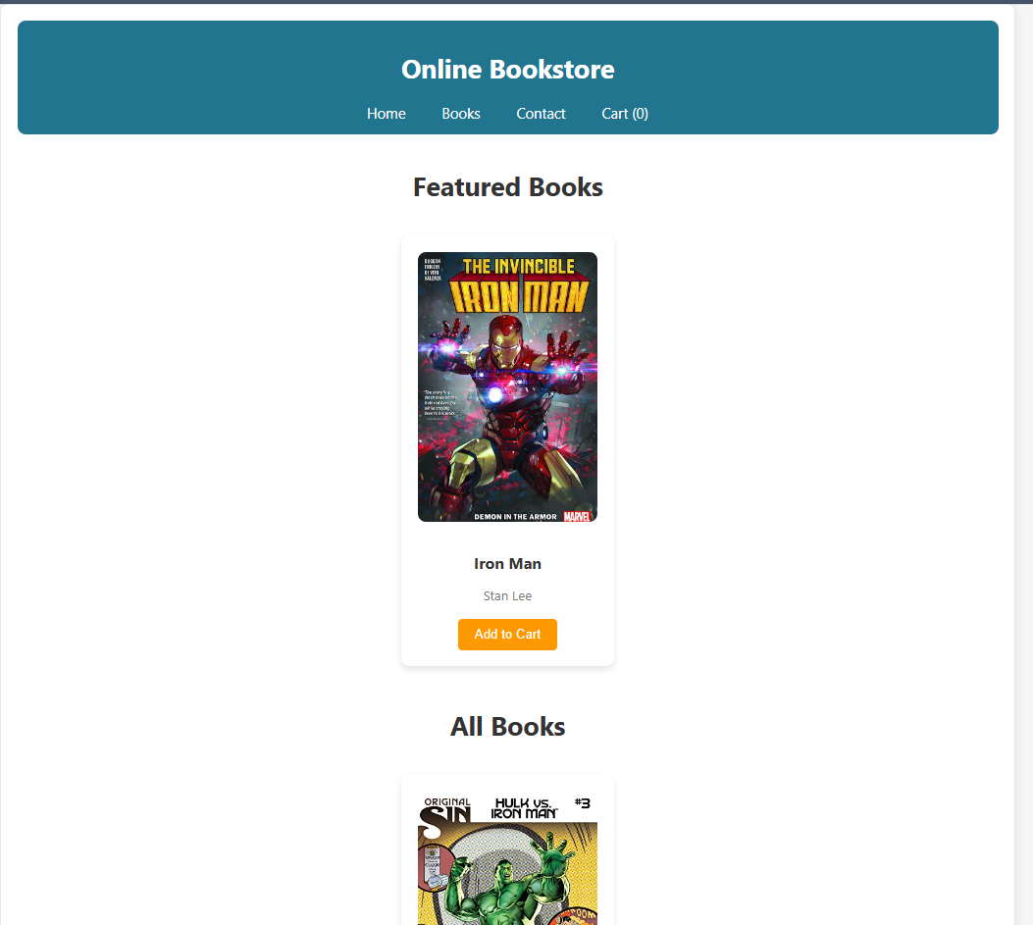

Problem Statement 4: Responsive Design • Implement responsive design techniques to make the website mobile-friendly. • Ensure that the navigation menu collapses into a hamburger menu on smaller screens. • Adjust the layout and font sizes for optimal viewing on various devices.

