Computer network lab

Assignment 6 : ARP lab

Parshwa Herwade , 22510064 ,SY BTECH CSE

1.Write down the contents of your computer’s ARP cache. What is the meaning of each column value?

Ans. The Internet Address column contains the IP address, the Physical Address column contains the MAC address, and the type indicates the protocol type i.e. ARP.

2.What are the hexadecimal values for the source and destination addresses in the Ethernet frame containing the ARP request message?

Ans. 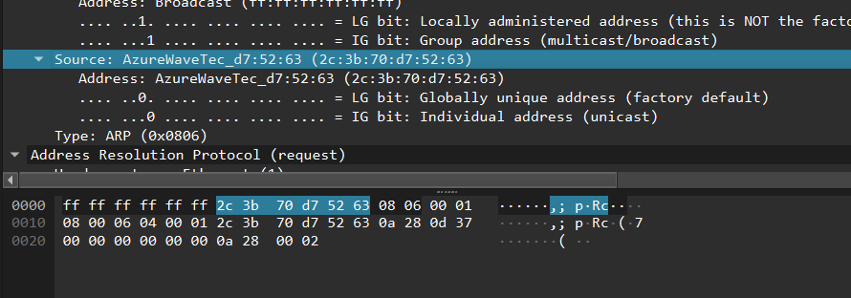

Source: 2c:3b:70:d7:52:63

Destination: ff:ff:ff:ff:ff:ff

3. Give the hexadecimal value for the two-byte Ethernet Frame type field. What upper layer protocol does this correspond to?

Ans. 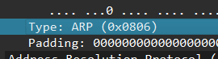

4. Download the ARP specification from ftp://ftp.rfc-editor.org/in-notes/std/std37.txt. A readable, detailed discussion of ARP is also at http://www.erg.abdn.ac.uk/users/gorry/course/inet-pages/arp.html.

a) How many bytes from the very beginning of the Ethernet frame does the ARP opcode field begin?

Ans. 20

b) What is the value of the opcode field within the ARP-payload part of the Ethernet frame in which an ARP request is made?

Ans. ARP-payload of the request is 0x0001.

c) Does the ARP message contain the IP address of the sender?

Ans. Yes,it does contain.

d) Where in the ARP request does the “question” appear – the Ethernet address of the machine whose corresponding IP address is being queried?

Ans. 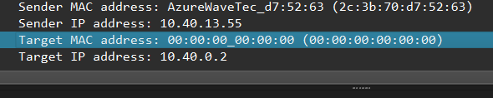

5. Now find the ARP reply that was sent in response to the ARP request.

a) How many bytes from the very beginning of the Ethernet frame does the ARP opcode field begin?

Ans. There are 20 bytes.

b) What is the value of the opcode field within the ARP-payload part of the Ethernet frame in which an ARP response is made?

Ans. ARP-payload of the request is 0x0002.

c) Where in the ARP message does the “answer” to the earlier ARP request appear – the IP address of the machine having the Ethernet address whose corresponding IP address is being queried?

Ans. Sender: 2c:3b:70:d7:52:63.

6. What are the hexadecimal values for the source and destination addresses in the Ethernet frame containing the ARP reply message?

Ans. 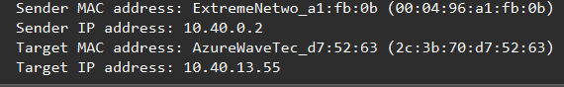

7. Open the ethernet-ethereal-trace-1 trace file in http://gaia.cs.umass.edu/wireshark-labs/wireshark-traces.zip. The first and second ARP packets in this trace correspond to an ARP request sent by the computer running Wireshark, and the ARP reply sent to the computer running Wireshark by the computer with the ARP-requested Ethernet address. But there is yet another computer on this network, as indicated by packet 6 – another ARP request. Why is there no ARP reply (sent in response to the ARP request in packet 6) in the packet trace?

Ans. We are not at the machine that sent the request. The ARP request is broadcast, but the ARP reply is sent back directly to the sender’s Ethernet address.