NAME: PARSHWA HERWADE (22510064)

SY BTECH CSE

**NETWORKING DEVICES:**

1. **Hub:**

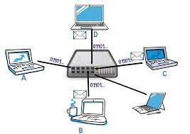

- **Responsibility:** Connects multiple devices in a network.

- **Function:** Broadcasts data to all connected devices in the network, regardless of the intended recipient.

- **Description:** Hubs operate at the Physical layer (Layer 1) and are essentially simple devices that amplify and repeat incoming electrical signals.

1. **Switch:**



**- Responsibility:** Efficiently manages data traffic within a local network.

- **Function:** Uses MAC addresses to forward data only to the specific device it is intended for, reducing network congestion.

- **Description:** Switches operate at the Data Link layer (Layer 2) and are more intelligent than hubs, creating separate collision domains for each port.

1. **Router:**

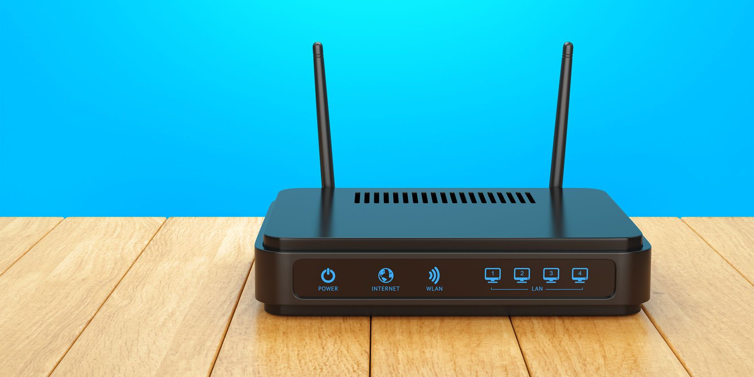

**- Responsibility:** Connects different networks and directs data between them.

- **Function:** Utilizes routing tables to determine the best path for data transmission based on IP addresses.

- **Description:** Routers operate at the Network layer (Layer 3) and are essential for interconnecting multiple networks.

1. **Bridge:**

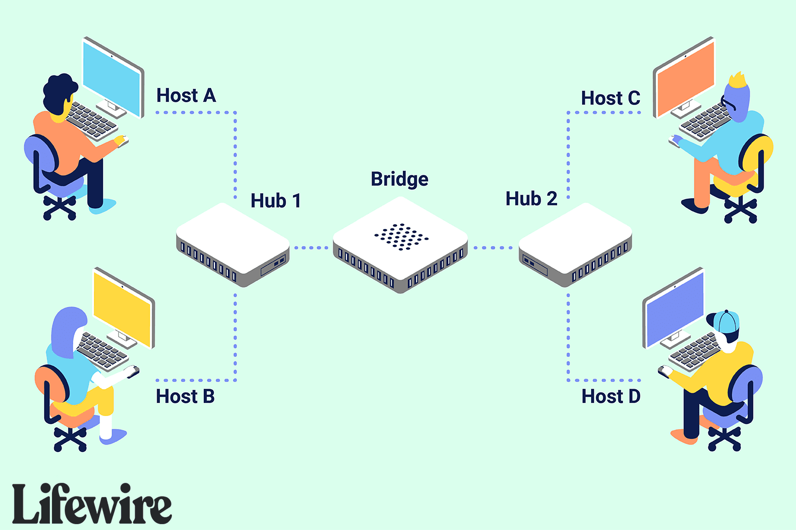

- **Responsibility:** Connects and filters traffic between two similar network segments.

- **Function:** Operates at the Data Link layer (Layer 2) and uses MAC addresses to forward data only to the intended segment, reducing collision domains.

- **Description:** Bridges are used to divide large networks into smaller segments for improved performance.

1. **Gateway:**

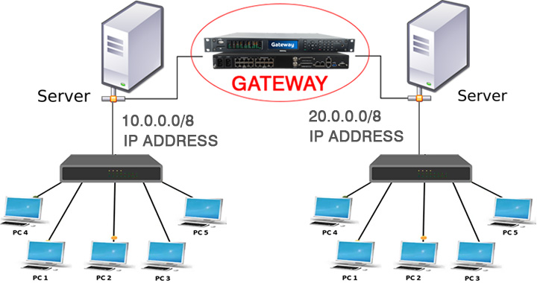

- **Responsibility:** Connects different types of networks, translating protocols if necessary.

- **Function:** Acts as a translator between different network architectures, allowing communication between incompatible systems.

- **Description:** Gateways can operate at multiple layers, depending on the specific translation requirements.

1. **Repeater:**

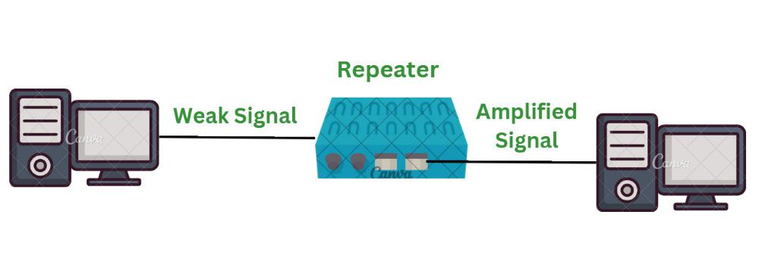

- **Responsibility:** Amplifies and retransmits signals over long distances.

- **Function:** Operates at the Physical layer (Layer 1) and regenerates weakened signals to extend the range of a network.

- **Description:** Repeaters are used to overcome signal attenuation and maintain signal integrity in long-distance transmissions.

1. **Firewall:**

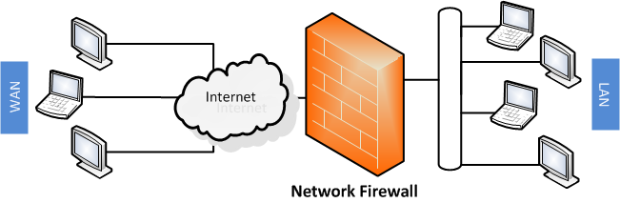

- **Responsibility:** Provides network security by controlling incoming and outgoing traffic.

- **Function:** Monitors and filters data packets based on predetermined security rules to prevent unauthorized access.

- **Description:** Firewalls operate at various layers, including the Network layer (Layer 3) and Transport layer (Layer 4), and can be implemented as hardware or software.

1. **Proxy Server:**

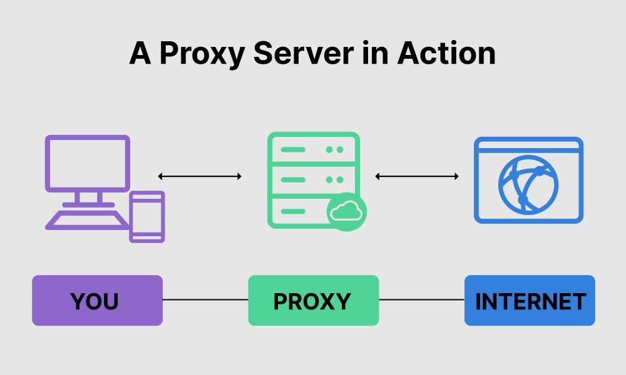

- **Responsibility:** Acts as an intermediary between clients and servers.

- **Function:** Caches frequently requested content, reducing bandwidth usage and improving response times**.**

**- Description:** Operates at the Application layer (Layer 7) of the OSI model and is often used for content filtering and access control.

1. **Load Balancer:**

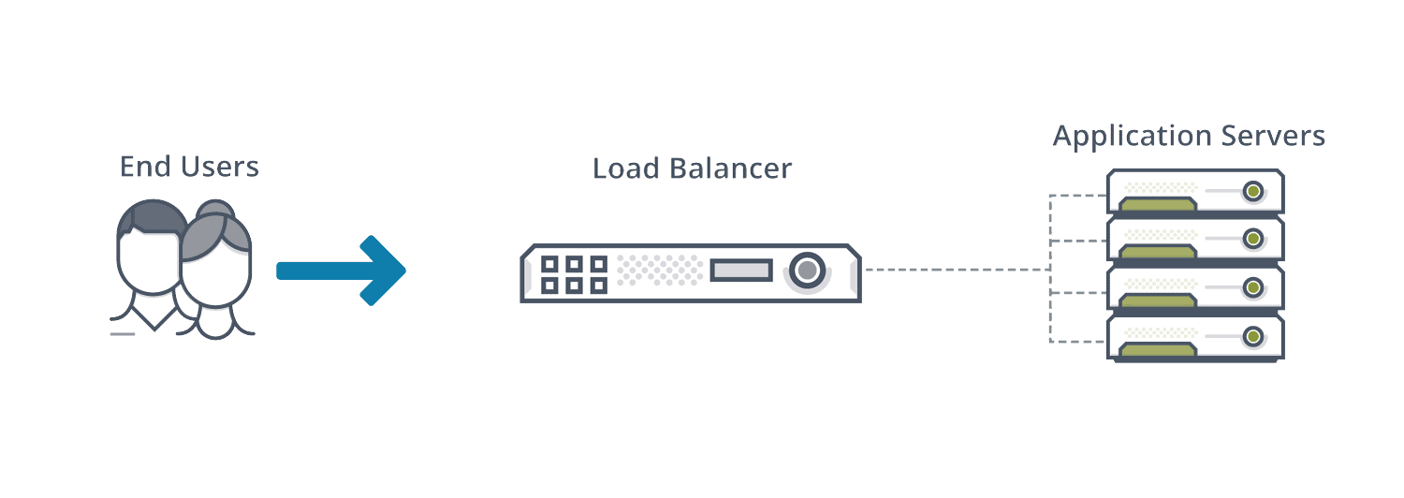

- **Responsibility:** Distributes network traffic across **multiple servers to prevent overload.**

**- Function:** Enhances network performance, ensures high availability, and avoids server congestion.

- **Description:** Load balancers operate at either the Application layer (Layer 7) or Transport layer (Layer 4), directing traffic based on factors like server health and load.

1. **Modem:**

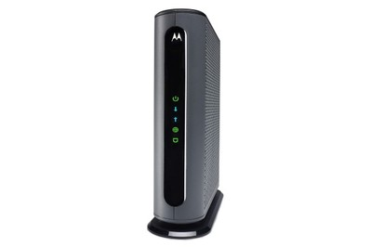

- Responsibility: Converts digital signals from a computer to analog signals for transmission over analog communication lines (and vice versa).

- **Function:** Modulates digital data into analog signals for transmission and demodulates incoming analog signals into digital data.

- **Description:** Modems primarily operate at the Physical layer (Layer 1) and are crucial for connecting digital devices to analog communication mediums.

1. **NIC (Network Interface Card):**

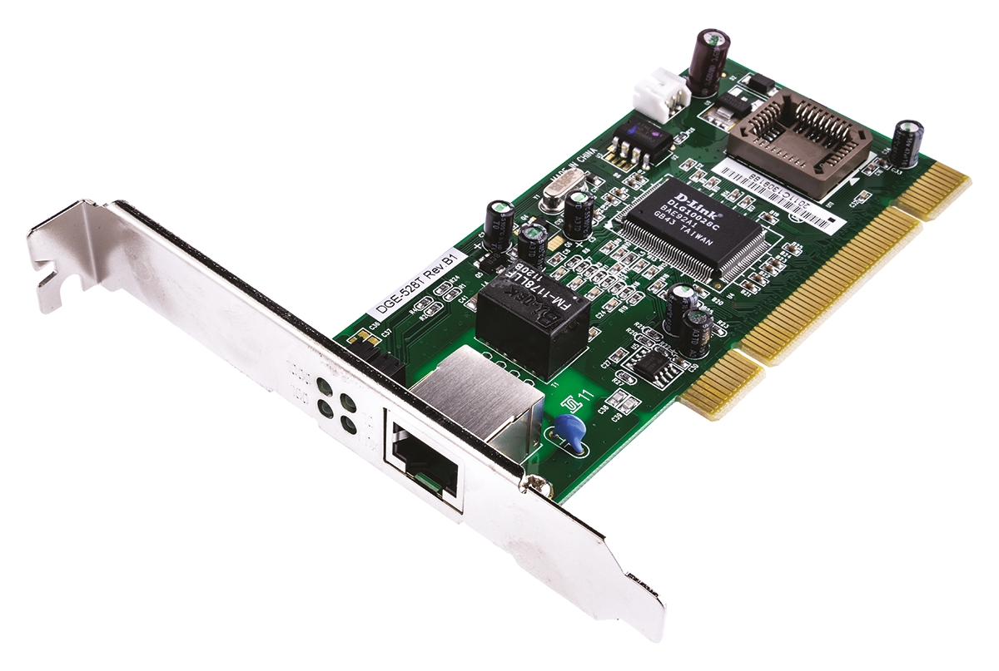

- **Responsibility:** Connects a computer or device to a network.

- **Function:** Manages the communication between the device and the network, handling tasks like addressing and packet transmission.

**- Description:** NICs operate at the Data Link layer (Layer 2) and Physical layer (Layer 1), providing the interface for network connectivity.

1. **Access Point:**

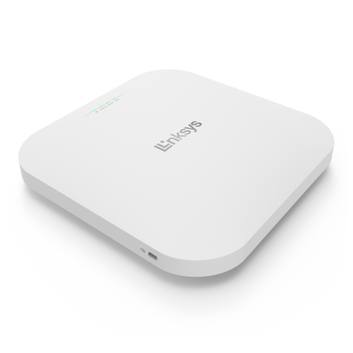

- **Responsibility:** Provides wireless connectivity to a wired network.

- **Function:** Acts as a central connection point for Wi-Fi-enabled devices to connect to the wired network.

- **Description:** Access points operate at the Data Link layer (Layer 2) and Physical layer (Layer 1) for wireless communication, facilitating wireless connections within a local area network (LAN).