NAME: PARSHWA HERWADE (22510064)

SY BTECH CSE

**NETWORKING COMMANDS:**

**Experiment no 2:**

1. **ipconfig (Windows) / ifconfig (Linux/macOS)**

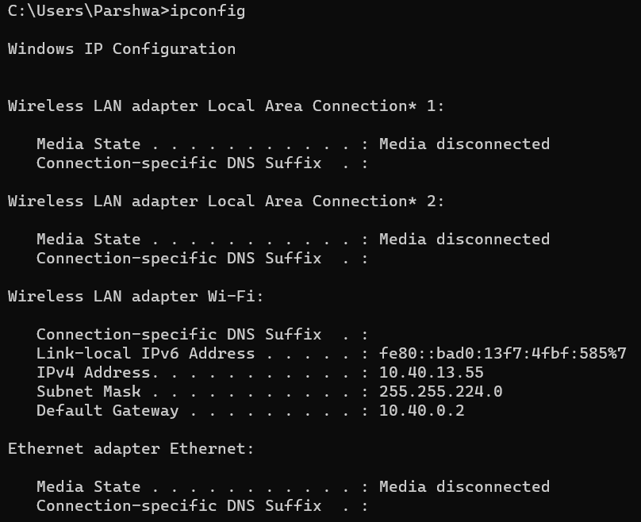

- Displays the configuration of network interfaces on a Windows system.

- Provides information such as IP address, subnet mask, default gateway, and DNS servers for each network interface.

1. **ping**

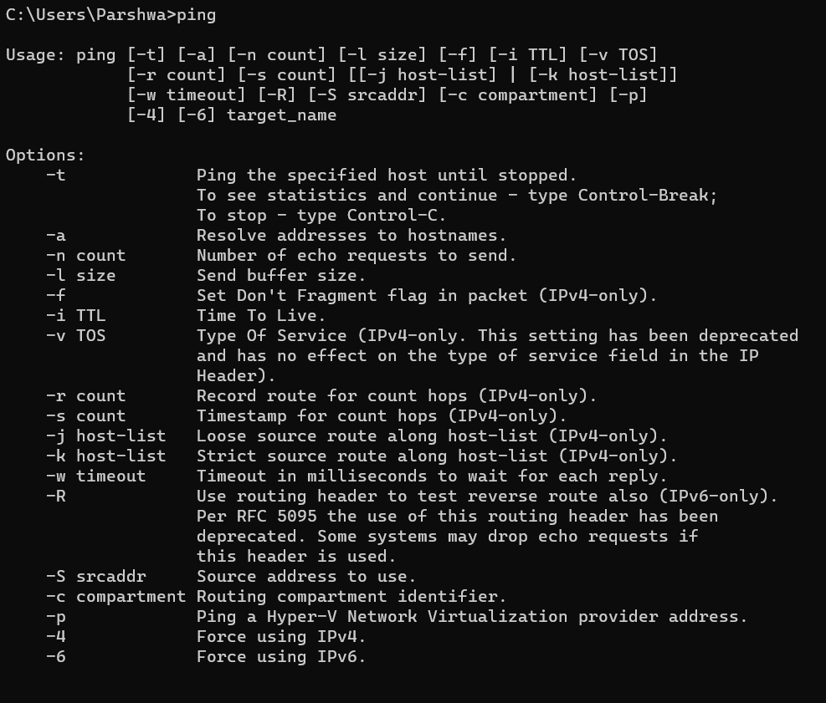

- Sends Internet Control Message Protocol (ICMP) Echo Request messages to a specified network host.

- Measures the round-trip time for messages to travel from the source to the destination and back.

- Helps in assessing network connectivity and latency.

1. **traceroute (Linux/macOS) / tracert (Windows)**

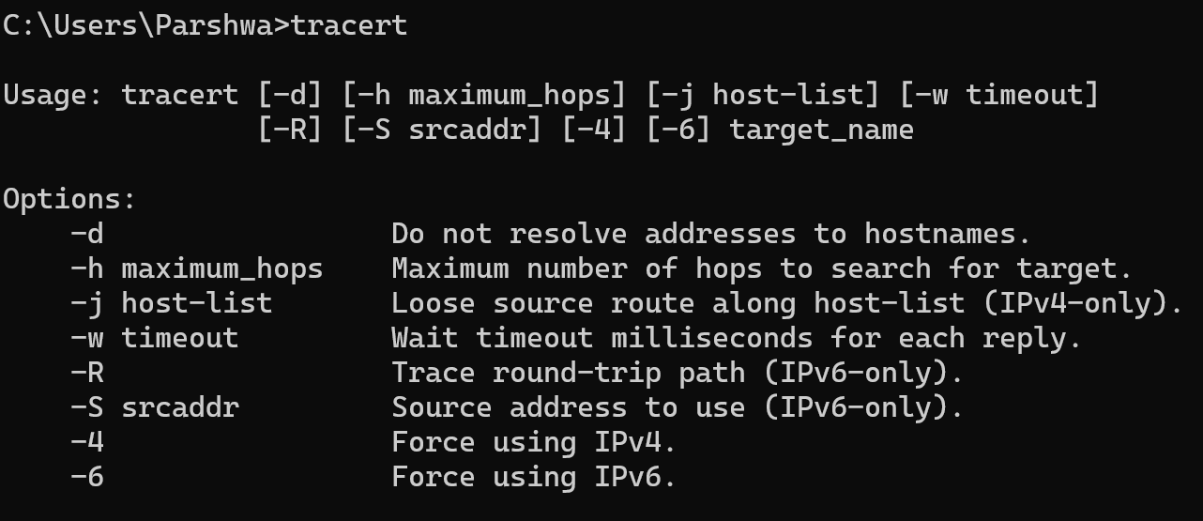

- Traces the route that packets take to reach a destination.

- Shows the IP addresses of routers along the path and the time it takes for packets to travel to each router.

- Useful for diagnosing network issues and identifying slow or problematic network segments.

1. **nslookup / dig**

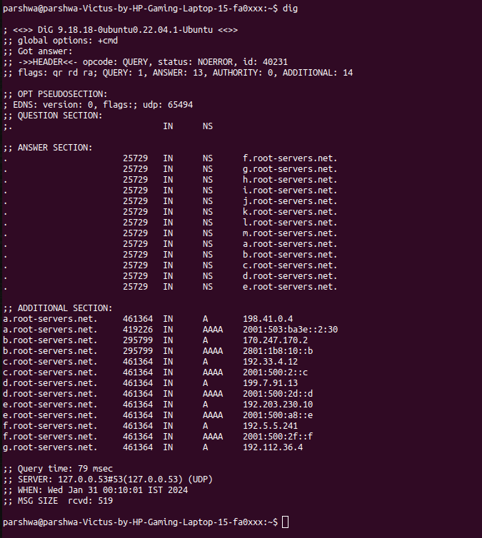

- nslookup (Windows): Resolves and displays domain name system (DNS) information, such as IP addresses associated with a domain.

- dig (Linux/Unix): A similar tool for DNS queries, providing detailed information about DNS records and their configurations.

1. **netstat**

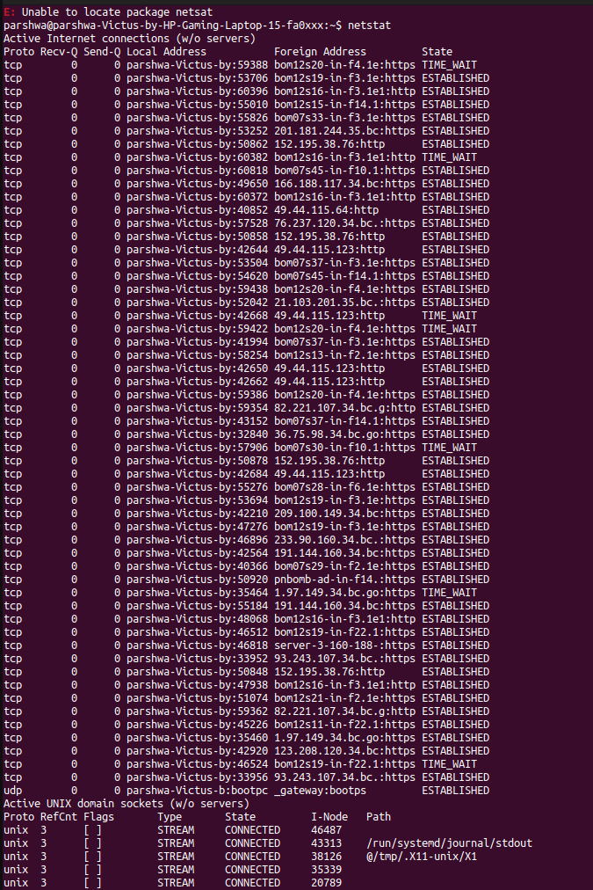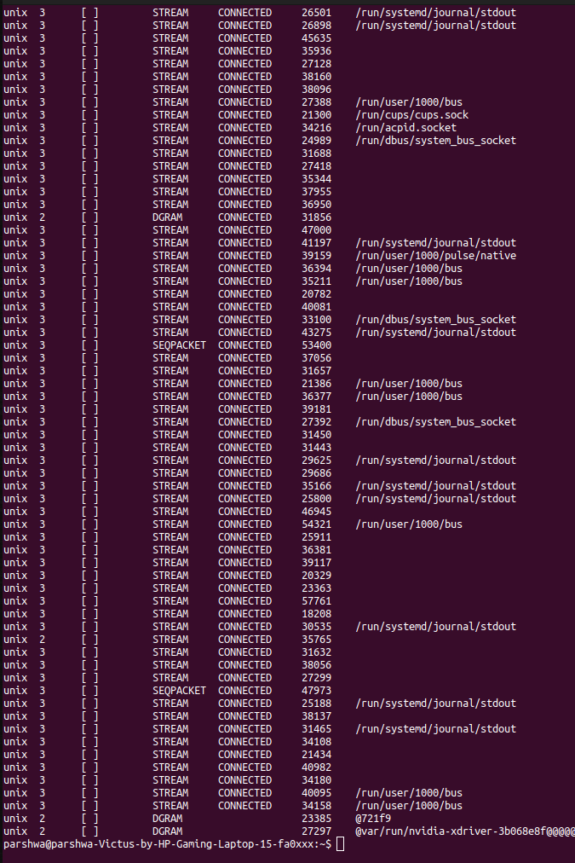

- Displays network connections, routing tables, interface statistics, masquerade connections, and more.

- Shows active network connections, listening ports, and information about each connection.

1. **route (Linux/macOS) / route print (Windows)**

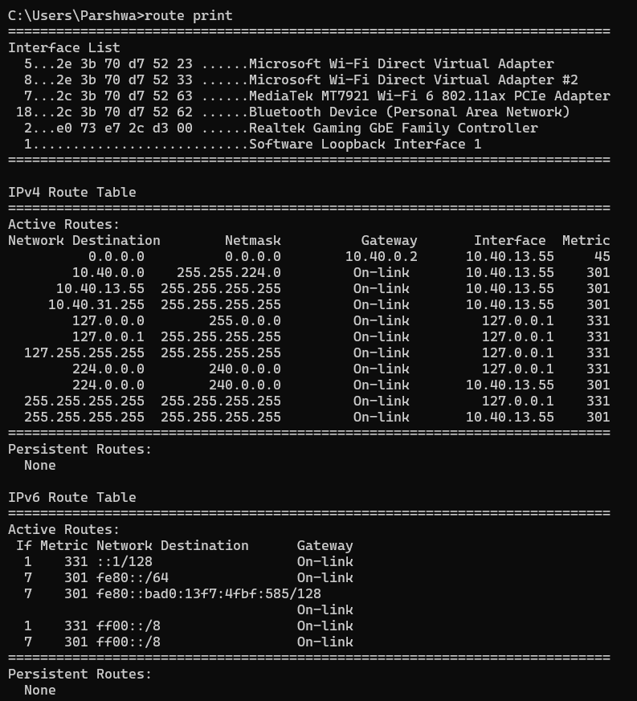

- Displays the IP routing table on a Windows system.

- Shows the routes that the system uses to forward IP packets, including destination IP addresses, subnet masks, gateways, and interface indices.

1. **arp**

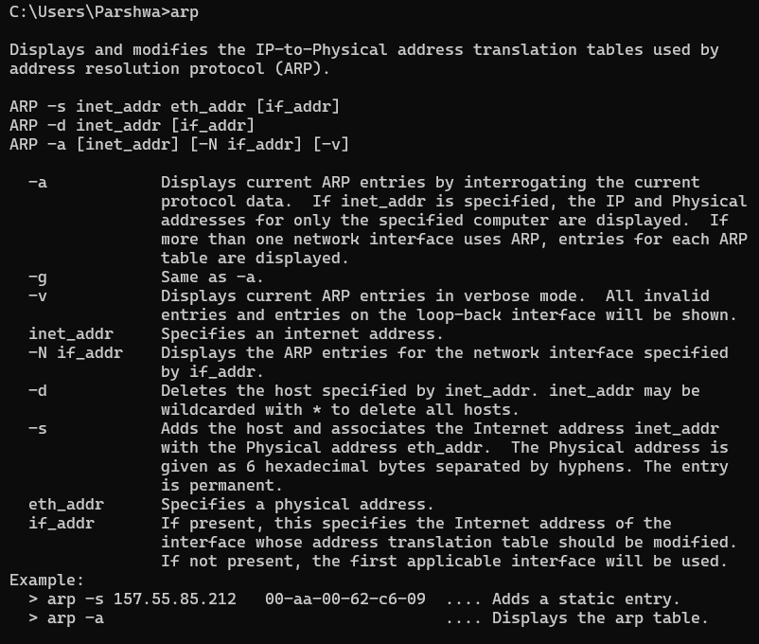

- Displays and modifies the Address Resolution Protocol (ARP) cache.

- Shows the mapping between IP addresses and MAC addresses on a local network

1. **nmap**

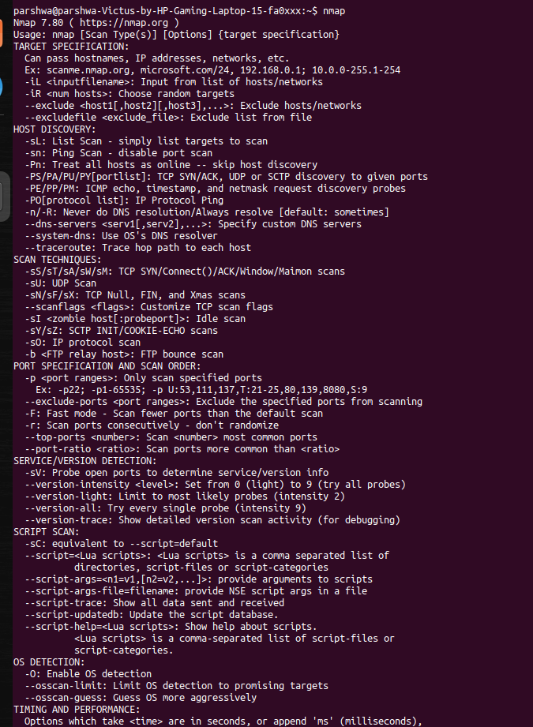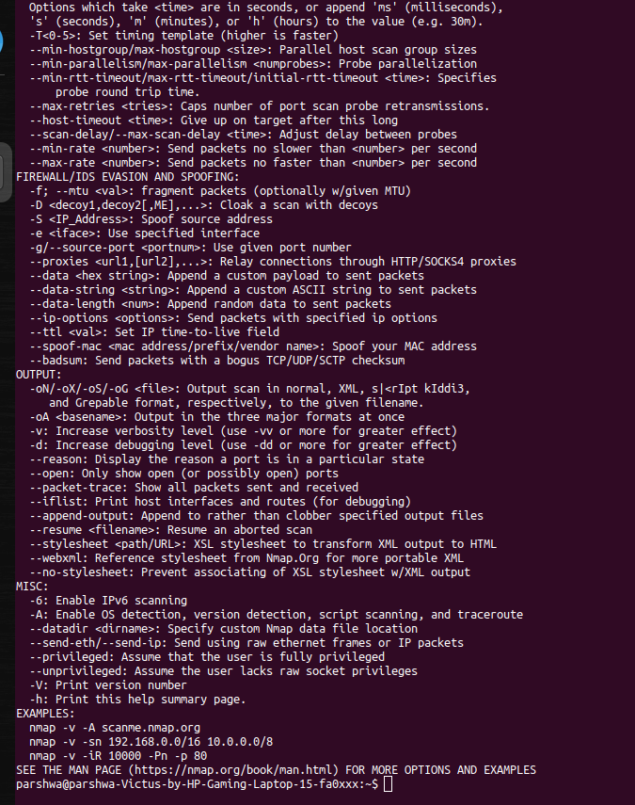

- Network scanning tool that discovers hosts and services on a computer network.

- Provides information about open ports, services running, and other details to assess the security of a network.

1. **telnet**

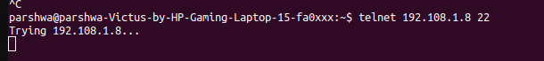

- Establishes a connection to a remote server using the Telnet protocol.

- Used for testing network connectivity and troubleshooting by connecting to a specified port on a remote host.

1. **hostname**



- Displays the hostname of the computer or device.

- Useful for identifying the local machine within a network.

1. **tcpdump**

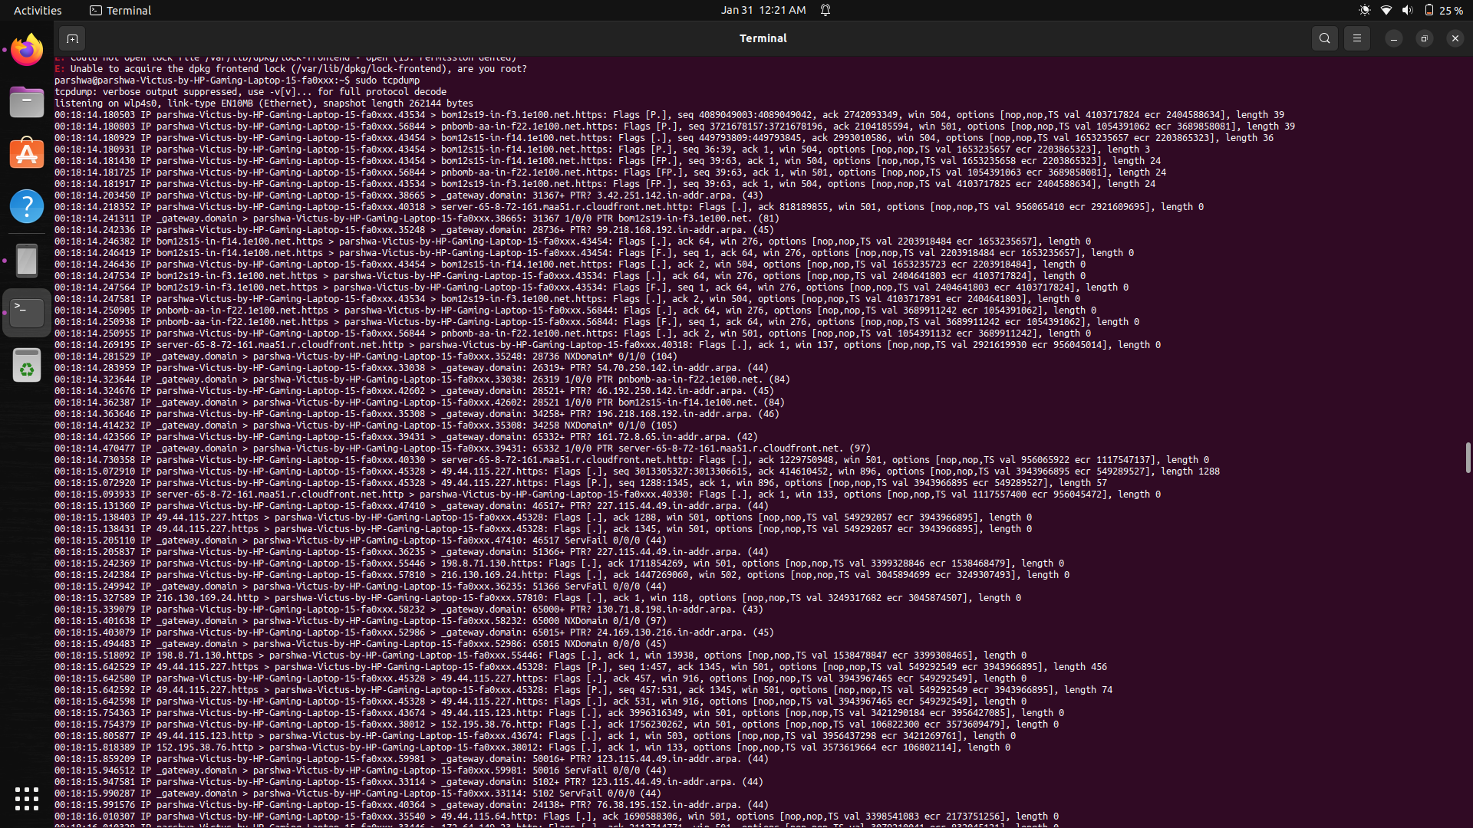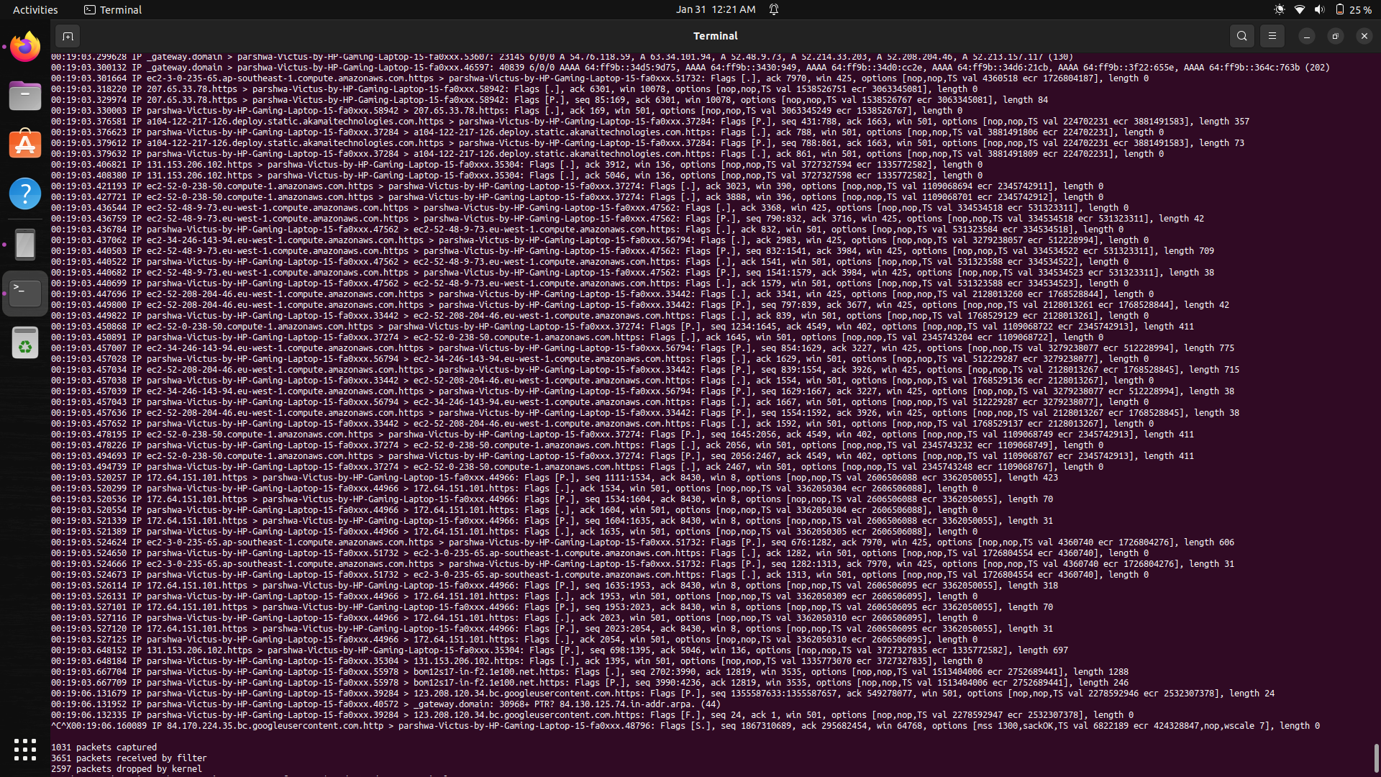

- A packet analyzer that captures and displays TCP/IP packets on a network.

- Provides detailed information about the data flowing through a network, including source and destination addresses, protocols, and content.