PARSHWA HERWADE (22510064)

SY BTECH CSE

COMPUTER NETWORK LAB

Assignment 3: Wireshark and packet tracer Installation:

1. Install Wireshark and packet tracer in your system

2. Prepare document showing each step of installation 3. Add screenshots

4. Write down the various functionalities offered by both and their use

🡪

**Wireshark Installation:**

1. Download Wireshark:

- Visit the official Wireshark website: [Wireshark Download](https://www.wireshark.org/download.html).

- Choose the appropriate version for your operating system (Windows) and download the installer.

2. Run the Installer:

- Double-click on the downloaded installer file to run the installation wizard.

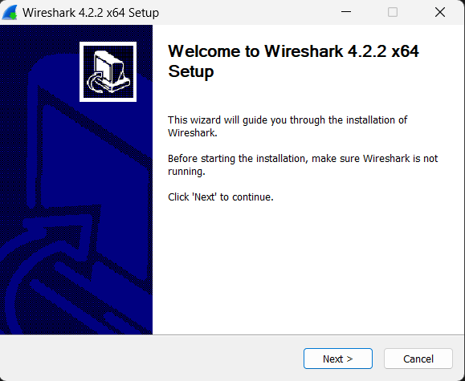

3. Follow Installation Wizard:

- Follow the instructions provided by the installation wizard.

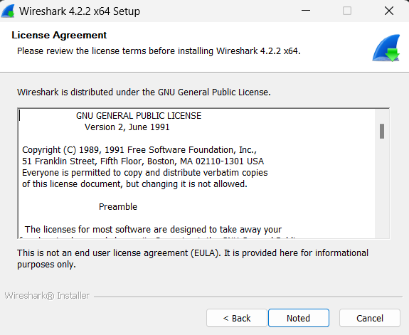

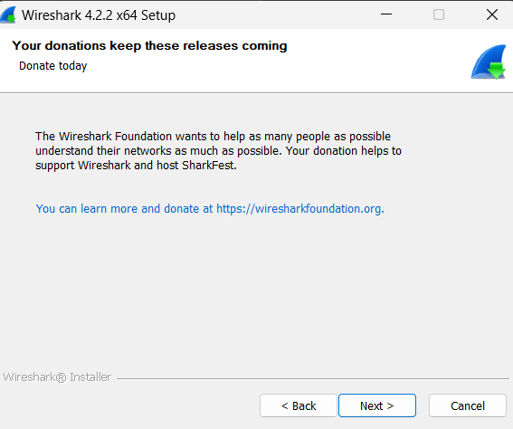

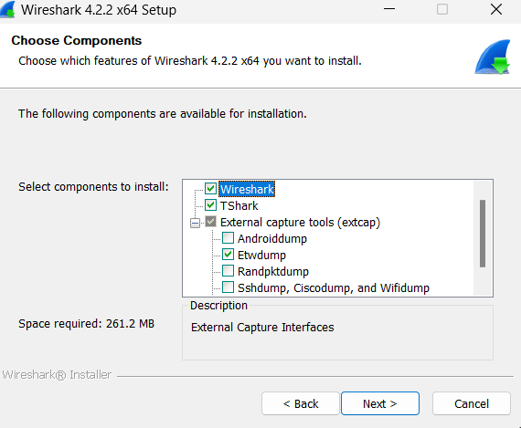

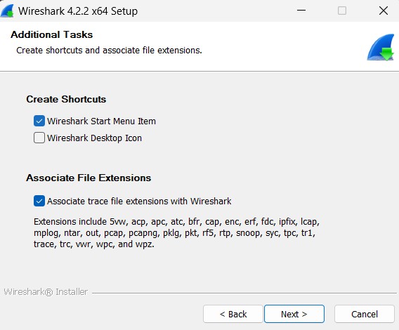

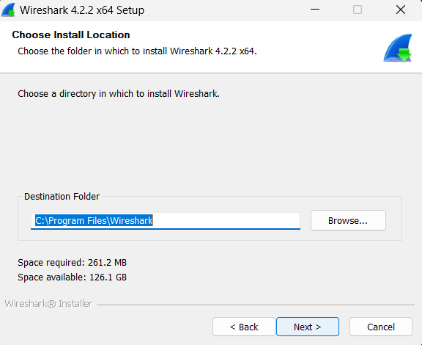

**nCap Installation:**

1. Download npCap:

While installing wireshark tick the option to also download npCap with other files

1. Follow Installation Instructions:

Look for any installation instructions provided in the downloaded files or on the official website.

1. Run the Installer :

Some tools come with installers. If an installer is provided, run it and follow the on-screen instructions.

1. Test npCap: After installation, open a command prompt or terminal and try running nCap with basic commands to ensure it's working as expected.

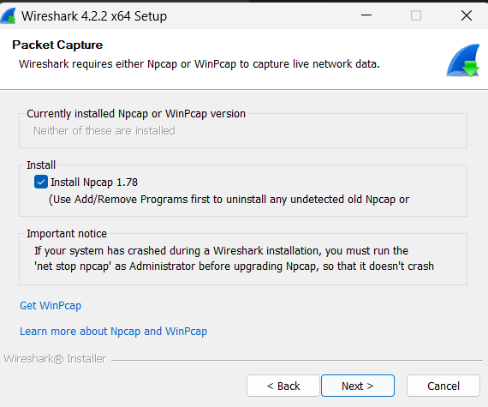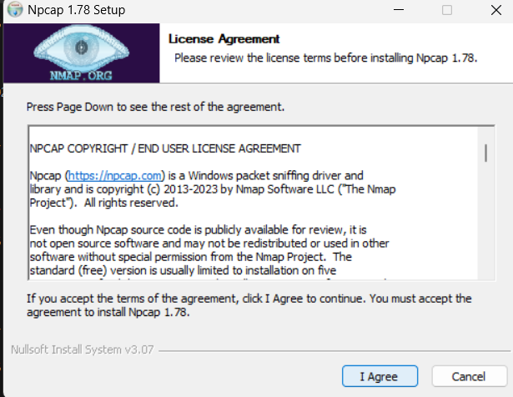

4. Completing Installation:

- Complete the installation process by clicking "Next" or "Install" as per the instructions.

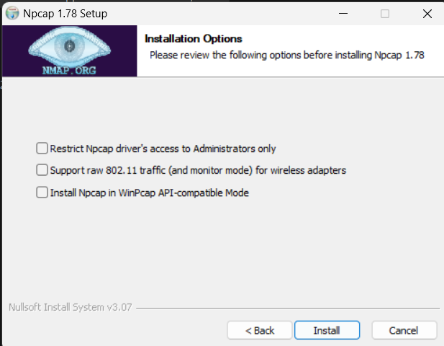

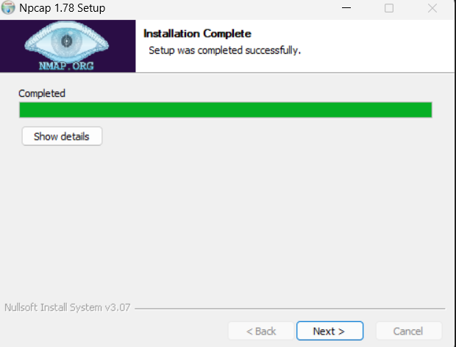

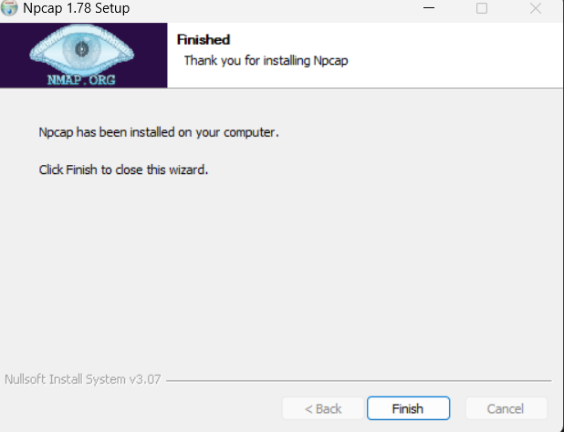

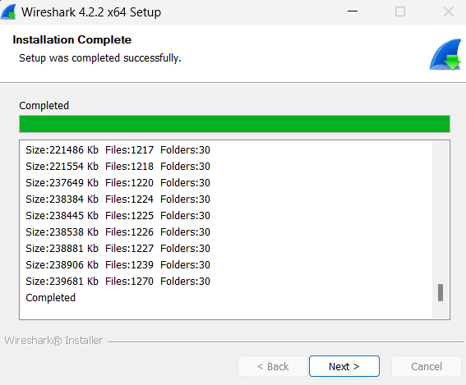

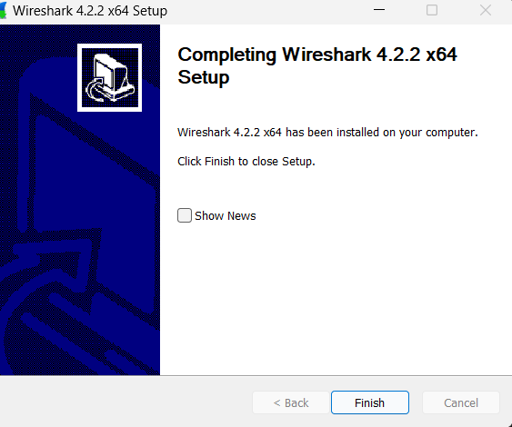

5. Run Wireshark:

- Once installed, you can run Wireshark from the Start menu or desktop shortcut.

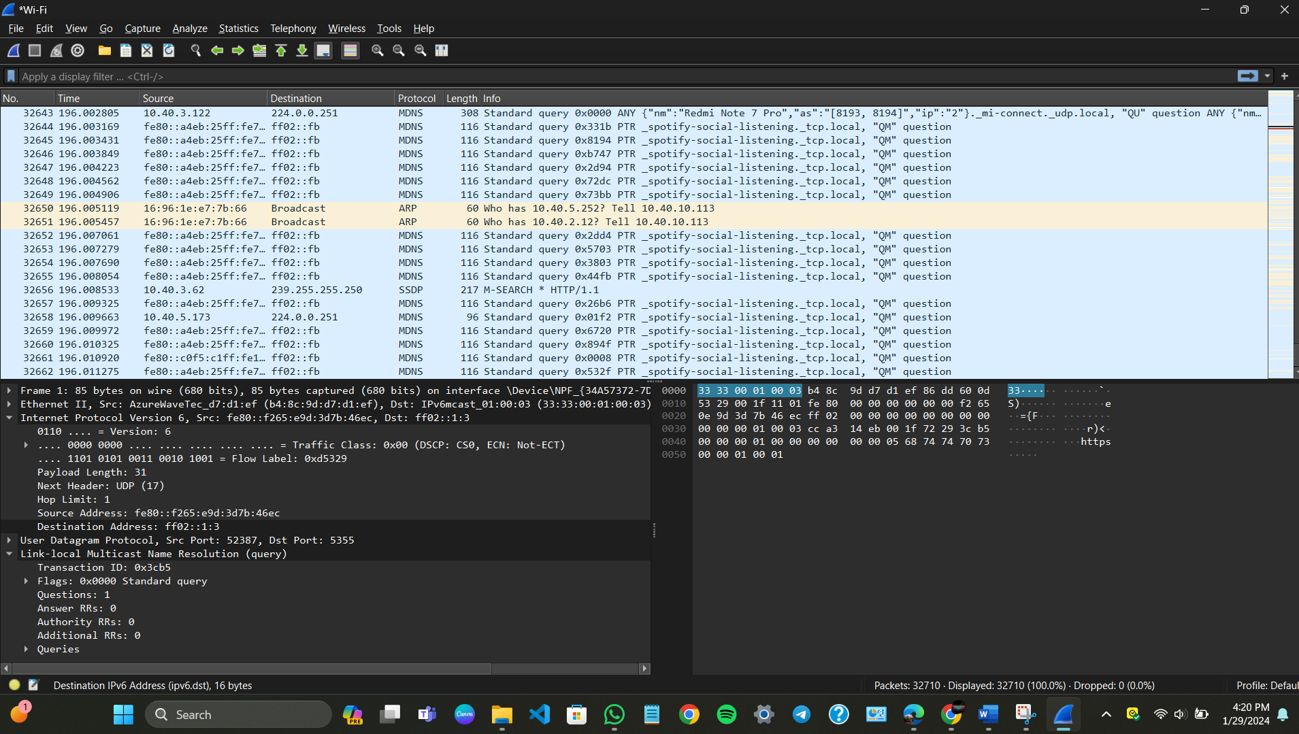

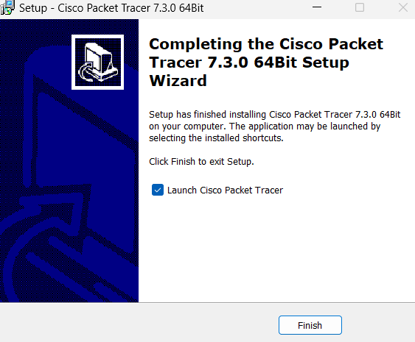

Clear Steps to Download Cisco Packet Tracer (Free Version):

1. Create a Free Account:

Go to the Cisco Networking Academy website: https://www.netacad.com/

Click on "Create Account" (top right corner)

Fill up the registration form and click "Create Account"

2. Verify your Email:

Check your email for a verification link and click it to activate your account.

3. Login and Download:

Go back to the Cisco Networking Academy website and log in.

Click on "Resources" in the top menu.

Click on "Download Packet Tracer."

Choose the version compatible with your operating system (Windows, Mac, Linux).

Click "Download Now" and save the installer file.

4. Run the Installer:

Locate the downloaded installer file on your computer (usually in Downloads).

Double-click the installer file.

Follow the on-screen instructions:

Accept the license agreement.

Choose your installation location (recommended to leave default).

Click "Install" and wait for the process to complete.

5. Launch Packet Tracer:

You can find Packet Tracer in your Start Menu/Applications folder.

Launch the software and start simulating networks!

