22510064 PARSHWA HERWADE

CN ASSIGNMNET 4: WIRESHARK LAB ETHERNET…

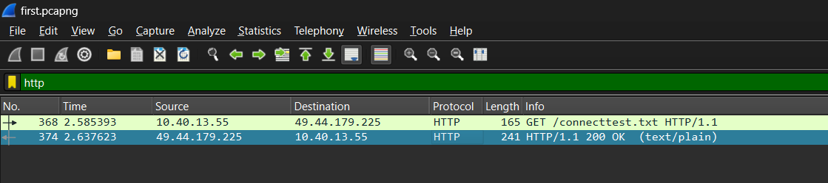

1.What is the 48-bit Ethernet address of your computer?

**ANS. Src: 10.40.13.55** (2c:3b:70:d7:52:63)

2. What is the 48-bit destination address in the Ethernet frame? Is this the Ethernet

address of [www.google.com](http://www.google.com)?

**ANS. Dst: 49.44.179.225** (00:04:96:a1:fb:0b).

It’s the address of the following link given as:

[Historical Documents:THE BILL OF RIGHTS (umass.edu)](http://gaia.cs.umass.edu/wireshark-labs/HTTP-ethereal-lab-file3.html)

opened in google chromium…

3. What device has this as its Ethernet address?

**ANS.** Our personal computer device.

4. Give the hexadecimal value for the two-byte Frame type field. What upper layer

protocol does this correspond to?

**ANS. IPv4:0x0800**

5. How many bytes from the very start of the Ethernet frame does the ASCII “G”

in “GET” appear in the Ethernet frame?

**ANS. 54**

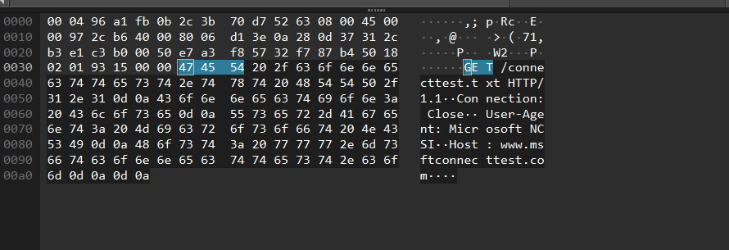

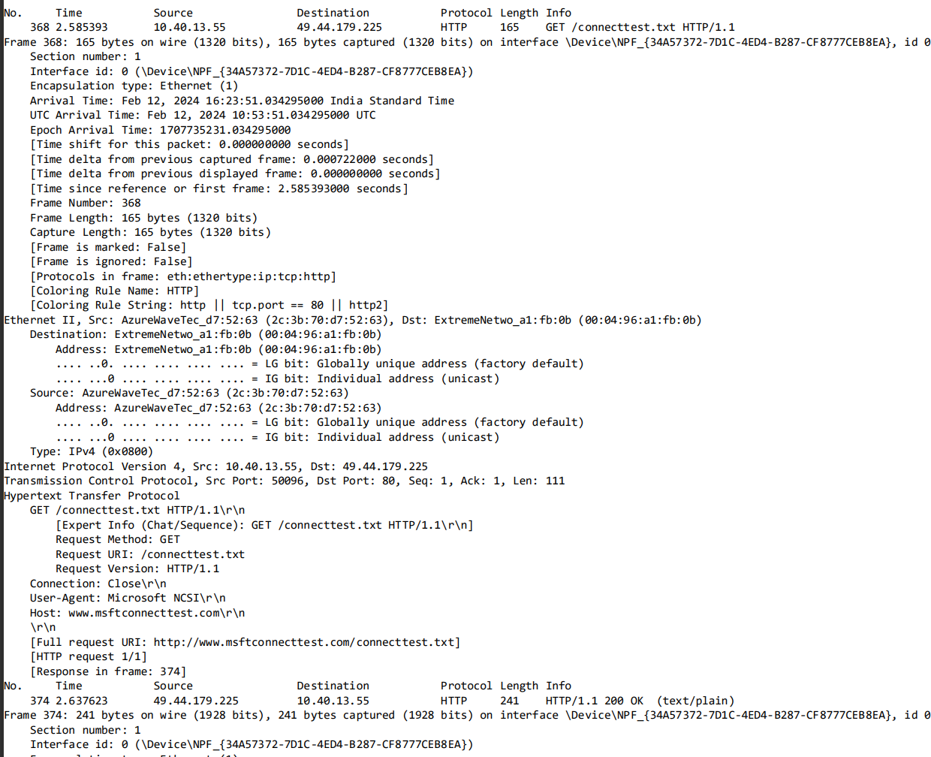

**Next, answer the following questions, based on the contents of the Ethernet frame**

**containing the first byte of the HTTP response message.**

1. What is the value of the Ethernet source address? Is this the address of your computer, or of www.google.com(Hint: the answer is no). What device has this

as its Ethernet address?

**ANS. Src:49.44.179.225** (00:04:96:a1:fb:0b)

2. What is the destination address in the Ethernet frame? Is this the Ethernet address

of your computer?

**ANS. Dst:10.40.13.55** (2c:3b:70:d7:52:63)

3. Give the hexadecimal value for the two-byte Frame type field. What upper layer

protocol does this correspond to?

**ANS. IPv4:0x0800**

4. How many bytes from the very start of the Ethernet frame does the ASCII “O” in

“OK” (i.e., the HTTP response code) appear in the Ethernet frame

**ANS. 67**

