PARSHWA HERWADE

22510064, SY BTECH CSE

ASSIGNMENT 9: UDP PROTOCOL

1. Select one packet. From this packet, determine how many fields there are in the UDP header. (Do not look in the textbook! Answer these questions directly from what you observe in the packet trace.) Name these fields.

**ANS.**  The UDP header contains 4 fields: source port, destination port, length, and checksum.

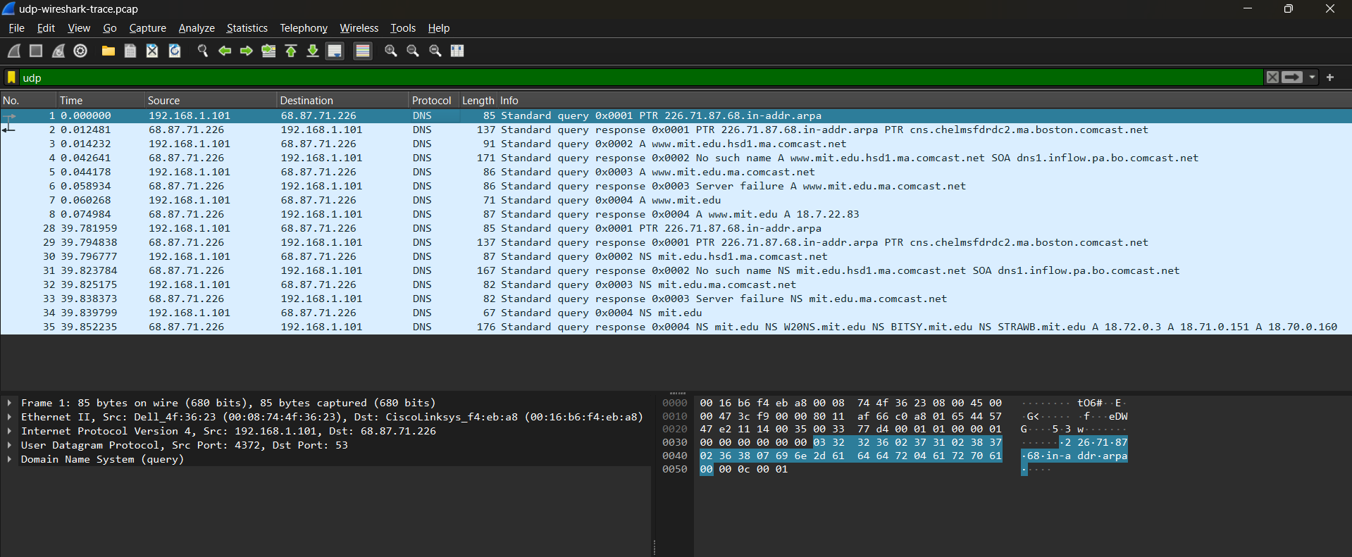

2. From the packet content field, determine the length (in bytes) of each of the UDP header fields.

**ANS.** Each of the UDP header fields is 2 bytes long

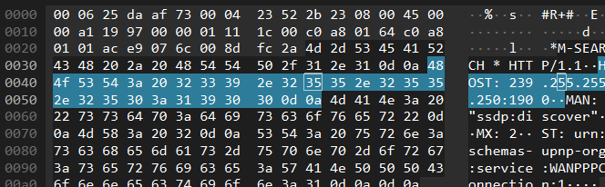

3. The value in the Length field is the length of what? Verify your claim with your captured UDP packet.

**ANS.** The value in the length field is the sum of the 8 header bytes, plus the 43 encapsulated data bytes.

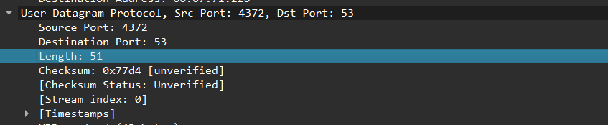

4. What is the maximum number of bytes that can be included in a UDP payload?

**ANS.** The maximum number of bytes that can be included in a UDP payload is 65,507 bytes (65,535 i.e 2^16 -1bytes total UDP packet size minus 8 bytes for the UDP header and 20 bytes for the IP header).

5. What is the largest possible source port number?

**ANS.** The largest possible source port number is 2^16 – 1 = 65535.

6. What is the protocol number for UDP? Give your answer in both hexadecimal and decimal notation. (To answer this question, you’ll need to look into the IP header.)

**ANS.**

The IP protocol number for UDP is 0x11 hex, which is 17 in decimal value.

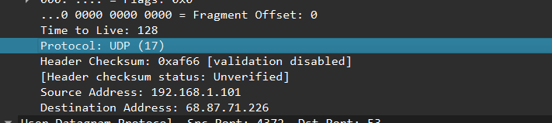

7. Search “UDP” in Google and determine the fields over which the UDP checksum is calculated.

**ANS.** The UDP checksum is calculated as the 16-bit one’s complement of the one’s complement sum of a **pseudo header** of information from the IP header, the **UDP header,** and the **data i.e payload.** This is padded as needed with zero bytes at the end to make a multiple of two bytes. If the checksum is computed to be 0, it must be set to 0xFFF

8. Examine a pair of UDP packets in which the first packet is sent by your host and the second packet is a reply to the first packet. Describe the relationship between the port numbers in the two packets.

**ANS.**

The source port of the UDP packet sent by the host is the same as the destination port of the reply packet, and conversely the destination port of the UDP packet sent by the host is the same as the source port of the reply packet.

