## ASSIGNMENT 3:

## TITLE: Introduction to Microprocessors and Study of 8085 Microprocessor and instruction set.

PRN: 22510064

DATE: 10/9/2023

AIM: a) Study all peripherals, ICs, connectors and basic operations on Dyna 8085 kit.

b) Perform 8-bit addition and subtraction using Dyna 8085 kit.

HARDWARE USED: DYNA 8085 KIT

SOFTWARE USED: GNU 8085 SIMULATOR.

1. Peripherals:

Peripherals are devices that are connected to the computer to expand its capabilities. Some of the peripherals that can be connected to Dyna Kit include:KeyboardMouseMonitorPrinterHard driveFloppy disk driveSound cardNetwork card

ICs:

Integrated circuits (ICs) are electronic components that contain many transistors and other electronic components in a single chip. Some of the ICs that are used in Dyna Kit include:CPU (Central Processing Unit): The CPU is the brain of the computer and it is responsible for carrying out instructions.RAM (Random Access Memory): RAM is used to store data that is currently being used by the computer.ROM (Read-Only Memory): ROM stores data that is permanently stored in the computer, such as the BIOS.I/O (Input/Output) ports: I/O ports allow the computer to communicate with peripherals.

Connectors:

Connectors are used to connect different components of the computer together. Some of the connectors that are used in Dyna Kit include:USB connector: USB connectors are used to connect peripherals such as keyboards, mice, and printers.VGA connector: VGA connectors are used to connect monitors to the computer.RJ-45 connector: RJ-45 connectors are used to connect the computer to a network.Serial connector: Serial connectors are used to connect peripherals such as modems and printers.

B)

**ADDITION OF TWO 8 BIT NUMBERS ON GNU:**

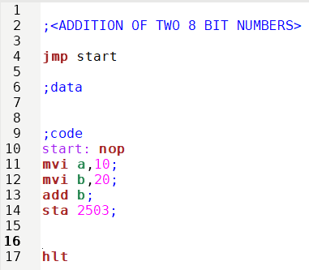

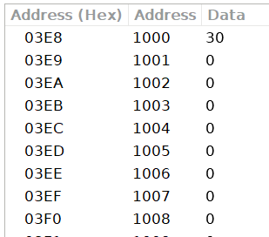

**ADDITION OF TWO 8 BIT NUMBERS ON DYNA KIT:**

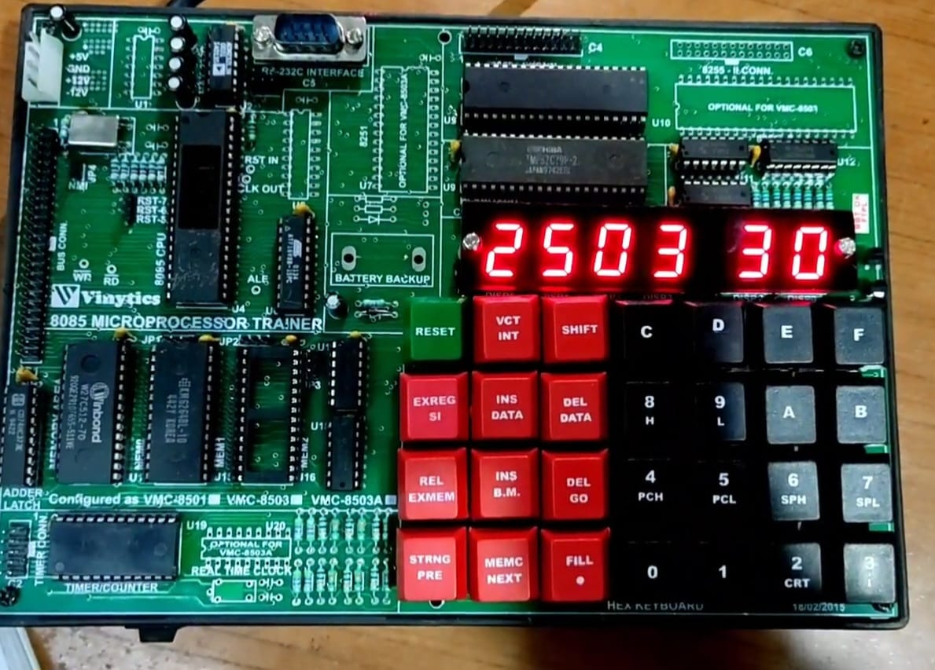

**SUBTRACTION OF TWO 8 BIT NUMBERS ON GNU:**

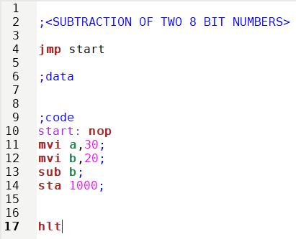

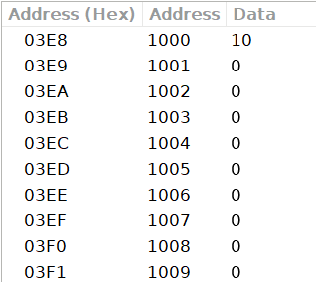

**SUBTRACTION OF TWO 8 BIT NUMBERS ON DYNA KIT:**

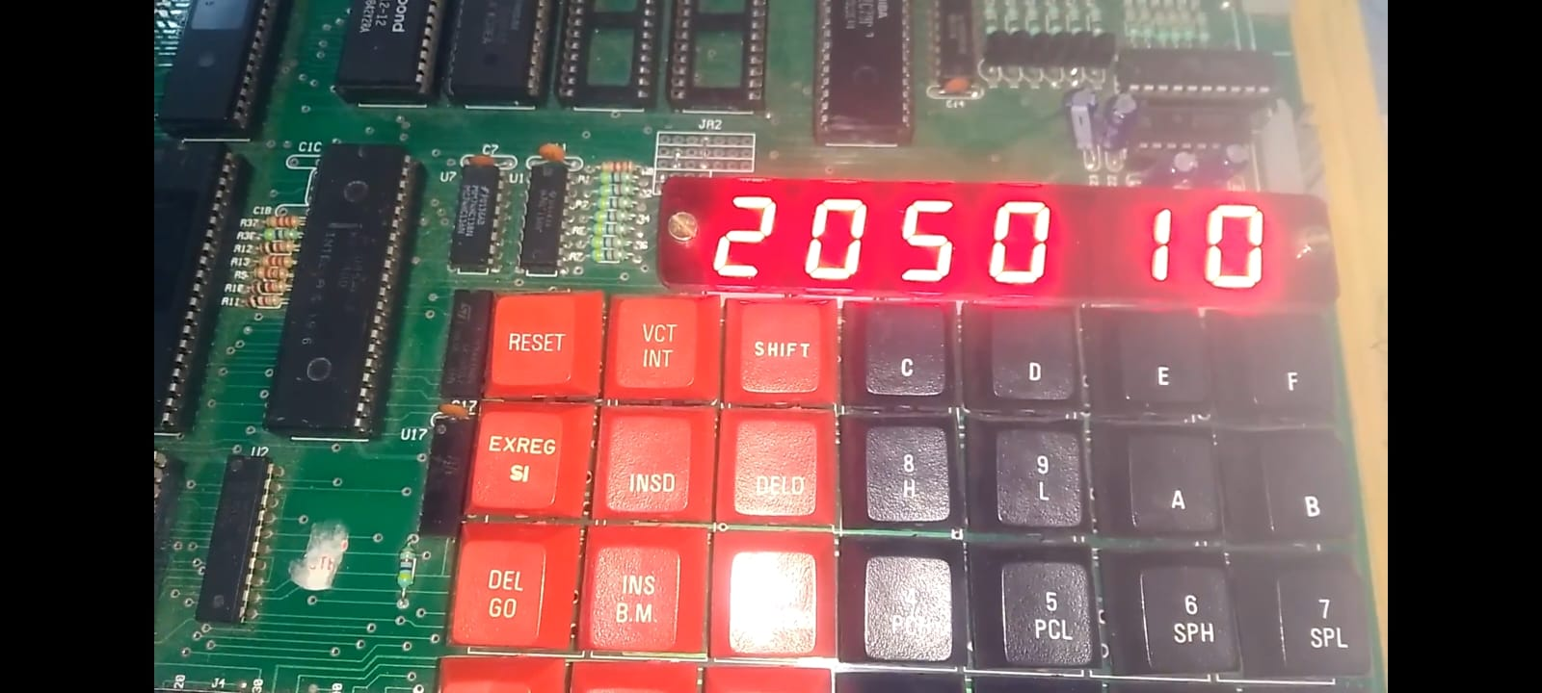

PROCEDURE:

* Install the GNU 8085 simulator software
* Open the simulator and create a new project.
* Write the assembly language code for your program in the editor.
* Assemble the code by clicking on the “assemble” button
* Run the program by clicking on the “run” button.

RESULTS:

1) The register window shows the values of the 8085 registers.2) The memory window shows the contents of the memory.3) The instruction window shows the currently executing instruction.4)The debugger window allows you to step through the program one instruction at a time.

CONCLUSION:

Thus, the addition, subtraction operations are successfully conducted on kit as well as simulator.